Assignment 3

Ben Fu (byf69)  
INF 385T – Personal Informatics

# Part 1 – Experience with Food Logging

For the first session, I recorded my meals for 3 days in MyFitnessPal, and I eat two meals per day so I logged a total of 6 meals plus occasional snacks. Because the food logging was for this assignment, I did not miss any episodes, but I did see the task of manual logging become tedious especially if I wasn’t motivated. The biggest factor that influenced logging was just forgetting to. This was probably my fault since I hadn’t really developed a habit for food logging. Another big factor was the inconsistency of the food database. When I tried to add a simple grilled chicken breast as a recipe, there were lots of different options to choose from and wildly varying nutritional content. After searching through a lot of other recipes, I noticed that many of them are pretty inaccurate, so it would be nice if MyFitnessPal provided some sort of community voting process where we could report a recipe for not being accurate on the mobile app similar to the functionality they have on their website. Other than that, I found it really cool that almost everything I ate had an existing recipe that I could choose from so that I didn’t have to enter the individual foods manually. Overall, I really enjoyed using MyFitnessPal, and I really like that they provide you with a daily caloric goal and also integrates with my Fitbit to include my daily exercise caloric burn as well. Another neat feature they provide is the ability to select a previous recipe/meal. This really came in handy because I ate the same brunch for two days.

For the second session, I recorded the same 6 meals and snacks by taking a picture. I immediately noticed how much faster this was because I didn’t have to manually log anything or open an app (the camera can be accessed from the lock screen). However, I also realized that I had pretty much no insight to the nutritional content of the food I was eating even though it was pretty much the same meals as the first three days (I usually meal prep for the week). I didn’t really experience any factors that prevented me from wanting to take pictures of my meals as the task is pretty quick and convenient. I tried to take all of the pictures at the same angle, which was straight above the food. Even though the pictures of the meal didn’t give me too much insight, it was good to remember the portions of the food I ate the day before so that I didn’t scoop too much food out and misjudge the portions subsequently. Other than that, another benefit was that having to take pictures of my food was a deterrent to eating more unhealthily, as I felt more inclined to take pictures of healthier meals (this must be some natural mental inclination). Overall, I found this method of food logging much quicker but also less insightful. I can also imagine that if I only used this form of food logging for my life, the pictures would become unorganized very quickly and I would lose the motivation to keep going.

# Part 2 – New Food Logging App

For a new semi-automated food logging system, I propose a combination of the methods we used for this assignment: manual logging with intelligent analysis. In this new system, users start by logging the food they eat at home or at restaurants. Then, the system will intelligently learn the user’s common food habits based on his or her previously logged data so that it can start making predictions after a certain amount of time. This new system still allows users the full control and ability to manually log everything like MyFitnessPal, but instead of having to do it for every meal, it provides predictive suggestions based on that user’s food diary history. Thus, this system continually learns based on the user’s daily food entries, and the goal is to automatically fill in as many meals as possible for the user.

## Functionality

### Dataset

One of the goals of this system is to provide users with an extensive database of food entries and recipes to choose from, including restaurant menus. Existing food item and recipe databases such as MyFitnessPal will be used, and we will likely create a separate interface specifically for restaurants. Restaurant owners and partners can then fill in and update their current menus to reflect the nutritional content of their menu items. This is more advantageous than using existing restaurant foods in MyFitnessPal’s database because those foods are often outdated and/or inaccurate. Working with actual employees from the restaurant ensures accurate and current food entries.

### Manual Logging

The manual logging element is critical to the learning phase of this system. When entering a food entry, users can search through existing food and recipe databases as well as his or her own past entries. Users can also take a photo of the food and can receive recipe and food suggestions based on the picture they uploaded. Additionally, the system will also consider the user’s current location and make suggestions based on that. For example, if the user is near Chuy’s, the system will ask the user if they are at the restaurant and then the user can select the food he or she is ordering from the menu.

The logging page would look something like this:

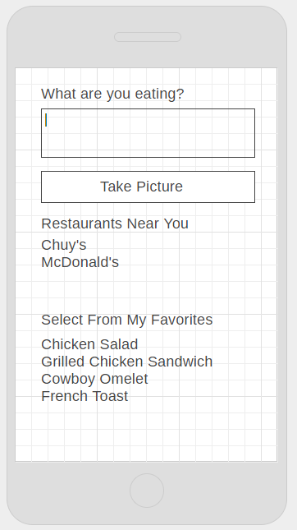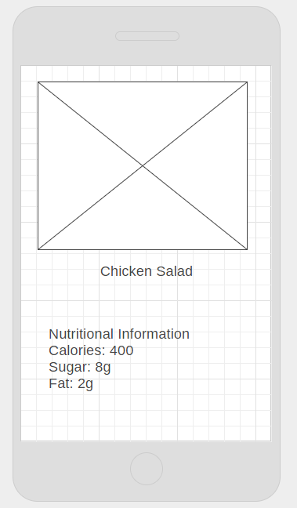

Now, the system will save the selected food as well as the corresponding timestamp, image, and restaurant (if applicable) to keep track of the context around the food entry.

### “Learning” the Diary

The transition from pure manual logging to a mostly automatic one may take a long time. The most important phase is the learning phase when users will be entering most if not all of their food data manually. The system is slightly more advanced than MyFitnessPal since the users can receive recipe data based on a picture instead of pure text entry, but the logging is still manual. Throughout this phase, the system will start training a machine learning model to look at the existing food entries and start to make predictions on what the next entry might be.

The features that the classification model will consider include the location, restaurant name (if applicable), close places, timestamp, image, image labels, recipe information, method of entry, time from last identical entry, number of identical entries, number of recent identical entries, and all recent entries for the past week. This model will continue to learn on the data until its accuracy reaches a certain threshold, about 50% accuracy. Even though this seems like a low accuracy to aim for, food prediction is a very difficult task and even if the system is able to be correct half of the time, that is already a great achievement. The goal of this model is to ultimately predict the user’s next food entry based on his or her previous patterns and contexts.

### Visualization

The final and perhaps most important part of this application is to provide an effective visualization for users. This will be similar to the home page of MyFitnessPal except that more information, such as the image of the food, the user’s location, and restaurant (if applicable), will be provided. The format will be that of a timeline that represents the user’s food entries for the past week. Then, the user can choose to view the complete history of his or her food entries or view a day or food entry in more detail.

## Implementation

The system should primarily be a server-based service, and most of the work should be happening on the server side. This allows the client side to be flexible so that users can user a web interface or their mobile phones to view the same data. This allows the user’s data to remain in the cloud for persistence.

## Experiment and Evaluation

To test this system, we would need to recruit volunteers to participate in this study. Users can download the appropriate apps or interface with the system through a web client. The study should run for at least 30 days and ideally for 6 months. The reason for this is because food logging is very scarce (only 3 real data points per day on average), and to train a model that is so complex, many more data points would be needed.

To evaluate the system, we will keep track of the accuracy of the predictive classification model. If the accuracy reaches the goal threshold (50%), we will consider this a working system.

## Extensions

One possible extension would be a specialization for recipes and cooking food at home. Since this system is already encompassing a wide variety of general food logging, an extension for recipe-specialized functionality would be helpful for those who tend to cook at home more. For example, users can report the weekly groceries that they buy, and the recipes found will automatically deduct the items from their inventory. This will add some additional features to the model or result in a completely separate model that specializes in recipe prediction.