- CONNECT
From terminal
ssh bgencarelli@ssh.swc.ucl.ac.uk
ssh bgencarelli@hpc-gw2
- UPLOAD THE BUILD
note: this requires creating the relevant folders with mkdir (‘bgenca’, ‘octagon’, etc.), as well as making a Linux build, which I did with a Unity package on Mac that allows to create a Linux build.
From terminal
rsync -av --progress \
/Users/benny/Documents/swc/agents/builds/split_cost_linux/ \
bgencarelli@hpc-gw2:/ceph/scratch/bgenca/octagon/builds/OctagonAgentSoloLinux/
In hpc (make the executable runnable)
chmod +x OctagonAgentSolo.x86_64
- COPY THE REPO WITH SIMULATOR SCRIPT AND OUTPUT FOLDERS
In hpc
rsync -av --progress \
/Users/benny/Repos/agent_training \
bgencarelli@swc-gateway:/ceph/scratch/bgenca/octagon/agent_training/
- UPLOAD ML-AGENTS YAML REFERENCE FILE
From terminal
rsync -av --progress \
/Users/benny/Repos/octagon/Assets/Scripts/MLConfigFiles/SoloSplitCostConfig.yaml \
bgencarelli@swc-gateway:/ceph/scratch/bgenca/octagon/template_yaml/SplitCostSolo.yaml
- CREATE LINUX-COMPTIBLE ENVIRONMENT VIA YAML
In hpc
module load miniconda/23.10.0
conda env create \
--prefix /ceph/scratch/bgenca/conda_envs/mlagents \
-f environment_hpc.yaml
conda activate /ceph/scratch/bgenca/conda_envs/mlagents
- RUN AND MONITOR THE JOB
In hpc
sbatch run_training.slurm
squeue -u $USER
tail -f logs/split_cost_<jobid>.out

FILES REFERENCED are in agent_training repo on main
Includes files for getting gpu node and training agents in hpc.
Under configs is the agent configuration file used to fill in the cost and use for training.
Currently, run_training_hpc.py runs the simulator with only one environment and only one agent; this was for the purpose of testing, however, training failed due to timeout error unity-side.

ERROR LOG BELOW
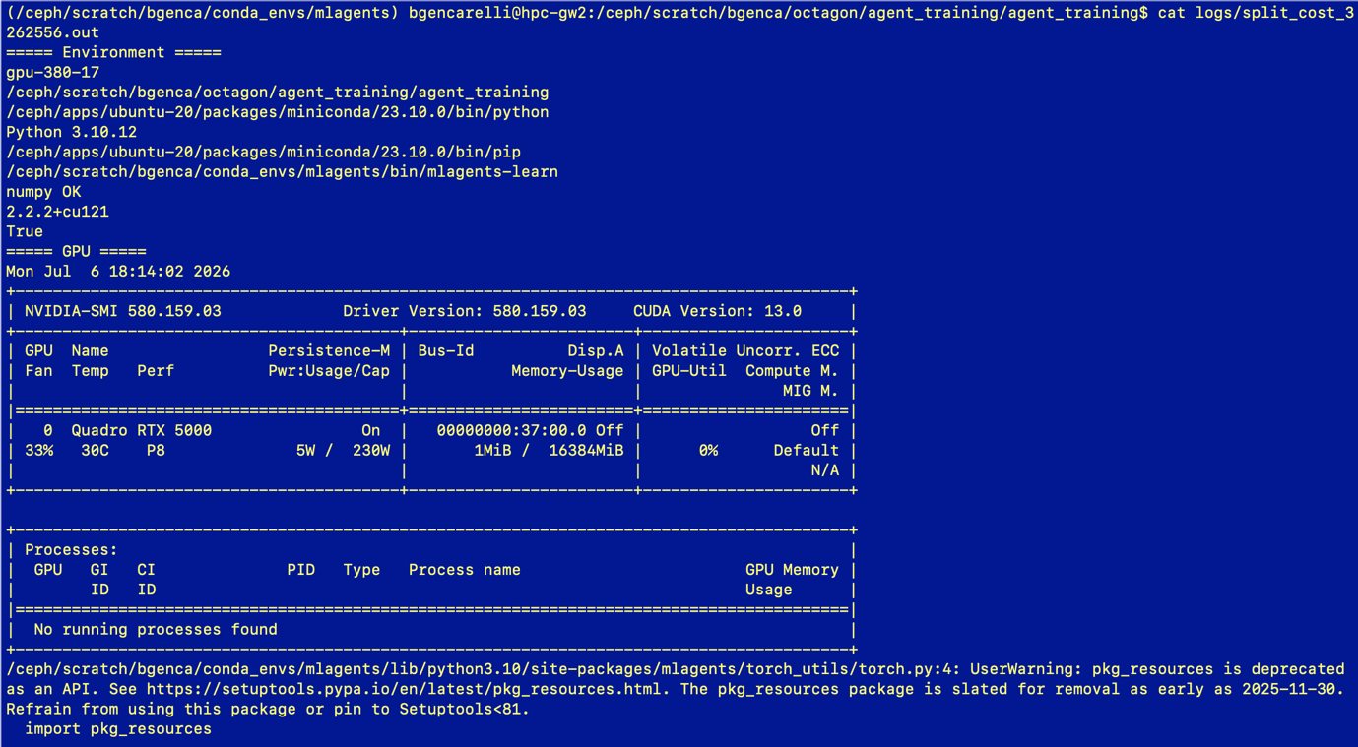
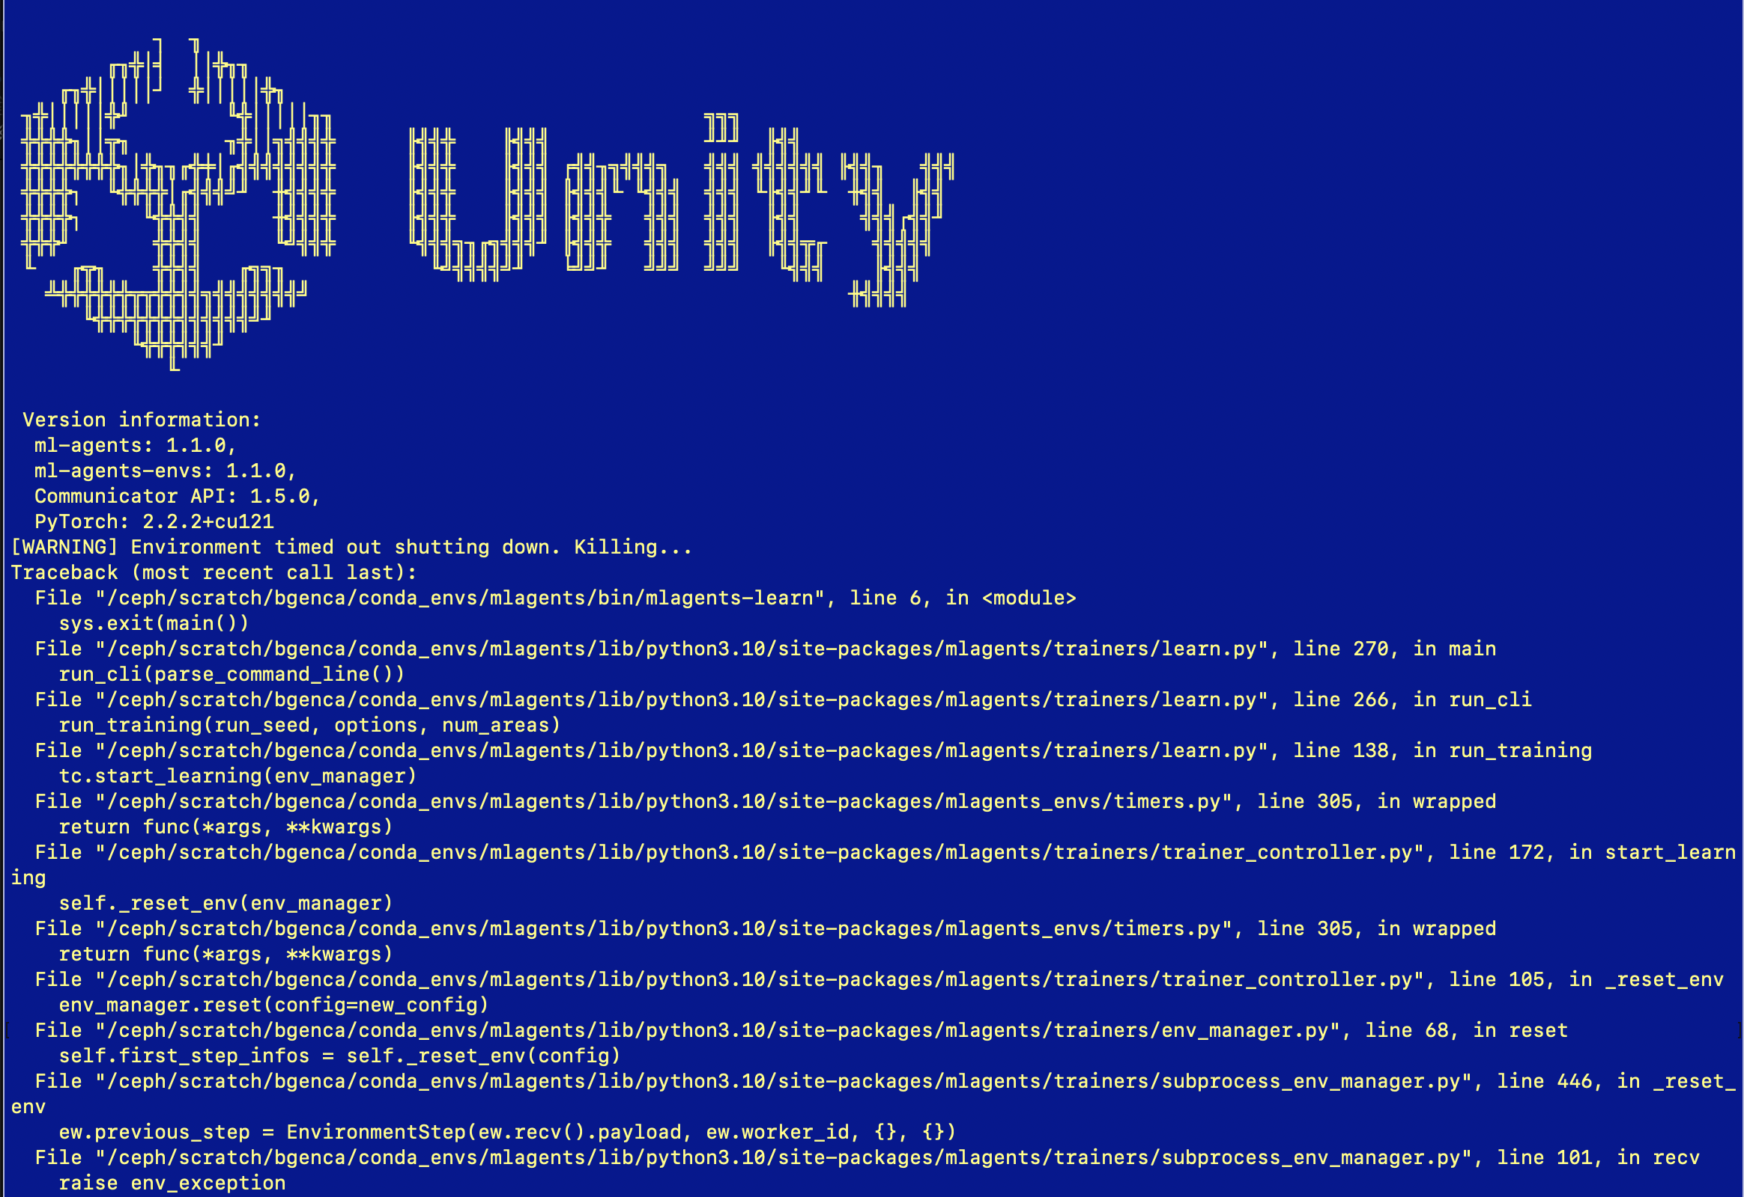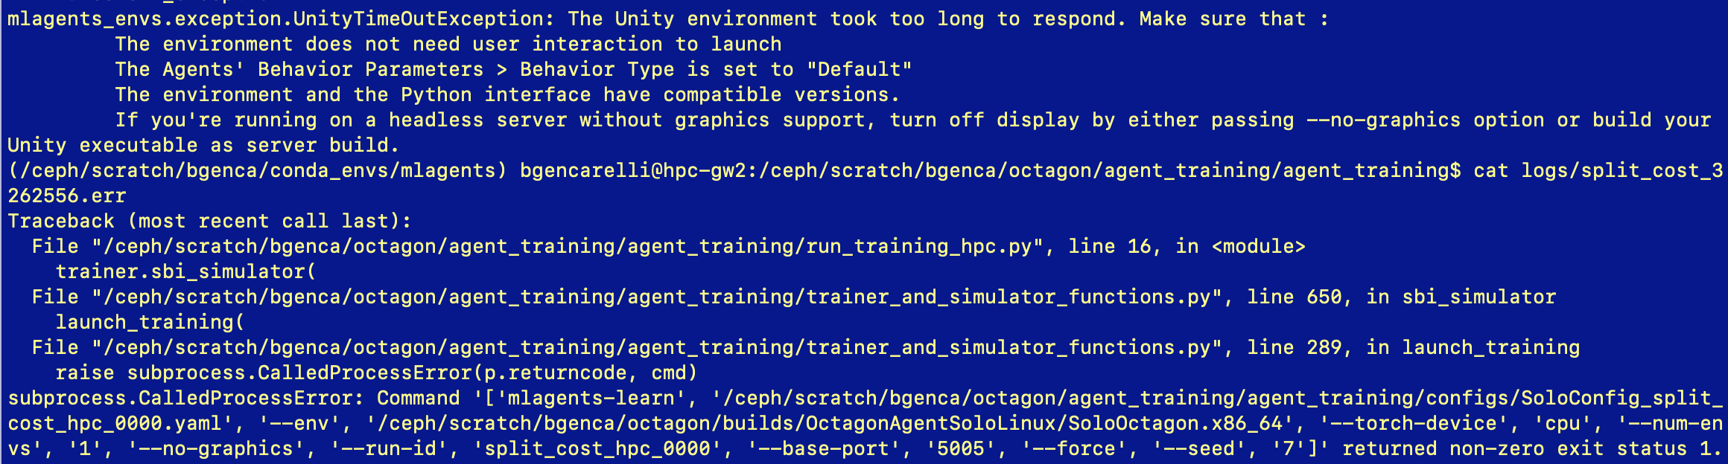
COPY-PASTED ERROR LOG
Here I submit the job
(/ceph/scratch/bgenca/conda_envs/mlagents) bgencarelli@hpc-gw2:/ceph/scratch/bgenca/octagon/agent_training/agent_training$ sbatch run_training.slurm
Submitted batch job 3262556

Here I check its status
(/ceph/scratch/bgenca/conda_envs/mlagents) bgencarelli@hpc-gw2:/ceph/scratch/bgenca/octagon/agent_training/agent_training$ squeue -u bgencarelli
JOBID PARTITION NAME USER ST TIME NODES NODELIST(REASON)
3262556 gpu split_co bgencare R 0:10 1 gpu-380-17

Here I check its status again
(/ceph/scratch/bgenca/conda_envs/mlagents) bgencarelli@hpc-gw2:/ceph/scratch/bgenca/octagon/agent_training/agent_training$ squeue -u bgencarelli
JOBID PARTITION NAME USER ST TIME NODES NODELIST(REASON)
3262556 gpu split_co bgencare R 0:20 1 gpu-380-17

again
(/ceph/scratch/bgenca/conda_envs/mlagents) bgencarelli@hpc-gw2:/ceph/scratch/bgenca/octagon/agent_training/agent_training$ squeue -u bgencarelli
JOBID PARTITION NAME USER ST TIME NODES NODELIST(REASON)
3262556 gpu split_co bgencare R 0:40 1 gpu-380-17

Again, and see it has failed

(/ceph/scratch/bgenca/conda_envs/mlagents) bgencarelli@hpc-gw2:/ceph/scratch/bgenca/octagon/agent_training/agent_training$ squeue -u bgencarelli
JOBID PARTITION NAME USER ST TIME NODES NODELIST(REASON)

Checking error logs, some in the list are from previous attempts
(/ceph/scratch/bgenca/conda_envs/mlagents) bgencarelli@hpc-gw2:/ceph/scratch/bgenca/octagon/agent_training/agent_training$ ls -lh logs
total 38K
-rw-rw-r-- 1 bgencarelli bgencarelli 509 Jul 6 15:18 split_cost_3262196.err
-rw-rw-r-- 1 bgencarelli bgencarelli 1.9K Jul 6 15:18 split_cost_3262196.out
-rw-rw-r-- 1 bgencarelli bgencarelli 628 Jul 6 16:30 split_cost_3262303.err
-rw-rw-r-- 1 bgencarelli bgencarelli 2.0K Jul 6 16:30 split_cost_3262303.out
-rw-rw-r-- 1 bgencarelli bgencarelli 401 Jul 6 16:37 split_cost_3262307.err
-rw-rw-r-- 1 bgencarelli bgencarelli 2.0K Jul 6 16:37 split_cost_3262307.out
-rw-rw-r-- 1 bgencarelli bgencarelli 952 Jul 6 16:45 split_cost_3262319.err
-rw-rw-r-- 1 bgencarelli bgencarelli 6.4K Jul 6 16:45 split_cost_3262319.out
-rw-rw-r-- 1 bgencarelli bgencarelli 952 Jul 6 17:12 split_cost_3262361.err
-rw-rw-r-- 1 bgencarelli bgencarelli 6.3K Jul 6 17:12 split_cost_3262361.out
-rw-rw-r-- 1 bgencarelli bgencarelli 949 Jul 6 17:41 split_cost_3262507.err
-rw-rw-r-- 1 bgencarelli bgencarelli 6.3K Jul 6 17:41 split_cost_3262507.out
-rw-rw-r-- 1 bgencarelli bgencarelli 949 Jul 6 18:15 split_cost_3262556.err
-rw-rw-r-- 1 bgencarelli bgencarelli 6.3K Jul 6 18:15 split_cost_3262556.out

Check error logs content and .out content which includes the output I ask for in run_training.slurm (in agent_training repo)
(/ceph/scratch/bgenca/conda_envs/mlagents) bgencarelli@hpc-gw2:/ceph/scratch/bgenca/octagon/agent_training/agent_training$ cat logs/split_cost_3262556.out
===== Environment =====
gpu-380-17
/ceph/scratch/bgenca/octagon/agent_training/agent_training
/ceph/apps/ubuntu-20/packages/miniconda/23.10.0/bin/python
Python 3.10.12
/ceph/apps/ubuntu-20/packages/miniconda/23.10.0/bin/pip
/ceph/scratch/bgenca/conda_envs/mlagents/bin/mlagents-learn
numpy OK
2.2.2+cu121
True
===== GPU =====
Mon Jul 6 18:14:02 2026
+-----------------------------------------------------------------------------------------+
| NVIDIA-SMI 580.159.03 Driver Version: 580.159.03 CUDA Version: 13.0 |
+-----------------------------------------+------------------------+----------------------+
| GPU Name Persistence-M | Bus-Id Disp.A | Volatile Uncorr. ECC |
| Fan Temp Perf Pwr:Usage/Cap | Memory-Usage | GPU-Util Compute M. |
| | | MIG M. |
|=========================================+========================+======================|
| 0 Quadro RTX 5000 On | 00000000:37:00.0 Off | Off |
| 33% 30C P8 5W / 230W | 1MiB / 16384MiB | 0% Default |
| | | N/A |
+-----------------------------------------+------------------------+----------------------+

+-----------------------------------------------------------------------------------------+
| Processes: |
| GPU GI CI PID Type Process name GPU Memory |
| ID ID Usage |
|=========================================================================================|
| No running processes found |
+-----------------------------------------------------------------------------------------+
/ceph/scratch/bgenca/conda_envs/mlagents/lib/python3.10/site-packages/mlagents/torch_utils/torch.py:4: UserWarning: pkg_resources is deprecated as an API. See https://setuptools.pypa.io/en/latest/pkg_resources.html. The pkg_resources package is slated for removal as early as 2025-11-30. Refrain from using this package or pin to Setuptools<81.
import pkg_resources

┐ ╖
╓╖╬│╡ ││╬╖╖
╓╖╬│││││┘ ╬│││││╬╖
╖╬│││││╬╜ ╙╬│││││╖╖ ╗╗╗
╬╬╬╬╖││╦╖ ╖╬││╗╣╣╣╬ ╟╣╣╬ ╟╣╣╣ ╜╜╜ ╟╣╣
╬╬╬╬╬╬╬╬╖│╬╖╖╓╬╪│╓╣╣╣╣╣╣╣╬ ╟╣╣╬ ╟╣╣╣ ╒╣╣╖╗╣╣╣╗ ╣╣╣ ╣╣╣╣╣╣ ╟╣╣╖ ╣╣╣
╬╬╬╬┐ ╙╬╬╬╬│╓╣╣╣╝╜ ╫╣╣╣╬ ╟╣╣╬ ╟╣╣╣ ╟╣╣╣╙ ╙╣╣╣ ╣╣╣ ╙╟╣╣╜╙ ╫╣╣ ╟╣╣
╬╬╬╬┐ ╙╬╬╣╣ ╫╣╣╣╬ ╟╣╣╬ ╟╣╣╣ ╟╣╣╬ ╣╣╣ ╣╣╣ ╟╣╣ ╣╣╣┌╣╣╜
╬╬╬╜ ╬╬╣╣ ╙╝╣╣╬ ╙╣╣╣╗╖╓╗╣╣╣╜ ╟╣╣╬ ╣╣╣ ╣╣╣ ╟╣╣╦╓ ╣╣╣╣╣
╙ ╓╦╖ ╬╬╣╣ ╓╗╗╖ ╙╝╣╣╣╣╝╜ ╘╝╝╜ ╝╝╝ ╝╝╝ ╙╣╣╣ ╟╣╣╣
╩╬╬╬╬╬╬╦╦╬╬╣╣╗╣╣╣╣╣╣╣╝ ╫╣╣╣╣
╙╬╬╬╬╬╬╬╣╣╣╣╣╣╝╜
╙╬╬╬╣╣╣╜
╙

Version information:
ml-agents: 1.1.0,
ml-agents-envs: 1.1.0,
Communicator API: 1.5.0,
PyTorch: 2.2.2+cu121
[WARNING] Environment timed out shutting down. Killing...
Traceback (most recent call last):
File "/ceph/scratch/bgenca/conda_envs/mlagents/bin/mlagents-learn", line 6, in <module>
sys.exit(main())
File "/ceph/scratch/bgenca/conda_envs/mlagents/lib/python3.10/site-packages/mlagents/trainers/learn.py", line 270, in main
run_cli(parse_command_line())
File "/ceph/scratch/bgenca/conda_envs/mlagents/lib/python3.10/site-packages/mlagents/trainers/learn.py", line 266, in run_cli
run_training(run_seed, options, num_areas)
File "/ceph/scratch/bgenca/conda_envs/mlagents/lib/python3.10/site-packages/mlagents/trainers/learn.py", line 138, in run_training
tc.start_learning(env_manager)
File "/ceph/scratch/bgenca/conda_envs/mlagents/lib/python3.10/site-packages/mlagents_envs/timers.py", line 305, in wrapped
return func(*args, **kwargs)
File "/ceph/scratch/bgenca/conda_envs/mlagents/lib/python3.10/site-packages/mlagents/trainers/trainer_controller.py", line 172, in start_learning
self._reset_env(env_manager)
File "/ceph/scratch/bgenca/conda_envs/mlagents/lib/python3.10/site-packages/mlagents_envs/timers.py", line 305, in wrapped
return func(*args, **kwargs)
File "/ceph/scratch/bgenca/conda_envs/mlagents/lib/python3.10/site-packages/mlagents/trainers/trainer_controller.py", line 105, in _reset_env
env_manager.reset(config=new_config)
File "/ceph/scratch/bgenca/conda_envs/mlagents/lib/python3.10/site-packages/mlagents/trainers/env_manager.py", line 68, in reset
self.first_step_infos = self._reset_env(config)
File "/ceph/scratch/bgenca/conda_envs/mlagents/lib/python3.10/site-packages/mlagents/trainers/subprocess_env_manager.py", line 446, in _reset_env
ew.previous_step = EnvironmentStep(ew.recv().payload, ew.worker_id, {}, {})
File "/ceph/scratch/bgenca/conda_envs/mlagents/lib/python3.10/site-packages/mlagents/trainers/subprocess_env_manager.py", line 101, in recv
raise env_exception
mlagents_envs.exception.UnityTimeOutException: The Unity environment took too long to respond. Make sure that :
The environment does not need user interaction to launch
The Agents' Behavior Parameters > Behavior Type is set to "Default"
The environment and the Python interface have compatible versions.
If you're running on a headless server without graphics support, turn off display by either passing --no-graphics option or build your Unity executable as server build.

Here I check the error log

(/ceph/scratch/bgenca/conda_envs/mlagents) bgencarelli@hpc-gw2:/ceph/scratch/bgenca/octagon/agent_training/agent_training$ cat logs/split_cost_3262556.err
Traceback (most recent call last):
File "/ceph/scratch/bgenca/octagon/agent_training/agent_training/run_training_hpc.py", line 16, in <module>
trainer.sbi_simulator(
File "/ceph/scratch/bgenca/octagon/agent_training/agent_training/trainer_and_simulator_functions.py", line 650, in sbi_simulator
launch_training(
File "/ceph/scratch/bgenca/octagon/agent_training/agent_training/trainer_and_simulator_functions.py", line 289, in launch_training
raise subprocess.CalledProcessError(p.returncode, cmd)
subprocess.CalledProcessError: Command '['mlagents-learn', '/ceph/scratch/bgenca/octagon/agent_training/agent_training/configs/SoloConfig_split_cost_hpc_0000.yaml', '--env', '/ceph/scratch/bgenca/octagon/builds/OctagonAgentSoloLinux/SoloOctagon.x86_64', '--torch-device', 'cpu', '--num-envs', '1', '--no-graphics', '--run-id', 'split_cost_hpc_0000', '--base-port', '5005', '--force', '--seed', '7']' returned non-zero exit status 1.

