Module timesheet

Current version **2.0**

Dolibarr minimum version: **3.5.6**

Dolibarr latest version tested : **6.0**

Table des matières

1. Prerequisites: 2

Other module 2

Project created and validated 2

Project open : 2

Task Created and open 2

User assigned to the task 2

2. Module setup 3

How to access the setup page 3

Setup page 3

Setup page: General Tab 3

Setup Page: Advanced tab 4

Setup page: Invoice tab 4

3. Entering time spent 5

Blank/draft/saved timesheet: 5

Submitted timesheet 5

Timesheet approved 6

Timesheet rejected 6

Timesheet challenged 6

4. Favoris 6

Favoris list 7

New favoris item 7

5. Approval: 7

Timesheets rights 7

Timesheet approval: team leader 8

User report :Normal layout: 10

User report :Export friendly layout 10

User report :Short layout 11

6. Project report 11

Project report :Normal layout 11

Project report :Export friendly layout 11

Project report :Short layout 12

8. Project Invoice 13

First invoice step: the general project’s invoice parameters 13

9. Timesheet admin access 14

Timesheet admin list 14

Timesheet admin details 14

Timesheet admin edit 14

Note: this module is not able to do any changes to created invoice, the only invoice related action possible is the creation of a draft invoice by using the Dolibarr core methods (there is no invoice related database request in the module)

# Prerequisites:

## Other module

Project module must be activated ( should be automatically activated upon timesheet activation)

## Project created and validated

draft project won’t be shown by default but they can be shown by changing the module configuration (see setup page part)

## Project open :

Timesheet only possible if date is between start and end date of the project; no start date mean that the project’s task will be shown until the en date; no end date means that the project’s task will be always shown after the start date

## Task Created and open

Timesheet only possible if date is between start and end date fo the task. No start date mean that the task will be shown until the en date; no end date means that the task will be always shown after the start date

## User assigned to the task

in order to assign an user to a task he must be first assign to the project via Project→contact Project. Then he can be assigned to the task : Task > resource assignation.

# Module setup

## How to access the setup page

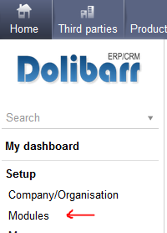 The module setup can be found in the Home(top menu)>Setup ( left Menu)>module

then on the timesheet line one must click on the icon at the right



## Setup page

The module setup page is made of 4 tabs, the change are not lost while changing tab so to reset the changes one must reload the page. The “Other” tab won’t be details in this manual as it is mostly a feeback email link.

## Setup page: General Tab

This tab include the setup that must be done after the module installation.

## 

## Setup Page: Advanced tab

This tab is to setup advanced behaviour of the timesheet such as the favoris task or the approval flows, this one can be left unchanged

## Setup page: Invoice tab

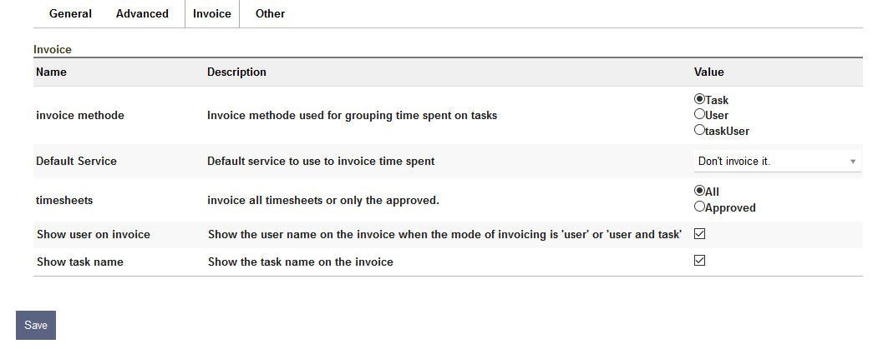This tab is to setup the deafult option in the invoice generation, the invoice generation is accessible from the project menu, either via the project report or via the Invoice Project Time left menu,

# Entering time spent

The default page of the timesheet main tab is the user screen to log the time spent on task. The screenshot were taken with the favoris, approval flow & note were activated

## Blank/draft/saved timesheet:

This screen id shown when no timesheet where submitted for approval, if there is already time saved, the time will be on a light green background (not configurable) and the day/task that are not eligible for time spend are on a grey background (not configurable) and are not editable

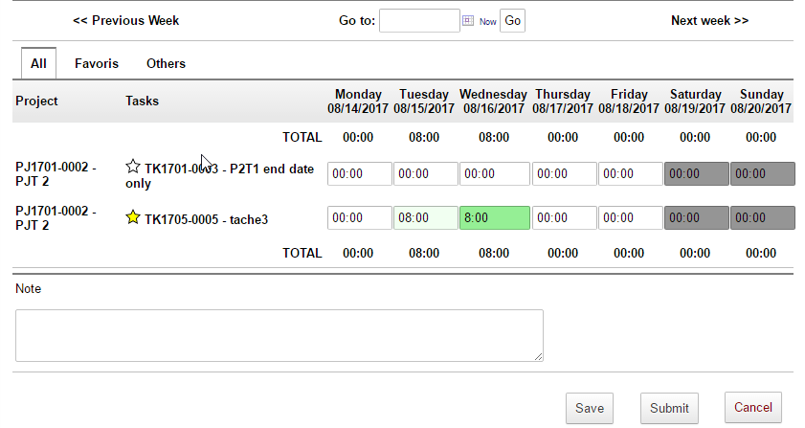Once filled in the timesheet can be save (the same layout will be used) and modified later or submitted for approval if the approval is set in the module configuration

the start is used to show and (un)set favoris by one click

## Submitted timesheet

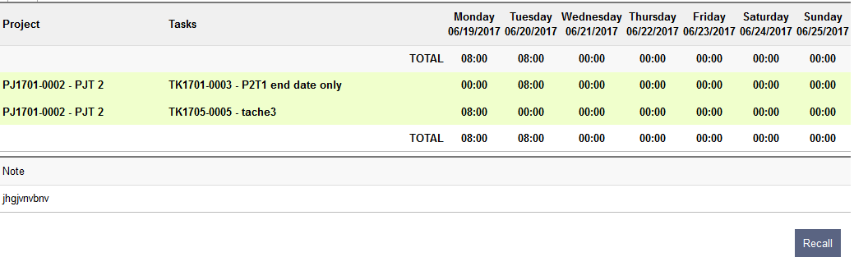

Once submitted, only task with time spend entered when submitted will be shown, the color of the line background enable to have a quick idea of the timesheet status (colours can be changed in the module config page).

the timesheet will also appear in the “timesheet to approve” of his managers ( N+1 & N+2 based on Dolibarr organization chart, the manager should also have the approver right Admin>User>Rights>timesheet>Approver)

The user can recall his timesheet to make change until the timesheet is approved

When the timesheet is under approval (eg. project approval activated), the user can no longer recall it but the layout & color will remain the same.

## Timesheet approved

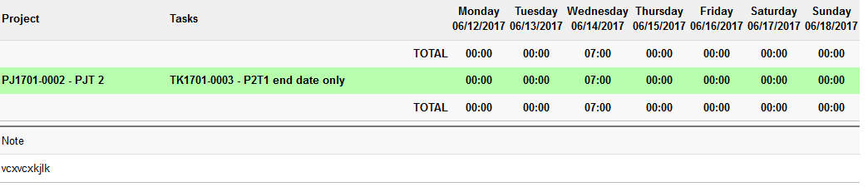

Once the timesheet is approved, the user can’t recall it anymore but he can still see what was approved (colours can be changed in the module config page). If for some reason the timesheet should be modified then it should be set back to draft via the timesheet admin view

## Timesheet rejected

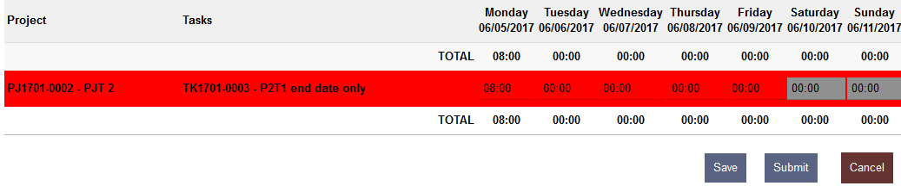The timesheet appear rejectected (editable) only when the teamleader will have rejected the timesheet, when a timesheet is challenged in the approval flow , it is sent back to the previous approval until the teamleader rejected it (cf.chanllenged timesheet)

## Timesheet challenged

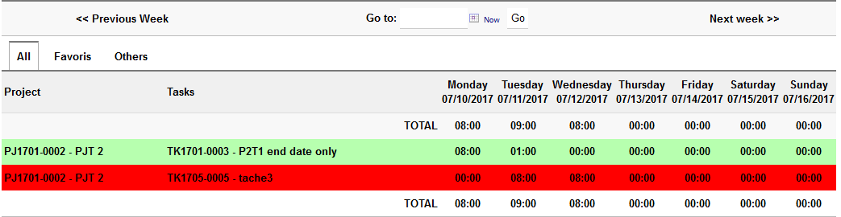During the approval flow a task of a timesheet could be challenged (eg. by the project lead) but the timesheet won’t be rejeted directly, the decision remain on the team leader hand, the timesheet will appear again in the “timesheet to approved” and he could contact the project leader for more details (note section will come shortly)

# Favoris

The favoris (white list & black list) enable a filtering the task list of the timesheet page so one can remove project/task from the default list

The behaviour can be set in the setup page: favoris, all but favoris or all by default

Additionally there is an option for the deactivation of this feature.

## Favoris list

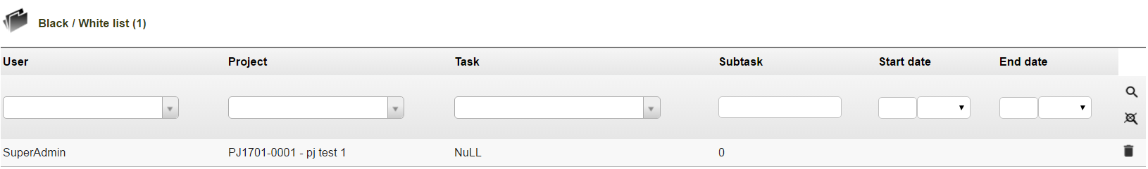

This view enable to see the current favoris list, one can remove easily items if not needed anymore.

## New favoris item

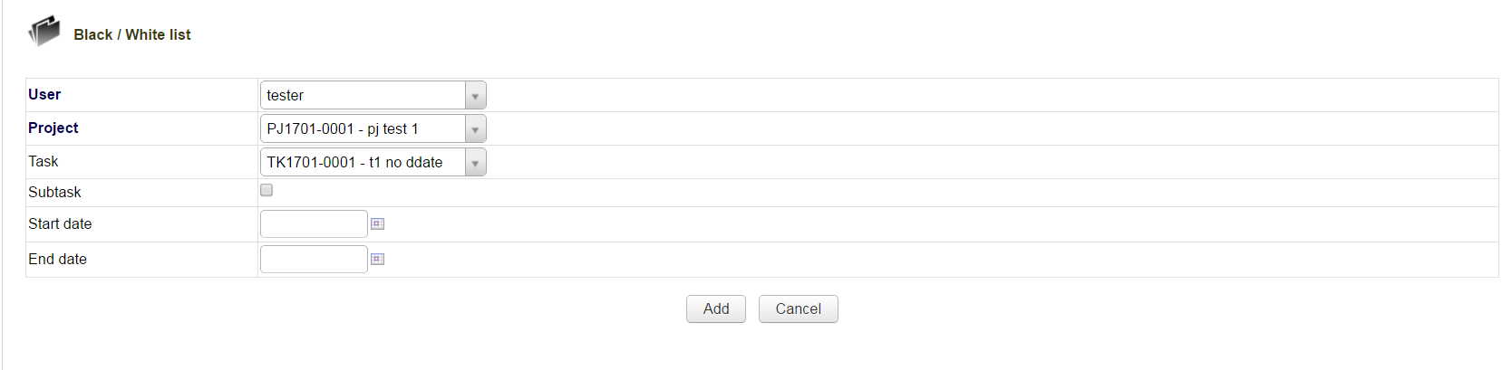

Add one item to the favorisr list by setting those parameters:

**User:** user to whom the item will be applied, Admin can choose it but the normal user can only set favoris list for themselves

**Project / Task / subtask**: define the target of the favoris list item, only project is mandatory; to apply the item to a specific task and its subtask is optional;

**Start Date/ End date:** define the timesheet timespan when the item should be taken into account. No date means no time limits

# Approval:

There is two types of approvals; the team approval and the “other” approval, the difference is that the team approval shows all the tasks for a week and for one user when the other approval shows only the task that concern the approver ( ie. a project leader should only see the time spent on his projects not on the others.)

The timesheet module approval feature takes the assumption that the team leader is the responsible for the team resources management therefore only the team manager can send back the timesheet to the user.

In order to have access to approve his subordinate’s timesheets one should have the timesheet approver rights

## Timesheets rights

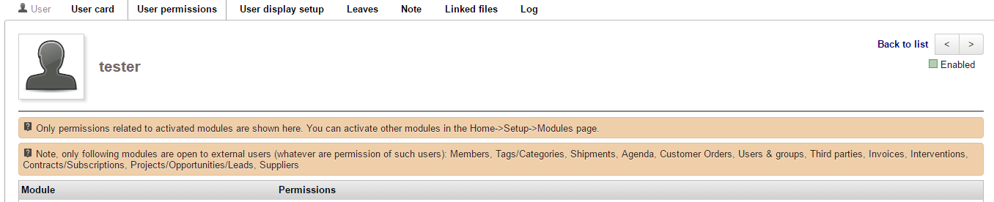

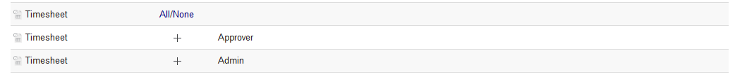

## Timesheet approval: team leader

The team approval screen can show the timesheet grouped per user, per week or per user/month, the maximum number of timesheet shown per page can be set in the module setup page.

Eg: timesheet per month.

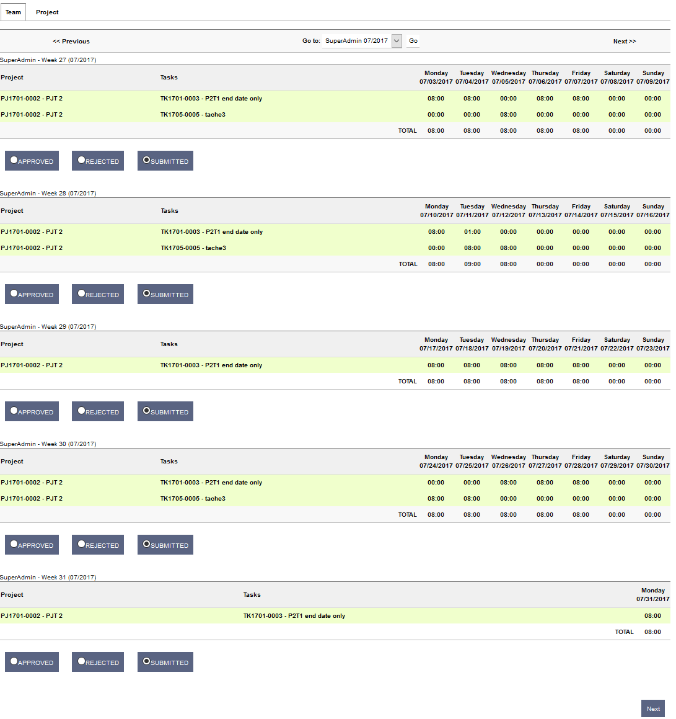

Timesheet approval: other

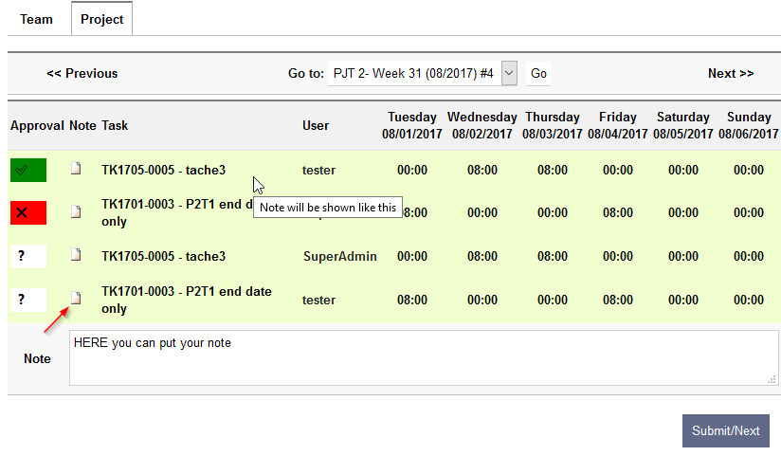the other approval are showed by week, the number of item to approve is indicated by the ‘#’ in the drop down list.

The approval is done by line by clicking on the means no change,  means approved and mean rejected.

Note section will appear when the user will click on the icon in the note column, when a note is saved it will aprear as an info as shown in the screenshoot.

User report

A limited report by user is available by month (in timesheet main tab), several layouts are possible, if both short and export friendly are choose then the export friendly will be shown .

Note: the search ribbon appear in every layout but the normal layout screenshot show it.

## User report :Normal layout:

## User report :Export friendly layout

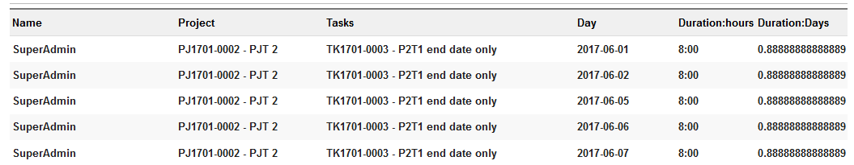

## User report :Short layout

# Project report

A limited report by project is available by month (in project main tab), several layout are possible, once the report is generated, a button appear to start the invoice creation based on this report. if both short and export friendly are choose then the export friendly will be shown .

Note: the search ribbon appear in every layout but the normal layout screenshot show it.

## Project report :Normal layout

## Project report :Export friendly layout

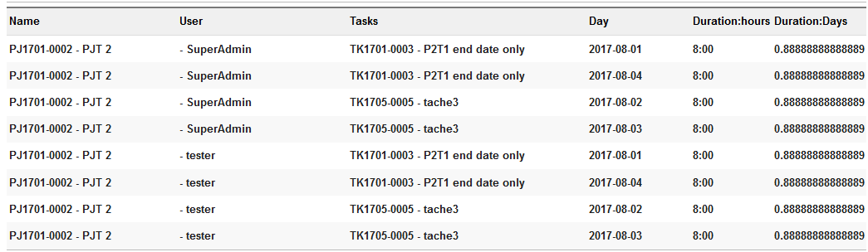

## Project report :Short layout

# 

# Project Invoice

This module enable the creation of an invoice based on the time spent. The time spent can be grouped by user, by task or by user and task to convert the sum of the time spent in quantity of existing services, or one time services (only for the invoice, not saved) or to not be invoiced.

**Prerequisite**: the user making the invoice must be part of the project, have right to make invoice and able to see the customer to bill.

In order to achieve it, there is two step before the draft invoice creation.

## First invoice step: the general project’s invoice parameters

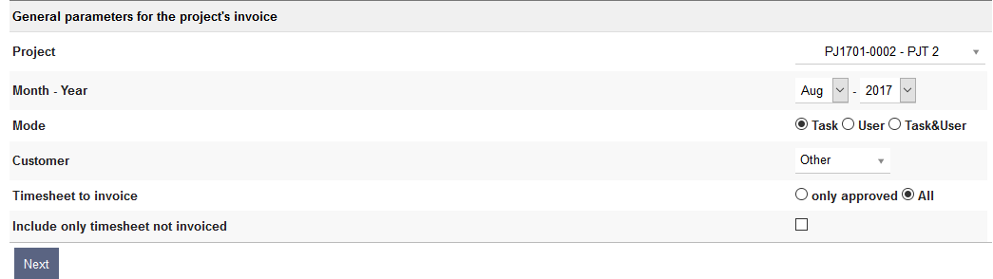in this screen, the project, the dates, the customer, the grouping method are defined

## Second Invoice step: assignation of service to each time spent group

This screen will define what will be shown in the invoice. Services defined in Product/service main menu could be used, one only have to define them in the “Existing:Service” field. This field is a search box, just typing text in it will fetch services with a name close to the text entered. the service consumption will be updated correctly as for a normal invoice where an existing service is used.

If something is entered in the description fields then an ad-hoc service will be used with the price & VAT specified in the other columns.

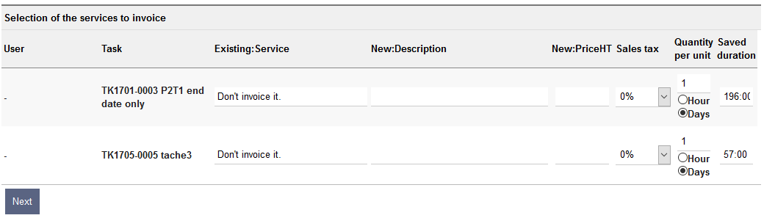The two last column are used the generate the quantity of the service that will be invoiced. The duration of the time spent on task are shown in the column “ Saved duration” and it will be converted base on quantity based on the Quantity per unit column. If day is selected, the calculation will use the hours per day set in the module setup page. The quantity is editable

Example:

196 hours, with 1 day (8 h) as Quantity per unit will make a quantity of 196/(1*8)= 24,5.

in the Latest Dolibarr, once the invoice is created the time spend will be linked to the invoice and invoice line (information not used today)

# Timesheet admin access

To be able to modify the status of the timesheet an admin page is available (see the users rights screenshots in the Approval section), even if all fields are editable it’s not recommended to change anything beside the status and/or note(a tasktime need to be in the correct week for the correct user to be taken into account in all the other screens)

## Timesheet admin list

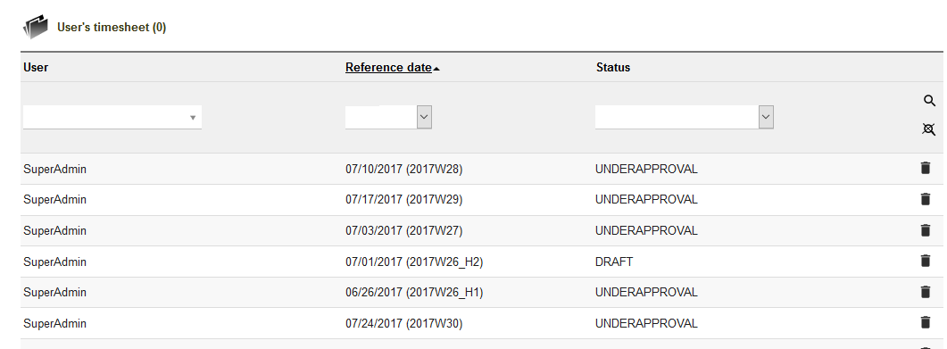

## Timesheet admin details

## Timesheet admin edit

