Security findings data report
Table of contents

Executive summary
- Reviewers reported 1217 findings across 192 reviews of 120 generated programs; 7 reviews had no findings.
- In the 48 matched Stage 1 pairs, Security-aware reviews averaged 6.56 findings versus 6.25 for Basic, for a mean delta of 0.31 with a CI from -0.29 to 0.94.
- In self-review, Security-informed had 5.79 findings per review and a 14.39 High/Critical %, compared with 6.25 and 16.67 for Basic and 6.56 and 17.78 for Security-aware.
- Sensitive data was the largest rule grouping, with 339 reviewer-reported findings and 27.9% of all findings; Authentication and access followed with 207 and 17.0%.
- CWE-307 was the most-reported CWE with 90 findings, while CWE labels showed less reviewer agreement than OWASP categories: 64.3% of CWE-label pairs were named by 1 reviewer, compared with 32.1% of OWASP-category pairs.

The eight Security-informed rules and the CWEs assigned to them
Table 1: The eight Security-informed rules and the CWEs assigned to them · All findings
rule | CWEs | findings | % of all findings
1 Trust boundaries | CWE-15, CWE-20, CWE-22, CWE-59, CWE-89, CWE-116, CWE-117, CWE-178, CWE-290, CWE-345, CWE-807, CWE-1284 | 99 | 8.1
2 Secrets | CWE-214, CWE-256, CWE-321, CWE-323, CWE-522, CWE-526, CWE-798 | 86 | 7.1
3 Authentication and access | CWE-284, CWE-287, CWE-306, CWE-307, CWE-521, CWE-636, CWE-645, CWE-799, CWE-862 | 207 | 17.0
4 Identifiers and tokens | CWE-330, CWE-338, CWE-352, CWE-384, CWE-613, CWE-614, CWE-1004 | 60 | 4.9
5 Sensitive data | CWE-226, CWE-244, CWE-276, CWE-316, CWE-319, CWE-359, CWE-377, CWE-400, CWE-532, CWE-549, CWE-732, CWE-770, CWE-779 | 339 | 27.9
6 Failure behaviour | CWE-200, CWE-203, CWE-204, CWE-208, CWE-209, CWE-754, CWE-1188 | 121 | 9.9
7 Concurrency | CWE-362, CWE-367 | 67 | 5.5
8 Prefer the platform | CWE-326, CWE-327, CWE-494, CWE-759, CWE-829, CWE-916, CWE-1395 | 79 | 6.5
No rule | every CWE not listed above | 159 | 13.1

Reviewer-reported findings were most concentrated in rule 5, Sensitive data, with 339 findings (27.9%), followed by rule 3, Authentication and access, with 207 (17.0%). Findings assigned to no rule numbered 159 (13.1%), while rule 4, Identifiers and tokens, had the smallest total at 60 (4.9%).

Study design
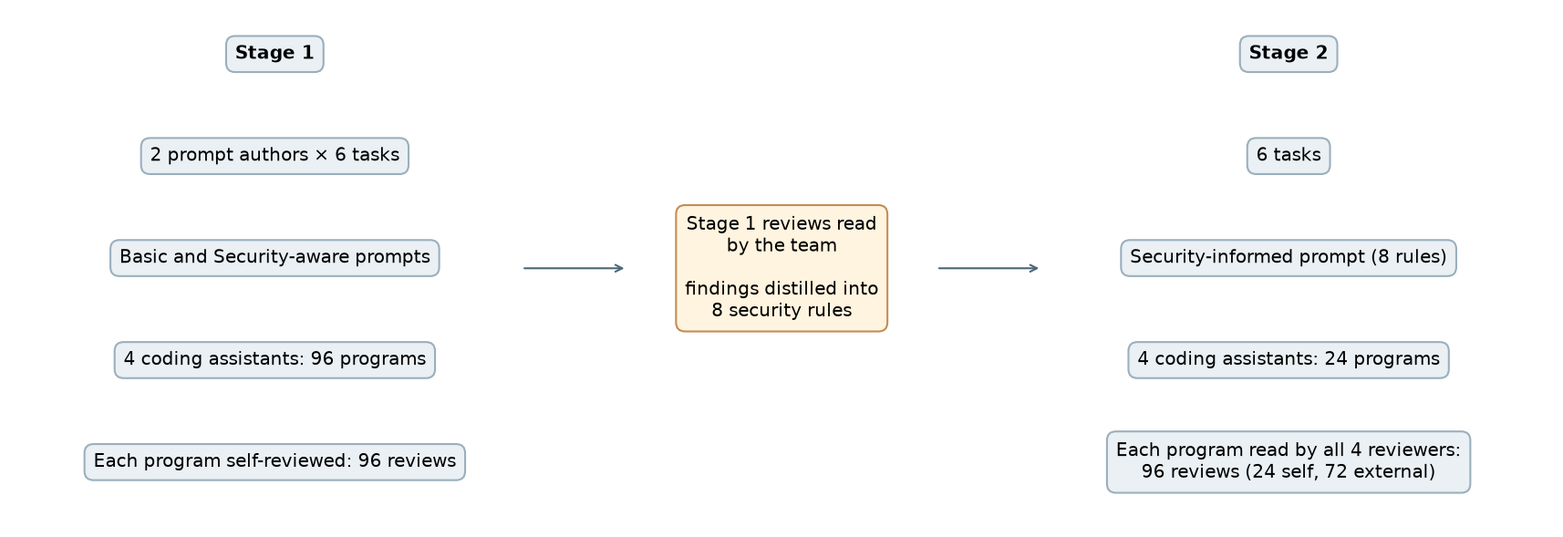
Figure 1: Study design · Stage 1, the eight rules, Stage 2
Figure 1 shows Stage 1 moving from Basic and Security-aware prompts through self-review, after which the team distilled the reviews into the eight rules used by the Security-informed prompt in Stage 2. Stage 2 adds external reviews so that each Security-informed program is read by every reviewer.

Programs, reviews and findings
Table 2: Programs, reviews and findings · All three conditions, all reviews
condition | stage | programs | self-reviews | external reviews | reviews with no findings | findings
Basic | Stage 1 | 48 | 48 | 0 | 0 | 300
Security-aware | Stage 1 | 48 | 48 | 0 | 1 | 315
Security-informed | Stage 2 | 24 | 24 | 72 | 6 | 602

Basic and Security-aware each comprised 48 programs and 48 self-reviews, yielding 300 and 315 reviewer-reported findings, respectively. Security-informed comprised 24 programs, 24 self-reviews and 72 external reviews, with 602 findings and 6 reviews with no findings.

Completed reviews per task and generator
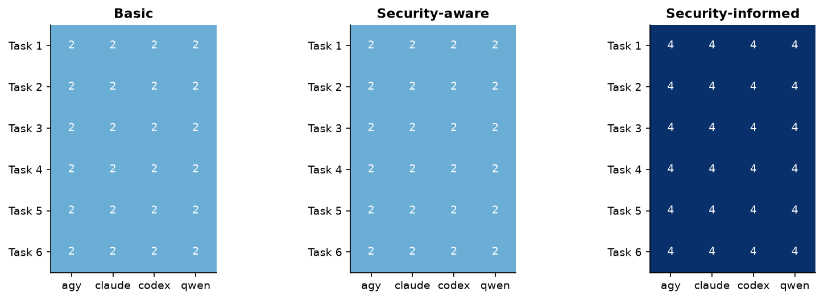
Figure 2: Completed reviews per task and generator · All three conditions, all reviews
Figure 2 shows uniform review completion across every task and generator within each condition. Basic and Security-aware have the same completion pattern, while Security-informed includes more completed reviews in every cell.

Paired difference in findings per review, overall and by generator
Table 3: Paired difference in findings per review, overall and by generator · Basic and Security-aware, matched pairs, self-review
scope | pairs | basic mean | aware mean | mean delta | median delta | fewer | more | ties | CI low | CI high
all | 48 | 6.25 | 6.56 | 0.31 | 0.0 | 18 | 23 | 7 | -0.29 | 0.94
agy | 12 | 6.33 | 7.42 | 1.08 | 1.0 | 2 | 9 | 1 | 0.17 | 1.92
claude | 12 | 5.5 | 5.75 | 0.25 | 0.0 | 3 | 5 | 4 | -0.83 | 1.25
codex | 12 | 4.33 | 3.58 | -0.75 | -1.0 | 7 | 4 | 1 | -1.67 | 0.17
qwen | 12 | 8.83 | 9.5 | 0.67 | -0.5 | 6 | 5 | 1 | -1.0 | 2.33

Across 48 matched pairs, Security-aware averaged 6.56 findings versus 6.25 for Basic, with a mean delta of 0.31 and a CI from -0.29 to 0.94; 23 pairs had more findings, 18 fewer and 7 ties. The generator-level mean deltas were 1.08 for agy, 0.25 for claude, -0.75 for codex and 0.67 for qwen.

Paired difference in findings per review by generator
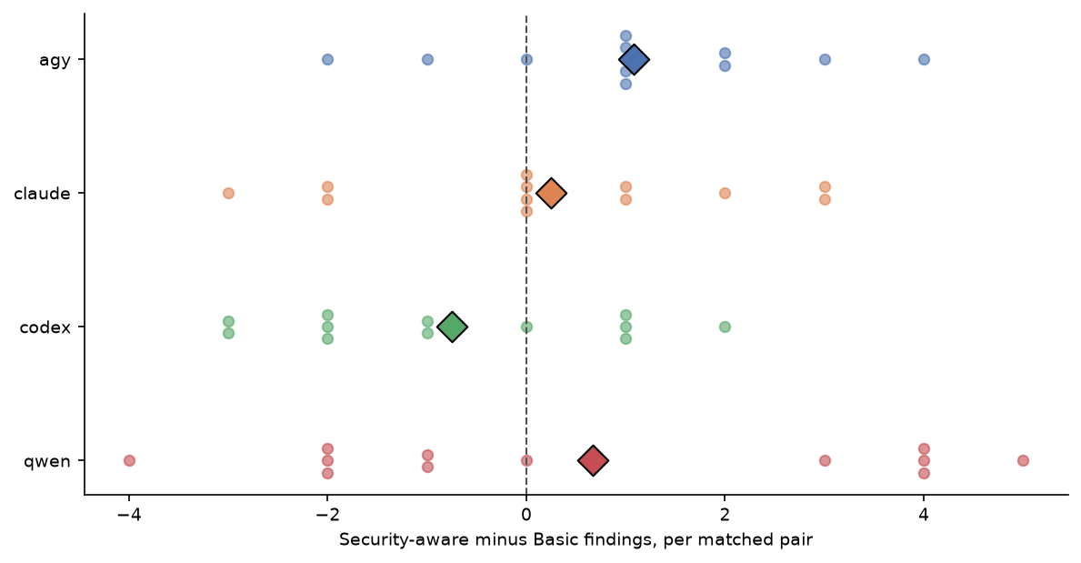
Figure 3: Paired difference in findings per review by generator · Basic and Security-aware, matched pairs, self-review
Figure 3 shows substantial pair-to-pair variation for every generator, with observations on both sides of no change. The mean marker is positive for agy, claude and qwen and negative for codex.

Findings per review, median and High/Critical share
Table 4: Findings per review, median and High/Critical share · All three conditions, self-review
condition | self-reviews | findings | findings per review | median | High/Critical %
Basic | 48 | 300 | 6.25 | 6.0 | 16.67
Security-aware | 48 | 315 | 6.56 | 7.0 | 17.78
Security-informed | 24 | 139 | 5.79 | 7.0 | 14.39

Basic had 300 reviewer-reported findings across 48 self-reviews, or 6.25 per review, while Security-aware had 315 across 48, or 6.56 per review. Security-informed had 139 findings across 24 self-reviews, or 5.79 per review, and the lowest High/Critical share at 14.39%.

Findings per review
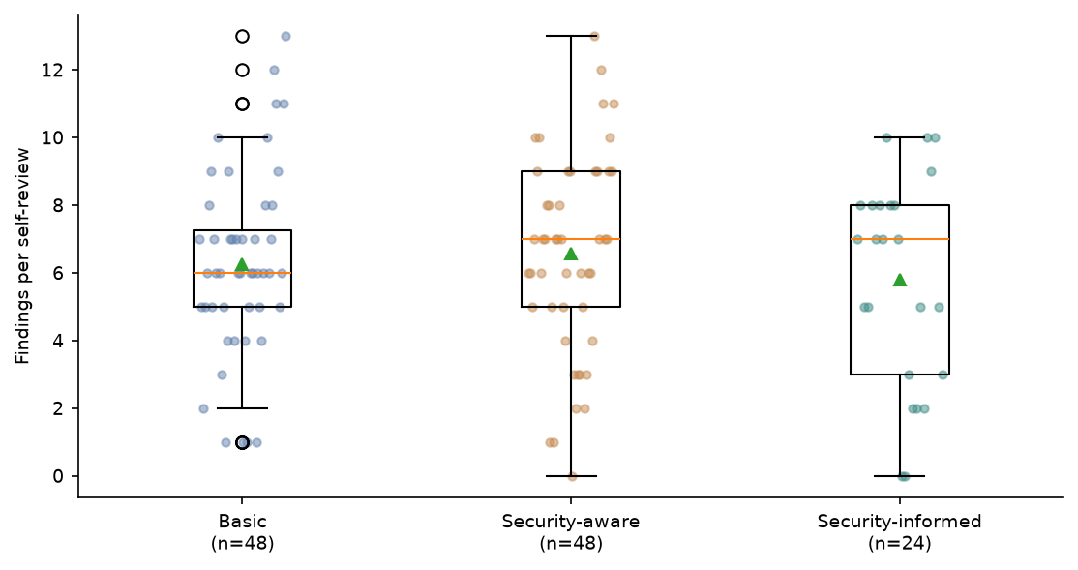
Figure 4: Findings per review · All three conditions, self-review
Figure 4 shows broad and overlapping distributions of findings per self-review across the three conditions. Security-aware has the highest median, while Security-informed has the lowest mean and a visibly wider middle range than Basic.

Findings per review by generator
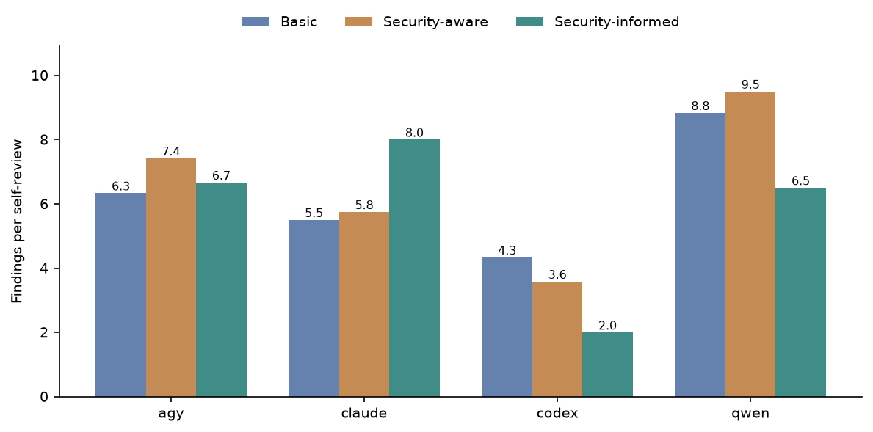
Figure 5: Findings per review by generator · All three conditions, self-review
Figure 5 shows that the condition pattern differs by generator: Security-aware is highest for agy and qwen, Security-informed is highest for claude, and Basic is highest for codex. Qwen is highest under Basic and Security-aware, while claude is highest under Security-informed.

Findings per review by task
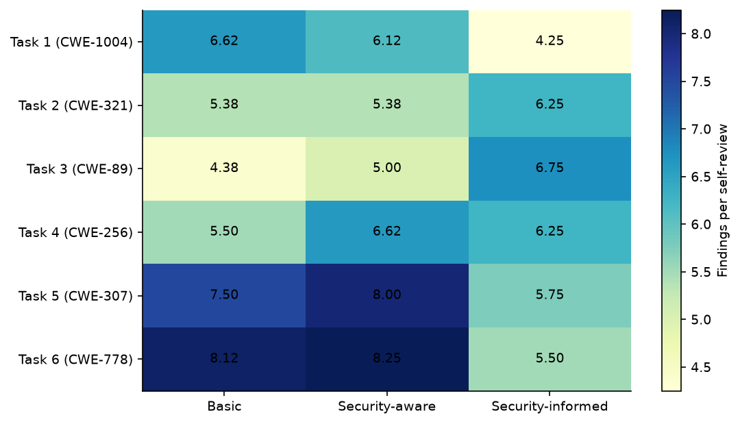
Figure 6: Findings per review by task · All three conditions, self-review
Figure 6 shows clear task-level variation in findings per self-review. Security-informed is highest for Tasks 2 and 3, while Basic or Security-aware is higher for Tasks 1, 4, 5 and 6.

Severity of findings
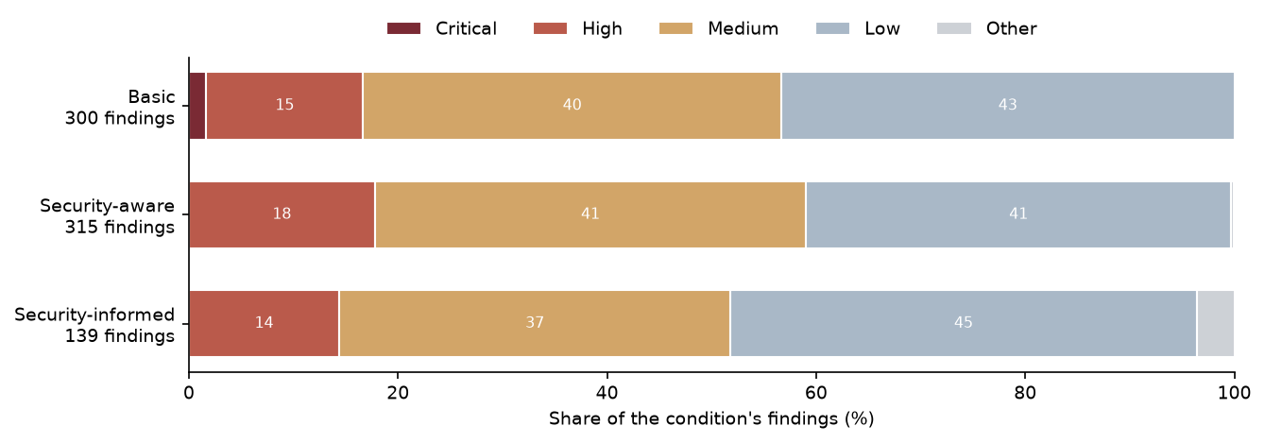
Figure 7: Severity of findings · All three conditions, self-review
Figure 7 shows that Low and Medium findings make up most reviewer-reported findings in every condition. Security-informed has a visibly smaller High/Critical share than Basic and Security-aware and is the only condition with a visible Other segment.

Reviews naming the task’s anchor CWE
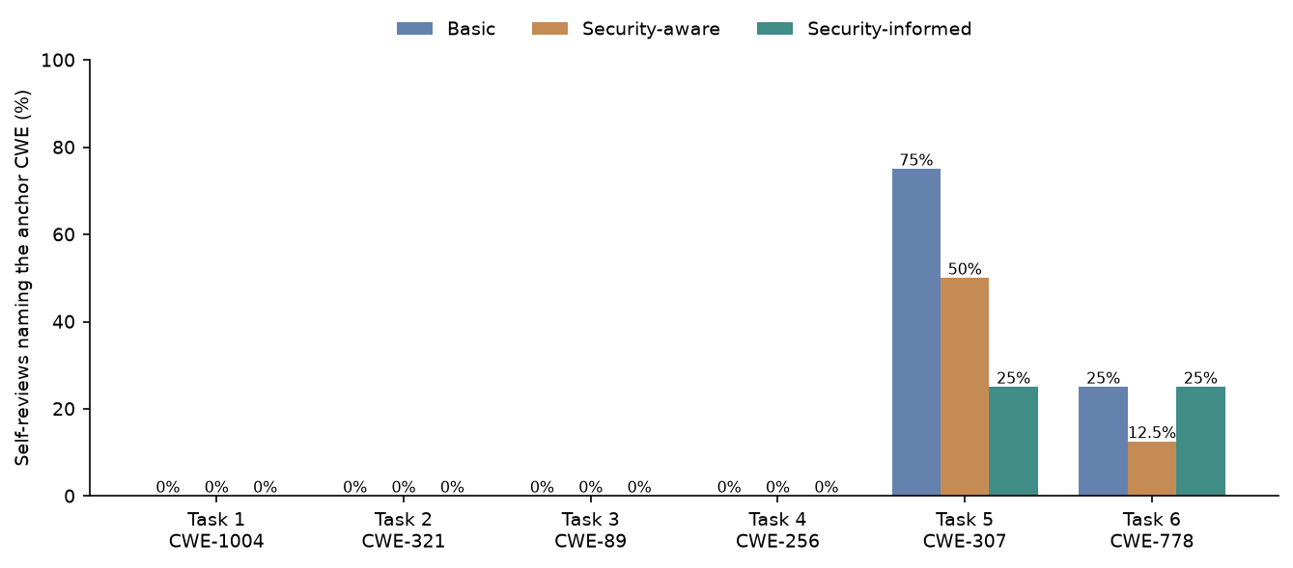
Figure 8: Reviews naming the task’s anchor CWE · All three conditions, self-review
Figure 8 shows that the task anchor CWE was named only for Tasks 5 and 6. For Task 5, the share falls from Basic to Security-aware to Security-informed; for Task 6, Basic and Security-informed are level and Security-aware is lower.

The 14 most-reported CWEs
Table 5: The 14 most-reported CWEs · All findings
rank | CWE | title | findings | cumulative %
1 | CWE-307 | Improper Restriction of Excessive Authentication Attempts | 90 | 7.4
2 | CWE-400 | Uncontrolled Resource Consumption | 82 | 14.1
3 | CWE-916 | Use of Password Hash With Insufficient Computational Effort | 58 | 18.9
4 | CWE-316 | Cleartext Storage of Sensitive Information in Memory | 52 | 23.2
5 | CWE-732 | Incorrect Permission Assignment for Critical Resource | 50 | 27.3
6 | CWE-521 | Weak Password Requirements | 49 | 31.3
7 | CWE-770 | Allocation of Resources Without Limits or Throttling | 40 | 34.6
8 | CWE-367 | Time-of-check Time-of-use (TOCTOU) Race Condition | 35 | 37.5
9 | CWE-362 | Concurrent Execution using Shared Resource with Improper Synchronization (‘Race Condition’) | 32 | 40.1
10 | CWE-208 | Observable Timing Discrepancy | 31 | 42.6
11 | CWE-532 | Insertion of Sensitive Information into Log File | 31 | 45.2
12 | CWE-798 | Use of Hard-coded Credentials | 31 | 47.7
13 | CWE-204 | Observable Response Discrepancy | 26 | 49.9
14 | CWE-209 | Generation of Error Message Containing Sensitive Information | 25 | 51.9

CWE-307 was the most-reported label with 90 findings (7.4% cumulative), followed by CWE-400 with 82 (14.1% cumulative) and CWE-916 with 58 (18.9% cumulative). The 14 listed CWEs together account for a cumulative 51.9% of all reviewer-reported findings.

Findings per review by CWE
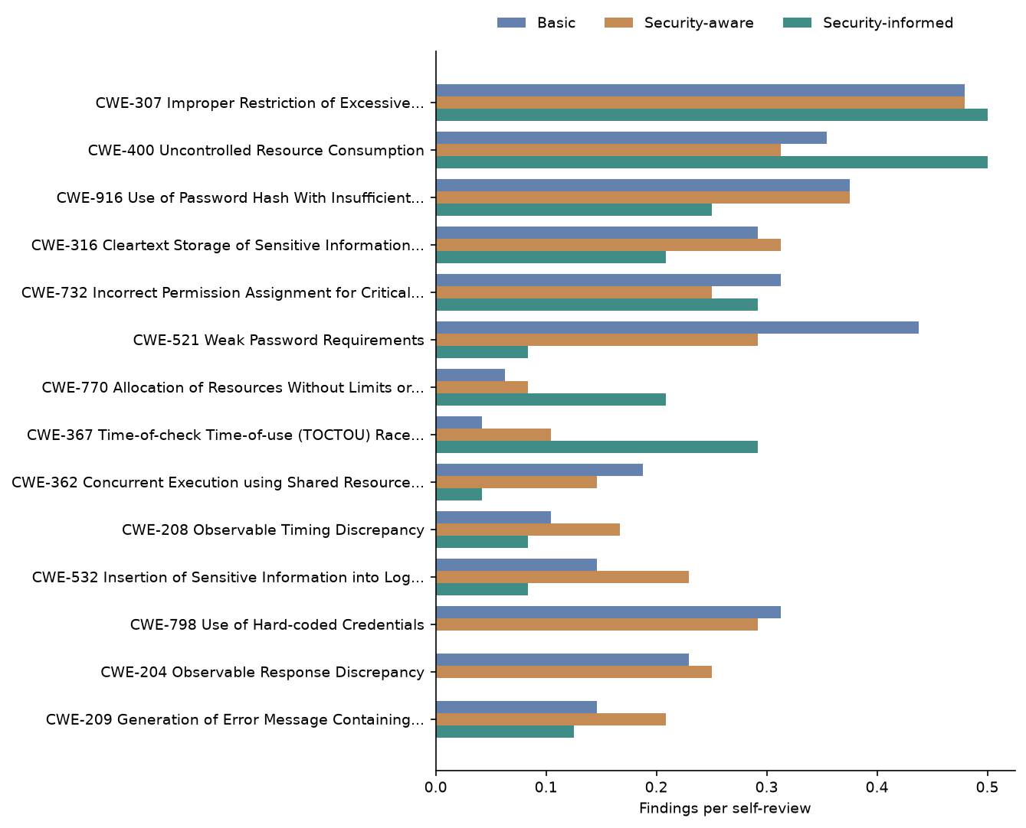
Figure 9: Findings per review by CWE · All three conditions, self-review
Figure 9 shows different condition profiles among the most-reported CWEs. Security-informed is highest for CWE-307, CWE-400, CWE-770 and CWE-367, but has no visible findings for CWE-798 or CWE-204.

Findings per review by CWE, with the change from the Stage 1 average
Table 6: Findings per review by CWE, with the change from the Stage 1 average · All three conditions, self-review
category | Basic | Security-aware | Security-informed | change vs Stage 1 average %
CWE-307 Improper Restriction of Excessive… | 0.48 | 0.48 | 0.5 | 4.0
CWE-400 Uncontrolled Resource Consumption | 0.35 | 0.31 | 0.5 | 50.0
CWE-916 Use of Password Hash With Insufficient… | 0.38 | 0.38 | 0.25 | -33.0
CWE-316 Cleartext Storage of Sensitive Information… | 0.29 | 0.31 | 0.21 | -31.0
CWE-732 Incorrect Permission Assignment for Critical… | 0.31 | 0.25 | 0.29 | 4.0
CWE-521 Weak Password Requirements | 0.44 | 0.29 | 0.08 | -77.0
CWE-770 Allocation of Resources Without Limits or… | 0.06 | 0.08 | 0.21 | 186.0
CWE-367 Time-of-check Time-of-use (TOCTOU) Race… | 0.04 | 0.1 | 0.29 | 300.0
CWE-362 Concurrent Execution using Shared Resource… | 0.19 | 0.15 | 0.04 | -75.0
CWE-208 Observable Timing Discrepancy | 0.1 | 0.17 | 0.08 | -38.0
CWE-532 Insertion of Sensitive Information into Log… | 0.15 | 0.23 | 0.08 | -56.0
CWE-798 Use of Hard-coded Credentials | 0.31 | 0.29 | 0.0 | -100.0
CWE-204 Observable Response Discrepancy | 0.23 | 0.25 | 0.0 | -100.0
CWE-209 Generation of Error Message Containing… | 0.15 | 0.21 | 0.12 | -29.0
Other | 2.77 | 3.06 | 3.12 | 7.0

Relative to the Stage 1 average, Security-informed had the largest increases for CWE-367 (300.0%) and CWE-770 (186.0%), while CWE-400 increased 50.0%. CWE-798 and CWE-204 each fell 100.0%, and CWE-521 fell 77.0%.

Findings per review by OWASP category
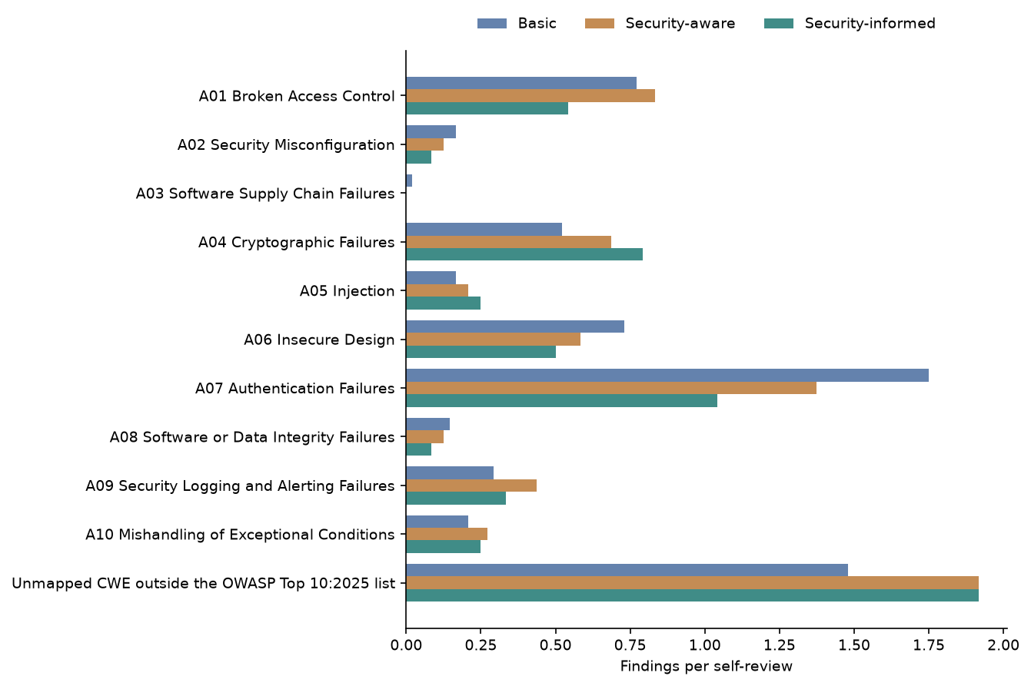
Figure 10: Findings per review by OWASP category · All three conditions, self-review
Figure 10 shows A07 as the highest mapped category in every condition, though its bar is shortest for Security-informed. The unmapped group is larger than any mapped category for Security-aware and Security-informed, while A04 and A05 rise across the three conditions.

Findings per review by OWASP category, with the change from the Stage 1 average
Table 7: Findings per review by OWASP category, with the change from the Stage 1 average · All three conditions, self-review
category | Basic | Security-aware | Security-informed | change vs Stage 1 average %
A01 Broken Access Control | 0.77 | 0.83 | 0.54 | -32.0
A02 Security Misconfiguration | 0.17 | 0.12 | 0.08 | -43.0
A03 Software Supply Chain Failures | 0.02 | 0.0 | 0.0 | -100.0
A04 Cryptographic Failures | 0.52 | 0.69 | 0.79 | 31.0
A05 Injection | 0.17 | 0.21 | 0.25 | 33.0
A06 Insecure Design | 0.73 | 0.58 | 0.5 | -24.0
A07 Authentication Failures | 1.75 | 1.38 | 1.04 | -33.0
A08 Software or Data Integrity Failures | 0.15 | 0.12 | 0.08 | -38.0
A09 Security Logging and Alerting Failures | 0.29 | 0.44 | 0.33 | -9.0
A10 Mishandling of Exceptional Conditions | 0.21 | 0.27 | 0.25 | 4.0
Unmapped CWE outside the OWASP Top 10:2025 list | 1.48 | 1.92 | 1.92 | 13.0

Compared with the Stage 1 average, Security-informed findings per review increased for A05 by 33.0%, A04 by 31.0% and A10 by 4.0%, while the unmapped group increased 13.0%. A03 fell 100.0%, and the other listed mapped categories declined by between 9.0% and 43.0%.

CWE make-up of findings
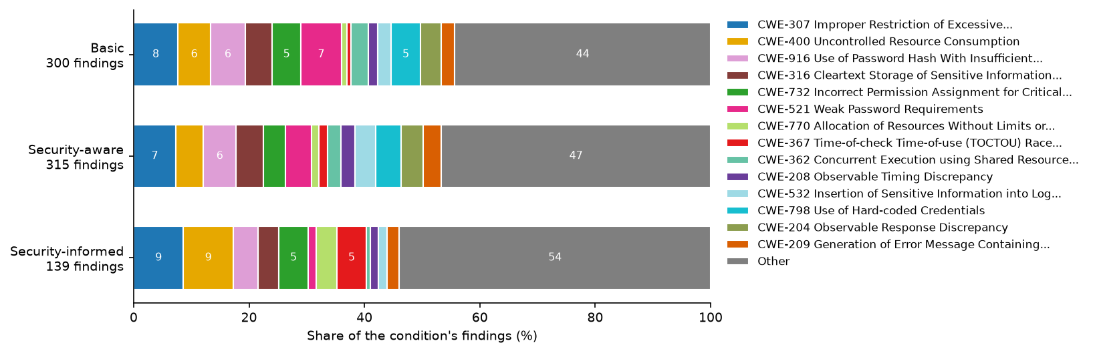
Figure 11: CWE make-up of findings · All three conditions, self-review
Figure 11 shows that the Other grouping is the largest part of the CWE mix in all three conditions and is largest for Security-informed. Among the displayed CWEs, Security-informed gives visibly more share to CWE-307, CWE-400 and CWE-367 and less to CWE-521, CWE-532, CWE-798 and CWE-204.

OWASP category make-up of findings
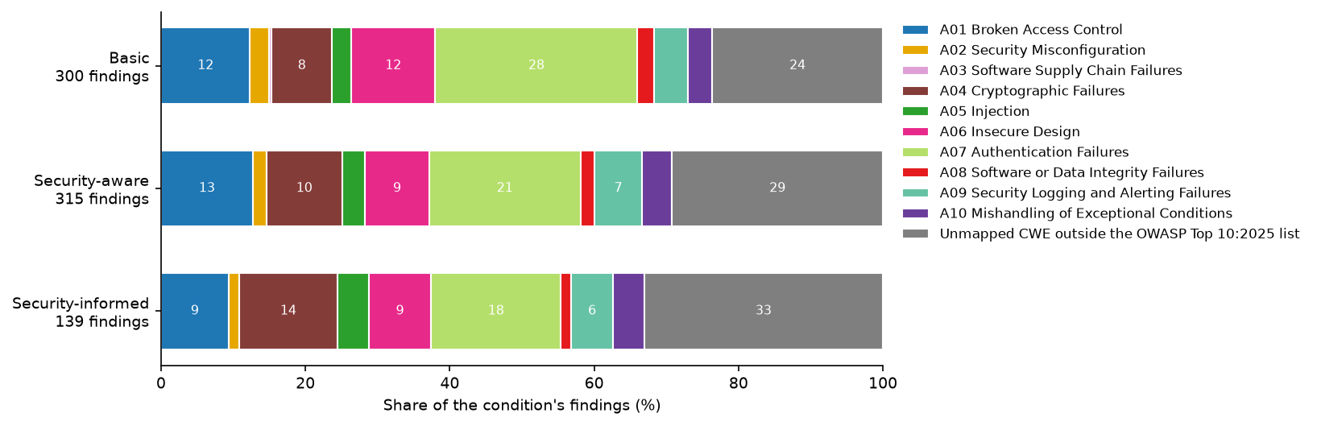
Figure 12: OWASP category make-up of findings · All three conditions, self-review
Figure 12 shows the unmapped share growing from Basic through Security-aware to Security-informed, while A07 contracts. A04 occupies a larger share in Security-informed than in the two Stage 1 conditions.

CWE make-up of findings by generator
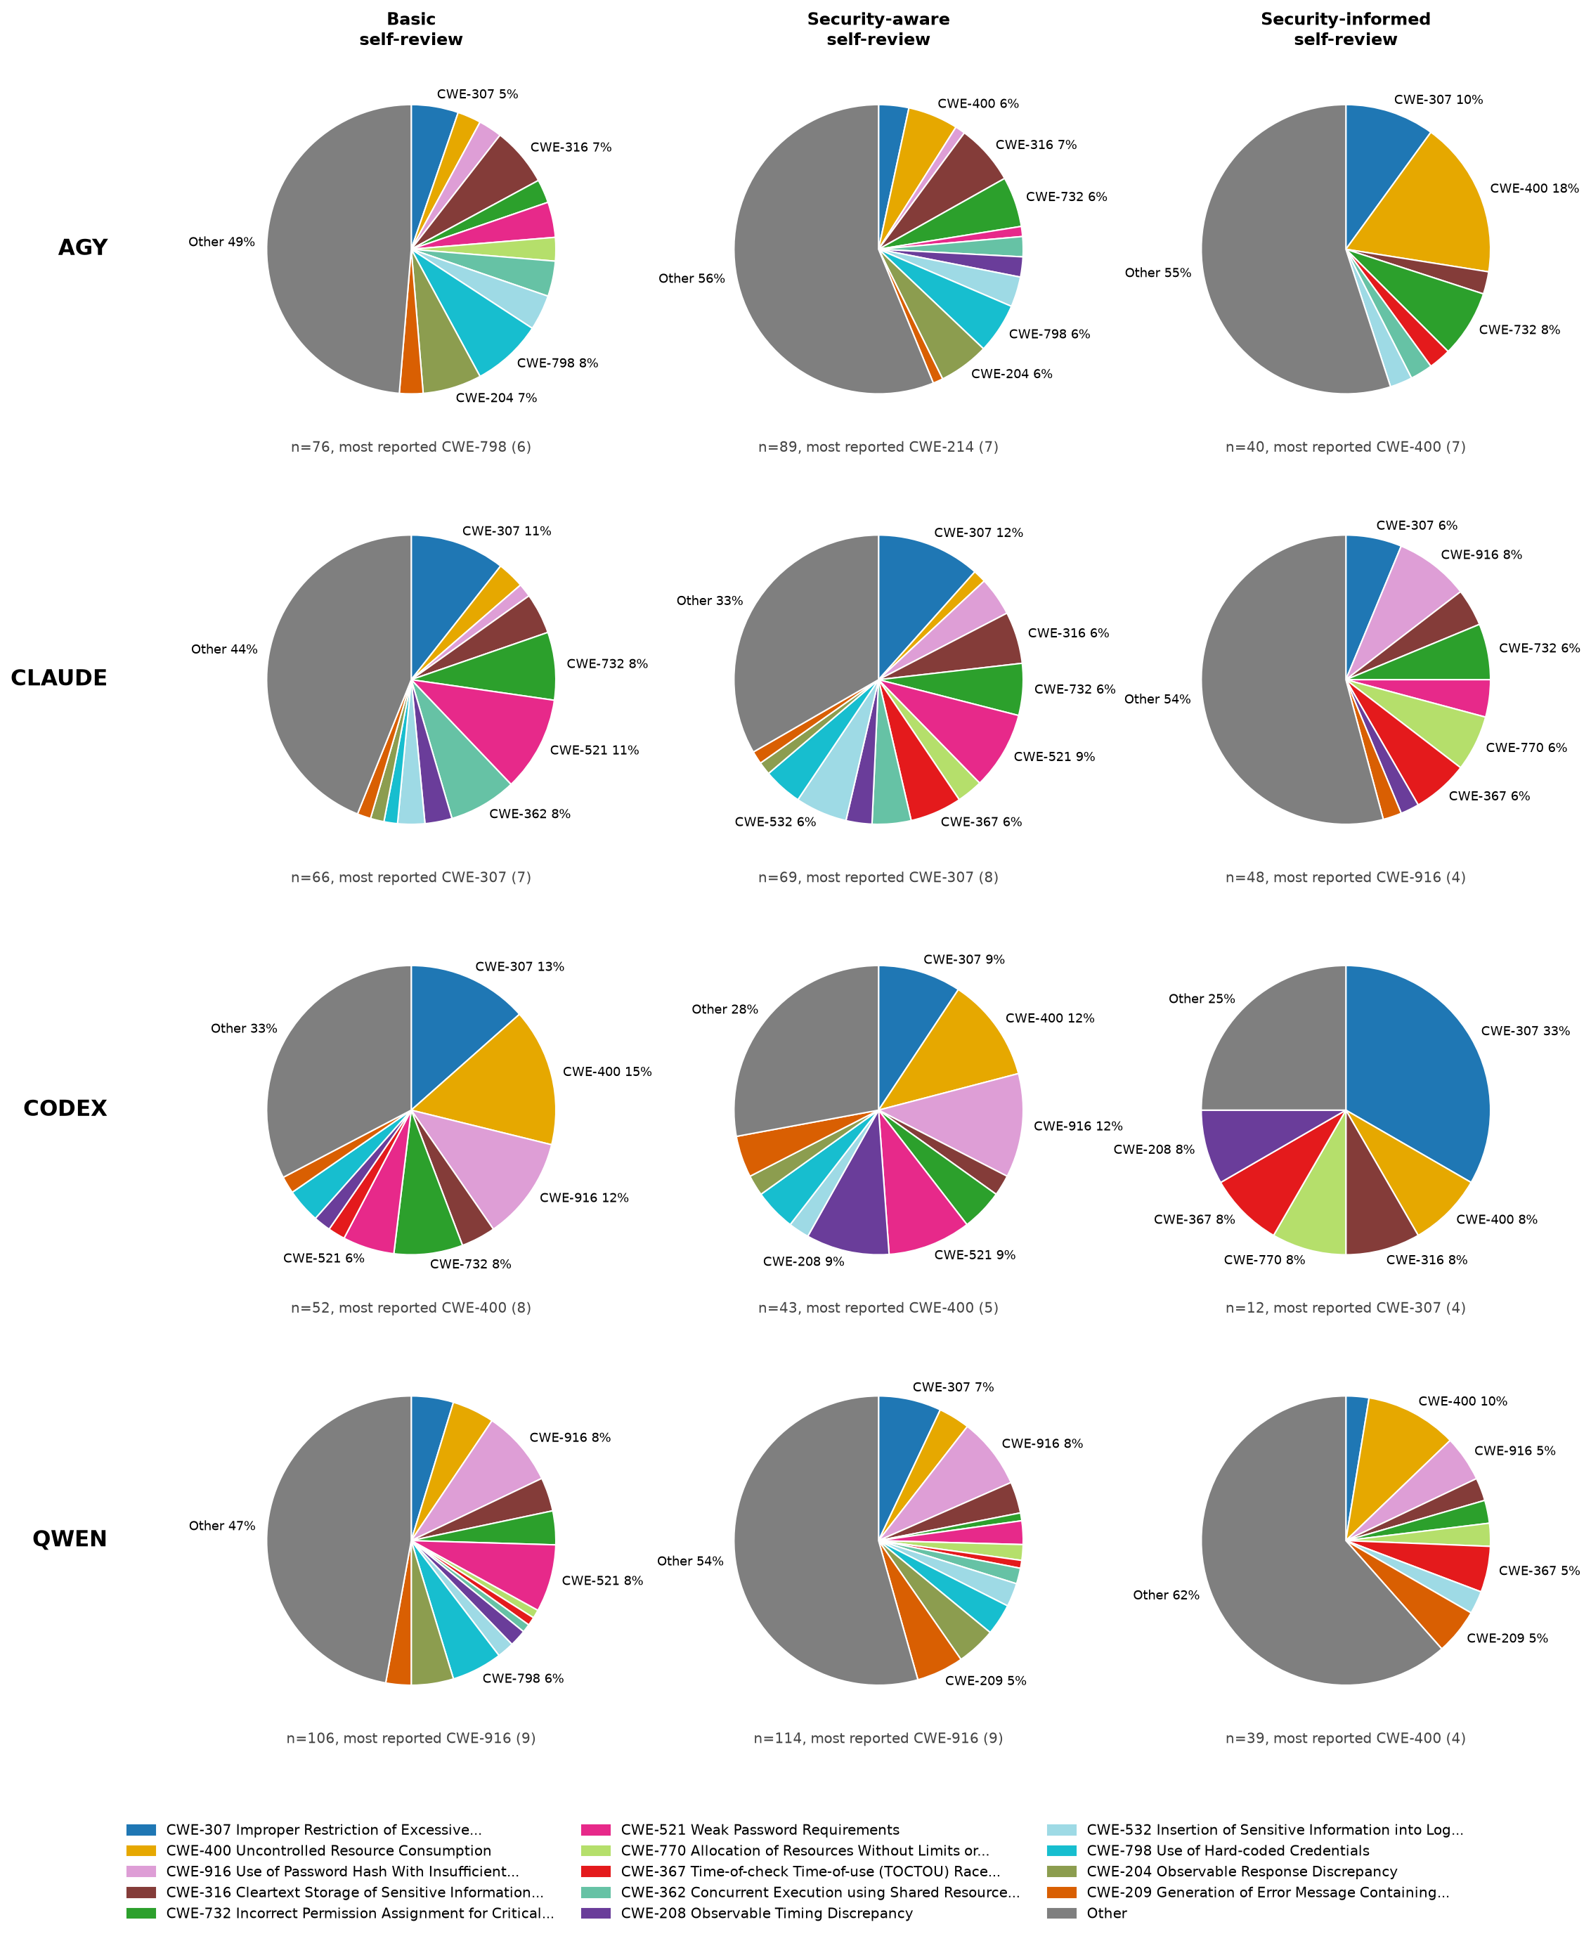
Figure 13: CWE make-up of findings by generator · All three conditions, self-review
Figure 13 shows substantial variation in CWE composition by generator and condition. The Other grouping is largest in most panels, while codex’s Security-informed self-review is dominated by CWE-307 and has a more concentrated displayed-CWE mix.

OWASP category make-up of findings by generator
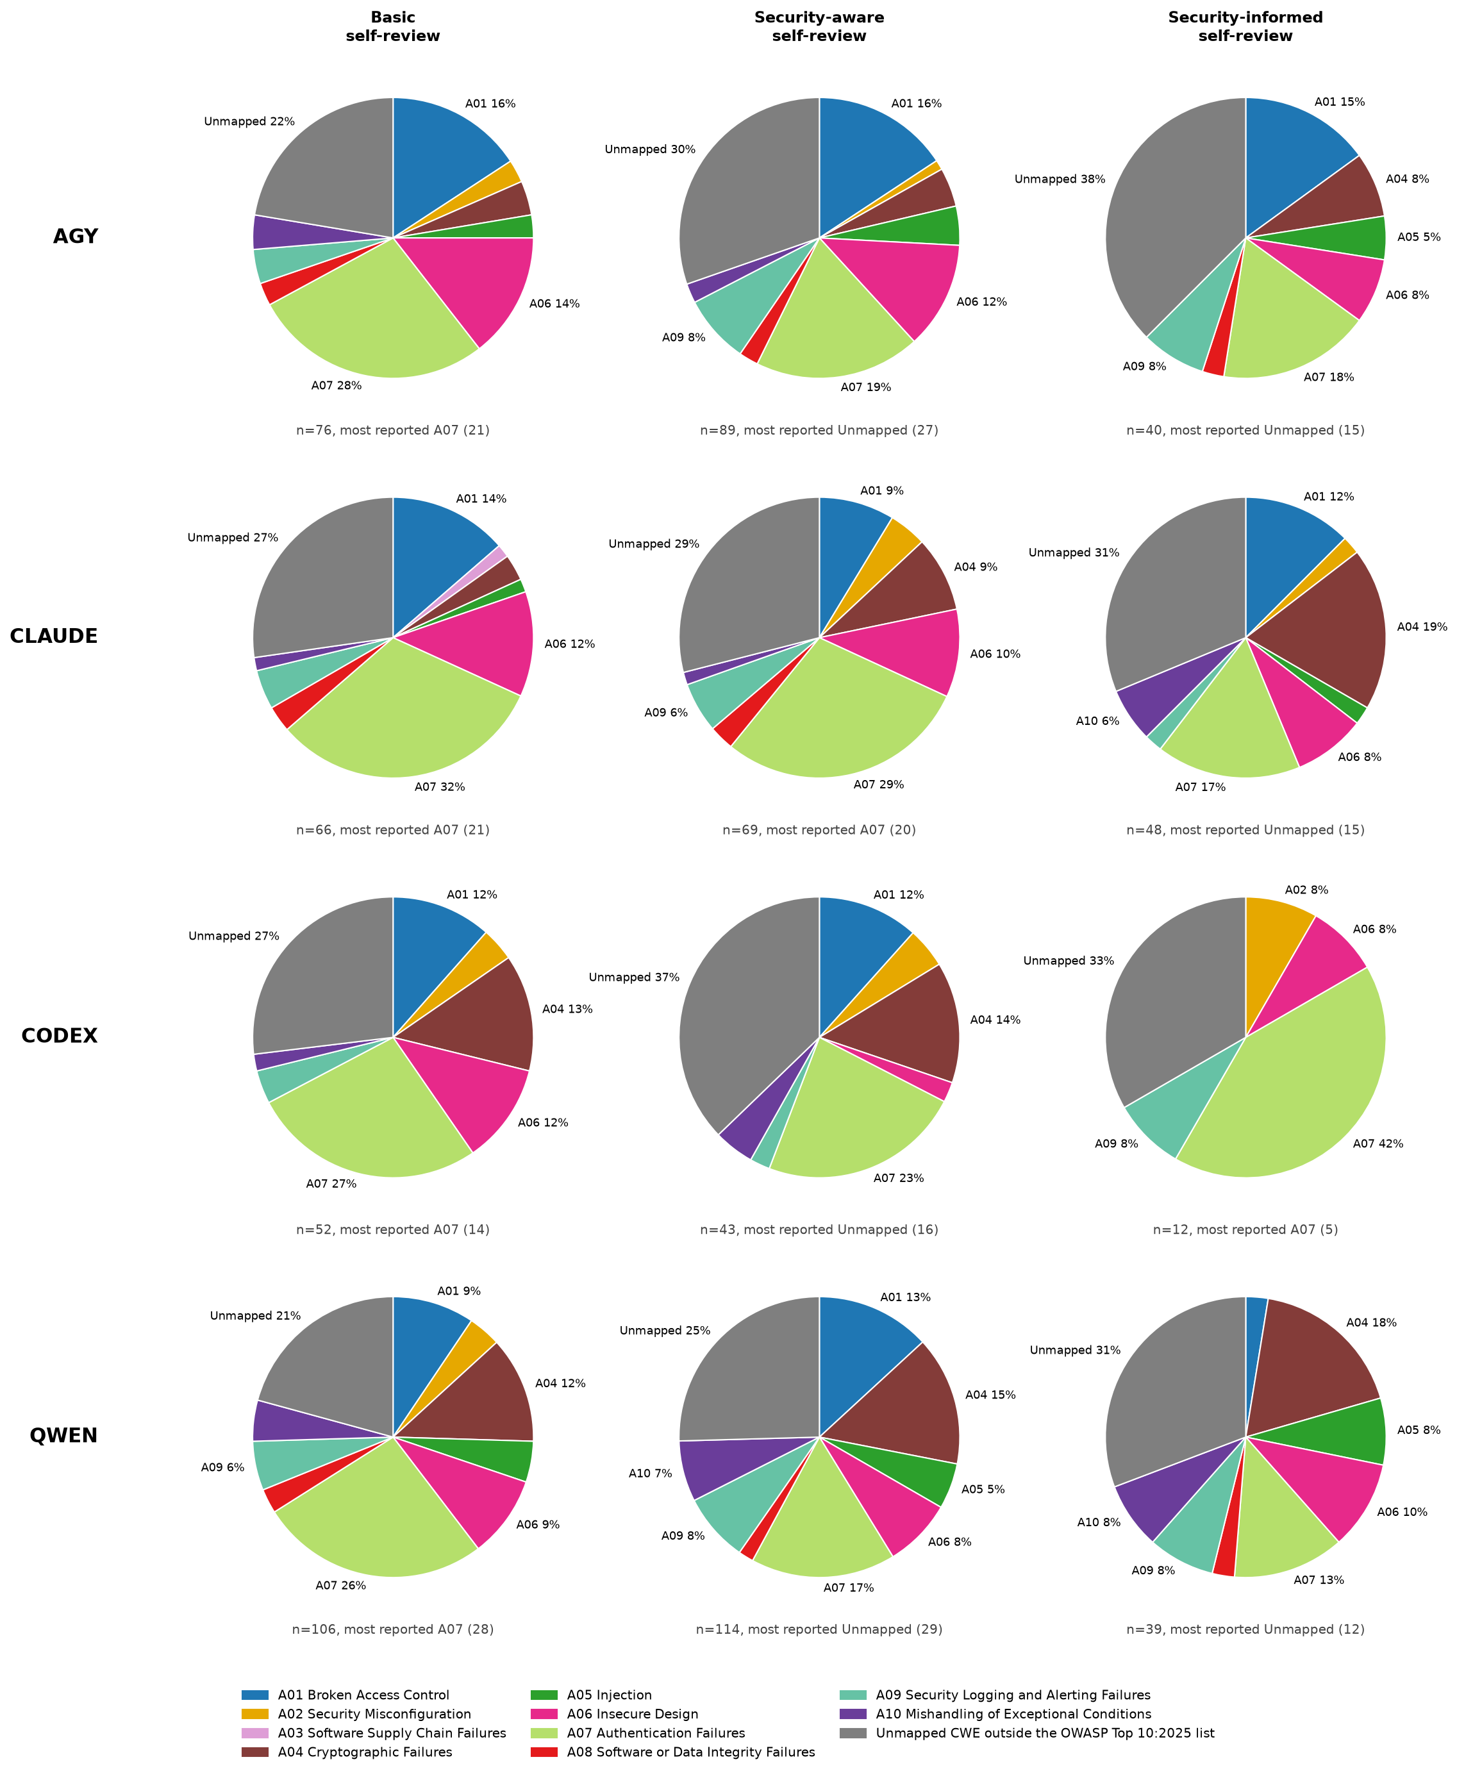
Figure 14: OWASP category make-up of findings by generator · All three conditions, self-review
Figure 14 shows that OWASP composition varies by generator as well as condition. A07 is prominent in many panels, the unmapped group leads several Security-aware and Security-informed panels, and A04 becomes especially prominent for claude and qwen under Security-informed.

Findings per review by Security-informed rule
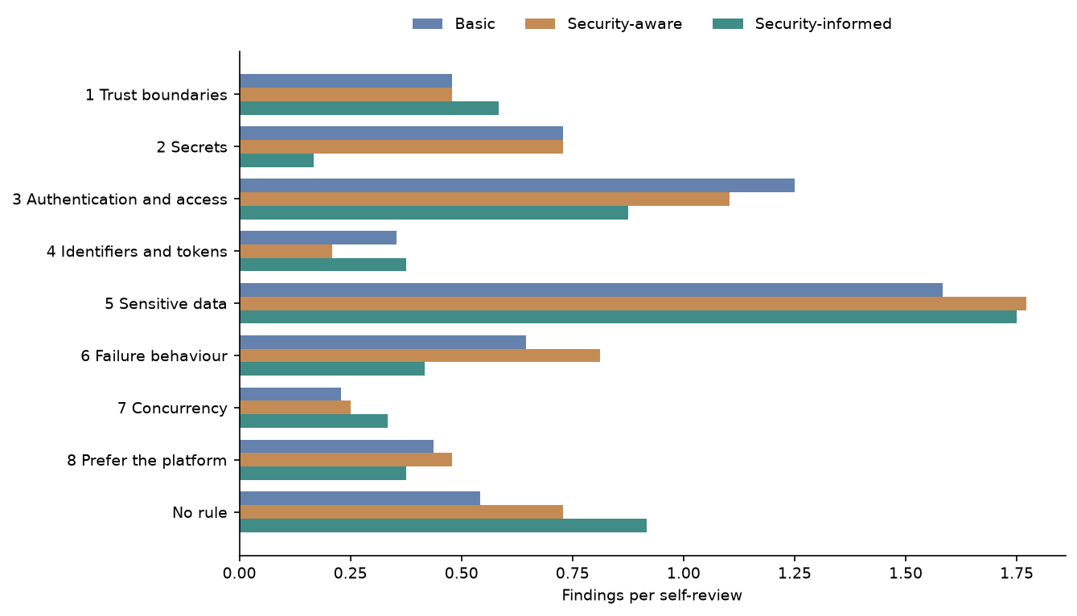
Figure 15: Findings per review by Security-informed rule · All three conditions, self-review
Figure 15 shows Sensitive data as the highest-rate rule in all conditions. Security-informed is higher for Trust boundaries, Identifiers and tokens, Concurrency and No rule, but lower for Secrets, Authentication and access, Failure behaviour and Prefer the platform.

Findings per review by Security-informed rule, with the change from the Stage 1 average
Table 8: Findings per review by Security-informed rule, with the change from the Stage 1 average · All three conditions, self-review
category | Basic | Security-aware | Security-informed | change vs Stage 1 average %
1 Trust boundaries | 0.48 | 0.48 | 0.58 | 22.0
2 Secrets | 0.73 | 0.73 | 0.17 | -77.0
3 Authentication and access | 1.25 | 1.1 | 0.88 | -26.0
4 Identifiers and tokens | 0.35 | 0.21 | 0.38 | 33.0
5 Sensitive data | 1.58 | 1.77 | 1.75 | 4.0
6 Failure behaviour | 0.65 | 0.81 | 0.42 | -43.0
7 Concurrency | 0.23 | 0.25 | 0.33 | 39.0
8 Prefer the platform | 0.44 | 0.48 | 0.38 | -18.0
No rule | 0.54 | 0.73 | 0.92 | 44.0

Against the Stage 1 average, Security-informed increased most for No rule (44.0%), Concurrency (39.0%), Identifiers and tokens (33.0%) and Trust boundaries (22.0%). Secrets fell 77.0%, Failure behaviour 43.0%, Authentication and access 26.0% and Prefer the platform 18.0%, while Sensitive data rose 4.0%.

Rule make-up of findings
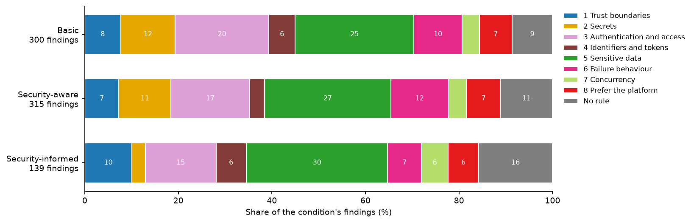
Figure 16: Rule make-up of findings · All three conditions, self-review
Figure 16 shows Sensitive data as the largest rule share under all three conditions. In Security-informed, No rule, Trust boundaries, Identifiers and tokens and Concurrency occupy visibly larger shares than in Stage 1, while Secrets and Failure behaviour occupy smaller shares.

Findings per review by reviewer and generator
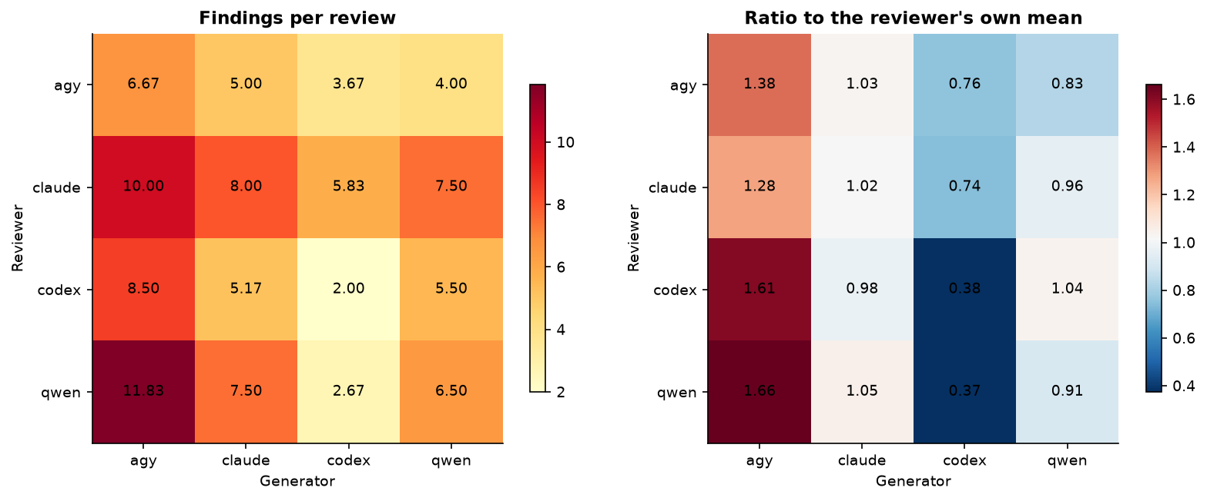
Figure 17: Findings per review by reviewer and generator · Security-informed, all four reviewers
Figure 17 shows strong reviewer and generator effects in Security-informed reviews. Programs generated by agy attract the highest review rates from claude, codex and qwen, whereas codex-generated programs attract the lowest rate from every reviewer, including codex itself.

Reviewer volume, severity and own-code contrast
Table 9: Reviewer volume, severity and own-code contrast · Security-informed, all four reviewers
reviewer | reviews | findings per review | High/Critical % | distinct CWEs | own code | other code | other minus own
agy | 24 | 4.83 | 29.31 | 50 | 6.67 | 4.22 | -2.44
claude | 24 | 7.83 | 7.98 | 60 | 8.0 | 7.78 | -0.22
codex | 24 | 5.29 | 14.96 | 46 | 2.0 | 6.39 | 4.39
qwen | 24 | 7.12 | 15.79 | 68 | 6.5 | 7.33 | 0.83

Claude reported the most findings per review at 7.83, followed by qwen at 7.12, codex at 5.29 and agy at 4.83; agy had the highest High/Critical share at 29.31%. Codex showed the largest positive other-minus-own contrast at 4.39, while agy showed the largest negative contrast at -2.44.

Reviewer volume against severity, and own code against other generators’ code
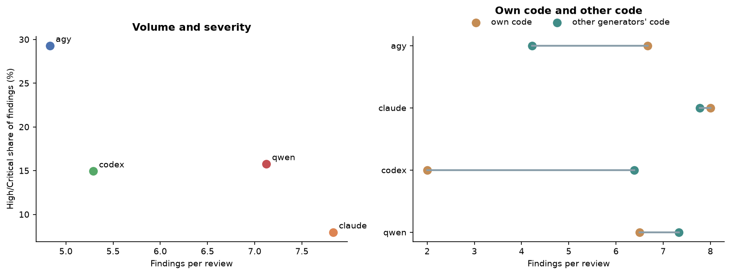
Figure 18: Reviewer volume against severity, and own code against other generators’ code · Security-informed, all four reviewers
Figure 18 separates reviewer volume from severity: claude has the highest finding volume but the lowest High/Critical share, while agy has the lowest volume and highest High/Critical share. Codex reports markedly more findings on other generators’ code than on its own, whereas agy shows the reverse pattern.

Severity of findings by reviewer
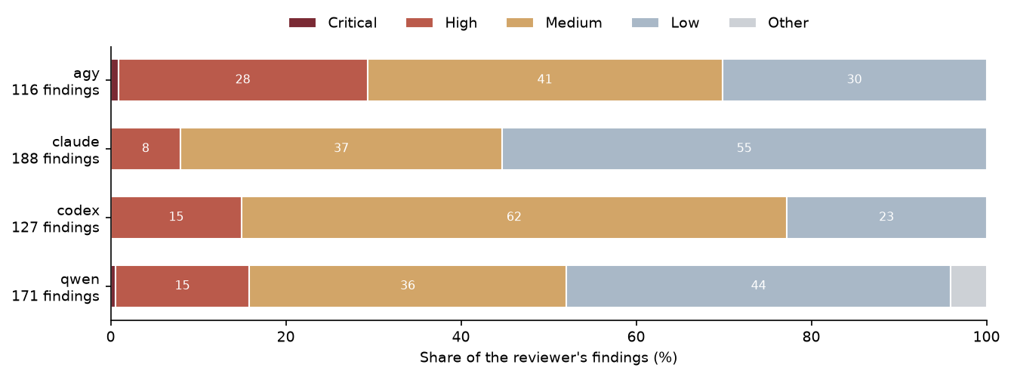
Figure 19: Severity of findings by reviewer · Security-informed, all four reviewers
Figure 19 shows distinct severity mixes across reviewers. Agy has the largest High/Critical share, claude the largest Low share, and codex the largest Medium share; qwen alone has a clearly visible Other segment.

Reviewers naming the same CWE, and the same OWASP category, on a program
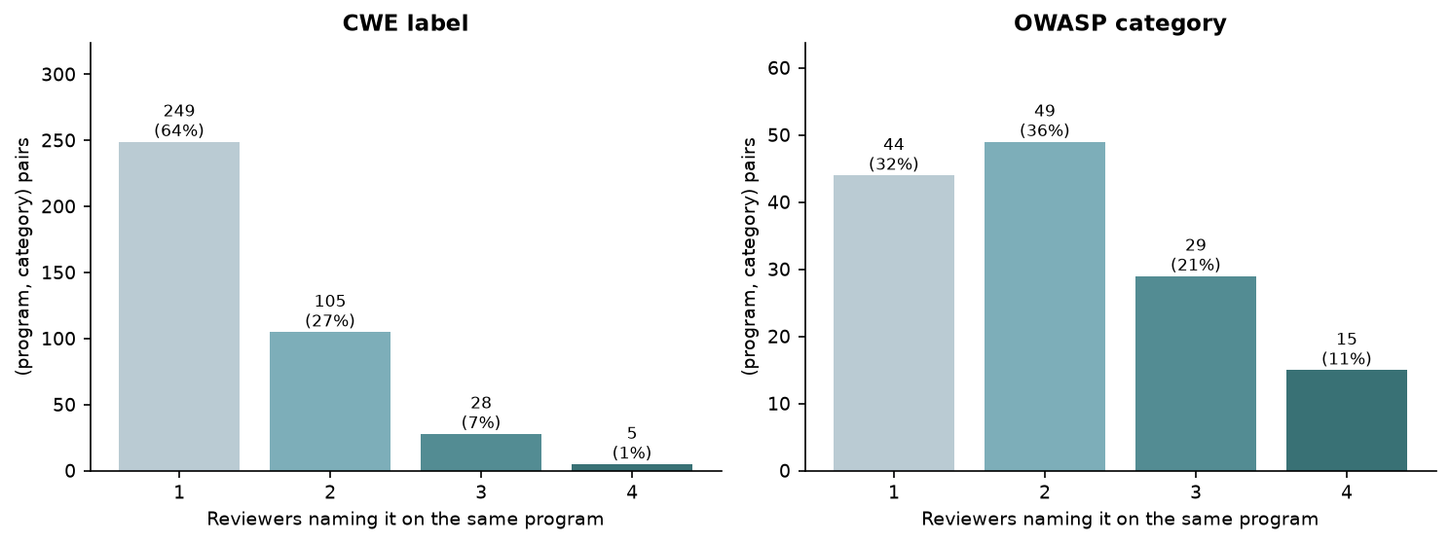
Figure 20: Reviewers naming the same CWE, and the same OWASP category, on a program · Security-informed, all four reviewers
Figure 20 shows that most program–CWE pairs are named by only one reviewer, with progressively fewer pairs shared by more reviewers. OWASP-category agreement is more distributed across two, three and four reviewers than CWE-label agreement.

Share of (program, category) pairs named by 1, 2, 3 or 4 reviewers
Table 10: Share of (program, category) pairs named by 1, 2, 3 or 4 reviewers · Security-informed, all four reviewers
level | pairs | named by 1 % | named by 2 % | named by 3 % | named by 4 %
CWE label | 387 | 64.3 | 27.1 | 7.2 | 1.3
OWASP category | 137 | 32.1 | 35.8 | 21.2 | 10.9

At the CWE-label level, 64.3% of 387 program–category pairs were named by 1 reviewer, 27.1% by 2, 7.2% by 3 and 1.3% by 4. At the OWASP-category level, the corresponding shares among 137 pairs were 32.1%, 35.8%, 21.2% and 10.9%.

Mean Jaccard overlap of each reviewer pair’s labels on the same program
Table 11: Mean Jaccard overlap of each reviewer pair’s labels on the same program · Security-informed, all four reviewers
reviewer pair | CWE Jaccard | OWASP Jaccard
agy / claude | 0.12 | 0.29
agy / codex | 0.12 | 0.26
agy / qwen | 0.1 | 0.31
claude / codex | 0.22 | 0.31
claude / qwen | 0.19 | 0.54
codex / qwen | 0.13 | 0.34

Mean CWE Jaccard overlap ranged from 0.1 for agy / qwen to 0.22 for claude / codex. Mean OWASP Jaccard overlap was higher for every pair, ranging from 0.26 for agy / codex to 0.54 for claude / qwen.

CWE make-up of findings by generator
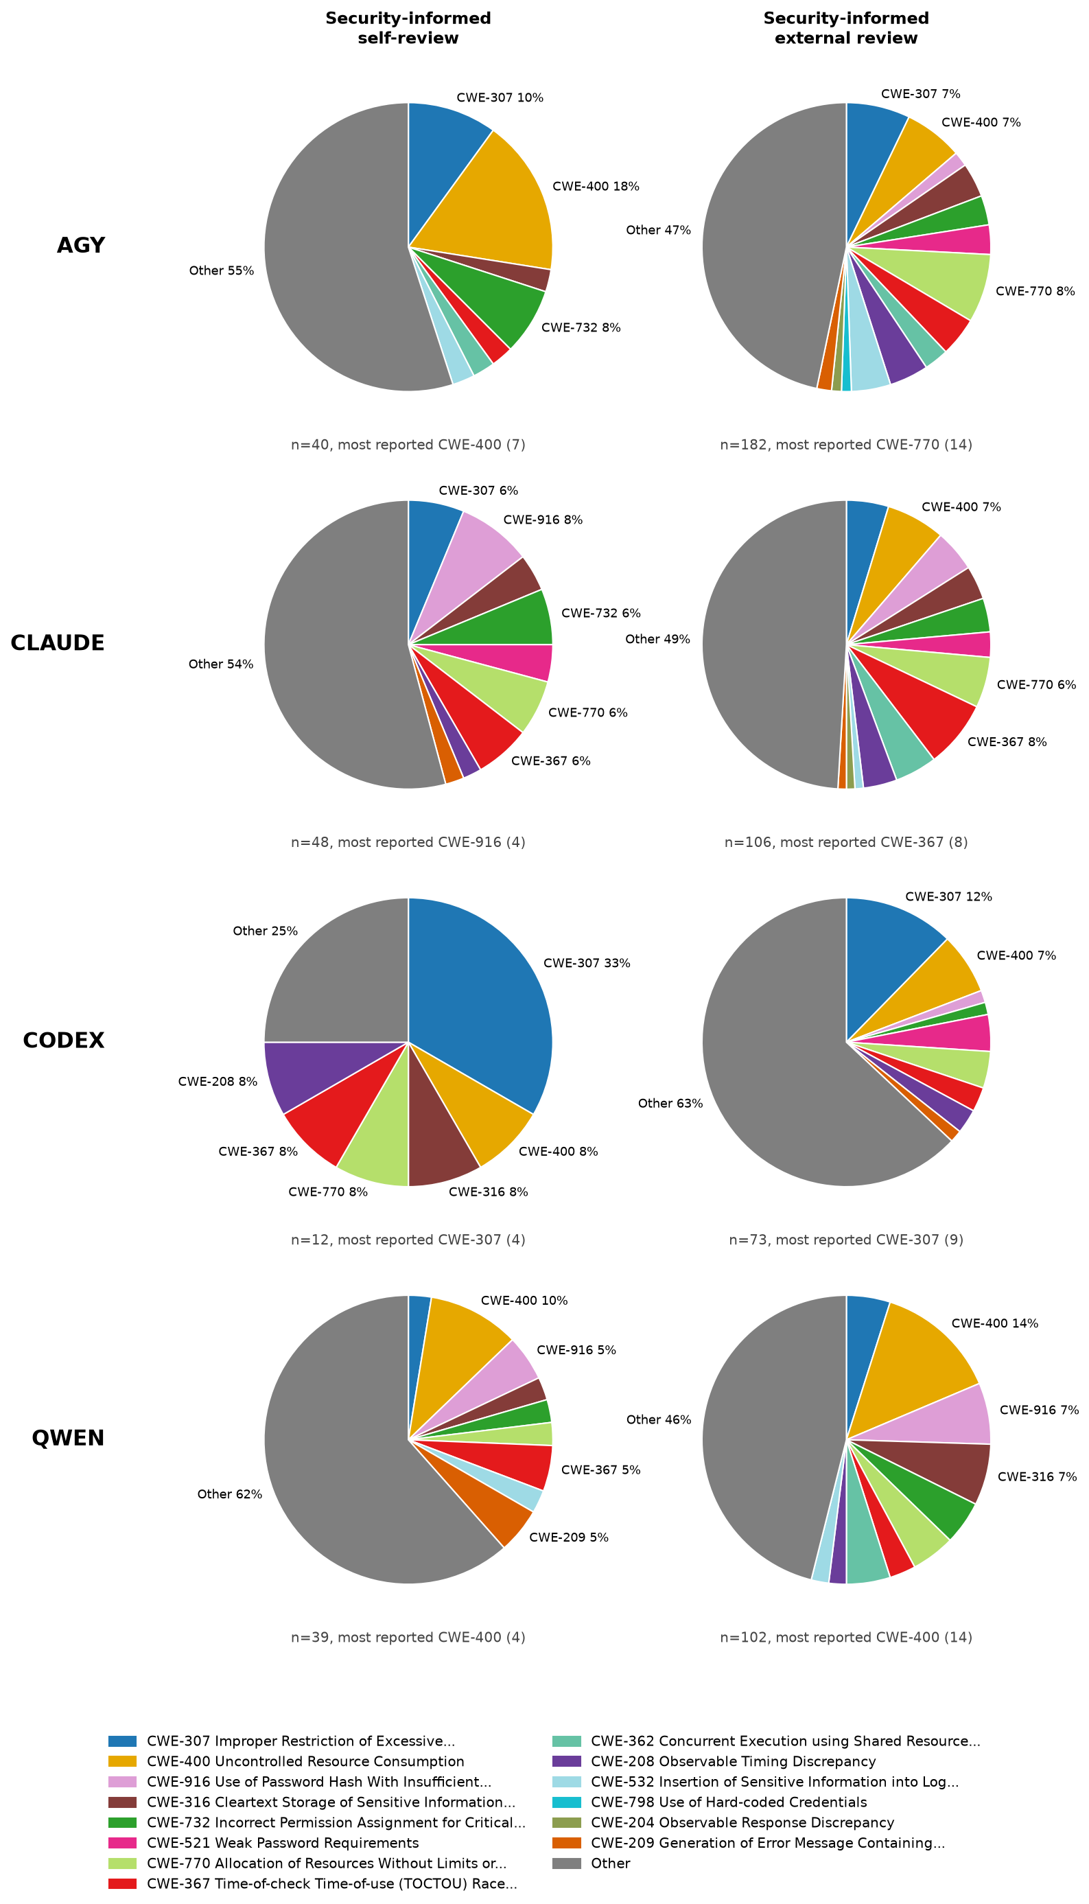
Figure 21: CWE make-up of findings by generator · Security-informed, self-review and external review
Figure 21 shows that Security-informed CWE composition changes between self-review and external review for every generator. External reviews are more dispersed across displayed CWEs for agy and claude, while codex’s external reviews have a much larger Other share than its self-review.

OWASP category make-up of findings by generator
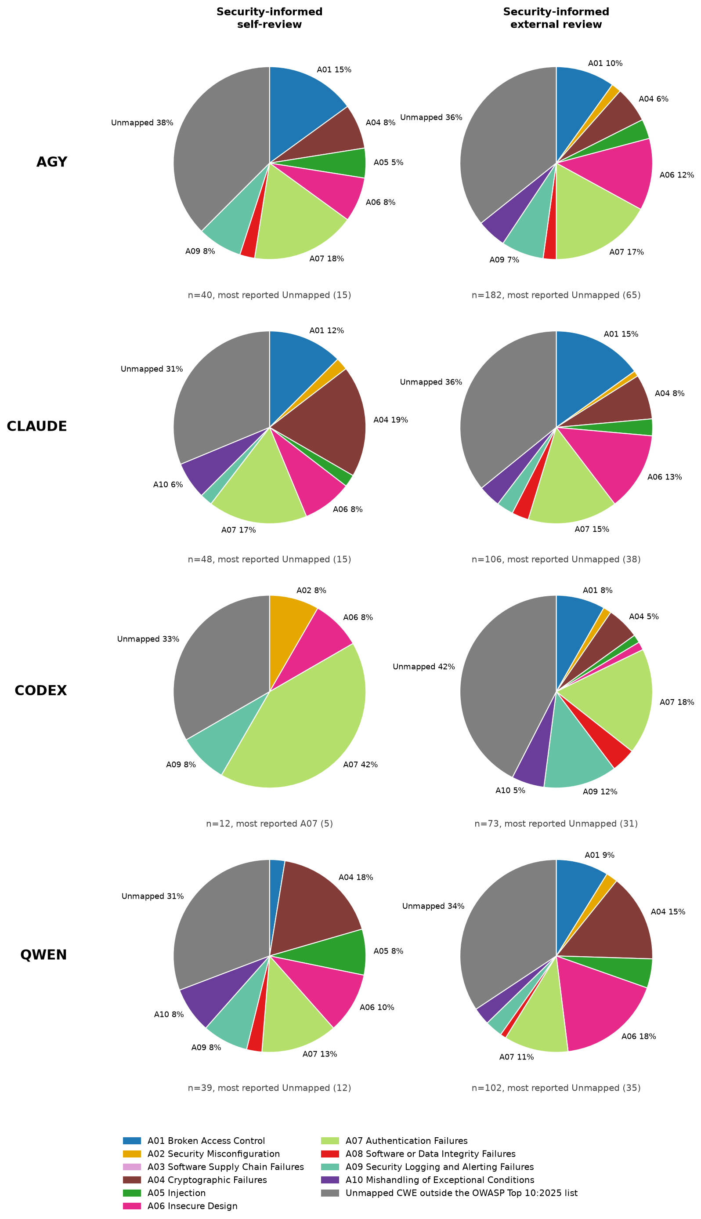
Figure 22: OWASP category make-up of findings by generator · Security-informed, self-review and external review
Figure 22 shows that the unmapped group is the largest category in most self-review and external-review panels. The clearest contrast is for codex: A07 dominates self-review, whereas the unmapped group dominates external review.

Findings per review by CWE and task
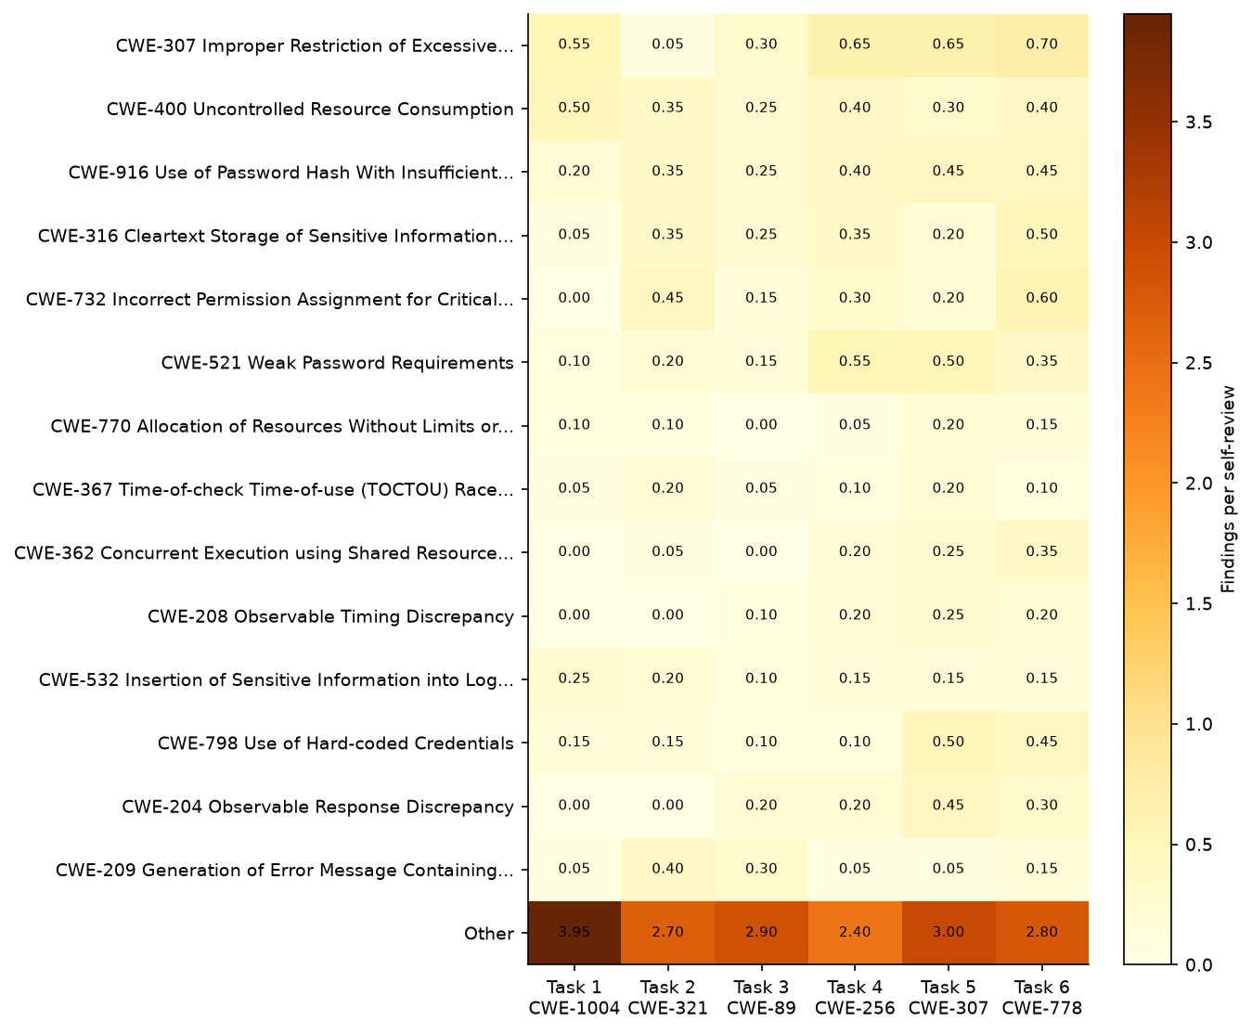
Figure 23: Findings per review by CWE and task · All three conditions, self-review
Figure 23 shows that the CWE profile differs substantially by task. CWE-307 is most prominent in the later tasks, CWE-732 is strongest for Tasks 2 and 6, and the Other group is especially prominent for Task 1.

Findings per review by OWASP category and task
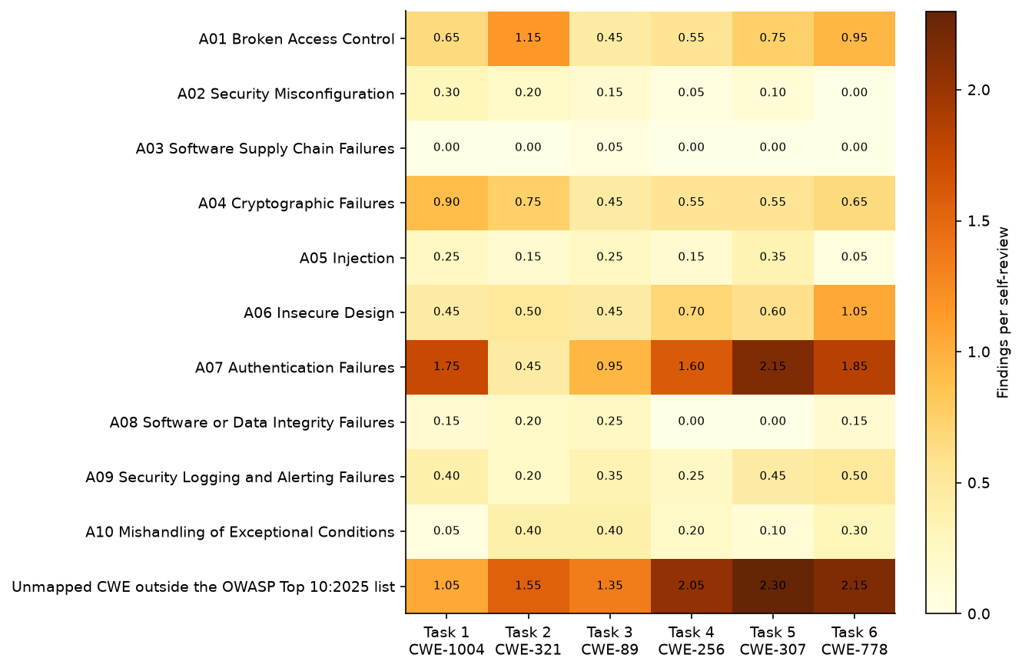
Figure 24: Findings per review by OWASP category and task · All three conditions, self-review
Figure 24 shows that A07 and the unmapped group are the most prominent rows across tasks. A07 is strongest for Task 5, the unmapped group is strongest for Tasks 4 through 6, and A01 is most prominent for Task 2.

Data checks
Table 12: Data checks · All reviews
check | value
CSV rows | 1224
Recorded findings | 1217
Reviews | 192
Reviews with no findings | 7
Generated programs | 120
Rows missing reviewer or generator | 0
Stage 2 programs with all 4 reviewers | 24
Duplicate CSV rows | 0
Findings with no CWE | 0
Findings with non-standard severity | 8
Repeated sec_id within one review | 0

The data checks record 1224 CSV rows, 1217 findings, 192 reviews and 120 generated programs, with 7 reviews containing no findings. There were 0 rows missing reviewer or generator, 0 duplicate CSV rows, 0 findings without a CWE and 0 repeated sec_id values within a review; 8 findings had non-standard severity.

About this report
Every table and figure is computed from findings.csv when the report is rendered. The text was written by an AI from the rendered tables and figures. All counts are reviewer-reported findings, not confirmed vulnerabilities.

