Security findings data report
Table of contents

Executive summary
- Across 120 generated programs and 192 reviews, reviewers reported 1217 findings; 7 reviews had no findings.
- Self-reviews produced 300 findings in Basic, 315 in Security-aware, and 139 in Security-informed, with 6.25, 6.56, and 5.79 findings per review, respectively.
- Across 48 matched Basic and Security-aware self-review pairs, the mean delta was 0.31 findings, with a CI from -0.29 to 0.94; 18 pairs had fewer findings, 23 had more, and 7 were ties.
- Sensitive data was the largest Security-informed rule grouping, with 339 findings (27.9%), followed by Authentication and access with 207 (17.0%); 159 findings (13.1%) were assigned no rule.
- CWE-307 was the most-reported CWE with 90 findings (7.4%); the 14 most-reported CWEs together accounted for 51.9% of all reviewer-reported findings.
- Exact-CWE agreement was limited: 64.3% of 387 (program, category) pairs were named by one reviewer, while OWASP-category pairs were more often shared across reviewers.

The eight Security-informed rules and the CWEs assigned to them
Table 1: The eight Security-informed rules and the CWEs assigned to them · All findings
rule | CWEs | findings | % of all findings
1 Trust boundaries | CWE-15, CWE-20, CWE-22, CWE-59, CWE-89, CWE-116, CWE-117, CWE-178, CWE-290, CWE-345, CWE-807, CWE-1284 | 99 | 8.1
2 Secrets | CWE-214, CWE-256, CWE-321, CWE-323, CWE-522, CWE-526, CWE-798 | 86 | 7.1
3 Authentication and access | CWE-284, CWE-287, CWE-306, CWE-307, CWE-521, CWE-636, CWE-645, CWE-799, CWE-862 | 207 | 17.0
4 Identifiers and tokens | CWE-330, CWE-338, CWE-352, CWE-384, CWE-613, CWE-614, CWE-1004 | 60 | 4.9
5 Sensitive data | CWE-226, CWE-244, CWE-276, CWE-316, CWE-319, CWE-359, CWE-377, CWE-400, CWE-532, CWE-549, CWE-732, CWE-770, CWE-779 | 339 | 27.9
6 Failure behaviour | CWE-200, CWE-203, CWE-204, CWE-208, CWE-209, CWE-754, CWE-1188 | 121 | 9.9
7 Concurrency | CWE-362, CWE-367 | 67 | 5.5
8 Prefer the platform | CWE-326, CWE-327, CWE-494, CWE-759, CWE-829, CWE-916, CWE-1395 | 79 | 6.5
No rule | every CWE not listed above | 159 | 13.1

Sensitive data was the largest rule grouping in Table 1, with 339 reviewer-reported findings (27.9%), followed by Authentication and access with 207 (17.0%). Findings assigned no rule numbered 159 (13.1%), while Identifiers and tokens was the smallest rule grouping with 60 (4.9%).

Programs, reviews and findings
Table 2: Programs, reviews and findings · All conditions, all reviews
condition | programs | self-reviews | external reviews | reviews with no findings | findings
Basic | 48 | 48 | 0 | 0 | 300
Security-aware | 48 | 48 | 0 | 1 | 315
Security-informed | 24 | 24 | 72 | 6 | 602

Table 2 contains 48 programs and 48 self-reviews each for Basic and Security-aware, and 24 programs, 24 self-reviews, and 72 external reviews for Security-informed. Reviewers reported 300, 315, and 602 findings in those conditions, respectively, with 0, 1, and 6 reviews having no findings.

Completed reviews per task and generator
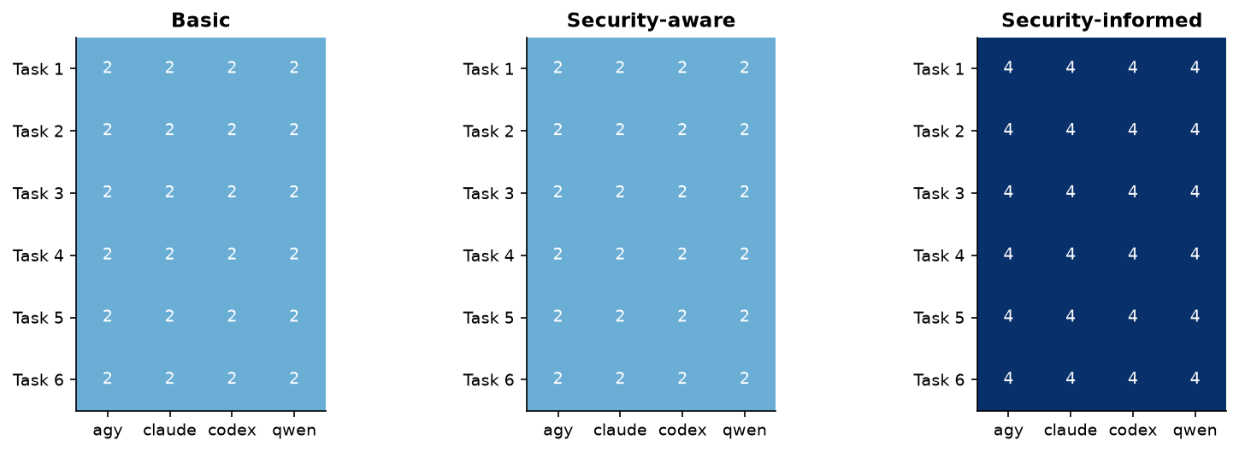
Figure 1: Completed reviews per task and generator · All conditions, all reviews
Figure 1 shows uniform completed-review coverage across every task and generator within each condition. The Security-informed panel includes both self-review and external-review coverage, while the Basic and Security-aware panels contain self-reviews.

Paired difference in findings per review, overall and by generator
Table 3: Paired difference in findings per review, overall and by generator · Basic and Security-aware, matched pairs, self-review
scope | pairs | Basic mean | Security-aware mean | mean delta | median delta | fewer | more | ties | CI low | CI high
all | 48 | 6.25 | 6.56 | 0.31 | 0.0 | 18 | 23 | 7 | -0.29 | 0.94
agy | 12 | 6.33 | 7.42 | 1.08 | 1.0 | 2 | 9 | 1 | 0.17 | 1.92
claude | 12 | 5.5 | 5.75 | 0.25 | 0.0 | 3 | 5 | 4 | -0.83 | 1.25
codex | 12 | 4.33 | 3.58 | -0.75 | -1.0 | 7 | 4 | 1 | -1.67 | 0.17
qwen | 12 | 8.83 | 9.5 | 0.67 | -0.5 | 6 | 5 | 1 | -1.0 | 2.33

Across all 48 matched pairs in Table 3, Security-aware averaged 6.56 findings versus 6.25 for Basic, for a mean delta of 0.31 and a CI from -0.29 to 0.94; 18 pairs had fewer findings, 23 had more, and 7 tied. The agy mean delta was 1.08 with a CI from 0.17 to 1.92, whereas the codex mean delta was -0.75 with a CI from -1.67 to 0.17.

Paired difference in findings per review by generator
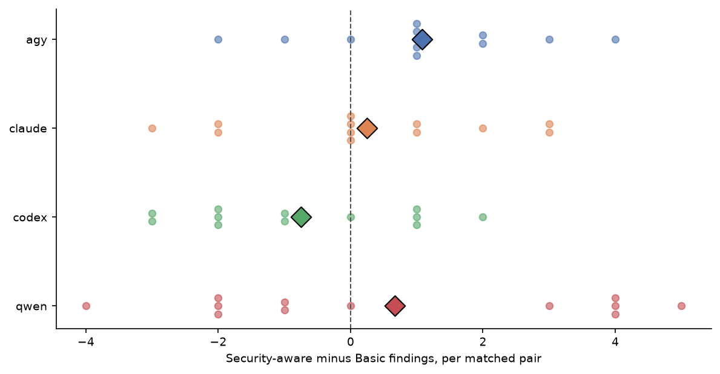
Figure 2: Paired difference in findings per review by generator · Basic and Security-aware, matched pairs, self-review
Figure 2 shows matched-pair changes on both sides of zero for every generator. The mean marker is positive for agy, claude, and qwen, and negative for codex, with agy showing the clearest positive shift.

Findings per review, median and High/Critical share
Table 4: Findings per review, median and High/Critical share · All conditions, self-review
condition | self-reviews | findings | findings per review | median | High/Critical %
Basic | 48 | 300 | 6.25 | 6.0 | 16.67
Security-aware | 48 | 315 | 6.56 | 7.0 | 17.78
Security-informed | 24 | 139 | 5.79 | 7.0 | 14.39

In Table 4, Basic, Security-aware, and Security-informed self-reviews had 6.25, 6.56, and 5.79 findings per review, with medians of 6.0, 7.0, and 7.0. Their High/Critical shares were 16.67%, 17.78%, and 14.39%, respectively; these are reviewer-reported findings rather than confirmed vulnerabilities.

Findings per review
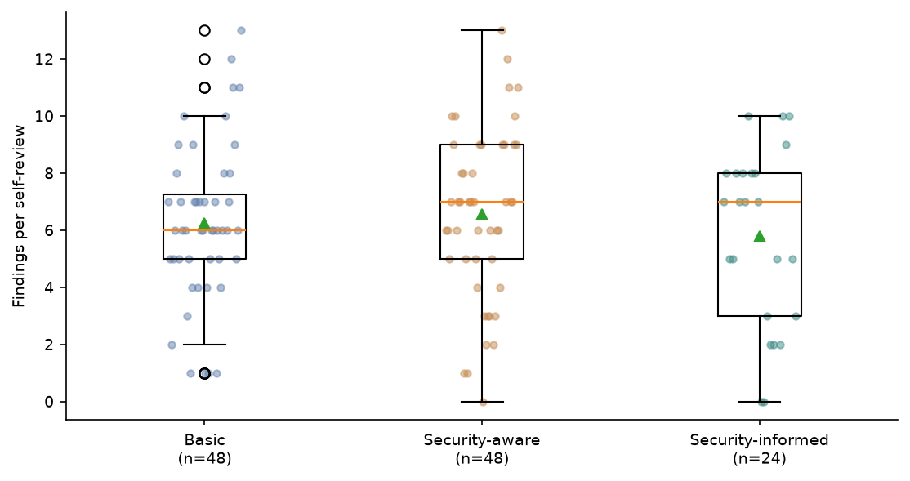
Figure 3: Findings per review · All conditions, self-review
Figure 3 shows substantial overlap in findings per self-review across the three conditions. Security-aware and Security-informed share a higher median than Basic, while Security-informed has the lowest mean and a broad spread.

Findings per review by generator
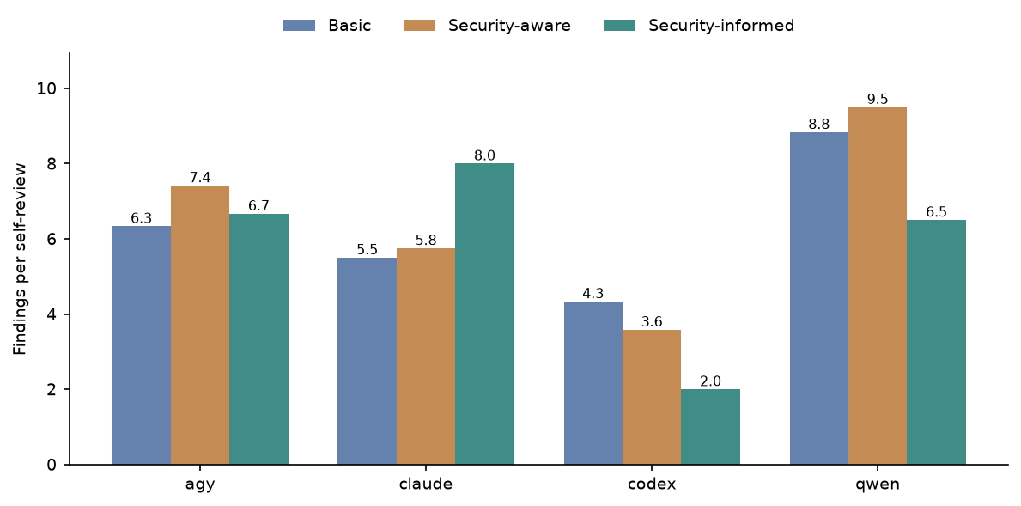
Figure 4: Findings per review by generator · All conditions, self-review
Figure 4 shows that qwen has the highest self-review finding rate in Basic and Security-aware, while claude is highest in Security-informed. Codex has the lowest rate in every condition and declines from Basic to Security-informed.

Findings per review by task
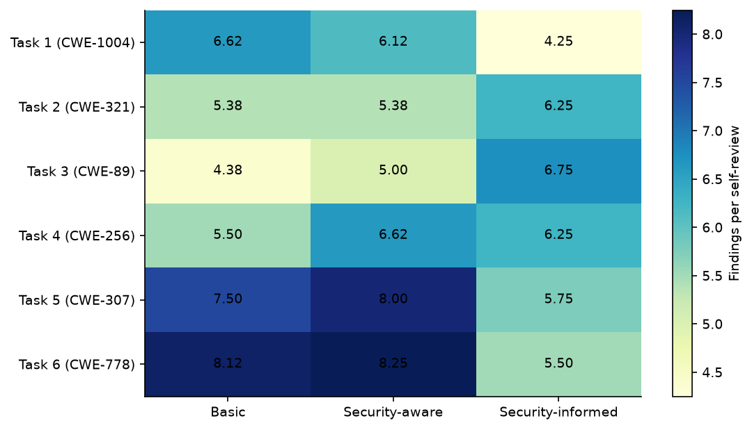
Figure 5: Findings per review by task · All conditions, self-review
Figure 5 shows that finding rates vary by task as well as condition. Security-informed is highest for the tasks anchored to CWE-321 and CWE-89, while Basic and Security-aware are higher for the tasks anchored to CWE-1004, CWE-307, and CWE-778.

Severity of findings
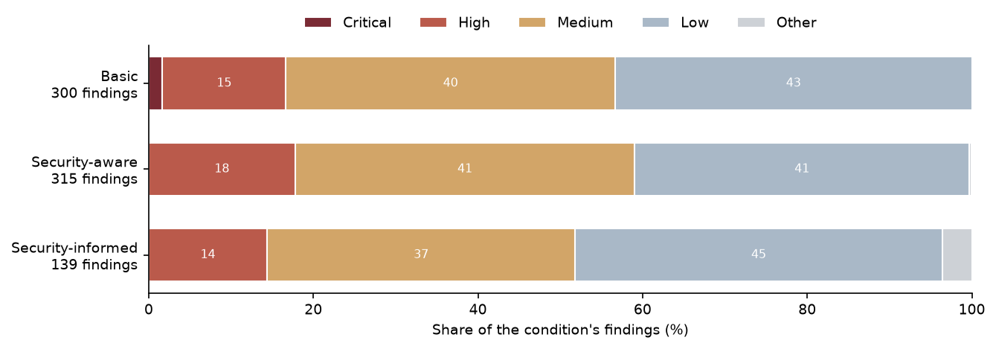
Figure 6: Severity of findings · All conditions, self-review
Figure 6 shows that Low and Medium findings make up most reviewer-reported findings in all three conditions. Security-informed has the largest Low share and the smallest combined High/Critical share, while Security-aware has the largest High share.

Reviews naming the task’s anchor CWE
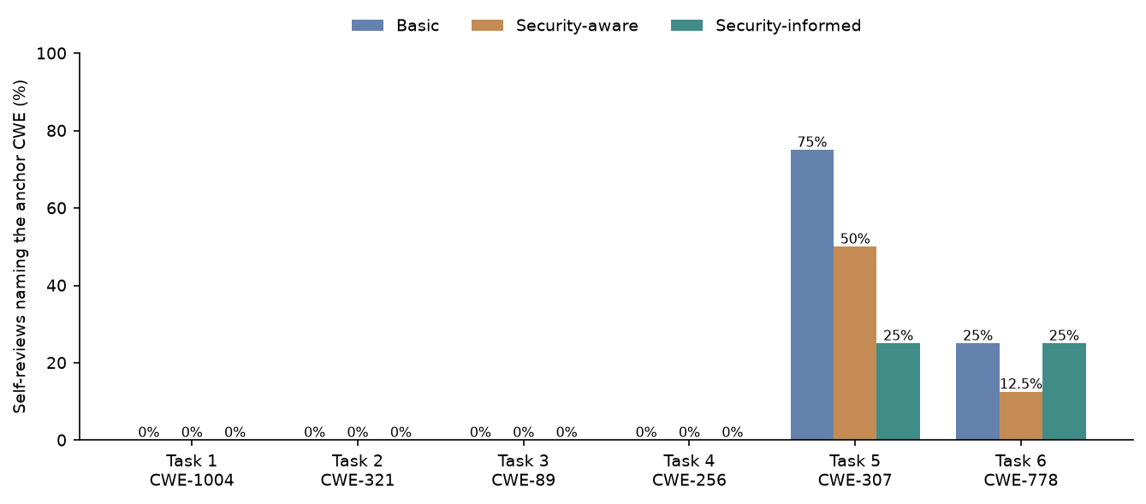
Figure 7: Reviews naming the task’s anchor CWE · All conditions, self-review
Figure 7 shows no self-reviews naming the anchor CWE for the tasks anchored to CWE-1004, CWE-321, CWE-89, or CWE-256. The anchor CWE is named most often for the CWE-307 task, especially under Basic, while the CWE-778 task has lower and more similar coverage across conditions.

The 14 most-reported CWEs
Table 5: The 14 most-reported CWEs · All findings
rank | CWE | title | findings | cumulative %
1 | CWE-307 | Improper Restriction of Excessive Authentication Attempts | 90 | 7.4
2 | CWE-400 | Uncontrolled Resource Consumption | 82 | 14.1
3 | CWE-916 | Use of Password Hash With Insufficient Computational Effort | 58 | 18.9
4 | CWE-316 | Cleartext Storage of Sensitive Information in Memory | 52 | 23.2
5 | CWE-732 | Incorrect Permission Assignment for Critical Resource | 50 | 27.3
6 | CWE-521 | Weak Password Requirements | 49 | 31.3
7 | CWE-770 | Allocation of Resources Without Limits or Throttling | 40 | 34.6
8 | CWE-367 | Time-of-check Time-of-use (TOCTOU) Race Condition | 35 | 37.5
9 | CWE-362 | Concurrent Execution using Shared Resource with Improper Synchronization (‘Race Condition’) | 32 | 40.1
10 | CWE-208 | Observable Timing Discrepancy | 31 | 42.6
11 | CWE-532 | Insertion of Sensitive Information into Log File | 31 | 45.2
12 | CWE-798 | Use of Hard-coded Credentials | 31 | 47.7
13 | CWE-204 | Observable Response Discrepancy | 26 | 49.9
14 | CWE-209 | Generation of Error Message Containing Sensitive Information | 25 | 51.9

CWE-307 ranks first in Table 5 with 90 findings (7.4%), followed by CWE-400 with 82; CWE-916 is third with 58. The 14 listed CWEs account for 51.9% of all reviewer-reported findings, with CWE-209 ranked 14th at 25 findings.

Findings per review by CWE
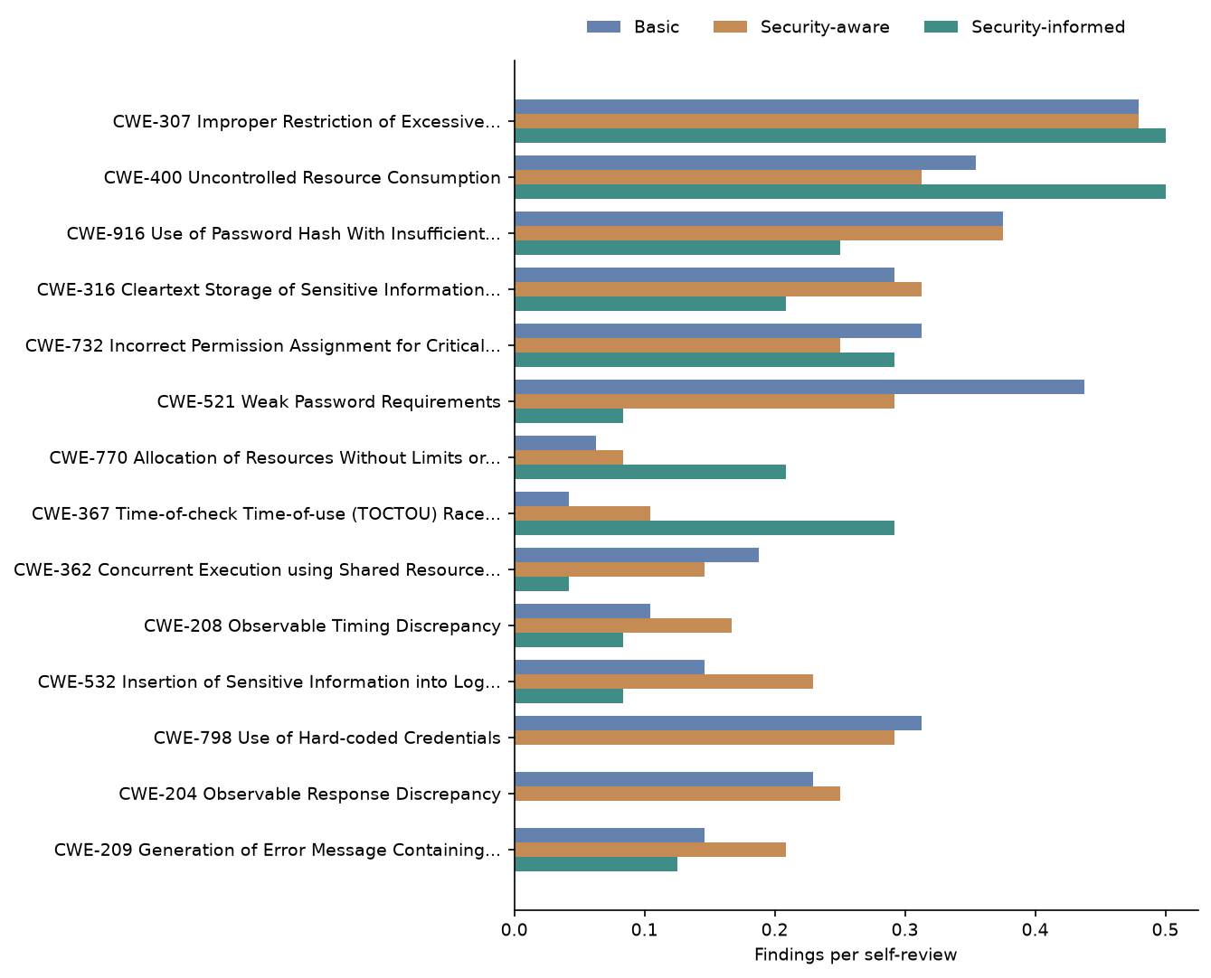
Figure 8: Findings per review by CWE · All conditions, self-review
Figure 8 shows different condition profiles among the most-reported CWEs. Security-informed is highest for CWE-307, CWE-400, CWE-770, and CWE-367, but lowest for several others, including CWE-521, CWE-362, CWE-532, CWE-798, CWE-204, and CWE-209.

Findings per review by CWE, per condition
Table 6: Findings per review by CWE, per condition · All conditions, self-review
category | Basic | Security-aware | Security-informed
CWE-307 Improper Restriction of Excessive… | 0.48 | 0.48 | 0.5
CWE-400 Uncontrolled Resource Consumption | 0.35 | 0.31 | 0.5
CWE-916 Use of Password Hash With Insufficient… | 0.38 | 0.38 | 0.25
CWE-316 Cleartext Storage of Sensitive Information… | 0.29 | 0.31 | 0.21
CWE-732 Incorrect Permission Assignment for Critical… | 0.31 | 0.25 | 0.29
CWE-521 Weak Password Requirements | 0.44 | 0.29 | 0.08
CWE-770 Allocation of Resources Without Limits or… | 0.06 | 0.08 | 0.21
CWE-367 Time-of-check Time-of-use (TOCTOU) Race… | 0.04 | 0.1 | 0.29
CWE-362 Concurrent Execution using Shared Resource… | 0.19 | 0.15 | 0.04
CWE-208 Observable Timing Discrepancy | 0.1 | 0.17 | 0.08
CWE-532 Insertion of Sensitive Information into Log… | 0.15 | 0.23 | 0.08
CWE-798 Use of Hard-coded Credentials | 0.31 | 0.29 | 0.0
CWE-204 Observable Response Discrepancy | 0.23 | 0.25 | 0.0
CWE-209 Generation of Error Message Containing… | 0.15 | 0.21 | 0.12
Other | 2.77 | 3.06 | 3.12

In Table 6, CWE-307 is similar across conditions at 0.48, 0.48, and 0.5 findings per review, while CWE-400 rises from 0.35 and 0.31 to 0.5 in Security-informed. Security-informed is also higher for CWE-770 at 0.21 and CWE-367 at 0.29, but records 0.0 for CWE-798 and CWE-204.

Findings per review by OWASP category
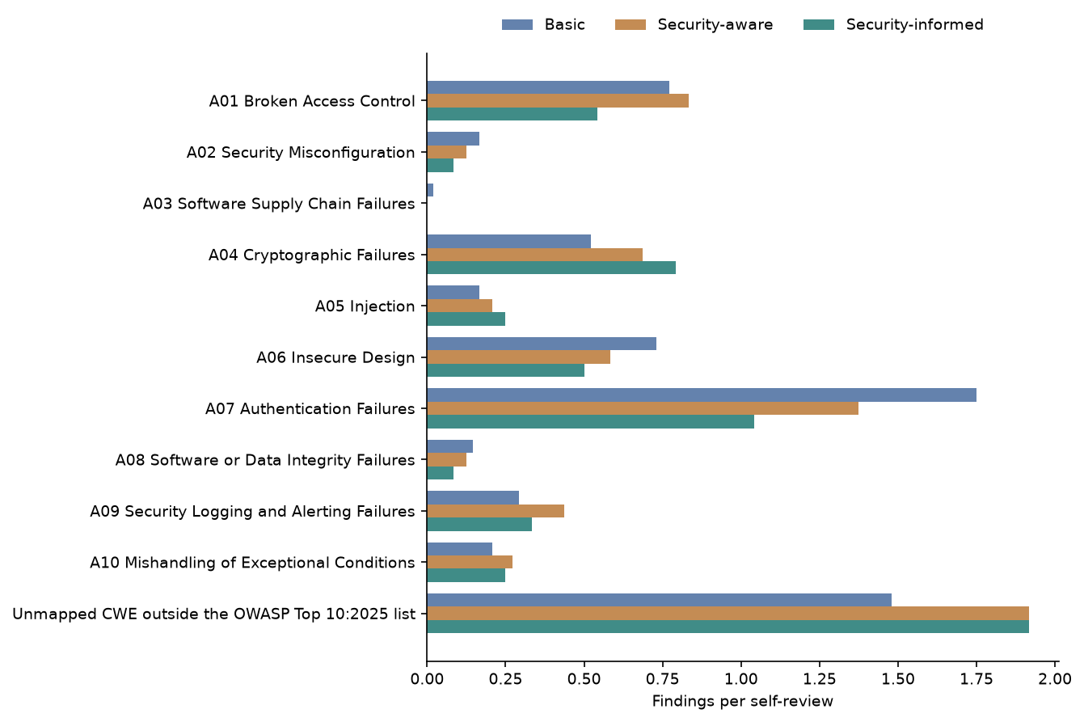
Figure 9: Findings per review by OWASP category · All conditions, self-review
Figure 9 shows A07 as the highest mapped OWASP category in each condition, although its rate declines from Basic through Security-informed. Unmapped CWEs have the highest overall rate in Security-aware and Security-informed, while A04 and A05 rise across the three conditions.

Findings per review by OWASP category, per condition
Table 7: Findings per review by OWASP category, per condition · All conditions, self-review
category | Basic | Security-aware | Security-informed
A01 Broken Access Control | 0.77 | 0.83 | 0.54
A02 Security Misconfiguration | 0.17 | 0.12 | 0.08
A03 Software Supply Chain Failures | 0.02 | 0.0 | 0.0
A04 Cryptographic Failures | 0.52 | 0.69 | 0.79
A05 Injection | 0.17 | 0.21 | 0.25
A06 Insecure Design | 0.73 | 0.58 | 0.5
A07 Authentication Failures | 1.75 | 1.38 | 1.04
A08 Software or Data Integrity Failures | 0.15 | 0.12 | 0.08
A09 Security Logging and Alerting Failures | 0.29 | 0.44 | 0.33
A10 Mishandling of Exceptional Conditions | 0.21 | 0.27 | 0.25
Unmapped CWE outside the OWASP Top 10:2025 list | 1.48 | 1.92 | 1.92

Table 7 shows A07 at 1.75, 1.38, and 1.04 findings per review for Basic, Security-aware, and Security-informed, while unmapped CWEs are 1.48, 1.92, and 1.92. A04 increases from 0.52 to 0.69 to 0.79, whereas A01 is 0.77, 0.83, and 0.54.

CWE make-up of findings
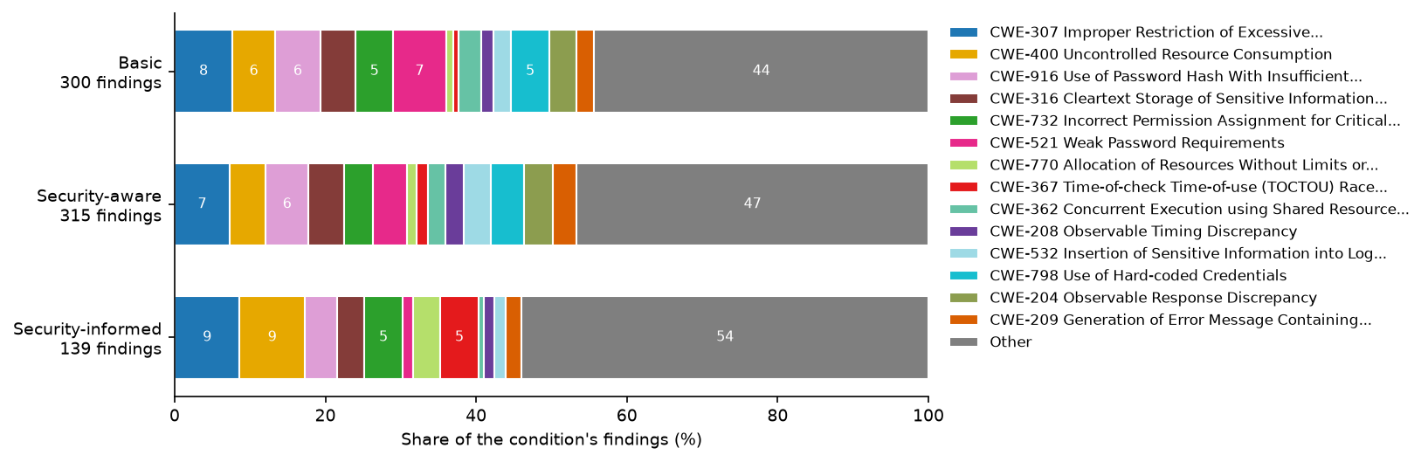
Figure 10: CWE make-up of findings · All conditions, self-review
Figure 10 shows that the combined Other CWEs form the largest share in every condition and are most prominent in Security-informed. Among the individually displayed CWEs, Security-informed gives relatively greater shares to CWE-307, CWE-400, CWE-770, and CWE-367, while CWE-521 is less prominent.

OWASP category make-up of findings
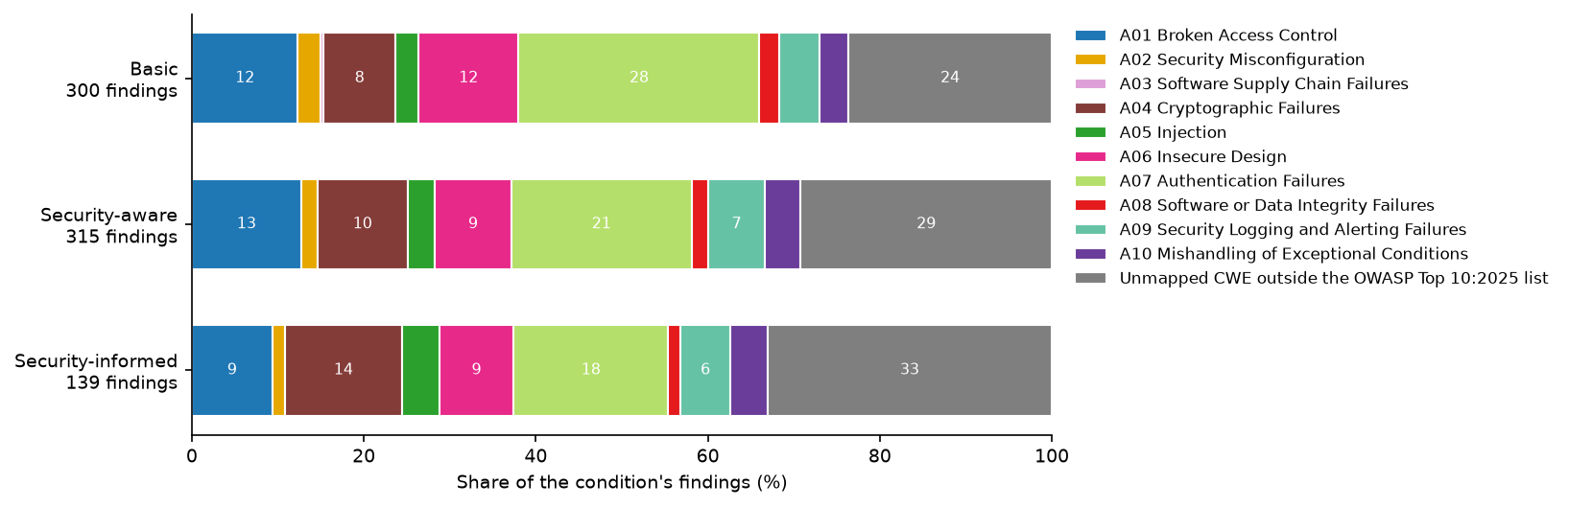
Figure 11: OWASP category make-up of findings · All conditions, self-review
Figure 11 shows unmapped CWEs taking a progressively larger share from Basic to Security-informed, while A07 takes a progressively smaller share. A04 also occupies a larger share in Security-informed than in the other conditions.

CWE make-up of findings by generator
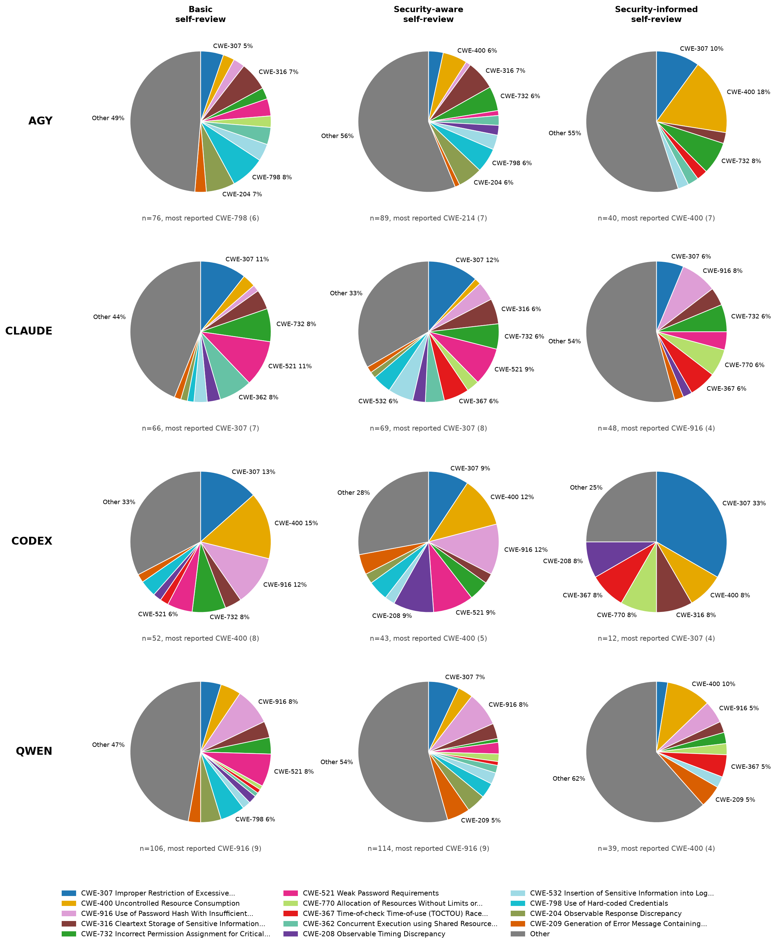
Figure 12: CWE make-up of findings by generator · All conditions, self-review
Figure 12 shows substantial variation in CWE composition across both generators and conditions. Other CWEs dominate most panels, while codex Security-informed is notably concentrated in CWE-307 and agy Security-informed gives the largest named slice to CWE-400.

OWASP category make-up of findings by generator
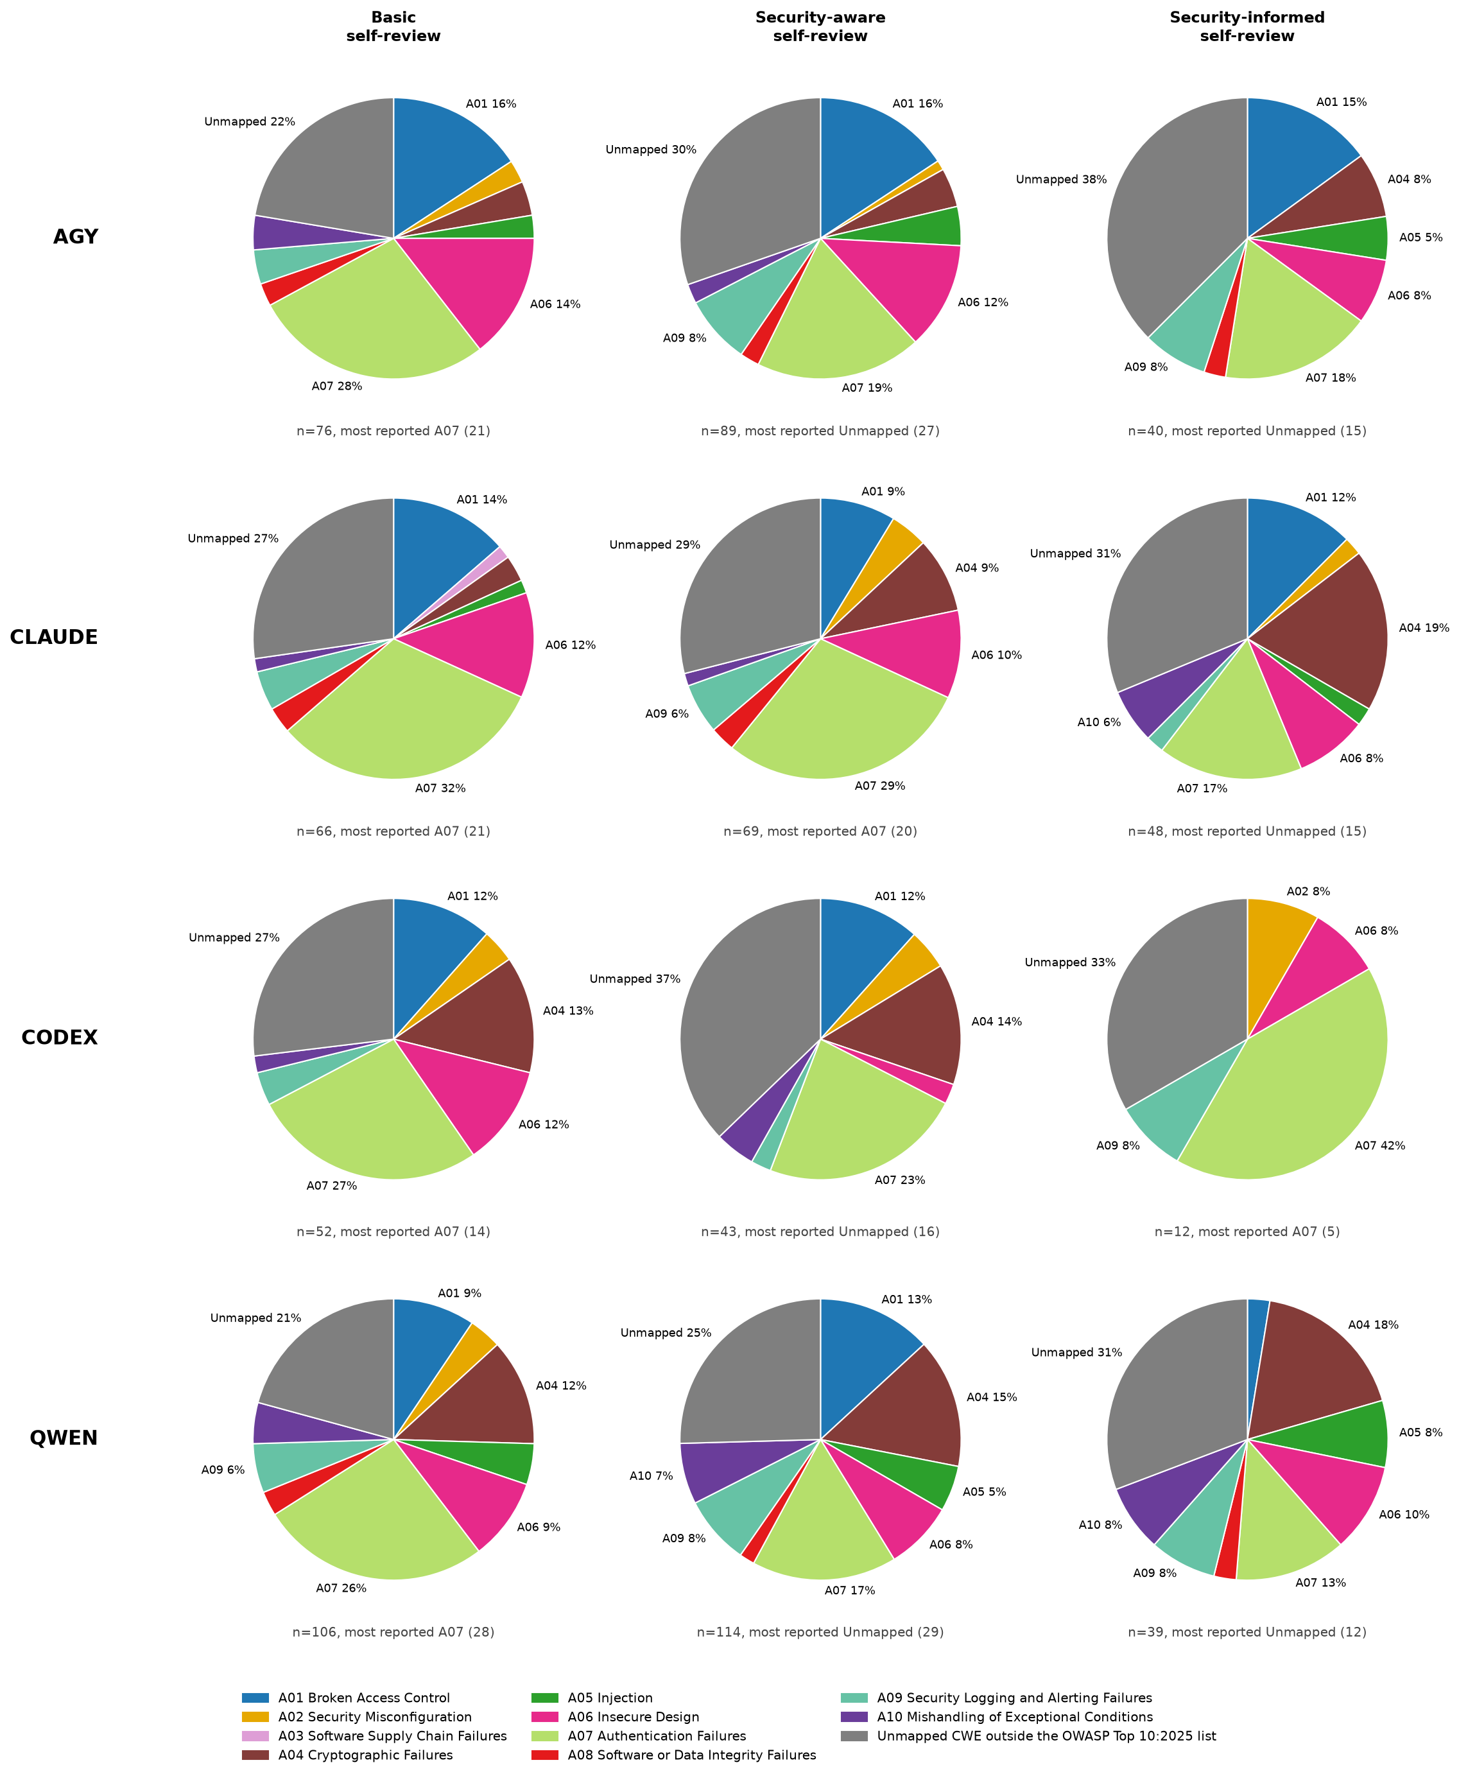
Figure 13: OWASP category make-up of findings by generator · All conditions, self-review
Figure 13 shows that A07 and unmapped CWEs are the dominant portions in most generator-condition combinations. The Security-informed mixes differ visibly by generator: codex is concentrated in A07, claude has a comparatively large A04 share, and agy and qwen are led by unmapped CWEs.

Findings per review by Security-informed rule
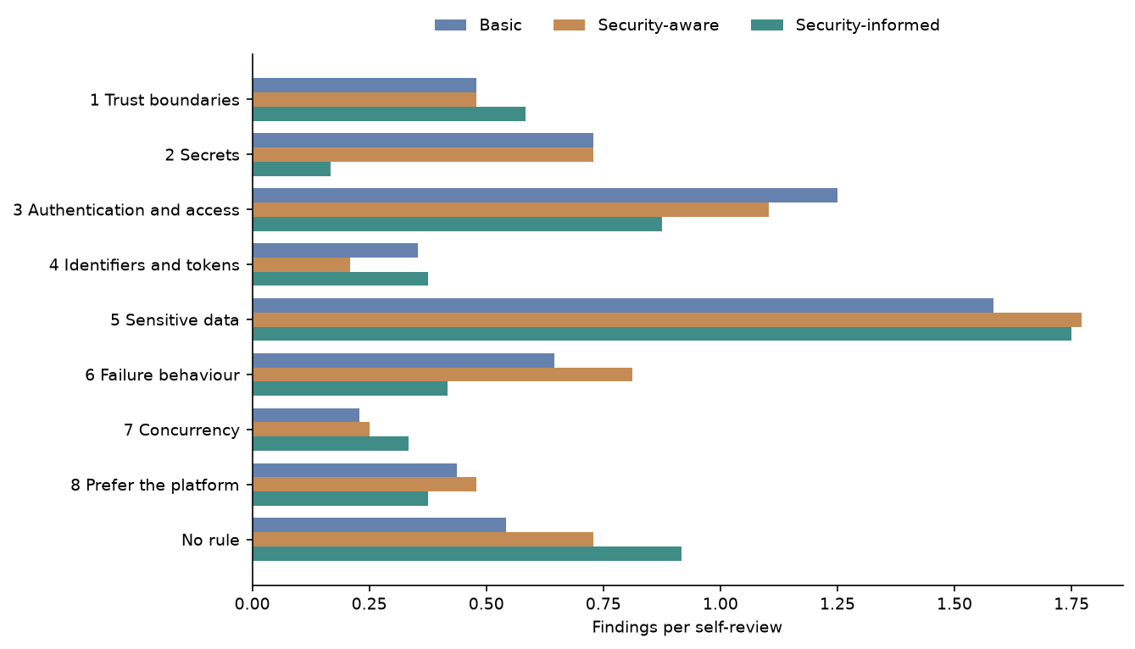
Figure 14: Findings per review by Security-informed rule · All conditions, self-review
Figure 14 shows Sensitive data as the highest-rate rule grouping in every condition. Security-informed is higher for Trust boundaries, Identifiers and tokens, Concurrency, and No rule, but lower for Secrets, Authentication and access, Failure behaviour, and Prefer the platform.

Findings per review by Security-informed rule, per condition
Table 8: Findings per review by Security-informed rule, per condition · All conditions, self-review
category | Basic | Security-aware | Security-informed
1 Trust boundaries | 0.48 | 0.48 | 0.58
2 Secrets | 0.73 | 0.73 | 0.17
3 Authentication and access | 1.25 | 1.1 | 0.88
4 Identifiers and tokens | 0.35 | 0.21 | 0.38
5 Sensitive data | 1.58 | 1.77 | 1.75
6 Failure behaviour | 0.65 | 0.81 | 0.42
7 Concurrency | 0.23 | 0.25 | 0.33
8 Prefer the platform | 0.44 | 0.48 | 0.38
No rule | 0.54 | 0.73 | 0.92

In Table 8, Sensitive data has 1.58, 1.77, and 1.75 findings per review across Basic, Security-aware, and Security-informed. Security-informed is much lower for Secrets at 0.17 versus 0.73 in both other conditions, while No rule rises from 0.54 to 0.73 to 0.92.

Rule make-up of findings
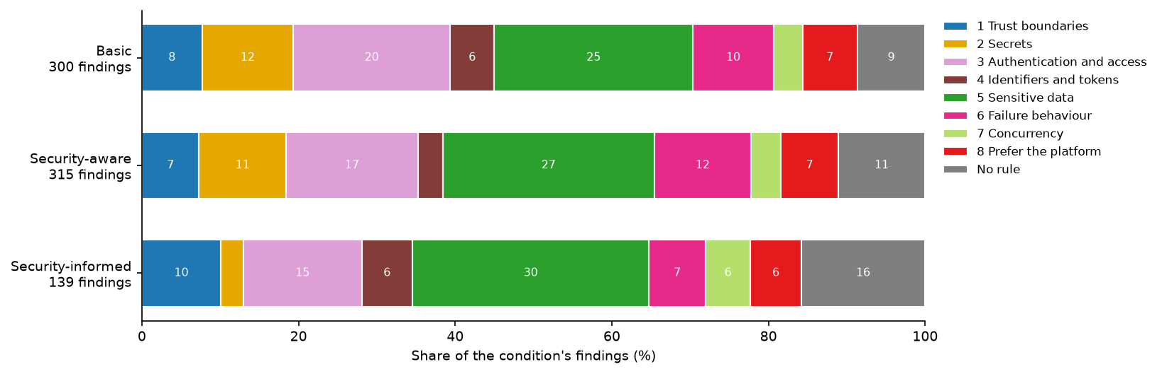
Figure 15: Rule make-up of findings · All conditions, self-review
Figure 15 shows Sensitive data as the largest share in all three conditions. Security-informed has larger shares for Trust boundaries, Identifiers and tokens, Concurrency, and No rule, alongside smaller shares for Secrets, Authentication and access, Failure behaviour, and Prefer the platform.

Findings per review by reviewer and generator
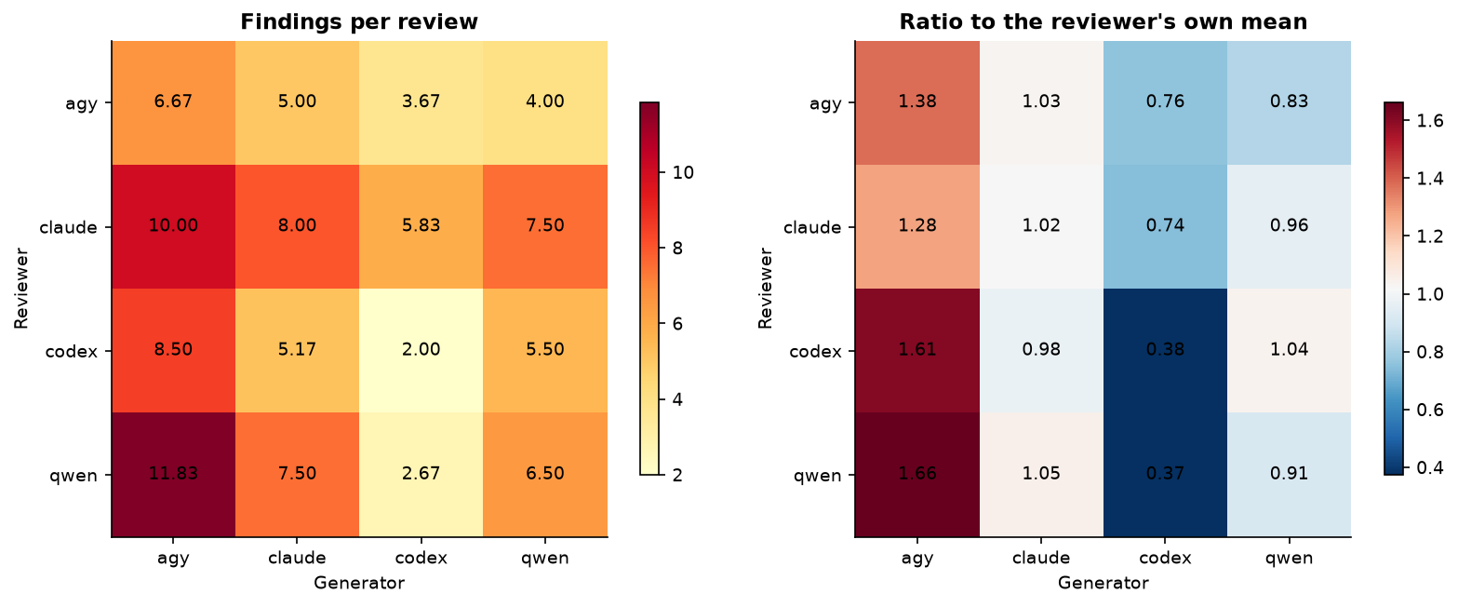
Figure 16: Findings per review by reviewer and generator · Security-informed, all four reviewers
Figure 16 shows that reviewer identity and generator identity both correspond to large differences in findings per review. Every reviewer reports the highest rate on agy-generated programs and a lower rate on codex-generated programs, with self-review cells especially low for codex and comparatively high for agy.

Reviewer volume, severity and own-code contrast
Table 9: Reviewer volume, severity and own-code contrast · Security-informed, all four reviewers
reviewer | reviews | findings per review | High/Critical % | distinct CWEs | own code | other code | other minus own
agy | 24 | 4.83 | 29.31 | 50 | 6.67 | 4.22 | -2.44
claude | 24 | 7.83 | 7.98 | 60 | 8.0 | 7.78 | -0.22
codex | 24 | 5.29 | 14.96 | 46 | 2.0 | 6.39 | 4.39
qwen | 24 | 7.12 | 15.79 | 68 | 6.5 | 7.33 | 0.83

Table 9 shows claude with the highest volume at 7.83 findings per review and agy with the highest High/Critical share at 29.31%; qwen reports the most distinct CWEs at 68. Codex reports 2.0 findings per review on its own code versus 6.39 on other code, an other-minus-own difference of 4.39, while agy shows -2.44.

Reviewer volume against severity, and own code against other generators’ code
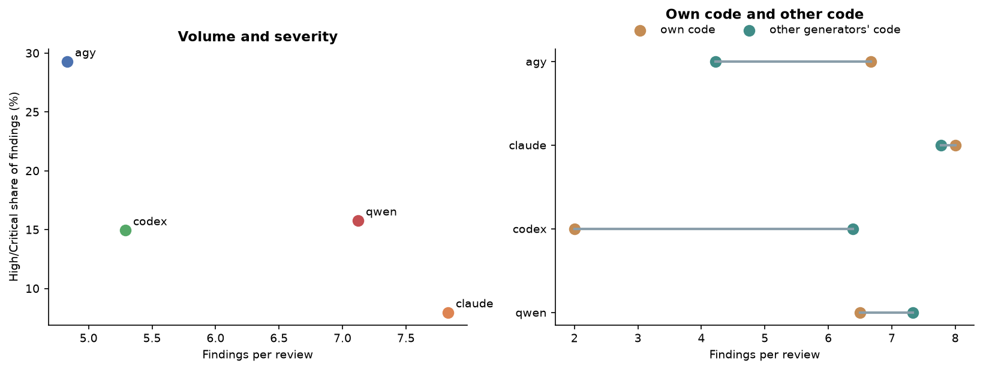
Figure 17: Reviewer volume against severity, and own code against other generators’ code · Security-informed, all four reviewers
Figure 17 separates the reviewers on both volume and severity: claude has the highest finding volume but the lowest High/Critical share, whereas agy has the lowest volume and highest High/Critical share. Codex reports markedly more findings on other generators’ code than on its own, while agy shows the reverse pattern.

Severity of findings by reviewer
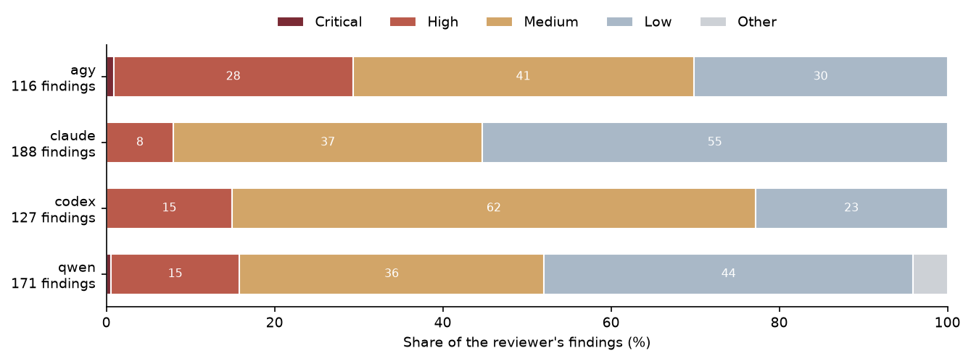
Figure 18: Severity of findings by reviewer · Security-informed, all four reviewers
Figure 18 shows distinct severity profiles by reviewer. Agy has the largest High share, codex is dominated by Medium findings, and claude and qwen have comparatively large Low shares; Critical findings are only thin slivers where present.

Reviewers naming the same CWE, and the same OWASP category, on a program
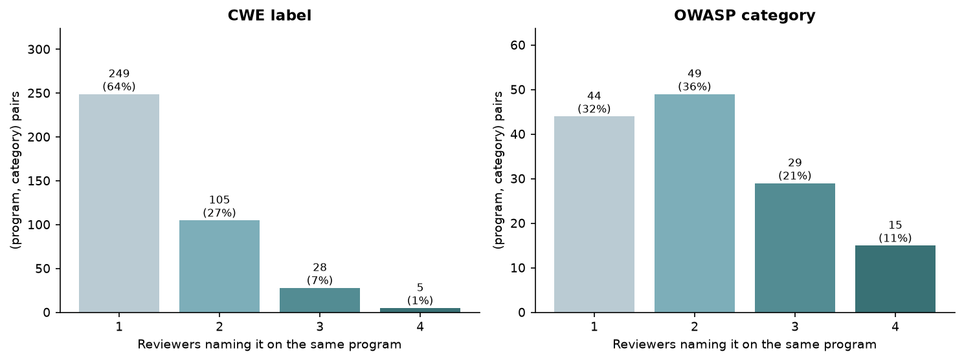
Figure 19: Reviewers naming the same CWE, and the same OWASP category, on a program · Security-informed, all four reviewers
Figure 19 shows that most exact CWE labels on a program are named by only one reviewer, with progressively fewer shared by two, three, or four reviewers. OWASP categories show broader agreement, with two-reviewer matches the largest group and visibly more three- and four-reviewer matches than for exact CWE labels.

Share of (program, category) pairs named by 1, 2, 3 or 4 reviewers
Table 10: Share of (program, category) pairs named by 1, 2, 3 or 4 reviewers · Security-informed, all four reviewers
level | pairs | named by 1 % | named by 2 % | named by 3 % | named by 4 %
CWE label | 387 | 64.3 | 27.1 | 7.2 | 1.3
OWASP category | 137 | 32.1 | 35.8 | 21.2 | 10.9

For the 387 CWE-label pairs in Table 10, 64.3% were named by 1 reviewer, 27.1% by 2, 7.2% by 3, and 1.3% by all 4. Among 137 OWASP-category pairs, the corresponding shares were 32.1%, 35.8%, 21.2%, and 10.9%.

Mean Jaccard overlap of each reviewer pair’s labels on the same program
Table 11: Mean Jaccard overlap of each reviewer pair’s labels on the same program · Security-informed, all four reviewers
reviewer pair | CWE Jaccard | OWASP Jaccard
agy / claude | 0.12 | 0.29
agy / codex | 0.12 | 0.26
agy / qwen | 0.1 | 0.31
claude / codex | 0.22 | 0.31
claude / qwen | 0.19 | 0.54
codex / qwen | 0.13 | 0.34

Table 11 shows low mean overlap for exact CWE labels, ranging from 0.1 for agy / qwen to 0.22 for claude / codex. OWASP overlap is higher for every pair, led by claude / qwen at 0.54 and lowest for agy / codex at 0.26.

CWE make-up of findings by generator
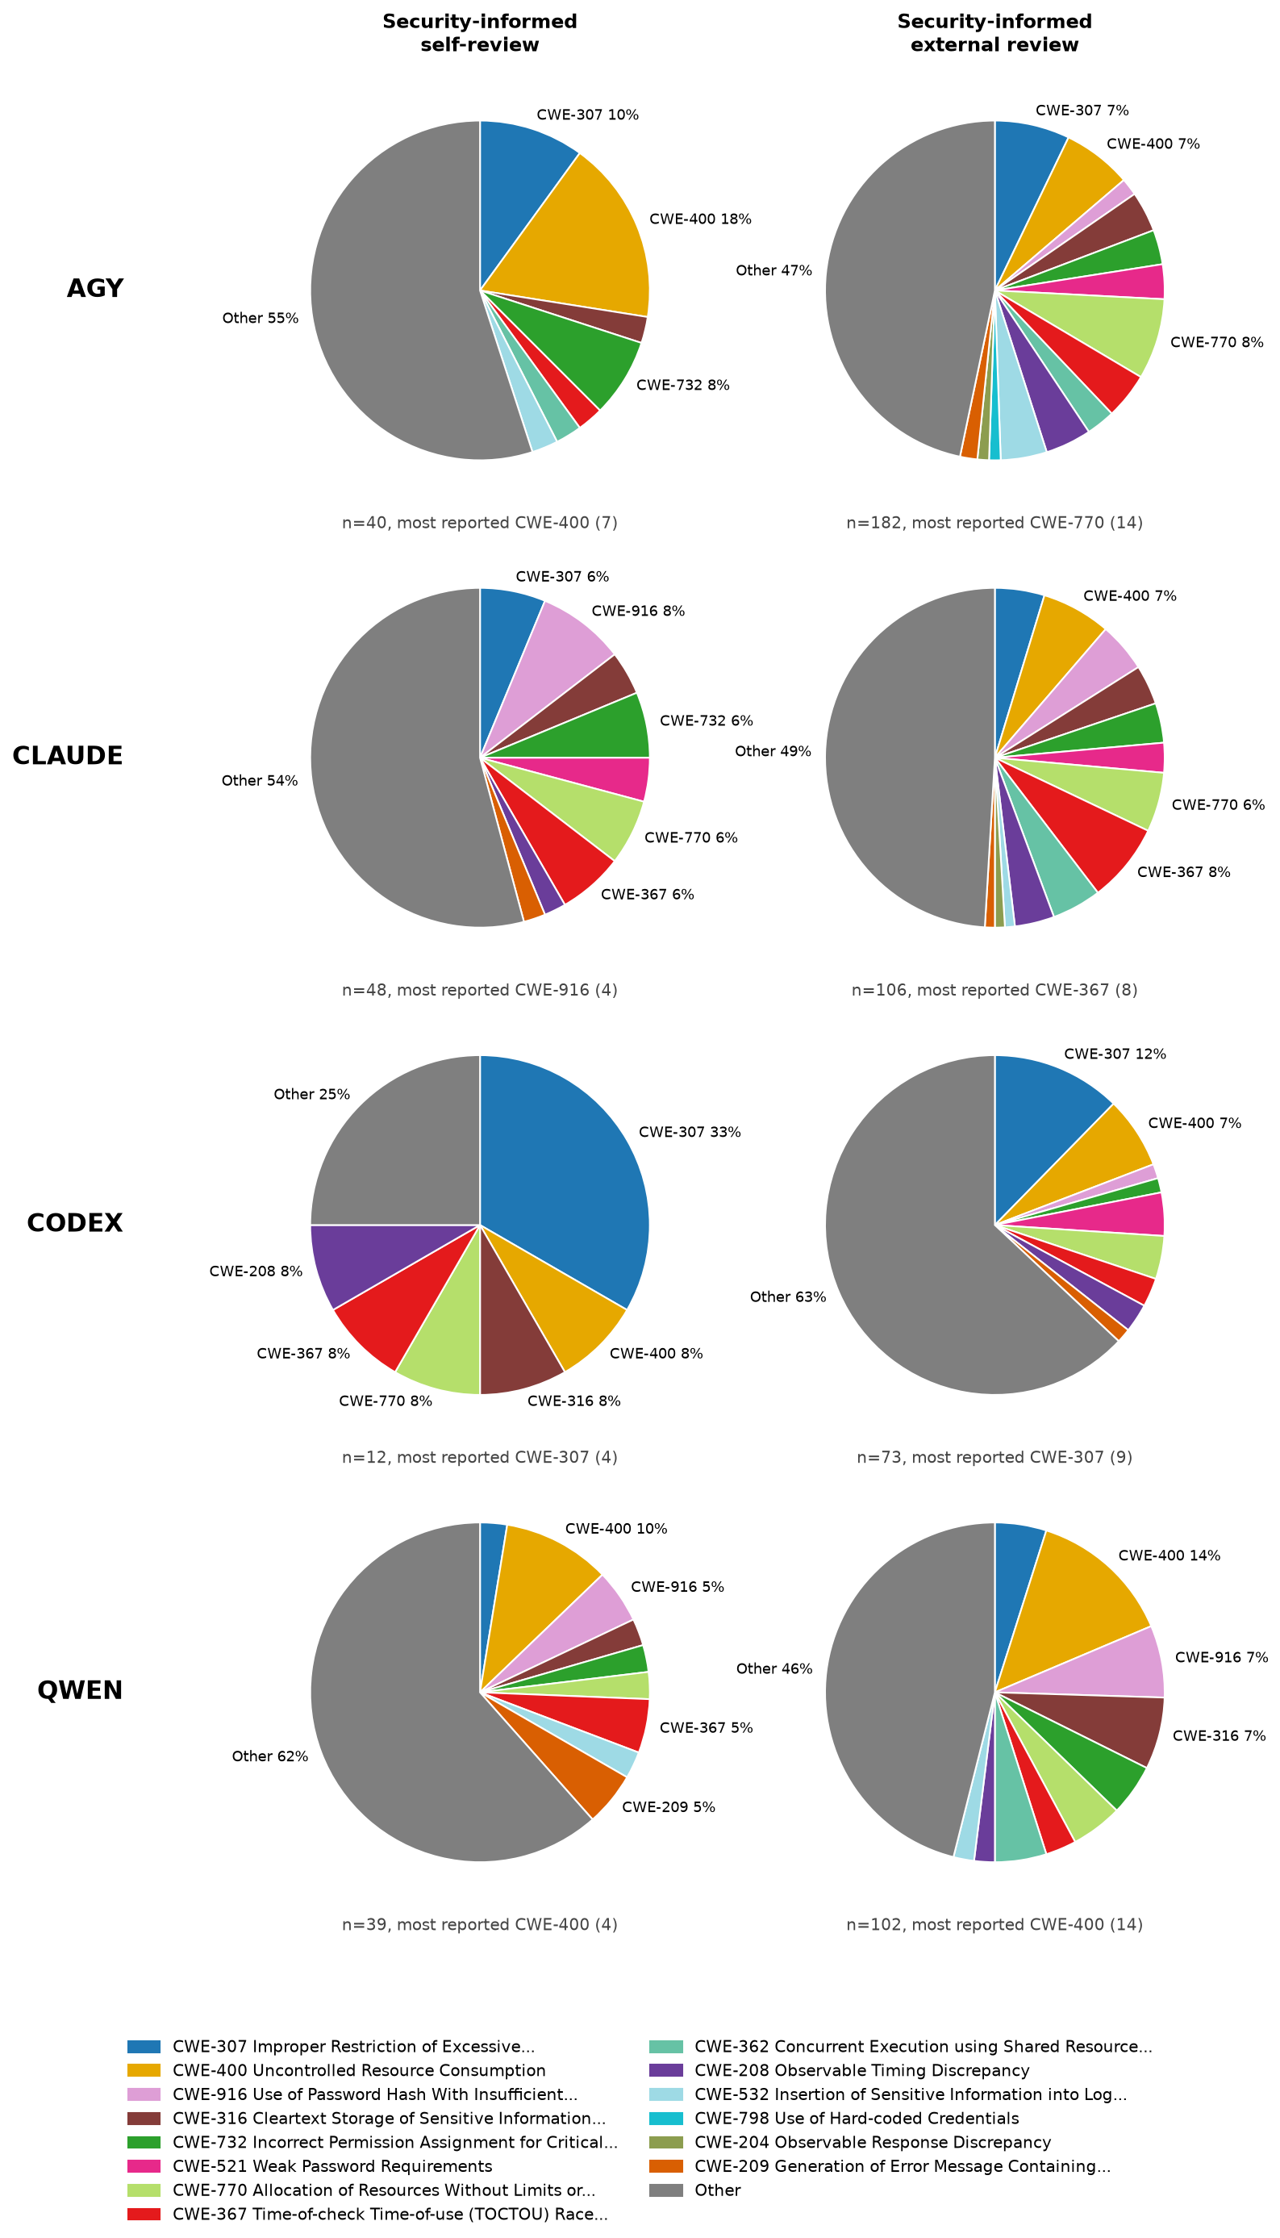
Figure 20: CWE make-up of findings by generator · Security-informed, self-review and external review
Figure 20 shows that Security-informed CWE composition differs between self-review and external review for every generator. External reviews are generally spread across more named CWE slices; the Other share decreases for agy and claude but increases markedly for codex, while qwen remains led by Other in both review types.

OWASP category make-up of findings by generator
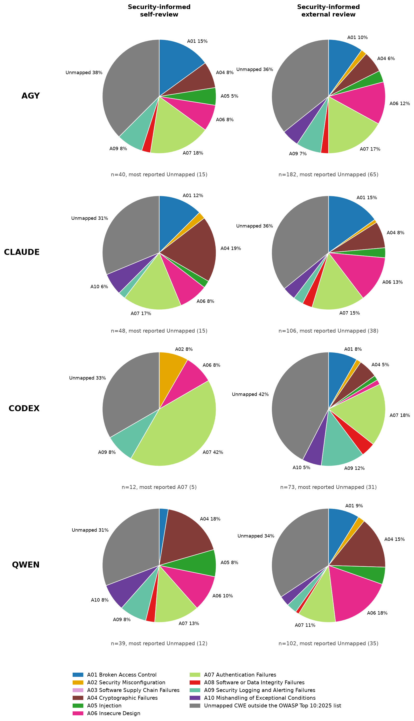
Figure 21: OWASP category make-up of findings by generator · Security-informed, self-review and external review
Figure 21 shows broadly similar leading OWASP groupings between Security-informed self-review and external review, but with generator-specific shifts. Unmapped CWEs lead most panels, while codex self-review is led by A07 and its external-review mix shifts toward unmapped CWEs and A09.

Findings per review by CWE and task
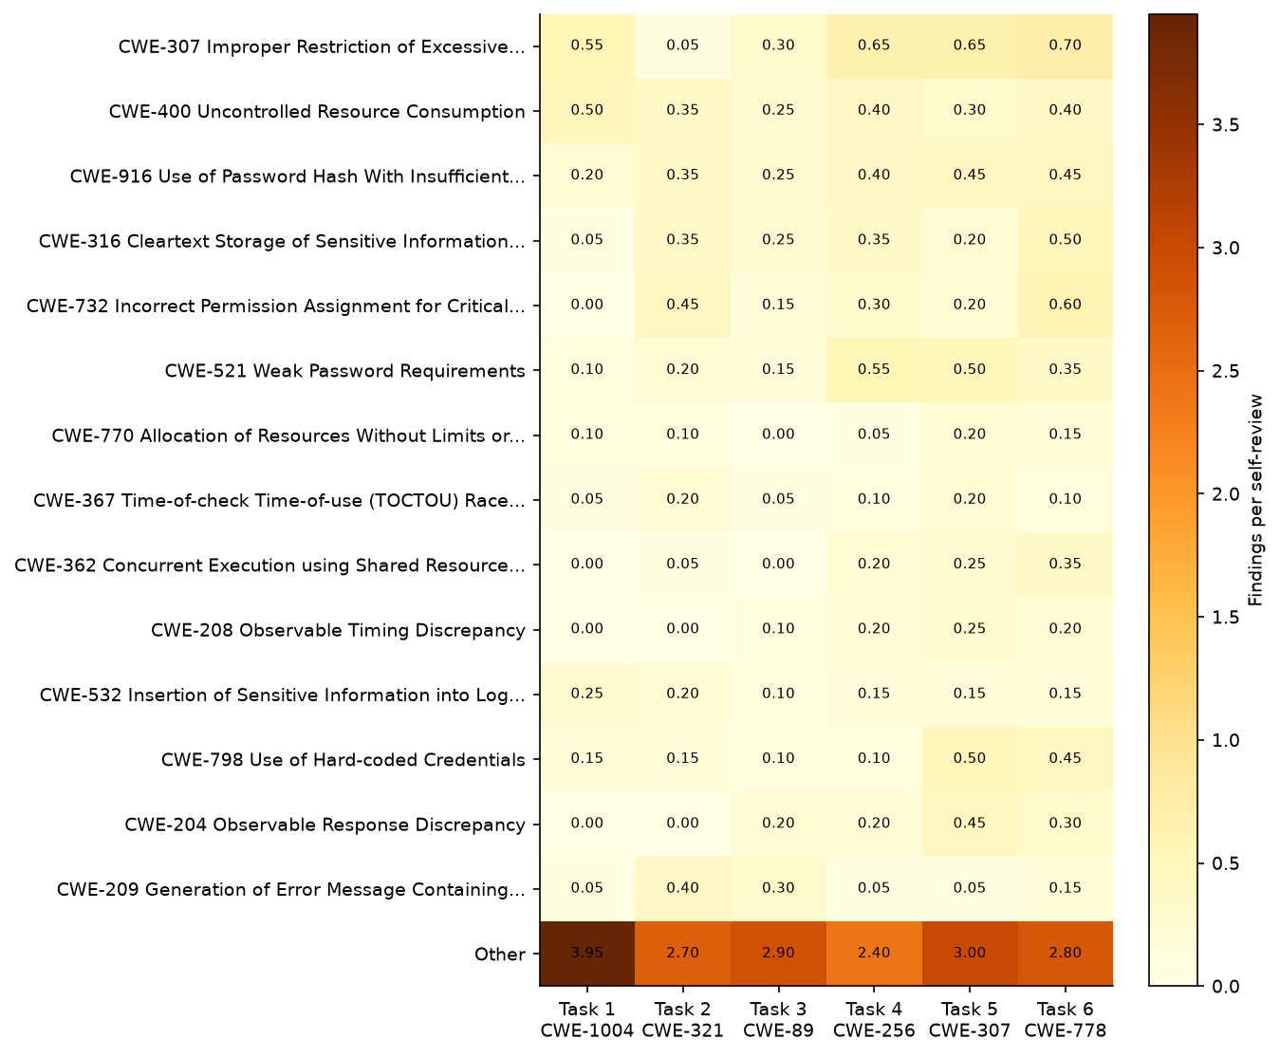
Figure 22: Findings per review by CWE and task · All conditions, self-review
Figure 22 shows distinct CWE profiles across tasks rather than a single dominant pattern. CWE-307 is most prominent on the later tasks, CWE-732 peaks on the CWE-778 task, and the combined Other group is largest on the CWE-1004 task.

Findings per review by OWASP category and task
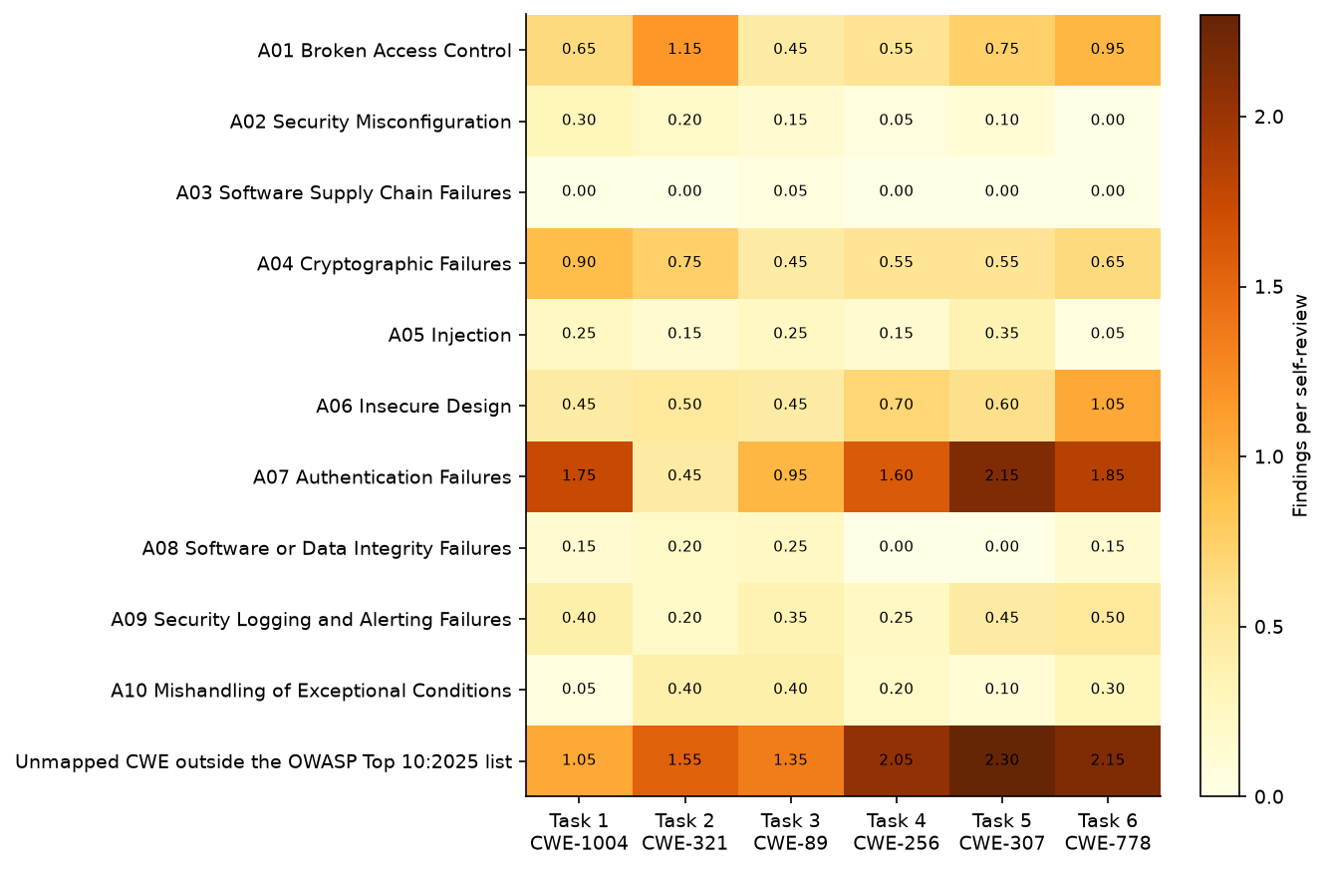
Figure 23: Findings per review by OWASP category and task · All conditions, self-review
Figure 23 shows A07 and unmapped CWEs as the largest categories across most tasks. A01 is most prominent on the CWE-321 task, A04 on the CWE-1004 task, and A06 on the CWE-778 task.

Data checks
Table 12: Data checks · All reviews
check | value
CSV rows | 1224
Recorded findings | 1217
Reviews | 192
Reviews with no findings | 7
Generated programs | 120
Rows missing reviewer or generator | 0
Programs read by all 4 reviewers | 24
Duplicate CSV rows | 0
Findings with no CWE | 0
Findings with non-standard severity | 8
Repeated sec_id within one review | 0

Table 12 records 1224 CSV rows representing 1217 findings across 192 reviews and 120 generated programs; 7 reviews had no findings. All 24 Security-informed programs were read by all 4 reviewers, with 0 rows missing reviewer or generator, 0 duplicate rows, 0 findings without a CWE, 8 findings with non-standard severity, and 0 repeated sec_id values within a review.

About this report
Every table and figure is computed from findings.csv when the report is rendered. The text was written by an AI from the rendered tables and figures. All counts are reviewer-reported findings, not confirmed vulnerabilities.

