Security Findings and Comparative Analysis
  - CSI6224 | Evaluating security-aware LLM code generation across four AI coding assistants
CSI6224 project team
2026-10-10
Table of contents

Executive summary
AI coding assistants can complete security-sensitive Java tasks while leaving weaknesses in authentication, credential handling, session management, cryptography, database access and audit logging. This project asks whether the way a task is prompted changes the security findings reported against the resulting code, whether those findings differ between four coding assistants, and how far four LLM security reviewers agree when they read the same program.
The study ran in two stages. Stage 1 compared a Basic prompt with a Security-aware prompt that adds a short hint about the task’s target weakness; each assistant reviewed its own code. The team then read the Stage 1 reviews and distilled the recurring problems into eight security rules, which became the Security-informed prompt used in Stage 2. In Stage 2 every program was read by all four reviewers, so reviewer behaviour can be separated from code quality.
Across 120 programs and 192 reviews the reviewers recorded 1,217 findings. The main results are:
- A short security hint did not change the volume of findings. Matched Stage 1 pairs moved from 6.25 to 6.56 findings per review, a difference of +0.31 whose 95% interval (−0.29 to +0.94) includes zero.
- The Security-informed prompt reduced findings in the areas its rules target most directly. Under self-review, findings per review fell by 77% for secrets, 43% for failure behaviour and 26% for authentication and access, compared with the Stage 1 average. They did not fall for sensitive data, concurrency, tokens or trust boundaries, and findings outside every rule rose by 44%, led by insufficient logging (CWE-778), which no rule mentions.
- Total volume fell only modestly, from 6.25 and 6.56 to 5.79 findings per self-review, with no shift towards higher severity (14.4% High/Critical against 16.7% and 17.8%).
- The mix moved away from the OWASP categories. Authentication Failures (A07) fell from 28.0% of self-review findings under Basic to 18.0% under Security-informed, while findings whose CWE sits outside the OWASP Top 10:2025 rose from 23.7% to 33.1%.
- Reviewers ranked the generators consistently at the ends. Every reviewer gave Codex-generated code the fewest findings and Antigravity-generated code the most.
- Reviewers agreed on the broad category far more than on the exact weakness. 64.3% of program–CWE pairs were named by only one of the four reviewers, against 32.1% of program–OWASP-category pairs.
All counts are reviewer-reported findings, not independently confirmed vulnerabilities. A larger count can reflect less secure code, a more thorough reviewer, or both.
Reader’s rule: a generated program is not a review, and a review is not a finding. One program can have four reviews, and one review can hold many findings. Every rate below states which of the three it counts, and which reviews it uses.

1 Background, aim and research questions
Prior research documents security API misuse in LLM-generated Java code (Mousavi et al., 2024) and security weaknesses persisting in AI-assisted development (Mousavi et al., 2026; Perry et al., 2023). The practical question is whether security guidance added to an otherwise fixed programming task improves the resulting code. This project uses the assistants’ native command-line tools rather than raw model APIs, so it evaluates the whole coding-assistant experience: model, provider scaffolding, tools and execution workflow. That is realistic for users of those assistants, but it limits claims about the underlying models.
RQ1 — Prompt strategy. How do the Basic, Security-aware and Security-informed prompts affect the security findings reported in generated Java programs?
RQ2 — Coding assistant. How do security findings differ across the four coding assistants when tasks, prompts and reviewers are held comparable?
RQ3 — Security reviewer. How consistently do four LLM security reviewers report weaknesses and assign severity when reviewing the same generated program?
The analysis prefers rates with stated denominators, paired comparisons and the mix of weaknesses over a single total. It also examines each task’s anchor CWE separately from all other findings, because meeting one named requirement is not the same as producing secure code around it.

2 Method

2.1 Six Java benchmark tasks
The six benchmark tasks and their design anchors
Task | Programming scenario | Intended OWASP anchor | Anchor CWE | Key assessment question
1 | Session cookie after authentication (Jakarta Servlet) | A02 Security Misconfiguration | CWE-1004 | Is a sensitive session cookie protected from client-side script access?
2 | Symmetric encryption/decryption of sensitive data | A04 Cryptographic Failures | CWE-321 | Is a cryptographic key handled without hard-coding?
3 | User account retrieval through JDBC | A05 Injection | CWE-89 | Is untrusted input kept separate from SQL syntax?
4 | User registration and credential storage | A06 Insecure Design | CWE-256 | Is a password protected rather than stored in plaintext?
5 | Login attempts and credential verification | A07 Authentication Failures | CWE-307 | Are repeated failed authentication attempts restricted?
6 | Authentication with activity logging | A09 Security Logging and Alerting Failures | CWE-778 | Are security-relevant authentication events recorded adequately?
These are deliberately constrained tasks, not a representative sample of secure Java programming. The OWASP column is the design anchor; the findings themselves may fall in any category.

2.2 Coding assistants and reviewers
The four tools are Antigravity (agy, Gemini), Claude Code (claude), Codex (codex, OpenAI) and Qwen Code (qwen, self-hosted Qwen). Project materials record a frozen tested configuration of Gemini 3.7 Flash/high, Claude Opus 5/medium, GPT-5.6 Sol/medium and Qwen3.8-Flash-Next/default xhigh for generation, the Qwen condition being the self-hosted Qwen/Qwen3.8-Flash-Next-NVFP4 checkpoint (mixture-of-experts, 125B total parameters with approximately 6B active per token) under the Qwen Community licence, with the later review-effort change for Qwen recorded separately. The same four tools act as the security reviewers. The study compares these tool configurations, not providers or model families in general.

2.3 Stage 1: Basic and Security-aware
Two team members each wrote a prompt set. For each of the six tasks there is a Basic prompt, which specifies the functional task with no security guidance, and a Security-aware prompt, which adds a short hint aimed at the task’s anchor weakness. Two authors × six tasks × two prompts × four assistants gives 96 programs. Each program was reviewed once, by the assistant that wrote it: a self-review.

2.4 From Stage 1 to the eight rules
After Stage 1 the team read the reviews and distilled the problems that kept recurring into eight task-independent rules. The user writes the task in their own words and appends the rules as a fixed block, which asks the assistant to think like an attacking reviewer before writing code and to finish with an adversarial review of its own. The full prompt is in Appendix B. In short, the rules cover:
- Trust boundaries — treat every input as attacker-controlled and validate it.
- Secrets — no working credentials in code; never print or log them.
- Authentication and access — verify against server-side state, fail closed, limit attempts per source and per account.
- Identifiers and tokens — generate session identifiers securely; correct cookie attributes.
- Sensitive data — mask in logs, private files only, bound sizes, clear from memory.
- Failure behaviour — generic errors, no account enumeration, no permissive defaults.
- Concurrency — make check-then-act sequences atomic.
- Prefer the platform — use built-in proven mechanisms and verified dependencies.
To measure whether each rule worked, every CWE a reviewer reported is assigned to the one rule that most directly forbids it (Table 1). A CWE no rule addresses is counted as No rule. The mapping covers 86.9% of all findings.
[TEAM TO CONFIRM] The CWE-to-rule mapping in Table 1 is a draft. Some CWEs could sit under two rules (for example CWE-532, sensitive data in a log file, under rule 2 or rule 5); each is placed once, under the rule whose wording is closest.
Table 1: The eight Security-informed rules and the CWEs assigned to them · All findings
rule | CWEs | findings | % of all findings
1 Trust boundaries | CWE-15, CWE-20, CWE-22, CWE-59, CWE-89, CWE-116, CWE-117, CWE-178, CWE-290, CWE-345, CWE-807, CWE-1284 | 99 | 8.1
2 Secrets | CWE-214, CWE-256, CWE-321, CWE-323, CWE-522, CWE-526, CWE-798 | 86 | 7.1
3 Authentication and access | CWE-284, CWE-287, CWE-306, CWE-307, CWE-521, CWE-636, CWE-645, CWE-799, CWE-862 | 207 | 17.0
4 Identifiers and tokens | CWE-330, CWE-338, CWE-352, CWE-384, CWE-613, CWE-614, CWE-1004 | 60 | 4.9
5 Sensitive data | CWE-226, CWE-244, CWE-276, CWE-316, CWE-319, CWE-359, CWE-377, CWE-400, CWE-532, CWE-549, CWE-732, CWE-770, CWE-779 | 339 | 27.9
6 Failure behaviour | CWE-200, CWE-203, CWE-204, CWE-208, CWE-209, CWE-754, CWE-1188 | 121 | 9.9
7 Concurrency | CWE-362, CWE-367 | 67 | 5.5
8 Prefer the platform | CWE-326, CWE-327, CWE-494, CWE-759, CWE-829, CWE-916, CWE-1395 | 79 | 6.5
No rule | every CWE not listed above | 159 | 13.1

The Security-informed prompt was therefore written after Stage 1 and informed by it. It is a follow-up intervention, not an independently pre-registered third treatment, and its results should be read that way. The multi-turn/few-shot condition originally proposed was replaced because of runtime cost, and because feeding a reviewer’s fixes back into the same code would test patch application rather than better first-time generation.

2.5 Stage 2: Security-informed and cross-review
One prompt author wrote the six Security-informed task prompts. Six tasks × four assistants gives 24 programs. Every program was reviewed by all four reviewers, giving 96 reviews: 24 self-reviews and 72 external reviews. This four-by-four design lets the same code be compared across reviewers, and the same reviewer be compared across generators.
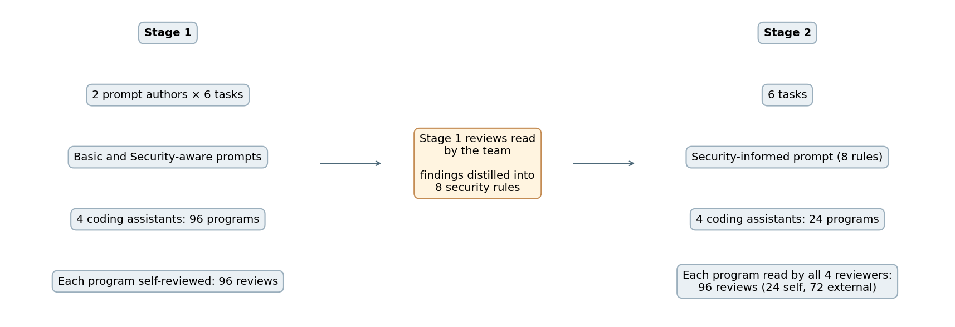
Figure 1: Study design · Stage 1, the eight rules, Stage 2

2.6 Which reviews each comparison uses
The two stages do not share the same reviews, so this report uses two fixed selections and every figure and table states which:
- Self-review, all three conditions. Stage 1 only has self-reviews. The only like-for-like comparison of Basic, Security-aware and Security-informed is therefore each assistant reviewing its own code: 48, 48 and 24 reviews. All of Section 4 uses these.
- Security-informed, all four reviewers. Questions about reviewers (RQ2 with the reviewer held fixed, and RQ3) can only be answered in Stage 2, where every program has all four reviews. All of Section 5 uses these.
Mixing the two would flatter or penalise Security-informed depending on the measure, because the three external reviewers do not report the same way as the self-reviewer.

2.7 Data, counting units and checks
Findings were transcribed from each security_review.md into the two project workbooks, reconciled cell by cell against the review files, and exported to findings.csv with one row per finding and one empty row per review that found nothing. Each finding’s OWASP Top 10:2025 category is derived from its CWE using the official OWASP CWE list; a CWE outside that list is Unmapped.
- A program is one piece of generated code: generator, author folder, task and prompt.
- A review is one reviewer reading one program.
- A finding is one issue row in a review. A finding ID such as SEC-01 is local to its review.
The corpus is complete. Every planned program and review exists, no finding lacks a CWE, and there are no duplicate rows. Seven reviews reported no findings, each confirmed by an explicit “no vulnerabilities were found” statement in the review file: one Security-aware self-review and two Security-informed self-reviews, all Codex reviewing its own code, plus four Antigravity external reviews. Eight findings carry a non-standard severity such as “Medium-High” or “Informational”; they are shown as Other and not counted as High/Critical. The companion notebook CSI6224_Security_Analysis.ipynb checks findings.csv against the workbooks and recomputes every number in this report.
Table 2: Programs, reviews and findings · All three conditions, all reviews
condition | stage | programs | self-reviews | external reviews | reviews with no findings | findings
Basic | Stage 1 | 48 | 48 | 0 | 0 | 300
Security-aware | Stage 1 | 48 | 48 | 0 | 1 | 315
Security-informed | Stage 2 | 24 | 24 | 72 | 6 | 602

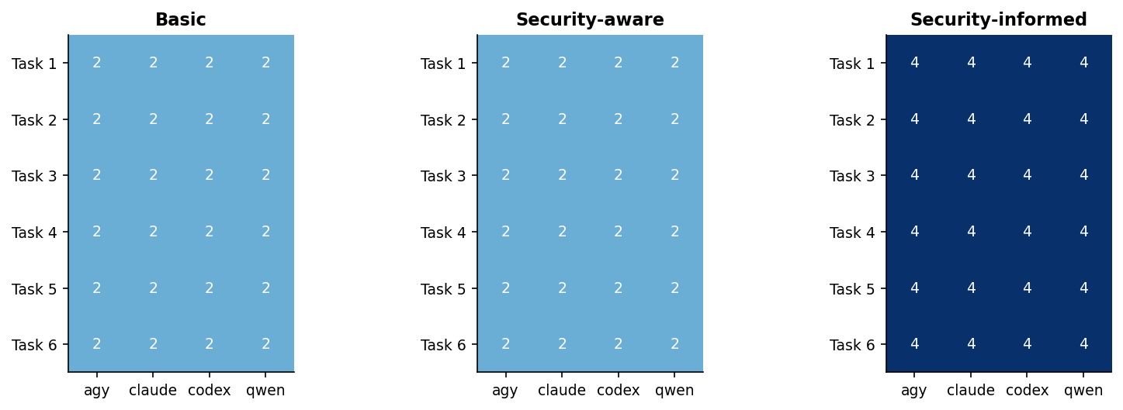
Figure 2: Completed reviews per task and generator · All three conditions, all reviews
Figure 2 shows two reviews in every Stage 1 cell (one per prompt author) and four in every Stage 2 cell (one per reviewer). A missing review would show as 0.

3 Stage 1 results: Basic against Security-aware
Stage 1 is the one comparison in the study where the code is matched pair by pair. Each pair shares the prompt author, task and generator, so only the prompt differs. The measure is findings per review.
Table 3: Paired difference in findings per review, overall and by generator · Basic and Security-aware, matched pairs, self-review
scope | pairs | basic mean | aware mean | mean delta | median delta | fewer | more | ties | CI low | CI high
all | 48 | 6.25 | 6.56 | 0.31 | 0.0 | 18 | 23 | 7 | -0.29 | 0.94
agy | 12 | 6.33 | 7.42 | 1.08 | 1.0 | 2 | 9 | 1 | 0.17 | 1.92
claude | 12 | 5.5 | 5.75 | 0.25 | 0.0 | 3 | 5 | 4 | -0.83 | 1.25
codex | 12 | 4.33 | 3.58 | -0.75 | -1.0 | 7 | 4 | 1 | -1.67 | 0.17
qwen | 12 | 8.83 | 9.5 | 0.67 | -0.5 | 6 | 5 | 1 | -1.0 | 2.33

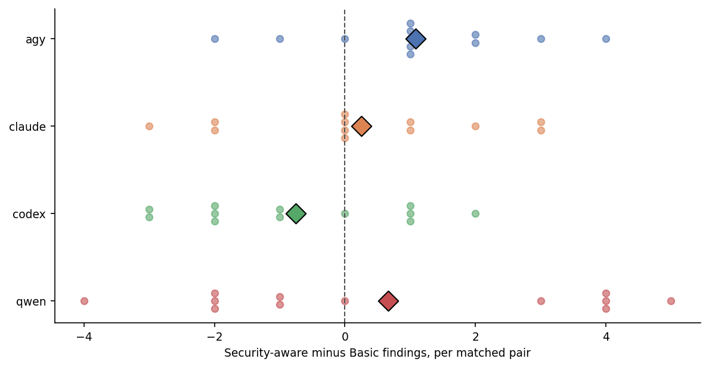
Figure 3: Paired difference in findings per review by generator · Basic and Security-aware, matched pairs, self-review
Across all 48 pairs Basic reviews recorded 6.25 findings and Security-aware reviews 6.56 (medians 6 and 7). The mean paired difference is +0.31 findings per review, a 5.0% rise on the Basic rate, with a median difference of 0. A 10,000-draw paired bootstrap gives a 95% interval of −0.29 to +0.94, which includes zero. 18 pairs had fewer findings under Security-aware, 23 had more and 7 were tied (Table 3).
The direction differs by generator (Figure 3). Antigravity’s code drew +1.08 more findings per review under Security-aware (interval +0.17 to +1.92, the only one that excludes zero), Qwen’s +0.67 and Claude’s +0.25, while Codex’s moved the other way at −0.75. By task the differences range from −0.50 (Task 1) through 0.00 (Task 2) to +0.50 (Task 5), +0.63 (Task 3) and +1.13 (Task 4).
A short security hint therefore did not reduce the volume of reported findings. This is not proof that the two prompts are equivalent, and because each pair compares two different programs, a difference can reflect genuine code divergence, the reviewer’s attention, or extra scope the hint itself introduced. It was this result, and the recurring weaknesses behind it, that led the team to write the eight rules.

4 Three conditions under self-review
This section compares all three prompts on equal terms: every number uses only self-reviews (48 Basic, 48 Security-aware, 24 Security-informed). The Security-informed column differs from Stage 1 in more than the prompt: it has one prompt author rather than two, it was run later, and it has half as many reviews. Its rates are descriptive.

4.1 Volume and severity
Table 4: Findings per review, median and High/Critical share · All three conditions, self-review
condition | self-reviews | findings | findings per review | median | High/Critical %
Basic | 48 | 300 | 6.25 | 6.0 | 16.67
Security-aware | 48 | 315 | 6.56 | 7.0 | 17.78
Security-informed | 24 | 139 | 5.79 | 7.0 | 14.39

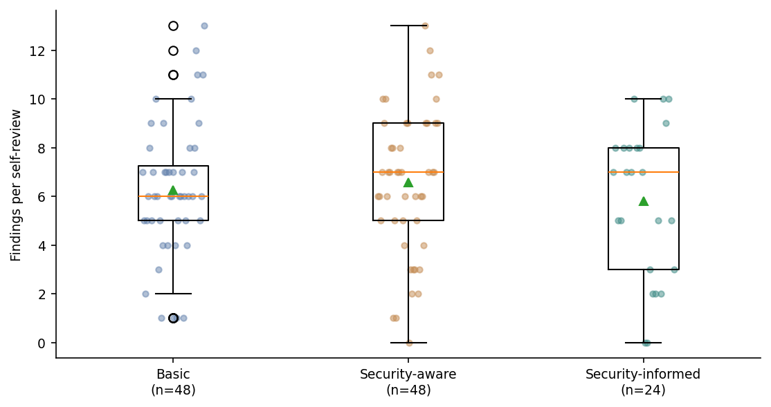
Figure 4: Findings per review · All three conditions, self-review
Security-informed self-reviews recorded 5.79 findings per review against 6.25 for Basic and 6.56 for Security-aware, with the same median of 7 as Security-aware (Table 4, Figure 4). The spread overlaps almost completely; the volume change is small.
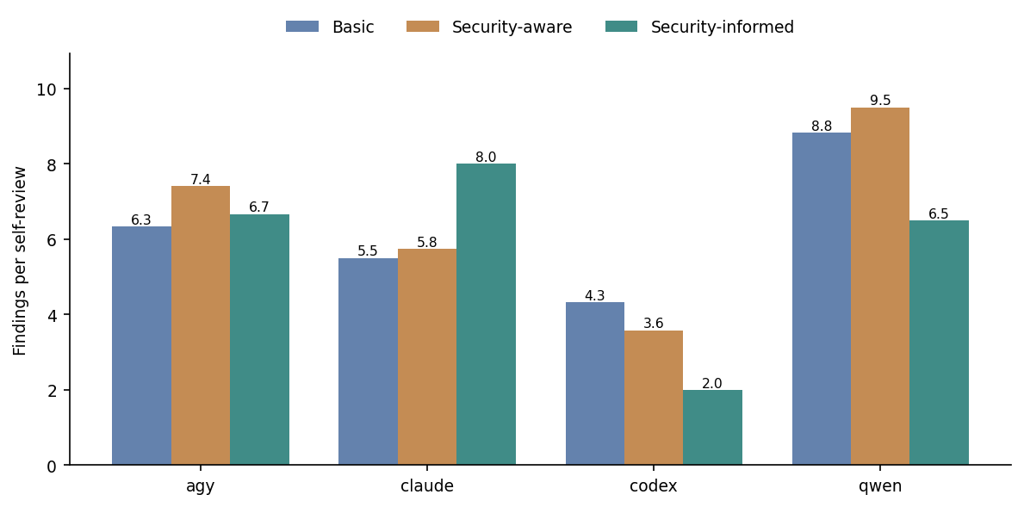
Figure 5: Findings per review by generator · All three conditions, self-review
The fall is not shared by every assistant (Figure 5). Codex’s self-reviews fell from 4.33 and 3.58 to 2.00 per review, and Qwen’s from 8.83 and 9.50 to 6.50. Antigravity’s stayed close to its Stage 1 level at 6.67, and Claude’s rose from 5.50 and 5.75 to 8.00. Each Security-informed bar is six reviews, so a single program moves it noticeably.
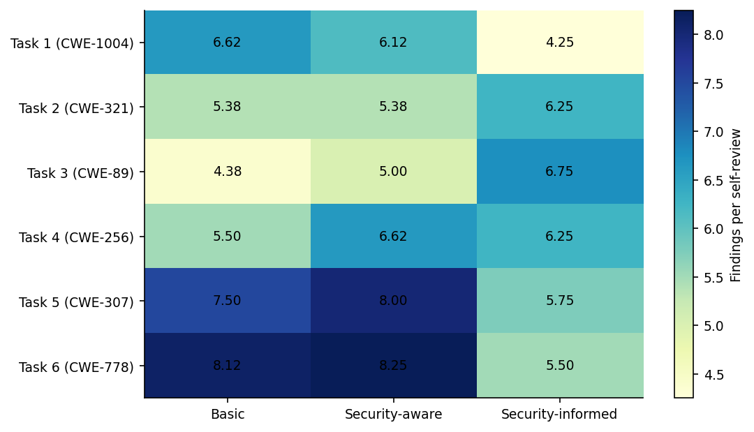
Figure 6: Findings per review by task · All three conditions, self-review
By task (Figure 6), Security-informed reviews recorded fewer findings than either Stage 1 prompt for Task 1 (4.25 against 6.62 and 6.12), Task 5 (5.75 against 7.50 and 8.00) and Task 6 (5.50 against 8.12 and 8.25), and more for Task 2 (6.25 against 5.38) and Task 3 (6.75 against 4.38 and 5.00).
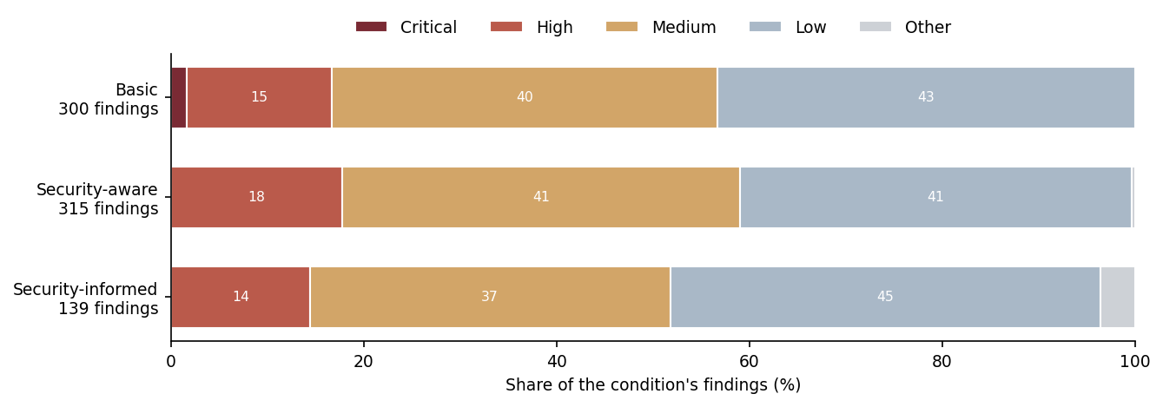
Figure 7: Severity of findings · All three conditions, self-review
Severity barely moves (Figure 7). High/Critical findings are 16.7% of Basic, 17.8% of Security-aware and 14.4% of Security-informed findings. The Security-informed condition reported fewer findings and not more severe ones. Severity is the reviewer’s own classification, not an externally calibrated risk score.

4.2 Anchor CWE reporting
A task can meet its named requirement and still contain other weaknesses. For each task, Figure 8 shows the share of self-reviews that named the task’s own anchor CWE. With findings-only data this is a reporting rate: a review that does not name the anchor has not proved it absent.
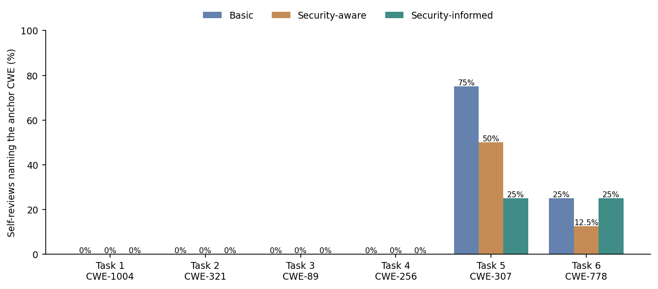
Figure 8: Reviews naming the task’s anchor CWE · All three conditions, self-review
For Tasks 1–4 (CWE-1004, CWE-321, CWE-89 and CWE-256) no self-review in any condition named the anchor. Across all 1,217 findings CWE-1004 and CWE-321 never appear, CWE-89 appears twice and CWE-256 once, all on other tasks. [TEAM TO CONFIRM from the review files: whether the Task 1–4 reviews describe the anchor weakness as correctly handled, or simply do not mention it.] For Task 5 (CWE-307) the anchor was named in 75% of Basic, 50% of Security-aware and 25% of Security-informed self-reviews; for Task 6 (CWE-778) in 25%, 12.5% and 25%. The decline on Task 5 matches rule 3, which asks for attempt limits per source and per account.

4.3 Which weaknesses: CWE and OWASP side by side
The same four views are given for CWE labels and for OWASP categories, so the two can be read against each other: findings per review in each category, the share each category makes up of a condition’s findings, and one pie per generator and condition. CWE views use the 14 most-reported CWEs across all findings (Table 5), which cover 51.9% of findings; the remaining 132 CWEs are combined as Other. OWASP views show all ten categories plus Unmapped.
Table 5: The 14 most-reported CWEs · All findings
rank | CWE | title | findings | cumulative %
1 | CWE-307 | Improper Restriction of Excessive Authentication Attempts | 90 | 7.4
2 | CWE-400 | Uncontrolled Resource Consumption | 82 | 14.1
3 | CWE-916 | Use of Password Hash With Insufficient Computational Effort | 58 | 18.9
4 | CWE-316 | Cleartext Storage of Sensitive Information in Memory | 52 | 23.2
5 | CWE-732 | Incorrect Permission Assignment for Critical Resource | 50 | 27.3
6 | CWE-521 | Weak Password Requirements | 49 | 31.3
7 | CWE-770 | Allocation of Resources Without Limits or Throttling | 40 | 34.6
8 | CWE-367 | Time-of-check Time-of-use (TOCTOU) Race Condition | 35 | 37.5
9 | CWE-362 | Concurrent Execution using Shared Resource with Improper Synchronization (‘Race Condition’) | 32 | 40.1
10 | CWE-208 | Observable Timing Discrepancy | 31 | 42.6
11 | CWE-532 | Insertion of Sensitive Information into Log File | 31 | 45.2
12 | CWE-798 | Use of Hard-coded Credentials | 31 | 47.7
13 | CWE-204 | Observable Response Discrepancy | 26 | 49.9
14 | CWE-209 | Generation of Error Message Containing Sensitive Information | 25 | 51.9

4.3.1 Findings per review by category
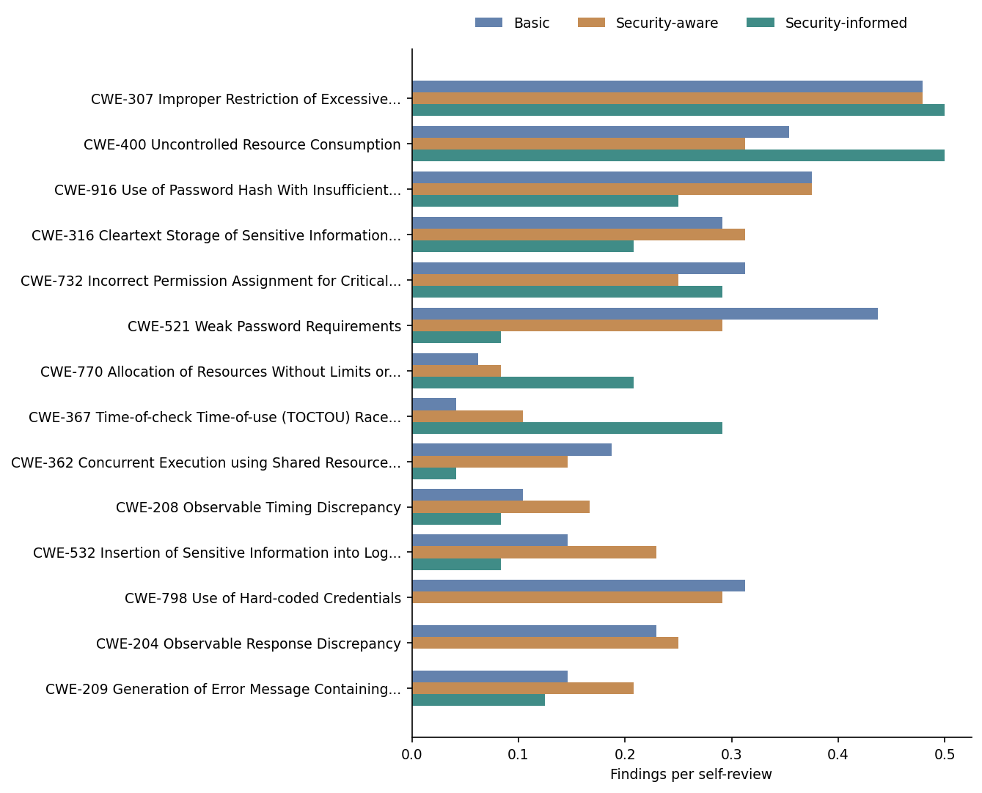
Figure 9: Findings per review by CWE · All three conditions, self-review
Table 6: Findings per review by CWE, with the change from the Stage 1 average · All three conditions, self-review
category | Basic | Security-aware | Security-informed | change vs Stage 1 average %
CWE-307 Improper Restriction of Excessive… | 0.48 | 0.48 | 0.5 | 4.0
CWE-400 Uncontrolled Resource Consumption | 0.35 | 0.31 | 0.5 | 50.0
CWE-916 Use of Password Hash With Insufficient… | 0.38 | 0.38 | 0.25 | -33.0
CWE-316 Cleartext Storage of Sensitive Information… | 0.29 | 0.31 | 0.21 | -31.0
CWE-732 Incorrect Permission Assignment for Critical… | 0.31 | 0.25 | 0.29 | 4.0
CWE-521 Weak Password Requirements | 0.44 | 0.29 | 0.08 | -77.0
CWE-770 Allocation of Resources Without Limits or… | 0.06 | 0.08 | 0.21 | 186.0
CWE-367 Time-of-check Time-of-use (TOCTOU) Race… | 0.04 | 0.1 | 0.29 | 300.0
CWE-362 Concurrent Execution using Shared Resource… | 0.19 | 0.15 | 0.04 | -75.0
CWE-208 Observable Timing Discrepancy | 0.1 | 0.17 | 0.08 | -38.0
CWE-532 Insertion of Sensitive Information into Log… | 0.15 | 0.23 | 0.08 | -56.0
CWE-798 Use of Hard-coded Credentials | 0.31 | 0.29 | 0.0 | -100.0
CWE-204 Observable Response Discrepancy | 0.23 | 0.25 | 0.0 | -100.0
CWE-209 Generation of Error Message Containing… | 0.15 | 0.21 | 0.12 | -29.0
Other | 2.77 | 3.06 | 3.12 | 7.0

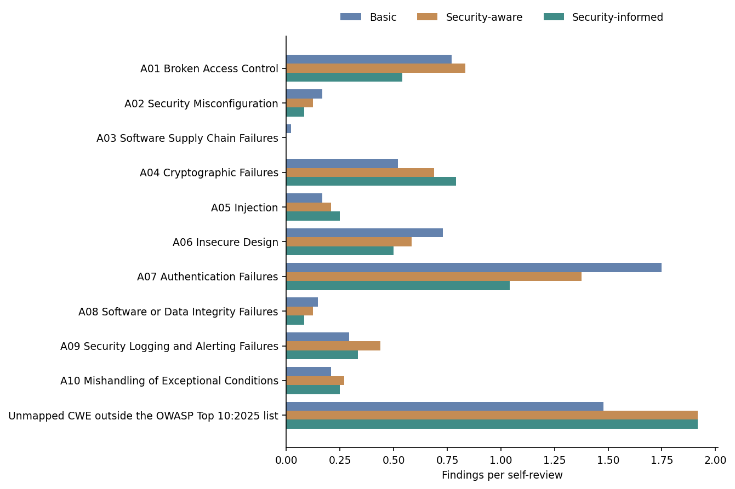
Figure 10: Findings per review by OWASP category · All three conditions, self-review
Table 7: Findings per review by OWASP category, with the change from the Stage 1 average · All three conditions, self-review
category | Basic | Security-aware | Security-informed | change vs Stage 1 average %
A01 Broken Access Control | 0.77 | 0.83 | 0.54 | -32.0
A02 Security Misconfiguration | 0.17 | 0.12 | 0.08 | -43.0
A03 Software Supply Chain Failures | 0.02 | 0.0 | 0.0 | -100.0
A04 Cryptographic Failures | 0.52 | 0.69 | 0.79 | 31.0
A05 Injection | 0.17 | 0.21 | 0.25 | 33.0
A06 Insecure Design | 0.73 | 0.58 | 0.5 | -24.0
A07 Authentication Failures | 1.75 | 1.38 | 1.04 | -33.0
A08 Software or Data Integrity Failures | 0.15 | 0.12 | 0.08 | -38.0
A09 Security Logging and Alerting Failures | 0.29 | 0.44 | 0.33 | -9.0
A10 Mishandling of Exceptional Conditions | 0.21 | 0.27 | 0.25 | 4.0
Unmapped CWE outside the OWASP Top 10:2025 list | 1.48 | 1.92 | 1.92 | 13.0

At CWE level (Figure 9, Table 6) the weaknesses the rules name explicitly almost disappear under Security-informed: hard-coded credentials (CWE-798) and response discrepancy (CWE-204) were not reported at all, against about 0.3 and 0.24 per review in Stage 1, and weak password requirements (CWE-521) fell from 0.44 and 0.29 to 0.08. Others rose: check-then-act races (CWE-367) from 0.04 and 0.10 to 0.29, unbounded allocation (CWE-770) from 0.06 and 0.08 to 0.21, and resource consumption (CWE-400) from 0.35 and 0.31 to 0.50. Attempt limiting (CWE-307), the most-reported CWE overall, stayed level at about 0.5 per review. The Other row is left off Figure 9 because, at around 3 findings per review, it would flatten every other bar; it is in Table 6.
At OWASP level (Figure 10, Table 7) Authentication Failures (A07) fell from 1.75 and 1.38 to 1.04 findings per review, and Broken Access Control (A01) from 0.77 and 0.83 to 0.54. Cryptographic Failures (A04) rose from 0.52 and 0.69 to 0.79. Unmapped findings rose from 1.48 to 1.92 and stayed there.

4.3.2 Make-up of each condition’s findings
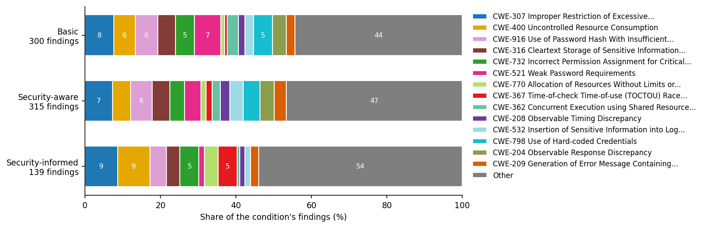
Figure 11: CWE make-up of findings · All three conditions, self-review
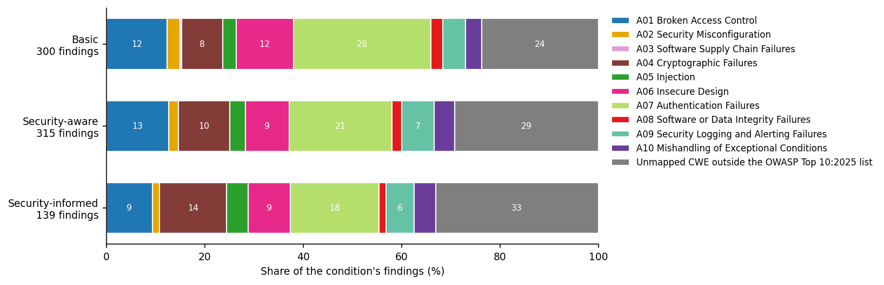
Figure 12: OWASP category make-up of findings · All three conditions, self-review
As a share of each condition’s findings (Figure 12), A07 falls from 28.0% under Basic to 21.0% under Security-aware and 18.0% under Security-informed, while A04 rises from 8.3% to 10.5% and 13.7%, and Unmapped from 23.7% to 29.2% and 33.1%. The prompts moved findings away from the categories the OWASP list emphasises and towards weaknesses it does not classify, mainly resource-limit and concurrency CWEs such as CWE-400, CWE-770 and CWE-367. An OWASP-only report would hide about a third of what the reviewers reported.

4.3.3 Make-up by generator
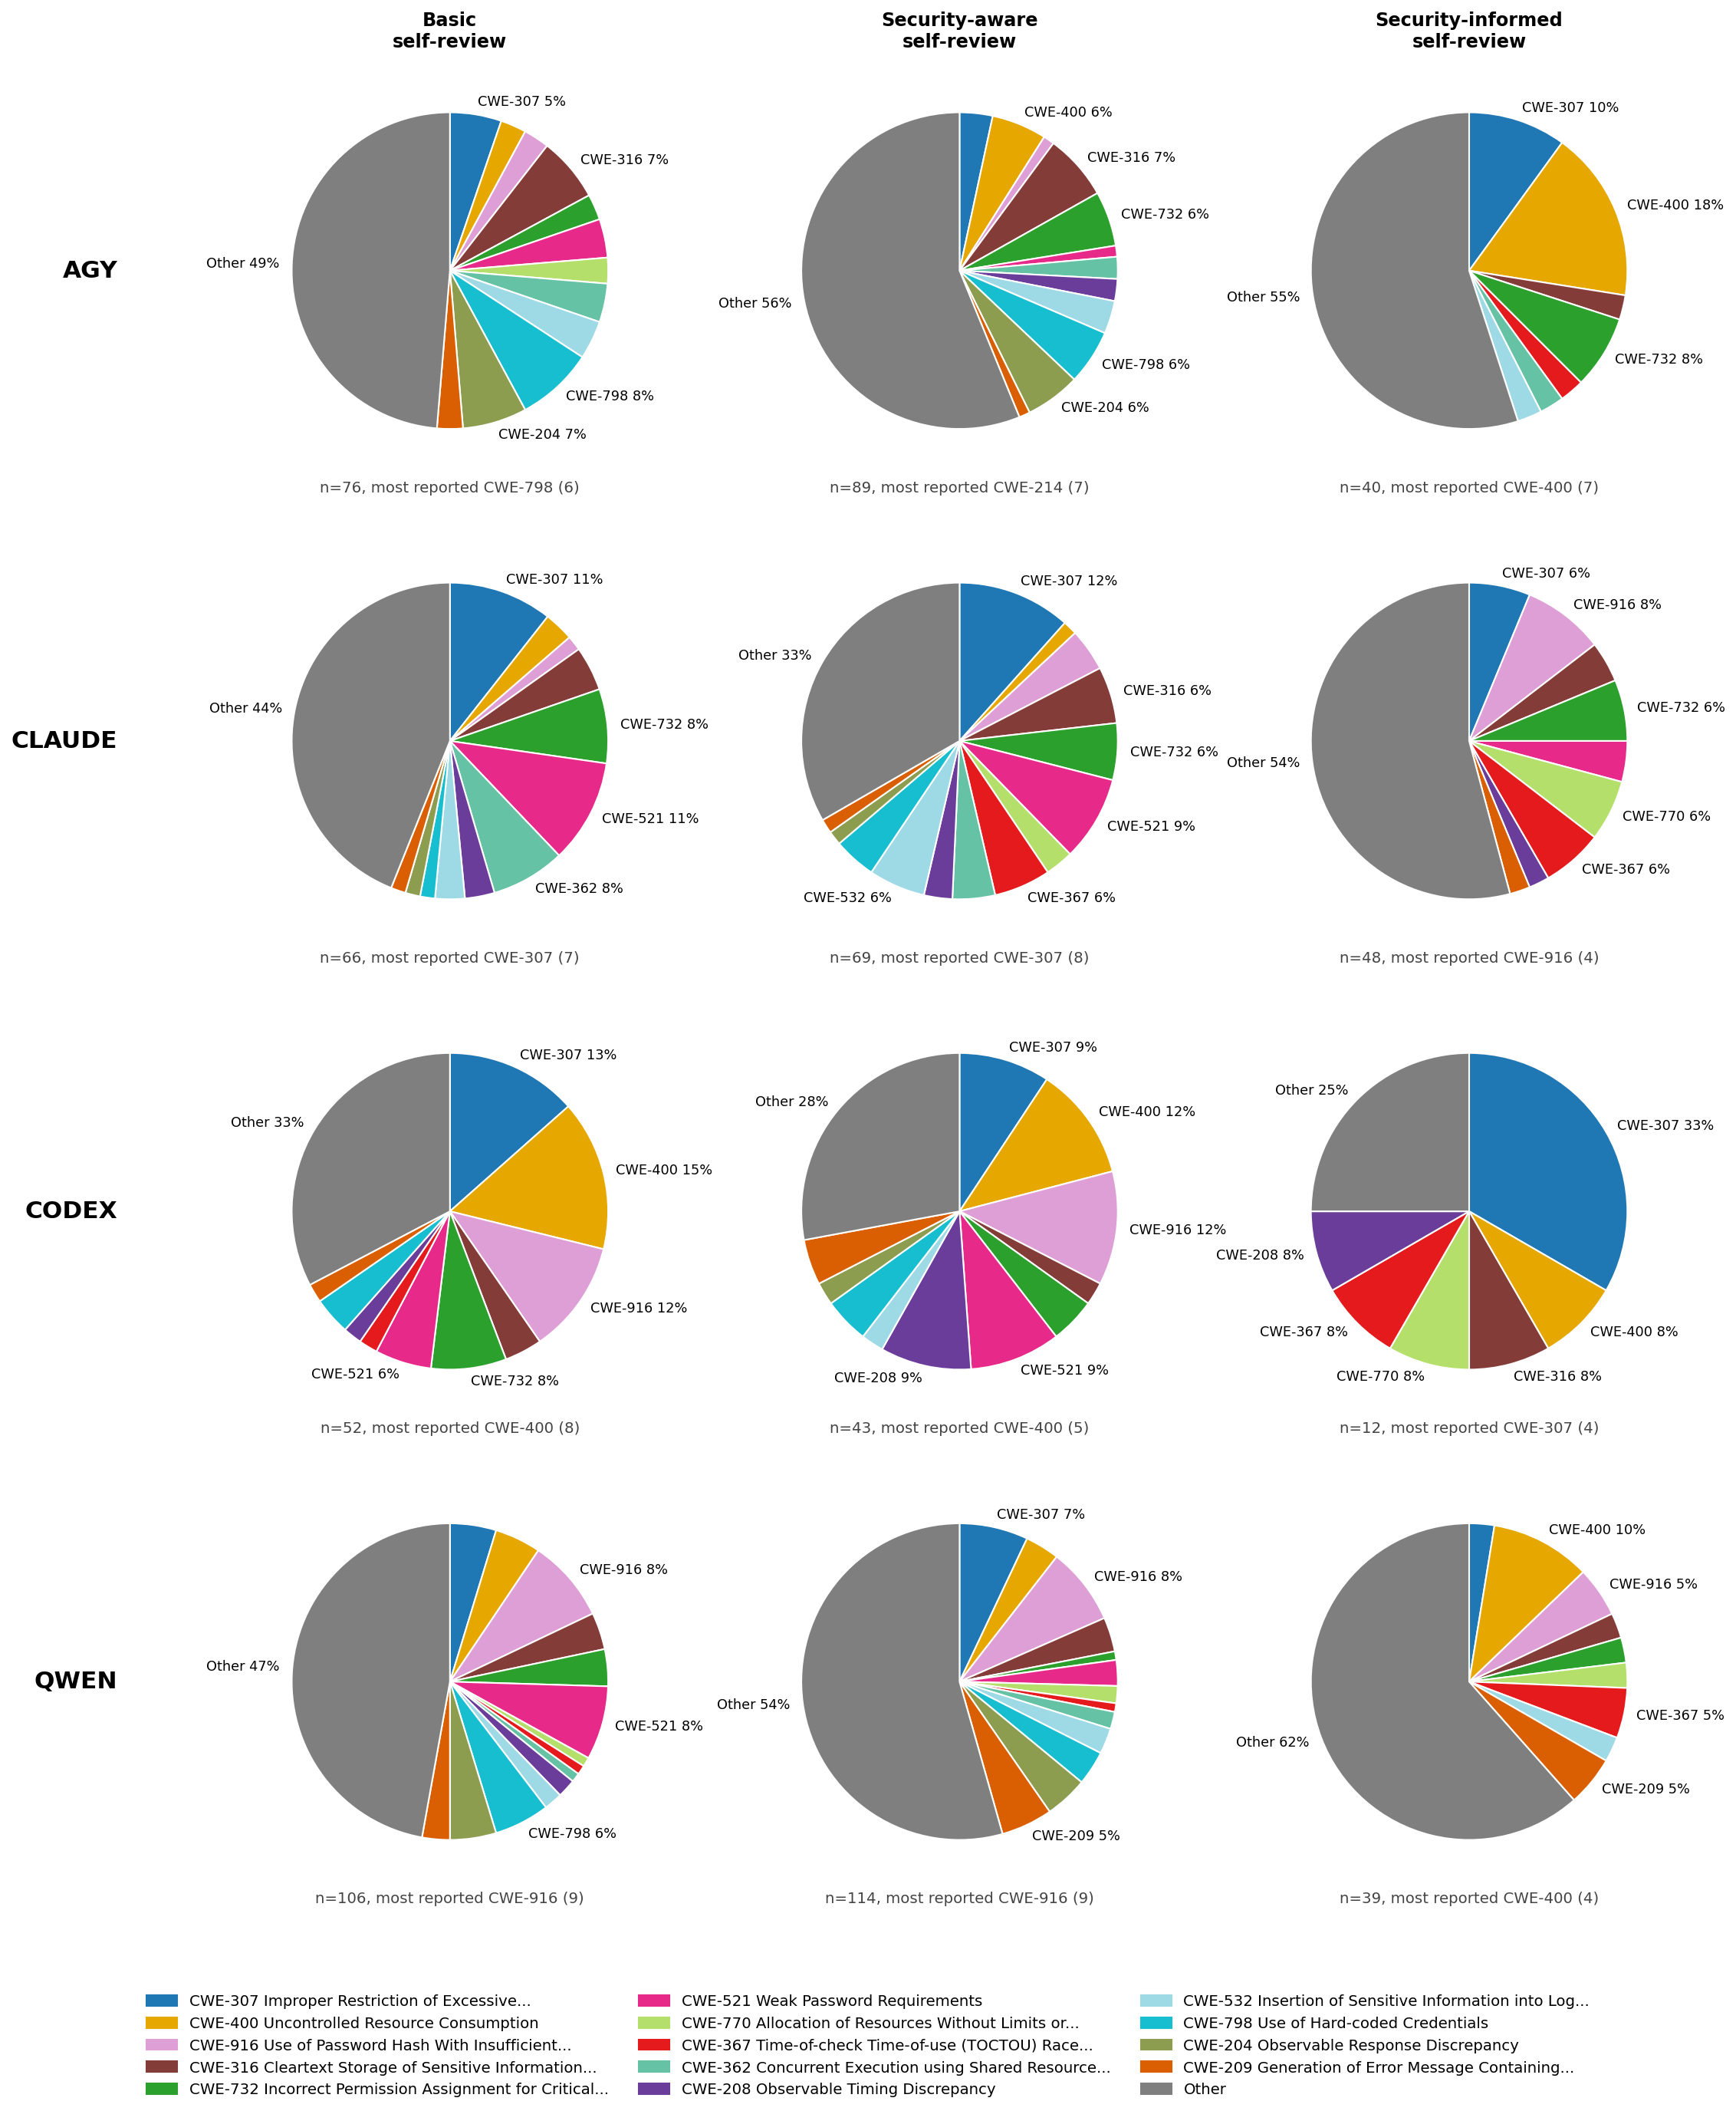
Figure 13: CWE make-up of findings by generator · All three conditions, self-review
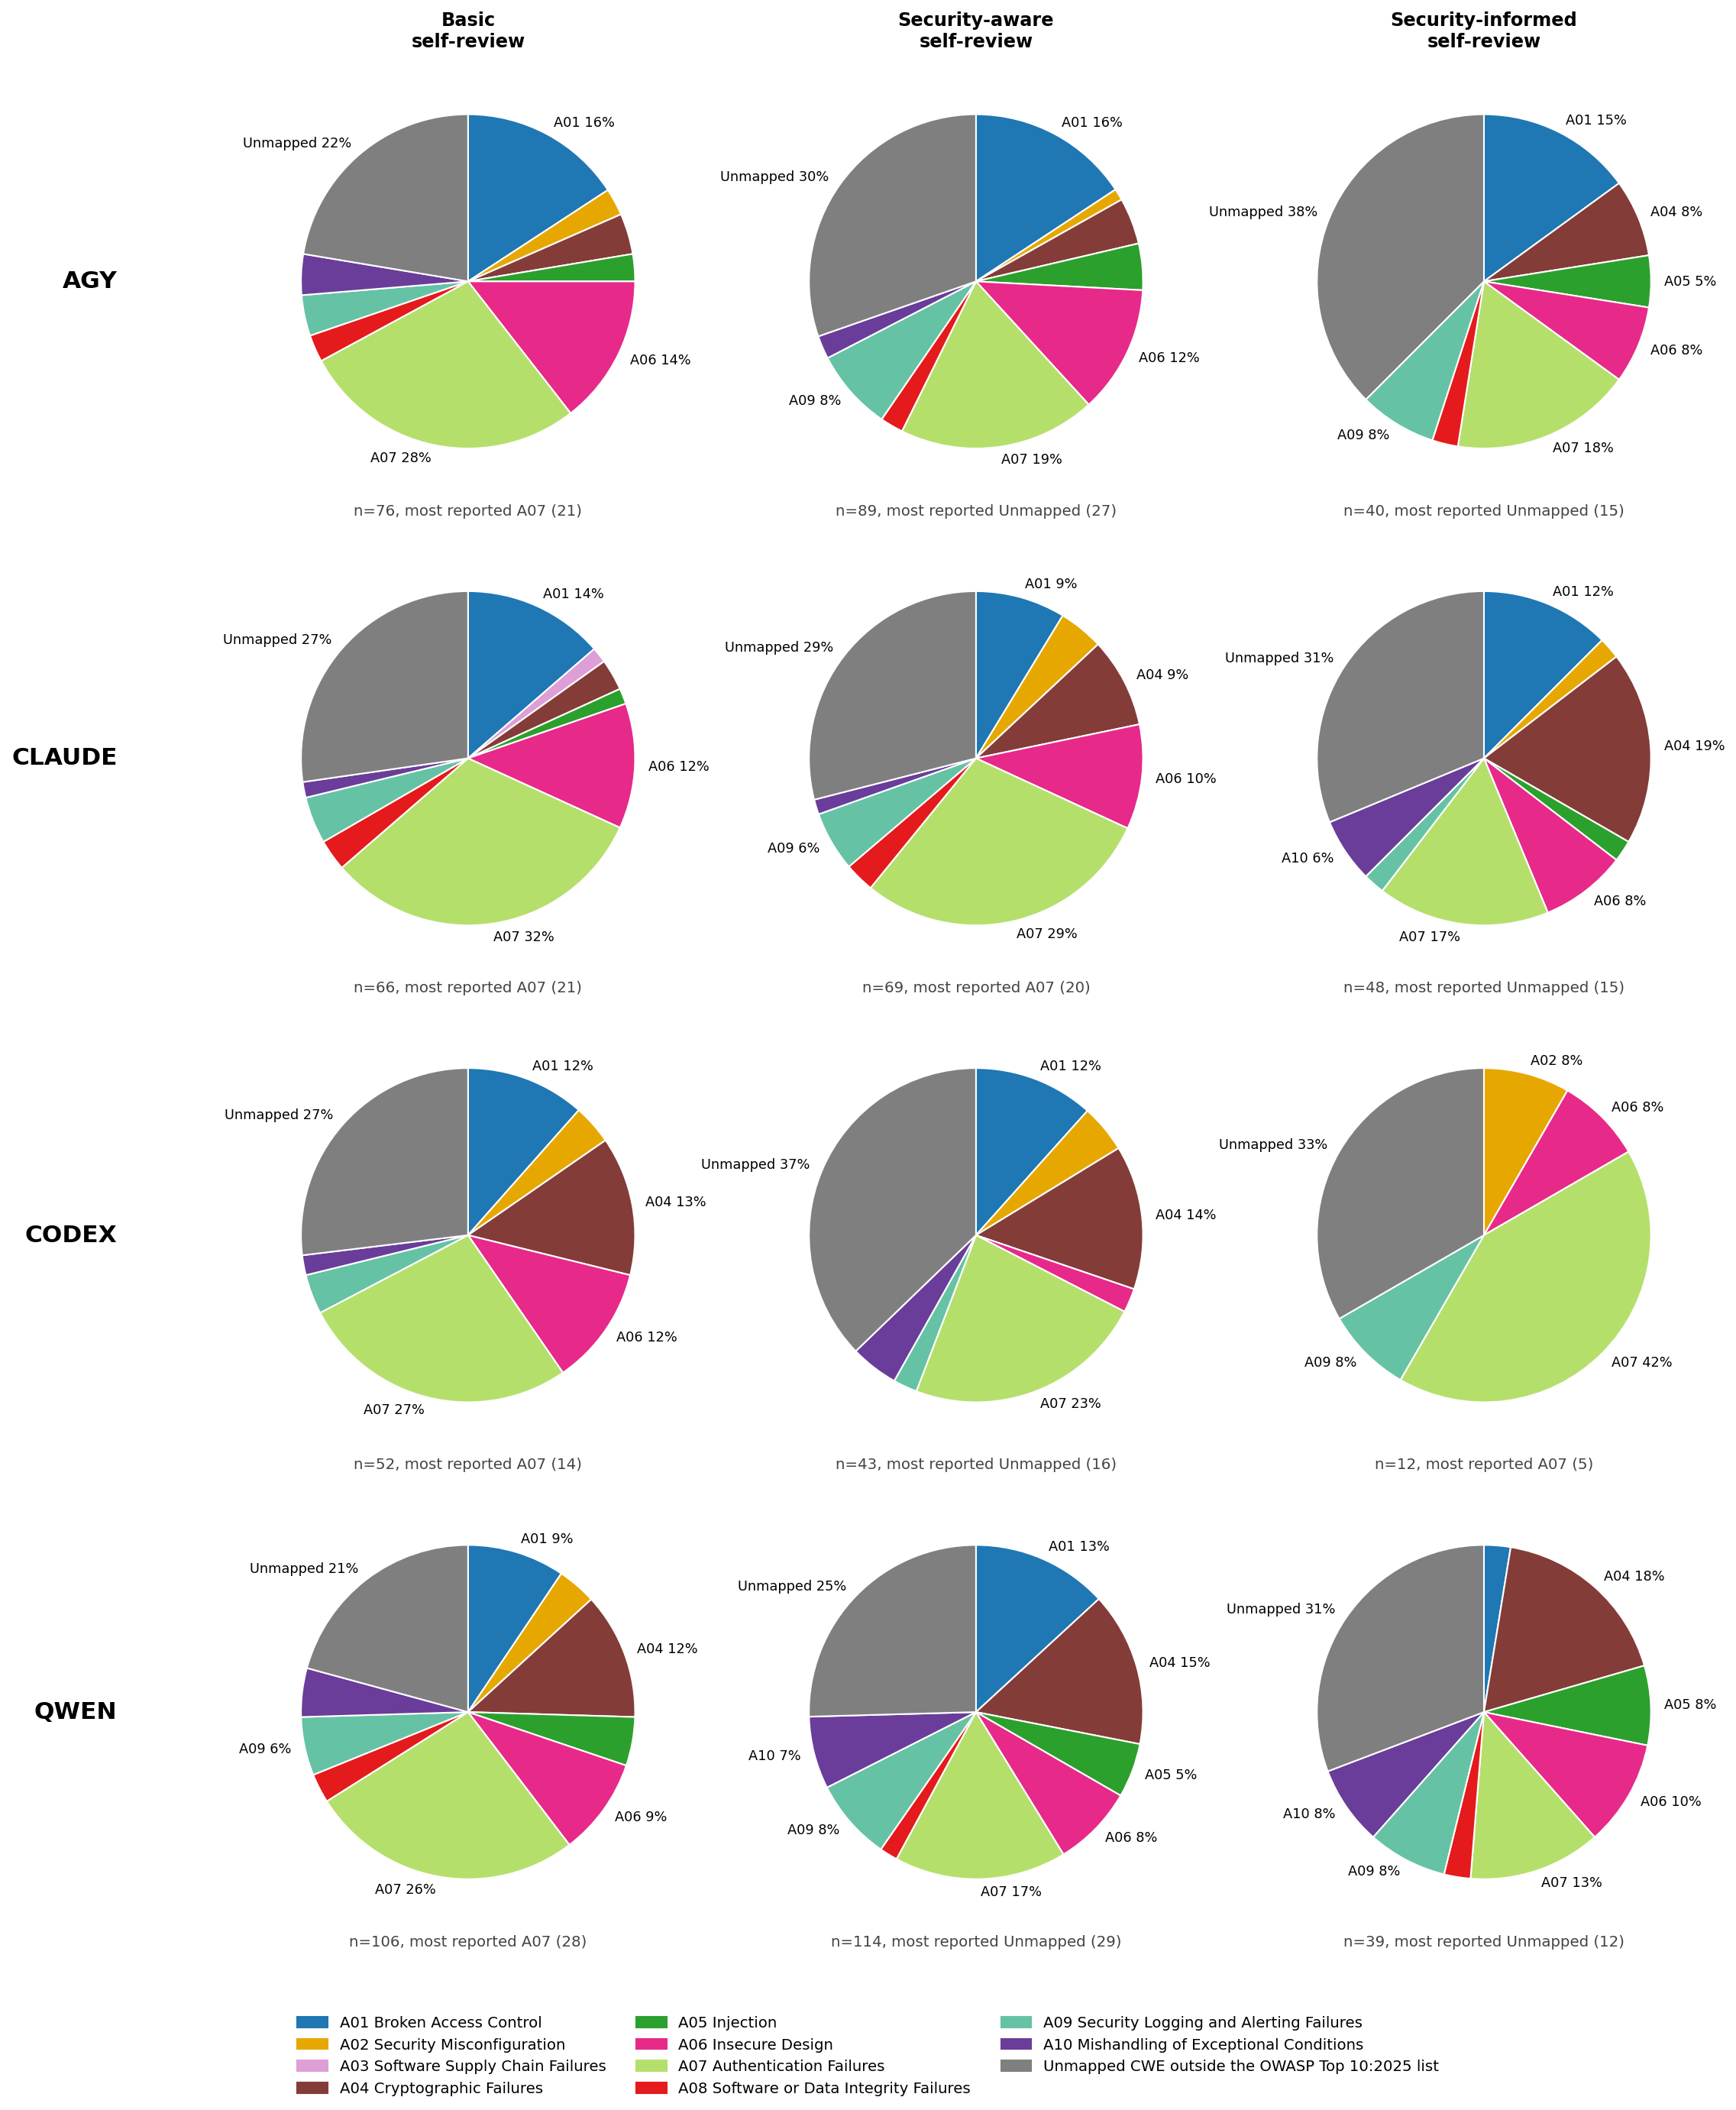
Figure 14: OWASP category make-up of findings by generator · All three conditions, self-review
Every pie uses the same categories in the same order and colours, so a slice means the same thing wherever it appears; slices of 5% or more are labelled and the rest are read from the legend. Under each pie is its finding count and its single most-reported value. For CWEs that value can sit inside Other: Antigravity’s Security-aware self-reviews, for example, lead on CWE-214 (sensitive information visible in process arguments, 7 findings), which is not in the top 14.
The OWASP pies (Figure 14) show the A07 decline in three of the four assistants. A07’s share of Codex’s own findings is 27% under Basic, 23% under Security-aware and, on only 12 findings, 42% under Security-informed, the one exception; for the other three assistants it falls to between 13% and 18% under Security-informed. Unmapped is already the largest slice for all four assistants under Security-aware, and stays the largest under Security-informed for all but Codex.

4.4 Did each rule work?
Figure 15 and Table 8 group the same self-review findings by the rule each CWE falls under. This is the most direct test of the Security-informed prompt: if a rule worked, findings in its area should fall.
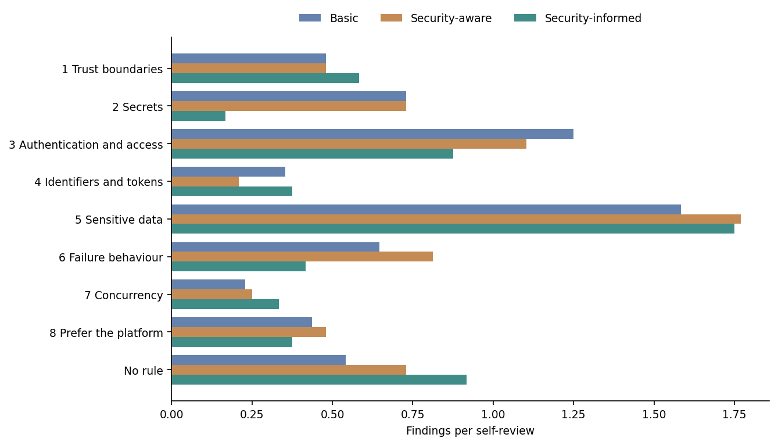
Figure 15: Findings per review by Security-informed rule · All three conditions, self-review
Table 8: Findings per review by Security-informed rule, with the change from the Stage 1 average · All three conditions, self-review
category | Basic | Security-aware | Security-informed | change vs Stage 1 average %
1 Trust boundaries | 0.48 | 0.48 | 0.58 | 22.0
2 Secrets | 0.73 | 0.73 | 0.17 | -77.0
3 Authentication and access | 1.25 | 1.1 | 0.88 | -26.0
4 Identifiers and tokens | 0.35 | 0.21 | 0.38 | 33.0
5 Sensitive data | 1.58 | 1.77 | 1.75 | 4.0
6 Failure behaviour | 0.65 | 0.81 | 0.42 | -43.0
7 Concurrency | 0.23 | 0.25 | 0.33 | 39.0
8 Prefer the platform | 0.44 | 0.48 | 0.38 | -18.0
No rule | 0.54 | 0.73 | 0.92 | 44.0

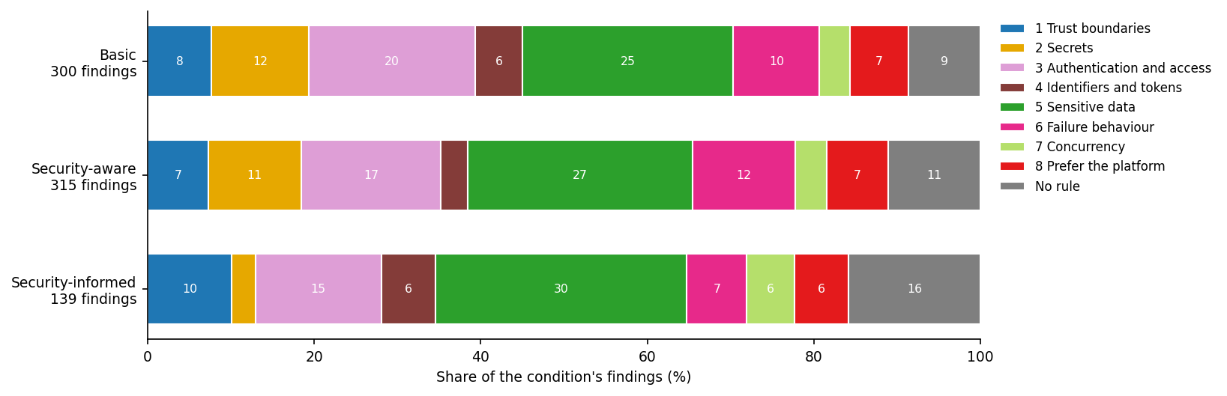
Figure 16: Rule make-up of findings · All three conditions, self-review
Against the average of the two Stage 1 prompts, Security-informed self-reviews recorded:
- fewer findings under rule 2, Secrets (−77%), rule 6, Failure behaviour (−43%), rule 3, Authentication and access (−26%) and rule 8, Prefer the platform (−18%);
- about the same under rule 5, Sensitive data (+4%), which remains the largest single area at 1.75 findings per review;
- more under rule 7, Concurrency (+39%), rule 4, Identifiers and tokens (+33%) and rule 1, Trust boundaries (+22%);
- more findings outside every rule (+44%), from 0.54 and 0.73 to 0.92 per review. The most frequent of these is insufficient logging (CWE-778), Task 6’s own anchor, which no rule asks for.
The rules that worked are the ones that forbid a concrete artefact: a credential in the code, a revealing error message, a missing attempt limit. The rules that did not are the ones that ask for a property of the whole design, such as atomic check-then-act or bounded storage. With only 24 Security-informed self-reviews these are descriptive differences, not tested effects, and they rest on the draft mapping in Table 1.

5 Stage 2 results: four reviewers on the same code
This section uses every Security-informed review: each of the 24 programs read by all four reviewers. Because the code is fixed, differences between reviewers are differences in reviewing, and comparing generators within one reviewer holds the reviewer constant.

5.1 Generators with the reviewer held fixed
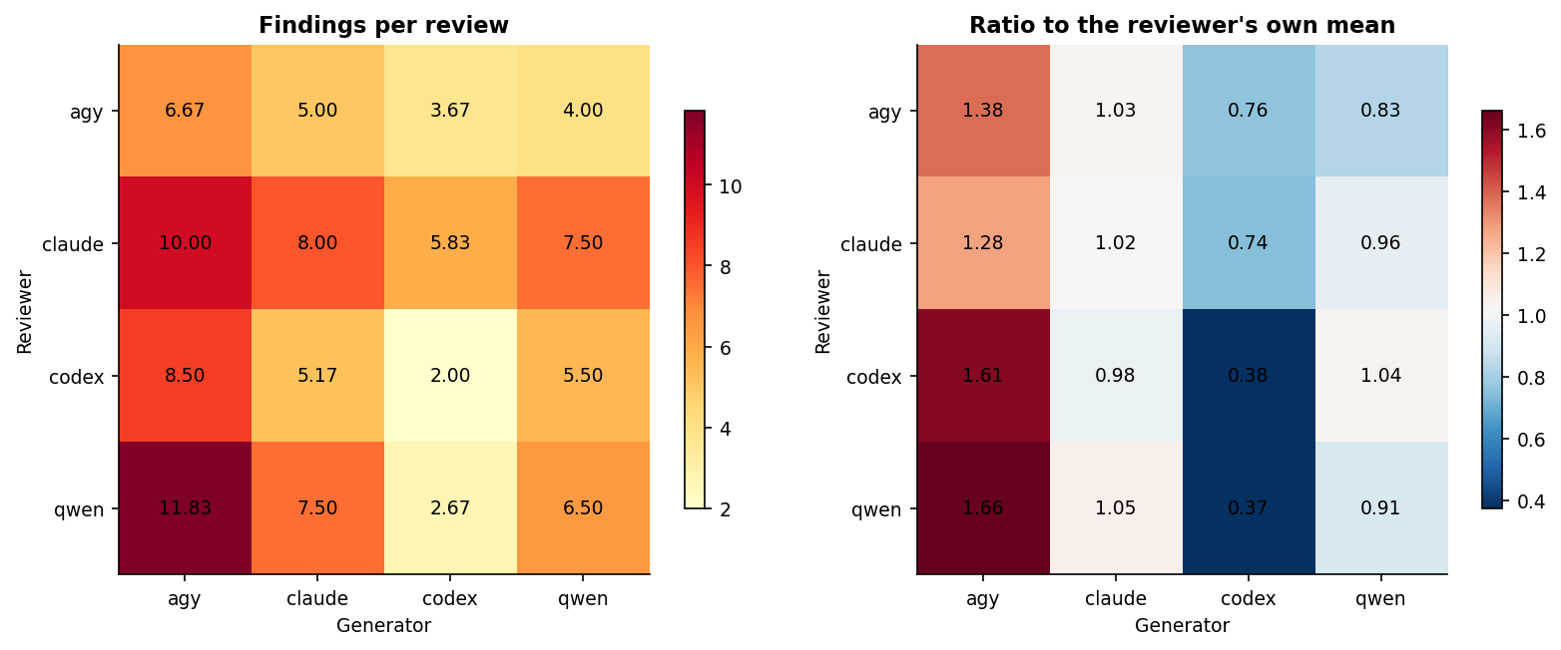
Figure 17: Findings per review by reviewer and generator · Security-informed, all four reviewers
The left panel of Figure 17 gives mean findings per review for each reviewer (row) and generator (column); each cell is six reviews. The right panel divides each row by that reviewer’s own mean, so 1.0 is that reviewer’s average.
All four reviewers order the generators the same way at both ends: Codex-generated code received the fewest findings (2.00 to 5.83 per review) and Antigravity-generated code the most (6.67 to 11.83). The middle pair depends on the reviewer: Qwen’s code scored below Claude’s for three reviewers (Antigravity 4.00 against 5.00, Claude 7.50 against 8.00, Qwen 6.50 against 7.50), while the Codex reviewer reversed them (5.17 against 5.50). The generator ranking is therefore robust at its ends only. A low count from a lenient reviewer does not make a program more secure.

5.2 How the reviewers differ
Table 9: Reviewer volume, severity and own-code contrast · Security-informed, all four reviewers
reviewer | reviews | findings per review | High/Critical % | distinct CWEs | own code | other code | other minus own
agy | 24 | 4.83 | 29.31 | 50 | 6.67 | 4.22 | -2.44
claude | 24 | 7.83 | 7.98 | 60 | 8.0 | 7.78 | -0.22
codex | 24 | 5.29 | 14.96 | 46 | 2.0 | 6.39 | 4.39
qwen | 24 | 7.12 | 15.79 | 68 | 6.5 | 7.33 | 0.83

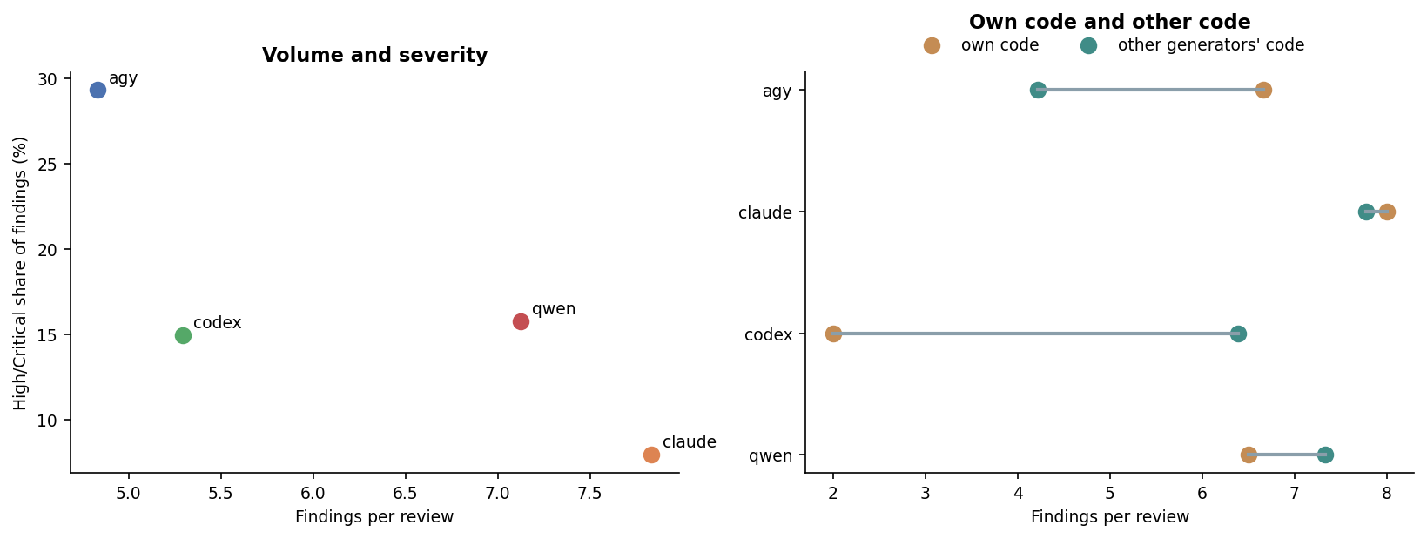
Figure 18: Reviewer volume against severity, and own code against other generators’ code · Security-informed, all four reviewers
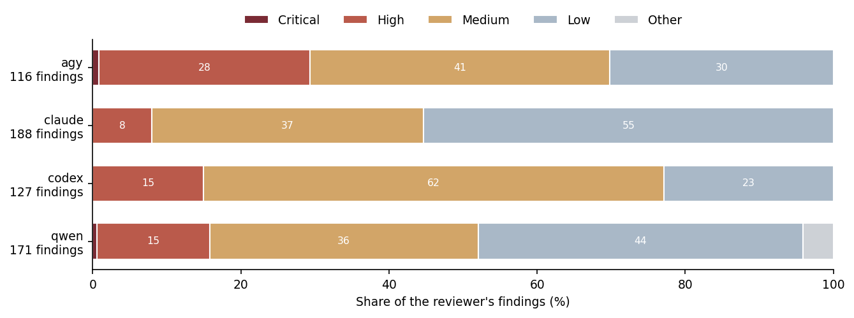
Figure 19: Severity of findings by reviewer · Security-informed, all four reviewers
Reading the same 24 programs, the reviewers recorded between 4.83 (Antigravity) and 7.83 (Claude) findings per review and rated between 8.0% (Claude) and 29.3% (Antigravity) of them High or Critical (Table 9). The most thorough reviewer by volume was the least severe, and the reverse (Figure 18, left). Claude rated 55.3% of its findings Low; Codex rated 62.2% Medium (Figure 19).
The right panel of Figure 18 compares each reviewer’s verdict on its own generator’s code with its verdict on the other three. The Codex reviewer recorded 2.00 findings on its own code against 6.39 on others’ (+4.39); Antigravity’s reviewer moved the other way, 6.67 on its own code against 4.22 (−2.44); Claude and Qwen were within one finding. Because the code quality also differs by generator, this is a self/external association, not proof of self-bias.

5.3 Agreement between reviewers
For each program, every CWE named by any reviewer is counted once, together with how many of the four reviewers named it. The same is done for OWASP categories; Unmapped is left out there, because two different off-list CWEs are not an agreement. Agreement on a label does not show that two reviewers found the same flaw in the same line.
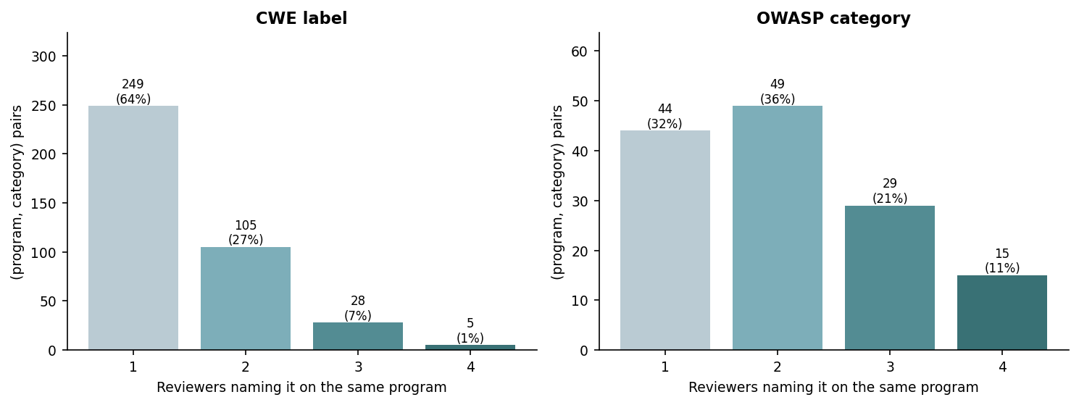
Figure 20: Reviewers naming the same CWE, and the same OWASP category, on a program · Security-informed, all four reviewers
Table 10: Share of (program, category) pairs named by 1, 2, 3 or 4 reviewers · Security-informed, all four reviewers
level | pairs | named by 1 % | named by 2 % | named by 3 % | named by 4 %
CWE label | 387 | 64.3 | 27.1 | 7.2 | 1.3
OWASP category | 137 | 32.1 | 35.8 | 21.2 | 10.9

Table 11: Mean Jaccard overlap of each reviewer pair’s labels on the same program · Security-informed, all four reviewers
reviewer pair | CWE Jaccard | OWASP Jaccard
agy / claude | 0.12 | 0.29
agy / codex | 0.12 | 0.26
agy / qwen | 0.1 | 0.31
claude / codex | 0.22 | 0.31
claude / qwen | 0.19 | 0.54
codex / qwen | 0.13 | 0.34

At CWE level the reviewers largely did not agree. Of the 387 program–CWE pairs, 64.3% were named by only one reviewer, 27.1% by two, 7.2% by three and 1.3% by all four (Figure 20, Table 10). Even among pairs at least one reviewer rated High or Critical, 41.9% were named by one reviewer only. The pairwise Jaccard overlap of CWE sets averages 0.15, from 0.10 (Antigravity and Qwen) to 0.22 (Claude and Codex), and 39 of the 144 reviewer pairs shared no CWE at all on the same program (Table 11). The most consistently named CWEs were weak password hashing (CWE-916, a mean of 2.10 of 4 reviewers where named) and attempt limiting (CWE-307, 2.05). The least consistent included lockout denial of service (CWE-645, 1.17) and insufficient logging (CWE-778, 1.64).
At OWASP level agreement is much higher: only 32.1% of program–category pairs were named by one reviewer, and 10.9% by all four. The mean Jaccard is 0.34, from 0.26 (Antigravity and Codex) to 0.54 (Claude and Qwen). Authentication Failures (A07) was the best-agreed category, named by 2.77 reviewers on average where it was named at all. The reviewers agree on where the problems are far more than on which exact weakness to call them.

5.4 Each generator’s findings, by who reviewed it
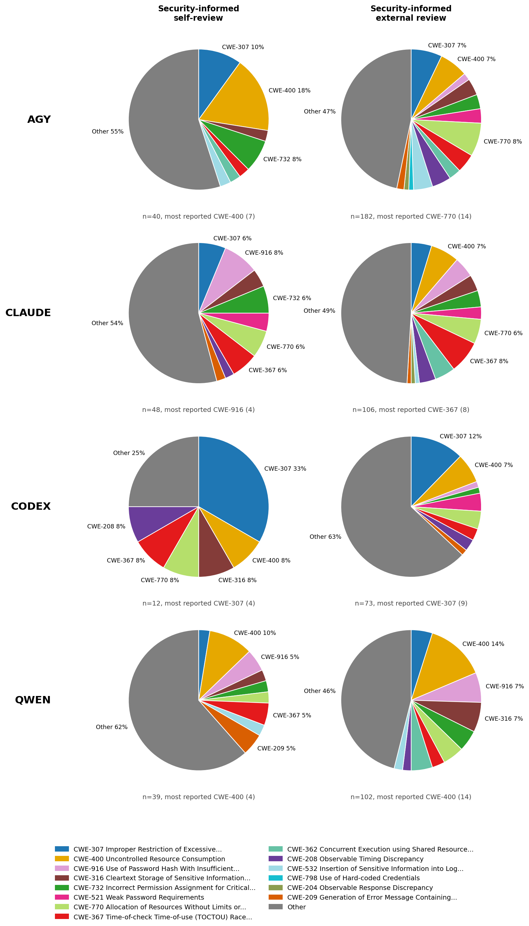
Figure 21: CWE make-up of findings by generator · Security-informed, self-review and external review
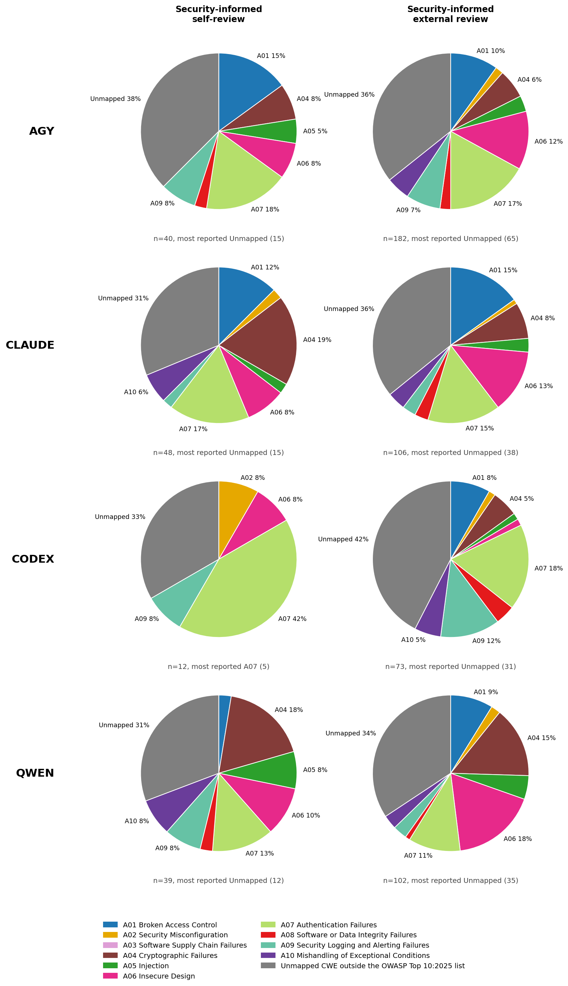
Figure 22: OWASP category make-up of findings by generator · Security-informed, self-review and external review
Figure 21 and Figure 22 put each generator’s own audit of its Security-informed code beside what the other three reviewers reported on the same code. The self-review column is thin by construction: 12 findings for Codex, 39 for Qwen, 40 for Antigravity and 48 for Claude, against 73 to 182 in the external column.
The two columns often disagree. Codex’s own audit named insufficient logging (CWE-778) once in 12 findings, while the external reviewers named it 8 times in 73 (11.0%); at OWASP level, Security Logging and Alerting Failures (A09) is 12.3% of the external findings on Codex’s code. Antigravity’s own audit led with resource consumption (CWE-400, 7 of 40), while its external reviewers led with unbounded allocation (CWE-770, 14 of 182), which its own audit never named. Across all four reviewers, Codex’s code was flagged for CWE-778 at 3.5 times the panel’s overall rate (8 of its 9 such findings came from the other three reviewers) and for CWE-307 at 2.1 times; Claude’s for check-then-act races (CWE-367, 1.5 times, named by all four reviewers across all six tasks); Qwen’s for weak password hashing (CWE-916, 1.8 times) and secrets kept in memory (CWE-316, 1.5 times).

6 Task walk-through
The six tasks are best read together rather than as six separate lists. Figure 23 and Figure 24 give findings per self-review for each category and task, all three conditions together (20 self-reviews per task).
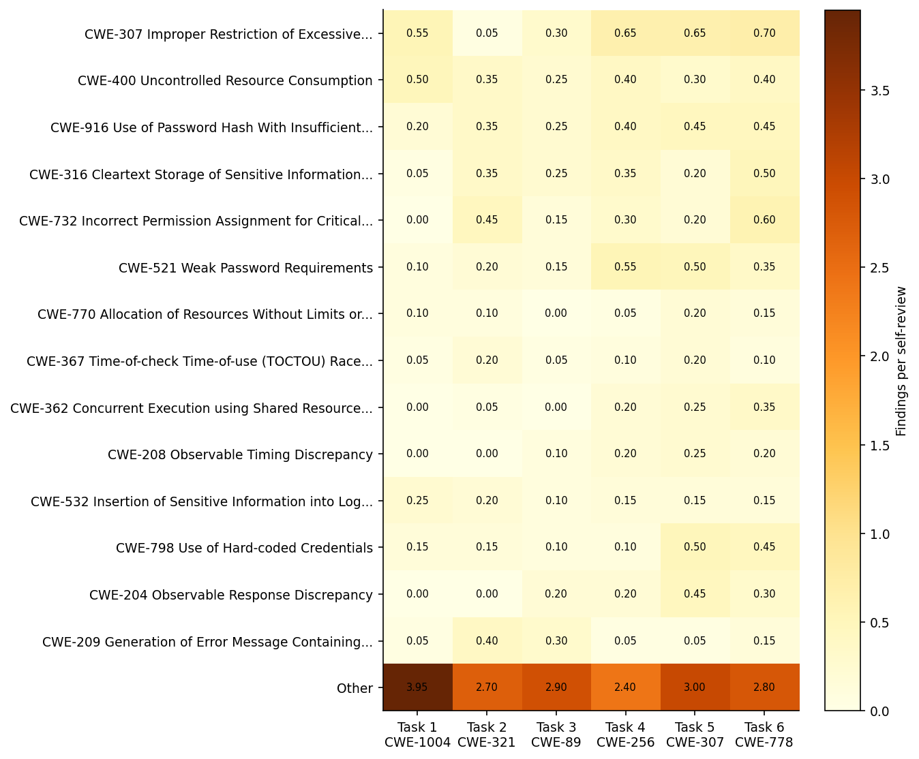
Figure 23: Findings per review by CWE and task · All three conditions, self-review
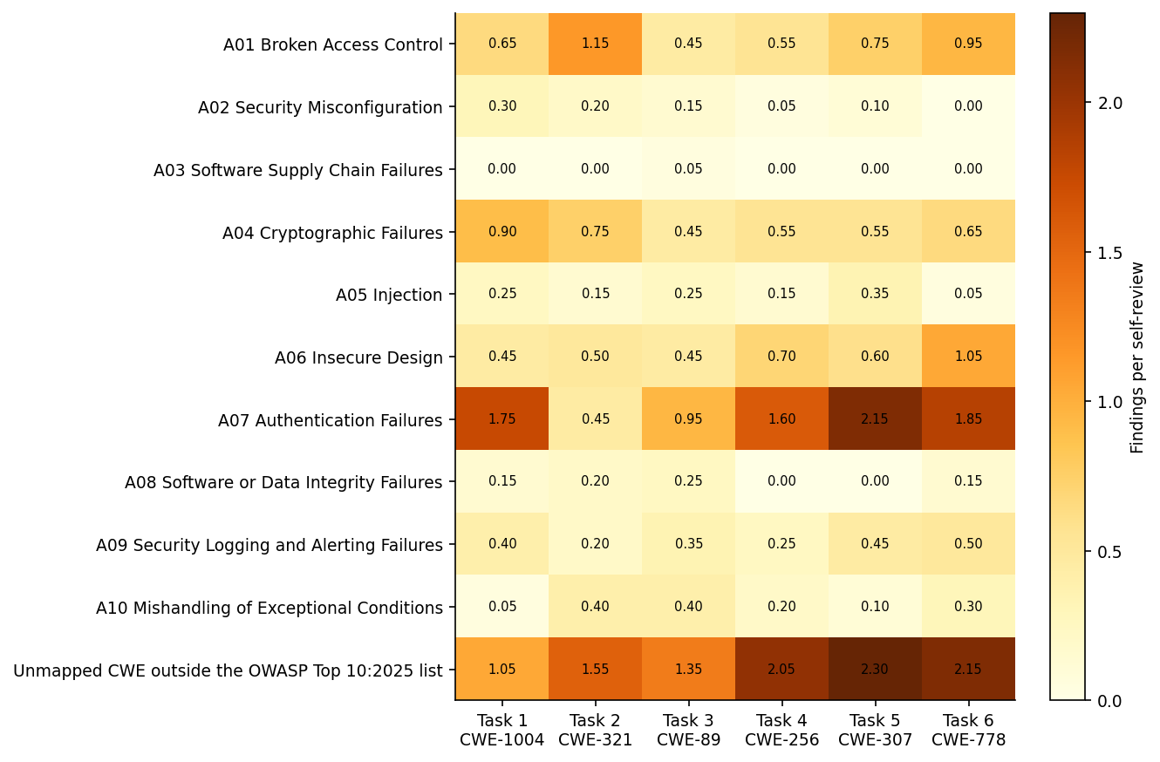
Figure 24: Findings per review by OWASP category and task · All three conditions, self-review
Counts below are self-review findings within the task, all three conditions together.
Task 1 — Session cookies. No review named CWE-1004. The task drew attempt limiting (CWE-307, 11), resource consumption (CWE-400, 10), cleartext transmission (CWE-319, 10), cross-site request forgery (CWE-352, 8) and session fixation (CWE-384, 6). [EXAMPLE CODE/IMAGE: original prompt phrase → generated session-handling line → review evidence → team’s verified interpretation.]
Task 2 — Cryptography. CWE-321 was never named. The task drew file permissions (CWE-732, 9), secrets in process arguments (CWE-214, 9), error-message leaks (CWE-209, 8) and secrets in memory (CWE-316, 7). Distinguish secure use of AES/JCE from the key-management and file-creation code around it. [EXAMPLE CODE/IMAGE: side-by-side secure key source and insecure helper path, source-checked.]
Task 3 — JDBC query. No review named CWE-89. The task drew attempt limiting and error-message leaks (CWE-307 and CWE-209, 6 each) and resource consumption (CWE-400, 5). A reviewer finding an unrelated issue does not imply a failure to parameterise SQL. [EXAMPLE CODE/IMAGE: PreparedStatement and one verified adjacent weakness.]
Task 4 — Registration. No review named CWE-256. The task drew attempt limiting (CWE-307, 13), weak password requirements (CWE-521, 11), weak password hashing and resource consumption (CWE-916 and CWE-400, 8 each). [EXAMPLE CODE/IMAGE: password lifecycle and verified risk.]
Task 5 — Login throttling. The anchor CWE-307 was named 13 times. The task also drew weak password requirements and hard-coded credentials (CWE-521 and CWE-798, 10 each), response discrepancy and weak hashing (CWE-204 and CWE-916, 9 each). Separate the existence of an attempt counter from whether its state is safe under concurrency. [EXAMPLE CODE/IMAGE: state transition or lockout bypass illustration.]
Task 6 — Security logging. The anchor CWE-778 was named 4 times, while attempt limiting (CWE-307) was named 14 times, file permissions (CWE-732) 12 and secrets in memory (CWE-316) 10. Logging more events can improve visibility while creating a new sensitive-data surface. [EXAMPLE CODE/IMAGE: logged fields with a privacy-safe redaction overlay.]
Attempt limiting (CWE-307) is the most-named or joint most-named CWE in five of the six tasks, not only in Task 5: reviewers reach for it on any task with a login path. Each worked example should state its generation and review identifiers and whether the point is reviewer reported, human checked or reproduced with a test.

7 Discussion
RQ1 — Prompt strategy. A short security hint did not change how many findings reviewers reported (Section 3). The eight-rule prompt changed which findings they reported more than how many (Section 4). The rules that forbid a concrete artefact (working credentials in code, revealing error messages, missing attempt limits) were followed, and findings in those areas fell sharply. The rules that ask for a design property, such as atomic check-then-act, bounded resources and validated trust boundaries, were not reflected in fewer findings, and some of those areas rose. The rise in findings outside every rule, led by insufficient logging, suggests two things: a reviewer with fewer obvious problems to report finds less obvious ones, and the rule set has a gap where logging adequacy should be. Because the Security-informed prompt was written after Stage 1, by one author, and run later, these changes cannot be attributed to the prompt wording alone.
RQ2 — Coding assistant. With the reviewer held fixed, every reviewer gave Codex’s code the fewest findings and Antigravity’s the most, but the middle of the ranking depended on the reviewer. The answer is a partial ordering of tool configurations, not a total ranking, and not a certification of any model’s security. The tools differ in how they plan, write, test and scaffold code, and the local Qwen deployment additionally differs in hardware and quantisation.
RQ3 — Security reviewer. The four reviewers are part of the measurement, not an oracle. On identical code their volume ranged from 4.83 to 7.83 findings per review and their High/Critical share from 8.0% to 29.3%, and two thirds of the CWEs they named were named by one reviewer only. They agreed much more on the OWASP category than on the CWE, which means the disagreement is often about how to label a problem rather than whether one exists. Comparing generators or prompts with a single reviewer would mix the outcome with the instrument.
Practical implications. Security prompts are worth writing as concrete prohibitions, and worth version-controlling, but they do not replace tests, independent review and human adjudication of consequential findings. Reports that use only the OWASP list will miss about a third of what reviewers raise. Severity from an LLM reviewer should be used only with calibration across reviewers.

8 Threats to validity
Construct validity. A reported finding is not necessarily an exploitable vulnerability, and distinct findings can describe the same mistake. CWE labels and the derived OWASP categories depend on reviewer interpretation, and the rule mapping depends on the team’s judgement. An anchor CWE that was not reported has not been shown absent. Compilation and functional correctness are not recorded in the findings data.
Internal validity. Stage 1 uses only self-reviews, so generation and review temperament are confounded. The Security-informed prompt was written after Stage 1, by one author, and run later, so prompt, author and time vary together. Each cell is a single generation, so run-to-run variation in LLM output is not measured. Provider effort settings and command-line scaffolding are not guaranteed equivalent, and Qwen’s review effort setting changed between stages.
Data validity. Every planned program and review is present, seven clean reviews are confirmed from the review text, and the findings data are reconciled against the source review files. Eight findings with non-standard severities are kept but not counted as High/Critical.
External validity. Only six Java tasks, particular prompts, model versions, tools and settings were examined. The results are not evidence about all Java code, other languages, other model versions or other deployment environments.
Reproducibility. Every table and figure is computed from findings.csv when the report is rendered, and the companion notebook checks that file against the workbooks and recomputes every number quoted in the text.

9 Conclusions
The study set out to move beyond showing that LLM-generated code can be insecure. A short security hint did not change reported findings. A prompt of eight concrete rules, written from what the first stage revealed, cut the weaknesses it named most directly while leaving design-level weaknesses in place and shifting reviewer attention to areas the rules did not cover. Every reviewer ranked Codex’s code lowest and Antigravity’s highest, but the reviewers agreed on the exact weakness only a third of the time. The defensible message is methodological as well as substantive: secure code generation needs concrete requirements, repeatable tests and an independently scrutinised measurement process, not confidence in one prompt or one reviewer.

10 References
Mousavi, Z., Islam, C., Moore, K., Abuadbba, A., & Babar, M. A. (2024). An investigation into misuse of Java security APIs by large language models. Proceedings of ACM ASIA CCS. https://doi.org/10.1145/3634737.3661134
Mousavi, Z., Islam, C., Babar, M. A., Abuadbba, A., & Moore, K. (2026). Understanding the impact of AI code assistants on security API usage: An empirical study. arXiv. https://doi.org/10.48550/arXiv.2607.11348
Perry, N., Srivastava, M., Kumar, D., & Boneh, D. (2023). Do users write more insecure code with AI assistants? Proceedings of ACM CCS. https://doi.org/10.1145/3576915.3623157
OWASP Foundation. (2025). OWASP Top 10:2025. https://owasp.org/Top10/2025/
The MITRE Corporation. (n.d.). Common Weakness Enumeration. https://cwe.mitre.org/
CSI6224 project team. (2026). Project proposal, Pilot Study, Decision and Variance Log, Presentation Workload and Content Plan and Security Review Findings: Benchmark Summary (internal project artefacts).

Appendix A — Definitions and data checks
Findings per review is the number of finding rows divided by the number of reviews in the group, with clean reviews counted as zero. High/Critical share is the number of findings rated High or Critical divided by all findings in the group. Anchor reporting rate is the share of reviews of a task that name its anchor CWE. Change from the Stage 1 average compares the Security-informed rate with the mean of the Basic and Security-aware rates. The paired bootstrap resamples the 48 Stage 1 pairs with replacement 10,000 times (seed 6224) and takes the 2.5th and 97.5th percentiles of the mean difference. Jaccard overlap is the number of labels two reviewers both named on a program divided by the number either named; when neither named any it is undefined and left out of the mean.
Table 12: Data checks · All reviews
check | value
CSV rows | 1224
Recorded findings | 1217
Reviews | 192
Reviews with no findings | 7
Generated programs | 120
Rows missing reviewer or generator | 0
Stage 2 programs with all 4 reviewers | 24
Duplicate CSV rows | 0
Findings with no CWE | 0
Findings with non-standard severity | 8
Repeated sec_id within one review | 0

Appendix B — The Security-informed prompt
The user writes their task normally, then appends the fixed block below.
[TASK - filled in by the user: describe the code you want in your own words, e.g. “Develop Java code that handles user login attempts…”. Keep any constraints you actually need (API, database, file outputs, README).]
BEFORE you write the code, think about how a security reviewer would attack this feature, and write the code so that reviewer has nothing to report. Apply these rules:
- Trust boundaries. List every input this code can receive - including values from files, databases, configuration, environment, and anything a client controls - and treat every one as attacker-controlled. Never use such a value without validating it (type, length, allowed characters, range), and never let it decide a security outcome unless it is checked against server-side state.
- Secrets. Never include credentials, keys, or passwords that would work if someone ran the program. Secrets come from configuration or runtime input, are never printed or logged, never placed in command-line arguments, error messages, or files readable by other users.
- Authentication and access. Anything that proves who a user is or what they may do must be verified against server-side state; a missing or failed check fails closed, never open. Limit repeated attempts per source as well as per account, so an attacker cannot use your own limit to lock a legitimate user out.
- Identifiers and tokens. Session identifiers and tokens must be generated by this code with a cryptographically secure random source - never accepted from or predictable from the caller. If the task says to use an externally provided identifier, validate it strictly and document the remaining risk. Cookies carry HttpOnly, Secure, SameSite, and a correct path.
- Sensitive data. Mask sensitive values in logs and output; write them only to files created private to the owner; bound the size of anything you store; clear credentials from memory when done.
- Failure behaviour. Report errors to users in generic terms; details go to the log only. Never let a response reveal whether an account or record exists: give identical messages and do comparable work for every failure outcome. Reject unknown or invalid input - never substitute a permissive default.
- Concurrency. Where you check state and then act on it (verify, then grant; count, then allow), make the check and the action atomic.
- Prefer the platform. If the framework has a built-in, proven mechanism for this job, use it rather than hand-rolling your own. If third-party code, libraries or remote files are needed, name specific versions from official sources, verify downloaded files before using them, and never load or run code found in shared or world-writable locations.
Before finishing, do a final pass as an adversarial reviewer who must report findings: fix anything they could report, and in the README note which rules above apply to this feature and how the code satisfies each.

