Run cost data report
Table of contents

Summary
- Across 30 generation runs and 48 review runs per assistant, Antigravity had 1 generation ERROR and 7 empty generation replies; every Claude, Codex and Qwen run was successful and non-empty.
- Qwen had the largest reported totals: generation used 50.98 hours and 709.11 million tokens processed, while review used 34.53 hours and 402.96 million tokens processed.
- Antigravity generation used 2.47 hours and 68.09 million tokens processed, and Claude generation used 2.84 hours and 15.81 million; Codex processed 8.28 million generation tokens but did not report run time.
- Security-informed generation was the highest-time and highest-token condition for every assistant shown, with the largest visual increase for Qwen.
- In the recovered Claude pilot, Sonnet 5 at max effort took 30.24 minutes and 21.0 turns, compared with 4.38 minutes and 12.0 turns for Opus 5 at medium on the same task.
- For Qwen’s security-informed panel, 6 self-reviews took 4.6 actual hours at medium and were estimated at 47.6 hours at xhigh; all 24 reviews took 14.4 actual hours and were estimated at 190.5 hours.
Reader’s rule: time and tokens describe the coding assistant as configured (model, effort setting, scaffolding and hardware), not the model alone. Codex records no run time, so it is absent from every time figure.

What was measured

Source of the numbers
This section distinguishes generation runs, whose cost is assigned to the generator, from review runs, whose cost is assigned to the reviewer. The tables and figures summarize completion, elapsed time, token use and, where shown, turns from the assistants’ CLI records.
- A generation run is one assistant writing one program. Its cost belongs to the generator.
- A review run is one reviewer reading one program. Its cost belongs to the reviewer.

Two token measures, one rule for every assistant
The table aligns each assistant’s reported input, cache and output fields with a common “tokens processed” measure. It also shows whether cached tokens are separate from input or already included in it.
How each assistant reports tokens, and the measure this report derives from them
Assistant | What “input” counts | Cached tokens | Tool’s own total | Tokens processed, as used here
Antigravity | input not read from cache | reported separately | input + output | input + cached read + output
Claude Code | input not read from or written to cache | reported separately, plus cache creation | input + output | input + cache creation + cached read + output
Codex | all input, cached included | already inside input | input + output | input + output
Qwen Code | the whole prompt, re-sent on every request | not reported | input + output | input + output

Gaps in the data
Codex did not report run time, so its time values and time-figure entries are absent. Antigravity had 1 generation run with ERROR status and 7 generation runs with empty replies, including 6 marked SUCCESS; the corresponding rows are listed below rather than estimated.

How the runs finished
Table 1: Run status and empty replies by assistant · All generation and review runs
assistant | stage | runs | status SUCCESS | status ERROR | empty reply
agy | generation | 30 | 29 | 1 | 7
agy | review | 48 | 48 | 0 | 0
claude | generation | 30 | 30 | 0 | 0
claude | review | 48 | 48 | 0 | 0
codex | generation | 30 | 30 | 0 | 0
codex | review | 48 | 48 | 0 | 0
qwen | generation | 30 | 30 | 0 | 0
qwen | review | 48 | 48 | 0 | 0

Table 1 shows 30 generation runs and 48 review runs for each assistant. Antigravity recorded 29 generation successes, 1 generation error and 7 empty generation replies, while all other assistant-stage combinations show only successes and no empty replies.
Table 2: Runs that ended in ERROR or returned no reply · All generation and review runs
run | stage | status | empty reply | minutes
agy/post_research/1/security/ | generation | ERROR | yes | 5.0
agy/ruth/3/basic/ | generation | SUCCESS | yes | 4.9
agy/ruth/5/basic/ | generation | SUCCESS | yes | 5.0
agy/ruth/5/security/ | generation | SUCCESS | yes | 4.9
agy/sallie/1/security/ | generation | SUCCESS | yes | 4.8
agy/sallie/3/basic/ | generation | SUCCESS | yes | 4.9
agy/sallie/3/security/ | generation | SUCCESS | yes | 4.9

All 7 runs in Table 2 are Antigravity generation runs. 1 ended in ERROR and the other 6 were marked SUCCESS, but every listed run returned an empty reply and had a reported time.

Overall cost per assistant
Table 3: Time and tokens per assistant · All generation runs (by generator) and all review runs (by reviewer); Codex records no time
assistant | stage | runs | total hours | mean minutes per run | total tokens processed (M) | mean tokens processed per run (M) | mean tokens generated per run (k)
agy | generation | 30 | 2.47 | 4.95 | 68.09 | 2.27 | 45.8
agy | review | 48 | 3.73 | 4.66 | 141.09 | 2.94 | 51.45
claude | generation | 30 | 2.84 | 5.68 | 15.81 | 0.53 | 27.11
claude | review | 48 | 5.3 | 6.63 | 56.78 | 1.18 | 28.25
codex | generation | 30 |  |  | 8.28 | 0.28 | 8.13
codex | review | 48 |  |  | 65.42 | 1.36 | 13.28
qwen | generation | 30 | 50.98 | 101.96 | 709.11 | 23.64 | 233.91
qwen | review | 48 | 34.53 | 43.17 | 402.96 | 8.39 | 98.67

Table 3 shows Qwen with the largest reported totals for both stages: 50.98 generation hours and 709.11 million processed tokens, then 34.53 review hours and 402.96 million processed tokens. Codex reported 8.28 million processed tokens for generation and 65.42 million for review, but its total hours and mean minutes were not reported.

Generation
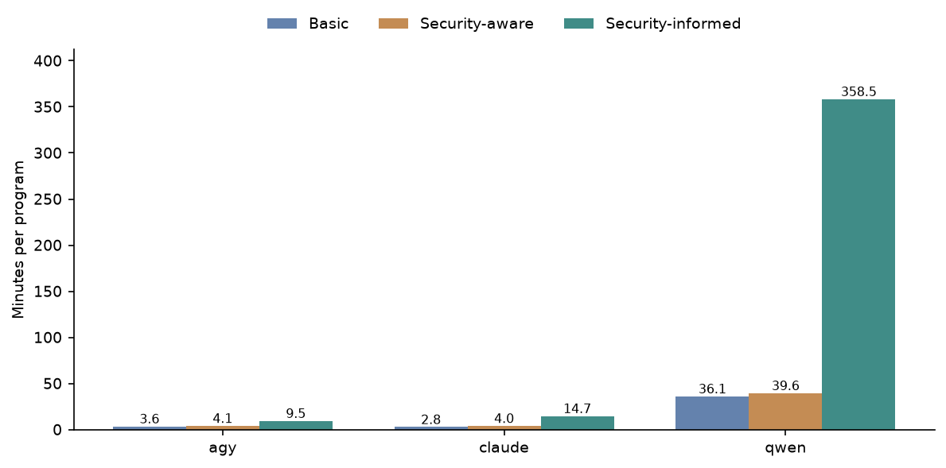
Figure 1: Mean minutes per program by generator and condition · All generation runs; Codex records no time
Figure 1 shows Qwen taking much longer per program than Antigravity or Claude in every plotted condition. Mean time rises from Basic through Security-aware to Security-informed for each timed generator, with the Security-informed increase especially pronounced for Qwen; Codex is absent because it did not report time.
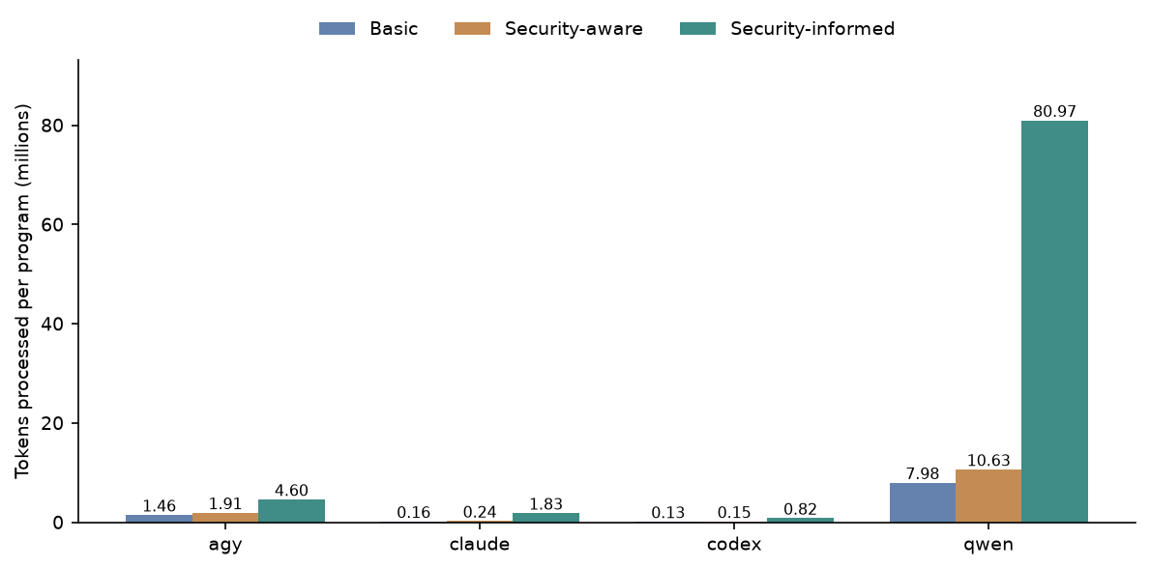
Figure 2: Mean tokens processed per program by generator and condition · All generation runs
Figure 2 shows Qwen processing the most tokens per program in every condition, followed by Antigravity, Claude and Codex. For every generator, Security-informed is the highest-token condition and Basic is the lowest.
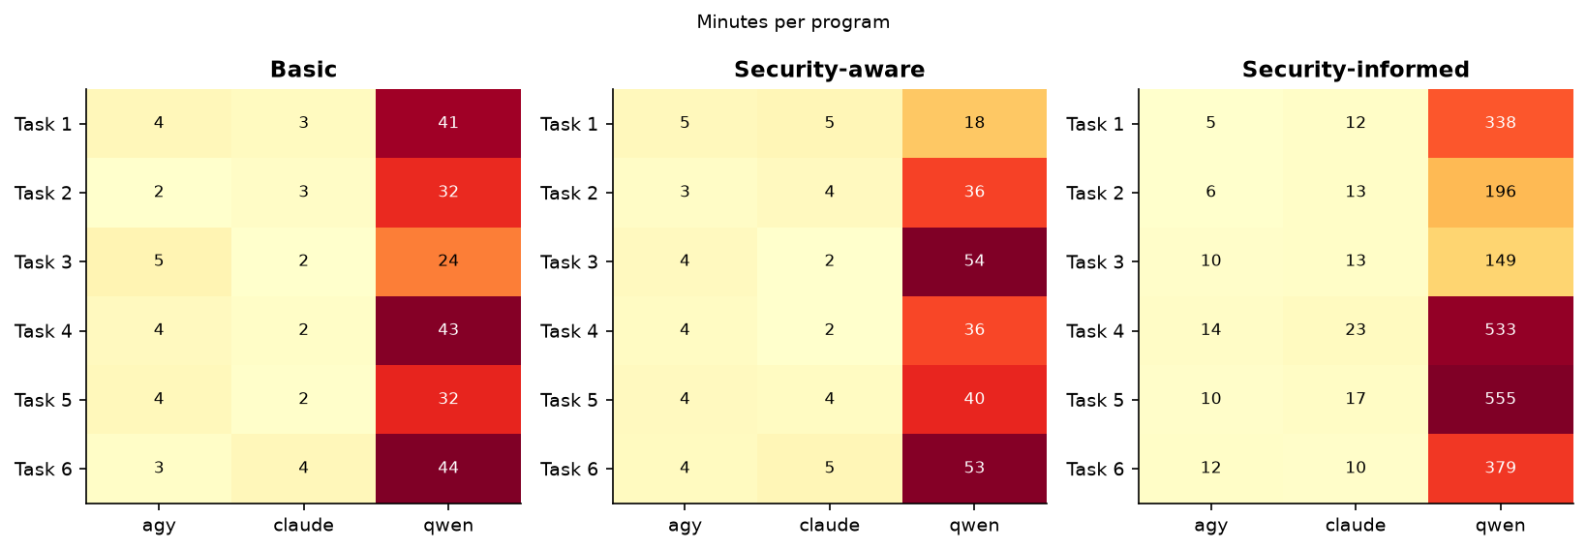
Figure 3: Mean minutes per program by task and generator · All generation runs; Codex records no time
Across the task panels in Figure 3, Qwen takes longer than Antigravity and Claude for every task and condition. The largest times cluster in Qwen’s Security-informed panel, particularly for Tasks 4 and 5, while Antigravity and Claude remain much lower across tasks; Codex is absent because it did not report time.
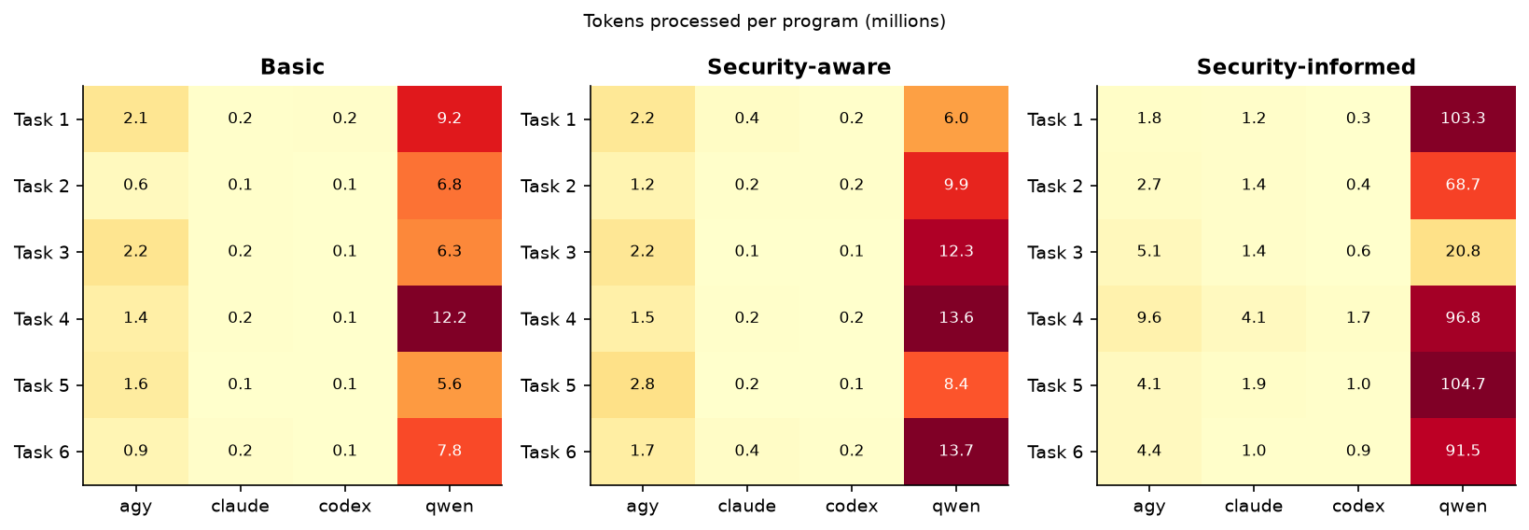
Figure 4: Mean tokens processed per program by task and generator · All generation runs
Figure 4 shows Qwen as the highest-token generator for every task and condition. Its Security-informed task values dominate the grid, while Antigravity, Claude and Codex also generally rise in that condition but remain well below Qwen.

Review
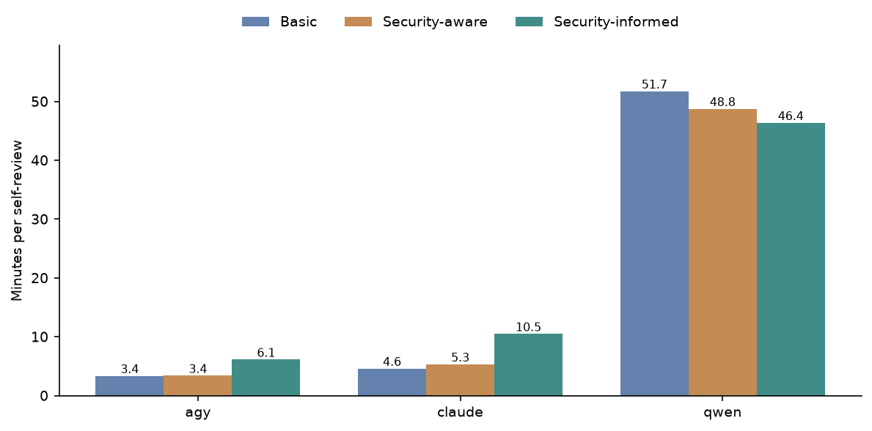
Figure 5: Mean minutes per self-review by reviewer and condition · All conditions, self-review; Codex records no time
Figure 5 shows Qwen self-reviews taking substantially longer than Antigravity or Claude self-reviews in all three conditions. Antigravity and Claude are highest in Security-informed, whereas Qwen decreases from Basic to Security-aware to Security-informed; Codex is absent because it did not report time.
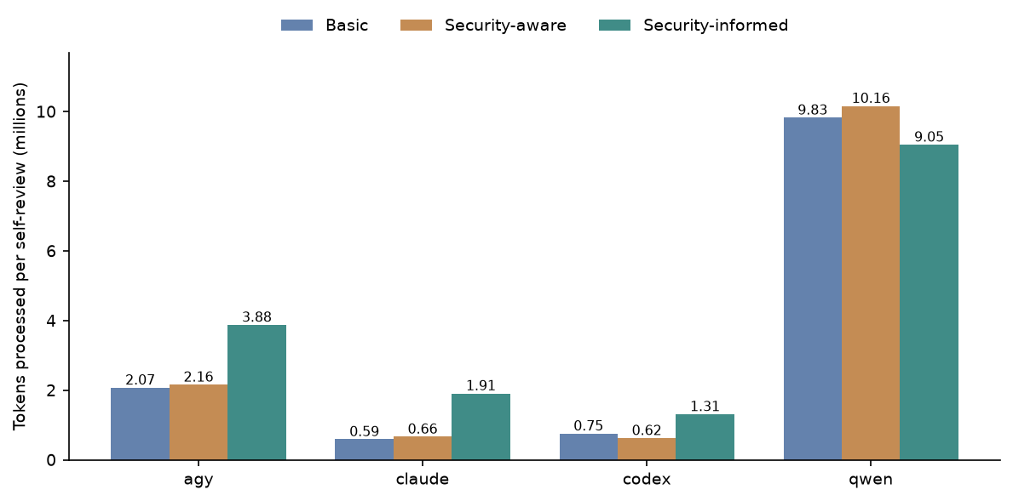
Figure 6: Mean tokens processed per self-review by reviewer and condition · All conditions, self-review
Figure 6 shows Qwen processing the most tokens per self-review in each condition. Security-informed is the highest condition for Antigravity, Claude and Codex, while Qwen is highest in Security-aware and lowest in Security-informed.
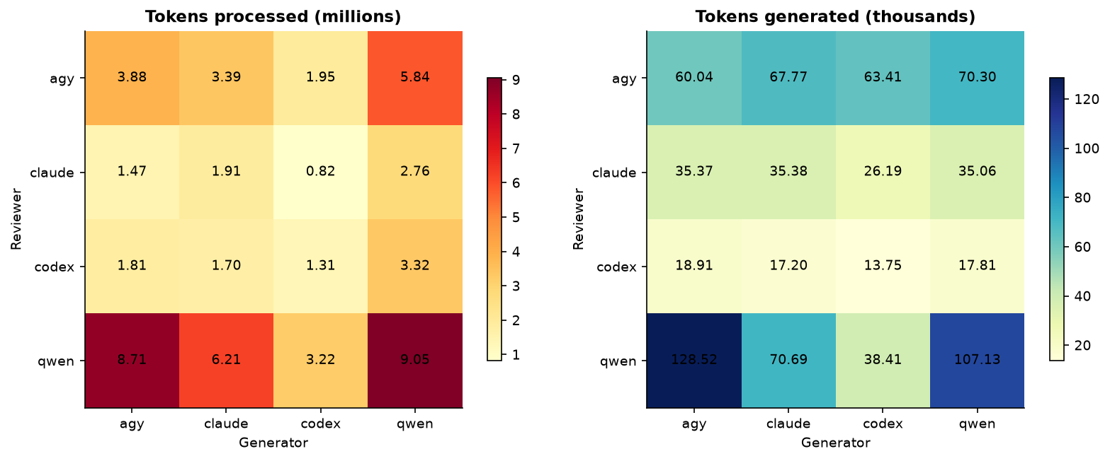
Figure 7: Mean tokens per review, reviewer × generator · Security-informed, all four reviewers
In Figure 7, Qwen is the highest-token processor for programs from every generator, and Qwen-generated programs require the most processed tokens within every reviewer row. Generated-token levels vary separately: Qwen’s reviews have the broadest spread across generators, while Antigravity’s are comparatively even.

Claude at maximum effort in the pilot
This section isolates the recovered Claude Sonnet 5 pilot generation run at max effort. The table compares it with Claude Opus 5 at medium on the same task and with Opus’s mean across 12 Basic runs, covering minutes, output and thinking tokens, processed tokens and turns.
Table 4: Claude Sonnet 5 at max effort (recovered pilot run) against Claude Opus 5 at medium · Task 1 Basic, generation; Opus mean over its 12 Basic runs
measure | Sonnet 5 max, pilot | Opus 5 medium, same task | Sonnet / Opus | Opus 5 medium, mean of 12 Basic runs
minutes | 30.24 | 4.38 | 6.91 | 2.81
output tokens | 166076.0 | 23639.0 | 7.03 | 13680.0
thinking tokens | 139895.0 | 7475.0 | 18.72 | 3234.25
thinking share of output % | 84.24 | 31.62 | 2.66 | 23.64
tokens processed (M) | 1.24 | 0.24 | 5.12 | 0.16
turns | 21.0 | 12.0 | 1.75 | 9.08

In Table 4, the Sonnet 5 max pilot took 30.24 minutes and processed 1.24 million tokens, versus 4.38 minutes and 0.24 million for Opus 5 medium on the same task, ratios of 6.91 and 5.12. Sonnet produced 166076.0 output tokens, including 139895.0 thinking tokens, and used 21.0 turns; the same-task Opus run produced 23639.0 output tokens, including 7475.0 thinking tokens, and used 12.0 turns.

Qwen review effort
This section compares Qwen generation and self-review time across conditions and their displayed effort settings. It also reports the actual Security-informed review hours at medium and the corresponding estimates at xhigh for 6 self-reviews and the full 24-review panel.
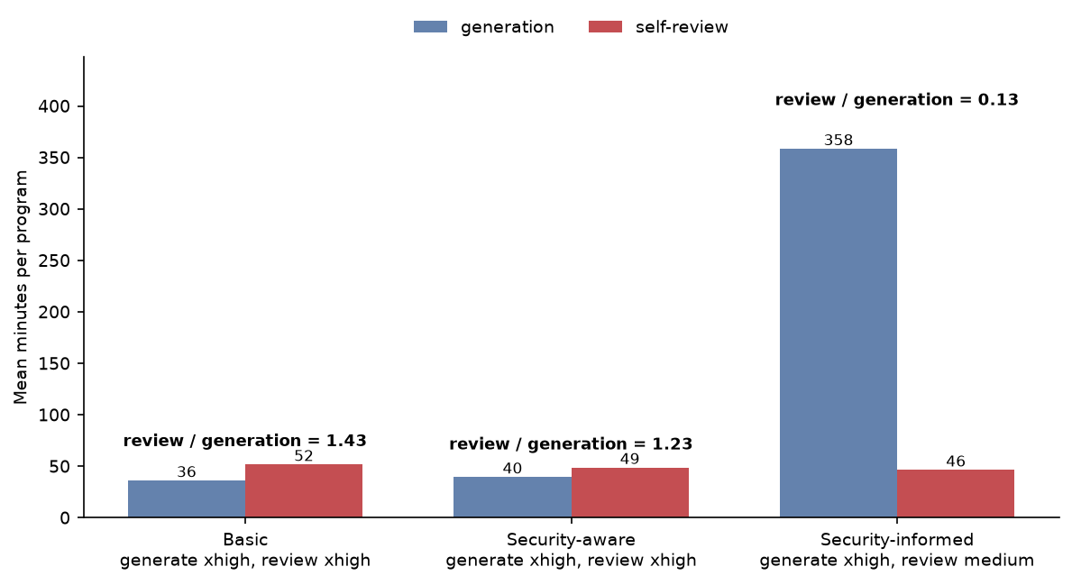
Figure 8: Qwen mean minutes to generate a program and to self-review it, with effort settings · All conditions, Qwen generation and self-review
Figure 8 shows self-review taking longer than generation in Basic and Security-aware when both use xhigh effort. In Security-informed, generation at xhigh is far longer than self-review at medium, reversing that relationship.
Table 5: Qwen generation and self-review time per program, with effort settings · All conditions, Qwen generation and self-review
condition | programs | generation effort | review effort | generation minutes | self-review minutes | review / generation
Basic | 12 | xhigh | xhigh | 36.11 | 51.75 | 1.43
Security-aware | 12 | xhigh | xhigh | 39.56 | 48.76 | 1.23
Security-informed | 6 | xhigh | medium | 358.46 | 46.38 | 0.13

In Table 5, Qwen’s Basic generation and self-review means are 36.11 and 51.75 minutes, and its Security-aware means are 39.56 and 48.76 minutes, with review/generation ratios of 1.43 and 1.23. For Security-informed, generation at xhigh averages 358.46 minutes and self-review at medium averages 46.38 minutes, for a ratio of 0.13.
Table 6: Qwen panel review hours at medium, and estimated at xhigh · Security-informed, Qwen as reviewer
Qwen panel reviews | actual hours at medium | estimated hours at xhigh
6 self-reviews | 4.6 | 47.6
24 reviews (all four generators) | 14.4 | 190.5

Table 6 reports 4.6 actual hours at medium for 6 Qwen self-reviews and 14.4 hours for all 24 reviews. The corresponding xhigh estimates are 47.6 hours and 190.5 hours.
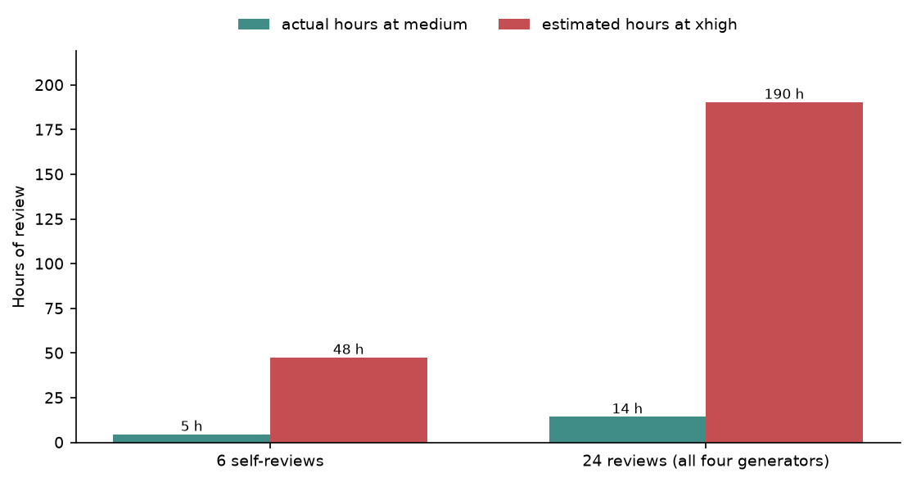
Figure 9: Qwen panel review hours: actual at medium and estimated at xhigh · Security-informed, Qwen as reviewer
Figure 9 shows the estimated xhigh review time far above the actual medium time for both the 6 self-reviews and the full 24-review panel. The gap is visibly larger for the full panel.

Reading these numbers
The headline table aggregates all generation runs by generator and all review runs by reviewer, while the condition and task figures show mean cost per run. Time is omitted wherever the CLI did not report it, and the token measures follow the assistant-specific accounting summarized above. The recovered Claude pilot and Qwen xhigh projections are presented separately from the main run totals.

