## Node.js

**环境变量：**

用户变量：

PATH = C:\Program Files\nodejs\node_global;%MAVEN_HOME%\bin\;

系统变量：

NODE_PATH = C:\Program Files\nodejs\node_global\node_modules

PATH = C:\Program Files\nodejs;

Npm

glup

## maven

**下载maven压缩包：**

apache-maven-3.5.4

**环境变量：**

系统变量：

MAVEN_HOME = D:\development\apache-maven-3.5.4

**检查配置是否成功：**

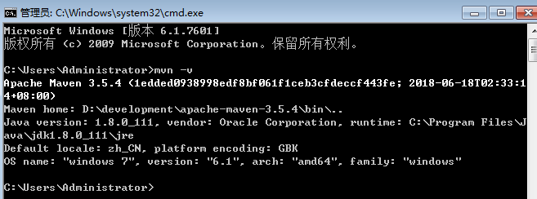

**配置Maven的本地仓库：**

打开之前下载的maven下的conf文件的settings.

并改写自己本地的maven仓库：

<localRepository>D:\development\maven-repository\</localRepository>

添加镜像：

<mirror>

<id>alimaven</id>

<mirrorOf>central</mirrorOf>

<name>aliyun maven</name>

<url>[http://maven.aliyun.com/nexus/content/repositories/central/</url](http://maven.aliyun.com/nexus/content/repositories/central/%3c/url)>

</mirror>

配置JDK：

<profile>

<id>jdk-1.8</id>

<activation>

<jdk>1.8</jdk>

<activeByDefault>true</activeByDefault>

</activation>

<properties>

<maven.compiler.source>1.8</maven.compiler.source>

<maven.compiler.target>1.8</maven.compiler.target>

<maven.compiler.compilerVersion>1.8</maven.compiler.compilerVersion>

</properties>

</profile>

Eclipse中添加maven配置：

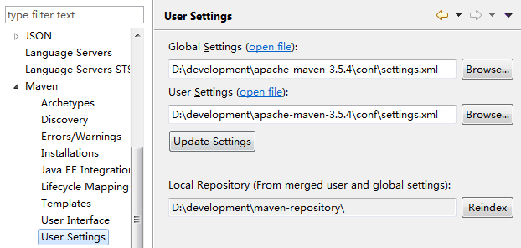

## react

https://blog.csdn.net/daxiazouyizou/article/details/79743832

https://blog.csdn.net/vichou_fa/article/details/54172928