How To... Prerequisites for Windows development

Applicable Releases:

SAP Mobile Platform 3.0

Version 1.0

December 2014

|  |  |
| --- | --- |
| © Copyright 2014 SAP AG. All rights reserved.   1. No part of this publication may be reproduced or transmitted in any form or for any purpose without the express permission of SAP AG. The information contained herein may be changed without prior notice. 2. Some software products marketed by SAP AG and its distributors contain proprietary software components of other software vendors. 3. Microsoft, Windows, Excel, Outlook, and PowerPoint are registered trademarks of Microsoft Corporation. 4. IBM, DB2, DB2 Universal Database, System i, System i5, System p, System p5, System x, System z, System z10, System z9, z10, z9, iSeries, pSeries, xSeries, zSeries, eServer, z/VM, z/OS, i5/OS, S/390, OS/390, OS/400, AS/400, S/390 Parallel Enterprise Server, PowerVM, Power Architecture, POWER6+, POWER6, POWER5+, POWER5, POWER, OpenPower, PowerPC, BatchPipes, BladeCenter, System Storage, GPFS, HACMP, RETAIN, DB2 Connect, RACF, Redbooks, OS/2, Parallel Sysplex, MVS/ESA, AIX, Intelligent Miner, WebSphere, Netfinity, Tivoli and Informix are trademarks or registered trademarks of IBM Corporation. 5. Linux is the registered trademark of Linus Torvalds in the U.S. and other countries. 6. Adobe, the Adobe logo, Acrobat, PostScript, and Reader are either trademarks or registered trademarks of Adobe Systems Incorporated in the United States and/or other countries. 7. Oracle is a registered trademark of Oracle Corporation. 8. UNIX, X/Open, OSF/1, and Motif are registered trademarks of the Open Group. 9. Citrix, ICA, Program Neighborhood, MetaFrame, WinFrame, VideoFrame, and MultiWin are trademarks or registered trademarks of Citrix Systems, Inc. 10. HTML, XML, XHTML and W3C are trademarks or registered trademarks of W3C®, World Wide Web Consortium, Massachusetts Institute of Technology. 11. Java is a registered trademark of Sun Microsystems, Inc. 12. JavaScript is a registered trademark of Sun Microsystems, Inc., used under license for technology invented and implemented by Netscape. 13. SAP, R/3, SAP NetWeaver, Duet, PartnerEdge, ByDesign, SAP BusinessObjects Explorer, StreamWork, and other SAP products and services mentioned herein as well as their respective logos are trademarks or registered trademarks of SAP AG in Germany and other countries.   Business Objects and the Business Objects logo, BusinessObjects, Crystal Reports, Crystal Decisions, Web Intelligence, Xcelsius, and other Business Objects products and services mentioned herein as well as their respective logos are trademarks or registered trademarks of Business Objects Software Ltd. Business Objects is an SAP company.   1. Sybase and Adaptive Server, iAnywhere, Sybase 365, SQL Anywhere, and other Sybase products and services mentioned herein as well as their respective logos are trademarks or registered trademarks of Sybase, Inc. Sybase is an SAP company. | 1. All other product and service names mentioned are the trademarks of their respective companies. Data contained in this document serves informational purposes only. National product specifications may vary. 2. The information in this document is proprietary to SAP. No part of this document may be reproduced, copied, or transmitted in any form or for any purpose without the express prior written permission of SAP AG. 3. This document is a preliminary version and not subject to your license agreement or any other agreement with SAP. This document contains only intended strategies, developments, and functionalities of the SAP® product and is not intended to be binding upon SAP to any particular course of business, product strategy, and/or development. Please note that this document is subject to change and may be changed by SAP at any time without notice. 4. SAP assumes no responsibility for errors or omissions in this document. SAP does not warrant the accuracy or completeness of the information, text, graphics, links, or other items contained within this material. This document is provided without a warranty of any kind, either express or implied, including but not limited to the implied warranties of merchantability, fitness for a particular purpose, or non-infringement. 5. SAP shall have no liability for damages of any kind including without limitation direct, special, indirect, or consequential damages that may result from the use of these materials. This limitation shall not apply in cases of intent or gross negligence. 6. The statutory liability for personal injury and defective products is not affected. SAP has no control over the information that you may access through the use of hot links contained in these materials and does not endorse your use of third-party Web pages nor provide any warranty whatsoever relating to third-party Web pages.   SAP “How-to” Guides are intended to simplify the product implement­tation. While specific product features and procedures typically are explained in a practical business context, it is not implied that those features and procedures are the only approach in solving a specific business problem using SAP NetWeaver. Should you wish to receive additional information, clarification or support, please refer to SAP Consulting.  Any software coding and/or code lines / strings (“Code”) included in this documentation are only examples and are not intended to be used in a productive system environment. The Code is only intended better explain and visualize the syntax and phrasing rules of certain coding. SAP does not warrant the correctness and completeness of the Code given herein, and SAP shall not be liable for errors or damages caused by the usage of the Code, except if such damages were caused by SAP intentionally or grossly negligent.  Disclaimer  Some components of this product are based on Java™. Any code change in these components may cause unpredictable and severe malfunctions and is therefore expressively prohibited, as is any decompilation of these components.  Any Java™ Source Code delivered with this product is only to be used by SAP’s Support Services and may not be modified or altered in any way. |

Document History

|  |  |
| --- | --- |
| Document Version | Description |
| 1.00 | First official release of this guide |

Typographic Conventions

|  |  |
| --- | --- |
| Type Style | Description |
| Example Text | Words or characters quoted from the screen. These include field names, screen titles, pushbuttons labels, menu names, menu paths, and menu options.  Cross-references to other documentation |
| **Example text** | Emphasized words or phrases in body text, graphic titles, and table titles |
| Example text | File and directory names and their paths, messages, names of variables and parameters, source text, and names of installation, upgrade and database tools. |
| Example text | User entry texts. These are words or characters that you enter in the system exactly as they appear in the documentation. |
| <Example text> | Variable user entry. Angle brackets indicate that you replace these words and characters with appropriate entries to make entries in the system. |
| EXAMPLE TEXT | Keys on the keyboard, for example, F2 or ENTER. |

Icons

|  |  |
| --- | --- |
| Icon | Description |
|  | Caution |
|  | Note or Important |
|  | Example |
|  | Recommendation or Tip |

Table of Contents

1. Business Scenario 1

2. Background Information 1

3. Prerequisites 1

4. Step-by-Step Procedure 2

4.1 Visual Studio 2013 Update 4 Community Edition 2

5. Appendix 3

5.1 NuGet Package Manager 3

5.1.1 Adding Windows SMP SDK package in Visual Studio 3

# Business Scenario

Travel Agency X would like to build an online mobile application for its customers, so they can book their flights anywhere, anytime from their devices. The **SAP Mobile Platform** provides a means for them to securely and efficiently access backend flight data exposed by their SAP NetWeaver Gateway system via OData-based REST services.

# Background Information

The goal of this exercise is to install all the necessary development tools for Windows application development.

# Prerequisites

This exercise has the following prerequisites:

* Access to internet
* Windows 8.1 or any Windows machine with .NET 4.5

Note: Windows 8.1 is required to build Windows Store applications. If you do not have Windows 8.1, you can still build WPF applications. In addition, it is recommended to enable hardware settings in BIOS to run Hyper-V.

# Step-by-Step Procedure

The following sections provide a detailed step-by-step procedure on how to install all the necessary development tools for Windows application development.

## Visual Studio 2013 Update 4 Community Edition

1. ...
   1. Browse to <http://www.visualstudio.com/>
   2. Click on Visual Studio – Download

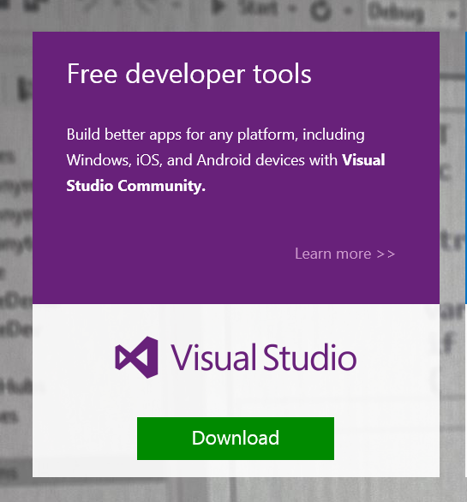

* 1. Click Run and Next. Click Install to complete the installation.

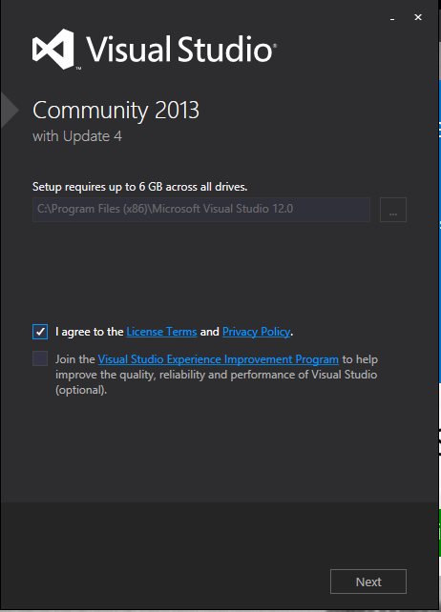 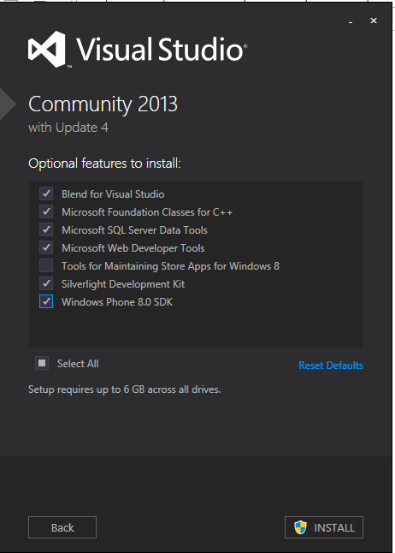

Note: If you don’t have Windows 8.1, the option for Windows Phone 8.0 SDK will not be available. That is alright.

Reboot the machine if prompted to complete the installation.

# Appendix

## NuGet Package Manager

NuGet is the package manager for the Microsoft development platform including .NET. The NuGet client tools provide the ability to produce and consume packages. Starting with Visual Studio 2012, NuGet is included in every edition (except Team Foundation Server) by default. Updates to NuGet can be found through the Extension Manager.

### Adding Windows SMP SDK package in Visual Studio

1. Find the location of the Windows SMP SDK files in your local development machine (default location is C:\SAP\MobileSDK3\NativeSDK\ODataFramework\Windows). (The .nupkg file contains libraries for both Windows Store and Windows desktop)

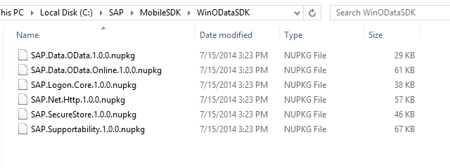

1. Open Visual Studio 2013 with Update 4. Click Tools -> NuGet Package Manager -> Package Manager Settings

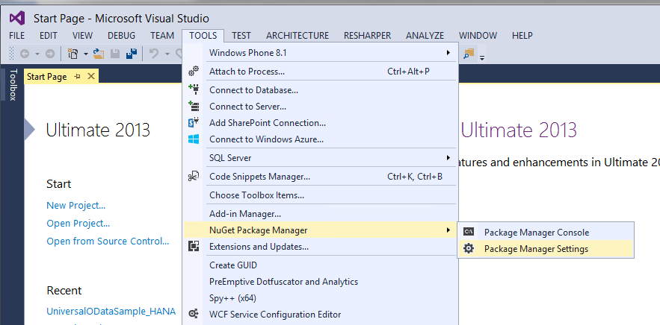

1. Click on NuGet Package Manager -> Package Sources on the left pane. On the right pane, click the + sign on the right pane to add a new package source. Enter a name for the package and browse to the source of the unzipped Windows SMP SDK files. Click Update.

**Name:** Windows SMP SDK

**Source:** C:\SAP\MobileSDK3\NativeSDK\ODataFramework\Windows

