Background
Interpreting log outputs of SAS is very tricky and there are many pitfalls. For example,
- SAS doesn’t display any summary of errors and warnings. (You need to go over all log text every time you run the code, or use “keyword search”.)
- Some critical notes, such as “### (= variable name) is not initialized”, “Merging key is not unique”, etc., are treated as neither ERROR nor WARNING. Therefore, they are difficult to detect.
In this context, I developed an automated log checking macro, which frees you from uncomfortable debugging work.

How to Use
- Create “saslog” folder on the location where your SAS code lies.
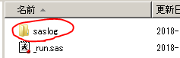

- Enclose your code with the following blocks of code.
/* setup for using log checking macro *********************************************/
%let MAIN_DIR = /* path to where this code is located */;
%let MACRO_DIR = \\srvhfile1\ShareFiles\Actuarial\DD\Tech_Pricing\working_2018\sas_macro;
%include "&MACRO_DIR.\macro_common.sas"; /* import log checking macro */

data _null_ ;
call symputx('EXC_DAY', put(today(), yymmddn.));
call symputx('EXC_TIME', tranwrd(substr(put(datetime(), datetime.), 9, 5), ":", "-"));
run;

%let LOG_FILE_NAME = &MAIN_DIR.\saslog\LOG_&EXC_DAY.-&EXC_TIME..log;
%let LOG_CHACK = &MAIN_DIR.\saslog\LOG_&EXC_DAY.-&EXC_TIME._CHECK.txt;

proc printto log="&LOG_FILE_NAME." new; /* output log as a text file */
run;

/***************************************************************************/
/* your code */
/***************************************************************************/

/* check log *********************************************************/
proc printto; /* stop outputting log as a text file */
run;

%check_log_jp(SASLOG="&LOG_FILE_NAME.", OUTPUT="&LOG_CHACK.");

- Run the code and you get the following two output files in “saslog” folder you created in step1.
  - LOG_YYYYMMDD-HH-mm.log : Log output of your code.
  - LOG_YYYYMMDD-HH-mm_CHECK.txt : Summary of above log.
(YYYYMMDD-HH-mm.log: When you started running the code)
How to Interpret LOG_YYYYMMDD-HH-mm_CHECK.txt
An example of output: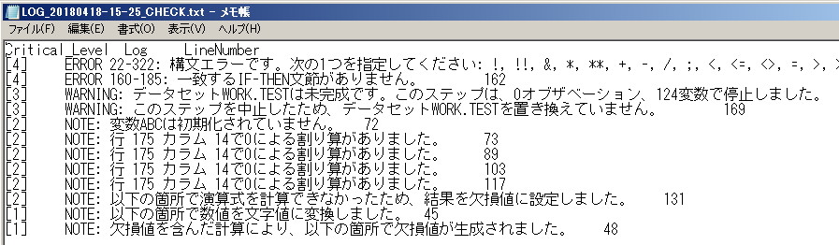
Critical_Level: [1] – [4]
- Special NOTE which tells you something you should not have intended occurred.
- Special NOTE which can cause serious error in the output.
- WARNING.
- ERROR.
Basically, [2] – [4] have to be solved if you want to avoid unexpected errors in the output. In contrast, you don’t necessarily have to solve [1].
Log: Detailed description of special NOTEs, WARNINGs or ERRORs.
LineNumber: The line number in the log files (LOG_YYYYMMDD-HH-mm.log) where you can find corresponding special NOTEs, WARNINGs or ERRORs.

Useful Template
Whenever you want to start coding SAS, I recommend using the following program as a template.
\\srvhfile1\ShareFiles\Actuarial\DD\Tech_Pricing\working_2018\sas_std_format\00_main.sas
This template already has the following features implemented.
- Initial setup for using log-checking macro.
- Having some useful SAS macros frequently used imported.
- Recommended initial setup which improves the performance of SAS.
Steps to use this Template
- Copy 00_main.sas to your working folder. (You can ignore other files, such as 01_cont.sas)
- Overwrite MAIN_DIR with the path to your working folder.
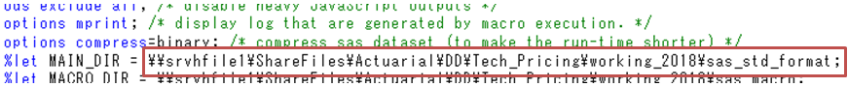
- Create “saslog” folder on your working folder.
- Start coding.

