Summary of motor contract data
Motor contract data is the one which we use the most frequently for daily analysis. It contains policy information for all our motor customers, including ex-customers.
Location | File name | Update Frequency | Update date
\\srvhsas3\DD\Library\MA020_weekly | contract.sas7bdat | Weekly | Every Sunday morning
\\srvhsas3\DD\Library\MA030_monthly | contract.sas7bdat | Monthly | 1th~2th every month
\\srvhfile1\ShareFiles\Technical\... | cnYYMMDD.sas7bdat | Monthly | 3th~5th every month

- Weekly contract data includes policy info that has been registered in ADJ’s system until the end of last Saturday.
- Monthly contract data includes policy info that has been registered until the end of last month.
- cnYYMMDD is monthly contract data as of the end of YYMMDD. (Let’s say today is 7th Apr 2017, then monthly contract data is completely the same as cn170331)

Terms definition: “Customer” vs. “Policy” vs. “Transaction”
A customer refers to a person who bought our insurance.
A policy refers to an insurance contract from its inception to maturity date.
A transaction refers to an insurance contract between points when the policy info is changed.
e.g.) imagine the following situation.
- You bought one-year-effective insurance about a year and a half ago and still stay in the same insurance now.
(Which means you renewed your contract when you got to maturity date once.)
- You changed your policy info during the previous contract (e.g. you replaced your old car with a new one).
- You have never changed your policy info since the new insurance period started.
In this case, you are a customer, and you have 2 polices and 3 transactions in our database.

Basic structure of contract data
Rows
- A row (or a record) represents a transaction. (Not a customer or a policy)
Important Columns
- PAR_ID: Customer ID which represents a customer (called Partner ID)
- POL_NUM: Policy ID which represents a policy.
- NUMBER: Policy version (1, 2, 3 …). The combination of POL_NUM and NUMBER represents a transaction.
(Accordingly, the combination of POL_NUM and NUMBER is the unique key of contract dataset.)
- DTINC_CO: Inception date – Insurance starting date of a policy.
- DT_EFFEC: Transaction starting date. This definition is not perfectly correct so you need to modify this column if you need true transaction starting date. (How? See next chapter).
- AIP_{COVER}: Annual premium per covers (perils).
- TARCODE: Tariff code (00001: Auto, 00004: Bike, 00005: Moped)

(Continue on next page)

Pre-processing required before using contract data
- Remove some wrong transactions (inserted by error of ADJ’s system)
- Add some important columns frequently used, such as
  - Maturity date of a policy
  - Corrected transaction starting date
  - Transaction ending date
  - Renewal times
These pre-processing are very tricky to implement so I prepared SAS macros which perform them.

SAS macros for pre-processing
Location: \\srvhfile1\ShareFiles\Actuarial\DD\Tech_Pricing\working_2018\sas_macro\macro_motor.sas
The following are the descriptions of each macro for contract data.
ini_policy(INPUT=, OUTPUT=)
- This macro adds the following columns to INPUT contract data.
  - AIP_FB: Annual premium of Family Bike
  - AIP_AXAP: Annual premium of AXA-Plus
  - AIP_TOTAL: Total annual premium for all perils
  - DTEXP_CO: Maturity date of a policy
  - RN_TIME: Renewal times
- It corrects contents of some columns.
  - Convert missing value of AIP_{COVERS} to 0
  - Correct wrong PAR_ID
  - Correct wrong TARCODE
calc_trans_period(INPUT=, OUTPUT=)
- This macro adds the following columns to INPUT contract data.
  - TRN_BEG: Corrected transaction starting date
  - TRN_END: Transaction ending date
  - TRN_PERIOD: Transaction period (= TRN_END – TRN_BEG)
- Important note: ini_policy has to be applied to INPUT data before you do this macro.
rem_ineffective_pol(INPUT=, OUTPUT=)
- This macro removes some wrong transactions (inserted by error of ADJ’s system)
- Important note: calc_trans_period has to be applied to INPUT data before you do this macro.

(Continue on next page)

Useful Template
If you use Useful Template introduced in “0_log_checking_macro.docx”, above macros are already imported.
\\srvhfile1\ShareFiles\Actuarial\DD\Tech_Pricing\working_2018\sas_std_format\00_main.sas
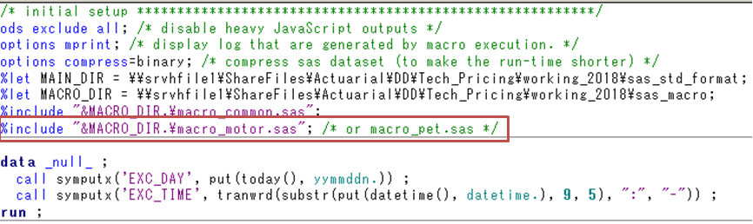
Also, it demonstrates exactly how to use those macros.
