Summary of motor claim data
This data contains all claim information which our motor customers have declared since we launched the product.
Location | File name | Update Frequency | Update date
\\srvhsas3\DD\Library\CL010DWH | claim.sas7bdat | Weekly | Every Monday morning
\\srvhsas3\DD\Library\CL060MonthlyData | claim.sas7bdat | Monthly | 1th~2th every month
\\srvhfile1\ShareFiles\Technical\... | clYYMMDD.sas7bdat | Monthly | 3th~5th every month

- Weekly claim data includes claim info that has been declared or modified until the end of last Sunday.
- Monthly claim data includes claim info that has been declared or modified until the end of last month.
- clYYMMDD is monthly claim data as of the end of YYMMDD. (Let’s say today is 7th Apr 2017, then monthly claim data is completely the same as cl170331)

Terms definition: “Event” vs. “Claim”
An event refers to an accident whose loss is (entirely or partly) covered by ADJ’s insurance.
A claim refers to a specific coverage for an event, such as BI, PD, PA…
e.g.) imagine the following situation.
- You had two vehicle accidents during a one-year insurance contract.
- One accident is covered by BI and PI, and another is covered by PD, OD.
In this case, during the one-year contract, you had 2 events and 4 claims.

Terms definition: “OS” vs. “Paid” vs. “Incurred”
OS (= outstanding loss) is an amount of insurance estimated by claim service.
Paid is an amount of insurance actually paid to a customer.
Incurred = OS + Paid.
Technically speaking, both OS, Paid and Incurred include claim handling cost, such as train fee to visit the accident place, outsourcing investigation fee, etc.

Basic structure of claim data
Rows
- A row (or a record) represents a claim. (Not an event)
Important Columns
- POL_NUM: Policy ID which represents a policy.
- NUMBER: Policy version (1, 2, 3 …). It has wrong info, so needs to be corrected. (How? See next chapter)
- EV_NBR: Event number, which identifies an event.
- EV_DTOCC: Event occurrence date.
- EV_DTNOT: Event declared date.
- CL_NBR: Claim number, which identifies a claim.
If CL_NBR is missing value, it means that an event has been declared by a customer but it cannot be covered by any coverage, hence, the accident cannot be insured by ADJ.
If you remove missing CL_NBR from the table, CL_NBR is a unique key.
If you don’t remove them, the combination of EV_NBR and CL_NBR is a unique key.
- PBB_NBR: Coverage code.
- SCOV_NBR: Sub coverage code.
You can find detailed definition of PBB_NBR and SCOV_NBR here.
\\srvhfile1\ShareFiles\Actuarial\DD\Tech_Pricing\working_2018\data_description\coverage_code.xlsx
- OUT_S, ACT_REC, PAY_CL, etc.: Insurance amount related columns. To calculate OS, Paid and Incurred, you need to manipulate these columns. But don’t worry; I prepared SAS macros to calculate them easily.

SAS macros for pre-processing of claim data
Location: \\srvhfile1\ShareFiles\Actuarial\DD\Tech_Pricing\working_2018\sas_macro\macro_motor.sas
The following are the descriptions of each macro for claim data.
ini_claim(INPUT=, OUTPUT=)
- This macro adds the following columns to INPUT contract data.
  - INC: Incurred (incl. claim handling cost)
  - OS: OS (incl. claim handling cost)
  - PAID: Paid (incl. claim handling cost)
  - INC_EXCL_EX: Incurred (excl. claim handling cost)
  - OS_EXCL_EX: OS (excl. claim handling cost)
  - PAID_EXCL_EX: Paid (excl. claim handling cost)
  - INC_EX: INC – INC_EXCL_EX
  - OS_EX: OS – OS_EXCL_EX
  - PAID_EX: PAID – PAID_EXCL_EX
  - CAT_Code: Natural disaster code, which identifies a natural disaster that caused the event.
  - CAT: Natural disaster flag. If the event was caused by a natural disaster then 1, else 0
  - EV_GROUP: If the event occurred while driving then “Driving”, else “Other”.
policy_version_correction(INPUT_CLM=, OUTPUT_CLM=, INPUT_CNT=, TRN_BEG_V=, TRN_END_V=)
- This macro corrects NUMBER column of INPUT_CLM data.
- To correct NUMBER, we need to use contract data, and it is to be specified into INPUT_CNT.
- Also INPUT_CNT has to contain Transaction staring date and ending date, which means calc_trans_period , which is introduced in “1_motor_contract_data.docx”, needs to be applied to INPUT_CNT. And their column name (e.g. TRN_BEG, TRN_END) has to be passed to TRN_BEG_V and TRN_END_V.

(Continue on next page)

Useful Template
If you use Useful Template introduced in “0_log_checking_macro.docx”, above macros are already imported.
\\srvhfile1\ShareFiles\Actuarial\DD\Tech_Pricing\working_2018\sas_std_format\00_main.sas
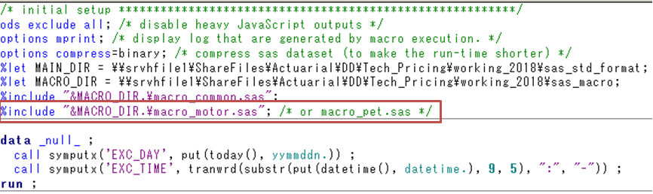
Also, it demonstrates exactly how to use those macros.
