MFDStudio - Detailed User Guide
design in `mfd_editor`, C++17 API generation, live client integration, framebuffer plugin, and launch scripts
Document generated on 2026-05-07 20:59
Scope: editor, architecture, generator, client API, framebuffer plugin, launch scripts
Target audience: MFD authors, C++ integrators, and runtime teams

Target document:
- MFD page and window authors
- C++ integrators who must control a window live
- teams who want to capture the framebuffer via a DLL plugin

Table of Contents
Table of Contents 2
1. What is MFDStudio 7
1.1 The main components 8
1.2 The minimum mental model 9
1.3 Who does MFDStudio serve? 11
1.4 What MFDStudio is not 11
2. Detailed Architecture 12
2.1 Depot modules 12
2.2 Author / runtime / client separation 12
2.3 The role of the file .generated.map 13
2.4 Runtime loop and feedback 13
2.5 Author model 14
2.6 Practical consequences for integration 14
3. Prerequisites and tools to build 15
3.1 Recommended Toolchain 15
3.2 Build local recommends 15
3.3 Useful binaries as needed 15
3.4 Tree structure to know 15
4. Use mfd_editor to design a window and its pages 16
4.1 Launch the editor 17
4.2 Anatomy of the interface 17
4.3 Create a new window 17
4.4 Configure UDP transports 17
Incoming commands to window 18
Feedback coming out of runtime to clients 18
4.5 Create a first page 18
4.6 Save what the editor writes 18
4.7 Add, choose and organize pages 19
4.8 Design of a page: layers, static reticles, dynamic bindings, strobe 19
Page layers 19
Static reticles 19
Dynamic reticle bindings 19
Page strobe 19
4.9 Important page fields 19
4.10 Supported primitives for constructing reticles 20
4.11 Selection and direct editing on the canvas 21
4.12 Menu View from the preview 21
Fullscreen preview 21
4.13 Layer Focus Mode 21
4.14 Import an existing page 22
4.15 Delete or detach a page 22
4.16 Properly rename a shared page 24
4.17 Properly renaming a shared reticle template 25
4.18 Highlight use of a template 25
4.19 Export of design documentation 25
4.20 Recommended authoring checklist 26
5. Generate the client API from the generator 27
5.1 Entry, exit, contract 27
5.2 Official CMake macro 27
5.3 client_api_generate_ui arguments 27
5.4 What the CMake macro does 28
5.5 Underlying Python script 29
5.6 Important generation rules 29
5.7 Rules for exposing primitives 29
5.8 What the generated API contains 30
5.9 What it contains .generated.map 30
5.10 Example of integration into a CMake target 31
5.11 When to regenerate 31
5.12 Common causes of generation failure 31
6. Use the generated API to communicate with a window 32
6.1 Two layers to distinguish 32
6.2 Load window configuration 33
6.3 Create the CommandClient 33
6.4 Generated UI root 33
6.5 Page wrappers 34
6.6 Activate a page and adjust its view 34
6.7 Modify the overall window display 35
6.8 Mutate a static reticle 35
Common reticle surface 35
6.9 Using exposed primitive handles 36
Common primitive surface 36
Specialized surfaces 36
Example of exposed primitive 37
6.10 Manage dynamic reticles 37
Surface of one generated dynamic set 37
What the dynamic set hides 37
6.11 Publish in batches 38
Batch without sequence 38
Batch with sequence and mappingHash 38
6.12 Use LatestBatchPublisher 38
6.13 Use strobe and feedback 38
6.14 What feedback guarantees 39
6.15 Client sanitization and hygiene 39
6.16 When to use raw API 39
6.17 Minimal end-to-end example 39
7. Write a framebuffer capture DLL plugin 41
7.1 Why a stable C ABI 41
7.2 Mandatory entry point 41
7.3 Structure MfdWindowFramebufferPluginApi 41
7.4 Structure MfdWindowFramebufferPluginInfo 42
7.5 Structure MfdWindowFramebufferFrame 42
7.6 Validation helpers provided 42
7.7 Plugin lifecycle 43
7.8 Minimal plugin skeleton 43
7.9 Example of repository reference plugin 45
7.10 What to do in submit_frame 45
7.11 What not to do 45
7.12 Practical consumption strategy 45
7.13 CMake build of the plugin 46
7.14 Recommended testing strategy 46
8. Launch a window with a script and a framebuffer plugin 47
8.1 Use of the script 49
8.2 Supported arguments 49
8.3 Runtime resolution 49
8.4 Plugin resolution 49
8.5 Example with the minimal script from the repository 50
8.6 Explicit example with custom plugin 50
8.8 Write your own project launch script 50
8.9 Launch checklist with plugin 50
8.10 If the plugin does not load 51
9. Overall Checklist Recommends 52
9.1 Complete project workflow 52
9.2 Design errors to avoid 52
9.3 Most important files to know 52
9.4 Conclusion 52
The table of contents will be updated by Word.

1. What is MFDStudio
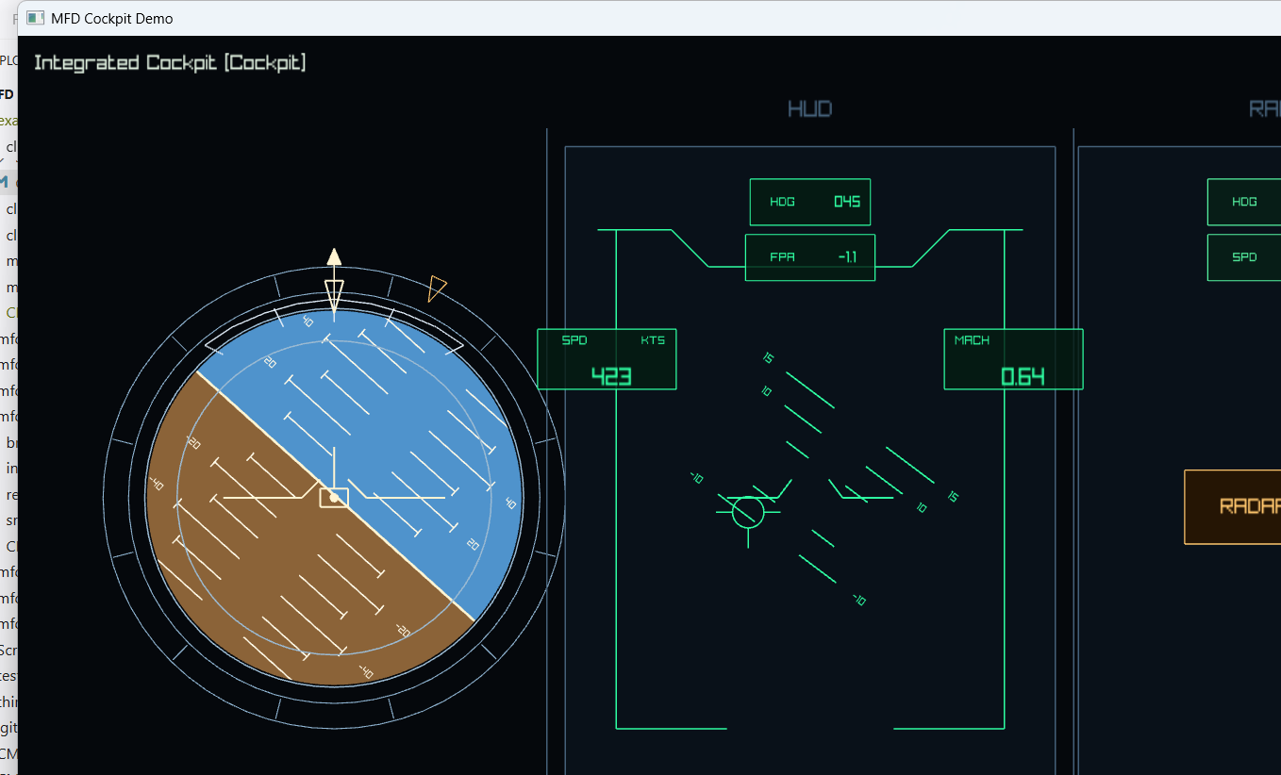
Cockpit runtime screenshot
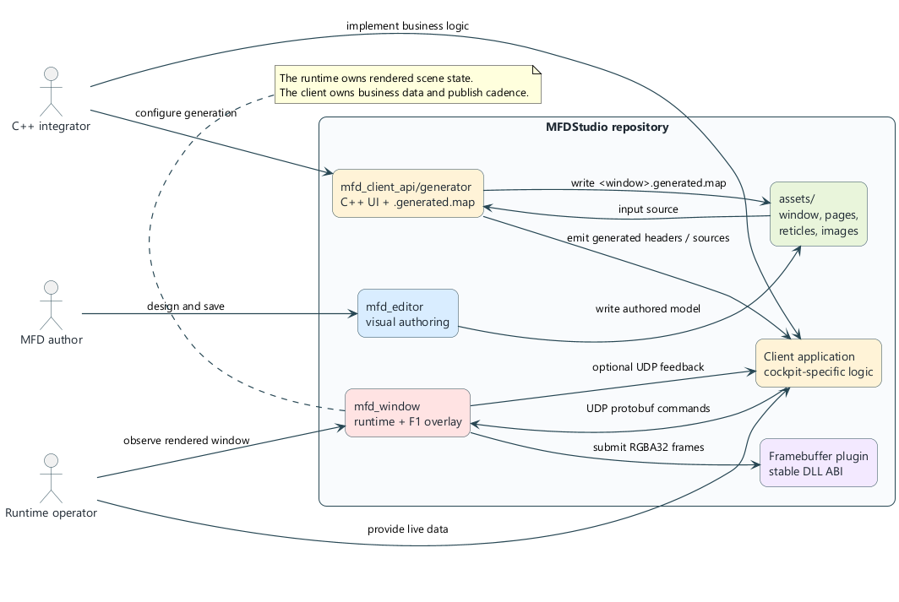
MFDStudio Overview
MFDStudio is a C++17 / CMake toolbox for designing, executing and controlling MFD type 2D windows from JSON files. The repository voluntarily separates three responsibilities:
- the content author defines versioned assets: window, pages, reticles, images, fonts
- the runtime mfd_window loads these assets and renders the active page
- the external client sends live commands via UDP to modify the runtime state without rewriting the assets
The historical technical prefix of the repository remains mfd in namespaces, CMake targets, folders, and public APIs. You must therefore distinguish:
- the product name: MFDStudio
- the technical prefix: mfd

1.1 The main components
Component | Role
mfd_editor | visual tool for authoring windows, pages, and reticles
assets/ | versioned source of truth
mfd_client_api/generator | generates typed C++ wrappers and the companion .generated.map file
mfd_window | runtime host that opens a JSON window, renders the active page, and accepts live commands
client_mockup | reference client that shows how to use the public API
mfd_window_plugin_api | stable C ABI for framebuffer capture DLL plugins

1.2 The minimum mental model
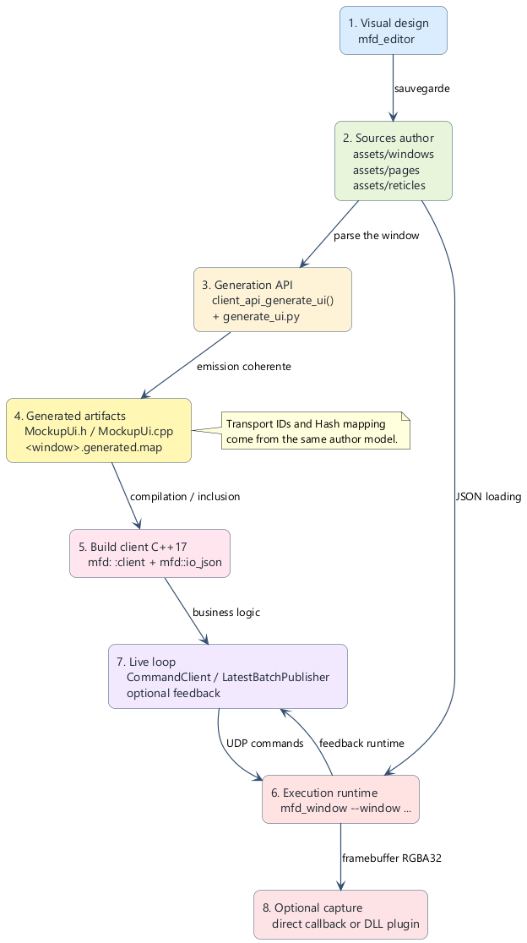
Pipeline authoring to runtime
The normal flow of an MFDStudio project is as follows:
- 1. we author a window and its pages in assets/ with mfd_editor
- 2. we generate a C++ client API specific to this window
- 3. we compile a business client which uses this generated API
- 4. we launch mfd_window on the JSON window
- 5. the client sends UDP commands to the runtime
- 6. the runtime can send UDP feedback to the client
- 7. optional, a DLL plugin receives the RGBA32 framebuffer at each frame

1.3 Who does MFDStudio serve?
MFDStudio is suitable when you need:
- cleanly separate graphic authoring and real-time logic
- keep a readable and versionable author model
- drive pages by an external client without embedding the rendering engine in the client
- generate C++ type wrappers from an author window
- plug a framebuffer capture pipeline into a stable DLL ABI

1.4 What MFDStudio is not
MFDStudio is not:
- a general Qt-type UI framework
- a 3D scene authoring system
- a generic network protocol independent of assets
- a plugin system open to any C++ ABI
Important: The runtime remains the owner of the scene state and the rendering. The client remains the owner of the business data and the transmission rate. It is this separation that gives stability to architecture.

2. Detailed Architecture
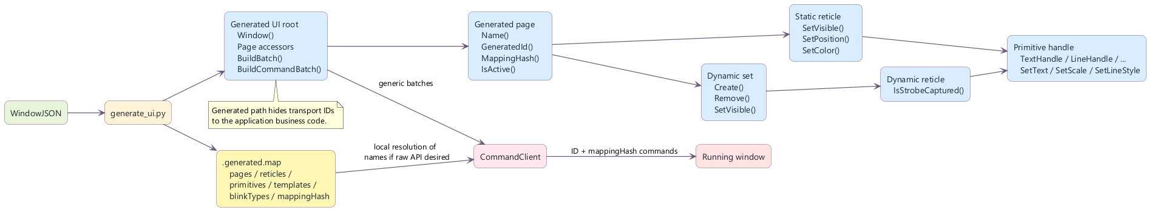
API and transport model
The repository architecture is modular. Each module keeps a deliberately narrow responsibility.

2.1 Depot modules
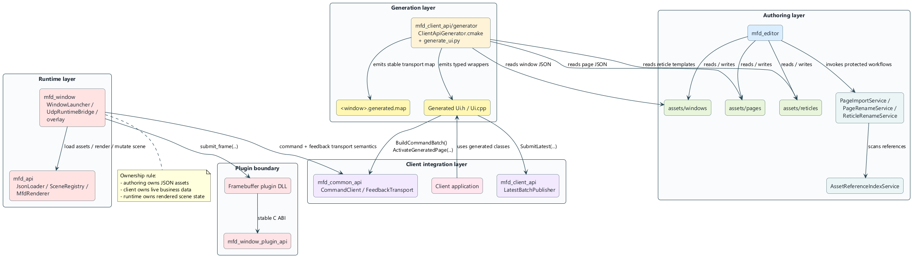
Modular layers of the repository
Module | Primary Responsibility
mfd_common_api | common types, low-level authoring model, transport and commands
mfd_api | loading JSON, runtime, rendering, scene registry
mfd_client_api | client overlay: handles, batching, publication, feedback
mfd_client_api/generator | derives a C++ UI and a transport map from a JSON window
mfd_editor | visual authoring and protected workflows on assets
mfd_window | generic runtime launcher and debug overlay
mfd_window_plugin_api | Stable C contract for framebuffer capture plugins
examples/ | reference clients and plugins

2.2 Author / runtime / client separation
The architecture is based on three layers which must not be mixed:
Layer | Possessed | Must not own
Authoring | visual structure and JSON assets | live business logic
Runtime | rendering and state authoritarian scene | knowledge of the customer business domain
Customer | live data, cadence, control intentions | the window rendering engine

2.3 The role of the file .generated.map
The generator emits two coherent artifacts:
- a C++ header/source generated for the client
- a <window>.generated.map file
The .generated.map contains stable transport IDs for:
- the pages
- static reticles
- the primitives exposed
- dynamic templates
- the blink types
It also contains a mappingHash used to prove that the client and the window are talking about the same author model.

2.4 Runtime loop and feedback
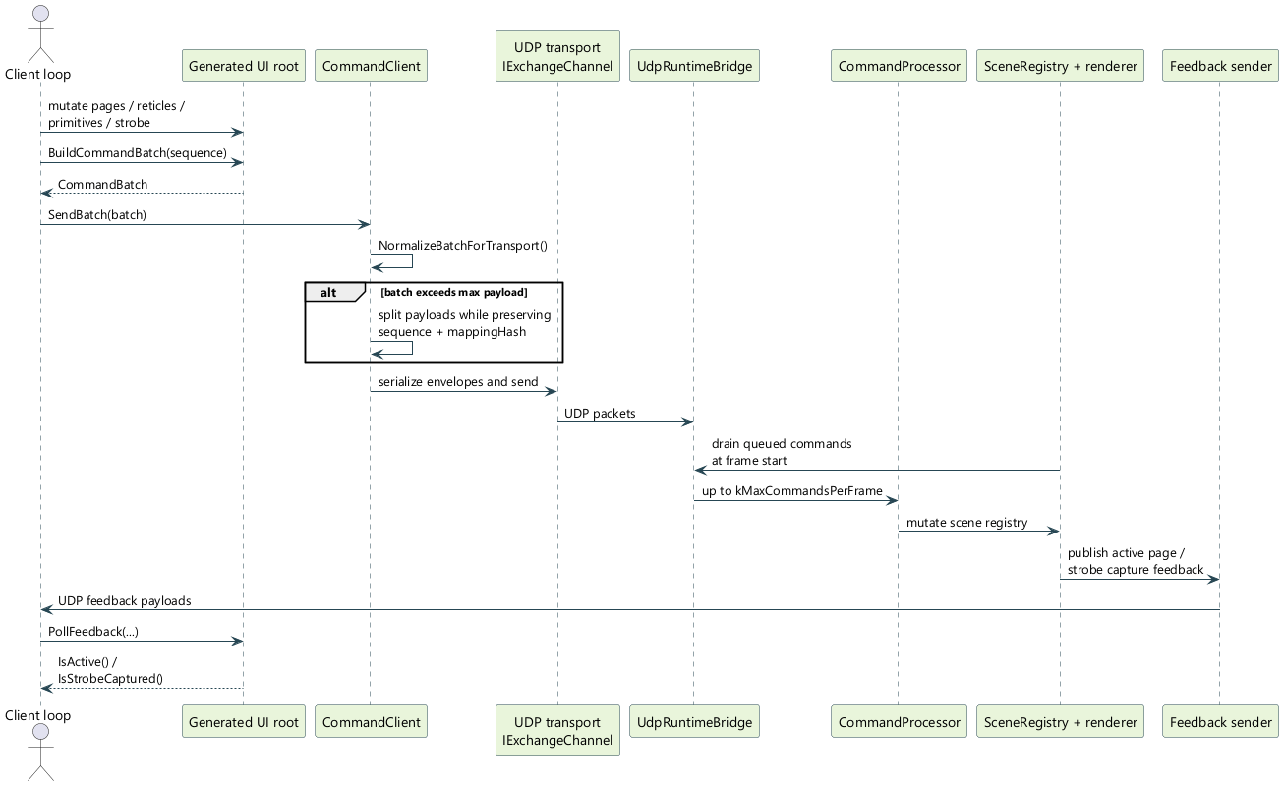
Command sequence and feedback
In the recommended mode:
- a UDP worker receives command packets
- the render thread drains commands at the start of the frame
- the runtime applies the mutations via the CommandProcessor and the scene
- the runtime can send authoritative feedback to the client
This feedback is used in particular to:
- the active page rendered
- the resolved state of the strobe
- capturing a dynamic reticle by the strobe

2.5 Author model
The minimal author model is:
- a window
- a list of pages
- of the staticReticles instances on each page
- a folder of reusable reticle templates
- of the dynamicReticleBindings on the pages
- A strobe optional per page
- of the blinkTypes defined at page level
The logical author and client coordinates are normalized in [-1, 1].

2.6 Practical consequences for integration
For a clean integration:
- authoring the visual structure into JSON
- only expose the necessary primitives to the client
- use the generated API rather than text names everywhere
- preserve CommandClient as final sending layer
- reserve framebuffer plugins for image output, not for business control

3. Prerequisites and tools to build

3.1 Recommended Toolchain
The target deposit in practice:
- Visual Studio 2022
- CMake 3.25 or higher
- C++17
- Python 3 for the generator

3.2 Build local recommends
The preferred local flow is Debug Win32:
cmake --preset vs2022-win32
cmake --build --preset debug-win32
ctest --preset test-debug-win32

3.3 Useful binaries as needed
To author and test the main flow:
cmake --preset vs2022-win32
cmake --build --preset debug-win32 --target mfd_window mfd_framebuffer_stdout_plugin client_mockup mfd_editor
For one specific generated client:
cmake --build --preset debug-win32 --target client_mockup_minimal

3.4 Tree structure to know
Case | Expected content
assets/windows | JSON root windows
assets/pages | JSON pages
assets/reticles | reticle templates
assets/fonts | possible fonts
examples | reference clients and plugins
Scripts | launch batches
_Exec | runtime staging regenerated by the build
Recommendation: Author in assets/and not in _Exec . _Exec is a runtime staging area, not the long-term source of truth.

4. Use mfd_editor to design a window and its pages
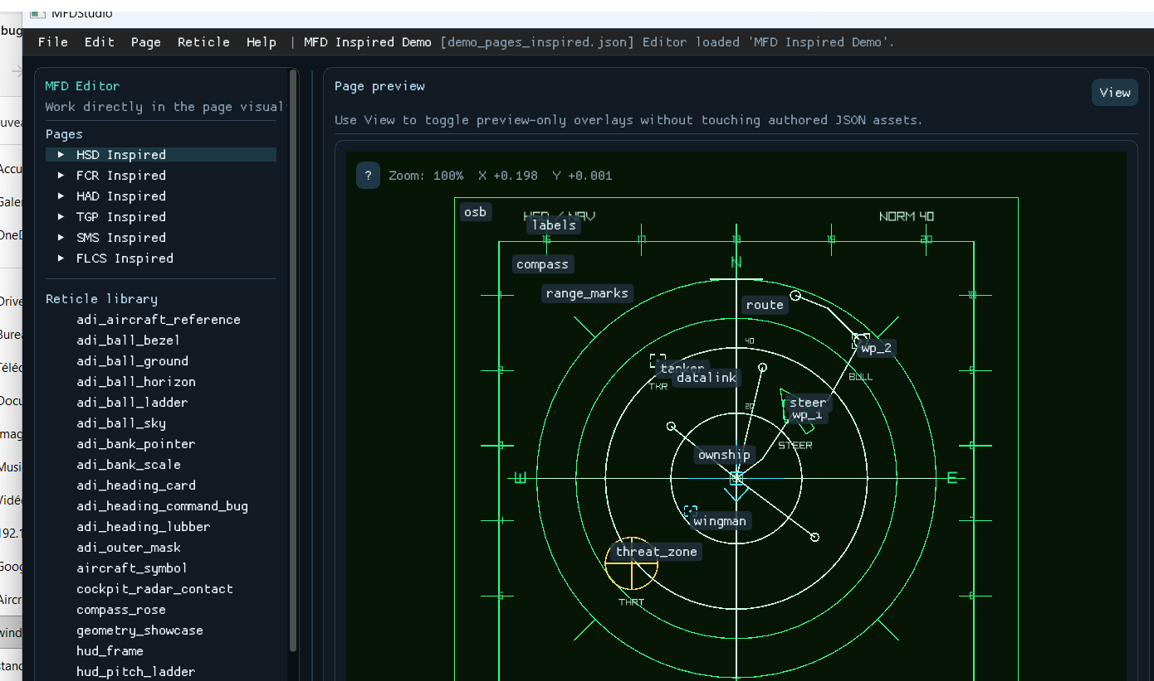
`mfd_editor` screenshot
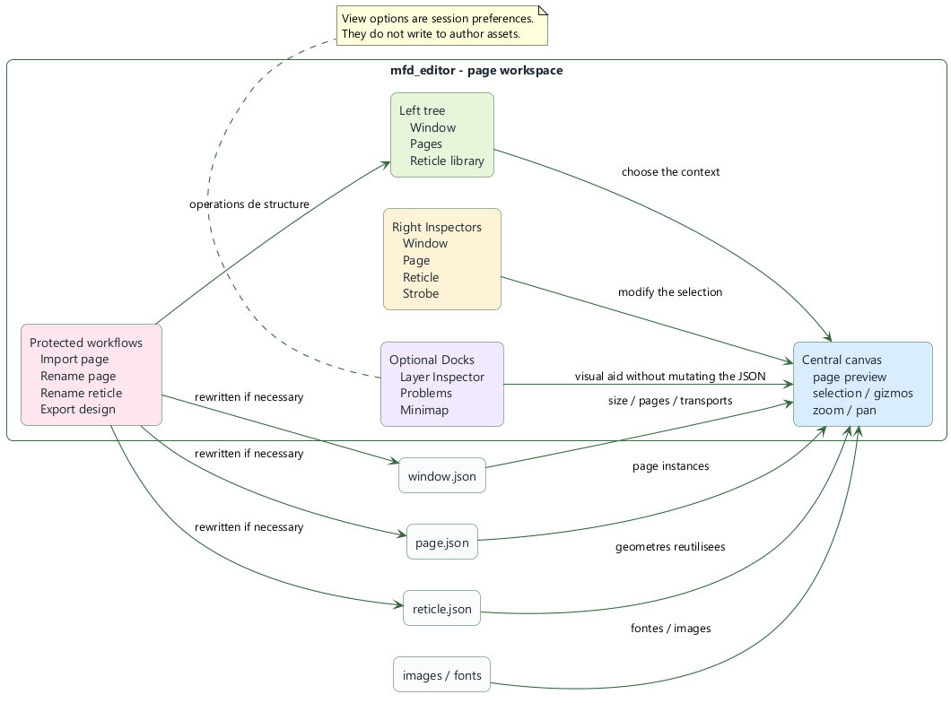
Editor workspace
This section describes how to use mfd_editor in detail to author a window, its pages, its reticles, and the associated asset-maintenance workflows.

4.1 Launch the editor
Once mfd_editor is built:
- launch mfd_editor.exe
- or launch the staged executable under _Exec
At startup, the editor does not automatically reload a copy from _Exec. It opens an empty document until the user:
- load an existing window
- or create a new window

4.2 Anatomy of the interface
The editor is organized around four areas:
Area | Use
left shaft | window, pages, reticle library
central canvas | page preview, selection, gizmos, zoom/pan
straight inspectors | contextual window editing, page, reticle, strobe
optional docks | Layer Inspector, Problems, Minimap
The preview remains the main surface. The Dockes panels reserve a real space and must not hide the canvas.

4.3 Create a new window
Menu:
- File > New window from scratch
The popup allows you to enter:
Field | Sense
Window file | path of the JSON window to create
Window title | title visible from window
Size (px) | window width/height
Position (px) | initial screen position
Font file (optional) | font used for text rendering
Reticle library folder | reusable templates folder
These fields correspond directly to the root of the JSON window.

4.4 Configure UDP transports
The editor exposes two configuration groups.

Incoming commands to window
Option | Effect
Enable command UDP | activates the command entry point
Command address | IPv4 listening or link address
Command port | UDP port
Command max packet | max size of a datagram

Feedback coming out of runtime to clients
Option | Effect
Enable feedback UDP | activates the return flow
Feedback address | target IPv4 address
Feedback port | UDP feedback port
Feedback max packet | max datagram size
For a single position, use 127.0.0.1.

4.5 Create a first page
During window creation, you can activate Create one initial page then enter:
Field | Sense
First page name | public page name
First page title | human title
First page file | JSON page path
First page background | background color
This first page becomes the defaultPage.

4.6 Save what the editor writes
The document first exists in memory. Nothing persists until the user does:
- File > Save
The writing may concern:
- the JSON window
- the JSON of the initial page
- reticle templates if the workflow has created them

4.7 Add, choose and organize pages
To add a page:
- Page > New page
To choose the default page:
- select the page in the tree
- enable Default page for this window in the page inspector

4.8 Design of a page: layers, static reticles, dynamic bindings, strobe

Page layers
Each page declares layers orders. They are the runtime source of truth for the drawing order.

Static reticles
A page can contain staticReticles :
- either library template instances
- either reticles inline
Each instance aims at layerId.

Dynamic reticle bindings
Section Dynamic reticles in the page inspector:
- 1. choose one Reticle template
- 2. choose one Layer
- 3. to click Add
Each entry creates a runtime binding, not a static instance drawn by default. The live client will then create the real runtime instances.

Page strobe
A page can expose a strobe optional. The editor allows you to assign a strobe template, its initial position and its capture/magnetization configuration.

4.9 Important page fields
The JSON page supports in particular:
Canonical field | Use
name | public page name
title | human title
backgroundColor | bottom
layers | ordered runtime layers
dynamicReticleBindings | dynamic templates allowed on the page
blinkTypes | page blink types
defaultBlink | blink by default
view.center | center of view
view.zoom | zoom
staticReticles | static reticles
strobe | optional strobe

4.10 Supported primitives for constructing reticles
The families of primitives supported by the author model are:
Primitive | Typical usage | Specific fields
text | labels, values | text, fontSize, letterSpacing
time | clock | format, utc, fontSize, letterSpacing
line | features | start, end
circle | markers | radius
ring | crowns | innerRadius, outerRadius, segments
rectangle | panels | width, height, size
ellipse | oval markers | width, height, radiusX, radiusY
square | square markers | size, width, height
diamond | waypoints | size, width, height
triangle | pointers | points
polyline | roads, frames | points, closed
bezier | curves | controlPoints, segments
arc | sectors, arcs | radius, startAngleDegrees, endAngleDegrees, segments
image | bitmaps | file, width, height, size
Common primitive fields cover:
- position
- rotationDegrees
- scale
- visible
- stroke
- thickness
- lineStyle
- filled
- fill

4.11 Selection and direct editing on the canvas
The page preview supports:
- Ctrl+click to add or remove a reticle from the selection
- Esc to empty the selection
- dragging a selection to move a group
- Ctrl+C, Ctrl+X, Ctrl+V, Del
In case of superimposed reticles:
- 1. right click in the area
- 2. choice of the desired reticle in the context menu
- 3. copy/cut/delete operations on the current selection

4.12 Menu View from the preview
The available toggles are:
Option View | Effect
Layer Inspector | layer dock and focus by layer
Minimap | mini navigation view
Problems | dockes diagnostics
Highlight reticle usages | highlights the pages that reference the selected template
Reticle names | displays names
Gizmos | shows visual manipulations
Page context | preview context linked to the page
These options are session preferences. They do not rewrite the author JSON.

Fullscreen preview
The button [], F11 Or Esc allows you to:
- hide sidebar, inspectors and docks
- keep the canvas interactive
- restore the previous state then

4.13 Layer Focus Mode
THE Layer Inspector allow :
- duty Full View
- to list the runtime layers
- to display a thumbnail and a counter per layer
- to focus a layer to leave only its reticles editable
The other visible layers remain rendered, but dimmed.

4.14 Import an existing page
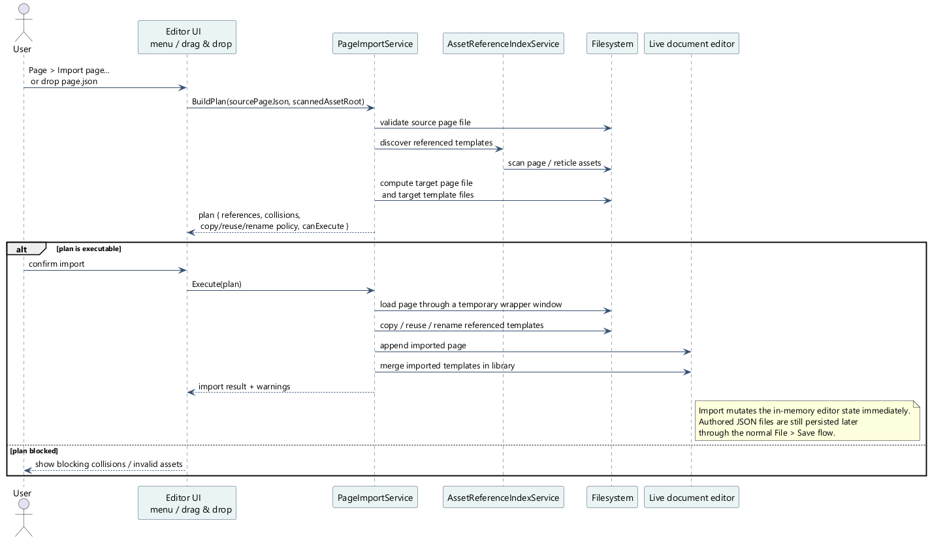
Page import sequence in the editor
Entries:
- Page > Import page...
- or drag and drop a page JSON
The workflow calculates a plan before execution:
- source page
- target in current tree
- template references
- collisions
- copy/reuse/rename strategy
The current rules are:
- target file missing: copy
- identical file already present: reuse
- different file already present: creation of a renamed copy

4.15 Delete or detach a page
Two distinct actions exist:
Action | Effect
Remove page from window | removes the page from the current window but keeps the file
Delete page asset... | removes the page and marks its JSON for deletion
Security guards:
- the window must keep at least one page
- we do not delete the default page without choosing another one
- deletion out assets/ blocked without explicit override

4.16 Properly rename a shared page
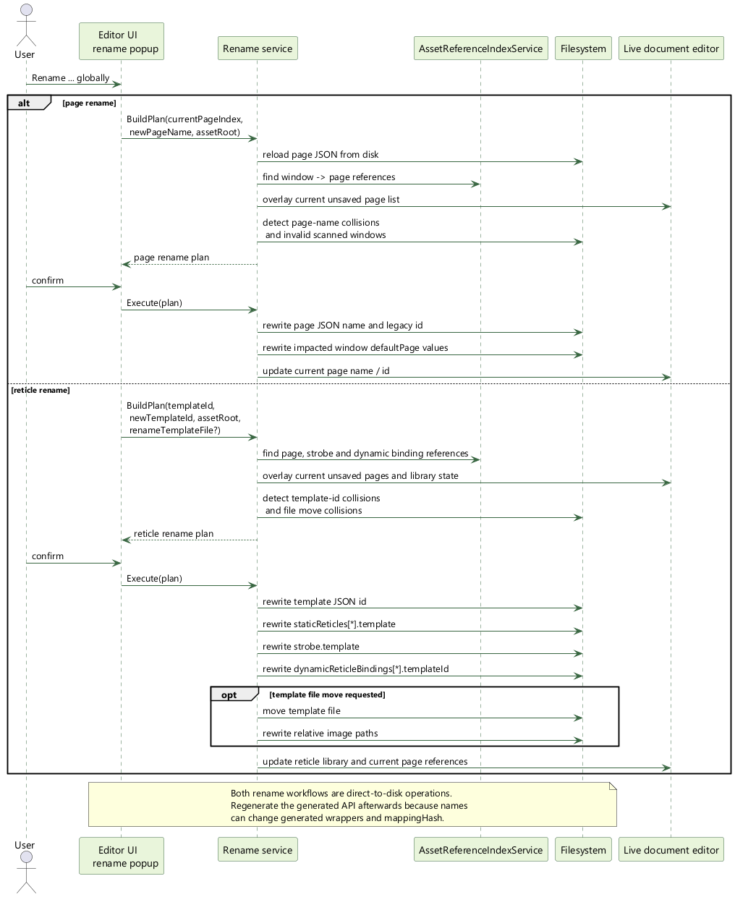
Global page/reticle rename sequence
Entries:
- right click page Rename page globally...
- inspector button
- menu Page > Rename current page globally...
The rename service:
- rescan references window -> page
- rewrites the page JSON
- rewrite the defaultPage impacts
- blocks collisions before any mutation
- warns that the generated API and the mappingHash can change

4.17 Properly renaming a shared reticle template
Entries:
- right click template Rename reticle globally...
- inspector button
- menu Reticle > Rename selected library reticle globally...
The workflow:
- rewrite the id of the template
- rewritten staticReticles[*].template
- rewritten strobe.template
- rewritten dynamicReticleBindings[*].templateId
- can also rename the template file
- updates relative image paths if file moves

4.18 Highlight use of a template
Normal flow:
- 1. select a reticle template in the tree
- 2. enable View > Highlight reticle usages
- 3. the editor highlights:
- the pages that reference this template
- the corresponding instances on the active page

4.19 Export of design documentation
Menu:
- File > Export > Export design...
The exported package may contain:
Exit | Content
README.md | package entry exports
window_icd.md | window view
pages/*.md | detailed views per page
images/*_design_exploded.png | exploded views if rendering was successful
data/design_manifest.json | design manifesto exports
Options available in the popup:
- Markdown ICD snippets
- exploded views
- contact details
- strobe
- blink
- primitive ids
- hash mapping

4.20 Recommended authoring checklist
- 1. create the window and its transports
- 2. define the pages and defaultPage
- 3. declare runtime layers
- 4. compose static reticles and only expose useful primitives to the client
- 5. declare the dynamicReticleBindings necessary
- 6. set strobe if page needs it
- 7. check Problems, Layer Inspector, Minimap
- 8. save as assets/
- 9. regenerate the API if the exposed runtime surface has changed

5. Generate the client API from the generator
This section covers the official generator mfd_client_api/generator.

5.1 Entry, exit, contract
The generator takes as input:
- a root window JSON
It produces:
- a generated C++ header
- a generated C++ source
- A .generated.map optional but highly recommended
The generator parses:
- the window
- the referenced pages
- the reticle library
He deduces:
- the pages exposed
- static reticles
- the primitives exposed
- dynamic templates
- the blink types
- stable transport IDs
- THE mappingHash

5.2 Official CMake macro
The normal path is the client_api_generate_ui(...) CMake macro.
Complete example:
client_api_generate_ui(
WINDOW_JSON "assets/windows/demo_pages_cockpit.json"
OUTPUT_HEADER "${CMAKE_CURRENT_SOURCE_DIR}/generated/MockupUi.h"
OUTPUT_SOURCE "${CMAKE_CURRENT_SOURCE_DIR}/generated/MockupUi.cpp"
OUTPUT_MAP "${MFD_ROOT_DIR}/assets/windows/demo_pages_cockpit.generated.map"
NAMESPACE "mockup_ui"
UI_CLASS_NAME "CockpitMockupUi"
HEADER_INCLUDE "MockupUi.h")

5.3 client_api_generate_ui arguments
Argument | Mandatory | Use
WINDOW_JSON | yes | root window to parse
OUTPUT_HEADER | yes | generated header
OUTPUT_SOURCE | yes | generated source
OUTPUT_MAP | recommended | generated transport map
NAMESPACE | no | generated C++ namespace
UI_CLASS_NAME | no | explicit UI root class name
PAGE_CLASS_SUFFIX | no | generated page class suffix
UI_CLASS_SUFFIX | no | generated UI root suffix when UI_CLASS_NAME is omitted
HEADER_INCLUDE | no | header name included by the generated .cpp
CONFIGURE_DEPENDS | no | extra CMake regeneration dependencies

5.4 What the CMake macro does
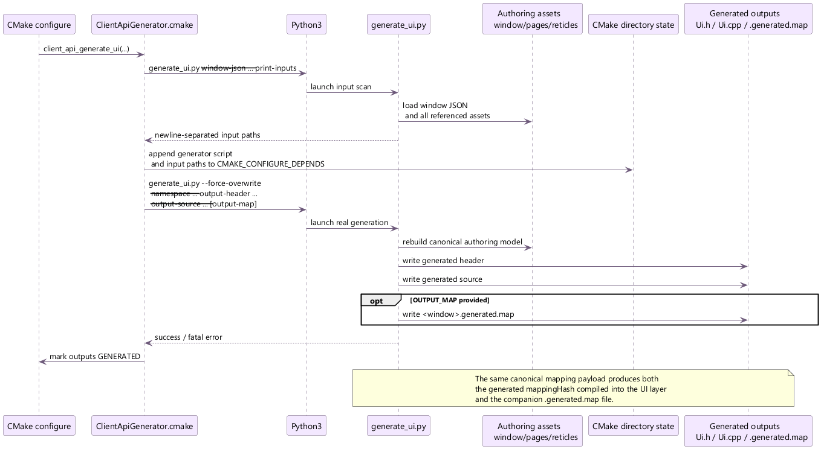
Client API generation sequence
The macro:
- 1. resolves the generator script path
- 2. resolves source and output paths
- 3. locates a Python 3 interpreter
- 4. runs an input scan via --print-inputs
- 5. records those inputs in CMAKE_CONFIGURE_DEPENDS
- 6. runs the real generation with --force-overwrite
Result:
- when one source asset changes, CMake knows it must regenerate
- generated outputs stay marked as GENERATED

5.5 Underlying Python script
The main script is:
mfd_client_api/generator/scripts/generate_ui.py
Main CLI interface:
--window-json
--output-header
--output-source
--output-map
--namespace
--ui-class-name
--page-class-suffix
--ui-class-suffix
--header-include
--print-inputs
--force-overwrite

5.6 Important generation rules
The generator:
- derives transport IDs from stable hashes of canonical keys
- emits the mappingHash from the canonical mapping payload
- rejects ID collisions
- checks the uniqueness of generated C++ names
- validates dynamicReticleBindings consistency
- exposes primitives according to the authored asset rules

5.7 Rules for exposing primitives
A primitive becomes a generated client handle when:
- it is explicitly marked exposed
- or the generator deduces that it must be according to the rules in force
The type of handle issued depends on the type of primitive:
Primitive author | Handle generated
text | TextHandle
time | TimeHandle
line | LineHandle
circle | CircleHandle
ring | RingHandle
rectangle | RectangleHandle
ellipse | EllipseHandle
square | SquareHandle
diamond | DiamondHandle
triangle | TriangleHandle
polyline | PolylineHandle
bezier | BezierHandle
arc | ArcHandle
image | ImageHandle

5.8 What the generated API contains
The generated API typically exposes:
- a UI root
- one class per page
- one class per static reticle
- a dynamic set per dynamic template
- one handle per exposed primitive
- of the BlinkType of page
- A StrobeHandle of page

5.9 What it contains .generated.map
The JSON map contains:
Painting | Content
pages | Stable page IDs
reticles | Stable static reticle IDs
primitives | Stable IDs of exposed primitives
templates | Stable IDs of dynamic templates
blinkTypes | Stable IDs of blink types
The top-level also contains:
- schemaVersion
- mappingHash
- window metadata

5.10 Example of integration into a CMake target
Minimal extract:
set(MY_GENERATED_DIR ${CMAKE_CURRENT_SOURCE_DIR}/generated)
client_api_generate_ui(
WINDOW_JSON "assets/windows/my_window.json"
OUTPUT_HEADER "${MY_GENERATED_DIR}/MyWindowUi.h"
OUTPUT_SOURCE "${MY_GENERATED_DIR}/MyWindowUi.cpp"
OUTPUT_MAP "${MFD_ROOT_DIR}/assets/windows/my_window.generated.map"
NAMESPACE "my_window_ui"
UI_CLASS_NAME "MyWindowUi"
HEADER_INCLUDE "MyWindowUi.h")
add_executable(my_client
src/main.cpp
${MY_GENERATED_DIR}/MyWindowUi.cpp
${MY_GENERATED_DIR}/MyWindowUi.h)
target_include_directories(my_client PRIVATE ${MY_GENERATED_DIR})
target_link_libraries(my_client PRIVATE mfd::client mfd::io_json)

5.11 When to regenerate
You must regenerate if you modify:
- the name of a page
- the name of a reticle template
- the primitives exposed
- the blink types
- dynamic bindings
- the visible structure of the window

5.12 Common causes of generation failure
Cause | Effect
JSON invalid window or page | parse failure
C++ generated name collision | generator abort
dynamicReticleBindings inconsistent | generator abort
unknown template | abortion
already existing output file without overwrite | abortion
Important: The generator is not a cosmetic convenience. It formalizes the customer contract. Any author development that changes this contract must be considered as an interface change.

6. Use the generated API to communicate with a window
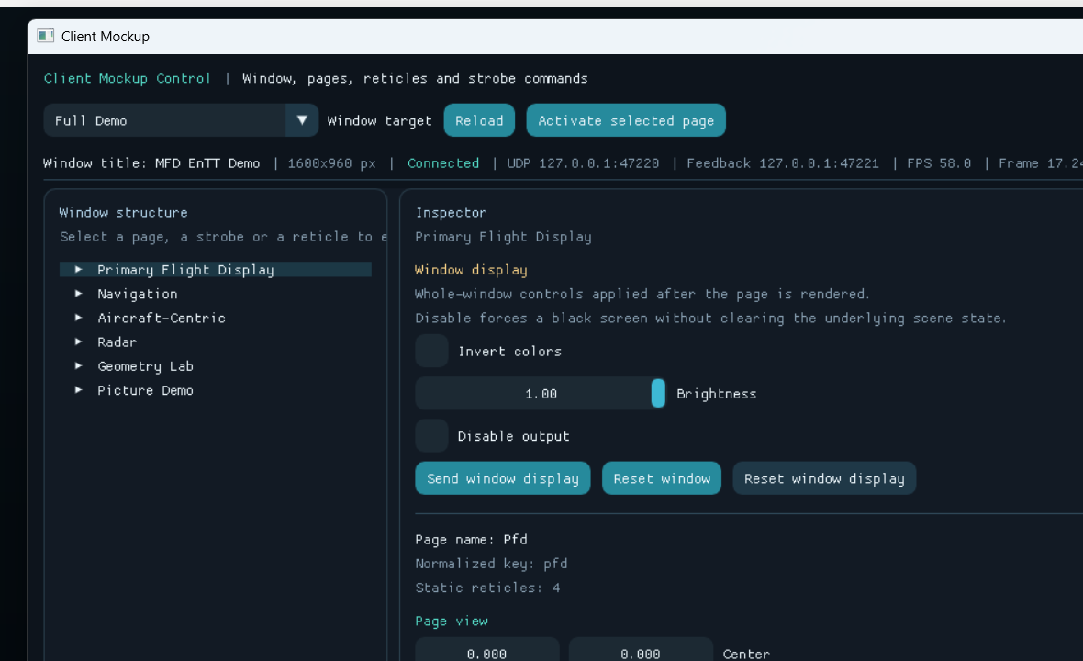
`client_mockup` runtime client screenshot
This section details the recommended way to drive a runtime window via the generated API.

6.1 Two layers to distinguish
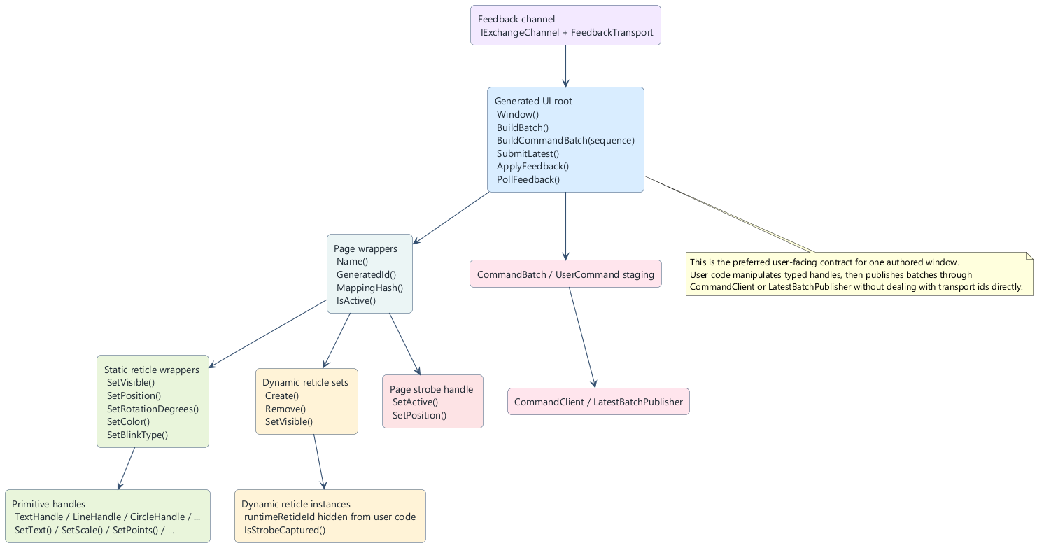
Generated API user contract
You should distinguish two layers:
- the generated layer, which is oriented around authored concepts
- CommandClient, which remains the final transport-sending boundary
The recommended usage is:
- 1. mutate the generated handles
- 2. build a batch
- 3. send it through CommandClient or LatestBatchPublisher

6.2 Load window configuration
The loading entry point is mfd::JsonLoader.
#include "mfd/io/JsonLoader.h"
mfd::JsonLoader loader;
const auto loaded = loader.LoadWindowConfiguration("assets/windows/demo_pages_cockpit.json");
The result contains:
- loaded.window
- loaded.document
- loaded.generatedTransportMap

6.3 Create the CommandClient
#include "mfd/control/CommandClient.h"
if (!loaded.window.commandTransports.udp.has_value() || !loaded.generatedTransportMap.has_value())
{
return 1;
}
mfd::CommandClient client(*loaded.window.commandTransports.udp, loaded.generatedTransportMap);
if (!client.IsReady())
{
// Inspect client.LastError()
return 1;
}

6.4 Generated UI root
Example with a generated UI:
#include "MockupUi.h"
mockup_ui::CockpitMockupUi ui;
Recommended startup skeleton:
auto& radar = ui.Radar();
radar.fixedTrackAlpha.SetVisible(true);
radar.fixedTrackAlpha.TrackLabel().SetText("MOCK");
client.ActivatePage(radar);
client.SetPageView(radar, {0.0f, 0.0f}, 1.0f);
client.SendBatch(ui.BuildCommandBatch(42U));
The UI root generally exposes:
Method | Role
Window() | patch whole-window display
page accessors | typed navigation
BuildBatch() | builds the staged UserCommand list
BuildCommandBatch(sequence) | builds a CommandBatch carrying the generated mappingHash
SubmitLatest(publisher, sequence) | publishes through LatestBatchPublisher
ApplyFeedback(...) | integrates decoded feedback
ApplyFeedbackPayload(...) | decodes one raw payload
PollFeedback(...) | drains a feedback channel
Reset() | resets the local staged state

6.5 Page wrappers
Each generated page typically exposes:
Member / method | Role
Name() | authored page name
GeneratedId() | stable transport ID
MappingHash() | compatibility hash
IsActive() | authoritative runtime state when feedback is connected
static reticle members | direct access
strobe | StrobeHandle of page
dynamic sets | one per dynamic template
blink types | BlinkType of page

6.6 Activate a page and adjust its view
The recommended route is to pass the generated page wrapper:
auto& radar = ui.Radar();
client.ActivatePage(radar);
client.SetPageView(radar, {0.0f, 0.0f}, 1.0f);
This forces the use:
- of the generated page ID
- of mappingHash partner

6.7 Modify the overall window display
The UI root exposes Window():
ui.Window().SetColorInverted(false);
ui.Window().SetBrightness(0.65f);
ui.Window().SetDisabled(false);
client.SendBatch(ui.BuildCommandBatch(42U));

6.8 Mutate a static reticle
Example :
auto& radar = ui.Radar();
radar.fixedTrackAlpha.SetVisible(true);
radar.fixedTrackAlpha.SetBlinkType(radar.fast);
radar.fixedTrackAlpha.SetPosition({0.30f, 0.18f});
radar.fixedTrackAlpha.SetRotationDegrees(-15.0f);
radar.fixedTrackAlpha.SetColor({77, 224, 255, 255});
radar.fixedTrackAlpha.TrackLabel().SetText("MOCK");
client.SendBatch(ui.BuildBatch());
Static wrappers derive from the mfd::client::Reticle contract.

Common reticle surface
Method | Effect
SetVisible | visibility
SetBlinkEnabled | activate or not the blink
SetBlink | active + type
SetBlinkType | explicit blink type
ClearBlinkType | return to default blink page
SetPosition | logical position
SetRotationDegrees | rotation
SetColor | color stroke
SetThickness | thickness
SetText | text
SetLetterSpacing | text spacing

6.9 Using exposed primitive handles
The great advantage of the generated API is to drive an exposed primitive without rebuilding the entire reticle.

Common primitive surface
Method | Effect
SetVisible | primitive visibility
SetPosition | local translation
SetRotationDegrees | local rotation
SetScale | ladder
SetColor | line color
SetFillColor | fill color
SetFilled | fill flag
SetThickness | thickness
SetLineStyle | solid, dotted, dashed

Specialized surfaces
Handle | Extensions
TextHandle | SetText, SetLetterSpacing
TimeHandle | SetLetterSpacing
LineHandle | SetStart, SetEnd
CircleHandle | SetRadius
RingHandle | SetInnerRadius, SetOuterRadius, SetSegments
RectangleHandle | SetWidth, SetHeight, SetSize
EllipseHandle | SetWidth, SetHeight, SetSize
SquareHandle | SetWidth, SetHeight, SetSize
DiamondHandle | SetWidth, SetHeight, SetSize
TriangleHandle | SetPoints
PolylineHandle | SetPoints, SetClosed
BezierHandle | SetControlPoints, SetSegments
ArcHandle | SetRadius, SetStartAngleDegrees, SetEndAngleDegrees, SetSegments
ImageHandle | common area only

Example of exposed primitive
auto& picture = ui.PictureDemo().pictureDemo;
picture.DemoPicture().SetVisible(true);
picture.DemoPicture().SetPosition({0.0f, 0.0f});
picture.DemoPicture().SetScale({1.10f, 1.10f});
picture.DemoPicture().SetRotationDegrees(8.0f);
client.SendBatch(ui.BuildBatch());

6.10 Manage dynamic reticles
The recommended route is the generated dynamic set.
auto& tracks = ui.Radar().DynamicRadarTrack();
auto& track = tracks.Create();
track.SetVisible(true);
track.SetPosition({0.18f, -0.24f});
track.SetRotationDegrees(55.0f);
track.TrackLabel().SetText("B21");
client.SendBatch(ui.BuildBatch());
To delete one instance:
tracks.Remove(track);
client.SendBatch(ui.BuildBatch());

Surface of one generated dynamic set
Method | Role
Create() | allocates a typed handle and a runtime id cache
Remove(handle) | deletes one instance
SetVisible(bool) | hides or shows the whole dynamic family
AppendCommands | builds runtime commands

What the dynamic set hides
The business code does not have to manage:
- the runtimeReticleId
- the mappingHash
- transport template ID

6.11 Publish in batches
Two forms are common.

Batch without sequence
client.SendBatch(ui.BuildBatch());

Batch with sequence and mappingHash
const auto batch = ui.BuildCommandBatch(42U);
client.SendBatch(batch);
The sequence is useful to:
- identify one external cycle
- group one coherent burst of mutations

6.12 Use LatestBatchPublisher
When a real-time client continuously computes the latest state, LatestBatchPublisher lets you publish the freshest batch through one dedicated path.
#include "mfd/client/LatestBatchPublisher.h"
mfd::client::LatestBatchPublisher publisher(*loaded.window.commandTransports.udp);
if (!publisher.IsReady())
{
return 1;
}
ui.SubmitLatest(publisher, 43U);

6.13 Use strobe and feedback
The strobe remains page-scoped.
auto& radar = ui.Radar();
if (radar.strobe.IsValid())
{
radar.strobe.SetActive(true);
radar.strobe.SetPosition({0.15f, -0.08f});
client.SendBatch(ui.BuildBatch());
}
Runtime feedback can then be connected:
#include "mfd/control/FeedbackTransport.h"
auto feedbackChannel = mfd::CreateFeedbackReceiverChannel(*loaded.window.feedbackTransports.udp);
std::string error;
ui.PollFeedback(*feedbackChannel, 8U, &error);
const bool pageActive = ui.Radar().IsActive();
For a dynamic reticle:
const bool captured = track.IsStrobeCaptured();

6.14 What feedback guarantees
Page::IsActive() is true only when the runtime confirms that the page is currently rendered as active.
DynamicReticle::IsStrobeCaptured() is true only when the latest strobe feedback points to that exact runtime instance.

6.15 Client sanitization and hygiene
The reference client applies safeguards that are worth keeping:
- clamp positions in [-1, 1]
- clamp brightness to [0, 1]
- zoom clean before sending
- rejection of empty dynamic ids
- verification of client.IsReady()
- display of client.LastError() on failure

6.16 When to use raw API
The Raw API CommandClient by author names remains useful for:
- generic tools
- transition code
- low level debugging
Example :
mfd::ReticlePatch patch;
patch.visible = true;
patch.position = mfd::Vec2 {0.25f, 0.10f};
patch.text = std::string {"T42"};
client.UpsertDynamicReticle("Radar", "track_42", "radar_track", patch);
But for a window-specific client, the generated path remains the right one.

6.17 Minimal end-to-end example
#include "MockupUi.h"
#include "mfd/control/CommandClient.h"
#include "mfd/io/JsonLoader.h"
int main()
{
mfd::JsonLoader loader;
const auto loaded = loader.LoadWindowConfiguration("assets/windows/demo_pages_cockpit.json");
if (!loaded.window.commandTransports.udp.has_value() || !loaded.generatedTransportMap.has_value())
{
return 1;
}
mfd::CommandClient client(*loaded.window.commandTransports.udp, loaded.generatedTransportMap);
if (!client.IsReady())
{
return 1;
}
mockup_ui::CockpitMockupUi ui;
auto& cockpit = ui.Cockpit();
client.ActivatePage(cockpit);
ui.Window().SetBrightness(0.65f);
cockpit.strobe.SetActive(true);
cockpit.strobe.SetPosition({0.12f, -0.05f});
client.SendBatch(ui.BuildCommandBatch(1U));
return 0;
}
Important: The recommended model is not "directly call the network everywhere". The recommended model is "mutate a local generated state, then build a coherent batch".

7. Write a framebuffer capture DLL plugin
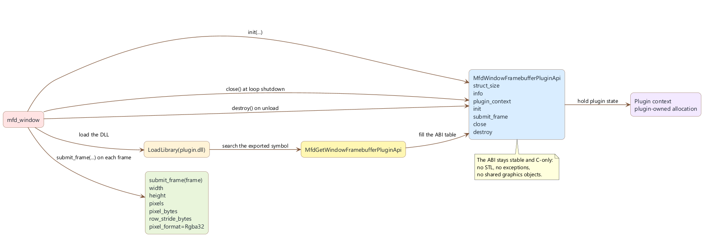
ABI framebuffer plugin
The framebuffer plugin path lets mfd_window hand each final frame to one dynamically loaded DLL as a raw RGBA32 buffer.

7.1 Why a stable C ABI
The ABI is in C to avoid:
- STL incompatibilities
- C++ ABI differences
- exceptions across the DLL boundary
- sharing host-owned graphic objects
The public header is:
mfd_window_plugin_api/include/mfd/window/WindowLauncherPlugin.h

7.2 Mandatory entry point
The mandatory export symbol is:
MfdGetWindowFramebufferPluginApi
The name constant also exists in the header:
MFD_WINDOW_FRAMEBUFFER_PLUGIN_ENTRY_POINT

7.3 Structure MfdWindowFramebufferPluginApi
The exported callback table contains:
Field | Role
struct_size | structure versioning
info | plugin metadata
plugin_context | plugin-owned opaque context
init | plugin initialization
submit_frame | per-frame callback
close | shutdown callback
destroy | final context destruction

7.4 Structure MfdWindowFramebufferPluginInfo
Field | Role
struct_size | versioning
abi_version | expected ABI
plugin_id | stable identifier
display_name | human-readable display name

7.5 Structure MfdWindowFramebufferFrame
The runtime returns a raw frame descriptor:
Field | Meaning
struct_size | structure size
pixel_format | pixel format, currently MfdWindowFramebufferPixelFormat_Rgba32
width | width in pixels
height | height in pixels
row_stride_bytes | stride per line
pixels | raw pointer to bytes
pixel_bytes | total number of bytes available

7.6 Validation helpers provided
The header also exports C helpers:
Function | Use
MfdWindowComputeFramebufferRgba32ByteCount | calculation of expected size
MfdWindowValidateFramebufferRgba32Layout | checks a raw RGBA32 buffer
MfdWindowValidateFramebufferFrame | validate one frame structure
They must be used defensively in the plugin.

7.7 Plugin lifecycle
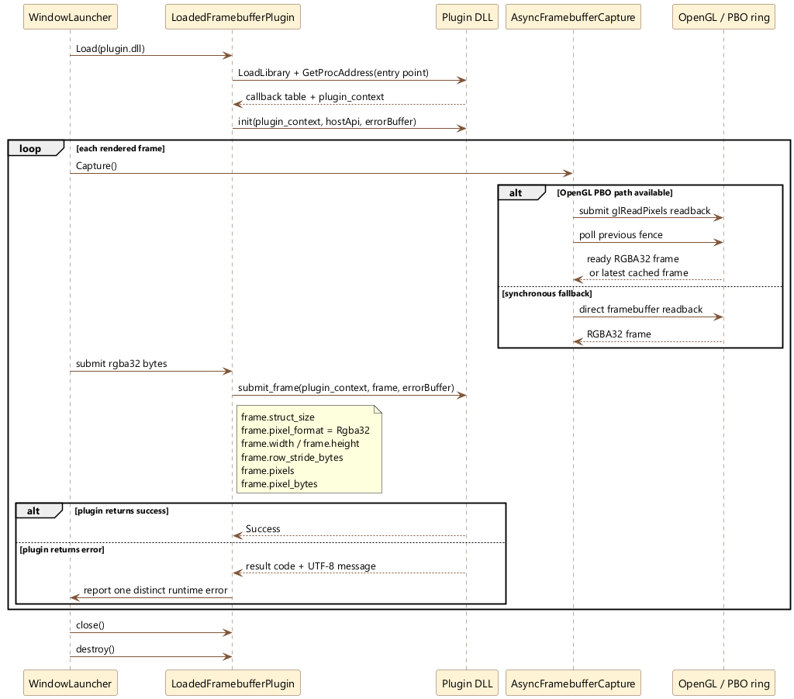
Framebuffer capture runtime sequence and plugin
The normal lifecycle is:
- 1. mfd_window loads the DLL
- 2. the runtime calls MfdGetWindowFramebufferPluginApi
- 3. the plugin allocates its context
- 4. the runtime calls init
- 5. the runtime calls submit_frame every frame
- 6. the runtime calls close at shutdown
- 7. the runtime calls destroy to free the context

7.8 Minimal plugin skeleton
#include "mfd/window/WindowLauncherPlugin.h"
struct MyPluginContext
{
bool initialized = false;
};
MfdWindowFramebufferPluginResultCode MFD_WINDOW_PLUGIN_CALL InitPlugin(
void* pluginContext,
const MfdWindowFramebufferPluginHostApi* host,
MfdWindowUtf8Buffer* error) noexcept
{
if (pluginContext == nullptr || host == nullptr ||
host->abi_version != MFD_WINDOW_FRAMEBUFFER_PLUGIN_ABI_VERSION)
{
return MfdWindowFramebufferPluginResultCode_InvalidArgument;
}
static_cast<MyPluginContext*>(pluginContext)->initialized = true;
return MfdWindowFramebufferPluginResultCode_Success;
}
MfdWindowFramebufferPluginResultCode MFD_WINDOW_PLUGIN_CALL SubmitFramePlugin(
void* pluginContext,
const MfdWindowFramebufferFrame* frame,
MfdWindowUtf8Buffer* error) noexcept
{
if (pluginContext == nullptr || frame == nullptr)
{
return MfdWindowFramebufferPluginResultCode_InvalidArgument;
}
if (MfdWindowValidateFramebufferFrame(frame) == 0)
{
return MfdWindowFramebufferPluginResultCode_InvalidArgument;
}
// Copier ou consommer frame->pixels ici.
return MfdWindowFramebufferPluginResultCode_Success;
}
void MFD_WINDOW_PLUGIN_CALL ClosePlugin(void* pluginContext) noexcept
{
(void)pluginContext;
}
void MFD_WINDOW_PLUGIN_CALL DestroyPlugin(void* pluginContext) noexcept
{
delete static_cast<MyPluginContext*>(pluginContext);
}
extern "C" __declspec(dllexport) MfdWindowFramebufferPluginResultCode MFD_WINDOW_PLUGIN_CALL
MfdGetWindowFramebufferPluginApi(MfdWindowFramebufferPluginApi* outApi, MfdWindowUtf8Buffer* error) noexcept
{
if (outApi == nullptr)
{
return MfdWindowFramebufferPluginResultCode_InvalidArgument;
}
auto* context = new MyPluginContext();
*outApi = {};
outApi->struct_size = sizeof(*outApi);
outApi->info.struct_size = sizeof(outApi->info);
outApi->info.abi_version = MFD_WINDOW_FRAMEBUFFER_PLUGIN_ABI_VERSION;
outApi->plugin_context = context;
outApi->init = &InitPlugin;
outApi->submit_frame = &SubmitFramePlugin;
outApi->close = &ClosePlugin;
outApi->destroy = &DestroyPlugin;
return MfdWindowFramebufferPluginResultCode_Success;
}

7.9 Example of repository reference plugin
The repository provides:
examples/mfd_framebuffer_stdout_plugin/src/FramebufferStdoutPlugin.cpp
This plugin:
- validate the frame
- displays a single line in the first frame
- illustrates context allocation and destruction

7.10 What to do in submit_frame
In submit_frame, you should:
- 1. check pluginContext != nullptr
- 2. check frame != nullptr
- 3. call MfdWindowValidateFramebufferFrame(frame)
- 4. consume or copy frame->pixels
- 5. return a clear error code on failure

7.11 What not to do
You should not:
- keep a pointer frame->pixels after return of callback without copy
- throw exceptions through the ABI
- assume another format than RGBA32
- assume the host is sharing GPU objects
- write to the memory pointed to by pixels

7.12 Practical consumption strategy
Depending on the need, the plugin can:
- copy the frame to a private CPU buffer
- push the frame to an internal lock-free queue
- convert the frame for an encoder
- publish the frame to another IPC system
The important rule is: the lifetime of raw bytes is only guaranteed during the call.

7.13 CMake build of the plugin
The reference plugin is a classic C++17 DLL. The critical point is not CMake itself, but:
- exporting the symbol MfdGetWindowFramebufferPluginApi
- the inclusion of the public header of the API plugin
- strict compliance with the ABI

7.14 Recommended testing strategy
To validate a framebuffer plugin:
- 1. start with a "stdout" or "log" plugin
- 2. check that init is called
- 3. check that submit_frame receives the expected dimensions
- 4. check the byte size via the validation helper
- 5. then connect the consumption business logic

8. Launch a window with a script and a framebuffer plugin
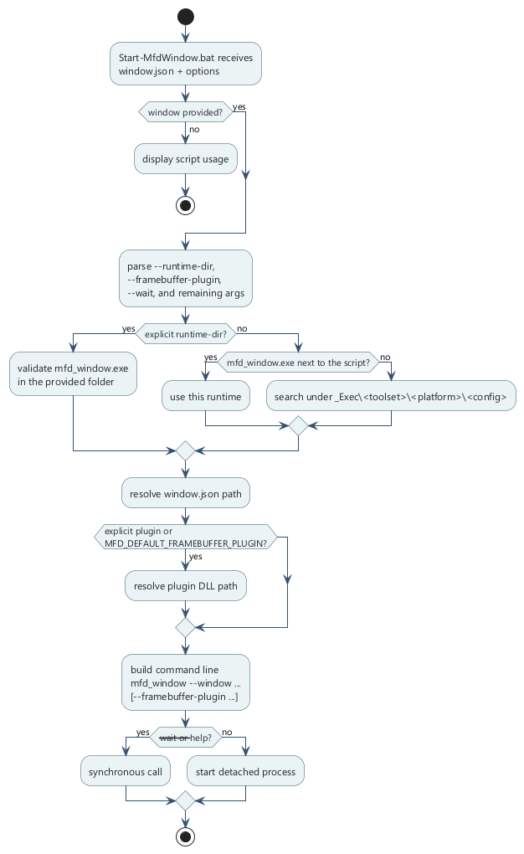
Launch script flow
The repository provides a reusable batch launcher:
Scripts/Start-MfdWindow.bat

8.1 Use of the script
The script expects at least:
Start-MfdWindow.bat <window.json>
Full usage:
Start-MfdWindow.bat <window.json> [--runtime-dir <dir>] [--framebuffer-plugin <plugin.dll>] [--wait] [extra launcher args]

8.2 Supported arguments
Argument | Effect
<window.json> | window to launch
--runtime-dir <dir> | force the folder containing mfd_window.exe
--framebuffer-plugin <plugin.dll> | explicitly injects a framebuffer plugin
--wait | synchronous runtime call
extra launcher args | args transmitted to the launcher

8.3 Runtime resolution
The script is looking for mfd_window.exe in this order:
- 1. the folder passed via --runtime-dir
- 2. the script folder if mfd_window.exe is present there
- 3. _Exec/<toolset>/<platform>/<config>
- 4. a fallback scan under _Exec

8.4 Plugin resolution
The plugin can come:
- from --framebuffer-plugin
- or from the MFD_DEFAULT_FRAMEBUFFER_PLUGIN environment variable
The script then resolves the path:
- absolute if given directly
- relative to the runtime folder
- relating to the root of the deposit
- relative to the script folder
- relating to the current file

8.5 Example with the minimal script from the repository
Scripts/Start-MfdMinimal.bat preconfigured:
@echo off
setlocal
set "MFD_DEFAULT_FRAMEBUFFER_PLUGIN=mfd_framebuffer_stdout_plugin.dll"
call "%~dp0Start-MfdWindow.bat" "assets/windows/demo_pages_minimal.json" %*
exit /b %ERRORLEVEL%
So the simplest call is:
.\Scripts\Start-MfdMinimal.bat
This is functionally equivalent to launching mfd_window with:
- the window assets/windows/demo_pages_minimal.json
- the plugin mfd_framebuffer_stdout_plugin.dll

8.6 Explicit example with custom plugin
.\Scripts\Start-MfdWindow.bat `"assets/windows/demo_pages_minimal.json"`
--framebuffer-plugin "build\vs2022-win32\examples\Debug\my_framebuffer_plugin.dll" `--wait```## 8.7 Command line equivalent` mfd_window `The runtime directly accepts:``` powershell
mfd_window --window assets/windows/demo_pages_minimal.json --framebuffer-plugin my_framebuffer_plugin.dll
The launcher usage text also covers:
- --help
- the absence or not of a default window
- the shortcuts F1, R, 1..9

8.8 Write your own project launch script
A clean project script generally contains:
- 1. the target window
- 2. an optional default plugin variable
- 3. the call has Start-MfdWindow.bat
Example :
@echo off
setlocal
set "MFD_DEFAULT_FRAMEBUFFER_PLUGIN=my_framebuffer_plugin.dll"
call "%~dp0Start-MfdWindow.bat" "assets/windows/my_window.json" %*
exit /b %ERRORLEVEL%

8.9 Launch checklist with plugin
Before launching, check:
- the JSON window exists
- mfd_window.exe was well constructed
- the plugin DLL exists in a resolvable path
- the symbol MfdGetWindowFramebufferPluginApi is exported
- the ABI of the plugin corresponds to the expected version

8.10 If the plugin does not load
Check in order:
- 1. correct dll path
- 2. DLL runtime dependencies present
- 3. symbol name exports correct
- 4. struct_size And abi_version correctly informed
- 5. absence of crashes in init

9. Overall Checklist Recommends

9.1 Complete project workflow
- 1. author the window and pages in mfd_editor
- 2. save as assets/
- 3. expose only the necessary primitives to the client
- 4. declare dynamic templates and strobe if necessary
- 5. generate Ui.h, Ui.cpp And <window>.generated.map
- 6. integrate the generated API into a C++17 client target
- 7. throw mfd_window
- 8. post orders via CommandClient
- 9. plug in UDP feedback if authoritative runtime state is required
- 10. plug in a framebuffer plugin if the image output needs to be captured

9.2 Design errors to avoid
- author directly in _Exec
- expose too many primitives without business need
- drive text names everywhere while a generated API exists
- keep pointers to the framebuffer after the callback returns
- forget to regenerate the API after renaming the page/template
- mix client business logic and visual authoring

9.3 Most important files to know
File | Why it is important
assets/windows/<window>.json | runtime and generator entry point
assets/windows/<window>.generated.map | stable transport mapping
mfd_client_api/generator/scripts/generate_ui.py | generator source
mfd_common_api/include/mfd/control/CommandClient.h | public transport facade
mfd_client_api/include/mfd/client/Animation.h | public client handles
mfd_window_plugin_api/include/mfd/window/WindowLauncherPlugin.h | ABI framebuffer plugin
Scripts/Start-MfdWindow.bat | resolution and launch logic

9.4 Conclusion
The recommended path in MFDStudio is clear:
- author the structure in the editor
- generate a typical C++ contract from the window
- control the window live in batches
- capture the rendering via a stable ABI plugin if necessary
This flow keeps:
- a modular architecture
- an intentional API surface
- good traceability between assets, client and runtime

