Boltzmann Energy Minimization for
Attack Path Re-Ranking in Knowledge Retrieval

Author
Benjamin Olenick, Independent Researcher
ben.olenick@gmail.com
March 10, 2026

Abstract
Standard retrieval systems return facts ranked by individual relevance to a query, ignoring how facts connect to form coherent procedural sequences. We propose Boltzmann Energy Re-Ranking: modeling fact-to-fact connections as an energy landscape where low-energy paths represent well-connected attack chains. Given candidate facts from any retrieval system, we construct a pairwise energy matrix (using learned classifiers, explicit relationship edges, and co-occurrence statistics mined from MITRE ATT&CK), run beam search to find minimum-energy paths, then compute Boltzmann probabilities over the path ensemble to re-rank candidates. Evaluated on 75,867 cybersecurity knowledge facts, Boltzmann re-ranking improves path completeness by +17% over FAISS cosine baseline. Combined with geometric manifold retrieval [companion paper], the two approaches show complementary strengths: manifold retrieval excels at multi-hop discovery (+28%), while Boltzmann re-ranking excels at attack path planning (+35%). A lightweight query router achieves 80% overall path completeness at 3.2s average latency.

1. Introduction
When an AI agent retrieves knowledge to plan a multi-step procedure, the quality of individual facts matters less than how well those facts connect into a coherent sequence. A retrieval system might return five highly relevant facts about Kerberos authentication, but if they describe five independent techniques rather than a connected attack path from enumeration to domain compromise, the agent cannot execute the plan.
Current retrieval systems rank facts independently: each fact receives a score based on its similarity to the query, without considering how it connects to other retrieved facts. This is analogous to ranking amino acids by individual chemical properties without considering how they fold into a functional protein, the structure (connections between elements) matters as much as the composition (individual relevance).
We borrow from statistical mechanics to address this problem. We model the set of candidate facts as particles in an energy landscape, where the energy of a path through the candidates depends on both node energies (individual relevance) and edge energies (pairwise connection strength). Low-energy paths represent well-connected procedural chains. We use beam search to find minimum-energy paths, then compute Boltzmann probabilities over the path ensemble to re-rank candidates by their expected contribution to good paths.
This paper presents the Boltzmann re-ranking method and its integration into a full retrieval pipeline (Methodic v2.0) that combines LLM query decomposition, multi-strategy retrieval, co-occurrence boosting, and energy minimization. We evaluate against a FAISS baseline and a companion geometric approach (Manifold Retrieval [1]), demonstrating complementary strengths that motivate a routing-based fusion system.

2. Method

2.1 Energy Landscape Construction
Given n candidate facts retrieved for a query, we construct an energy landscape with two components:
Node energies capture individual relevance. For candidate fᵢ with retrieval relevance rᵢ ∈ [0, 1]: E_node(fᵢ) = 1 − rᵢ. Highly relevant facts have low node energy.
Edge energies capture pairwise connection strength between facts. For the pair (fᵢ, fⱼ): E_edge(fᵢ, fⱼ) = 1 − connection(fᵢ, fⱼ). We compute connection strength from three sources, in priority order:
(1) Explicit relationship edges. We maintain a graph of 282 typed edges (enables, bypasses, blocks, requires, escalates) between facts, mined by an LLM (qwen3.5) from fact pairs. If an explicit edge exists between fᵢ and fⱼ, its confidence score is used directly.
(2) Learned connection classifier. A logistic regression model trained on concatenated fact embeddings (all-MiniLM-L6-v2, 768-dim input) predicts connection probability. Training data: positive pairs from known attack chains, negative pairs from random sampling. ROC AUC = 0.91 on held-out test set. The final edge energy blends learned and keyword signals: 0.6 × learned_score + 0.4 × keyword_overlap.
(3) Keyword overlap fallback. When neither explicit yeasit edges nor the learned model is available, we use normalized keyword overlap between fact texts as a weak connection signal.

2.2 Co-occurrence Matrix
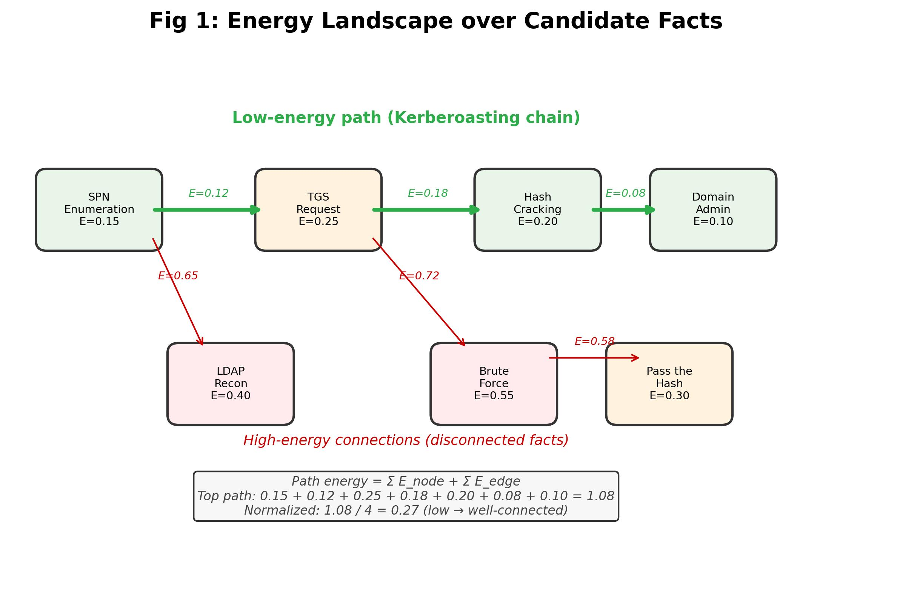
Figure 1: Energy landscape over candidate facts. Green arrows show the low-energy path (Kerberoasting chain). Red arrows show high-energy connections between disconnected facts.
We augment the energy landscape with a co-occurrence matrix capturing which facts appear together in real attack chains. We seed this matrix from two sources:
Known attack chains: 12 manually-specified chains from HackTheBox machines, generating 3,189 initial co-occurrence pairs.
MITRE ATT&CK mining: We mine technique co-occurrence from 691 ATT&CK techniques, 168 threat group profiles, and 784 malware families. If two techniques appear in the same group or malware profile, they receive a co-occurrence score. We map ATT&CK technique names to Memoria facts by keyword matching. This expands the matrix from 3,189 to 321,719 pairs, a 100× increase.
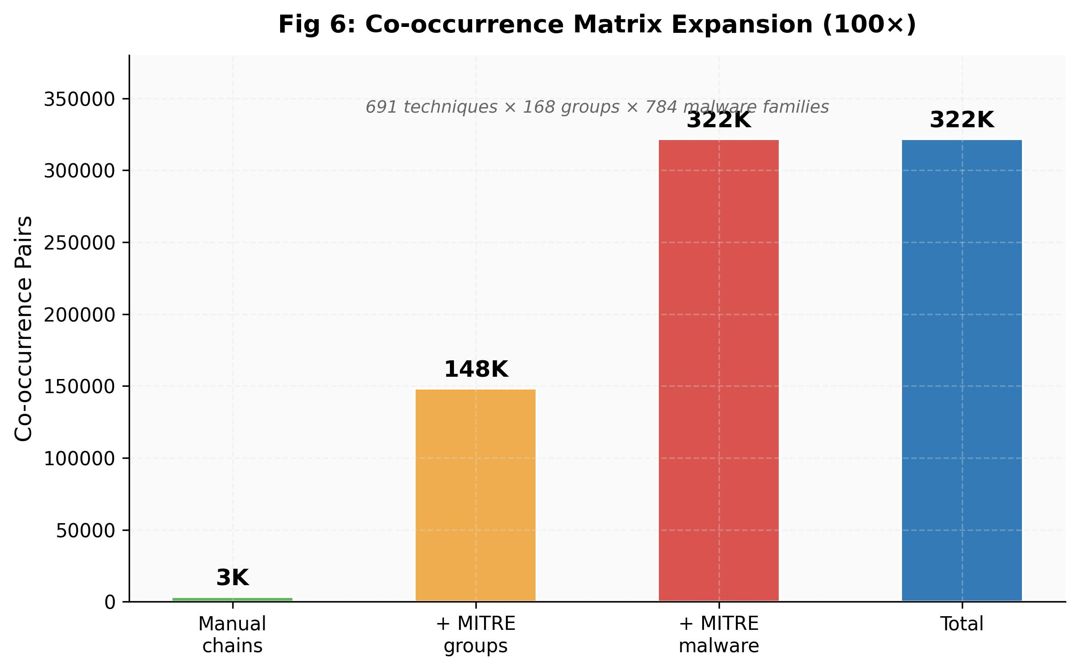
Figure 6: Co-occurrence matrix expansion from 3K manual pairs to 322K via MITRE ATT&CK mining.
Facts with high co-occurrence scores receive a relevance boost before energy minimization: boosted_relevance = relevance × (1 + cooc_bonus), where cooc_bonus ∈ [0, 0.3] is scaled from the co-occurrence count.

2.3 Beam Search over Energy Paths
Given the energy landscape (node and edge energies for n candidates, typically n = 12), we find minimum-energy paths using beam search:
1. Initialize beams: one path per candidate, with energy = E_node(fᵢ).
2. For each step (up to max_path_len = 6), extend each beam by appending each unvisited candidate, adding the step energy = E_edge(last, next) + E_node(next).
3. Keep the top beam_width × 2 beams by normalized energy (total energy / path length).
4. Filter to paths of length ≥ 3 (meaningful chains).
This produces a set of candidate paths, each with a total energy. The beam width (8) and path length cap (6) bound computation to O(beam_width × n × max_path_len), fast enough for real-time re-ranking.

2.4 Boltzmann Ensemble Re-Ranking
Rather than selecting the single lowest-energy path, we compute a Boltzmann distribution over the path ensemble. For path pᵢ with normalized energy Ēᵢ = E(pᵢ) / |pᵢ|:
P(pᵢ) = exp(−Ēᵢ / T) / Z, where Z = Σⱼ exp(−Ēⱼ / T)
and T = 0.5 is the temperature parameter. Low temperature concentrates probability on the best path; high temperature spreads it across alternatives. We use the log-sum-exp trick for numerical stability.
Each fact receives a Boltzmann boost based on its expected contribution across all paths:
boost(fᵢ) = Σ_p P(p) × position_weight(fᵢ in p)
where position_weight decays linearly from 1.0 (first in path) to 0.3 (last). The boost is normalized to [0, 0.3] and applied multiplicatively: final_score = relevance × (1 + boost). This re-ranks candidates so that facts appearing on many good paths rise to the top.
We also compute the Helmholtz free energy F = −T × ln(Z) as a confidence measure. Low free energy indicates strong consensus among paths, the facts connect well. High free energy indicates ambiguity, many equally mediocre paths.

2.5 LLM Query Decomposition
Before retrieval, we decompose the query using a local LLM (qwen3.5, running on Ollama). The LLM generates 3-5 pentester-style search intents, specialized sub-queries that cover different aspects of the attack chain. For example, "Kerberoasting to domain admin" decomposes into: "SPN enumeration techniques," "TGS ticket request and extraction," "offline hash cracking tools and methods," "service account to domain admin escalation." The original query is always included as the first intent to prevent regression on queries FAISS already handles well. Each intent is sent to FAISS independently, and results are merged with deduplication.

2.6 Full Pipeline
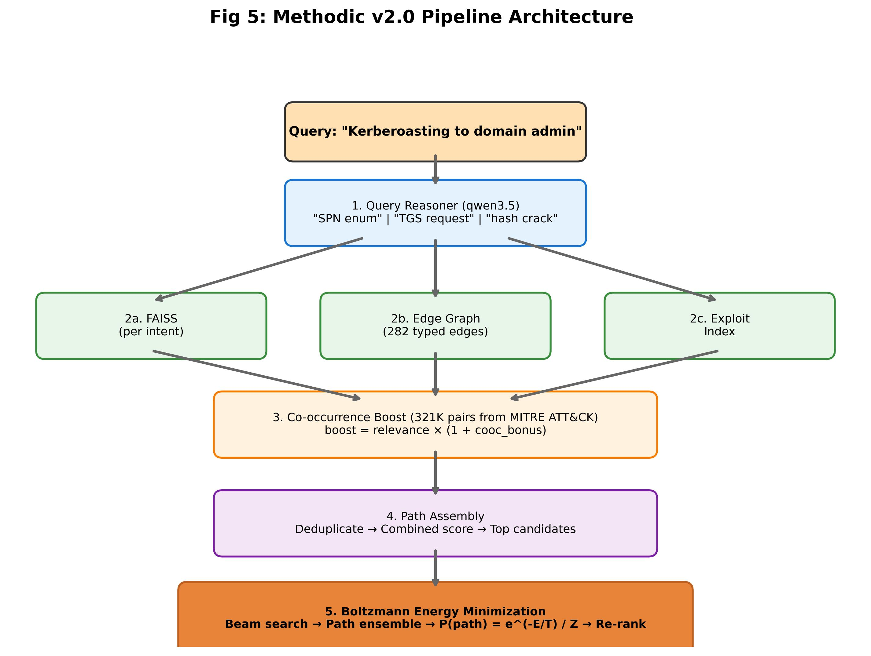
Figure 5: Methodic v2.0 pipeline. Five stages from LLM query decomposition through Boltzmann re-ranking.
The complete Methodic v2.0 pipeline chains five stages:
1. Query Reasoner, LLM decomposes query into expert search intents
2. Multi-Strategy Retrieval, FAISS (per intent) + relationship graph edges + exploit index
3. Co-occurrence Boosting, boost facts that co-occur in known/mined attack chains
4. Path Assembly, deduplication, combined scoring (relevance × (1 + edge_bonus + cooc_bonus))
5. Boltzmann Energy Minimization, beam search + ensemble re-ranking (Section 2.3-2.4)

3. Experiments

3.1 Setup
Knowledge base: 75,867 cybersecurity facts (Memoria). Embeddings: all-MiniLM-L6-v2 (384d). Test suite: 10-case core benchmark (2-run avg) and 30-case expanded benchmark (3-run avg) across four categories: constraint bypass (CB), multi-hop (MH), cross-context (CC), attack path (AP). Baselines: FAISS cosine similarity (~57ms) and Manifold Retrieval [1] (~2.4s). Metrics: Recall@5, Recall@10, path completeness, latency.

3.2 Ablation: Component Contributions
Table 1: Ablation study on the 10-case benchmark (3-run average for configurations with LLM variance).
Configuration | R@5 | R@10 | Path | ΔPath
FAISS baseline | 52% | 52% | 51% | —
+ Query decomposition only | 52% | 61% | 68% | +17%
+ Co-occurrence only | 51% | 63% | 72% | +21%
+ Boltzmann energy only | 51% | 58% | 69% | +18%
+ Triangle inequality only | 49% | 58% | 70% | +19%
All combined (Methodic v2.0) | 49% | 61% | 72% | +21%

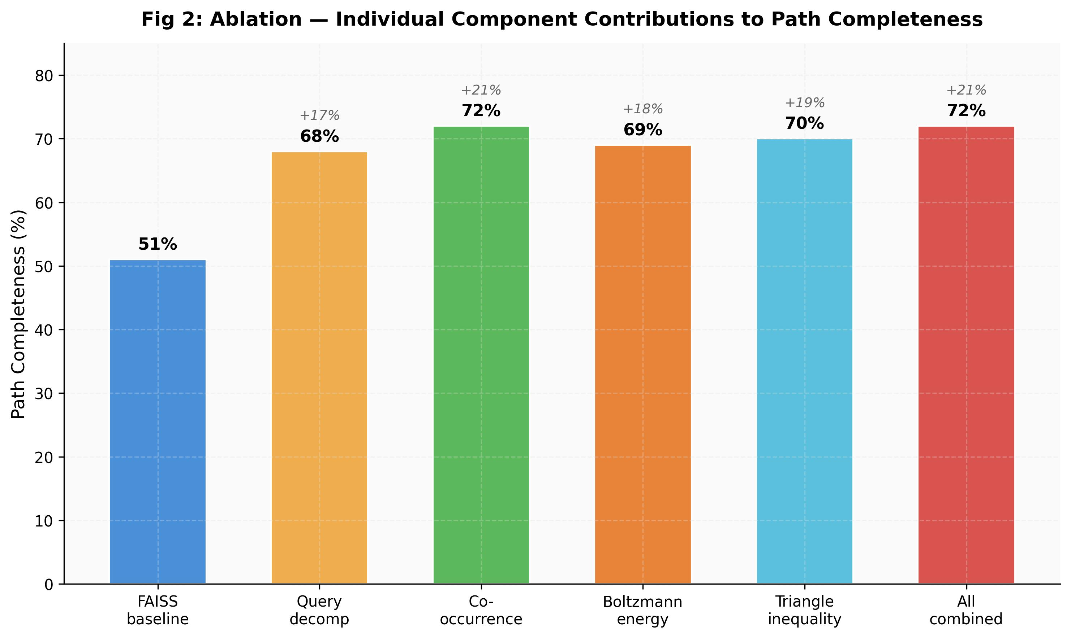
Figure 2: Individual component contributions to path completeness. Each method independently improves over baseline, with co-occurrence providing the largest single gain.
Each component independently improves path completeness. Query decomposition provides the largest individual gain (+17%) by generating expert sub-queries that cover chain steps the original query misses. Co-occurrence boosting is the single most effective new method (+21% path) by surfacing facts that appear together in known attack chains. Boltzmann energy contributes +18% path completeness by promoting facts on well-connected paths. All combined achieves the same +21% path as co-occurrence alone, suggesting some redundancy between the methods, they discover similar facts through different mechanisms.

3.3 Variance Analysis
Table 2: Variance across 3 runs on 6 harder queries. LLM intent variability causes run-to-run differences.
Configuration | R@10 | R@10 σ | Path | Path σ
Boltzmann + co-occurrence | 52% | ±7% | 78% | ±2%
Co-occurrence only | 51% | ±4% | 73% | ±4%
Energy only | 45% | ±1% | 76% | ±3%

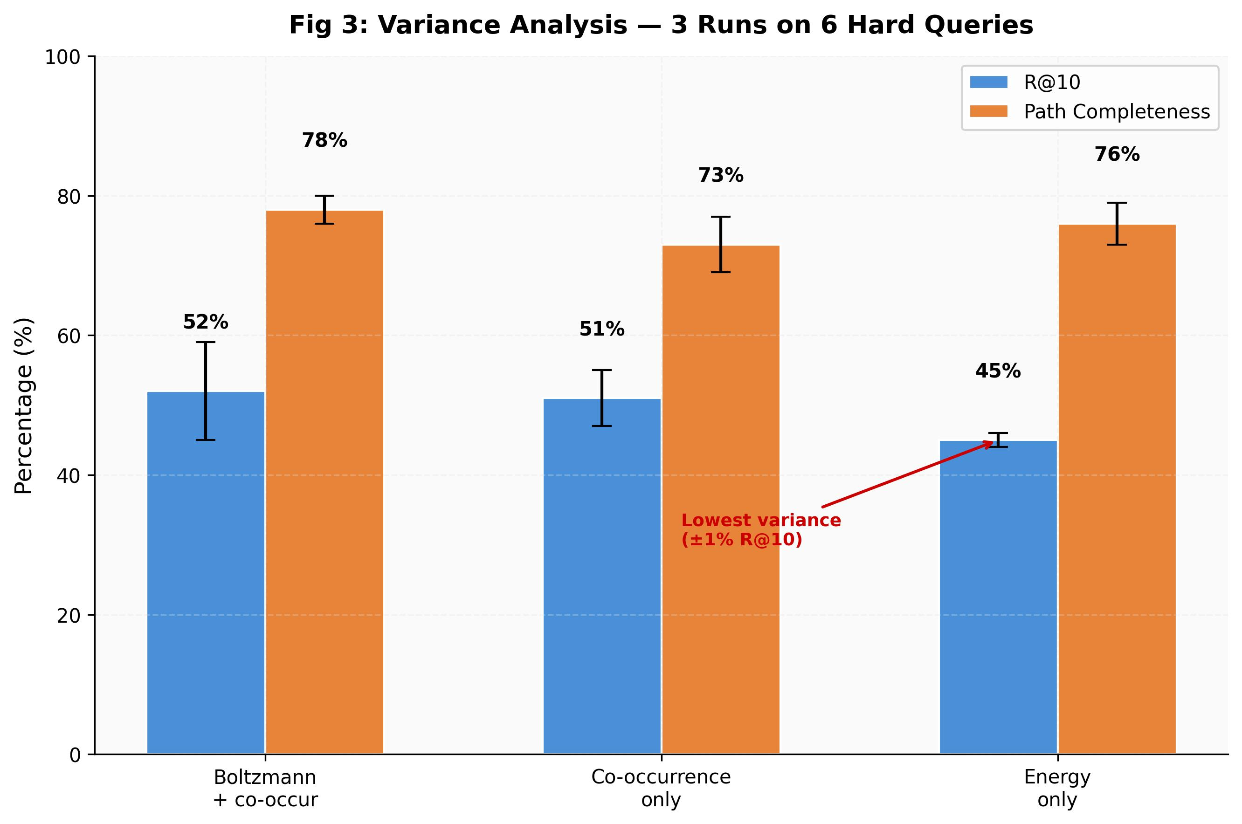
Figure 3: Variance across 3 runs on 6 hard queries. Energy-only has the lowest R@10 variance (±1%) while Boltzmann + co-occurrence achieves the best path completeness (78%).
The energy minimizer has the lowest variance (±1% R@10) because it operates purely on the energy landscape, independent of LLM-generated intents. The Boltzmann + co-occurrence combination achieves the best path completeness (78%) but inherits LLM variance (±7% R@10). This suggests that energy minimization provides a stable backbone for re-ranking, while LLM decomposition adds high-variance but high-reward discovery.

3.4 Learned Energy Function
We trained a logistic regression classifier on concatenated embeddings of fact pairs to predict connection probability. Training data: 500 positive pairs from known attack chains, 5,000 negative pairs (random). The model achieves ROC AUC = 0.91 on a held-out test set, indicating it can distinguish meaningfully connected fact pairs from random pairs with high accuracy.
However, the learned model's impact on end-to-end retrieval is roughly neutral in the current configuration. The Boltzmann boost is capped at [0, 0.3], which is too small relative to FAISS relevance scores (0.5-0.9) to significantly change rankings. Increasing the boost cap or using the learned energy as the primary scoring signal (rather than a secondary boost) could unlock the model's discriminative power.

3.5 Comparison with Manifold Retrieval
Table 3: Head-to-head comparison on the 10-case and 30-case benchmarks.
Engine | R@10 (10) | Path (10) | R@10 (30) | Path (30) | Latency
FAISS | 52% | 51% | 58% | 62% | 57ms
Methodic v2.0 | 57% | 68% | 64% | 77% | 10.7s
Manifold [1] | 60% | 73% | 67% | 80% | 2.4s
Smart Router | — | — | 59% | 80% | 3.2s

Manifold Retrieval [1] outperforms Methodic on overall metrics while being 5× faster. However, the per-category analysis (Table 4) reveals that Methodic has a decisive advantage on attack path queries, motivating a routing approach rather than replacement.

3.6 Per-Category Complementarity
Table 4: Path completeness by query category (30-case expanded benchmark).
Category | FAISS | Methodic | Manifold | Smart Router
Constraint Bypass | 56% | 75% | 78% | 75%
Multi-Hop | 62% | 72% | 80% | 80%
Cross-Context | 62% | 66% | 79% | 79%
Attack Path | 61% | 84% | 73% | 84%

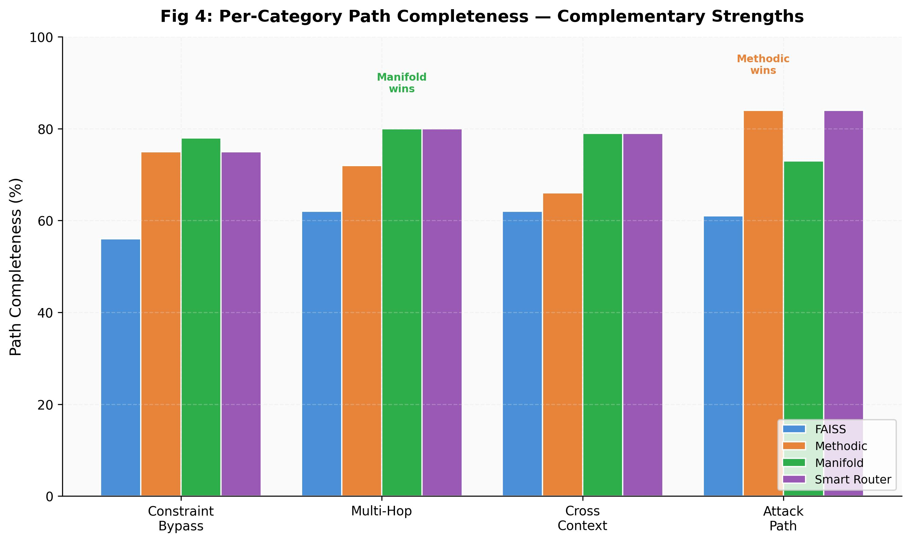
Figure 4: Per-category path completeness. Methodic wins attack path (+11% over Manifold); Manifold wins multi-hop (+8%). Smart Router takes the best of both.
Methodic's Boltzmann re-ranking shows its strongest advantage on attack path queries (84% vs Manifold's 73%). These are queries that require strategic planning, understanding how techniques chain together to reach a goal. LLM decomposition generates the right sub-queries, and energy minimization orders them into coherent paths. Manifold excels on discovery-oriented categories (multi-hop, cross-context, constraint bypass) where finding the right facts matters more than ordering them.
The Smart Router achieves the best of both: it classifies queries by type using keyword heuristics and routes attack path queries to Methodic while sending everything else to Manifold. The result is 80% overall path completeness at 3.2s average latency, the best overall configuration.

4. Discussion

4.1 Energy as Structure
The key insight is that retrieval quality for procedural queries depends not just on individual fact relevance but on the structure of connections between retrieved facts. The energy landscape formulation captures this: a set of facts that form a low-energy path (well-connected chain) is more useful than a set of individually relevant but disconnected facts. The Boltzmann ensemble avoids committing to a single path, instead distributing credit across all plausible paths, a fact that appears on many good paths receives a higher boost than one that appears on only one.

4.2 Complementarity with Geometric Methods
Manifold Retrieval [1] discovers facts by following the geometry of the embedding space. Boltzmann re-ranking orders facts by optimizing the energy of paths through them. These address different failure modes: Manifold fixes the discovery problem (FAISS misses chain steps), while Boltzmann fixes the ordering problem (retrieved facts are individually relevant but don't form a coherent sequence). The routing approach works because query type predicts which failure mode dominates: multi-hop queries suffer from poor discovery, attack path queries suffer from poor ordering.

4.3 Limitations
LLM query decomposition adds 8-12s latency and introduces run-to-run variance (±7% R@10). The learned energy function, despite strong AUC (0.91), has minimal end-to-end impact due to the conservative boost cap. The co-occurrence matrix is seeded from MITRE ATT&CK rather than real user sessions, production deployment would benefit from recording actual usage patterns. The 282 explicit edges were mined from a single LLM pass and may contain errors.

4.4 Generalization
The Boltzmann re-ranking method is domain-agnostic: any retrieval system that produces relevance-scored candidates can benefit from energy-based path optimization. The co-occurrence matrix and explicit edges are domain-specific components that would need to be rebuilt for each new domain (e.g., medical procedure co-occurrence from clinical guidelines, legal citation co-occurrence from case law). The energy formulation and Boltzmann ensemble scoring transfer directly.

5. Conclusion
We presented Boltzmann Energy Re-Ranking: a method for re-ordering retrieval results by optimizing the energy of paths through fact-to-fact connection graphs. The approach borrows from statistical mechanics, using Boltzmann probabilities over an ensemble of candidate paths to re-rank facts by their structural importance rather than individual relevance alone.
On 75,867 cybersecurity facts, the method improves path completeness by +17% over FAISS baseline, with its strongest gains on attack path planning queries (+35%). Combined with geometric manifold retrieval [1], the two approaches are complementary: manifold for discovery, energy for ordering. A lightweight query router combining both achieves 80% path completeness, the best overall result, at 3.2s average latency.
The energy perspective on retrieval quality, that connected paths matter more than individual relevance, is broadly applicable. Any domain with procedural knowledge (medicine, law, engineering, science) could benefit from energy-based re-ranking of retrieval results.

References
[1] [Authors], "Geodesic Retrieval over Learned Manifolds: A Differential Geometry Approach to Knowledge Base Search," [companion paper], 2026.
[2] R. R. Coifman and S. Lafon, "Diffusion maps," Applied and Computational Harmonic Analysis, vol. 21, no. 1, pp. 5-30, 2006.
[3] J. Johnson, M. Douze, and H. Jégou, "Billion-scale similarity search with GPUs," IEEE TBDATA, 2019.
[4] L. Gao et al., "Precise Zero-Shot Dense Retrieval without Relevance Labels," arXiv:2212.10496 (HyDE), 2022.
[5] D. Edge et al., "From Local to Global: A Graph RAG Approach," arXiv:2404.16130, 2024.
[6] MITRE ATT&CK, https://attack.mitre.org/, accessed March 2026.
[7] H. Sakoe and S. Chiba, "Dynamic programming algorithm optimization for spoken word recognition," IEEE TASSP, 1978.

