**Introduction**

Reduce. Reuse. Grow has partnered with the Philippine Eagle Foundation and the Friends of the Usambara to plant over 9 million trees. RRG created a database with pertinent information on each species planted, including relevant cultural significance, practical use, life cycle modeling, and estimated carbon sequestration.

**Methodology**

***Woody Biomass and Change in Carbon Stock (equations 2 and 1)***

Per section 8.6 of the VM 0047 methodology, the change in woody biomass is calculated from ex ante estimates of modelled growth and yield values. RRG conducted a literature review and forest inventory to gather data on species’ DBH at an assortment of ages. RRG then created a regression “engine” using the statistical programming language, R, to calculate values outside of the inventory. This engine serves as a program to run many species’ models at once. It takes inputs (Age vs. DBH) and produces graphs, prediction curves and statistical results. RRG utilized the port algorithm within the nls() function to solve for constants (a,b,c below). This algorithm solves for residuals, or the difference between observed and predicted values. Models failed to converge, or solve, if the port algorithms first guess did not reduce the residuals. This is because some of the mathematical equations, primarily the Chapman Richard’s, did not always represent the inventory data (sigmoid shape). In this case, the model would fail to converge and would crash the program. To account for this, RRG utilized the tryCatch function within R to complete the program despite the model failing. When failures occurred, the program would print the results from the previous success. This resulted in some species’ graphs showing inaccurate projections. However, when selecting models, it is easy for users to not select those model predictions. The methodology and program code for the engine is attached to the FRP website. Below are the five equations used and their initial parameter guesses:

1. 2nd Order Polynomial

$$f\left(x\right)= x^{2}+x+b$$

Where f(x) = DBH (cm)

x = Age (years)

b = constant

1. 3rd Order Polynomial

$$f\left(x\right)= {x^{3}+x}^{2}+x+b$$

Where f(x) = DBH (cm)

x = Age (years)

b = constant

1. Logarithmic

$$f\left(x\right)=a+b*log{x}$$

Where f(x) = DBH (cm)

x = Age (years)

b = 10

a = 0.5

1. Power

$$f\left(x\right)=b*x^{a}$$

Where f(x) = DBH (cm)

x = Age (years)

b = 10

a = 0.5

1. Chapman Richards

$$f\left(x\right)=a*{(1-\exp\left(-k*t\right))}^{b}$$

Where f(x) = DBH (cm)

t = Age (years)

a= upper asymptote or maximum DBH growth

k= 0.3

b= 1 (can be 0-2.5)

***Model Details***

To create the most robust dataset, when there were multiple species within the same genus, RRG chose to model these data points together. Individual species models were compared for prediction size (DBH) and statistical result (R2 test). RRG selected the most accurate result (highest R2 value) as the ex-ante estimation of DBH growth. If statistical results were similar, RRG chose the most conservative estimation. Some polynomial and logarithmic models negatively estimated early-stage growth. If these models were still chosen due to conservative estimates, the negative estimations were replaced with 0. A list of models chosen, their justification, statistical results, graphs, and growth predictions can be found on the FP website.

There was variance in the availability of data points for each species’ model. Some had 10+ datapoints in different age ranges and some only had 4-6 data points. Furthermore, some of datapoints were collected in regions outside of Tanzania. It is commonly known that statistical regression models increase in accuracy with an increase in data availability. Because of this RRG chose a large uncertainty deduction to account for the non-robust dataset. RRG and FOU will need to inventory each species throughout the project duration to update the model and ensure accuracy. Below is a graph of the model for the species *Cordia Africana.*

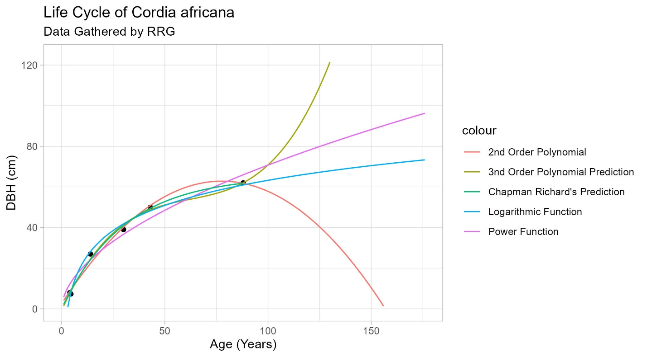

***Species Filter for Average DBH Growth***

RRG maintains a spreadsheet with chosen species growth models. RRG then filtered the dataset for the species within each planting parcel. Per equation 2 of the VM 0047 methodology, these smaller datasets were averaged to determine the average DBH growth for each planting composition from years 1-50.

**Allometric and Carbon Conversion**

Allometric equations were applied, which translated the DBH, in cm, to a mass, in kg. These equations are unique to species and regions of the world. RRG conducted a thorough comparison of allometric equations from scientific journals and the database Glob Allome Tree. RRG compared unique species allometric equations and regional allometric equations. RRG ran both model scenarios and determined the region allometric equation was the most conservative. The chosen equation is for Afromontane forests and is as follows[1].

The carbon a tree sequesters (absorbs) is simply a proportion of its total weight. So, the mass of each tree was multiplied by the percent carbon of trees or 0.47. These values were then multiplied by the C to Co2e conversion, or 44/12. This value, of t Co2e from years 0-50, represents equation 1 or the carbon stock change. The spreadsheets for allometric equations, their sources, and average changes in woody biomass are on the FP website.

***Other Carbon Pools***

Per the guidelines set out by VM 0047 section 8.6, all other carbon pools for ex-ante estimation including non-woody biomass, leaf litter, dead wood and soil organic carbon were set to zero. Upon validation events, these pools will be calculated and tested for significance. If pools contribute less than 5% of the total removals, they will be determined de minims. The following equation will be used to determine each pool’s significance.

***Performance Benchmark***

The analysis for the performance benchmark can be found in the CCB Document posted on the Verra registry. Because the project is in early stages, RRG assumed a performance benchmark value of 1 or 100% of the modeled growth vs. yield values at full stocking. Upon validation events, RRG will complete the entire methodology.

***Uncertainty***

Due to a lack of inventory data, RRG assumes the growth vs. yield values may be over projecting. Section 8.6 of the VM0047 methodology requires users to employ a 10% uncertainty deduction rate. Upon validation events, uncertainty for carbon pools will be calculated by propagating errors associated with estimates of included pools following this equation.

1. <https://www.researchgate.net/publication/377334390_Species-specific_allometric_models_for_reducing_uncertainty_in_estimating_above_ground_biomass_at_Moist_Evergreen_Afromontane_Forest_of_Ethiopia>