# Instruction Manual

## Congressional Voting Database Interface

## Purpose

This interface allows users to add and query data in the Congressional Voting Database, which tracks parties, members, votes, and rollcalls in the U.S. Senate and House of Representatives. This instruction manual will demonstrate how to use the interface to perform these actions.

**In order to set up the software, the database must be placed in the appropriate folder. Please ensure that the “*voting.db*” database is in the SAME folder as the “*VotingRecordDB.jar*” executable file** (or the “*src*” folder if compiling with Java). This will allow the program to run correctly and interface with the proper database.

## The Data

Each table in the Congressional Voting Database contains many variables. When querying or adding data to the database using text entry boxes, variables should be in the forms below. *Note that depending on the search or add conditions, not all of these variables may be available for querying or adding*.

**Members**

*congress*: Up to 3-digit integer

*chamber*: House, Senate, or President

*icpsr*: Up to 5-digit integer

*state*_*icpsr*: Up to 2-digit integer

*district_code*: Up to 2-digit integer

*state_abbrev*: 2-letter abbreviation for the state (example: MA for Massachusetts)

*party_code:* Up to 4-digit integer (typically 3-digit)

*bioname:* LASTNAME, Firstname AdditionalName, Suffix.

*bioguide_id*: String of integers and capital letters

*born:* Year (4-digit integer)

*died:* Year (4-digit integer)

**Parties**

*congress*: Up to 3-digit integer

*chamber*: House, Senate, or President

*party_code:* Up to 4-digit integer (typically 3-digit)

*party name*: String

*n_members*: Integer

**Rollcalls**

*congress*: Up to 3-digit integer

*chamber*: House, Senate, or President

*rollnumber*: Integer

*date*: YYYY-MM-DD

*session:* 1-digit integer

*clerk_rollnumber:* Up to 3-digit integer

*bill_number*: String of integers and capital letters

*vote_result*: String (example: Passed)

*vote_desc:* Multi-word string (example: “Sgt. Zachary M. Fisher Post Office”)

*vote_question*: Multi-word string (example: On Motion to Suspend the Rules and Pass)

*dtl_description:* Multi-word string, all capitals (example: TYDINGS MOTION TO ADJOURN.)

**Votes**

*congress*: Up to 3-digit integer

*chamber*: House, Senate, or President

*rollnumber*: Integer

*icpsr*: Up to 5-digit integer

*cast_code*: Integer in range 1 to 9

## Start Menu

When starting up the software, users begin on a menu with two choices: Enter Data, and Query Data. These are the two actions that can be performed by the software. Clicking either button brings the user to a menu with further instruction. This starting menu is shown below.

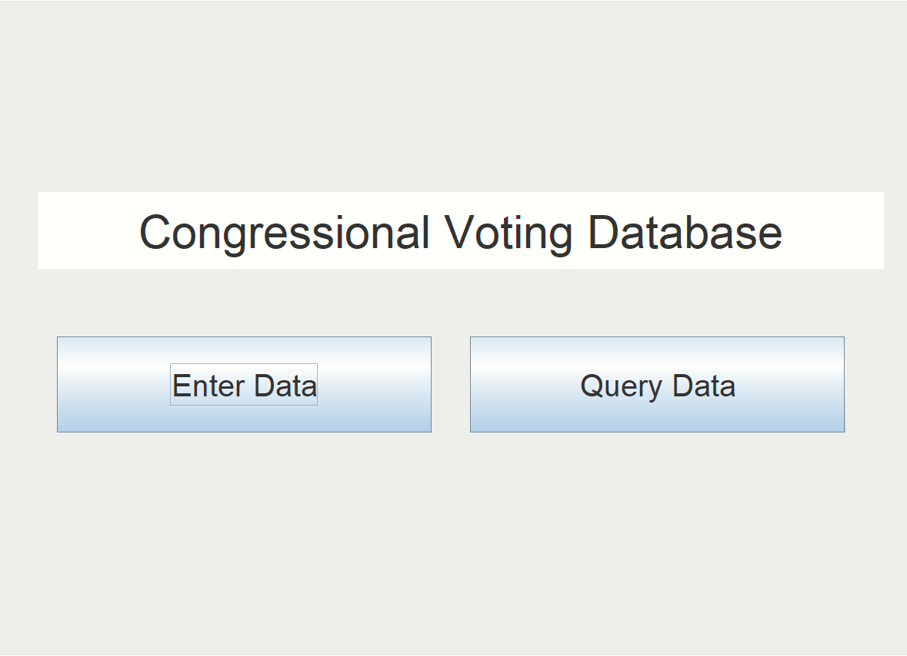

## Adding Data

Clicking “Enter Data” brings the user to a menu where they may add data entries. The Congressional Voting Database contains four data tables representing different record types: votes, rollcalls, members, and parties. The user may select which table to which they want to add data by clicking on the appropriate button on the left.

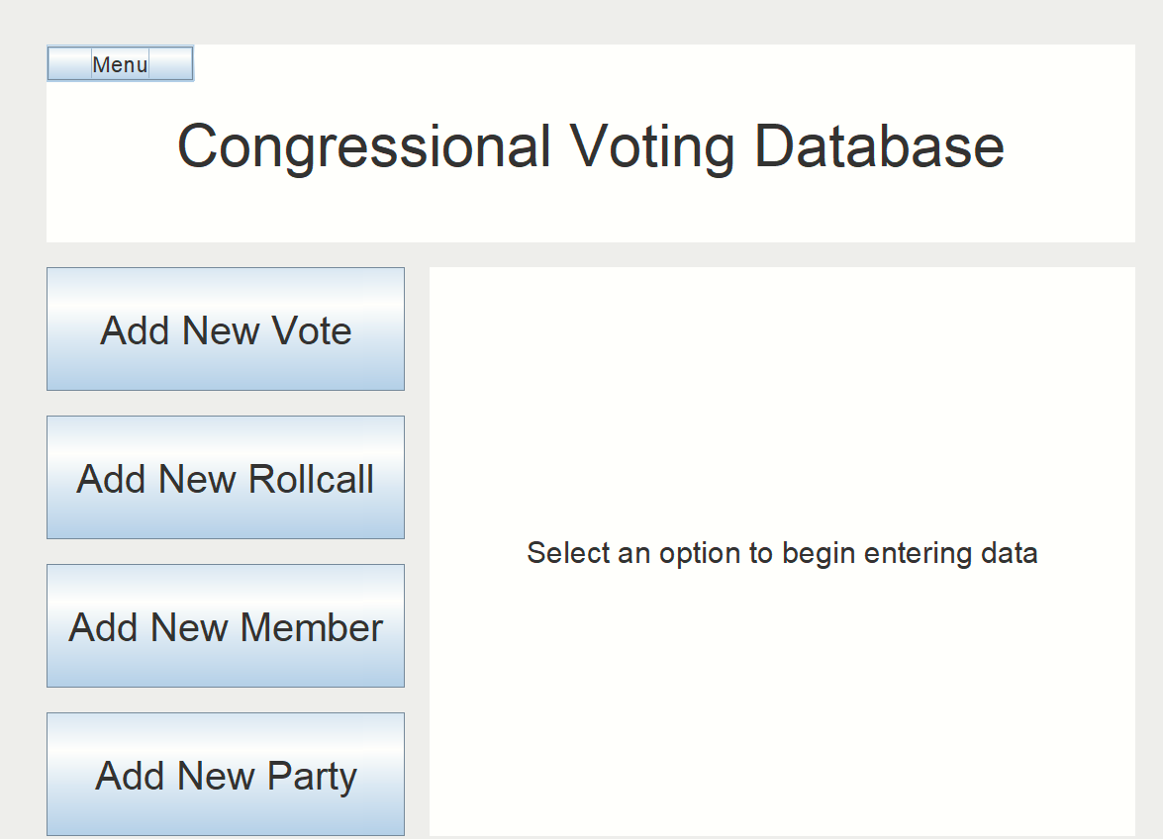

Once a table has been selected, the interface will display a panel of text entry boxes and dropdown menus for inputting data. To add a new vote/rollcall/member/party, just fill in the appropriate boxes with the information for the new table entry and then press the “Enter Data” button. Make sure to fill in all fields to add a new database entry. An example is shown below.

**NOTE:** **After typing in a text box, be sure to press enter to confirm that the text that you’ve entered is included. If you do not press enter, the entry will not be put into the system.**

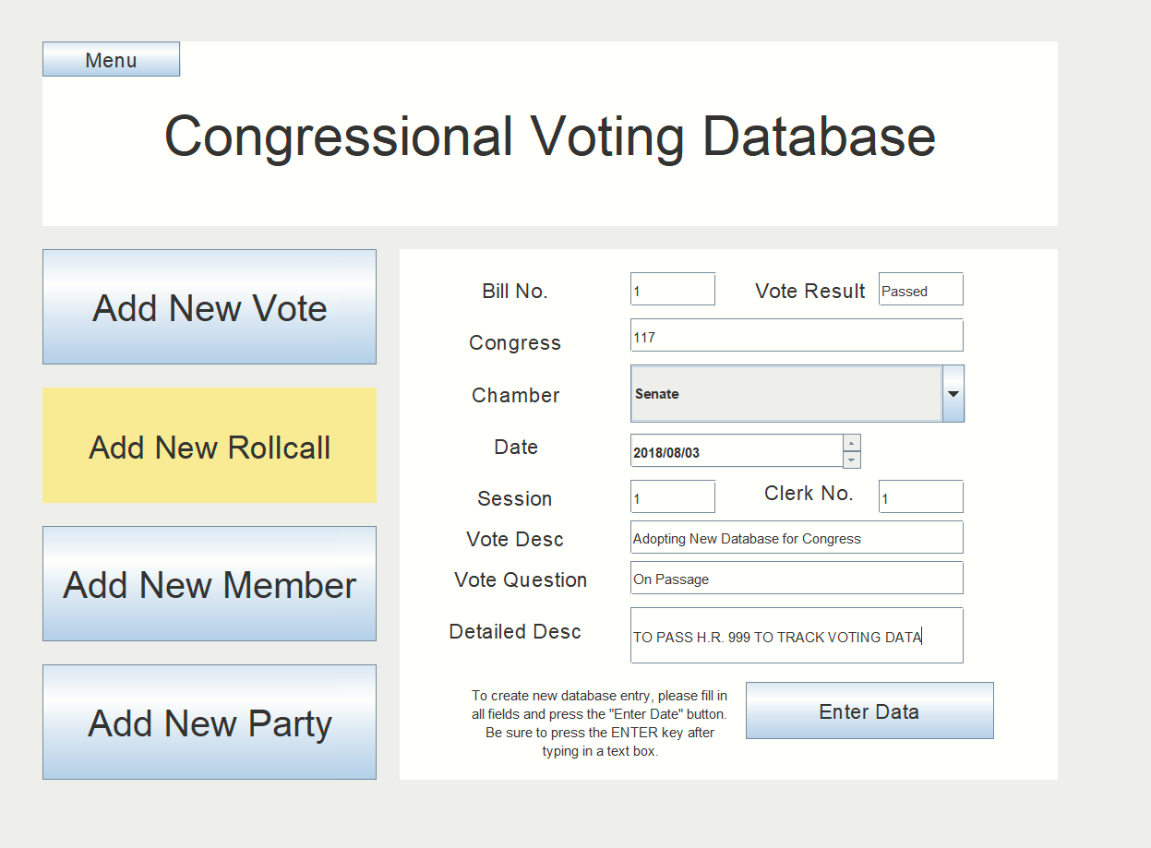

Users can return to the main menu or select a different type of data record to add using the “menu” button and the side buttons.

## Querying Data

This software also allows users to search the congressional voting database. To search for votes/rollcalls/members/parties in the database, users must click “Query Data” in the main menu. This will bring them to the Basic Search, where they can search for records in the database that meet a certain criterion. From here, users can also toggle to the “Advanced Search” which has a greater amount of options for searching.

### Basic Search

To search the database by a certain criterion, the user must first select the field by which they want to query. For example, if they want to search the database for congress members from a certain state, they can select the filter criteria “Members - state_abbrev” (or “Members - state_icpsr” if they know the icpsr code for the state offhand). Then, the user must enter the value of the criteria by which they are searching. For instance, if they have selected “Members - state_abbrev” they can enter *MA* in the search box to search for members of congress from Massachusetts. Or, to search for votes from the 115th congress, they can select “Votes – congress” and type 115 in the search box to search for votes in the 115th congress.

### Advanced Search

Users can also click “Advanced Search” to query the database for votes/rollcalls/members/parties by multiple criteria. In Advanced Search, users may specify a filter criterion and a value to filter their database search by that value, which is the same as in the Basic Search. In addition, however, they may also specify a specific congress and chamber from a drop-down menu, as well as a date range. The advanced search will then match all the criteria provided and return a list of either rollcalls, or of members/parties/votes that were involved in the rollcalls that correspond to the selected date range.

An example of a query using the Advanced Search is shown below. This query returns the votes cast by congress members from Massachusetts in the 115th Congress, from the House of Representatives, between May 16th, 2000 and August 3rd, 2017 (note that here, the date range is redundant since it includes the entirety of the 115th Congress records in the database).

# 

Users can also toggle back and forth between Basic Search and Advanced Search by clicking the appropriate button, or go back to the main menu by clicking the “Menu” button in the top left corner.

## Other Potential Issues (FAQ)

Q. I used the Java code to run the program instead of the executable .jar file. Why can’t I enter data or query the database?

A. This software uses the SQLite JDBC driver. If compiling the provided Java code to run the program instead of the executable, be sure to set the “lib” variable in the *.classpath* file to the file path location of your driver. This can be done in Eclipse by selecting Window > Preferences > Java > Classpath variables and adding the driver. Otherwise, the program will not work. This driver has been provided as an auxiliary file in the “misc” folder. Using the executable .jar file does not require adding the driver, however.

Q. I tried to enter data and the program said “Fill in all fields”, but all fields are filled. Why isn’t it working?

A. When filling in text entry, you must press enter to confirm each value that you enter. You may have forgotten to press enter on one of the boxes. If this is still the case, check that the executable file (or src folder if using the Java code files) are in the same folder as the database.

Q. Why is the program stuck with the “Search” button pressed?

A. Most queries should take less than 15 seconds. However, depending on the parameters of the advanced search, some queries may take a long time to return, up to roughly 12-15 minutes for the most complex queries. Please be patient. If the query is running for too long, you may want to quit the program and run the query again. If the query does not return any result, check the parameters that you specified to make sure they are valid and try again.

Q. Why does Advanced Search show multiples of the same member/party?

A. Unlike Basic Search, Advanced Search always shows members/parties/votes associated with particular rollcalls. This is because Advanced Search allows searching within a date range. Therefore, the result shows all rollcalls in which each member/party has participated, since rollcalls are used to track dates. The same member and party may show up multiple times since the query will show all dates in which that member/party was present in Congress.