### 1. Before you start

You can print out an image of the circuit board ([silkscreen](https://www.amb.org/audio/delta1/delta1_100_silk.pdf) in PDF format) to use as a guide for installing components.   
  
While you look at the board layout, please also take the time to look at the [schematic diagram](https://www.amb.org/audio/delta1/schematic.shtml) and associate each part with their location in the circuit. While this is not normally required to build a working circuit, one of the opportunities of DIY is to learn about how the circuit works. Try to determine what each part does and why the particular part or value is chosen. There are many web resources to help you with this, including the [AMB DIY audio forum](https://www.amb.org/forum/). You will find the overall DIY experience more rewarding as a result.   
  
Some parts are optional, or require different components depending on your specific configuration. See the [Parts list](https://www.amb.org/audio/delta1/parts.shtml) for details.   
  
If you're installing less than 8 relays, start with K0 and go up as shown in the [Resistors calculator](https://www.amb.org/audio/delta1/rcalc.cgi). Then, the RS*n*[LR] resistor positions associated with any unpopulated relays should be jumpered with a wire (such as a resistor lead cutoff). This is necessary to connect the unused elements of the R-2R ladder to the output connectors. The RP*n*[LR] positions associated with the unpopulated relays may be left open.

### 2. δ1 board assembly instructions

Clean both sides of the blank δ1 board with paper towel and isopropyl alcohol or electronics flux remover, then solder the parts to the board, starting with the lowest profile parts and work your way up. Typically this means starting with the discrete resistors, the ferrite bead, the multilayer ceramic capacitors, the IC sockets, the resistor networks, the LED arrays, the relays, the electrolytic capacitors, then the connectors and headers. If your chosen attenuator resistors are tall, then their installation order may be changed.   
  
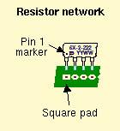   
  
Make sure the correct part goes into each position on the circuit board. Measure each resistor with your multimeter to ensure it's the proper value. Pay attention to the polarity of the electrolytic capacitors, and the orientation of the resistor networks, LED arrays and IC sockets. Install the ICs into their sockets *after* you're done with all the soldering, and make sure each one is seated completely.   
  
**Note**: Do not mix up R2+/R2- (47Ω) with R5+/R5- (47KΩ)! The former is usually marked "470" whereas the latter "473".   
  
R3 and R4 are I²C bus pullup resistors, and L1 connects the LCDuino-1 system digital ground to the chassis through a mounting screw and metal standoff. If you have multiple δ1 or δ2 boards in a stack, only one of them needs to have R3, R4 and L1 installed. It is recommended to install these parts on the lowest board in the stack, so that they do not disappear from the system if the upper boards are removed for testing/debugging purposes.   
  
The optional ground loop breaker components (RGL, RGR, CGL and CGR) may be installed if you are building a single-chassis amplifier where AC mains voltage will be present in the chassis. The chassis should be connected to AC earth (via the AC power cord's ground prong), while the amplifier's signal ground should be isolated from the chassis. The ground loop breaker will add a resistive connection (bypassed by the capacitor) between the signal ground and the chassis, through the board's mounting hole pads and metal standoffs. This allows the chassis to function as a RFI shield.   
  
If your δ1 board will remains in one piece, plug the J4 right-angle unshrouded pin header and J5 right-angle pin receptacle into each other, insert the assembly into the board's J4 and J5 pads, then solder the assembly in place. See the photos below.   
  
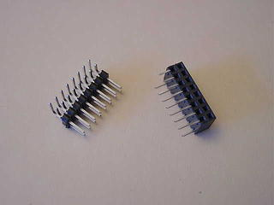  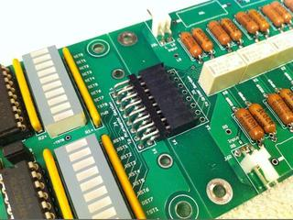   
  
If your δ1 board was snapped apart into separate driver and attenuator sections, then solder the right-angle shrouded pin headers into the J4 and J5 positions on the board, then make IDC ribbon cable assembly. The photo below shows a right-angle shrouded pin header soldered to the driver section. The attenuator side will have the same pin header. Note that this pin header is a slightly different style than the ones specified in the Parts list. It has extra latch/eject levers but the larger footprint blocks the holes meant for mounting this board behind the LCDuino-1 board as a "backpack".   
  
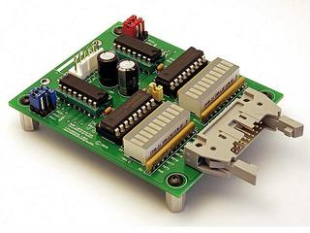   
  
When all soldering is done on the board, clean the solder flux residue from the board with isopropyl alcohol (or electronics flux remover) and a brush.   
  
Lastly, build the Molex wiring harnesses for the audio input/output and I2C/Power/Ground connections, and proceed to the next section to connect everything together.

### 3. Power options

Normally, the δ1 and δ2 stack of boards are powered completely by a +5V DC feed (VCC) from the LCDuino-1 board via the 6-wire I²C/PWR/GND cable. This power is supplied on both pins 1 and 2 of that cable. On δ1 and δ2, J1 pins 1 and 2 are designated as **+5V IN** and **ALT PWR IN**, respectively, as described in the following table:

|  |  |  |
| --- | --- | --- |
| Pin | LCDuino-1 side (J4) | δ1 / δ2 side (J1) |
| 1 | VCC | +5V IN |
| 2 | VCC | ALT PWR IN |
| 3 | GND | GND |
| 4 | GND | GND |
| 5 | I²C (SDA) | I²C (SDA) |
| 6 | I²C (SCL) | I²C (SCL) |

On δ1 and δ2, the +5V input from J1 pin 1 is always used to power the I²C port expanders U1+ and U1-. The relays coils and the darlington drivers U2+ and U2- can be configured to get their power from either J1 pin 1 or J1 pin 2, by installing a jumper across JP2 1-2 or JP2 2-3, respectively.   
  
In the standard configuration (with a straight-through 6-wire cable), LCDuino-1 supplies +5V to both pins, therefore it doesn't really matter how you set the JP2 jumper, all parts on the δ1/δ2 boards will get their +5V power from the LCDuino-1. Nevertheless the recommended setting is to install the jumper across JP2 2-3 so that the power for the I²C port expanders rides on a different wire than the power for the relays and their darlington drivers. This configuration is shown in the left side diagram below (click diagram to enlarge).   
  
If you want to power the relay coils and the darlington drivers from a separate power supply, you may build the alternative configuration, where the I²C/PWR/GND cable is modified such that δ1/δ2's J1 **ALT PWR IN** pin receives its power from that separate supply. This configuration may be used if you want to install relays with a different coil voltage specification than what's listed in the [Parts list](https://www.amb.org/audio/delta1/parts.shtml) or if you want to reduce the load on the 5V supply that provides power to the LCDuino-1 board. If you are using relays with a different coil voltage, then you'll need to use an alternate power supply with an output voltage of 0.5V higher than the coil voltage specification. You would still install the jumper across JP2 2-3 in this configuration, shown in the right side diagram below. Note that the only time you would install a jumper across JP2 1-2 is if your system is wired for the alternate power option, but you want to change back to using the +5V power feed from the LCDuino-1 for the relay coils and darlington drivers.   
  
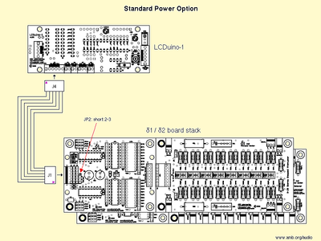  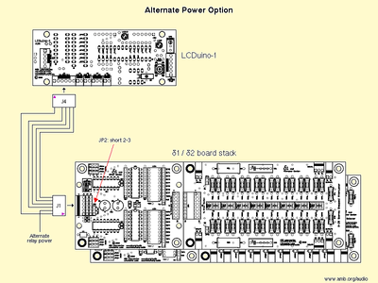

### 4. Wiring

Use the information found in the "Wiring" section of the [LCDuino-1](https://www.amb.org/audio/lcduino1/) website to connect your δ1 board. Also see [Power options](https://www.amb.org/audio/delta1/instructions.shtml" \l "power_options) above. If you have multiple δ1 and/or δ2 boards, they can be stack-mounted and interconnected with 6P header and receptacle pairs mounted between the boards in J2 or J3. This way only one I²C/Power/Ground wire harness is needed from the LCDuino-1 to connect to all stacked δ1/δ2 boards. See the following illustration:   
  
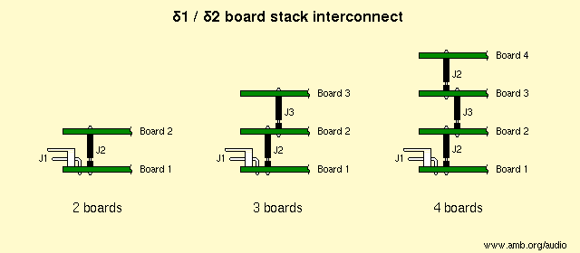   
  
When you are stacking boards, check to make sure that the tops of the C1 and C3 capacitors of the lower board(s) will not touch the bottom of the board above. Otherwise a short circuit may occur.   
  
If you are building an [α10](https://www.amb.org/audio/alpha10/) stereo pre-amplifier, the special backplane board provides an alternate wiring scheme. Please refer to the α10 website for details.   
  
For the audio input and output wiring, treat the δ1 as a stereo potentiometer or stepped attenuator and connect it accordingly. If you are also using the δ2 input/output selector board, please refer to the [δ2](https://www.amb.org/audio/delta2/) website for additional information.   
  
If you're building a fully-passive (i.e., no active line stage or amplifier) configuration with one δ1 and one δ2 board in a stack, the IBUS and OBUS connectors on the δ2 board are aligned with the INPUT and OUTPUT connectors on the δ1, so you could use 2P pin headers and receptacles to connect them rather than Molex connectors and wires.   
  
**Note**: Do not apply power to the δ1 board in a standalone fashion. It should be powered up at the same time as the controlling LCDuino-1 board (running Volu-Master firmware). The firmware initializes the δ1 board on power-up. Also, do not change the jumpers settings while the power is on.

### 5. Initial setup

Before you power up the δ1 board(s) for the first time, you must set a few jumpers:

|  |  |
| --- | --- |
| Jumper(s) | description |
| **JP1** | There are two sets of three jumpers, JP1[ABC]+ and JP1[ABC]-, which set the I²C addresses of each board. You may either pre-set these jumpers to the default values prior to powering up for the first time, or run LCDuino-1's "Menu setup" to select your addresses and then set the jumpers to match (see the "Setup" page at the [LCDuino-1](https://www.amb.org/audio/lcduino1/) website.   The default settings assume that you used PCF8574A chips for U1+ and U1- on all δ1 and δ2 boards, and are listed as follows (a "1" means to install a jumper across the 1 and 2 pins, a "0" means to install a jumper across the 2 and 3 pins):   |  |  |  |  |  |  |  | | --- | --- | --- | --- | --- | --- | --- | | Board # | JP1C+ | JP1B+ | JP1A+ | JP1C- | JP1B- | JP1A- | | δ1 #1 | 1 | 1 | 1 | 1 | 1 | 0 | | δ1 #2 | 1 | 0 | 1 | 1 | 0 | 0 | | δ2 #1 | 0 | 1 | 1 | 0 | 1 | 0 | | δ2 #2 | 0 | 0 | 1 | 0 | 0 | 0 |   **Note**: Each I²C address on the bus should be unique. |
| **JP2** | This is a "Power select" jumper. See [Power options](https://www.amb.org/audio/delta1/instructions.shtml" \l "power_options) above. |
| **JP3** | If you don't have LED+, LED-, R1+ and R1- installed, then you may leave this jumper open. Otherwise, install a jumper here to enable the onboard LED diagnostic display, or remove the jumper to disable it. |

After the jumpers are set, and you have connected all the wiring, perform the initial setup of all functions according to the [LCDuino-1](https://www.amb.org/audio/lcduino1/) website, and test everything to make sure they work. If you are stacking multiple δ1/δ2 boards, connect and test one board at a time, starting from the bottom of the stack.   
  
If everything is successful, then you are done. Enjoy.