***The LCDuino-1 display I/O processor***

### Instructions

#### Before you start

You can print out an image of the circuit board silkscreens ([top side](https://www.amb.org/audio/lcduino1/lcduino1_101_topsilk.pdf), [bottom side](https://www.amb.org/audio/lcduino1/lcduino1_101_btmsilk.pdf), both in PDF format) to use as a guide for installing components.   
  
While you look at the board layout, please also take the time to look at the [schematic diagram](https://www.amb.org/audio/lcduino1/schematic.shtml) and associate each part with their location in the circuit. While this is not normally required to build a working circuit, one of the opportunities of DIY is to learn about how the circuit works. Try to determine what each part does and why the particular part or value is chosen. There are many web resources to help you with this, including the [AMB DIY audio forum](https://www.amb.org/forum/). You will find the overall DIY experience more rewarding as a result.

#### LCDuino-1 board assembly instructions

Clean both sides of the blank LCDuino-1 board with paper towel and isopropyl alcohol or electronics flux remover before soldering any parts on it.   
  
Some parts are optional. See the [Parts list](https://www.amb.org/audio/lcduino1/parts.shtml) for details.   
  
Most parts are to be mounted on the top side of the board (and soldered on the bottom), but there are a few parts that should be just the opposite (VR1, X2, SW1, both LEDs and all Molex KK 254 headers). The board silkscreens also show which side each part should be mounted. Note that the horizontal style of the supercapacitor (Cs) should be mounted on the top side of the board, but the vertical style should be mounted on the bottom side.   
  
Do not install the J1 and J2 pin headers at this time, these are deferred to the [Display module instructions](https://www.amb.org/audio/lcduino1/instructions.shtml" \l "display_module) section below.   
  
**γ3 only**: Do not populate the real time clock chip (U2) and its socket, the quartz crystal (X2) and the supercapacitor (Cs).   
  
**Volu-Master only**: If you will be installing the real time clock chip (U2), the first thing is to mount the cylinder crystal (X2) on the bottom side of the board and solder it on the top side, *before* you install the IC socket for U2. Bend a cut resistor lead into a U-shape, slip it over the crystal and insert the lead ends into the two holes on the board, on each side of the crystal. Solder the leads to the board on the top side of the board as a way to secure the crystal. When done, it should look like the photo below.   
  
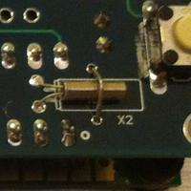   
  
Then, solder the remaining components to the board. Do one side at a time, starting with the lowest profile parts and work your way up. There are two basic mounting options for the IR receiver (U4):

1. Wired off-board and mounted on the front panel as shown in the photos below (with the "dome" exposed to the outside through a hole on the panel). See AMB's reference [α10 pre-amplifier](https://www.amb.org/audio/alpha10/) or [γ3 DAC](https://www.amb.org/audio/gamma3/).
2. Mounted directly on the top side of the board (with the leads bent 90°).

The first mounting option is shown in the photos at the bottom of this page. The following diagram illustrates the second option.   
  
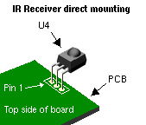   
  
**Note**: The second mounting option requires a wider panel cutout for the display module, in order to expose the IR receiver. A clear/tinted piece of plastic lens could then be mounted in front to finish the look. Also, the IR receiver's leads should be insulated individually with heat-shrink or other tubing in order to prevent short circuits between the pins, or to circuitry on the display module. Be sure to connect the IR receiver correctly. It will be damaged if the wiring is reversed.   
  
LED13 is an "activity light" which, by default, flashes when a valid command is received from the IR remote control. You may solder it on the board, or mount it on the front panel and wire it to the board.   
  
Make sure the correct part goes into each position on the circuit board. Measure each resistor with your multimeter to ensure it's the proper value. Pay attention to the polarity of electrolytic capacitors, and the orientation of the trimpots and IC sockets. Install the ICs into their sockets *after* you're done with all the soldering, and make sure each one is seated completely.   
  
Due to U1's 28 pins, if you chose to use a socket with machined contacts, a considerable amount of force will be needed to insert the IC fully or to remove it from the socket. Be careful so that you do not bend or break the IC pins or damage the socket. Also take extra care to avoid pricking your finger on the pins.   
  
For γ3 only, you should break the 9P single-row 0.1" pitch pin headers into two 3P and one 2P pieces, Then, mount them on the back of the LCDuino-1 board in the \_D2/\_D3/\_D4, \_D5/\_D6 and \_D10/\_D11/\_D12 positions. See the [Wiring](https://www.amb.org/audio/lcduino1/wiring.shtml) section for information about how these will be used to connect more signals between LCDuino-1 and γ3.   
  
Clean up the solder flux residue from the board with isopropyl alcohol (or electronics flux remover) and a brush.

#### Display module instructions

You may need to enlarge the display module's four mounting holes *slightly* in order to fit imperial #4-40 or metric M3 machine screws through them.   
  
To ensure proper alignment and electrical contact, the LCDuino-1 board's J1 and J2 pin headers should be mated to their matching 6P female pin receptacles, and then soldered to the LCDuino-1 board and the display module while they're bolted together on their mounting standoffs.   
  
Make sure that the two 6P receptacles go in the correct pads on the display module. Use the row of pads on the top side of the back of the display module. There is a row of 16 pads. The two 6P receptacles should be soldered to pads 1-6 and 11-16. There are four unused pads in the center. See the following photo (click image to enlarge):   
  
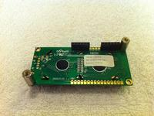   
  
Plug the LCDuino-1 board into the display module via the J1 and J2 connectors.

#### Miscellany

Since the LCDuino-1 and display module board holes are plated through, you only need to solder the parts on the opposite side of the board that the part is mounted on. Do not drill or enlarge the holes because that would damage the through-plating.   
  
Inspect all solder connections carefully, using a magnifying glass, to make sure there are no solder bridges or cold solder joints. Use a multimeter in ohms scale to check for short circuits, and correct any mistakes.   
  
When all steps on this page are completed, proceed to the [Wiring & ground](https://www.amb.org/audio/lcduino1/wiring.shtml) section for details about wiring up the connections to the board. 

### Preface

The LCDuino-1 can be used in many applications and configurations, it's not possible to document every case. This section covers the most common usage, namely, as a controller for the δ1 stereo attenuator and δ2 stereo input/output selector boards in an audio amplifier; and as the controller for the γ3 DAC.   
  
The internal layout of your enclosure is an important factor to good performance. The placement and orientation of the boards and routing of wires must be carefully considered.

* LCDuino-1 does not emit a strong RFI, but it is prudent to keep a good distance between the digital and analog circuitry. Since LCDuino-1 with its display module will typically be mounted on the front panel, it is therefore logical to locate the analog circuitry toward the rear of the enclosure, close to the input and output jacks. The δ1 and δ2 have snap-apart digital control and analog board sections to help in tight situations. The γ3 backplane board is likewise designed to be located against the rear panel.
* The power transformer(s) should be placed far away from analog circuitry to prevent hum, preferably in a separate enclosure.

Most connections in the LCDuino-1 system use Molex KK 254 connectors. The Molex KK 254 crimp housing and terminal accepts wires up to 22 AWG. You should use 22 AWG stranded hookup wires for all power, ground, and potentiometer motor wiring. For all other LCDuino-1 wiring, 24-28 AWG stranded hookup wire is sufficient. Please do not use solid wires as they may become fatigued and break.   
  
J7 and J8 on the LCDuino-1 board are currently unused. They are for future expansion.

### System wiring for LCDuino-1 with δ1 and δ2

The following is a wiring diagram for an unbalanced system using one δ1 stereo attenuator board and one δ2 stereo input/output selector board. A balanced system will require two δ1 and two δ2 boards. Virtually all connections are done via Molex KK 254 connectors for easy disassembly. You will need to build the wiring harnesses first.   
  
**Notes**:

* J3 is normally used to supply power to the LCDuino-1 system. Only pins 1 through 3 are used for this purpose. However, this connector is also used for flashing new firmware. To do so, you must unplug J3 and insert the 6-wire FTDI TTL-232R cable instead (See [Compile and flash the firmware](https://www.amb.org/audio/lcduino1/firmware.shtml" \l "compile_flash_firmware) for details). The δ1 and δ2 boards are powered through the I2C/PWR/GND harness from the LCDuino-1 board.
* If you are building the α10 stereo pre-amplifier, the α10 backplane board takes the place of some of the wiring. Please see the [α10 website](https://www.amb.org/audio/alpha10/) for details.
* Do not connect the J4 (I2C/PWR/GND harness) to the δ1 and δ2 boards and power up the system, unless the LCDuino-1 has the Atmel MCU pre-flashed with Volu-Master firmware!

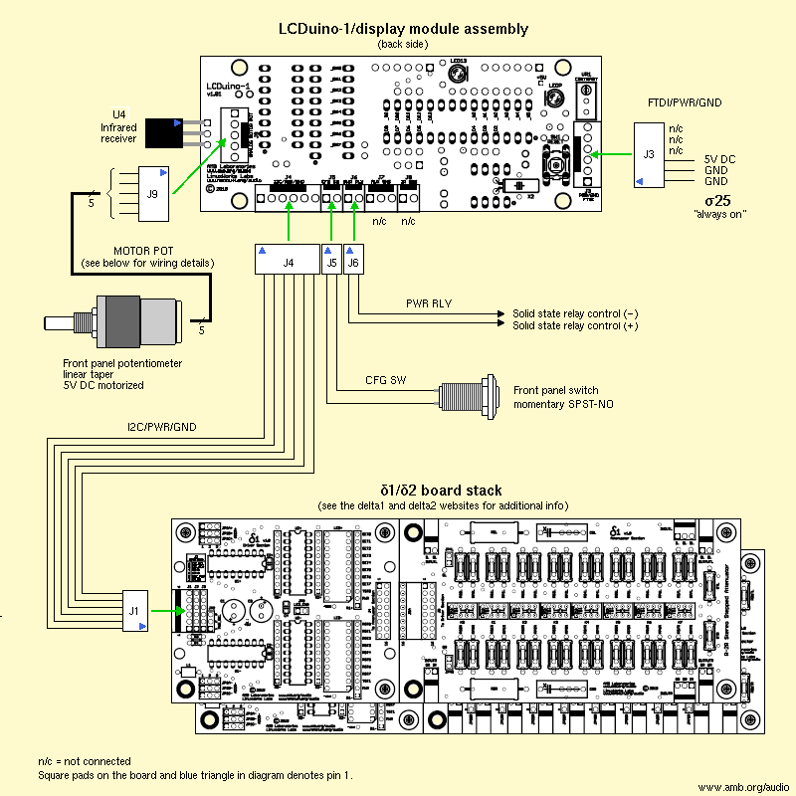

### System wiring for LCDuino-1 with γ3

The following is the wiring diagram for the LCDuino-1 in a γ3 DAC. For easy disassembly, virtually all wire connections are done with Molex KK 254 connectors on both ends.   
  
**Notes**:

* The LCDuino-1 gets its power from the γ3 backplane board via the J4, the I2C/PWR/GND connector. J3 is therefore unused for normal operation. However, this connector is also used for flashing new firmware. To do so, be sure to first disconnect the LVDD power supply from the γ3 board, then insert the 6-wire FTDI TTL-232R cable into J3 (See [Compile and flash the firmware](https://www.amb.org/audio/lcduino1/firmware.shtml" \l "compile_flash_firmware) for details).
* If you are using the ε31 bridge board, it takes the place of most of the wiring. Also, some connectors used on the LCDuino-1 and γ3 boards are different. Please see the [ε31](https://www.amb.org/forum/epsilon31-gamma3-lcduino-1-bridge-board-t3036.html) forum thread for further information.

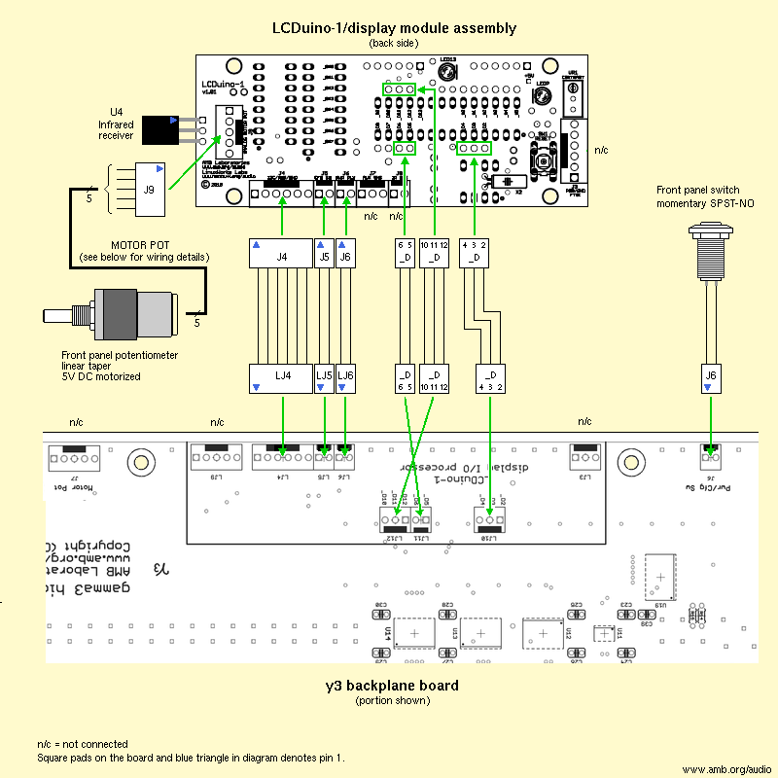

### Motorized potentiometer wiring

The potentiometer wiring detail for the Alps RK16812MG099 is shown below. Click on the image to see a larger version. The potentiometer's body should be grounded to the metal chassis via its panel-mounting nut. If your panel is non-conductive, then you should add a ground wire.

|  |
| --- |
|  |

### Power supply wiring for LCDuino-1 with δ1 and δ2

It is assumed that you have a "constantly-on", regulated 5V DC power supply for the LCDuino-1, δ1 and δ2 boards. A good candidate would be the [σ25](https://www.amb.org/audio/sigma25/) power supply. See the [overview page](https://www.amb.org/audio/lcduino1/overview.shtml) about power supply requirements.   
  
Note that there are two power transformers. The T2 power transformer (powered as long as the AC cord is plugged in) feeds a σ25 power supply with 5V DC output, providing power to the LCDuino-1, δ1 and δ2 boards. The solid-state relay, controlled by LCDuino-1, switches the AC mains power to the T1 transformer, which supplies power to the amplifier circuit.   
  
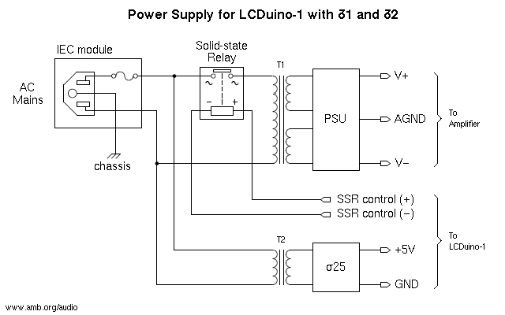

### Power supply wiring for LCDuino-1 with γ3

It is assumed that you have a "constantly-on", regulated 5V DC power supply for the LCDuino-1 board. This power supply will also provide power to some circuitry on the γ3. A good candidate would be the [σ11](https://www.amb.org/audio/sigma11/) power supply. See the [overview page](https://www.amb.org/audio/lcduino1/overview.shtml) about power supply requirements.   
  
Note that there are three power transformers. The T3 power transformer (powered as long as the AC cord is plugged in) feeds a σ11 power supply with 5V DC output, providing power to the LCDuino-1 and a portion of the γ3. The solid-state relay, controlled by LCDuino-1, switches the AC mains power to the T1 and T2 transformers, which provide power to the γ3 DAC analog and digital circuitry.   
  
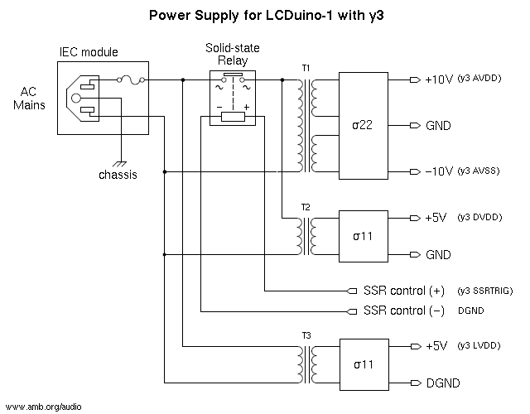   
  
AMB's reference γ3 used an R-core transformer with multiple secondary windings for a combined T1 and T2, and a separate toroidal transformer for T3. As with the reference γ3, it is recommended that you use a separate chassis for the power supply, to eliminate any potential hum due to transformer magnetic field interference.

### User guide

LCDuino-1 is easy and intuitive to use. This section is a general operating manual for the LCDuino-1 running unmodified Volu-Master or γ3 firmware. The following is a summary of the topics covered:

1. [Remote control quick reference](https://www.amb.org/audio/lcduino1/userguide.shtml" \l "remote_quick_reference)
2. [Front panel controls](https://www.amb.org/audio/lcduino1/userguide.shtml" \l "front_panel_controls)
3. [Detailed function descriptions](https://www.amb.org/audio/lcduino1/userguide.shtml" \l "detailed_desc)
4. [System reset](https://www.amb.org/audio/lcduino1/userguide.shtml" \l "system_reset)

### 1. Remote control quick reference

All features of the LCDuino-1 are accessible via the wireless remote control. LCDuino-1 must be adapted to your remote control with "Learn IR". See the[Setup section](https://www.amb.org/audio/lcduino1/setup.shtml" \l "basic_initialization) for details.   
  
The following is a table of learned remote control keys and their functions during normal operating mode. In [Menu setup](https://www.amb.org/audio/lcduino1/setup.shtml" \l "menu_setup) mode, some the keys are unused while others are used for navigating the menu system.

|  |  |
| --- | --- |
| Key | Description |
| **Up Arrow** | [Increase volume](https://www.amb.org/audio/lcduino1/userguide.shtml" \l "change_volume) (coarse) |
| **Down Arrow** | [Decrease volume](https://www.amb.org/audio/lcduino1/userguide.shtml" \l "change_volume) (coarse) |
| **Right Arrow** | [Increase volume](https://www.amb.org/audio/lcduino1/userguide.shtml" \l "change_volume) (fine) |
| **Left Arrow** | [Decrease volume](https://www.amb.org/audio/lcduino1/userguide.shtml" \l "change_volume) (fine) |
| **Mute** | [Mute/un-mute audio](https://www.amb.org/audio/lcduino1/userguide.shtml" \l "change_volume) |
| **Up Alias** | [Increase volume](https://www.amb.org/audio/lcduino1/userguide.shtml" \l "change_volume) (fine) |
| **Down Alias** | [Decrease volume](https://www.amb.org/audio/lcduino1/userguide.shtml" \l "change_volume) (fine) |
| **Power** | [Turn power on/off](https://www.amb.org/audio/lcduino1/userguide.shtml" \l "power_on_off) |
| **Menu** | [Enter/exit Menu setup mode](https://www.amb.org/audio/lcduino1/setup.shtml" \l "menu_setup) |
| **Sleep** | [Enable/disable sleep timer](https://www.amb.org/audio/lcduino1/userguide.shtml" \l "sleep_timer) (Volu-Master only) |
| **Anti-clip** | [Enable/disable anti-clip mode](https://www.amb.org/audio/lcduino1/userguide.shtml" \l "anti_clip) (γ3 only) |
| **Backlight** | [Toggle between three display backlight modes](https://www.amb.org/audio/lcduino1/userguide.shtml" \l "backlight_control) |
| **Display** | [Toggle between different main screens](https://www.amb.org/audio/lcduino1/userguide.shtml" \l "main_screen) |
| **1..8** (numeric key) | [Select input or output port(s)](https://www.amb.org/audio/lcduino1/userguide.shtml" \l "select_input_output) (Volu-Master only) |
| **0..4** (numeric key) | [Select digital input](https://www.amb.org/audio/lcduino1/userguide.shtml" \l "select_digital_input) (γ3 only) |
| **Multi-out** | [Enable/disable multi-output mode](https://www.amb.org/audio/lcduino1/userguide.shtml" \l "select_input_output) (Volu-Master only) |
| **Filter** | [Select filter](https://www.amb.org/audio/lcduino1/userguide.shtml" \l "select_filter) (γ3 only) |

### 2. Front panel controls

LCDuino-1 supports a front-panel mounted pushbutton switch and an optional potentiometer. Further, the potentiometer may be a motorized unit.

#### Pushbutton:

* + As [power on/off](https://www.amb.org/audio/lcduino1/userguide.shtml" \l "power_on_off) switch: When the power is on, press and hold for a few seconds to turn off. When power is off, press briefly to turn on.
  + As [mute/un-mute](https://www.amb.org/audio/lcduino1/userguide.shtml" \l "change_volume) switch: When power is on, a brief press mutes the audio. Press again to un-mute.
  + At power-on, the switch could be used to trigger [Basic initialization](https://www.amb.org/audio/lcduino1/setup.shtml" \l "basic_initialization) mode, which let's you restore all configuration data to factory defaults, perform the "Learn IR" sequence, or skip keys while in Learn IR.

#### Potentiometer (if equipped):

* + As [volume control](https://www.amb.org/audio/lcduino1/userguide.shtml" \l "change_volume): Turn clockwise to increase volume, turn counter-clockwise to decrease. If you use the remote control to change the volume, and your potentiometer is motorized, LCDuino-1 will activate the motor and synchronize the knob position to the current volume.
  + Since LCDuino-1 remembers the volume level on a per-input basis, if you change the input, the volume will be restored to the previous level on that port, and the potentiometer motor will be activated to move to the restored level.
  + In [Menu setup](https://www.amb.org/audio/lcduino1/setup.shtml" \l "menu_setup) mode, the potentiometer is used as an alternative to the remote control for selecting field entries. If the potentiometer is motorized, when exiting Menu setup mode, LCDuino-1 will activate the motor and re-synchronize the knob position to the current volume.

### 3. Detailed function descriptions

The following sections describe the functions you could perform while LCDuino-1 is in normal mode (i.e., it is displaying the [Main screen](https://www.amb.org/audio/lcduino1/userguide.shtml" \l "main_screen)).

### Power on/off

Since LCDuino-1 is always powered, "Power on/off" here refers to LCDuino-1's control of power to the rest of system being managed, which is usually the analog amplifier circuitry. See the [Wiring section](https://www.amb.org/audio/lcduino1/wiring.shtml) for details.

#### Power on

Turn on the power by briefly pressing the **Power** key on your remote control, or the front panel CFG/PWR pushbutton.   
  
With Volu-Master, after the power is on, the display shows a countdown of the muting delay feature. During this time, all of δ2's output ports are disabled to prevent any turn-on noise. The delay interval is adjustable via [Menu setup](https://www.amb.org/audio/lcduino1/setup.shtml" \l "timers). If it was configured to be 0 seconds, then this screen is skipped and all outputs ports are enabled immediately.

|  |
| --- |
| Volu-Master |
|  |

After the muting delay interval, if the power was turned on using the CFG/PWR pushbutton, then the start-up banners appear briefly. These banners can be customized through [Menu setup](https://www.amb.org/audio/lcduino1/setup.shtml" \l "user_banner1). The following shows the default banner text. The banners are not displayed if the power is turned on using the remote control for faster start-up.

|  |  |  |
| --- | --- | --- |
| Volu-Master |  | γ3 |
|  |  |  |

The LCDuino-1 then displays the [Main screen](https://www.amb.org/audio/lcduino1/userguide.shtml" \l "main_screen) and enters normal operating status.

#### Power off

Briefly press the **Power** key on the remote control. When using the front panel CFG/PWR pushbutton to turn off the power, you must press the the button and hold it down for a few seconds.   
  
With Volu-Master, LCDuino-1 disables all δ2's output ports before killing the power, to prevent any turn-off noise. After the power is off, the display shows the first banner and the clock (or the second banner if your LCDuino-1 is not [configured with a clock](https://www.amb.org/audio/lcduino1/setup.shtml" \l "motor_pot_clock)). With γ3, after the power if off, the display shows both the first and second banners.

|  |  |  |
| --- | --- | --- |
| Volu-Master |  | γ3 |
|  |  |  |

The display will either be on, auto-dimmed, or completely dark depending on your [Backlight control](https://www.amb.org/audio/lcduino1/userguide.shtml" \l "backlight_control) setting.

### Main screen

The main screen is what you see on the display when LCDuino-1 is in the normal operating mode. With the exception of the "large font" screen, all other screens are divided into four quadrants, each of them up to eight characters long. Each quadrant shows screen-specific operating information.   
  
   
  
With Volu-Master, there are four versions of the main screen that you could cycle through by pressing the **Display** key of your remote control. Note that the Volu-Master screen examples shown below have [user-defined input/output port names](https://www.amb.org/audio/lcduino1/setup.shtml" \l "ioport_config) ("gamma2" and "beta24", referring to the AMB [γ2](https://www.amb.org/audio/gamma2/)DAC and [β24](https://www.amb.org/audio/beta24/) power amplifier, respectively). With γ3, there are three main screens.   
  
The current main screen is remembered across a power off/on cycle.

|  |  |  |
| --- | --- | --- |
| Volu-Master |  | γ3 |
| **A** |  | **A** |
|  |  |  |
| **B** |  | **B** |
|  |  |  |
| **C** |  | **C** |
|  |  |  |
| **D** |  |  |
|  |  |  |

**Main screen "A"**

This version shows the input selector port name in the upper left quadrant, a volume control bargraph in the lower left quadrant, and a volume control dB readout in the lower right quadrant. If [Mute](https://www.amb.org/audio/lcduino1/userguide.shtml" \l "change_volume) is on, then the bargraph area shows "MUTE".   
  
With Volu-Master, the upper right quadrant shows the output selector port name. If [Multi-Out](https://www.amb.org/audio/lcduino1/userguide.shtml" \l "select_input_output) mode is enabled, then the output port name area shows the port status rather than the name. If your LCDuino-1 is not configured with a [volume control engine](https://www.amb.org/audio/lcduino1/setup.shtml" \l "vol_io_engine), then the bargraph and dB readout are not displayed.   
  
With γ3, the upper right quadrant shows the current digital input sample rate. If the DAC cannot lock on to a valid sample rate, then this quadrant will show a blank.

**Main screen "B"**

This screen shows the volume dB attenuation in a large font face for easy viewing from a distance. If Mute is on, then the display shows *hyphen* characters ("−") instead of the dB value.   
  
With Volu-Master, if the Sleep timer is on, then a small clock icon appears on the right side of the display. This screen is not available if your LCDuino-1 is not configured with a [volume control engine](https://www.amb.org/audio/lcduino1/setup.shtml" \l "vol_io_engine).

**Main screen "C"**

With Volu-Master, this screen is similar to main screen "A", except the lower left quadrant shows the sleep timer countdown ("S*nn*", where *nn* is the number of minutes remaining to shutdown). If sleep mode is not active, then "S--" is shown. The descriptions for Main screen A regarding Multi-Out and Mute modes also apply to the lower left and upper right quadrants.   
  
With γ3, the lower left quadrant shows the selected filter response number (there are five to choose from). The upper right quadrant shows "AntiClip" if the anti-clip mode is enabled, otherwise it's blank. The descriptions for Main screen A regarding Mute mode also apply to the lower left quadrant.

**Main screen "D"**

Same as main screen "A", except the lower left quadrant shows the clock (current time in 24-hour format). The descriptions for Main screen A regarding Multi-Out and Mute modes also apply here. This screen is not available if your LCDuino-1 is not [configured with a clock](https://www.amb.org/audio/lcduino1/setup.shtml" \l "motor_pot_clock).

The following are more screen examples. This screen below shows main screens "A", "C" or "D" while Mute is on:

|  |  |  |
| --- | --- | --- |
| Volu-Master |  | γ3 |
|  |  |  |

This is main screen "B" while Mute is on:

|  |
| --- |
| Volu-Master and γ3 |
|  |

This is main screen "B" while the Sleep timer is on:

|  |
| --- |
| Volu-Master |
|  |

### Backlight control

You could choose from three display backlighting modes by pressing the **Backlight** key on your remote control.

**Backlight On**

The display is always "bright".

**Backlight Auto**

The display is "bright" when there is user activity, but goes to a "dim" state after a few seconds.

**Backlight Off**

The display is "bright" when there is user activity, but goes completely dark after a few seconds.

"User-activity" refers to pressing a remote control key, turning the volume knob, etc. The bright and dim levels are user-adjustable via [Menu setup](https://www.amb.org/audio/lcduino1/setup.shtml" \l "display_brightness).   
  
When you change the backlight mode, a screen message appears momentarily to show the new mode:

|  |  |  |  |  |
| --- | --- | --- | --- | --- |
|  |  |  |  |  |

Then, the display reverts to the [Main screen](https://www.amb.org/audio/lcduino1/userguide.shtml" \l "main_screen). The following shows examples of the main screen in bright, dimmed and off states:

|  |  |  |  |  |
| --- | --- | --- | --- | --- |
|  |  |  |  |  |

The selected backlight mode also applies when the LCDuino-1 is in the powered-off state.

### Changing the volume

You can change the volume using your remote control or, if equipped, the front-panel potentiometer. You can also mute and un-mute the audio using the remote control, or the front panel PWR/CFG pushbutton. These controls act on both stereo channels of all installed δ1 boards simultaneously.   
  
With the remote control, you have the choice of *fine* and *coarse* volume adjustments:

**Fine adjustment** - Right Arrow, Left Arrow, Up Alias and Down Alias keys

Each key-press increases or decreases the volume by one "native" step (according to your δ1 board's resistor values). This is configured in[Menu setup](https://www.amb.org/audio/lcduino1/setup.shtml" \l "d1relays_dbstep).

**Coarse adjustment** - Up Arrow and Down Arrow keys

Each key-press increases or decreases the volume by a user-specified step size. It allows you to make large volume changes quickly. See[Menu setup](https://www.amb.org/audio/lcduino1/setup.shtml" \l "coarse_vol_stepsize)

With the front panel potentiometer, turn clockwise to increase the volume or counterclockwise to decrease.   
  
In all cases, the volume adjustment range (minimum and maximum limits) is also user-configurable, via [Menu setup](https://www.amb.org/audio/lcduino1/setup.shtml" \l "vol_range_limits). These limits are applied to the total rotational sweep of the potentiometer. For example, if you set the minimum and maximum limits to -40.0dB and -10.0dB, respectively, then these will become the potentiometer's fully-counterclockwise and fully-clockwise positions.   
  
The **Mute** feature allows you to silence the audio temporarily. To activate, simply press the **Mute** key on your remote control or the front panel PWR/CFG pushbutton. To un-mute, just press the **Mute** remote key or PWR/CFG pushbutton again. Increasing the volume will also cause an un-mute, but decreasing the volume will not. This lets you change to a lower volume setting while muted, and then un-mute to the new setting.   
  
Mute applies to all inputs -- if you enable mute while on one input, it will remain muted if you change to a different input. With Volu-Master, the muted level is not necessarily total-silence -- it is also governed by the minimum volume limit described above.   
  
The current volume level and mute status (if enabled) are displayed on the [Main screen](https://www.amb.org/audio/lcduino1/userguide.shtml" \l "main_screen). The following shows the main screen in bargraph mode, at minimum and maximum volume settings (with Volu-Master, for an 8-relay, 0.5dB/step configuration):

|  |  |  |
| --- | --- | --- |
| Volu-Master |  | γ3 |
|  |  |  |
|  | |  |
|  |  |  |

If the potentiometer motor is running, you should wait for it to stop before using the potentiometer to change the volume. You can use the remote control to override the motor at any time.   
  
If the motor is running while you enter [Menu Setup](https://www.amb.org/audio/lcduino1/setup.shtml" \l "menu_setup), the motor will stop. When you exit Menu Setup, the motor will be activated to restore the volume position if necessary.

### Selecting input and output(s) (Volu-Master only)

The **1** to **8** keys of your remote control's numeric keypad are used for selecting the δ2 input and output ports. The key number correspond to the port number on the δ2 board *plus one*, because the board's port numbers are 0 to 7.   
  
Only one input port may be selected at a time. Selecting a new input port will de-select the previous input port. The selected input port name (user-customizable) is displayed on the [Main screen](https://www.amb.org/audio/lcduino1/userguide.shtml" \l "main_screen).   
  
For output ports, there are two modes, *Single-Out* or *Multi-Out*. You choose between the two modes by pressing the **Multi-Out** key on your remote control.

**Single-Out**

Only one output port may be selected at a time. Selecting a new output port will de-select the previous output port. The selected output port name (user-customizable) is displayed on the [Main screen](https://www.amb.org/audio/lcduino1/userguide.shtml" \l "main_screen).   
  
The example main screen below is in Single-Out mode. The input port named "gamma2" and the output port named "beta24" are selected.   
  


**Multi-Out**

Multiple output ports may be selected simultaneously. The remote control's numeric keys become toggles on each output port - press to enable, press again to disable. The output port name area on the [Main screen](https://www.amb.org/audio/lcduino1/userguide.shtml" \l "main_screen) changes to show the status of each port. The eight character positions, from left to right, corresponds to the port numbers 1 through 8. An "I" character indicates that the port is the selected input port. A *hyphen* ("−") character means that the port is de-selected, and *digit* characters ("1" to "8") show all enabled output ports. Note that in this mode it is possible to disable or enable all output ports.   
  
The example main screen below shows Multi-Out mode, where the input port named "gamma2" is selected, and output ports 5 and 8 are enabled. We could also see that "gamma2" is port 1.   
  


|  |  |
| --- | --- |
| Notes: | |
| • | Each δ2 port can be set up as an input or output port via jumpers. See the [δ2 website](https://www.amb.org/audio/delta2/). The port configuration should then be configured via[Menu setup](https://www.amb.org/audio/lcduino1/setup.shtml" \l "ioport_config). |
| • | Each "port" mentioned here is actually two physical ports (the left and right channels) on each δ2 board. These controls act on both stereo channels of all installed δ1 boards simultaneously. |
| • | LCDuino-1 remembers the volume setting on a per-input port basis. When you change input ports, the volume will be restored to the previous level on that port. |
| • | LCDuino-1 remembers the selected output port in Single-Out mode. When you change from Multi-Out mode back to Single-Out, the saved port will be restored. |

**Screen Messages**   
  
When the display is in [Main screen C](https://www.amb.org/audio/lcduino1/userguide.shtml" \l "main_screen) ("big font") mode, if you change input or output ports, the screen momentarily displays the original port and the new port we've switched to, then the display reverts to the main screen. Here is an example of the screen message when you switch the input port from "gamma2" to the port "gamma1":   
  
   
  
Here is an example of the screen message when you switch the output port from "beta24" to "beta22" while we're in *Single-Out* mode.   
  
   
  
This is a screen message example in *Multi-Port* mode, where output port 5 was already enabled but we've also enabled output port 6:   
  


### Selecting input (γ3 only)

The **0** to **4** keys of your remote control's numeric keypad are used for selecting the γ3 digital input. Key 0 correspond to the USB input, while keys 1 to 4 refer to the four AES/EBU or S/PDIF inputs.   
  
Only one input may be selected at a time. Selecting a new input will de-select the previous input. The selected input name (user-customizable) is displayed on the [Main screen](https://www.amb.org/audio/lcduino1/userguide.shtml" \l "main_screen).

### Sleep timer (Volu-Master only)

The sleep timer feature, when activated, will cause the power to be turned off automatically after a user-defined amount of time. To activate the sleep timer, press the **Sleep** key on your remote control. Pressing the key a second time will deactivate it. The amount of time (in minutes) to auto-shutoff can be set via [Menu setup](https://www.amb.org/audio/lcduino1/setup.shtml" \l "timers).   
  
When you activate or deactivate the sleep timer, a screen message appears momentarily:

|  |  |  |
| --- | --- | --- |
|  |  |  |

Then the display reverts to the [Main screen](https://www.amb.org/audio/lcduino1/userguide.shtml" \l "main_screen). When the sleep timer is activated, the main screen may either show a time countdown or a clock icon (depending on the main screen mode selected).   
  
If you manually turn off the power while the sleep timer is still active, it will be deactivated when you turn the power on again.

### Anti-clip mode (γ3 only)

The **Anti-clip** key on your remote control can be used to enable or disable anti-clip mode. When enabled, a 2dB digital attenuation is internally applied in the DAC.   
  
The new mode is displayed on the screen as you are making the change, as well as on [Main screen C](https://www.amb.org/audio/lcduino1/userguide.shtml" \l "main_screen).

### Selecting the filter response (γ3 only)

The **Filter** key on your remote control can be used to toggle amongst five digital anti-alias filter responses, as follows:

* + 1. Linear Phase "soft knee" filter
    2. Minimum Phase "soft knee" filter
    3. Linear Phase "brick wall" filter
    4. Minimum Phase Apodizing filter
    5. Linear Phase Apodizing filter

The new filter response is displayed on the screen as you are making the change, as well as on [Main screen C](https://www.amb.org/audio/lcduino1/userguide.shtml" \l "main_screen).

### Menu setup

LCDuino-1 has a number of user-defined settings and options. These are done through Menu Setup. See the [Setup section](https://www.amb.org/audio/lcduino1/setup.shtml" \l "menu_setup) for details.

### 4. System reset

You can reset the LCDuino-1 using one of two methods. In the unlikely event that the Atmel MCU encounters a glitch or hang, this will reboot it. Resetting in this manner does not erase your custom configuration settings.

* + Press the "Reset" pushbutton located on the LCDuino-1 board.
  + Unplug the power cord from the AC wall outlet, wait a few seconds, and then re-plug it. This interrupts the "constantly-on" 5V DC powering the LCDuino-1 board and forces a reboot.

Note that neither method would erase the EEPROM data, which contains your configuration/setup information and saved states.