create database FfdbDWStage

select p.passenger_id, passportno, firstname, lastname, birthdate,

sex, street, city, zip, country, emailaddress, telephoneno

into dbo.FFDBStagePassengers

from ffdb1.dbo.passenger p join ffdb1.dbo.passengerdetails q

on p.passenger_id = q.passenger_id

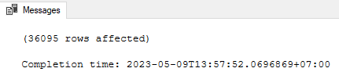

select p.airport_id, iata, icao, p.[name], city, country, latitude, longitude

into dbo.FFDBStageAirports

from ffdb1.dbo.airport p join ffdb1.dbo.airport_geo q

on p.airport_id = q.airport_id

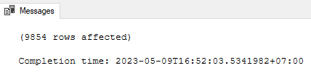

select airline_id, iata, airlinename, base_airport

into dbo.FFDBStageAirlines

from ffdb1.dbo.airline

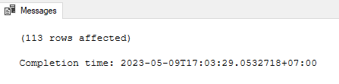

select airplane_id, capacity, p.[type_id], airline_id, identifier, [description]

into dbo.FFDBStageAirplanes

from ffdb1.dbo.airplane p join ffdb1.dbo.airplane_type q

on p.[type_id] = q.[type_id]

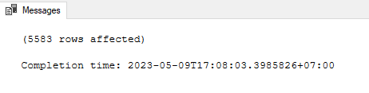

select flightno, [from], [to], departure, arrival, airline_id

into dbo.FFDBStageFlights

from ffdb1.dbo.flightschedule

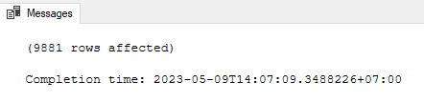

select employee_id, firstname, lastname, birthdate,

sex, street, city, zip, country, emailaddress,

telephoneno, salary, department, username, [password]

into dbo.FFDBStageEmployees

from ffdb1.dbo.employee

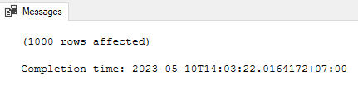

select min(departure) as StartDepartureDate, max(departure) as EndDepartureDate,

min(arrival) as StartArrivalDate, max(arrival) as EndArrivalDate

from ffdb1.dbo.flight

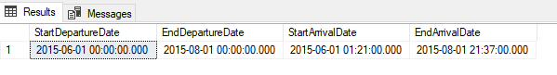

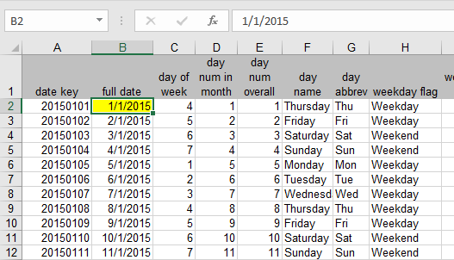

create database temp

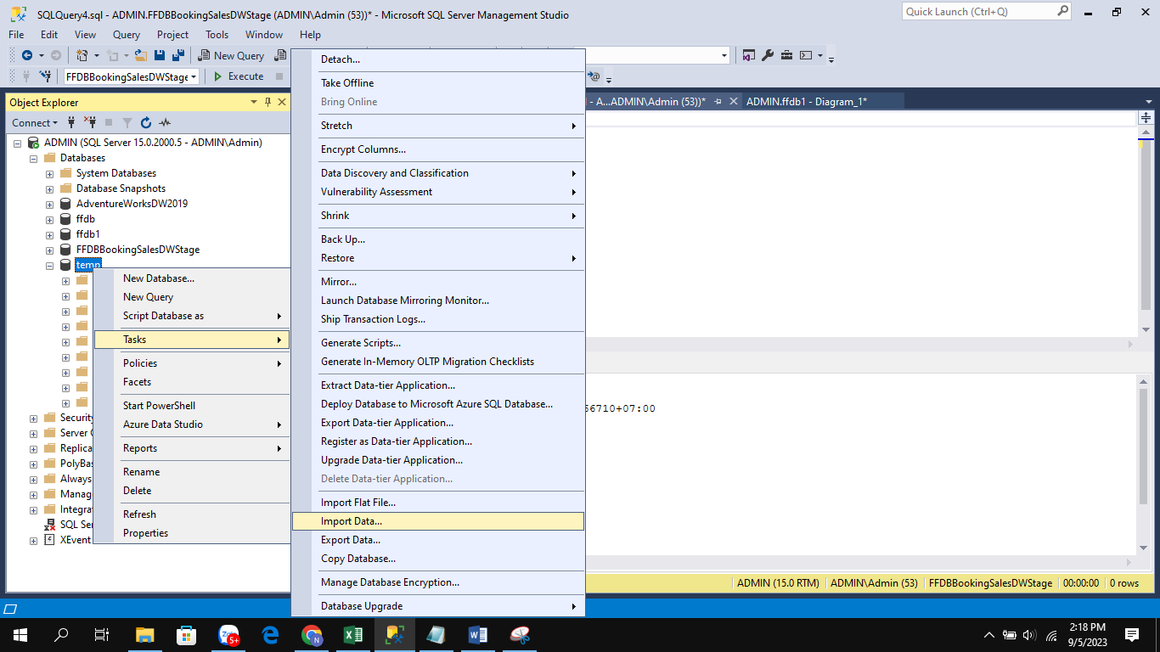

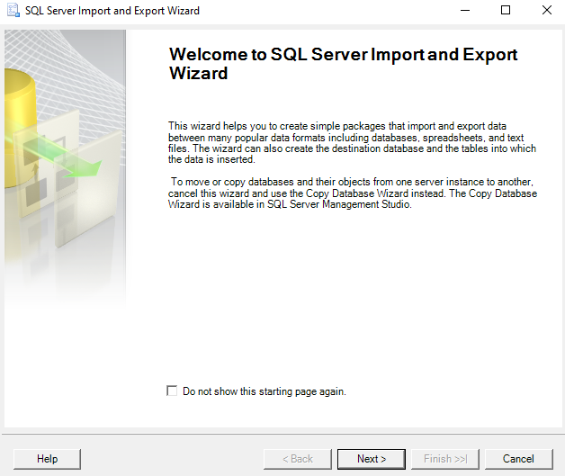

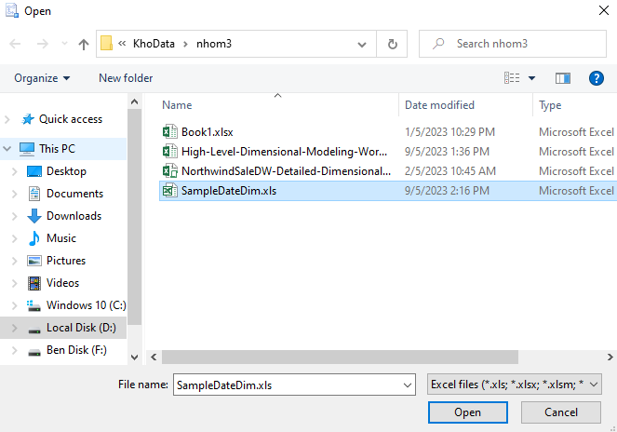

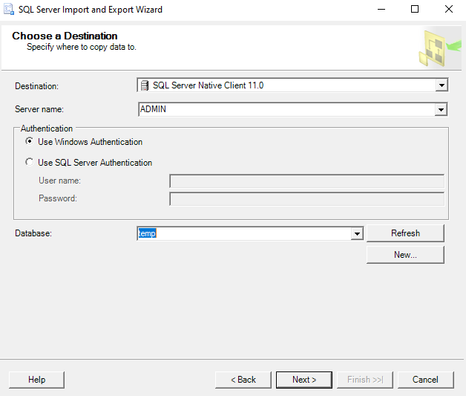

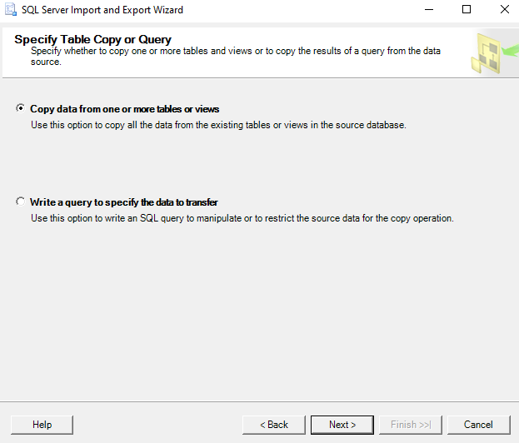

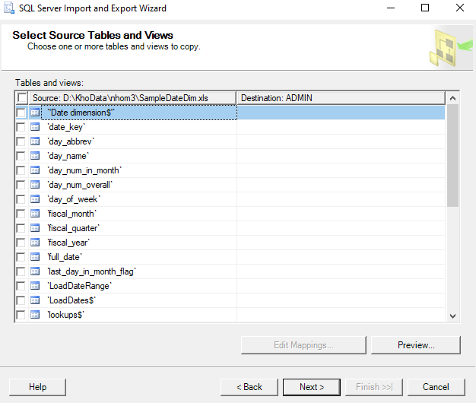

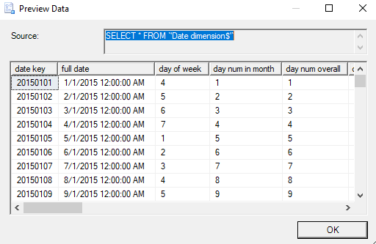

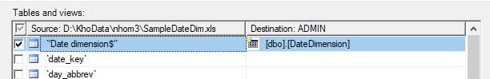

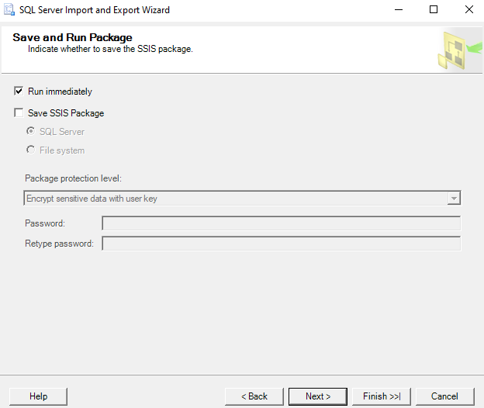

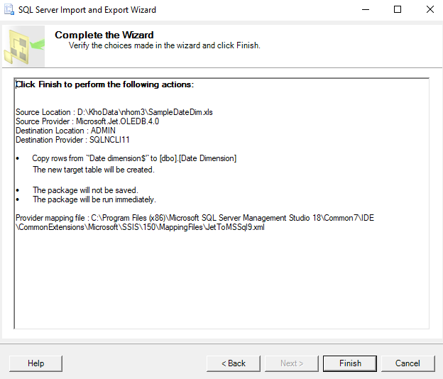

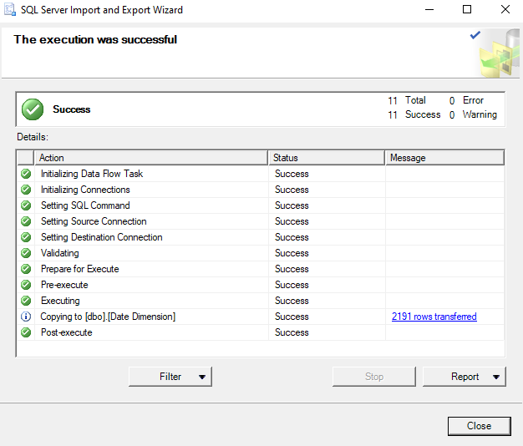

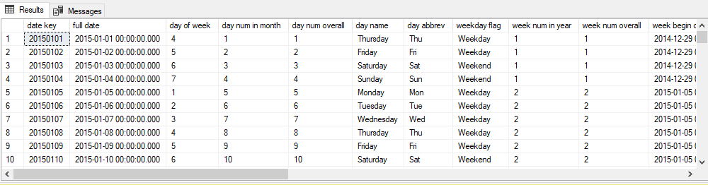

select *

into dbo.FFDBStageDate

from temp.dbo.[DateDimension]

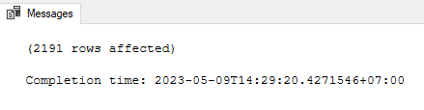

select booking_id, q.flightno, passenger_id, seat, price,

cast(departure as date) as departuredate,

cast(arrival as date) as arrivaldate

into dbo.FFDBStageBookingSales

from ffdb1.dbo.booking p join ffdb1.dbo.flight q

on p.flight_id = q.flight_id

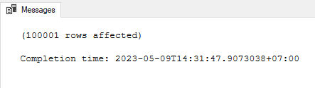

select flight_id, p.flightno, p.[from], p.[to],

q.departure, q.arrival,

p.airline_id, airplane_id,

cast(p.departure as date) as departuredate,

cast(p.arrival as date) as arrivaldate

into dbo.FFDBStageFlightSchedule

from ffdb1.dbo.flight p join ffdb1.dbo.flightschedule q

on p.flightno = q.flightno

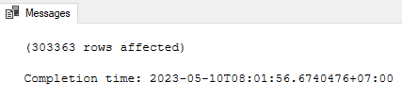

select employee_id, firstname, lastname, birthdate,

sex, street, city, zip, country, emailaddress,

telephoneno, salary, department, username, [password]

into dbo.FFDBStageEmployeeSalary

from ffdb1.dbo.employee

create database FfdbDW

select passenger_id as PassengerId, passportno as PassportNo, firstname as FirstName, lastname as LastName,

birthdate as BirthDate, sex as Sex, street as Street, city as City, zip as Zip, country as Country,

emailaddress as EmailAddress, telephoneno as TelephoneNo

into dbo.DimPassenger

from FfdbDWStage.dbo.FFDBStagePassengers

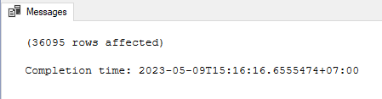

alter table DimPassenger

add PassengerKey int identity(1,1)

select airport_id as AirportId, iata as IATA, icao as ICAO,

[name] as [AirportName], city as City, country as Country,

latitude as Iatitude, longitude as Iongitude

into dbo.DimAirport

from FfdbDWStage.dbo.FFDBStageAirports

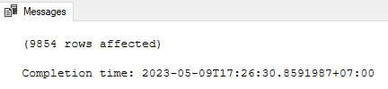

alter table DimAirport

add AirportKey int identity(1,1)

select airline_id as AirlineId, p.iata as IATA,

airlinename as AirlineName, q.AirportKey as BaseAirport

into dbo.DimAirline

from FfdbDWStage.dbo.FFDBStageAirlines p join FfdbDW.dbo.DimAirport q

on p.base_airport = q.AirportId

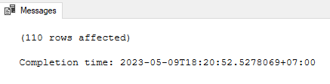

alter table DimAirline

add AirlineKey int identity(1,1)

select airplane_id as AirplaneId, capacity as Capacity,

[type_id] as TypeId, q.AirlineKey as Airline,

identifier as Identifier, [description] as [Description]

into dbo.DimAirplane

from FfdbDWStage.dbo.FFDBStageAirplanes p join FFdbDW.dbo.DimAirline q

on p.airline_id = q.AirlineId

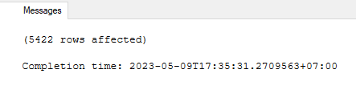

alter table DimAirplane

add AirplaneKey int identity(1,1)

select flightno as FlightNo, q.AirportKey as [From], r.AirportKey as [To],

departure as Departure, arrival as Arrival, s.AirlineKey as Airline

into dbo.DimFlight

from FfdbDWStage.dbo.FFDBStageFlights p join FfdbDW.dbo.DimAirport q

on p.[from] = q.AirportId

join FfdbDW.dbo.DimAirport r

on p.[to] = r.AirportId

join FfdbDW.dbo.DimAirline s

on p.airline_id = s.AirlineId

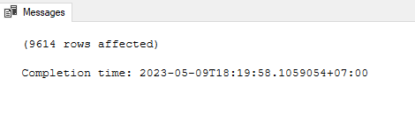

alter table DimFlight

add FlightKey int identity(1,1)

select street as Street, city as City,

zip as Zip, country as Country

into dbo.DimAddress

from FfdbDWStage.dbo.FFDBStageEmployees

alter table DimAddress

add AddressKey int identity(1,1)

select department as Department

into dbo.DimDepartment

from FfdbDWStage.dbo.FFDBStageEmployees

alter table DimDepartment

add DepartmentKey int identity(1,1)

select employee_id as EmployeeId, firstname as FirstName, lastname as LastName,

birthdate as BirthDate, sex as Sex, emailaddress as EmailAddress,

telephoneno as TelephoneNo,

username as UserName, [password] as [Password]

into dbo.DimEmployee

from FfdbDWStage.dbo.FFDBStageEmployees

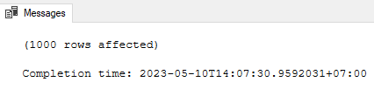

alter table DimEmployee

add EmployeeKey int identity(1,1)

select

[date key] as DateKey, [full date] as [Date], [day of week] as DateOfWeek, [day name] as [DayName],

[day num in month] as [DayOfMonth],

[day num overall] as [DayOfYear], [week num in year] as WeekOfYear, [month name] as [MonthName],

[month] as MonthOfYear, [quarter] as [Quarter],

case

when [quarter] >= 1 and [quarter] <= 3 then 'First'

when [quarter] >= 4 and [quarter] <= 6 then 'Second'

when [quarter] >= 7 and [quarter] <= 9 then 'Third'

when [quarter] >= 10 and [quarter] <= 12 then 'Fourth'

end as [QuarterName],

[year] as [Year], [weekday flag] as IsAWeekday

into dbo.DimDate

from FfdbDWStage.dbo.FFDBStageDate

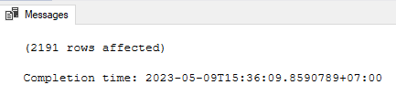

select r.FlightKey, q.PassengerKey, p.booking_id as BookingId,

p.seat as Seat, p.price as Price,

Day(p.departuredate) + Month(p.departuredate) * 100 + Year(p.departuredate) * 10000 as DepartureDate,

Day(p.arrivaldate) + Month(p.arrivaldate) * 100 + Year(p.arrivaldate) * 10000 as ArrivalDate

into dbo.FactBookingSales

from FfdbDWStage.dbo.FFDBStageBookingSales p

join FfdbDW.dbo.DimPassenger q

on p.passenger_id = q.PassengerId

join FfdbDW.dbo.DimFlight r

on p.flightno = r.FlightNo

select p.flight_id as FlightId, q.FlightKey, r.AirportKey as [From], s.AirportKey as [To],

t.AirlineKey, u.AirplaneKey,

Day(p.departuredate) + Month(p.departuredate) * 100 + Year(p.departuredate) * 10000 as DepartureDate,

Day(p.arrivaldate) + Month(p.arrivaldate) * 100 + Year(p.arrivaldate) * 10000 as ArrivalDate

into dbo.FactFlightSchedule

from FfdbDWStage.dbo.FFDBStageFlightSchedule p join FfdbDW.dbo.DimFlight q

on p.flightno = q.FlightNo

join FfdbDW.dbo.DimAirport r

on p.[from] = r.AirportId

join FfdbDW.dbo.DimAirport s

on p.[to] = s.AirportId

join FfdbDW.dbo.DimAirline t

on p.airline_id = t.AirlineId

join FfdbDW.dbo.DimAirplane u

on p.airplane_id = u.AirplaneId

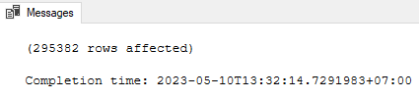

alter table DimAirport

add primary key (AirportKey)

alter table DimAirline

add primary key (AirlineKey)

alter table DimAirplane

add primary key (AirplaneKey)

alter table DimFlight

add primary key (FlightKey)

alter table DimPassenger

add primary key (PassengerKey)

alter table DimDate

alter column DateKey int not null

alter table DimDate

add primary key (DateKey)

alter table DimAddress

add primary key (AddressKey)

alter table DimDepartment

add primary key (DepartmentKey)

alter table DimEmployee

add primary key (EmployeeKey)

alter table DimAirline

add foreign key (BaseAirport) references DimAirport(AirportKey)

alter table DimAirplane

add foreign key (Airline) references DimAirline(AirlineKey)

alter table DimFlight

add foreign key ([From]) references DimAirport(AirportKey)

alter table DimFlight

add foreign key ([To]) references DimAirport(AirportKey)

alter table DimFlight

add foreign key (Airline) references DimAirline(AirlineKey)

alter table FactBookingSales

add primary key (FlightKey, PassengerKey, BookingId)

alter table FactBookingSales

add foreign key (FlightKey) references DimFlight(FlightKey)

alter table FactBookingSales

add foreign key (PassengerKey) references DimPassenger(PassengerKey)

alter table FactBookingSales

add foreign key (DepartureDate) references DimDate(DateKey)

alter table FactBookingSales

add foreign key (ArrivalDate) references DimDate(DateKey)

alter table FactFlightSchedule

add primary key (FlightId, FlightKey, [From], [To], AirlineKey, AirplaneKey)

alter table FactFlightSchedule

add foreign key (FlightKey) references DimFlight(FlightKey)

alter table FactFlightSchedule

add foreign key ([From]) references DimAirport(AirportKey)

alter table FactFlightSchedule

add foreign key ([To]) references DimAirport(AirportKey)

alter table FactFlightSchedule

add foreign key (AirlineKey) references DimAirline(AirlineKey)

alter table FactFlightSchedule

add foreign key (AirplaneKey) references DimAirplane(AirplaneKey)

alter table FactFlightSchedule

add foreign key (DepartureDate) references DimDate(DateKey)

alter table FactFlightSchedule

add foreign key (ArrivalDate) references DimDate(DateKey)

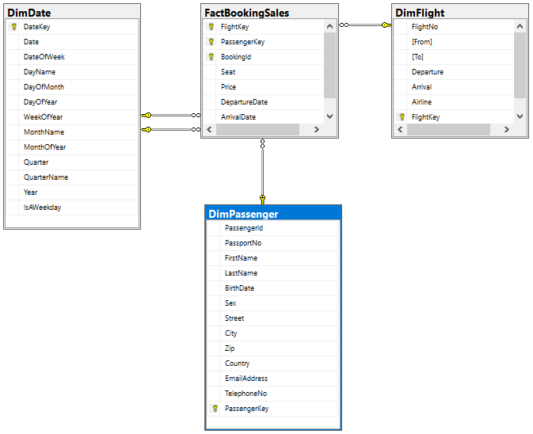

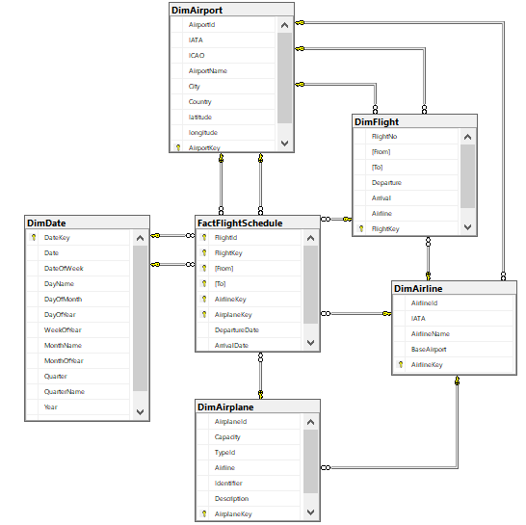

select q.EmployeeKey, r.AddressKey, s.DepartmentKey, p.salary as Salary

into FfdbDW.dbo.FactEmployeeSalary

from FfdbDWStage.dbo.FFDBStageEmployeeSalary p join FfdbDW.dbo.DimEmployee q

on p.employee_id = q.EmployeeId

join FfdbDW.dbo.DimAddress r

on p.street = r.Street and p.city = r.City and p.zip = r.Zip and p.country = r.Country

join FfdbDW.dbo.DimDepartment s

on p.department = s.Department

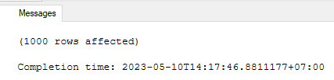

alter table FactEmployeeSalary

add primary key (EmployeeKey,AddressKey,DepartmentKey)

alter table FactEmployeeSalary

add foreign key (EmployeeKey) references DimEmployee(EmployeeKey)

alter table FactEmployeeSalary

add foreign key (AddressKey) references DimAddress(AddressKey)

alter table FactEmployeeSalary

add foreign key (DepartmentKey) references DimDepartment(DepartmentKey)