

Practices for Secure Software Report
Artemis Financial
Benjamin Roark
CS 305 Project Two
October 18 2026

Table of Contents
Practices for Secure Software Report 1
Document Revision History 3
Client 3
Instructions 3
Developer 4
1. Algorithm Cipher 4
2. Certificate Generation 5
3. Deploy Cipher 6
4. Secure Communications 7
5. Secondary Testing 8
6. Functional Testing 10
7. Summary 11
8. Industry Standard Best Practices 12

Document Revision History

Version | Date | Author | Comments
1.0 | October 18 2026 | Benjamin Roark | Security refactoring

Client



Developer
Benjamin Roark

Algorithm Cipher

Artemis Financial needs confidentiality while data travels across the network and a separate way to detect changes in transferred content. The recommended transport cipher is AES-256-GCM within TLS 1.3. AES is a symmetric block cipher with a 128-bit block size and 128-, 192-, or 256-bit keys. GCM adds authentication to encryption. The server also permits TLS_AES_128_GCM_SHA256 for interoperability; both allowed suites use authenticated encryption. Java’s TLS implementation manages encryption rather than application-written cipher code (NIST, 2023; NIST, 2007).
The file-verification component uses SHA-256, a member of the SHA-2 family. It maps the exact UTF-8 data bytes to a 256-bit digest displayed as 64 hexadecimal characters. SHA-256 is a one-way hash, not an encryption cipher: it uses no encryption key and cannot decrypt a message. Its generic collision resistance is about 128 bits and preimage resistance about 256 bits. A trusted reference digest is needed for meaningful verification; an attacker who can replace both data and digest can defeat an unauthenticated checksum (NIST, 2015).
The TLS suite TLS_AES_256_GCM_SHA384 uses a 256-bit AES key and SHA-384 in the TLS key schedule. That SHA-384 role is separate from the application’s SHA-256 checksum. The certificate’s asymmetric RSA-3072 key pair authenticates possession of the server private key after the client trusts the certificate. Ephemeral key agreement establishes shared session secrets; RSA does not directly encrypt the web-page payload. TLS derives symmetric traffic keys from those secrets. Fresh cryptographic randomness supports key generation and handshakes. GCM nonces must never repeat under one key, so nonce construction and key updates are delegated to the TLS library (IETF, 2018).
Historically, DES and later Triple DES served older systems; AES was standardized in 2001 and its specification was updated editorially in 2023. SHA-2 replaced older hash choices for modern integrity uses. This project avoids MD5, SHA-1 as a checksum choice, and obsolete SSL/TLS protocols. TLS 1.3 is the only enabled protocol. Certificate tools may display a SHA-1 fingerprint as an identifier; the actual certificate signature here is SHA256withRSA. Continued algorithm review, certificate renewal, and dependency updates remain necessary as standards and threats change.

Certificate Generation

A self-signed X.509 certificate was generated with the Java 21 Keytool command, using an RSA-3072 key pair, SHA256withRSA signature, and a 365-day validity period. The subject is CN=localhost, OU=CS 305, O=Artemis Financial, C=US. Subject Alternative Names include DNS localhost and IP address 127.0.0.1. Key usage is digitalSignature and extended key usage is serverAuth (Oracle, n.d.).
The certificate was exported to certs/localhost.cer in DER format and certs/localhost.pem in PEM format. Figure 1 shows the actual Keytool output for the exported CER. The reproducible generation and export commands are provided in scripts/generate-certificate.sh. Keytool was executed from the terminal for this run; the same commands can be run in an Eclipse terminal with the project JDK selected.
The PKCS12 keystore and a randomly generated password are held in .local with restrictive file permissions and are excluded from the ZIP. The run script generates a fresh pair for another machine. A self-signed certificate supports a local exercise; public deployment requires a certificate issued by a trusted authority and controlled key storage.
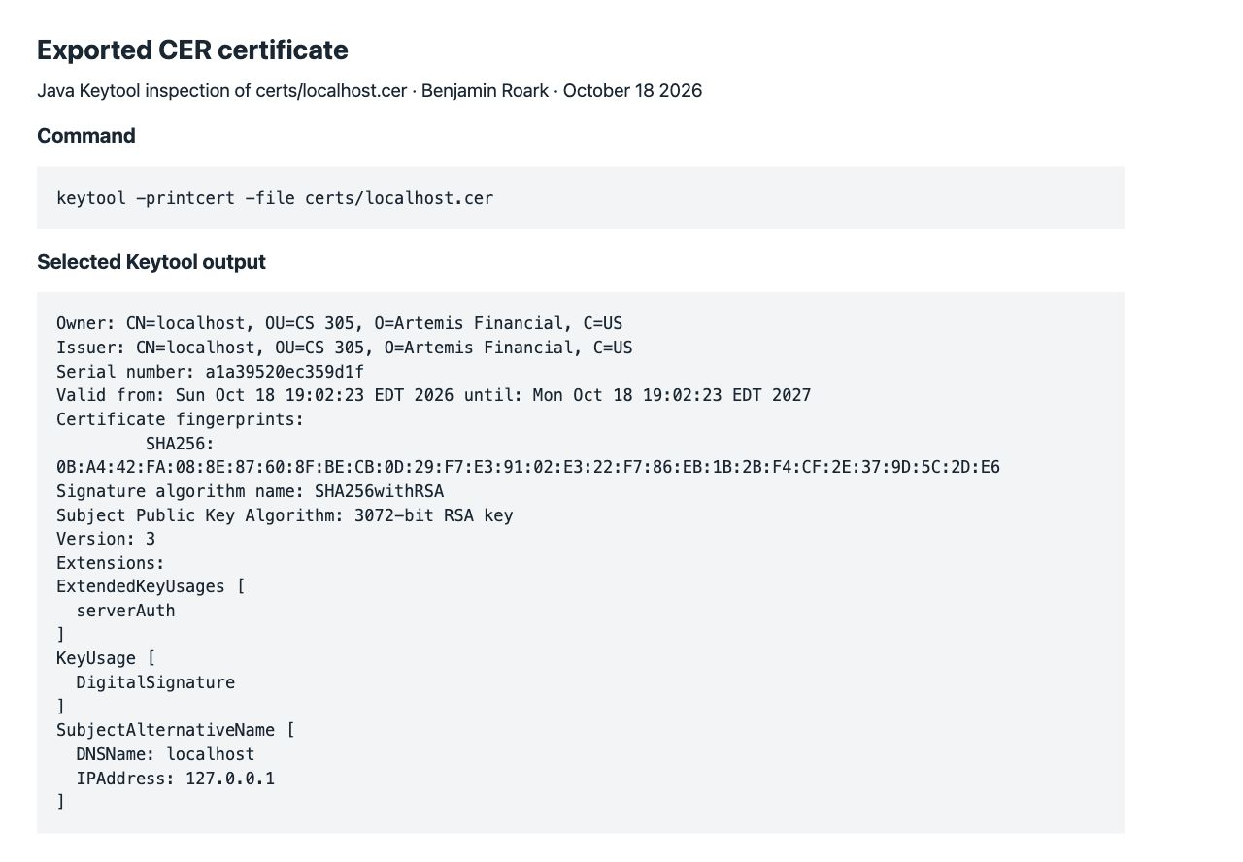
Figure 1. Selected actual Keytool output for the exported localhost.cer file.

Deploy Cipher

HashService calculates SHA-256 using Java MessageDigest and StandardCharsets.UTF_8. Each call creates its own digest instance, which avoids shared mutable digest state during concurrent requests. HexFormat produces a complete 64-character result, including leading zeros. Comparison uses MessageDigest.isEqual on decoded digest bytes.
GET /hash displays Benjamin Roark and the unique demonstration string below. The expected digest was calculated independently with Python hashlib and confirmed with OpenSSL, then stored as the reference constant. The page shows MATCH for the exact data and MISMATCH when the suffix “ altered” is appended. This negative check demonstrates that verification can reject changed content. GET /api/hash exposes the same result as JSON; POST /api/verify accepts a bounded data string and a valid 64-character hexadecimal reference digest.
Demonstration data: Benjamin Roark | Artemis Financial | CS305 Project Two | 2026-10-18 | 9064a812-5d78-447e-91eb-b26f063519d2
SHA-256: 97732146821bd5f7fc58217d213ca5521752fc414e037217cdab64a82f632fcb
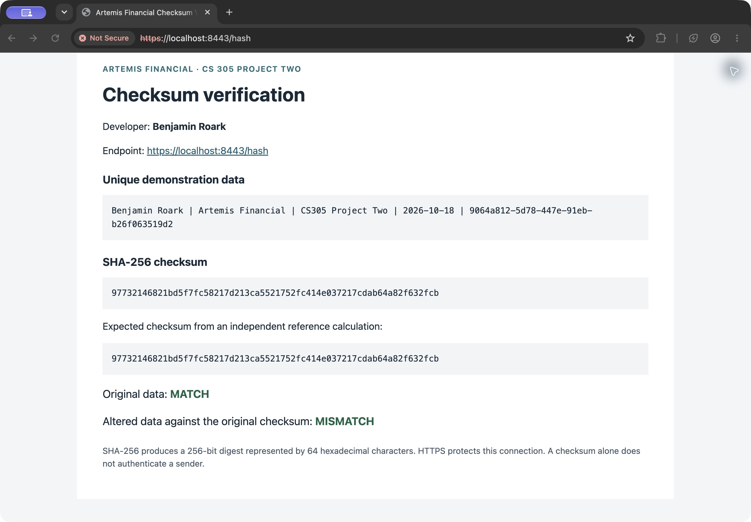
Figure 2. Live checksum page showing Benjamin Roark, the unique string, MATCH, and MISMATCH.

Secure Communications

application.properties enables SSL on port 8443, specifies the PKCS12 keystore and localhost alias, and obtains the password from TLS_KEYSTORE_PASSWORD. Only TLS 1.3 and the two AES-GCM suites are enabled. Binding to 127.0.0.1 keeps the demonstration local. No HTTP connector is added.
Live tests negotiated TLSv1.3 with TLS_AES_256_GCM_SHA384. Both the Python HTTPS client and curl explicitly trusted certs/localhost.pem and validated the localhost identity; neither used a certificate-validation bypass. GET /api/hash returned HTTP 200 with verified=true. A TLS 1.2-only handshake was rejected, and no plaintext listener was found on port 8080.
The response includes a restrictive Content Security Policy, nosniff, frame denial, no-referrer, no-store, and Strict-Transport-Security on HTTPS responses. The page uses an external local stylesheet and does not run JavaScript. The screenshot in Figure 3 shows the actual browser page. Chrome was opened to https://localhost:8443/hash and its local certificate warning was manually accepted. Chrome still labels the certificate Not Secure because it is self-signed and not in the browser trust store. The screenshot demonstrates the loaded HTTPS endpoint, not a publicly trusted certificate. The separate validated-client tests establish the encrypted connection with an explicitly trusted local certificate.
Figure 3. HTTPS endpoint in Chrome. The self-signed certificate remains untrusted by the browser.

Secondary Testing

The dependency stack was upgraded from Spring Boot 2.2.4.RELEASE and Java 8 to Spring Boot 4.1.1 and Java 21. The unused spring-boot-starter-data-rest dependency was removed to reduce the dependency surface. OWASP Dependency-Check was upgraded from 5.3.0 to 13.0.0 and placed in the security Maven profile, which executes during verify when -Psecurity is used.
The first scan of an intermediate upgrade found known vulnerabilities in Jackson, Log4j, Spring Framework, and Tomcat. The final configuration uses Spring Framework 7.0.9, Jackson 3.1.5, Log4j API 2.25.5, and an explicit Tomcat 11.0.27 override. After rebuilding, Dependency-Check 13.0.0 reported 39 dependency entries, 17 unique dependencies, zero vulnerable dependencies, zero vulnerabilities, and zero suppressions. The security verification finished successfully on October 18, 2026. NVD data was checked that day; its recorded last-modified timestamp was October 16, 2026.
Dependency-Check is software composition analysis: it associates third-party dependencies with published vulnerability records. It does not prove the Java source is free of logical flaws. Source changes were therefore also reviewed manually and exercised by tests. The build keeps failOnError enabled and uses failBuildOnCVSS=0 so reported vulnerabilities stop the security verification. No vulnerability suppressions were added.
The scan used the official NVD JSON feeds and CISA data. The optional Sonatype OSS Index analyzer was disabled because credentials were not supplied. The Maven plugin’s default test-scope exclusion was retained, so these findings describe the runtime dependency scan, not all test tooling or unpublished vulnerabilities. HTML and JSON reports are included in evidence/.
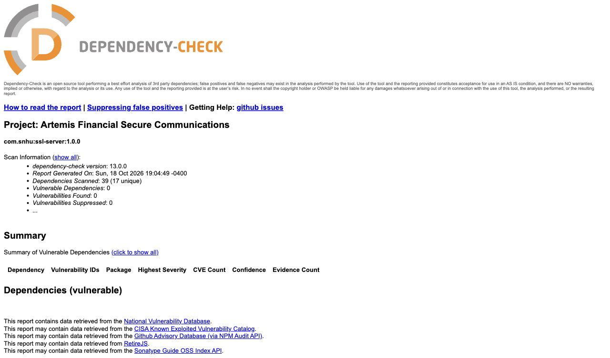
Figure 4. Actual Dependency-Check report showing zero known vulnerabilities and no suppressions.
Build verification evidence
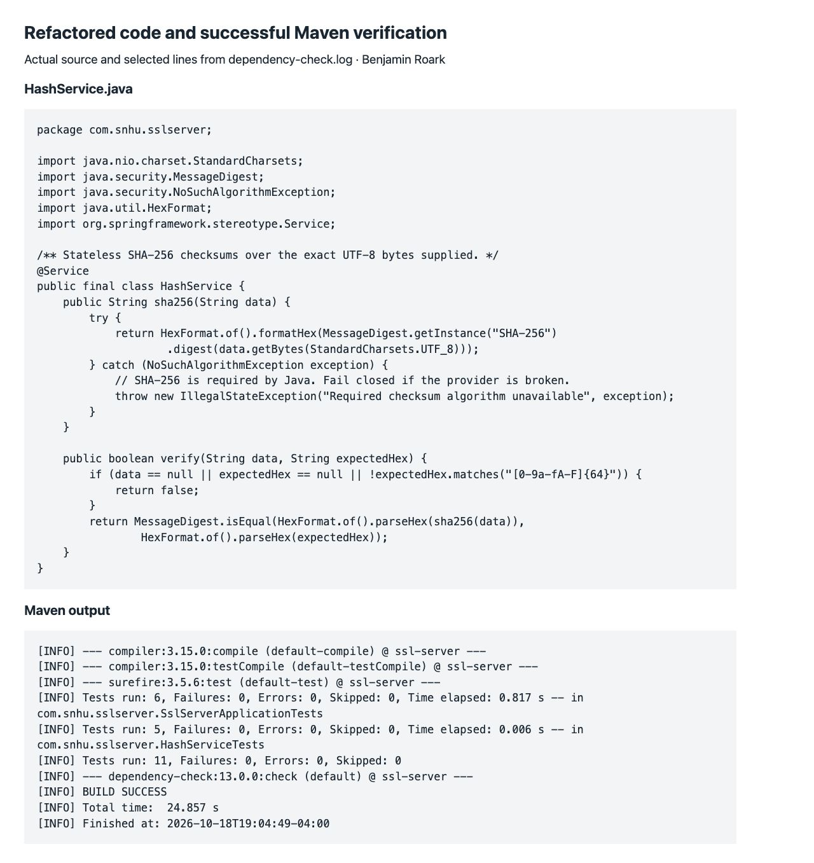
Figure 5. Actual HashService source and selected successful Maven execution output.

Functional Testing

The manual review traced the request flow through HashController, HashService, RequestSizeLimitFilter, SecurityHeadersFilter, and the TLS configuration. The checksum path uses an explicit UTF-8 encoding, a fixed algorithm name, and a fresh MessageDigest. The HTML output escapes the data. The public demonstration exposes no account records, database operations, file-system path selection, or stored financial data.
Input checks reject missing fields, malformed digests, and data strings longer than 4,096 characters. The verification route limits the request stream to 16,384 bytes before JSON deserialization, including requests without Content-Length. Declared oversized bodies receive 413; oversized streamed or malformed JSON receives a client error. Error responses do not include stack traces or exception details.
All 11 JUnit tests passed with zero failures, errors, or skipped tests. Coverage includes the published SHA-256 vectors for “abc” and an empty string, UTF-8 and whitespace handling, changed data, invalid digests, 100 parallel hash operations, HTML and JSON responses, invalid request data, the request-body cap, and HTTPS headers. Maven compiled and packaged the application successfully. The separate live test script passed all 16 checks against the running TLS server.
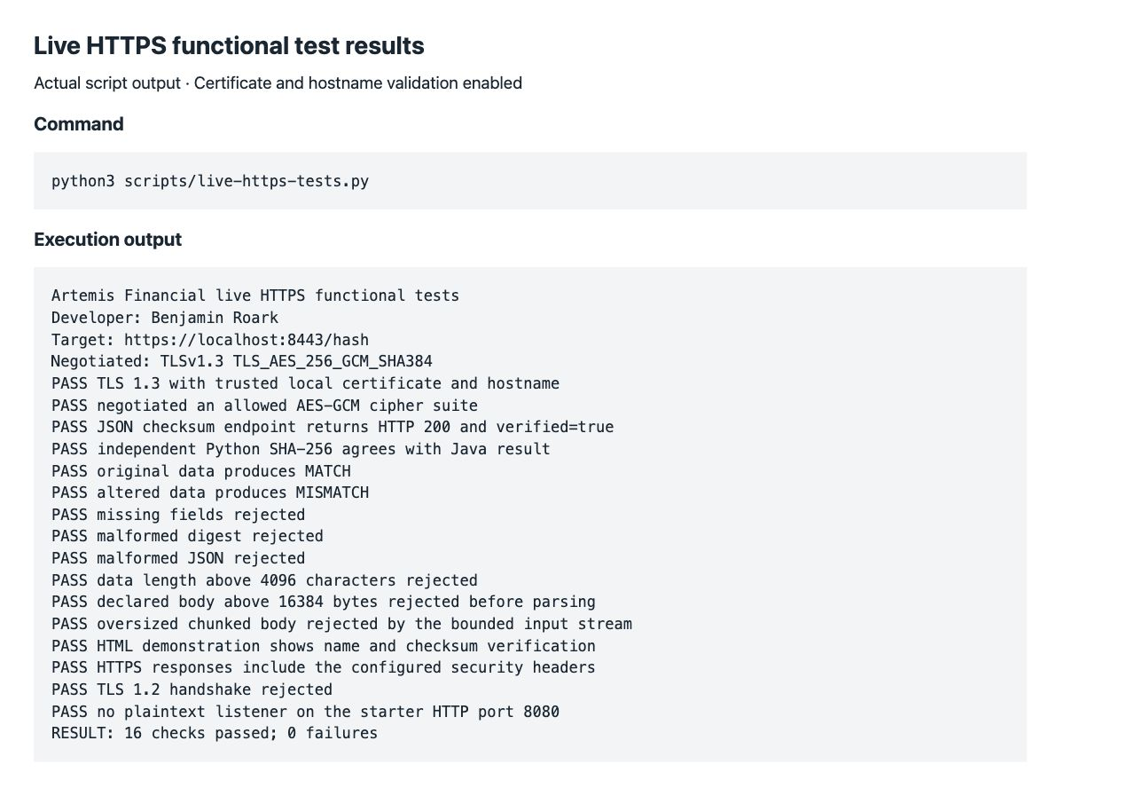
Figure 6. Actual live HTTPS test execution showing all 16 checks passed.

Summary

The refactoring adds a working integrity-verification demonstration and a protected local transport path to the supplied starter. The assessment followed the supplied Vulnerability Assessment Process Flow Diagram: architecture review first, then the seven security areas, focused code review, and a summary of findings and mitigations.
Input Validation: The verification API requires a well-formed hexadecimal digest and bounded data, with an early stream-size cap. Invalid JSON and missing fields produce client errors. APIs: Read and verification routes have explicit HTTP methods and media types; the demonstration has no external service calls or permissive CORS policy.
Cryptography: SHA-256 provides the checksum; TLS 1.3 AES-GCM protects the connection; Keytool creates a certificate with appropriate localhost identities. Client / Server: The browser connects to HTTPS on 8443, certificate verification is tested separately, and no plaintext HTTP listener is configured.
Code Error: Unexpected runtime details are withheld from responses, invalid requests fail safely, and absence of SHA-256 fails closed. Code Quality: The dependency stack is updated, unnecessary dependencies are removed, and known-answer, negative, concurrency, MVC, and live TLS tests cover the changed behavior. Encapsulation: HashService is stateless, the controller receives it by constructor injection, response records are immutable, and private key material is outside source control and the submission.
The layers address different failure modes: a checksum detects byte changes against a trusted reference; authenticated TLS protects the network exchange; validation bounds untrusted input; browser headers reduce content-injection exposure; restricted errors limit information leakage; dependency review and repeatable tests support maintenance. These controls do not establish a complete financial application. User authentication, authorization, audit logging, business transaction validation, and production certificate operations require separate implementation before real customer data is handled.

Industry Standard Best Practices

The project uses standard Java cryptographic and TLS providers instead of custom algorithms. Secrets are injected at runtime, and local key files have restrictive permissions. The public CER can be shared without exposing the private key. The existing Spring Boot entry point and project identity are retained while the incomplete TLS properties and missing checksum functionality are replaced with tested behavior.
Secure coding also means treating error paths as part of the interface. The verification API limits input before parsing, validates its schema, and does not disclose implementation exceptions. The page contains only the intended demonstration data, escapes its HTML content, and sends security headers. The tests check altered data and bad inputs as well as the successful path. The dependency scan is paired with a manual source review because each method detects different classes of problem.
For Artemis Financial, these practices reduce the chance of data exposure, undetected alteration, service disruption, and expensive emergency fixes. Reproducible build and scan commands support review and future maintenance. An operational release should use centrally managed secrets and a trusted certificate, rescan dependencies with current vulnerability data, and add the account and transaction controls appropriate to financial records. The self-signed local demonstration is not a production deployment.
Code attachments
The accompanying Benjamin_Roark_CS305_Refactored_Code.zip contains one ssl-server_student project folder with the complete source, tests, Maven wrapper, Eclipse project settings, public certificates, scripts, and execution evidence. The following files implement or verify the refactoring.
HashController.java provides /hash, /api/hash, and /api/verify. HashService.java implements SHA-256 and digest comparison. SslServerApplication.java retains the Spring Boot entry point.
SecurityHeadersFilter.java applies browser response controls. RequestSizeLimitFilter.java bounds JSON input. application.properties configures HTTPS, TLS versions, ciphers, and error handling. static/hash.css styles the demonstration page.
pom.xml pins the dependency stack and defines the security verification profile. HashServiceTests.java and SslServerApplicationTests.java contain the 11 JUnit tests.
scripts/generate-certificate.sh generates local credentials and exports the public CER and PEM. scripts/run-local.sh builds and runs the server. scripts/security-scan.sh runs Dependency-Check. scripts/live-https-tests.py performs the 16 live checks.
certs/ contains the public certificate used in the screenshots. evidence/ contains the HTML and JSON dependency reports, test logs, and screenshots. README.md provides reproduction steps. Private keystores and passwords are intentionally excluded; a new local certificate is generated on first run.

References
National Institute of Standards and Technology. (2023). Advanced Encryption Standard (AES), FIPS 197. https://csrc.nist.gov/pubs/fips/197/final
National Institute of Standards and Technology. (2007). Recommendation for block cipher modes of operation: Galois/Counter Mode (GCM) and GMAC, SP 800-38D. https://csrc.nist.gov/pubs/sp/800/38/d/final
National Institute of Standards and Technology. (2015). Secure Hash Standard, FIPS 180-4. https://csrc.nist.gov/pubs/fips/180-4/upd1/final
Internet Engineering Task Force. (2018). The Transport Layer Security (TLS) protocol version 1.3, RFC 8446. https://www.rfc-editor.org/rfc/rfc8446
Oracle. (n.d.). The keytool command, Java SE 21. https://docs.oracle.com/en/java/javase/21/docs/specs/man/keytool.html
OWASP Foundation. (n.d.). OWASP Dependency-Check. https://owasp.org/projects/dependency-check
OWASP Dependency-Check. (n.d.). Maven check goal documentation. https://dependency-check.github.io/DependencyCheck/dependency-check-maven/check-mojo.html
Apache Software Foundation. (n.d.). Apache Tomcat 11 security information. https://tomcat.apache.org/security-11.html
Apache Software Foundation. (n.d.). Apache Logging Services security. https://logging.apache.org/security.html

