Aircraft Accident Visualization

Analytical Tasks

* Filter
* Compute Derived Value
* Find Extremes
* Characterize Distribution
* Find anomalies
* Correlate
* Details on Demand
* Select
* Connect

Design

The goal of our visualization is to understand when and where accidents happen. There is a large amount of data cases in the “Incident” category, but the data does not explain the nature of any of the incidences, so this visualization focuses on non-fatal and fatal accidents. This exclusion avoids obscuring the meaningful data with an overflow of uninjured passenger statistics from potentially insignificant events categorized as incidents in the records.

The first visualization provides the user control over the other visualizations. Instead of a dropdown or text entry, this interface makes selected or unselected states visually obvious. The second and third visualizations ask the questions “Where do accidents occur,” and “During what phase of flight do they occur,” respectively. Our goal was to allow users of various knowledge levels to discover information. Those with only surface knowledge of flight may be interested in just seeing which states or phases spike in accidents or exploring the likelihood of injury. Users with in-depth knowledge, perhaps working in aviation, may wish to look across the state and phase visualizations to look for correlations that indicate problems. They may see that a certain state or phase has high accident or fatality rates; this visualization therefore allows users to ask “why,” and indicates where they should go and investigate further.

User Interface

State selection:

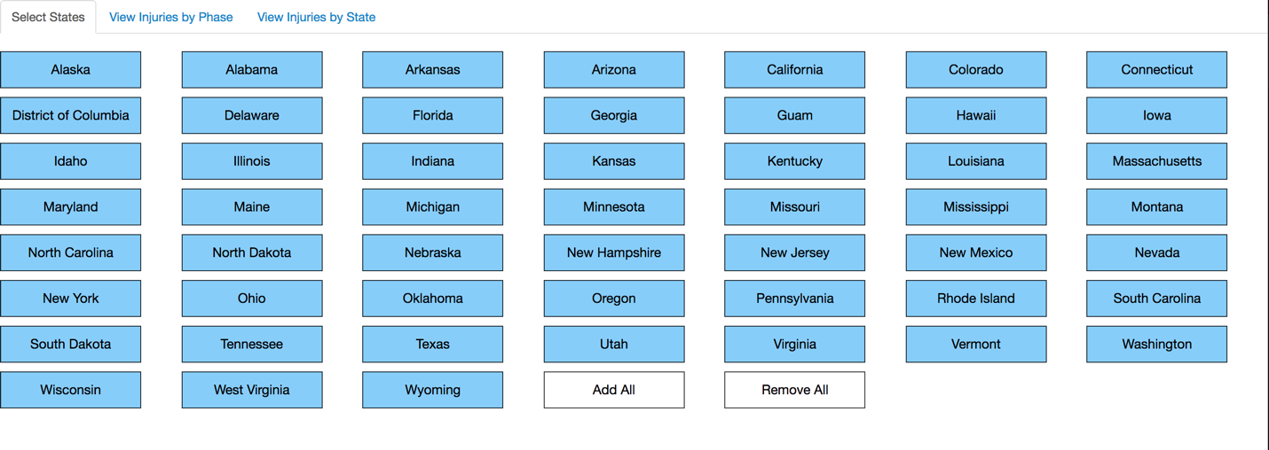

States are highlighted blue if selected. Only states that are selected will be included in the corresponding views.

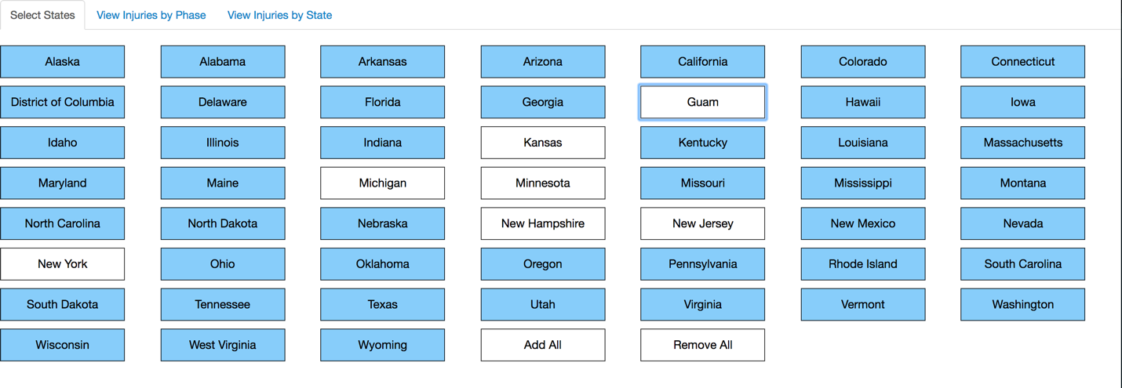

Injuries by phase of flight. A specific stage’s details are displayed beside the graph upon mouseover or click.

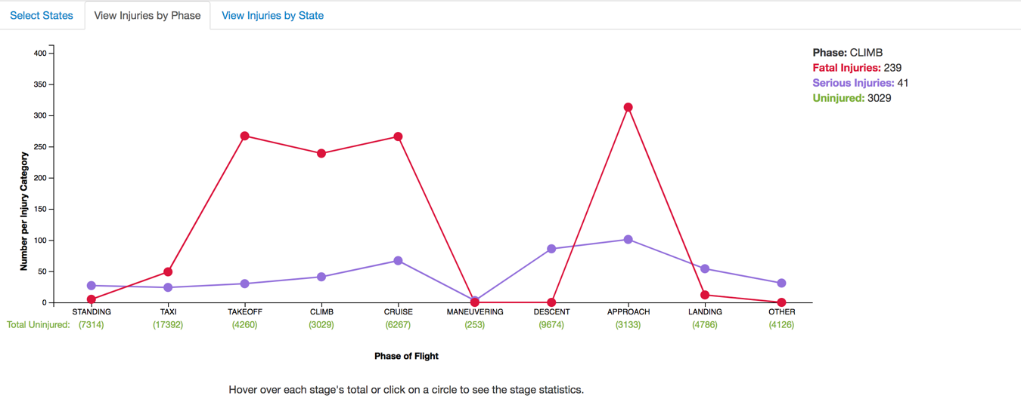

Injuries by state of flight. A specific state’s details are displayed beside the graph upon mouseover.

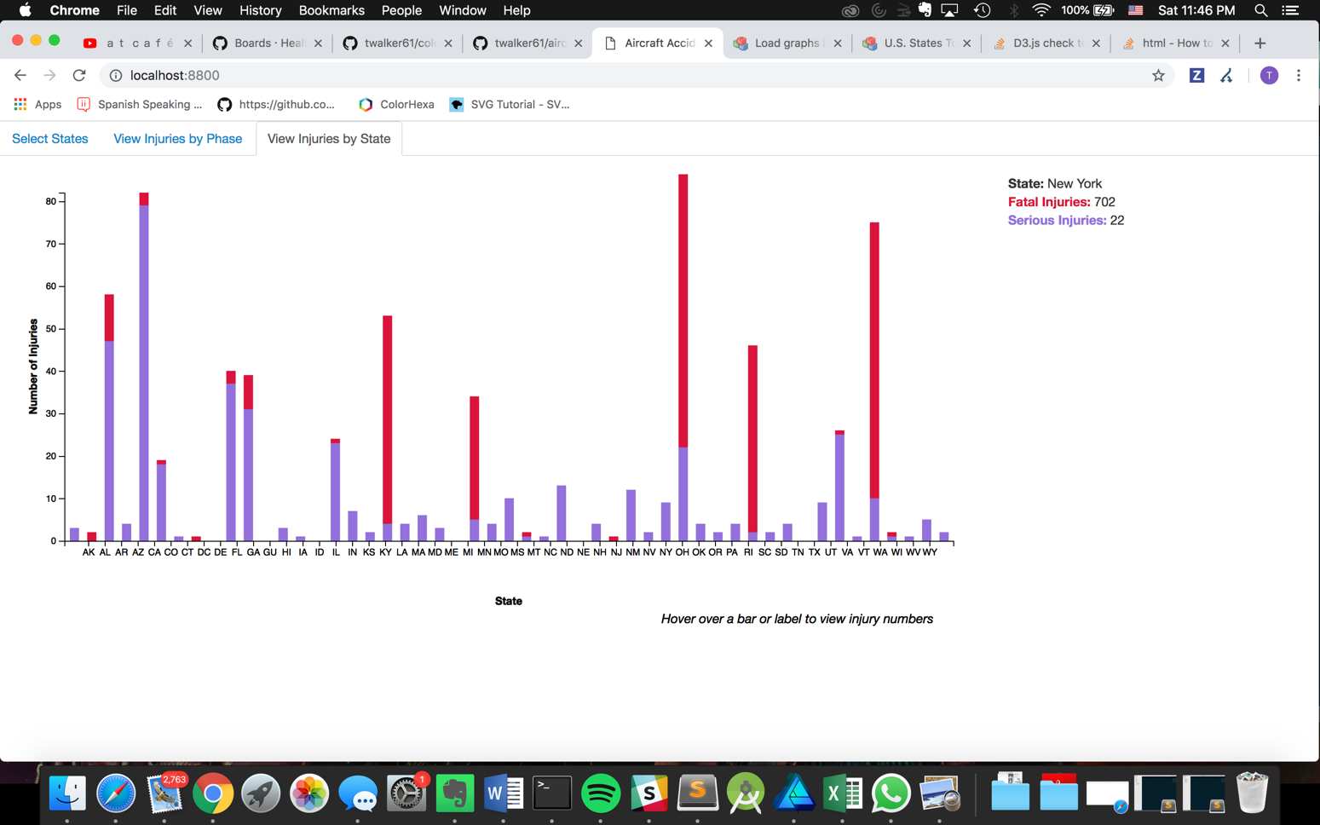

Scenario: Select all states except New York

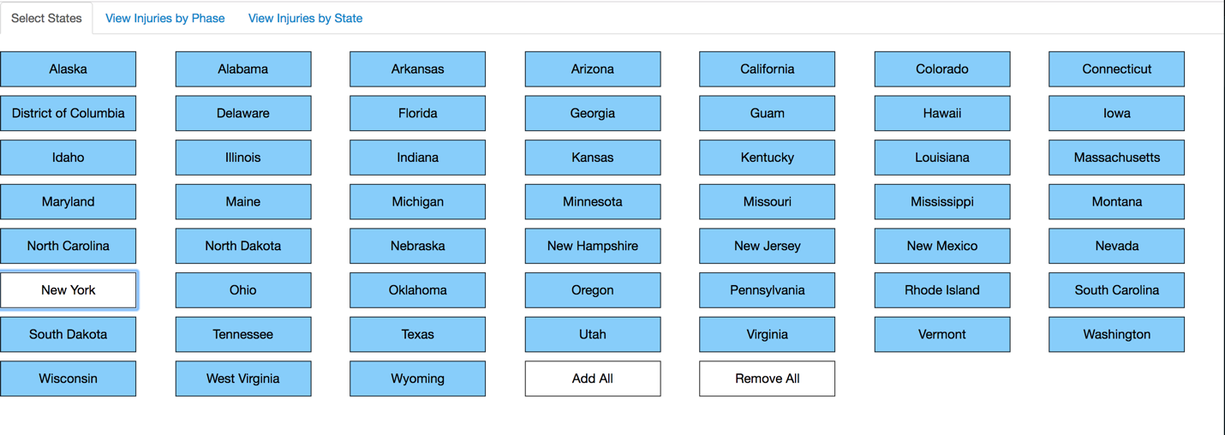

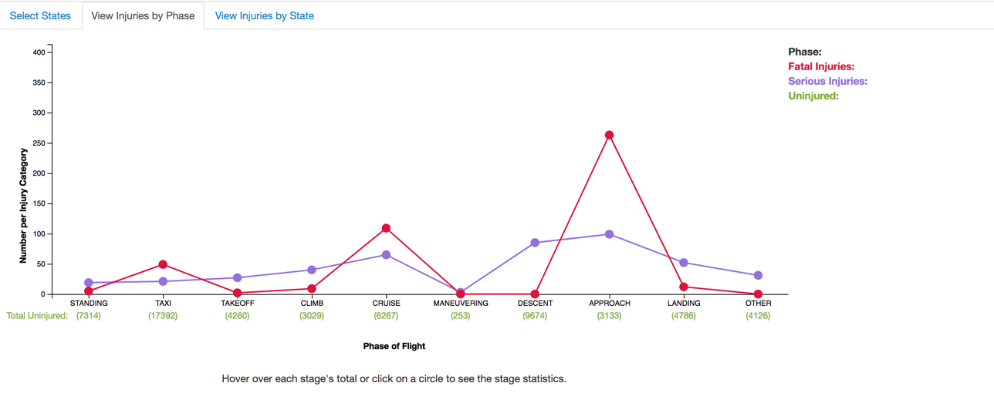

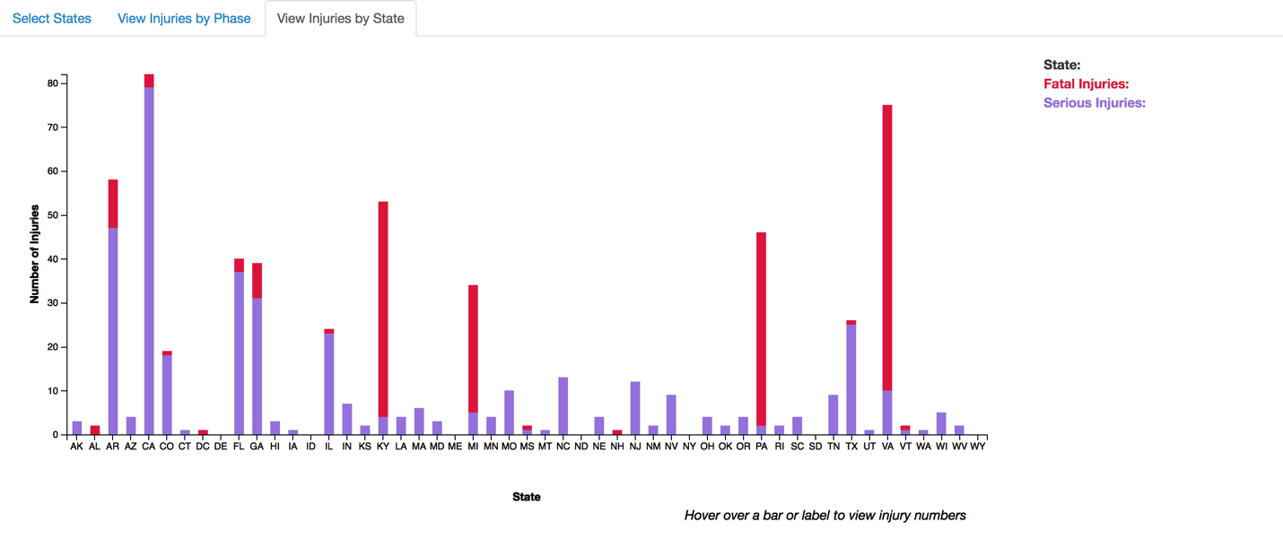

Scenario: All states deselected.

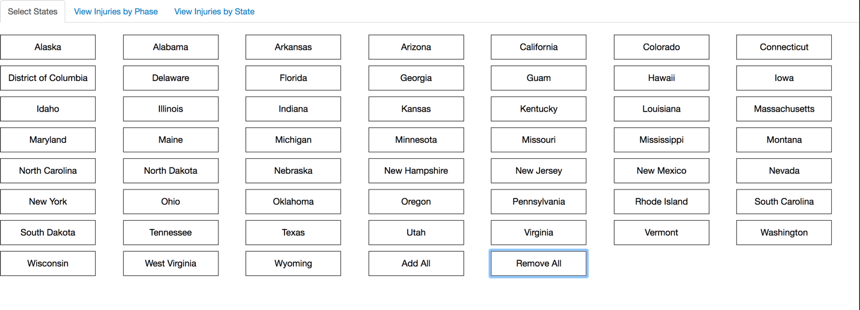

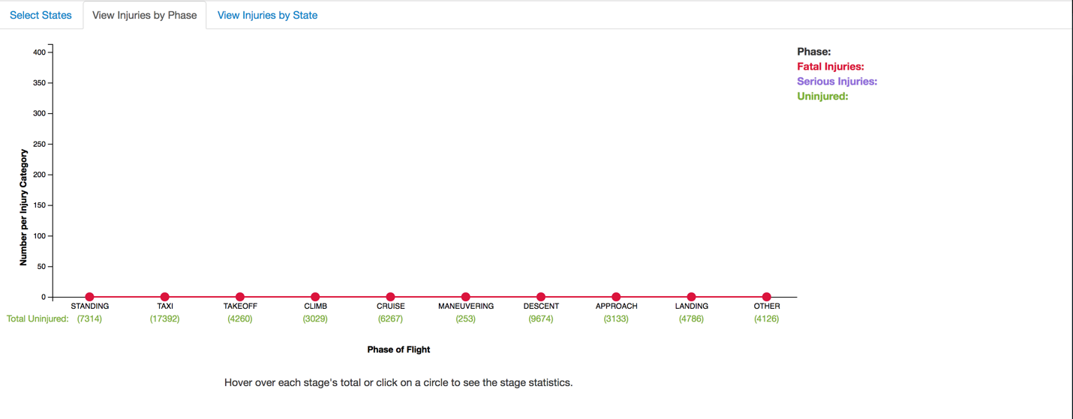

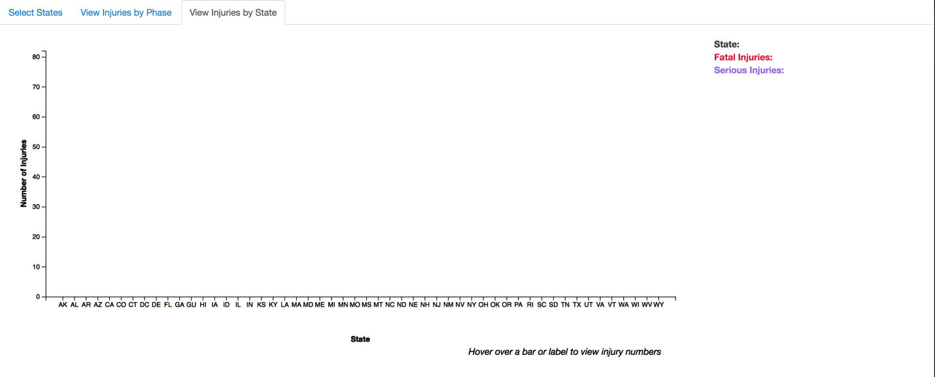

Visualization Details

Although data for all three categories of passenger injury – uninjured, injured, and fatal – the graphs display only injured and fatal because the number of uninjured passengers is so large that it would ruin the graph scale, making the other categories’ values appear to be zero. We chose therefore to represent the uninjured numbers in the details of specific data cases.