Lucinduce

*Sleep tracker and lucid dream inducer*

*Ben Reid (benreid@buffalo.edu)*

*University at Buffalo; CSE 321*

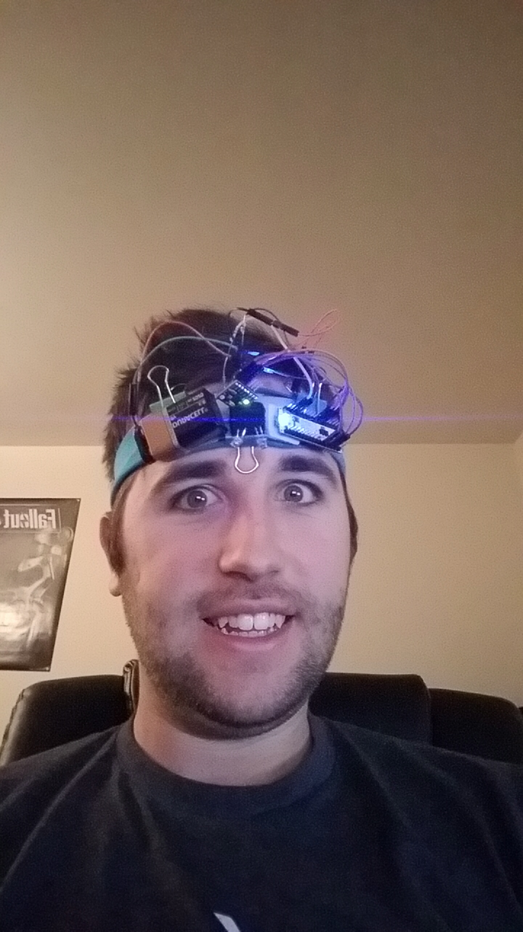

An early prototype

**Summary:** Lucinduce is a wearable headband that tracks the wearer’s motion as they sleep to determine when they enter REM sleep. Using light audio and visual cues the band can indicate to the user that they are dreaming without waking them, allowing them to lucid dream. The band can also be configured to act as an alarm clock that wakes the user up at the most optimum time for them to feel well rested.

**Objectives:**

* Accurately track movement throughout the night
* Log movement in EEPROM, this can be used as a diagnostic for those with sleep disorders
* Reliably analyze movement levels and frequency to determine REM cycles
* Provide sufficient stimuli to alert user without waking them
* Keep track of time in order to more precisely determine REM cycles and to wake the user
* Provide an easy interface to set wake time, clock time and to see recorded data

**Approach:** The hardware consists of an Arduino Micro, a rechargeable LiPo battery, a voltage step-up chip, a 6-axis gyro/accelerometer and two LEDs. The early prototype has all of the hardware secured to a headband on a piece of cardboard and everything is connected via jumper cables. It triggers the LEDs based on a timer alone, and logs user movement throughout the night. The point of this is to graph the data and figure out how to determine REM cycles from movement. Once a pattern is found it will be programmed into the firmware and that will be what triggers the LEDs.

**Project Description:** Movement is recorded as the sum of the angular velocity about each axis as measured by the gyros. The movement is polled once every 100 milliseconds. The maximum movement every minute is recorded, as well as the average for that minute. The recordings are written to the EEPROM so they are preserved when unplugged. This data can be read by a computer via USB.

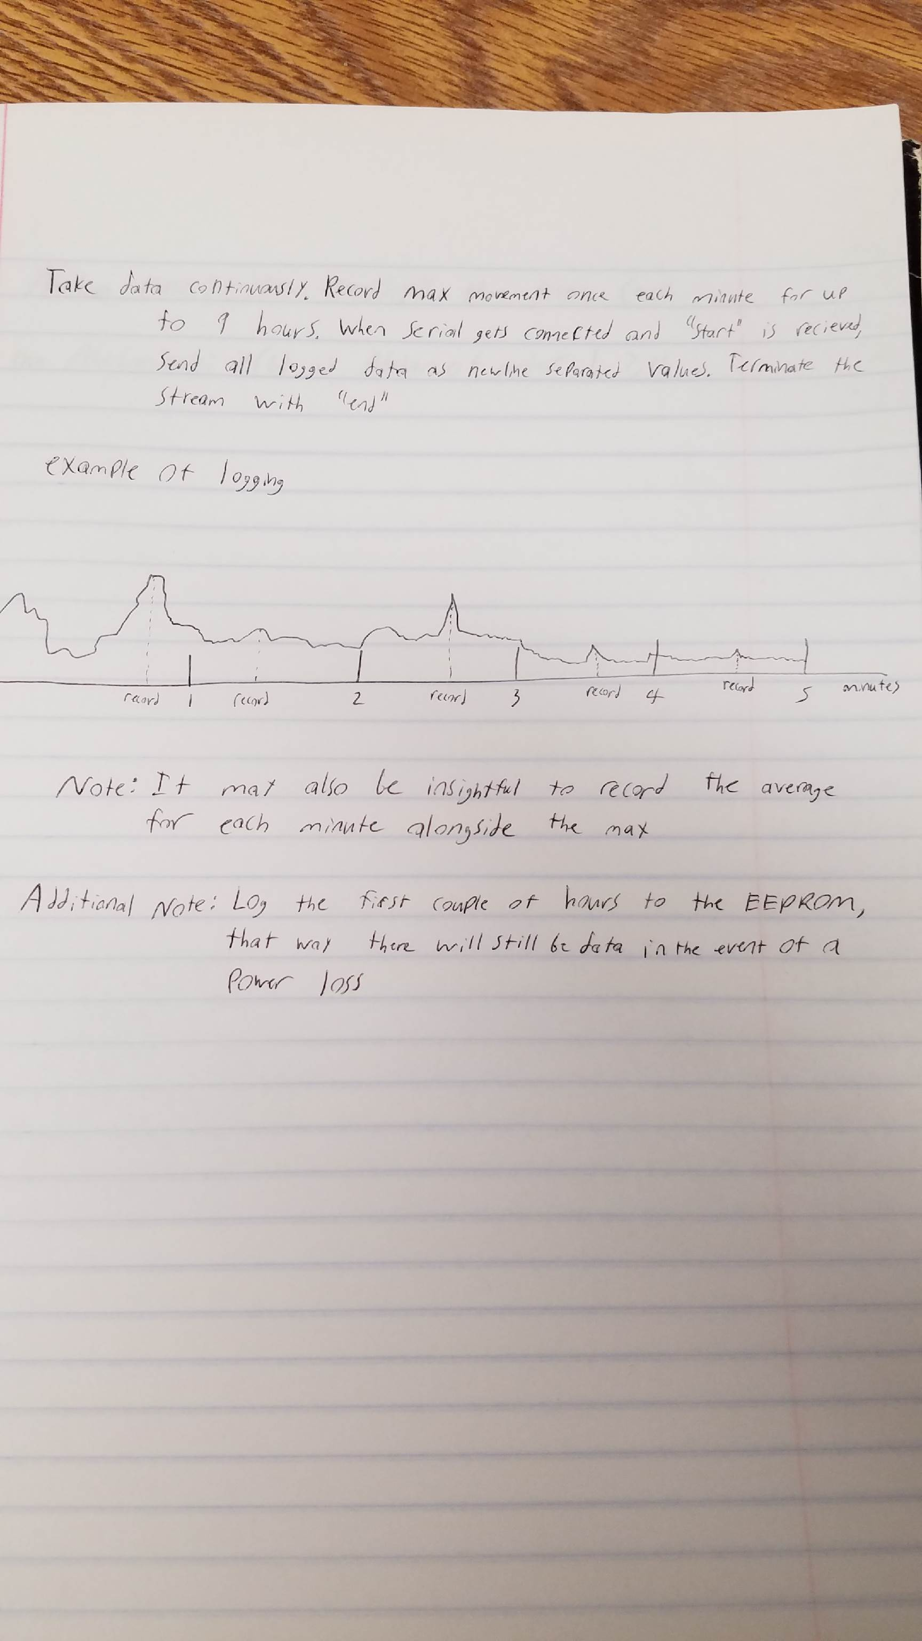

*A visual detailing data logging*

Above is a data capture for a night’s sleep. The first graph is all of the averages and the second is a graph of all the maximums. It is easy to see that I fell asleep after about 30 minutes, based on the initial movement. REM sleep first occurs around 70 minutes after you fall asleep, and repeats every 90 minutes. Using that timing, in conjunction with the movement graphs, we can see that REM occurred around 90 minutes and between 180 to 200 minutes. The third REM cycle is hard to identify due to all the movement, which is likely an indicator of restless sleep. It is possible that the third REM cycle accounted for most of that, but considering that woke up it is more probable that the sleep was restless. To accurately identify REM cycles, the program must first determine when the user falls asleep, which is easy, and then use both movement and timing to try and predict REM cycles.

**Design Details:** The Arduino Micro is the main component of the project. Movement is captured by an MPU6050 gyroscope chip and power is delivered by a voltage step-up chip from Adafruit. The LEDs are controlled by PWM pins to allow easy brightness adjustment and the MPU6050 is controlled via the I2C bus. The main sketch records the data and triggers the LEDs, and there’s a separate sketch that reads the EEPROM if the user wants to see their data. Future implementations may want to put both of these in one and have an easy to use interface in place of the Arduino IDE. Some knobs and switches on the headset could also be added to allow for various parameters (LED brightness, wakeup time, movement sensitivity, etc) to be adjusted without having to plug the headset into a computer.

**User Manual:** To operate the prototype simply plug it into a computer and load the main sketch onto the board. To turn it on plug the battery into the regulator board and leave it sitting still for 3 seconds to allow the gyros to be calibrated. To charge, unplug the battery and plug it into the charger. To read the data; connect pin A1 to the 5V pin and plug the board into a computer via USB. It is very important that you connect A1 to 5V otherwise the program will clear the EEPROM. The headset will then print the RAW EEPROM data to the console. Every two values are a minute of data. The first value is the average movement during that minute and the second value is the maximum movement during that minute. These values are unit-less, it is how they change over time that is useful, not their absolute values.

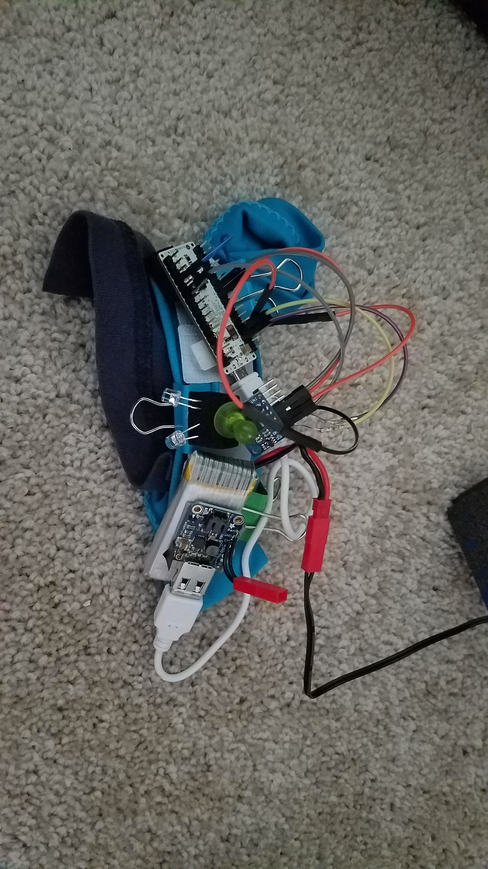

*Headset plugged into charger*

**Programmer Manual:** To assemble; attach all components to a headband of your choosing. 3d printing a housing is recommended. The LEDs are connected to pins 9 and 10 on the Arduino. The SDA pin on the MPU6050 goes to pin 2, the SCL goes to pin 3. Connect Vcc on the MPU6050 to the 5V pin on the Arduino and the ground pin to the Arduino ground. For ease of use it is recommended to connect the step-up chip via a USB cable and to solder a battery connector to the chip for easing plugging and unplugging. See above picture for reference.

**References:**

* Rapid Eye Movement Sleep. (n.d.). Retrieved November 28, 2016, from https://en.wikipedia.org/wiki/Rapid_eye_movement_sleep