COMPTE RENDU DES ATELIERS ANGULAR (1, 2 & 3)
Application : Gestion des Watches (MesWatches)
Framework : Angular 17+ (Standalone Components, Control Flow, Services & Routing)

1. ATELIER 01 : Initialisation, Composants & Navbar Bootstrap
1.1. Commandes Angular CLI
ng new MesWatches
npm install bootstrap@5.3.3
ng g c watches --skip-tests
ng g c add-watche --skip-tests

1.2. Configuration de Bootstrap (angular.json)
"styles": [
"src/styles.css",
"node_modules/bootstrap/dist/css/bootstrap.min.css"
],
"scripts": [
"node_modules/bootstrap/dist/js/bootstrap.bundle.min.js"
]

1.3. Barre de navigation (app.html)
<nav class="navbar navbar-expand-lg navbar-light bg-light">
<div class="container-fluid">
<a class="navbar-brand" href="#">Gestion des Watches</a>
<div class="collapse navbar-collapse" id="navbarSupportedContent">
<ul class="navbar-nav me-auto mb-2 mb-lg-0">
<li class="nav-item">
<a class="nav-link active" routerLink="/watches">Home</a>
</li>
<li class="nav-item dropdown">
<a class="nav-link dropdown-toggle" href="#" id="navbarDropdownWatches"
role="button" data-bs-toggle="dropdown">Watches</a>
<ul class="dropdown-menu">
<li><a class="dropdown-item" routerLink="/add-watche">Ajouter</a></li>
<li><a class="dropdown-item" routerLink="/watches">Lister</a></li>
</ul>
</li>
</ul>
</div>
</div>
</nav>
<router-outlet />

2. ATELIER 02 : Modèle Watche, Service, $index et Formulaire d'Ajout
2.1. Modèle de données (src/app/model/watche.model.ts)
export class Watche {
idWatche?: number;
marque?: string;
prixWatche?: number;
dateFabrication?: Date;
typeMouvement?: string;
}

2.2. Service Watche (src/app/services/watche.service.ts)
import { Injectable } from '@angular/core';
import { Watche } from '../model/watche.model';
@Injectable({
providedIn: 'root'
})
export class WatcheService {
watches: Watche[];
watche!: Watche;
constructor() {
this.watches = [
{ idWatche: 1, marque: 'Rolex', prixWatche: 12500, dateFabrication: new Date('2021-03-15'), typeMouvement: 'automatique' },
{ idWatche: 2, marque: 'Seiko', prixWatche: 350.5, dateFabrication: new Date('2019-07-22'), typeMouvement: 'quartz' },
{ idWatche: 3, marque: 'Omega', prixWatche: 5800, dateFabrication: new Date('2020-11-08'), typeMouvement: 'mécanique' }
];
}
listeWatches(): Watche[] { return this.watches; }
ajouterWatche(w: Watche) { this.watches.push(w); }
}

2.3. Affichage du tableau avec @for et $index (watches.component.html)
<table class="table table-striped">
<tr>
<th>N°</th>
<th>Id</th>
<th>Marque</th>
<th>Prix</th>
<th>Date Fabrication</th>
<th>Type Mouvement</th>
<th>Actions</th>
</tr>
@for (watche of watches; track watche.idWatche; let index = $index) {
<tbody>
<tr>
<td>{{index}}</td>
<td>{{watche.idWatche}}</td>
<td>{{watche.marque}}</td>
<td>{{watche.prixWatche}}</td>
<td>{{watche.dateFabrication | date:'dd/MM/yyyy'}}</td>
<td>{{watche.typeMouvement}}</td>
<td>
<a class="btn btn-danger" (click)="supprimerWatche(watche)">Supprimer</a>
<a class="btn btn-success" [routerLink]="['/updateWatche', watche.idWatche]">Modifier</a>
</td>
</tr>
</tbody>
}
</table>

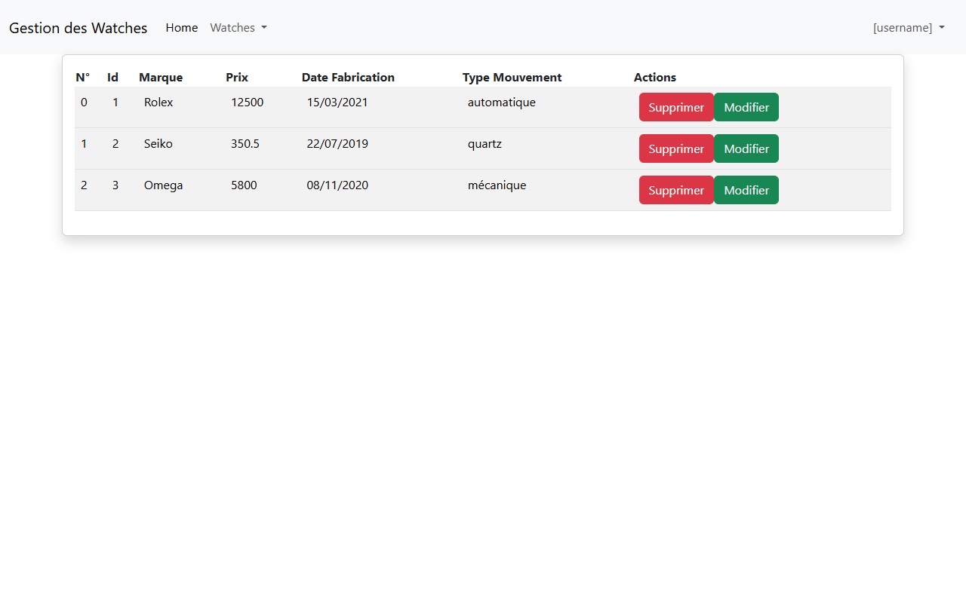
Figure : Affichage de la liste des watches avec la colonne N° ($index), tableau Bootstrap et actions
2.4. Formulaire d'ajout de Watche (add-watche.component.html)

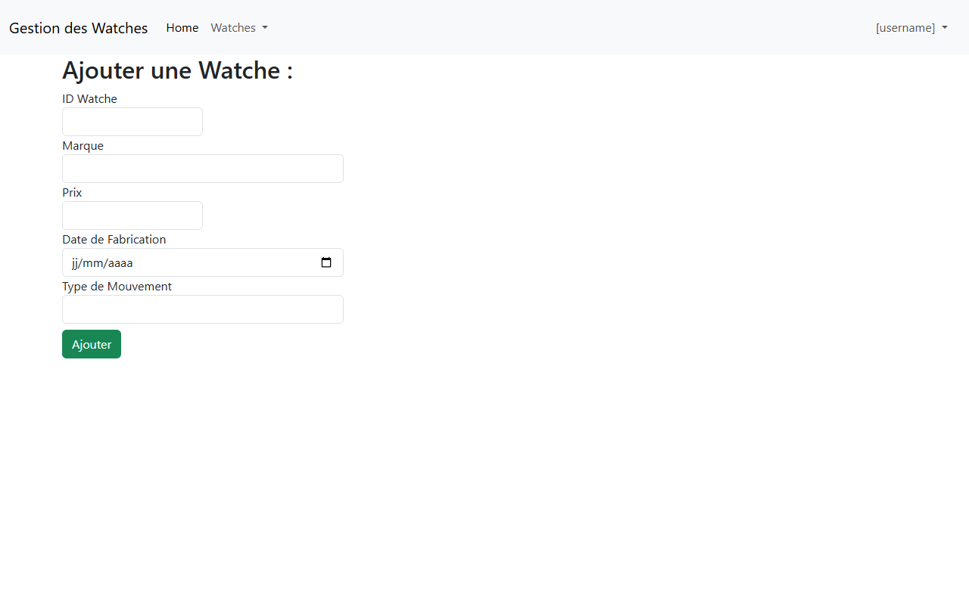
Figure : Formulaire d'ajout d'une nouvelle watche avec ngModel
3. ATELIER 03 : Modification, Suppression & ActivatedRoute
3.1. Méthodes CRUD dans WatcheService
supprimerWatche(w: Watche) {
const index = this.watches.indexOf(w, 0);
if (index > -1) { this.watches.splice(index, 1); }
}
consulterWatche(id: number): Watche {
this.watche = this.watches.find(w => w.idWatche == id)!;
return this.watche;
}
updateWatche(w: Watche) {
let index = this.watches.indexOf(w, 0);
if (index === -1) { index = this.watches.findIndex(item => item.idWatche == w.idWatche); }
if (index > -1) {
this.watches.splice(index, 1);
this.watches.splice(index, 0, w);
}
}

3.2. Formulaire de modification (update-watche.component.html)

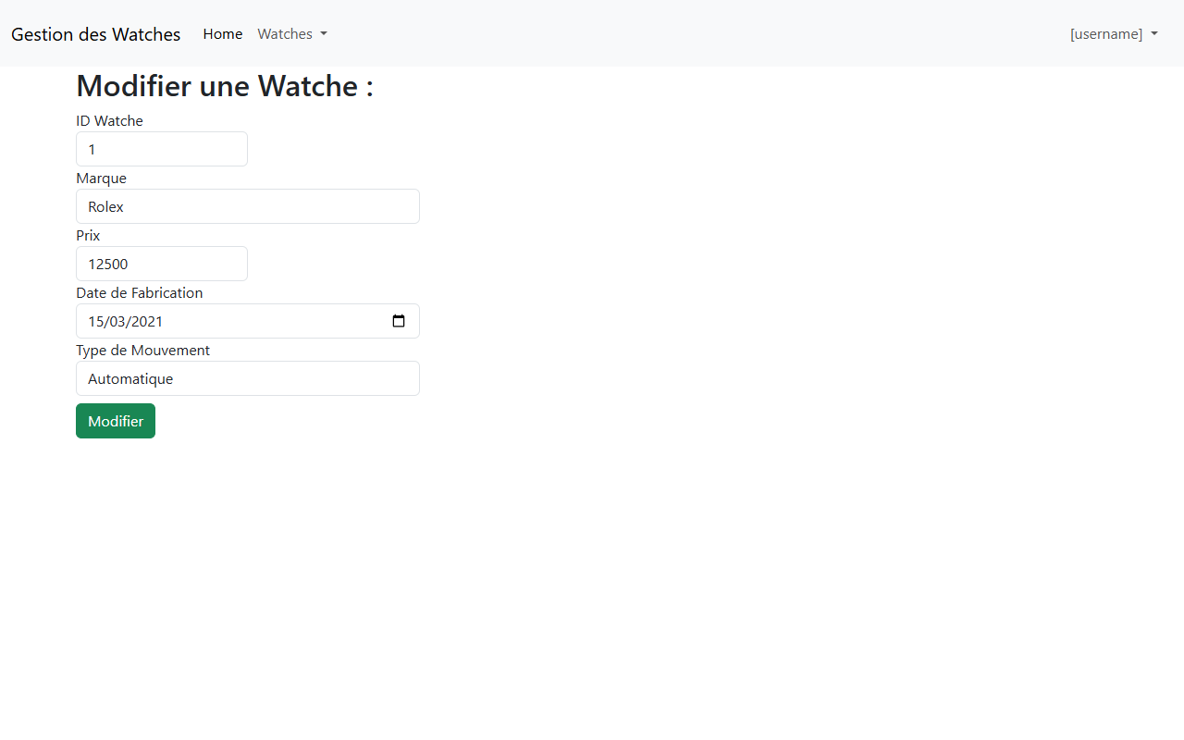
Figure : Formulaire de modification d'une watche avec ID en lecture seule (readonly)
3.3. Configuration des Routes finales (app.routes.ts)
import { Routes } from '@angular/router';
import { WatchesComponent } from './watches/watches';
import { AddWatcheComponent } from './add-watche/add-watche';
import { UpdateWatcheComponent } from './update-watche/update-watche';
export const routes: Routes = [
{ path: 'watches', component: WatchesComponent },
{ path: 'add-watche', component: AddWatcheComponent },
{ path: '', redirectTo: 'watches', pathMatch: 'full' },
{ path: 'updateWatche/:id', component: UpdateWatcheComponent }
];

