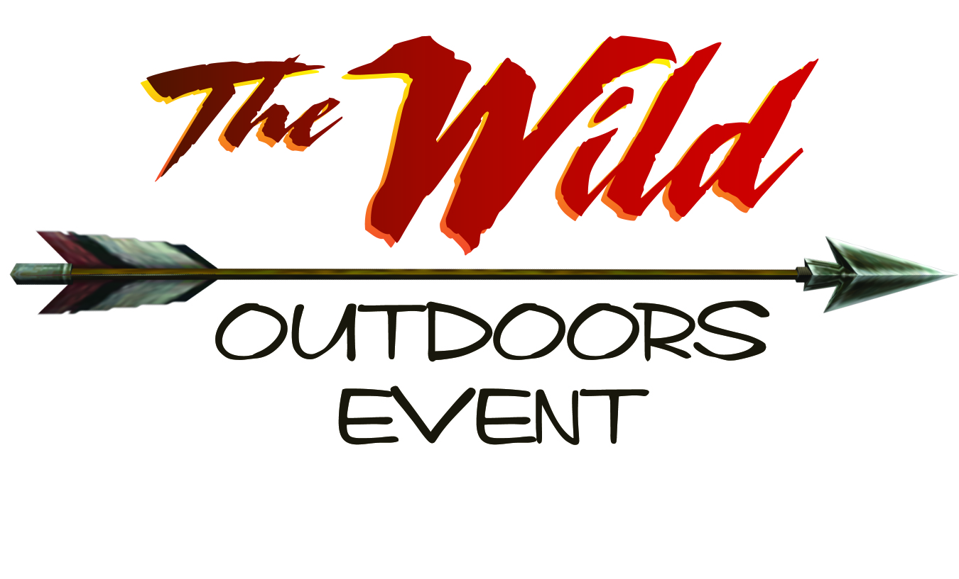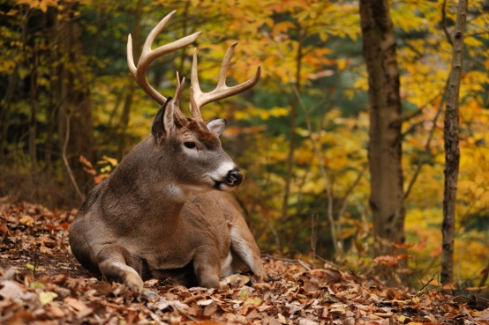

Dear Potential Sponsor:

We are so excited to tell you about our annual Wild Outdoors Event & Dinner Saturday, February 2nd 2013. The New Locust Grove Middle School has allowed us to use their space to host this event again for the 250+ that we plan on attending. This event is an annual growing community event sponsored of Flat Run Baptist Church in Locust Grove, Virginia. The event is geared to those that love the outdoors and will include an archery competition, trout pound for kids, special speakers, live music, wild dish competition, a dinner and many door prizes. Will you please consider making a monetary donation or donation in product, discount or gift card to help us host this event to the community for free?

1. **small game sponsorship.** All sponsors will be recognized when their door prize is given away during the event.

2. **big game sponsorship.**  Sponsors that give door prizes or gifts valuing $100.00 or more will have the opportunity to put a promotional item in our sponsor bag that each attendee will be given.

3. **trophy game sponsorship.** Sponsors that provide door prizes valuing $200 or more will be listed on the event website with a link to your website. Your business will also be featured on banners, t-shirts, sponsor bag and other ways.

*Consider making a $25 donation to Hunter’s for the Hungry. This free event will be accepting donations for hunters for the hungry. Each $25 donated feeds 75 people!

For tax purposes our tax id is **54-1258402**. Should you have any comments or questions please contact us at flat run. [www.flatrun.org](http://www.flatrun.org)

Thank you for considering partnering with us on this event!

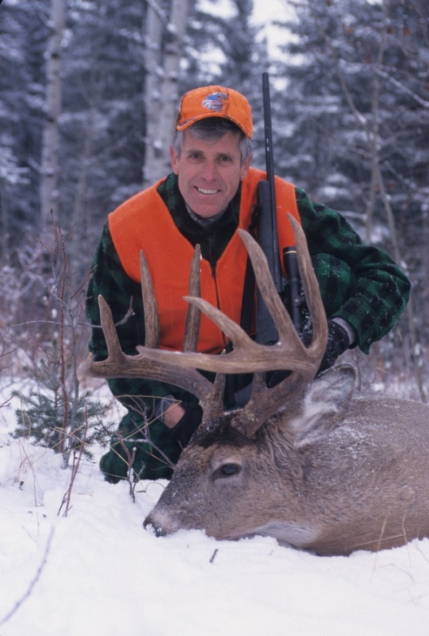We are excited to announce that we have scheduled outdoor writer, photographer, and speaker Charles Alsheimer for the 2013 Wild Outdoor Event. We look forward to him leading the afternoon seminar and speaking to us after the wild game dinner.

Charles Alsheimer is an award-winning outdoor writer, nature photographer, lecturer, and whitetail consultant from Bath, New York. Alsheimer was born and raised on a farm and has devoted his life to photographing, writing and lecturing about the wonders of God’s creation. His specialty – both as a writer and photographer – is the white-tailed deer.

He is the northern field editor for *Deer and Deer Hunting* magazine and host of their national television show, *Deer & Deer Hunting TV*, which airs on the VS. network. He is also a contributing editor for *Whitetail News.*

In the past 25 years, Alsheimer’s work has taken him across North America. His photography has won numerous state and national contest, and his articles and photographs have appeared in nearly every major outdoor publication, including *Outdoor Life, Field & Stream, Sports Afield,* Harris Publications and *Deer and Deer Hunting*. In addition, he has written seven popular books on whitetail and co-authored an eighth. Alsheimer also owns and operates a white-tailed deer research facility and provides consulting services to various segments of the whitetail industry.

In a national poll conducted in January 2000 by *Deer and Deer Hunting*, Alsheimer was honored as one of deer hunting’s top five inspirational leaders of the past century. The ballot included the names of nearly 60 scientists, manufacturers, politicians, celebrities, communicators, and hunters. These individuals were selected for their efforts to enhance America’s understanding of the white-tailed deer and promote the sport of deer hunting through such means as establishing national forests, developing camouflage patterns, and writing popular books. When the results of the survey were compiled, Alsheimer ranked third behind bowhunter Fred Bear and conservationist Aldo Leopold. President Theodore Roosevelt and outdoor apparel designer Bill Jordan finished fourth and fifth, respectively. This honor illustrates the respect Alsheimer ahs among America’s deer hunters.

Alsheimer lives with his wife on their farm in rural upstate New York. Additional information about him and his work can be found on his website, www.charlesalsheimer.com