Experiment Notes

Date: 01.04.2020

# Test subject: **1**

* Drank substance ABY from cup number **3**
* Status: DIED

# Test subject: **2**

* Drank substance ABY from cup number **8**
* Status: DIED

# Test subject: **3**

* Drank substance XBA from cup
* Status: DIED

Lab Memo #378

Date: 01.04.2020

Good news Team – Bruce has discovered that the Poison No. 0762 seems to increase the density of liquids. We have developed an orange pill that can be used to detected the poison – it should float in liquids that have been spiked.

PLEASE USE CAUTION: the pills are not reusable and therefore can only be used once, and need to be stored in the special containers on the shelf.

Also, Bruce is requesting anyone with spare amounts of yellow substance XBB, to get in touch with him as he has run out.

Lab Memo #380

Date: 03.04.2020

IMPORTANT PLEASE READ! The previously mentioned ‘Orange Pill’ test for Poison No. 0762 is not as reliable as we initially thought.

There have been a series of deaths after employees digested substance XBA, even after testing it with the orange pills.

Email – From Bruce

Date: 05.04.2020

Hi Jane, I left a secret stash of the orange pills just in case we need them. There is a clue to the hiding place on the laptop, I set the password to a memorable date for you! Best, Bruce

Password format: DD.MM.YYYY

PS. We just received a new substance for testing. It’s pink and has been labelled ABX in the computer system.

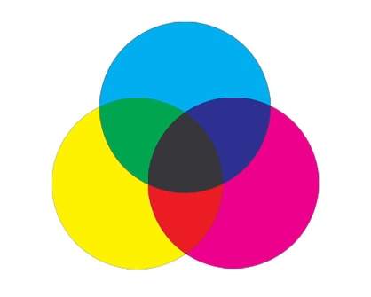

Email – From Jane

Date: 06.04.2020

Thanks Bruce, I appreciate the information on the backup pills.

There have been some worrying developments here, it seems that all the assumed antidotes to poison No. 0908 **are actually toxic when taken by themselves!**

However, there has been some initial success in **combining two antidotes**. The pattern seems to be:

* The combined liquids should match the colour of Poison No. 0908
* The antidotes should mix easily without any stirring or shaking – this can be tested by carefully and slowly injecting an antidote onto the surface of another using a syringe.
* It’s good to split the liquids and test smaller amounts in new glasses (just in case you make a mistake)

**BE CAREFUL: If they don’t mix properly, then don’t drink!**

Drink me to start the game!

**Poison No. 0908**

Caution! Toxic.

Kills in 45 minutes.

Potential antidotes   
need to be kept cool.

ANNOUNCEMENT – From Company HR

Date: 22.03.2020

Dear all. Please be aware that several employees have become ill recently and one has died. We have reported the incidents to the police who have determined the events to be not suspicious. Despite this, we ask you to please keep a close eye on any poisons you are working with and ensure that you use caution when drinking in communal areas.

In happier news, we would like congratulate Jane on her 20th wedding anniversary yesterday.

Please remember that you must submit your expenses for the first quarter of 2020 by the 30.03.2020 at the latest.

**Oh dear… The clock is ticking! The phone will help you find the antidote, better hurry!**

Code for the phone: **1 2 4 5 6 7**

**If these drinks have been spiked with Poison No. 0762, replace the matching drink number in the code above with a 0 in order to unlock the phone!**

1 2 3 4 5 6 7 8