Project : Megamip
Developer guide for the Megamip software
Project manager : Davin Sufer
By : Messaoud Bensalem

Description
Some technical details about the megamip software.

History
Version | Description |  | Author | Date
1 | First outline |  | Messaoud Bensalem | Jully 21st, 2013

Content

Introduction 3
What is Megamip ? 4
Megamip software design 6
Megamip GUI 9
References 13

Introduction
In this document we present some technical details regarding the Megamip software. This document is intended to maintain a reference documentation for the Megamip software.

What is Megamip ?

Megamip is the codename for a robot prototype project, the same codename will be used for the robot itself. In this section we will introduce just the parts that are concerned by the version 1.0 of the software. For a full description of the Megamip project you can check the link :Megamip project
This robot is composed by 3 major units :

- Display unit ( based on Cinemin slice projector )
- Control unit ( a mini pc android device based on a HiMedia Q5)
- Real time unit ( based on an Arduino Uno micro-controller )

The display unit is the robot's eyes which provide a 7” screen display. We can switch also to a projection mode where we can see the contents on the wall.

The control unit is an android OS system where the Megamip software is deployed. In the next section we will provide more details about this software.

The real time unit is the one which manages all the Megamip's sensors, motors.. etc. This unit contains the software for the balancing system and it can communicate with the “Control unit” through a USB connection.

The user of a Megamip will interact with it by voice commands or movement commands. The voice command “ picture tennis”, for example, will show a thumbnail of pictures related to the keyword “tennis”. The user can than with a movement command ( left/right movements ) select a picture and ask Megamip with the voice command “show” to display the selected picture. The following diagram shows the screen sequences for the Megamip software :
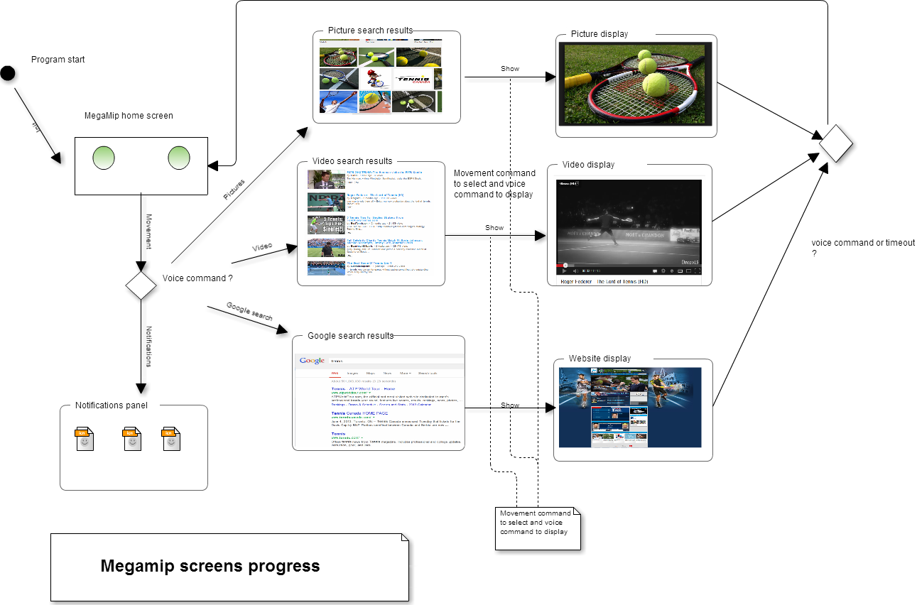

Megamip software design
The first version of the megamip software will include 4 major features. The first 3 features are picture search, video search and a web search. The last feature is to get a notifications screen to check the battery level, new emails ... etc. The next “use case diagram” shows these 4 features :

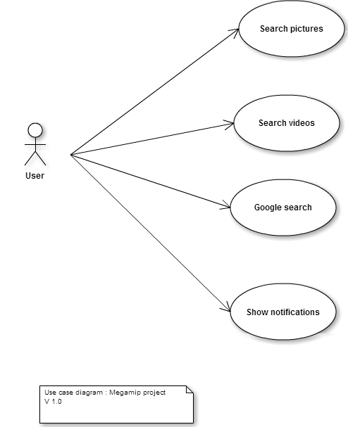

We are following an iterative life-cycle for the application development. The first version of the Megamip software design is as follow :
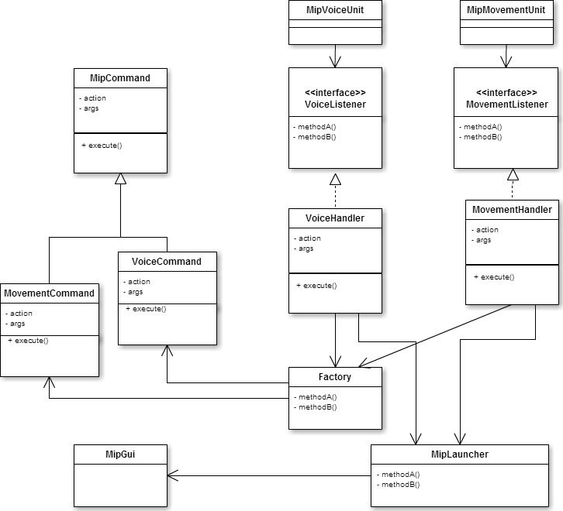

Ddddp

Megamip GUI

our la 4eme semain
For the GUI we took the decision to use html and JavaScript technologies. This choice is based on the fact that a completly customized GUI will be complicated and will probably take a long period of time if we chose the standard “android widget toolkit”. For example, the main screen of our GUI is the Megamip eyes. Making this screen using html and setting up the layout with a CSS is straitghtforward. We present on the next two screens, two possible versions for the Megamip eyes screens.

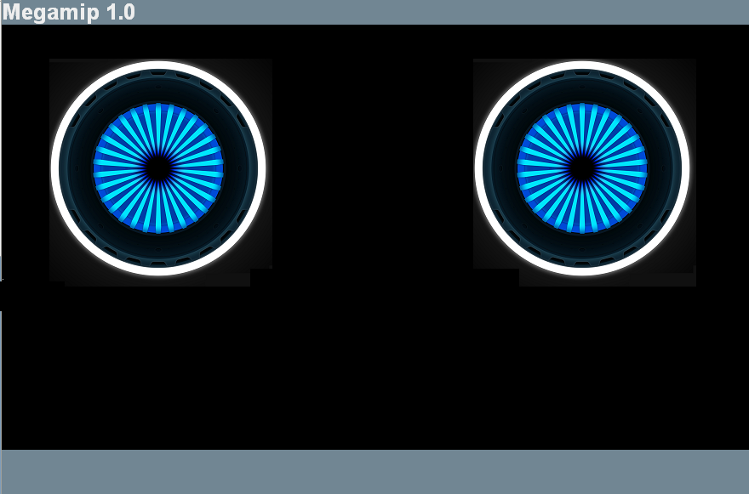

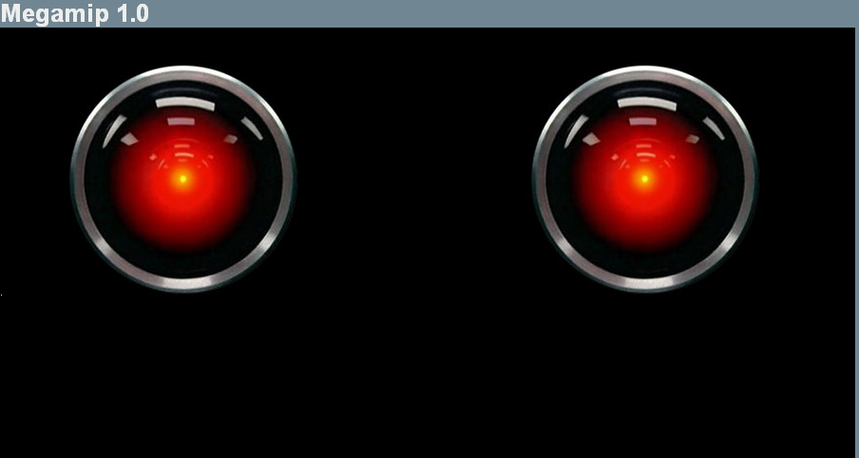

We need to mention that we dont use a regular web browser to display our GUI but we use our own module which is a Webview component. This last one uses the popular and efficient chromium engine.
The main problem we faced by taking this choice is to figure out how to make a link between our html-javascript GUI and our Java main module. The main module is the one which handles the voice and movement commands and passes to our html-javascript GUI the appropriate requests to display picture, video or web search.
We found that basically there's two evident ways to fix this issue. The first one is by using a framework like PhoneGap. The second way is to use the WebView component's interface through the method “addJavascriptInterface()”. The last way is the one we have chosen.
We faced also two other problems regarding our GUI, that is :
- Provide a customized display for search results
- Select an item from the search results and display it without using the touchscreen ( or the mouse).
For the first point we found that instead of using the regular « google API » we have to use the « Ajax google API ». This last one returns a JSON formated result wich we can exploit it and display the way we want. For the second point, we found that by using the jQuery method « trigger() » we can fire manually an event, for example, a mouse click on a graphical component. The display of a picture is made with the pluggin FancyBox ( ref 1.0) and to select an item we use the jQuery methods addClass() and removeClass().
On the following 2 screens we show the layout for a picture search screen using all the technics mentionned above :
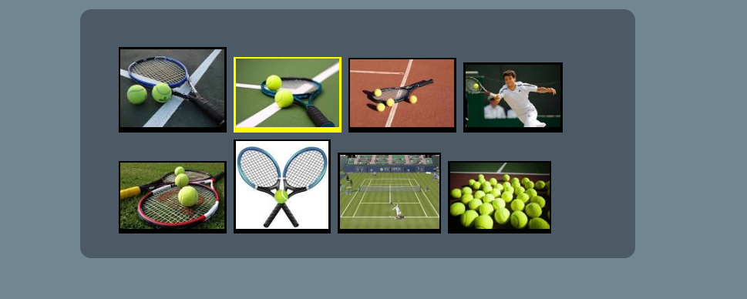
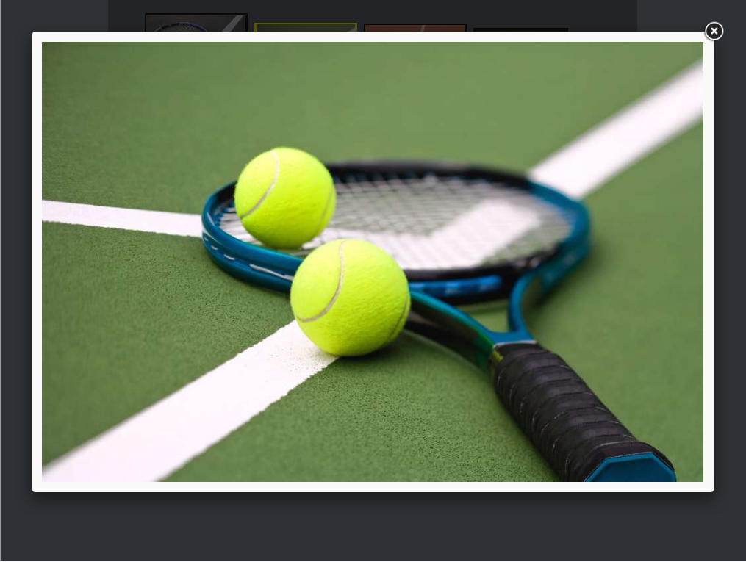

References

Ref 1.0 : http://fancybox.net/

