**Query 1:**

Select ?i ?c Where {

?i rdf:type ?c

}

**Query 2:**

Select ?i Where {

?i rdf:type ub:GraduateStudent.

?i ub:takesCourse ub:GC1.

}

**Query 3:**

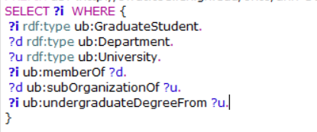

**Query 4:**

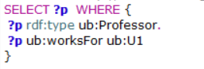

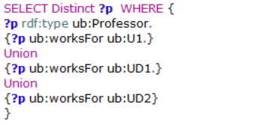

Q4:

Select ?x ?y

Where{

?x rdf:type ub:Professor.

?y rdf :type ub :department.

?y ub:subOrganizationOf ub:U1.

?x ub:worksFor ?y.

}

**Query 5:**

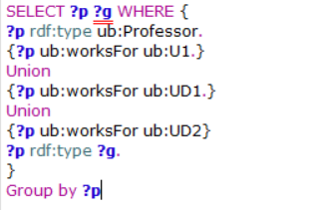

Q5:

Select ?x ?g

Where{

?x rdf:type ub:Professor.

?y rdf :type ub :department.

?y ub:subOrganizationOf ub:U1.

?x rdf:type ?g

Filter((?g!=ub:Fullperson)&& (?g!=ub:Thing))

}

**Query 6:**



**Query 7:**

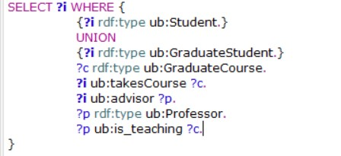

**Query 8:**

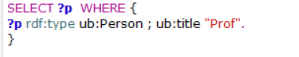

**Query 9:**

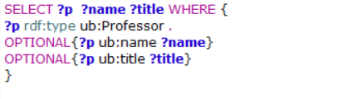

**Query 10:**

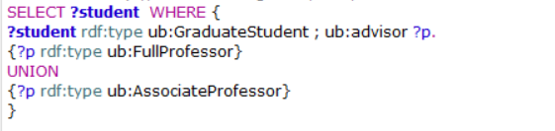

**Query 11:**

