Project Design Documentation Template:
Last updated: July 29th, 2026

1. Project Title & Version Control

Project Title
Design and Implementation of an Automated Network Lab for Cyber Security Analysis.
Version Control
Version: DRAFT
Date: 08/03/2026
Change Log: Initial project design document created for 12-week Network Security Home Lab project

2. Project Summary (2-3 sentences)
The purpose of this project is to design, build, and document a secure virtual network security laboratory that simulates a real-world enterprise network. The lab will provide an isolated environment where cybersecurity techniques can be practiced safely without affecting production systems.
The project focuses on the responsibilities of a Network Cybersecurity Analyst by implementing network monitoring, vulnerability assessments, packet analysis, attack simulation, firewall configuration, and network segmentation. The environment will be built using virtualization technologies and open-source cybersecurity tools, allowing realistic security testing while maintaining a controlled environment.
Throughout the twelve-week development period, the project will progress from planning and virtual network design to security implementation, testing, documentation, and final evaluation. The completed project will demonstrate practical cybersecurity skills while producing professional documentation suitable for academic and portfolio purposes.

3. Problem Statement / Use Case
Modern organizations rely heavily on secure computer networks to conduct daily business operations. Cyber threats such as ransomware attacks, unauthorized access, malware infections, phishing campaigns, and network intrusions continue to increase in both frequency and sophistication.
Organizations require trained cybersecurity professionals capable of identifying vulnerabilities before attackers exploit them. However, practicing offensive and defensive security techniques on production systems is unsafe and unethical. Therefore, organizations and cybersecurity students require isolated laboratory environments where security testing can be performed safely.
This project addresses this problem by creating a virtual network security home lab that simulates a small enterprise network. The environment allows a Network Cybersecurity Analyst to safely perform vulnerability assessments, analyze network traffic, configure firewalls, monitor attacks, and document security findings without placing real systems or sensitive data at risk.
The intended users include:
- Entry-level security analysts
- Network administrators
- Individuals preparing for cybersecurity certifications
- Organizations such as health , and education, or any.

4. Goals and Objectives
The 2 main goals of this lab I aim for are:
- creating a safe, controlled environment to test malware behavior and practice ethical hacking techniques.
- allowing users to simulate real-world attacks and defenses, enhancing their practical skills.
By the end of 12 weeks, the completed project would accomplish these objectives:

Objective 1
Design and deploy an isolated virtual network using virtualization software.

Objective 2
Configure multiple virtual machines representing different network roles.

Objective 3
Perform network reconnaissance using industry-standard tools.

Objective 4
Capture and analyze network traffic using Wireshark.

Objective 5
Conduct vulnerability assessments using Nmap and controlled attack simulations.

Objective 6
Deploy and configure a pfSense firewall to secure the network.

Objective 7
Implement network segmentation and firewall rules to improve network security.

Objective 8
Document all configurations, findings, screenshots, and security recommendations throughout the project.

5. Key Features / Functions

The completed project will include the following major features:

Virtual Network Design
A completely isolated virtual network will be created using VirtualBox to simulate an enterprise environment.

Attacker Machine
A Kali Linux virtual machine will function as the cybersecurity analyst workstation and penetration testing system.

Vulnerable Target Machine
A Metasploitable virtual machine will simulate a vulnerable enterprise server.

Packet Capture
Wireshark will capture network traffic for analysis of protocols, packets, and security events.

Network Scanning
Nmap will identify active hosts, open ports, running services, and operating systems.

Controlled Attack Simulation
The Metasploit Framework will demonstrate how attackers exploit vulnerable services.

Firewall Protection
pfSense will provide enterprise firewall functionality including:
- Access control
- Traffic filtering
- Network monitoring
- Default-deny security policies

Network Segmentation
Separate LAN and DMZ networks will be configured to demonstrate secure network architecture.

Documentation
Throughout the project, detailed documentation will include:
- Network diagrams
- Firewall rules
- Packet analysis
- Vulnerability reports
- Weekly progress
- Final security recommendations

6. Tech Stack and Tools

Tool | Purpose
Oracle VirtualBox | Creates and manages virtual machines
Kali Linux | Penetration testing and security analysis
Metasploitable 2 | Vulnerable target machine
Wireshark | Network traffic capture and packet analysis
Nmap | Network discovery and vulnerability assessment
Metasploit Framework | Controlled exploitation demonstrations
pfSense | Firewall and network security gateway
Linux Command Line | System administration
Markdown / Microsoft Word | Documentation

7. Architecture / Workflow Diagram
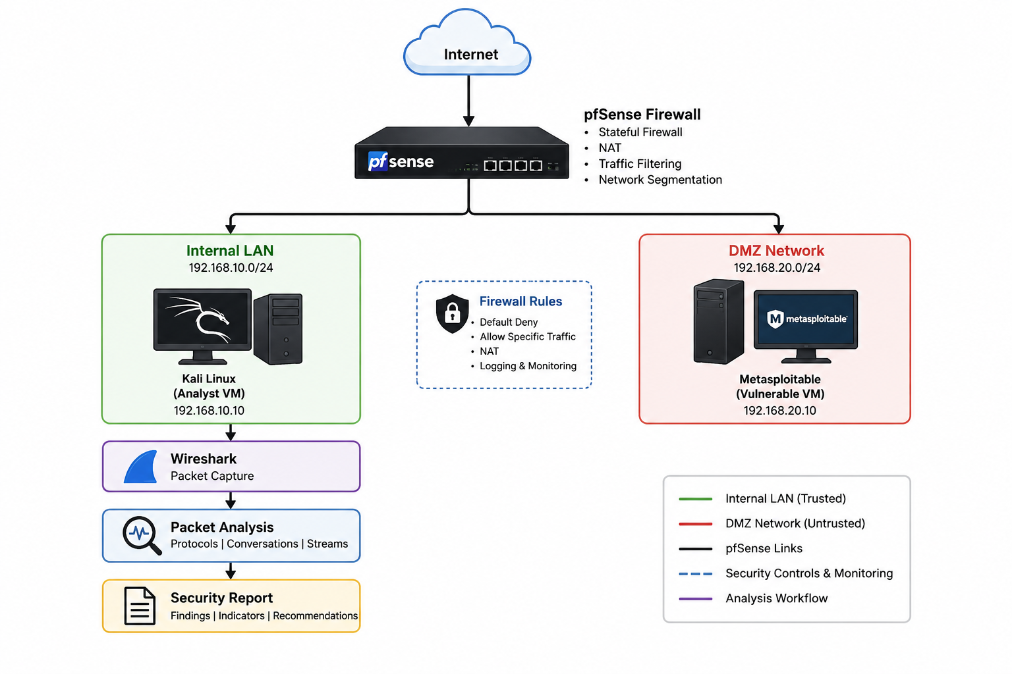

8. Timeline / Weekly Milestones

Week | Project Outcome | SDLC Stage and What It Means
Week 1 | Install VirtualBox and configure isolated virtual networking. Document IP addressing and network topology. | Discovery & Planning
Week 2 | Deploy Kali Linux VM and configure the analyst workstation. Update packages and verify functionality. | Requirements Analysis
Week 3 | Deploy Metasploitable VM, assign networking, and verify communication between systems. | Project Planning
Week 4 | Perform baseline network testing, take VM snapshots, and review the completed environment. | System Design
Week 5 | Install Wireshark, capture normal network traffic, and learn packet analysis techniques. | Implementation Setup
Week 6 | Simulate FTP/HTTP traffic, capture packets, and analyze clear-text credentials. | Implementation
Week 7 | Conduct Nmap scans, identify hosts and services, and analyze reconnaissance traffic. | Implementation & Integration
Week 8 | Execute a controlled Metasploit exploit, capture network evidence, and review logs. | Testing & Quality Assurance
Week 9 | Implement firewall policies using default-deny rules and allow only required traffic. | Validation & Refinement
Week 10 | Implement firewall policies using default-deny rules and allow only required traffic. | Release Preparation
Week 11 | Create a DMZ, segment the network, and verify isolation between internal and external zones. | Deployment
Week 12 | Re-test attacks against the secured environment, export configurations, complete documentation, and present findings. | Release & Maintenance Planning

9. Risks and Risk Mitigation

Risk | Impact | Mitigation
Limited computer resources | Virtual machines may run slowly | Allocate sufficient RAM and close unnecessary applications.
Virtual machine corruption | Loss of progress | Take regular VM snapshots and backups.
Firewall misconfiguration | Connectivity issues | Test changes incrementally and document configurations.
Learning curve for security tools | Delays in project progress | Use official documentation and complete tasks step by step.
Accidental exposure to home network | Security risk | Keep the lab on an isolated host-only or internal virtual network.
Time management | Missed milestones | Follow the weekly schedule and review progress at the end of each week.

10. Evaluation Criteria

The project will be considered successful if:
- The virtual lab is fully deployed and all virtual machines communicate as intended.
- Wireshark successfully captures and displays network traffic for analysis.
- Nmap identifies active hosts and services within the lab environment.
- Controlled Metasploit demonstrations execute successfully in the isolated environment.
- pfSense blocks unauthorized traffic according to the configured firewall rules.
- Network segmentation separates the internal LAN and DMZ effectively.
- All project documentation, diagrams, screenshots, and reports are complete and organized.
- The project can be demonstrated from start to finish, showing planning, implementation, testing, and security improvements.

11. Future Considerations
Although this project focuses on a 12-week home lab implementation, several enhancements could be added in future versions:
- Deploy a SIEM solution such as Wazuh for centralized log collection and analysis.
- Integrate an IDS/IPS solution such as Suricata or Snort.
- Add a Windows Server domain with Active Directory for identity and access management scenarios.
- Expand the environment to include additional client systems and simulated enterprise services.
- Explore cloud networking concepts using platforms such as AWS or Azure.
- Incorporate endpoint detection and response (EDR) tools.
- Map security controls to compliance frameworks such as HIPAA or NIST to extend the project into regulatory and governance topics.

