Five sample runs are presented, which consist of input, output, and a graphical representation of the parse tree. Individual .txt and .png files are available in the /tests directory
In addition to printing a text representation to the console, a [testName]-output.txt file is created, containing the output for each program parsed
In order to write errors to this output .txt file, we had to create a custom error listener. The class overrides ANTLR’s syntaxError(), and also provides a getErrors() method so we can request a list of errors and write them to a .txt file
Sample 1
Input
x := 2;
y := 3;
read(a, b);
write(a,b,a+b*(2*x/y));

Output
Parse Tree:
(program (stmt_list (stmt x := (expr (term (factor 2) factor_tail) term_tail) ;) (stmt_list (stmt y := (expr (term (factor 3) factor_tail) term_tail) ;) (stmt_list (stmt read ( (id_list a (id_list_tail , b id_list_tail)) ) ;) (stmt_list (stmt write ( (expr_list (expr (term (factor a) factor_tail) term_tail) (expr_list_tail , (expr (term (factor b) factor_tail) term_tail) (expr_list_tail , (expr (term (factor a) factor_tail) (term_tail (add_op +) (term (factor b) (factor_tail (mult_op *) (factor ( (expr (term (factor 2) (factor_tail (mult_op *) (factor x) (factor_tail (mult_op /) (factor y) factor_tail))) term_tail) )) factor_tail)) term_tail)) expr_list_tail))) ) ;) stmt_list)))))

Errors:

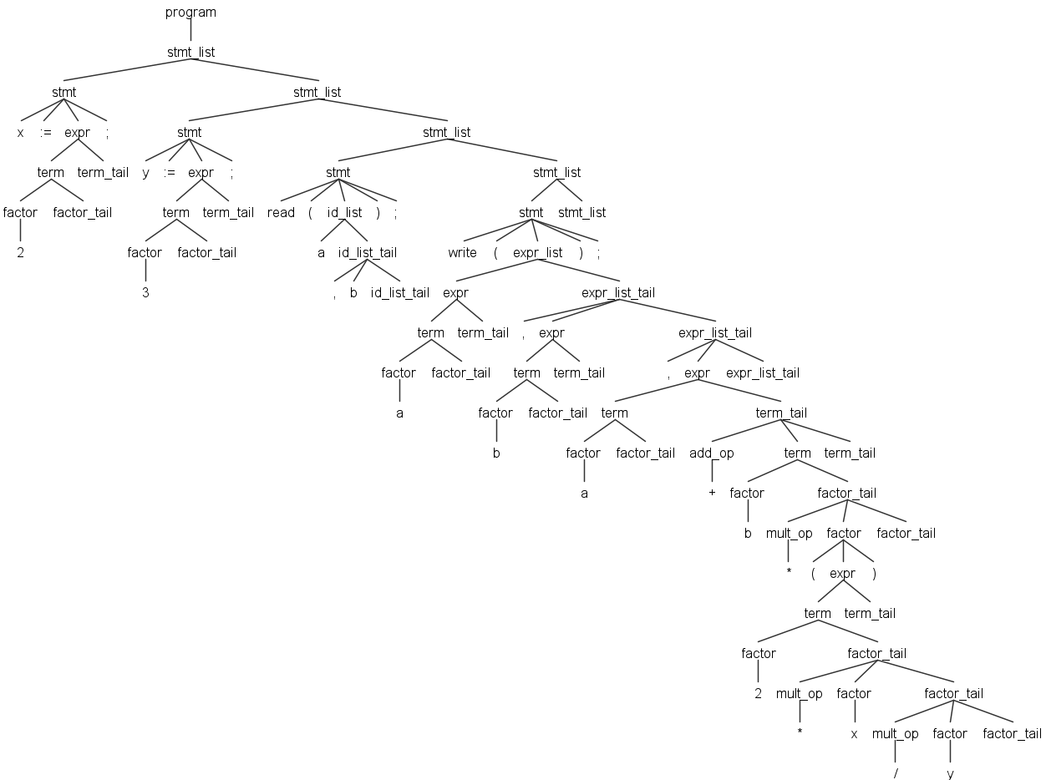

Sample 2
Input
x := 2;
y := 3;
read(a, b);
write(a,b,a+b*(2*x/y);

Output
Parse Tree:
(program (stmt_list (stmt x := (expr (term (factor 2) factor_tail) term_tail) ;) (stmt_list (stmt y := (expr (term (factor 3) factor_tail) term_tail) ;) (stmt_list (stmt read ( (id_list a (id_list_tail , b id_list_tail)) ) ;) (stmt_list (stmt write ( (expr_list (expr (term (factor a) factor_tail) term_tail) (expr_list_tail , (expr (term (factor b) factor_tail) term_tail) (expr_list_tail , (expr (term (factor a) factor_tail) (term_tail (add_op +) (term (factor b) (factor_tail (mult_op *) (factor ( (expr (term (factor 2) (factor_tail (mult_op *) (factor x) (factor_tail (mult_op /) (factor y) factor_tail))) term_tail) )) factor_tail)) term_tail)) (expr_list_tail ;))))) stmt_list)))))

Errors:
line 4:21 no viable alternative at input ';'
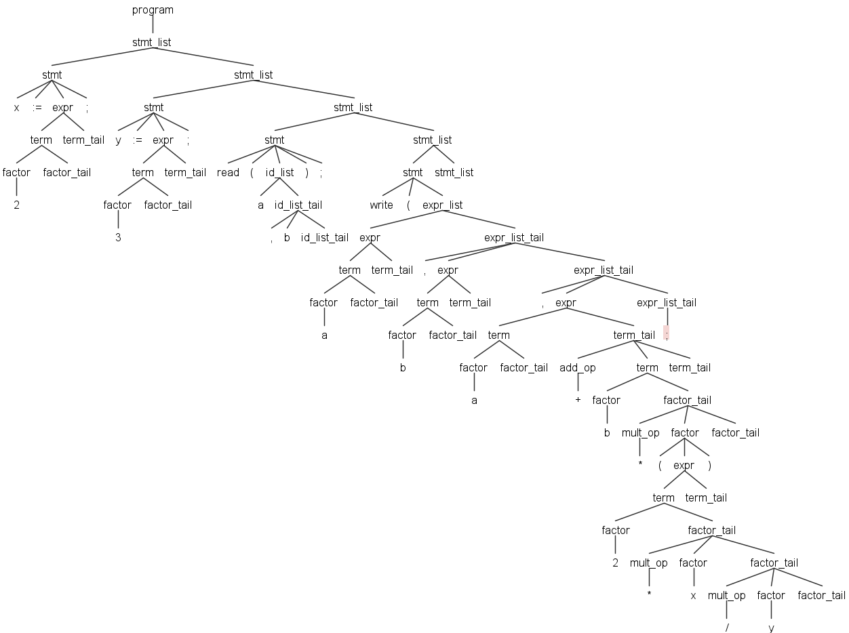

Sample 3
Input
x := 2;
y := 3;
read(a, b)
write(a, b,a+b*(2*x/y));

Output
Parse Tree:
(program (stmt_list (stmt x := (expr (term (factor 2) factor_tail) term_tail) ;) (stmt_list (stmt y := (expr (term (factor 3) factor_tail) term_tail) ;) (stmt_list (stmt read ( (id_list a (id_list_tail , b id_list_tail)) ) <missing ';'>) (stmt_list (stmt write ( (expr_list (expr (term (factor a) factor_tail) term_tail) (expr_list_tail , (expr (term (factor b) factor_tail) term_tail) (expr_list_tail , (expr (term (factor a) factor_tail) (term_tail (add_op +) (term (factor b) (factor_tail (mult_op *) (factor ( (expr (term (factor 2) (factor_tail (mult_op *) (factor x) (factor_tail (mult_op /) (factor y) factor_tail))) term_tail) )) factor_tail)) term_tail)) expr_list_tail))) ) ;) stmt_list)))))

Errors:
line 4:0 missing ';' at 'write'
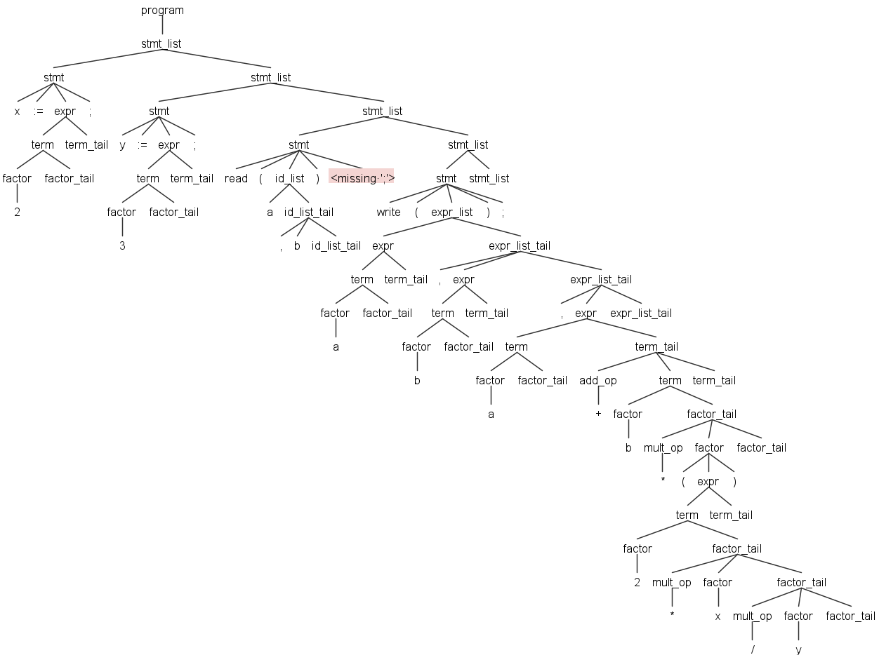

Sample 4
Input
x := 2;
y := 3;
read(a b);
write(a, b,a+b*(2*x/y));

Output
Parse Tree:
(program (stmt_list (stmt x := (expr (term (factor 2) factor_tail) term_tail) ;) (stmt_list (stmt y := (expr (term (factor 3) factor_tail) term_tail) ;) (stmt_list (stmt read ( (id_list a id_list_tail) b ) ;) (stmt_list (stmt write ( (expr_list (expr (term (factor a) factor_tail) term_tail) (expr_list_tail , (expr (term (factor b) factor_tail) term_tail) (expr_list_tail , (expr (term (factor a) factor_tail) (term_tail (add_op +) (term (factor b) (factor_tail (mult_op *) (factor ( (expr (term (factor 2) (factor_tail (mult_op *) (factor x) (factor_tail (mult_op /) (factor y) factor_tail))) term_tail) )) factor_tail)) term_tail)) expr_list_tail))) ) ;) stmt_list)))))

Errors:
line 3:7 no viable alternative at input 'b'
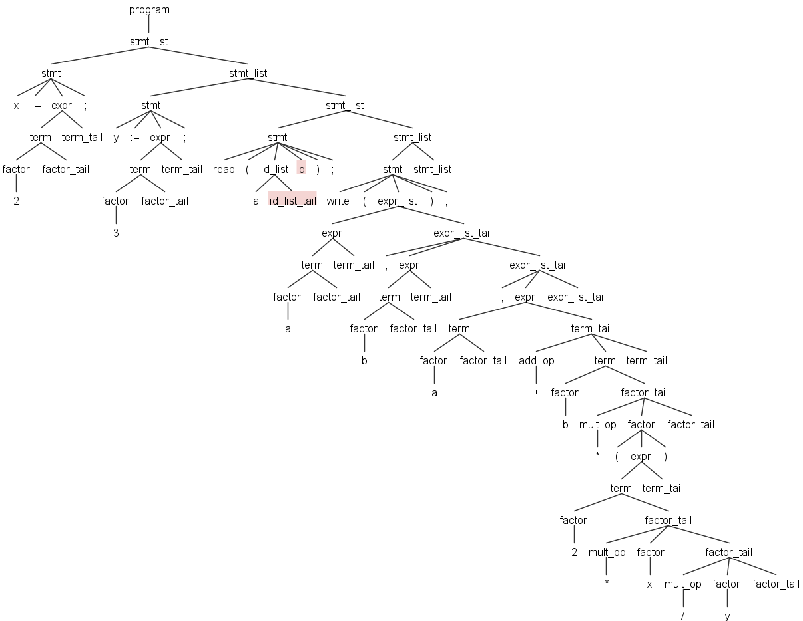

Sample 5
Input
read(x, y, z, v);
read( c ); temp := (x - y)*(2*x + z/4) /v;
a := (c);
write( temp / );

Output
Parse Tree:
(program (stmt_list (stmt read ( (id_list x (id_list_tail , y (id_list_tail , z (id_list_tail , v id_list_tail)))) ) ;) (stmt_list (stmt read ( (id_list c id_list_tail) ) ;) (stmt_list (stmt temp := (expr (term (factor ( (expr (term (factor x) factor_tail) (term_tail (add_op -) (term (factor y) factor_tail) term_tail)) )) (factor_tail (mult_op *) (factor ( (expr (term (factor 2) (factor_tail (mult_op *) (factor x) factor_tail)) (term_tail (add_op +) (term (factor z) (factor_tail (mult_op /) (factor 4) factor_tail)) term_tail)) )) (factor_tail (mult_op /) (factor v) factor_tail))) term_tail) ;) (stmt_list (stmt a := (expr (term (factor ( (expr (term (factor c) factor_tail) term_tail) )) factor_tail) term_tail) ;) (stmt_list (stmt write ( (expr_list (expr (term (factor temp) (factor_tail (mult_op /) factor factor_tail)) term_tail) expr_list_tail) ) ;) stmt_list))))))

Errors:
line 4:17 mismatched input ')' expecting {ID, NUMBER, '('}
