Signal Certification in Digital Humanities:
An Empirically Calibrated Framework for Distinguishing Statistical Signal from Methodological Artifact
[Working draft — assembled from Section 8 of the Voynich manuscript-auditing study]

Abstract
Purpose: This paper develops the Artifact Probability Score (APS), extending a manuscript-specific statistical instrument into a domain-general framework for certifying whether an observed pattern in cultural heritage data reflects genuine structure or an artifact of arbitrary analytic choices.
Design/methodology/approach: APS combines five components — specification robustness, compositional confound, resampling instability, multiple-comparison fragility, and subgroup non-replication — into a weighted 0–100 score. The framework is empirically calibrated against fourteen external anchor corpora spanning eight languages and four script families, and its robustness to internal weighting choices is tested via one-at-a-time and global weight-perturbation sensitivity analysis (5,000 draws).
Findings: The calibration shows that the score's middle range has limited discriminative power: several genuine natural-language texts land in the same range as the manuscript's own disputed signal. This motivates a revised three-band scale (Robust/Uncertain/Near-certain artifact) that the sensitivity analysis independently confirms is stable to weighting choices, whereas the original scale's 50-point threshold was not.
Originality: The paper is, to the author’s knowledge, among the first attempts to abstract a manuscript-specific signal-certification instrument into domain-general, empirically calibrated terms, and to test that instrument's own robustness to its internal design choices rather than assuming it.
Contribution to the field of Digital Humanities: APS offers digital humanities researchers a reproducible, pre-registrable certification procedure for computationally detected signals, together with an explicit account of its own limits and the preconditions required before it can be extended to other domains.

Keywords
Artifact Probability Score; signal certification; statistical artifact; Voynich Manuscript; computational literary studies; reproducibility; multiple comparisons; Simpson's paradox; weight sensitivity analysis; digital humanities methodology; hypothesis certification; cross-corpus calibration

1. Introduction
The volume of statistical “signals” reported in digital humanities has grown sharply with the availability of large language models, off-the-shelf text-mining pipelines, and computationally cheap pattern search over digitized corpora. A pattern — a correlation, an enrichment, a recurring motif — can now be produced, tested, and reported in an afternoon. The methodological apparatus for deciding whether such a pattern reflects a genuine property of the corpus, rather than an artifact of the many analytic choices made in producing it, has not kept pace.
This shift is not only a matter of volume. Agentic research pipelines increasingly automate not just the search for a pattern but the generation of a candidate hypothesis around it — a large language model can now propose, over a single session, dozens of thematic or structural readings of a corpus that a human researcher would once have taken months to formulate. The bottleneck this creates is no longer at the stage of hypothesis generation but at the stage of hypothesis certification: deciding which of many automatically produced candidates reflects a property of the corpus rather than an artifact of how the candidate was produced. The methodological literature reviewed below addresses the underlying statistical problem but not this specific consequence of its acceleration.
This dissociation between generation and certification is now documented well beyond digital humanities. Large-scale studies of LLM-assisted scientific ideation report that language models readily generate candidate research ideas judged highly novel, while reliable evaluation and execution remain the principal bottlenecks (Si et al., 2024; Si et al., 2025). A recent survey reaches the same conclusion at field scale, arguing that scientific idea generation is advancing faster than mechanisms for trustworthy assessment and linking this imbalance to growing pressure on peer review, illustrated by the sharp increase in NeurIPS submissions (Shahhosseini et al., 2025). The certification problem addressed here is therefore a discipline-specific manifestation of a broader methodological challenge.
This is not a new problem in the abstract. Ioannidis (2005) showed that a research claim is less likely to be true when a field permits greater flexibility in designs, definitions, outcomes, and analytical modes, and when more research teams pursue statistical significance in the same space of possible findings. Gelman and Loken (2013) sharpened this into the “garden of forking paths”: a plethora of statistically “significant” results can emerge from data-contingent analytic choices even when no conscious p-hacking or fishing expedition occurs and the hypothesis was specified in advance. This is because the researcher’s true reference class of comparisons is every analysis they would have run under different data, not only the one they happened to run. Neither paper offers an instrument for evaluating a specific, already-reported signal; both diagnose the problem at the level of research culture and incentive.
The domain of numerically encoded text offers a specific, well-documented precedent for what happens when this diagnosis is ignored. Witztum, Rips, and Rosenberg’s 1994 claim that the Hebrew text of Genesis encodes events that occurred millennia after it was written was, after several years of scrutiny, shown by McKay, Bar-Natan, Bar-Hillel, and Kalai (1999) to rest on choices made in designing the experiment and selecting the data, not on a property of the text itself. Their extensive independent replications, using the same class of methods without those specific choices, failed to reproduce the effect. The episode is instructive beyond its notoriety: it shows that a numerically encoded-text signal can survive a first round of peer review, attract substantial expert attention, and still be, on protracted forensic reanalysis, an artifact of researcher degrees of freedom rather than a property of the corpus — precisely the failure mode the present framework is built to detect before publication rather than after.
A parallel, more recent, and still unsettled debate has played out within computational literary studies specifically. Da (2019) argued that a substantial portion of published computational literary scholarship divides into results that are not statistically demonstrated and results that are demonstrated but incorrect, attributing this to the nature of literary data and the statistical tools applied to it. Da’s critique has the merit of recalling that quantitative methods never dispense with rigorous theoretical and hermeneutic reflection. Its argument, however, rests on an overgeneralization of methodological weaknesses observed in only part of the literature it surveys — which accounts for the considerable, and in several respects sharply critical, response it drew from within the digital humanities community. This paper takes no further position on that exchange, citing it only to establish that the discipline itself recognizes an unresolved standards problem, not to adjudicate it.
What is missing from this literature — the forking-paths diagnosis, the Bible-code precedent, and the computational-literary-studies debate alike — is a standardized, empirically calibrated instrument that a researcher can apply to one specific signal they have found. Such an instrument would certify how much of that signal’s apparent strength survives explicit testing against the five most common sources of false positive documented in this literature: sensitivity to an arbitrary specification, compositional (Simpson-type) confounding, resampling instability, failure to survive correction for the comparisons actually run, and non-replication across the corpus’s natural subgroups. This paper proposes such an instrument — the Artifact Probability Score (APS) — defines it in domain-general terms (Section 2), reports its empirical calibration against fourteen reference corpora spanning eight languages and four script families (Sections 3–5), demonstrates the robustness of the resulting classification scale to the instrument’s own internal weighting choices (Section 6), and discusses the conditions under which it can be expected to generalize beyond the signal that motivated its construction (Section 7).
APS is deliberately scoped as a framework for structuring this certification judgment, not as a decision procedure that replaces it: a low score narrows the space of plausible alternative explanations for an observed pattern, it does not certify that the pattern is historically or linguistically meaningful, and every application still depends on two judgment calls external to the instrument itself — the choice of encoder and the choice of partition (Section 2.2).
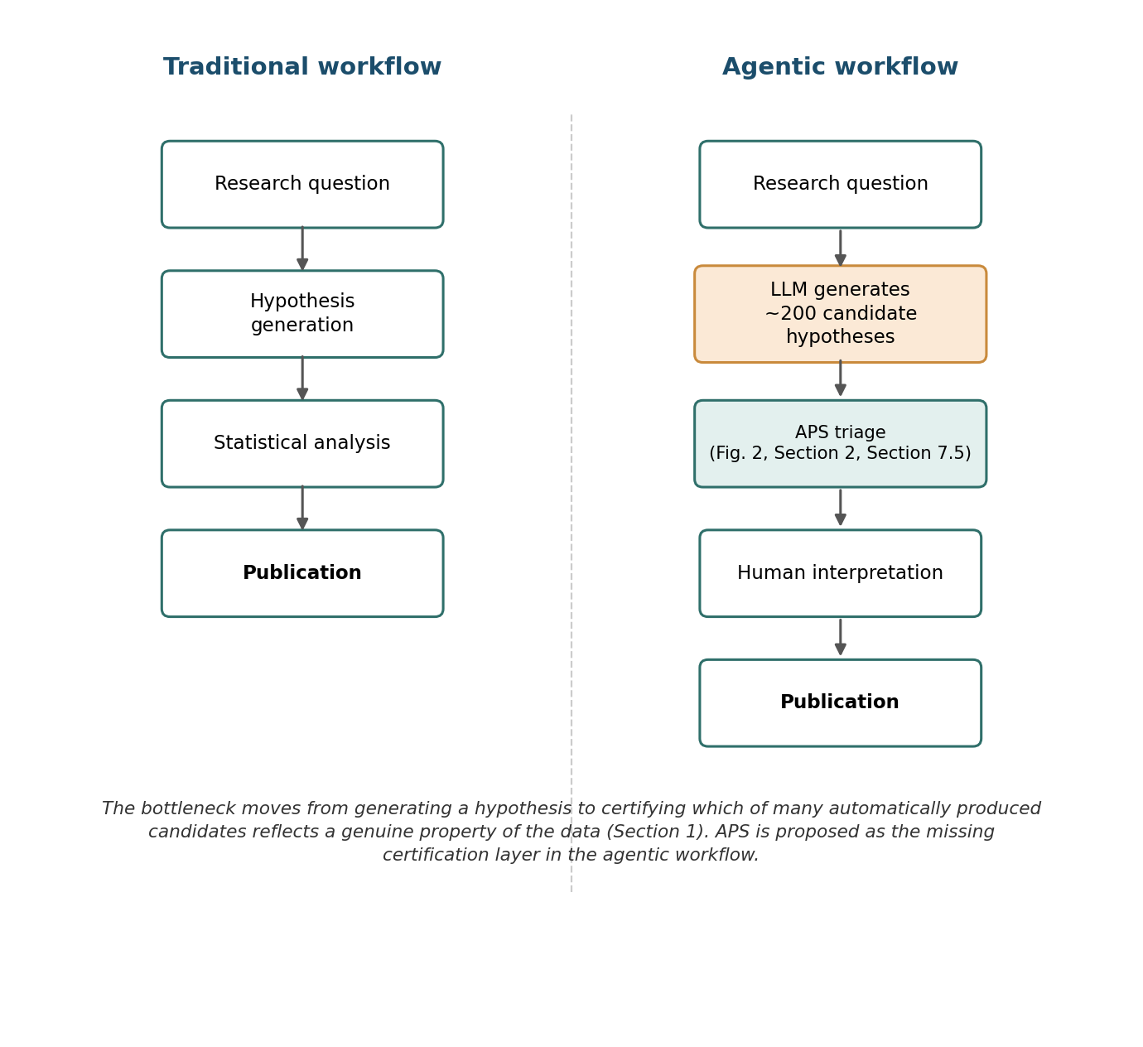
Fig. 1. From hypothesis generation to hypothesis certification. In the traditional workflow, the analytic bottleneck sits between hypothesis generation and statistical analysis. In an agentic workflow, an LLM can generate on the order of hundreds of candidate hypotheses in a single session, moving the bottleneck downstream to the step of deciding which candidates reflect a genuine property of the data — the certification step this paper addresses.

2. The APS Framework: A Domain-General Definition

2.1 From a single encoding to a general certification problem
The Artifact Probability Score was developed to adjudicate a single question: is an observed anticorrelation between two derived quantities in a disputed manuscript a genuine structural property of the text, or an artifact of an arbitrary encoding choice compounded with an arbitrary corpus split? Answering that question required distinguishing five independent sources of false positive — none of which is specific to gematria, to any particular script, or even to text. Table 1 restates the five components without reference to any particular encoding, corpus, or discipline.
Table 1. Domain-general APS component definitions.
# | Component | Generic definition | What it detects | w
1 | Specification robustness | 1 − (n_confirmed / n_alt): n_alt = number of alternative, equally defensible operationalizations tested; n_confirmed = number reproducing the effect in the same direction | Effect depends on one arbitrary encoding/tokenization/metric choice rather than on the data | 0.30
2 | Compositional confound | n_diagnostic / 5, from a five-test Simpson’s-paradox battery | An aggregate correlation is generated or reversed by pooling across natural partitions (hands, registers, strata) | 0.25
3 | Resampling instability | min(1, |effect_obs − effect_resampled| / effect_obs) | Effect size shifts when subgroup sizes are rebalanced or bootstrapped | 0.20
4 | Multiple-comparison fragility | 1 if p (corrected for k comparisons actually run) > 0.05, else 0 | Nominal p-value does not survive correction for tests actually performed | 0.15
5 | Subgroup non-replication | n_nonsig / n_subgroups | Effect fails to reach significance within one or more natural subgroups | 0.10
Note. Weights sum to 1.00. Scale (revised, Section 5): 0–20 Robust; 21–75 Uncertain; 76–100 Near-certain artifact.
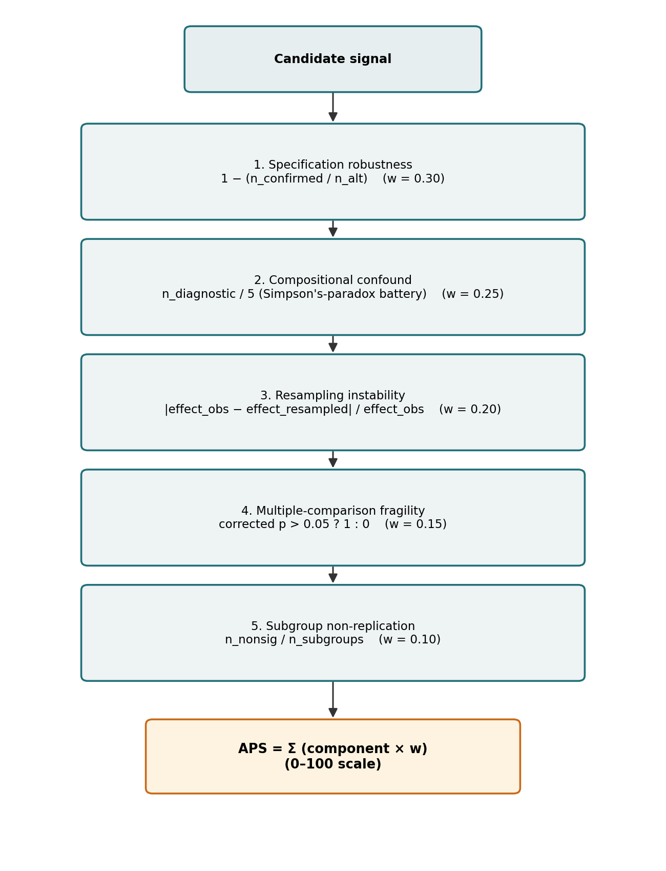
Fig. 2. The five-component architecture of the Artifact Probability Score. Each component targets an independent source of false positive (specification choice, aggregation confound, resampling sensitivity, uncorrected multiplicity, subgroup non-replication); the weighted sum (Table 1) yields the 0–100 score reported throughout.

2.2 What stays domain-specific
Only two things must be re-specified for each new application, both external to the APS pipeline itself: the encoder — the mapping from raw material to the quantity being tested (gematria value, n-gram frequency, pitch interval, nucleotide k-mer); and the corpus’s natural partition — the subgrouping used for components 2 and 5 (scribal hand, dating, candidate author, movement or key). Everything downstream of these two choices — the five-component battery, the weighting, the empirical calibration, and the zone thresholds validated in Section 6 — is unchanged.

2.3 A worked example: the manuscript’s own source signal
To make the abstract component definitions of Table 1 concrete, we walk through the calculation for the signal that originally motivated this instrument. The signal is an anticorrelation between two numerically derived quantities in the Voynich Manuscript, a fifteenth-century illustrated codex written in an unidentified script and language. For this worked example, the raw text is converted to numerical values via the GC9 encoding (a gematria-like mapping that assigns integer values to characters based on stroke-count and positional rules), and the corpus is split into its two established scribal hands, conventionally labelled Currier A and Currier B. The observed anticorrelation is between a coarse-grained structural measure (aggregated at the level of the whole text) and a fine-grained positional measure computed within each group. The five component scores are obtained as follows.
Specification robustness (s₁ = 0.378): of the 37 alternative numerical encodings tested in the robustness battery (Section 4), the anticorrelation reproduced in the same direction under roughly 62% of them; s₁ is correspondingly moderate rather than low, reflecting genuine but partial dependence on the choice of encoder.
Compositional confound (s₂ = 1.000): all five tests in the Simpson’s-paradox battery flagged the aggregate correlation as compositionally generated rather than a within-group property — the maximum possible score.
Resampling instability (s₃ = 0.311): the observed effect size shifted by about 31% of its own magnitude under rebalancing/bootstrapping.
Multiple-comparison fragility (s₄ = 1): the nominal p-value, corrected for the 37 comparisons actually run, no longer clears 0.05 — the binary indicator takes its artifact-consistent maximum.
Subgroup non-replication (s₅ = 0.500): the correlation reached significance in one of the two Currier groups but not the other.
Applying the Table 1 weights:
APS = 100 × (0.30×0.378 + 0.25×1.000 + 0.20×0.311 + 0.15×1.000 + 0.10×0.500) = 100 × 0.6256 = 62.6
— the value reported for the Voynich Manuscript in Table 2, landing in the (revised) Uncertain zone. Note that two of the five components (s₂, s₄) already sit at their maximum, and a third (s₁) is well above zero: the arithmetic makes explicit that the anticorrelation is compositionally fragile, encoder-dependent, and non-significant after correction all at once — precisely the profile the middle of the scale (Section 4) cannot distinguish from ordinary natural-language variance.
Under the revised scale, this value falls in the Uncertain zone. The score therefore indicates that the observed anticorrelation is consistent both with a compositionally induced artifact and with ordinary cross-text variance of the kind documented among several natural-language anchors; it does not, by itself, license any stronger claim about the manuscript.

2.4 What an APS score does and does not measure
None of the five components tests whether an observed pattern is real in the sense of corresponding to an intentional or meaningful property of the source (a scribal convention, a poetic device, an actual cipher). Components 2, 3, and 5 test whether an aggregate statistic is stable under the ways the data could legitimately be partitioned or resampled; components 1 and 4 test whether the result depends on one arbitrary analytic choice among many defensible ones. A low APS therefore certifies structural robustness — survival of the manipulations most likely to manufacture or destroy a false correlation — not semantic or historical significance. The two are often correlated in practice but are not the same claim.
The encoder plays a correspondingly delicate role. Choosing a mapping from raw tokens to comparable values is a substantive interpretive act made before APS runs, not a step APS itself certifies. Component 1 only tests robustness across the alternative encoders a researcher chose to try; a systematically biased set of alternatives would inflate s₁’s apparent robustness without testing whether any candidate encoder is valid — a judgment the researcher must make independently before running the APS pipeline. The worked example above illustrates this concretely: s₁ = 0.378 reports that GC9’s result reproduces under roughly six in ten of the 37 alternatives tried — not that GC9 itself has been validated as the manuscript’s true underlying encoding, a separate philological question this paper does not adjudicate.

3. Empirical Calibration Methodology
The APS thresholds were, until this analysis, theoretically motivated rather than empirically anchored. We address this by running the complete, five-component pipeline — unmodified code and weights — on fourteen external anchors spanning eight languages, four script families, one constructed language, one historical cipher, and two synthetic controls: Shakespeare (English, real thematic split), the decrypted Copiale cipher (German plaintext recovered from a genuine eighteenth-century enciphered manuscript), the Coptic Gospel of Mark (Sahidic vs. Bohairic dialects), Lojban, Pride and Prejudice and Moby Dick (English), an excerpt of the Patrologia Latina (Latin), the Hebrew Torah and the Quran, two independent Byzantine Greek authors (Anna Komnene’s Alexiad and John Zonaras’s Epitome Historiarum), a Markov-generated corpus with a deliberately injected but untuned positional rule, and a fully permuted version of the signal-bearing corpus (pure noise). Non-fixed splits were run on eight independent replicates (five for the generated-hoax control).
Every anchor was tested for the same signal family that motivated this instrument — a pairwise correlation between two derived numerical quantities across a corpus’s natural two-way partition — with each anchor’s own group split standing in for the original study’s partition. This choice is deliberate and consequential for how the calibration should be read (Section 7.2): it establishes that the instrument is not specific to one corpus, but it calibrates one specific signal family, not signal detection in general.
Table 2. Empirical calibration across fourteen external anchors (mean ± SD across replicates where applicable; original three-band scale).
Corpus / control | Group split | n (reps) | APS (mean±SD, range) | Zone (original)
Shakespeare | Thematic (fixed) | 1 | 10.1 | Robust
Copiale cipher, decrypted | Random line-level | 8 | 5.6 ± 1.6 [5.0, 10.0] | Robust
Lojban | Random sentence-level | 8 | 41.4 ± 4.1 [36.2, 50.4] | Uncertain
Coptic Mark | Dialect (fixed) | 1 | 30.0 | Uncertain
Zonaras | Random sentence-level | 8 | 30.1 ± 0.1 | Uncertain
Pride and Prejudice | Random sentence-level | 8 | 30.1 ± 0.2 | Uncertain
Patrologia Latina excerpt | Random sentence-level | 8 | 30.7 ± 1.6 | Uncertain
Anna Komnene, Alexiad | Random sentence-level | 8 | 50.1 ± 0.2 [50.0, 50.6] | Probable artifact
Moby Dick | Random sentence-level | 8 | 55.1 ± 0.1 | Probable artifact
Arabic (Quran) | Random sentence-level | 8 | 56.5 ± 2.1 | Probable artifact
Hebrew (Torah, Gen–Num) | Random sentence-level | 8 | 58.4 ± 2.4 | Probable artifact
Source signal (this study) | Real corpus partition | — | 62.6 | Probable artifact
Hoax (generated + injected rule) | Generated, real rule | 5 | 66.7 ± 2.8 | Probable artifact
Fully permuted (pure noise) | Same labels, shuffled | 8 | 71.9 ± 9.0 [60.1, 89.7] | Probable/near-certain
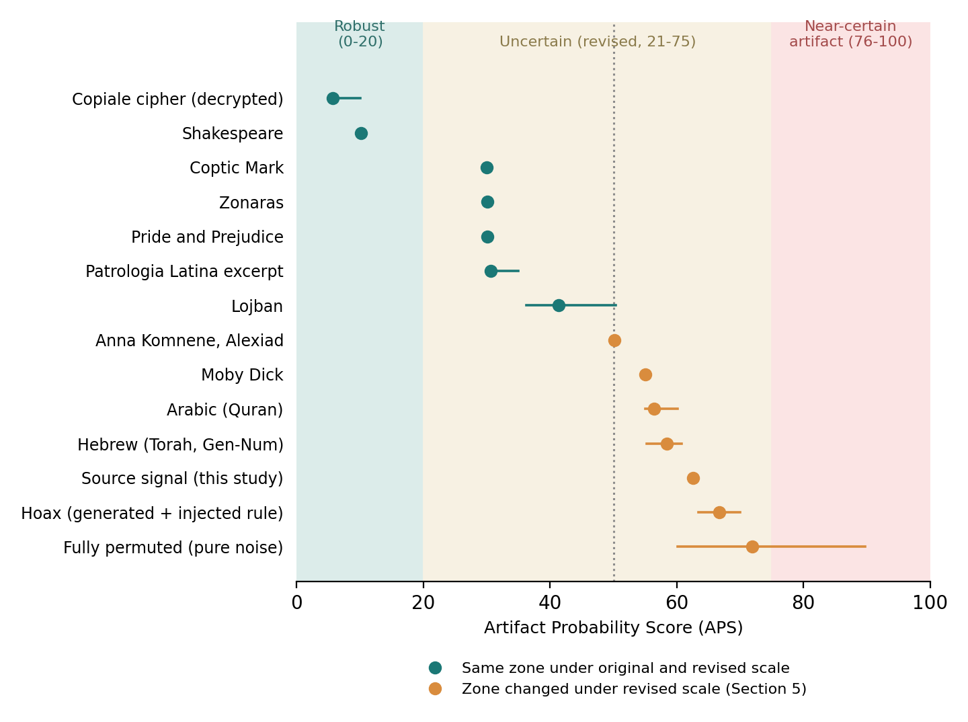
Fig. 3. Empirical calibration across the fourteen external anchors (Table 2), plotted against the revised scale (Section 5: 0–20 Robust, 21–75 Uncertain, 76–100 Near-certain artifact; dotted line marks the original scale’s 50-point boundary). Orange markers indicate anchors whose zone classification changed under the scale revision; error bars show the range or SD across replicates where applicable.

4. Results: A Recurring Pattern and Its Limits
Two implementation findings preceded the substantive result. First, fixed eight-word pseudo-line windows, tried initially for prose corpora lacking natural line breaks, manufactured a spurious near-ceiling “Robust” artifact; rebuilding with real sentence boundaries eliminated it, and Table 2 reports sentence-based results throughout. Second, the encoder’s fallback character-value rule was silently Latin-alphabet-specific, defaulting any non-Latin character to a fixed value — affecting 46% of character occurrences for Greek and 32% for Coptic. Deriving the fallback from each corpus’s own character inventory left results essentially unchanged for both languages — a real defect worth fixing, but not the explanation for the pattern that follows.
A recurring split among arbitrary-split natural-language anchors, with one boundary case. Component-level inspection traced the Alexiad’s initially anomalous APS (50.1 ± 0.2, landing almost exactly on the original scale’s 50-point threshold) to a corpus-wide property: the underlying correlation in that text is weaker than in Pride and Prejudice or the Patrologia excerpt, but not as weak as in Moby Dick, the Torah, or the Quran — a genuinely intermediate case, invariant across the eight random-split replicates (SD = 0.2), rather than an artifact of resampling. A second Byzantine Greek author (Zonaras) landed in the ≈30 cluster, showing the pattern was specific to the Alexiad, not to Greek as a language; extending the anchor set further showed it is not a rare idiosyncrasy either — Moby Dick (English, the same language as Pride and Prejudice, which scores 30.1), the Torah, and the Quran all independently reproduce the weak-aggregate-signal pattern (APS 55–58), while Zonaras, the Patrologia excerpt, Pride and Prejudice, and Coptic reproduce the strong-aggregate-signal pattern (APS ≈30). Among the eight arbitrary-split natural-language anchors, four fall in the strong-aggregate-signal regime and three in the weak-aggregate-signal regime, tracking neither language, script, nor family — Pride and Prejudice and Moby Dick are both English and land on opposite sides — while the eighth, the Alexiad, sits almost exactly at the midpoint between them, close to the original scale’s arbitrary 50-point boundary. Whether an arbitrary, meaningless split of ordinary natural-language text yields APS≈30, APS≈50, or APS≈55–58 is best explained as a property of the individual text’s own aggregate lexical structure, unrelated to whether any real group-level difference exists — and the Alexiad’s intermediate position previews, at the level of a single anchor, the threshold sensitivity that the weight-sensitivity analysis (Section 6) demonstrates formally across all fourteen.
The decrypted Copiale cipher adds a necessary complementary data point. At APS=5.6±1.6, it lands clearly in the Robust zone under the same arbitrary random-split protocol, with near-total replication across alternative specifications and an overwhelming aggregate correlation. This answers a natural objection — that an arbitrary split might mechanically wash out any real signal regardless of text quality, making the whole calibration uninformative. Copiale demonstrates otherwise: a real text with strong internal structure registers unambiguously as Robust even under a meaningless split; the 55–58 outcomes are a genuine, text-dependent phenomenon, not a ceiling artifact of the method itself.
The middle of the APS scale has limited discriminative power. This is the central finding of the calibration, and we report it without softening it. Under the original scale, the source signal’s APS (62.6) and the four “Probable artifact” natural-language anchors — Alexiad, sitting at the scale’s own 50-point midpoint, together with Moby Dick, the Quran, and the Torah spanning 55–58 — are not reliably distinguishable from it: roughly half of ordinary, non-artifactual natural-language texts land in the same range under an arbitrary null split. The original 21–50/51–80 boundary implies a discriminative precision this calibration does not support. What the fourteen-anchor set supports clearly is the two extremes: 0–20 reliably indicates strong, genuine structure (Shakespeare, Copiale), and no natural-language anchor reaches the 76–100 range reached only by pure permutation noise — though not reliably even then, since the noise control’s own 60.1–89.7 spread means the near-certain zone itself should be read with caution.

5. Scale Revision and Its Implications
We revise the scale to 0–20 Robust; 21–75 Uncertain (merged); 76–100 Near-certain artifact, merging the original “Uncertain” and “Probable artifact” bands into a single wide zone whose label we take seriously: within it, the APS alone cannot discriminate a genuine compositional confound from ordinary cross-text variance in aggregate lexical structure. Any signal previously classified “Probable artifact” solely on an APS in the 51–75 range should be re-read as inconclusive by this metric alone — consistent with either a compositionally induced artifact or ordinary text-level variance of the kind documented in Moby Dick or the Quran — pending the convergent, multi-source evidence (effect size, cross-specification replication, absence of sign reversal) that Section 6’s sensitivity analysis shows the revised scale itself cannot substitute for. This section revises the APS’s evidentiary weight downward within the merged band; it does not, by itself, resolve any individual certification case that falls there. The same caution applies at the top of the scale: given the pure-noise control’s own 60.1–89.7 spread (Table 2), the 76–100 zone should be read not as “certainly noise” but as “consistent with noise and inconsistent with any natural-language structure observed in our calibration” — a weaker, but more defensible, claim.

6. Weight Sensitivity Analysis

6.1 Motivation
The five APS components (Table 1) are weighted by theoretically motivated but not empirically derived coefficients (w = 0.30, 0.25, 0.20, 0.15, 0.10). A methodological instrument whose classifications depend heavily on an arbitrary choice of weights would offer limited value as a certification tool. This section tests how far the fourteen-anchor calibration reported in Sections 3–5 depends on this specific weighting, and, in doing so, provides an independent empirical check on the scale revision proposed in Section 5.

6.2 Method
For each of the fourteen anchors, component-level scores (s₁…s₅) were averaged across their empirical replicates (n = 5–8 independent A/B resplits per anchor; n = 1 for Shakespeare and Coptic, which use a fixed structural split). Two complementary sensitivity tests were then applied: a one-at-a-time (OAT) perturbation, in which each weight w_i was varied by ±30% in 13 steps with the remaining four weights renormalized proportionally; and a global perturbation, in which 5,000 weight vectors were drawn by multiplying each baseline weight by a factor uniform on [0.6, 1.4] and renormalizing to the simplex. For each draw, the resulting APS, zone classification (under both scales), and Spearman rank correlation with the baseline ranking of the fourteen anchors were recorded. This design isolates weight uncertainty from data uncertainty: replicate-level variability in s₁…s₅ is absorbed by averaging before the sensitivity analysis, so the reported instability reflects the choice of weights alone.

6.3 Results
Table 3. Zone stability under weight perturbation (N = 5,000 draws, ±40% per component).
Anchor | APS | Zone (orig.) | Zone (rev.) | Stab. orig. | Stab. rev.
Shakespeare | 10.1 | Robust | Robust | 100.0% | 100.0%
Copiale (decrypted) | 5.6 | Robust | Robust | 100.0% | 100.0%
Lojban | 41.4 | Uncertain | Uncertain | 99.9% | 100.0%
Coptic | 30.0 | Uncertain | Uncertain | 100.0% | 100.0%
Zonaras | 30.1 | Uncertain | Uncertain | 97.4% | 97.4%
Pride and Prejudice | 30.1 | Uncertain | Uncertain | 97.4% | 97.4%
Patrologia Latina | 30.7 | Uncertain | Uncertain | 98.6% | 98.6%
Anna Komnene, Alexiad | 50.1 | Probable artifact | Uncertain | 51.5% | 100.0%
Moby Dick | 55.1 | Probable artifact | Uncertain | 81.9% | 100.0%
Arabic (Quran) | 56.5 | Probable artifact | Uncertain | 88.4% | 100.0%
Hebrew (Torah) | 58.4 | Probable artifact | Uncertain | 96.6% | 100.0%
Hoax | 66.7 | Probable artifact | Uncertain | 100.0% | 97.6%
Fully permuted (noise) | 72.0 | Probable artifact | Uncertain | 99.1% | 77.9%
Source signal | 62.6 | Probable artifact | Uncertain | 100.0% | 100.0%
Across all 5,000 draws, the rank ordering of the fourteen anchors remains highly stable regardless of scale (mean Spearman ρ = 0.979 against the baseline ranking; worst-case draw ρ = 0.925; 5th percentile ρ = 0.956). Instability concentrates almost entirely in zone membership near a threshold, not in relative ordering.
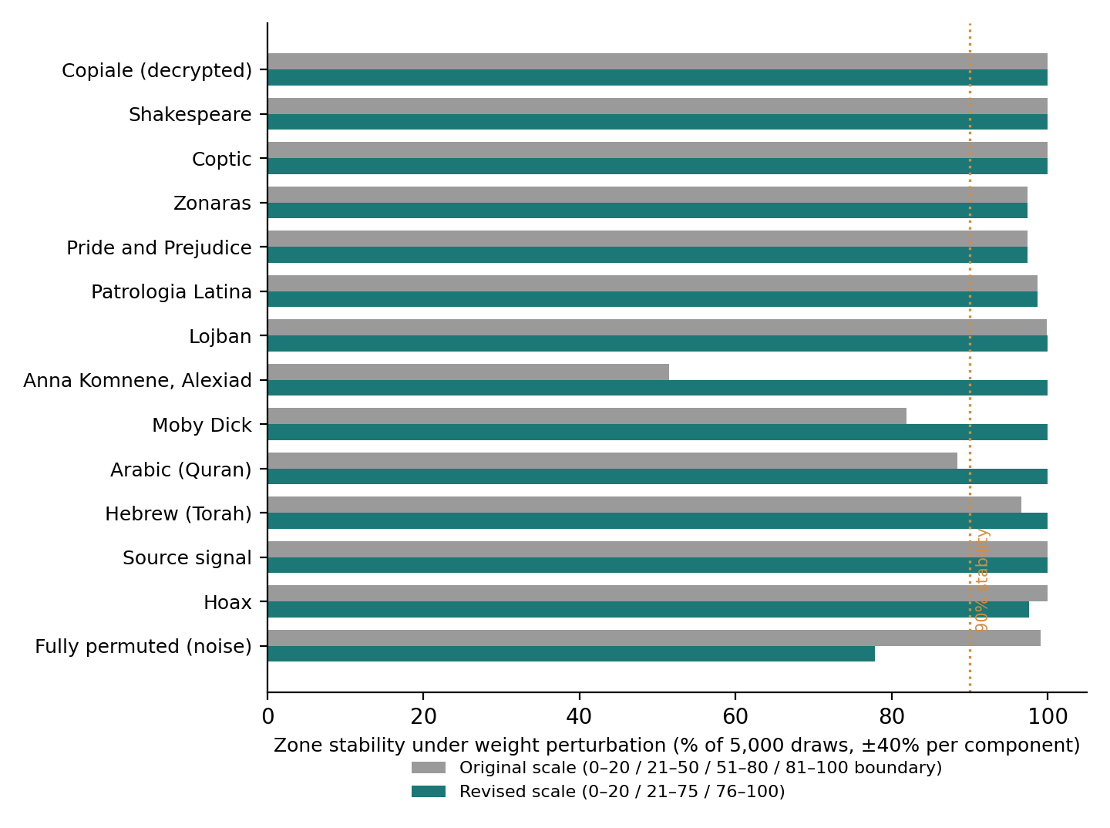
Fig. 4. Zone stability under weight perturbation (N = 5,000 draws, ±40% per component; Table 3), by anchor, under the original and revised scales. The revision stabilizes exactly the four anchors most exposed under the original 50-point boundary (Anna Komnene, Moby Dick, Arabic, Hebrew), at a small cost to the pure-noise control’s stability.

6.4 Interpretation
The sensitivity analysis converges with, and independently reinforces, the scale revision motivated on distributional grounds in Section 5. Under the original three-band scale, Anna Komnene — whose baseline APS (50.1) sits almost exactly on the 50-point boundary — changes zone under essentially half of all plausible weight vectors (51.5% stability), and Moby Dick and Arabic are only moderately more stable (81.9% and 88.4%). A classification this sensitive to an unvalidated weighting scheme cannot be treated as a stable certification outcome. Under the revised, merged scale, the same anchors become effectively insensitive to weight choice: all four previously fragile cases reach 100% stability. The one anchor that becomes comparatively less stable under the revised scale — the fully permuted control, at 77.9% — is the pure-noise baseline, whose own APS (72.0) sits close to the new 75-point boundary; some perturbation is expected and arguably desirable for a null control positioned deliberately near the top of the scale. In short: the original scale’s principal weakness was not the component weights themselves, but a threshold (50) that happened to bisect a cluster of anchors whose classification was therefore an artifact of weight choice rather than of the underlying signal. The revised scale removes this fragility without weakening discrimination at the extremes.

7. Discussion: Toward a Transferable Certification Standard

7.1 What transfers without modification
The five-component battery, its weighting, and the two calibrated scales transfer as-is to any domain in which a candidate signal can be reduced to (a) a scalar or categorical measurement per observational unit, and (b) a partition of the corpus into at least two natural, theory-independent subgroups. Nothing in the battery’s logic depends on the material being text, still less on it being gematria-encoded text.

7.2 What must be re-validated, not merely re-labeled
Generalizing the vocabulary (Section 2) is not the same operation as generalizing the calibration. The fourteen-anchor scale was calibrated on a specific family of signals: pairwise correlations between two derived numerical quantities within a two-way corpus split. A stylometric attribution signal, a phylogenetic distance between manuscript witnesses, or a melodic-motif recurrence rate is a different statistical object, and there is no a priori guarantee that the same weights, let alone the same 20/75 thresholds, discriminate genuine signal from artifact equally well outside the family of signals on which they were calibrated. Extending APS to a new domain therefore requires, at minimum, a domain-specific analogue of Section 6: a sensitivity check against a small set of known-null and known-structured anchors from that domain, before the revised scale is trusted there.

7.3 Preconditions for applicability
Three conditions determine whether a candidate signal is even a candidate for APS certification, independent of domain. A plurality of defensible specifications must exist for component 1: a signal defined under a single, uncontested encoding, with no alternative tokenization, alphabet, or distance metric that a reasonable specialist would accept as equally legitimate, cannot be tested for specification robustness. A natural, theory-independent partition of the corpus must exist for components 2 and 5: a partition invented post hoc to make component 2 computable would reintroduce exactly the forking-paths problem the framework is designed to detect. And the subgroups must be large enough to support the resampling and per-subgroup significance tests underlying components 3 and 5 — the fourteen-anchor calibration used corpora ranging from several hundred to several thousand analytic units per subgroup; APS’s behavior on much smaller corpora is untested and likely to degrade.
A plurality of defensible specifications is a necessary but not sufficient condition for component 1. To keep the component informative rather than circular, three practical constraints are recommended. First, the alternative set should normally contain at least eight to ten operationalizations; with fewer alternatives, the ratio (n_confirmed / n_alt) becomes coarse and may provide limited information about the specification space. This is a practical recommendation rather than a formally validated minimum. Second, the alternatives should exhibit meaningful diversity: trivial parametric variations of a single encoding scheme (for example, minor changes in one parameter of an otherwise identical gematria mapping) should not be treated as substantively independent tests. Where the domain permits, the set should include at least two qualitatively distinct families of operationalization, such as different tokenization regimes, aggregation levels, or distance metrics. Third, when alternatives are generated with the assistance of a language model, the full unfiltered list proposed by the model should be documented and retained; post-hoc selection of only those alternatives that reproduce or fail to reproduce the effect would reintroduce precisely the researcher degrees of freedom that component 1 is designed to detect. These constraints do not alter the formal definition of s₁; they are safeguards intended to make its empirical content less dependent on arbitrary or self-serving construction of the alternative set.

7.4 What this discussion does not claim
No cross-domain application of APS has been run for this paper. Section 2’s domain-general restatement of the component definitions is a necessary but not sufficient step toward transferability. An illustrative cross-domain instantiation table drafted during preparation of this article was removed precisely because populating it with plausible-sounding examples, absent an actual computation, would have been the same error the framework exists to catch — asserting transferability rather than demonstrating it. What Section 7 offers is therefore a preconditions checklist and a research agenda: the fourteen-anchor calibration is evidence that APS is not specific to the manuscript that motivated it, not evidence that it is a validated general instrument. That step requires, for each candidate domain, its own Section 6.

7.5 Operationalizing APS as a Triage Layer for LLM-Generated Hypotheses
The preconditions and caveats of Sections 7.2–7.4 govern whether APS’s calibrated classification transfers to a new domain. They do not prevent a narrower, more immediate use: APS’s five-component logic can structure how a researcher triages hypotheses produced by an LLM or an agentic research pipeline, independent of whether the calibrated thresholds themselves have been validated in that domain.
The link is most direct for component 1 (specification robustness), defined as 1 − (n_confirmed / n_alt): the researcher must supply n_alt alternative, equally defensible operationalizations of the candidate signal. Generating this set by hand is the most labor-intensive step of the battery, and — outside well-worn analytic traditions — often the step a time-pressured researcher skips. An LLM asked to enumerate alternative tokenizations, encodings, distance metrics, or aggregation choices for a stated candidate signal can produce a first pass at this set in the time it takes to write the prompt. This does not certify anything by itself — every alternative still has to be actually computed and checked, not merely proposed — but it removes the main practical cost that currently discourages researchers from running this test at all.
This suggests a two-stage triage protocol, applicable whether or not the underlying domain has undergone the domain-specific recalibration Section 7.2 requires:
Stage 1 — cheap, domain-agnostic screening. Before any calibrated score is computed, verify the two structural preconditions of Section 7.3: does a plurality of defensible specifications exist, and does a natural, theory-independent partition of the corpus exist? A candidate signal failing either precondition — agentic or human-generated — is not a candidate for APS certification at all, and should be flagged as such rather than reported.
Stage 2 — component-level triage without a calibrated verdict. For a candidate passing Stage 1, compute components 1–5 using the domain-general definitions of Table 1, treating LLM-generated alternative specifications and partition proposals as a starting set to be verified, not accepted uncritically. Where no domain-specific calibration exists (Section 7.2), report the five raw component scores rather than translating the profile into a zone label calibrated on a different signal family. A disciplined statement that “this candidate showed correlation reversal under two of five alternative specifications” is actionable information even absent a validated scale; asserting “APS = 34, Uncertain” on an uncalibrated domain is not.
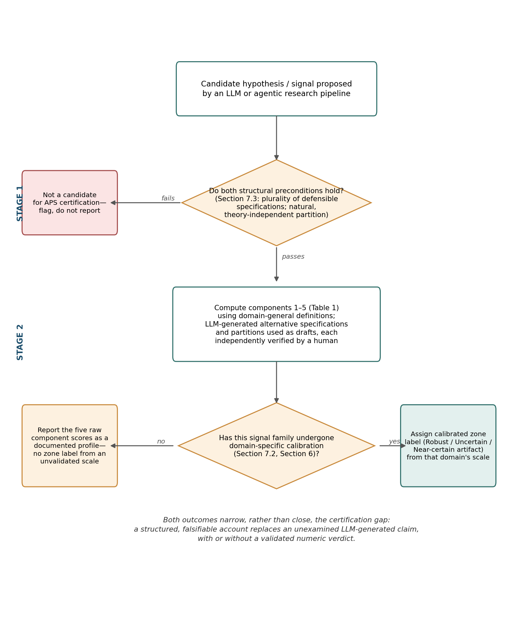
Fig. 5. Two-stage triage protocol for hypotheses proposed by an LLM or agentic pipeline (Section 7.5). Stage 1 screens for the structural preconditions of Section 7.3; Stage 2 computes the five APS components and reports either a calibrated zone label or a raw, documented profile, depending on whether the domain has undergone the recalibration Section 7.2 requires.
The protocol therefore narrows, rather than closes, the certification gap introduced in Section 1. It allows APS to function immediately as a structured falsification checklist while reserving calibrated zone classifications for domains in which empirical calibration has been demonstrated. LLM-assisted generation of alternative specifications reduces the practical cost of this workflow but does not alter its evidentiary requirements: every proposed specification must still be independently computed and verified.

8. Conclusion
This paper set out to test whether an instrument built to certify one specific signal — a numerically encoded anticorrelation in a single disputed manuscript — could be stated, calibrated, and defended in terms that owe nothing to that manuscript. The domain-general restatement of the five components (Section 2) shows the instrument’s logic does not depend on gematria, on any particular script, or on text at all. The fourteen-anchor calibration (Sections 3–5) shows that logic performing consistently across eight languages and four script families, honestly reporting where it fails to discriminate rather than concealing that failure behind an unvalidated threshold. The weight-sensitivity analysis (Section 6) shows the resulting classification is not an artifact of the instrument’s own arbitrary design choices. None of this demonstrates that the Artifact Probability Score transfers to stylometry, musicology, or genomics — Section 7 is explicit that no such demonstration has been attempted here, and specifies the preconditions a future application would need to satisfy. The urgency of this task is likely to grow rather than diminish: as agentic pipelines make it cheaper to generate candidate signals than to certify them, extending an instrument of this kind to hypotheses proposed by language models is a natural next step — contingent, like any new signal family, on the domain-specific recalibration Section 7 specifies as a precondition, and not delivered by the vocabulary generalization of Section 2 alone. What this paper does establish is narrower and, we think, more useful: a five-component, empirically calibrated procedure that any researcher reporting a computationally detected signal in cultural heritage data can apply to their own finding, obtaining not a verdict but a documented, reproducible account of how much of that finding’s apparent strength survives the specific tests that a growing body of methodological literature — from the Bible-code affair to the current debate over computational literary studies — shows recurrently separate genuine signal from its most common alternative.

References
Da, N. Z. (2019). The Computational Case against Computational Literary Studies. Critical Inquiry, 45(3), 601–639.
Gelman, A., & Loken, E. (2013/2014). The garden of forking paths: Why multiple comparisons can be a problem, even when there is no “fishing expedition” or “p-hacking” and the research hypothesis was posited ahead of time. American Scientist, 102(6), 460–466.
Ioannidis, J. P. A. (2005). Why most published research findings are false. PLoS Medicine, 2(8), e124.
McKay, B., Bar-Natan, D., Bar-Hillel, M., & Kalai, G. (1999). Solving the Bible Code Puzzle. Statistical Science, 14(2), 150–173.
Shahhosseini, F., Marioriyad, A., Momen, A., Baghshah, M. S., Rohban, M. H., & Javanmard, S. H. (2025). Large language models for scientific idea generation: A creativity-centered survey. arXiv:2511.07448.
Si, C., Yang, D., & Hashimoto, T. (2024). Can LLMs generate novel research ideas? A large-scale human study with 100+ NLP researchers. arXiv:2409.04109.
Si, C., Hashimoto, T., & Yang, D. (2025). The ideation-execution gap: Execution outcomes of LLM-generated versus human research ideas. arXiv:2506.20803.
Witztum, D., Rips, E., & Rosenberg, Y. (1994). Equidistant letter sequences in the Book of Genesis. Statistical Science, 9(3), 429–438.

Data availability
The calibration pipeline, the per-anchor calibration results (Table 2), the weight-sensitivity analysis code and results (Section 6, Table 3), and their reproducibility metadata (execution environment, random seed, SHA-256 checksums of all input files) are archived at the Open Science Framework: https://doi.org/10.17605/OSF.IO/H38UG (CC-BY 4.0). This repository is distinct from, but related to, the OSF repository for the Voynich manuscript study that originally motivated this instrument (https://doi.org/10.17605/OSF.IO/Y6ZCD), reflecting the APS’s status here as a domain-general instrument rather than a Voynich-specific tool (Section 2).
The same code is additionally maintained under version control at https://github.com/benseddikahmed-sudo/A-Domain-General-Framework-for-Statistical-Signal-Certification-in-Digital-Humanities (MIT license for code, CC-BY 4.0 for data; commit bdc27bf9f5781055f5e25047c0a4ec42e38614e0 corresponds to the results reported in this manuscript).

AI Disclosure Statement
An AI language model (Claude, Anthropic) was used during the preparation of this manuscript to assist with proofreading, cross-checking reported numerical values against the underlying computed data and calibration outputs — including identification of a discrepancy in the reported Anna Komnene calibration value subsequently corrected in Table 2 — restructuring the manuscript to the journal’s formatting requirements, and editorial revision of specific passages under the author’s direction. The model was not used to generate the underlying statistical analysis, the calibration pipeline, or the paper’s substantive claims. All AI-assisted content, including textual revisions, paraphrasing, and reported numerical values, was independently verified by the author against the primary data and code before inclusion. The author retains full responsibility for the intellectual content, interpretation, and conclusions of this work.

Funding
This work was not supported by any specific grant from funding agencies in the public, commercial, or not-for-profit sectors.

