PHD Wireless Internet
Request for Proposals

Table of Contents

1. Schedule
2. General Information
2.0 Purpose and Overview
  - Little Tokyo Service Center Background
  - Contract Term
3. Technical Requirements
  - Specifications
    - Design and Planning
    - Documentation
    - Compatibility
    - Broadband
    - Network Security and Monitoring
    - Safety Concerns
    - Electrical Compliance
    - Maintenance Plan
    - Expandability
  - Project Scope and Expectations
    - Develop Deployment Plan
    - Purchase Equipment
    - Internet Service Provider
    - Deployment
3.1.4a Documentation
3.1.4b Network Security and Maintenance
3.1.4c Post-Deployment Followup
    - Ongoing Maintenance
  - Project Management and Monitoring Deliverables
4. Vendor Requirements
  - Qualifications, Experience, and Organization
  - References
  - Resumes
5. Proposal Response Format
6. Cost Proposal
7. More Information for Potential Bidders
  - Contact LTSC
  - On-Site Walkthrough
8. Selection Criteria
  - Evaluation of Proposal
  - Interviews of Finalists
  - Best and Final Offers
9. Attachments
  - Buildings and Units
  - Building Site Plans
1.
Schedule

Event Date
RFP Released October 22, 2009
Proposals Due November 12, 2009
Evaluation Period November 12-15, 2009
Finalist Interviews November 16-17, 2009
Bidder Selected November 18, 2009
2.
General Information

2.0 Purpose and Overview

Little Tokyo Service Center (LTSC) requests competitive proposals for the construction and ongoing maintenance of five independent residential wireless networks for the five existing buildings that make up the Professional Housing and Development Apartments (PHD Apartments) located at 1020 S. Kingsley, 1400 S Kenmore, 1401 S. Arlington, 1745 W 20th, and 1910 S. Magnolia in Los Angeles. Together, these buildings consist of 83 residential units, all of which must be provided with free wireless broadband internet access. The construction of these networks would coincide with the rehabilitation construction of these five apartments.

Responsive bids must be received by October 22, 2009.

2. 1 Little Tokyo Service Center Background

LTSC is a community development and social services corporation that currently maintains free wireless internet services at many of its affordable housing projects. In conjunction with providing wireless internet, LTSC also provides residents with computer learning opportunities through its DISKovery technology centers.

2.2 Contract Term

This contract would begin as early as March 2010. The duration of the contract will depend on a few factors, including the contractor's proposed schedule for deployment. Contract term includes construction and a maintenance agreement.

3.
Technical Requirements

3. 0 Specifications

The contractor will provide a proposal that details a plan for meeting the following technical requirements. Provide an overview of the wireless network architecture and elements and how they will fulfill the specifications required in this RFP.

3. 0.1 Design and Planning
Wireless coverage must provide adequate (at least 1Mbps down and 500 Kbps up) signal and bandwidth to every apartment in the 83-unit PHD Apartments project and to the common areas in each building. Preferably, contractor should explore the use of wireless mesh to provide this wireless coverage. Describe the planning and design tools and approaches to be used. Will site surveys be required? How many Access Points (APs) will be necessary? How will the contractor ensure adequate coverage of each floor and unit? How will the contractor ensure seamless roaming between APs?

How long will it take for the contractor to build out the network? How will the contractor coordinate and work around the General Contractor (GC)?

3.0.2 Documentation
LTSC recognizes that documentation is a key part of network planning as well as maintenance. How will the contractor document this deployment process, from design through deployment? How will network passwords, logins, the locations of hardware, etc., be stored and shared? Will there be a post-mortem, and if so, what will it include?

3.0.3 Compatibility
To ensure compatibility with tenant computers, the wireless networks must minimally be compliant with IEEE 802.11b/g protocols. Will the network support WEP? WPA/2? MAC Address filtering?

3.0.4 Broadband Speed
LTSC seeks to provide broadband internet to its 83-unit PHD Apartments through the creation of wireless networks. These wireless networks must have the option of being either open access or encrypted. The wireless network must minimally support broadband connections of 1Mbps down/500 Kbps up to residential users. Describe how the contractor will provide adequate backhaul for these networks, keeping in mind that these are residential units (see appendix).

3.0.5 Network Security and Monitoring
Networks should be able to be monitored remotely so that adequate service and maintenance can be provided. To ensure the security of the network for residents, LTSC requires that the networks have the ability to be access restricted (for example, with encryption or MAC Address filtering). Networks should also be able to be deployed as open (unrestricted) wireless networks. How will the contractor fulfill these security needs? Will the system provide the ability to block certain network users? Does the hardware come with a management system/software? Is there a web-based API? How will LTSC be able to monitor how many unique users are on its network over time? Describe any limitations of the chosen network security and monitoring systems.

3.0.6 Safety Concerns
LTSC is aware that some hardware might need to be in a public place. All equipment deployed, especially equipment placed in public areas such hallways or common areas, must be secured against theft and vandalism. Describe how the network will be secured against theft and vandalism and for working with LTSC and building managers to develop a security strategy.

3.0.7 Electrical Compliance
How will the contractor ensure that the network is up to electrical codes (for example, safely securing cables, installation of surge protectors, etc)?

3.0.8 Maintenance Plan
Proposals should include a plan for long-term maintenance that includes which responsibilities will belong to the contractor. This plan should also include how the contractor will coordinate ongoing maintenance with LTSC. During the maintenance period, how will the contractor ensure minimal service outages? The contractor may include a step-by-step of how and how quickly the contractor would respond to a maintenance call.

3.0.9 Expandability
How will the contractor ensure that this network, if required, will be easily expandable and modifiable?

3.1 Project Scope and Expectations

When developing the proposal, the contractor should take into consideration the scope of this project. Proposals must be feasible within the project scope and the contract duration. The following are guidelines to give the contractor a better idea about the scope of this project.

3.1.1 Develop Deployment Plan
Upon selection, the contractor will further develop their wireless network proposal in coordination with LTSC. This process will involve site visitations, conferences with LTSC staff, presentation of development plan to staff, and subsequent iteration of the plan. The plan will include a detailed time line of the deployment and meet the specifications detailed above.

3.1.2 Purchase Equipment
Contractor will be responsible for the cost of purchasing equipment needed to deploy the network as outlined in the deployment plan. Contractor will provide LTSC with an itemized list of purchased equipment and where it was used. Contractor will provide identification/labeling of each piece of network equipment.

3.1.3 Internet Service Provider
Contractor will coordinate with LTSC to select an internet service provider that will provide the bandwidth necessary to support the wireless network.

3.1.4 Deployment
Contractor will deploy the network hardware according to the deployment plan.

3.1.4a Documentation
Before, during, and after deployment, contractor will maintain thorough documentation of relevant network information.

3.1.4b Network Security and Monitoring
Contractor will enable at least one type of network security and brief LTSC on the operation and maintenance of this security and educate LTSC about the use of any network monitoring tools.

3.1.4c Post-Deployment Followup
After the deployment of the network, contractor must confirm the functionality of the network and attend a post-deployment followup conference to address any lingering deployment issues and how to address these issues.

3.1.5 Ongoing Maintenance
Contractor will provide timely, ongoing maintenance for the networks for one year after deployment., after which there will be an option to renew the maintenance contract.

3.2 Project Management and Monitoring Deliverables

During the deployment process, contractor must provide LTSC with timely progress and status updates. LTSC will schedule meetings to discuss timetables and deliverables with the contractor. The contractor is responsible for meeting the goals described in their proposal and in the deployment plan. If deployment problems arise that change the deployment plan, contractor is responsible for notifying LTSC of those problems. Contractor must obtain LTSC approval for major changes to the deployment plan.

Describe how the contractor will maintain contact with LTSC and provide updates. Who will be the primary contact from the contractor organization?

4.
Vendor Requirements

4.0 Qualifications, Experience, and Organization
Describe the structure of your organization and how it qualifies for this request. In addition, describe the experience of both the organization and staff in deploying and maintaining wireless networks.

4.1 References
The contractor will provide a minimum of three trade references. For each reference, include the name, position, phone number, the address of the person to be contacted, and a brief summary of work done. These references should be instances where the contractor provided similar services to those requested in this RFP.

4.2 Resumes
For each staff member who will be involved in the implementation of the project outlined in the proposal, the contractor will provide a resume that indicates education, experience, license and certifications of each individual.

5.
Proposal Response Format

While proposals do not need to follow a particular format, all proposals must address all technical specifications. Contractors may choose to follow a format similar to this:

Deployment Proposal
Technical Specifications
Schedule
Cost Proposal
Cost of Network Deployment
Inclusion of estimated ISP cost is preferred
Cost of Maintenance
Include terms of maintenance, response times, etc
Include cost for 1 year and 3 years of maintenance
Summary of Qualifications and References
Include licensing, relevant experience, references and their contact information

6.
Cost Proposal

The contractor shall submit a cost proposal that details the costs of their technical proposal. This proposal must include a detailed list of hardware, software, and work hours required and their estimated costs.

7.
More Information for Potential Bidders

7.0 Contact LTSC
For specific questions related to this RFP, contact

Melissa Niiya
Americorps*VISTA Wireless Outreach Coordinator
231 E 3rd St Suite G106
Los Angeles, CA 90013
213-473-1642
mniiya@ltsc.org

7.1 On-Site Walkthrough

In addition to the information in this RFP, LTSC is offering an optional on-site walkthrough. Contractors will be able to inspect the sites and ask questions. The visit will include a tour as well as a conference afterward for additional questions. Contractor shall fully inform itself prior to submitting the Bid as to existing conditions and limitations under which the work is to be performed and include in the bid the cost of all items necessary to complete the deployment and maintenance work as set forth in the Bid documents. No allowance will be made because of lack of such examination or knowledge. Submission of the Bid will be considered conclusive evidence that such examination has been made.

Date of on-site visit: October 28, 2009. 10AM.
Start location: 1401 S. Arlington Ave, Los Angeles, CA 90019

Please call Melissa Niiya at 213-473-1642 or e-mail at mniiya@ltsc.org to confirm your attendance of the walkthrough.

8.
Selection Criteria

8.0 Evaluation of Proposals
A team composed of LTSC employees will evaluate the proposals. Proposals will be evaluated on their understanding and fulfillment of the technical requirements as well as the feasibility of meeting these requirements in a timely manner. Selection will also be based on the relevant experience and references of the contractor. Cost proposals will also be taken into account.

8.1 Interviews of Finalists
Following the review period, LTSC will select two contractors to participate in "finalist" interviews. At the interview, each contractor will have the opportunity to clarify their bid proposal and answer committee questions. The LTSC reviewing committee will judge each of the finalists on their bid and cost proposal and interview. LTSC will then award the contract to one of the two finalists.

8.2 Best and Final Offers
LTSC may either accept an contractor's initial proposal by award of a contract or enter into discussions with contractors whose proposals pass the evaluation process. After discussions, an contractor may be allowed to submit a "Best and Final Offer" for consideration.

9.
Attachments

9.0 Buildings and Units

Building | # Units
1020 S. Kingsley Dr, Los Angeles, CA 90006 | 24
1400 S. Kenmore Ave, Los Angeles, CA 90006 | 16
1401 S. Arlington Ave, Los Angeles, CA 90019 | 12
1745 W. 20th St, Los Angeles, CA 90007 | 21
1810 S. Magnolia Ave, Los Angeles, CA 90006 | 10

  - Building Site Plans

9.1.0 1020 S Kingsley Dr

FIRST FLOOR
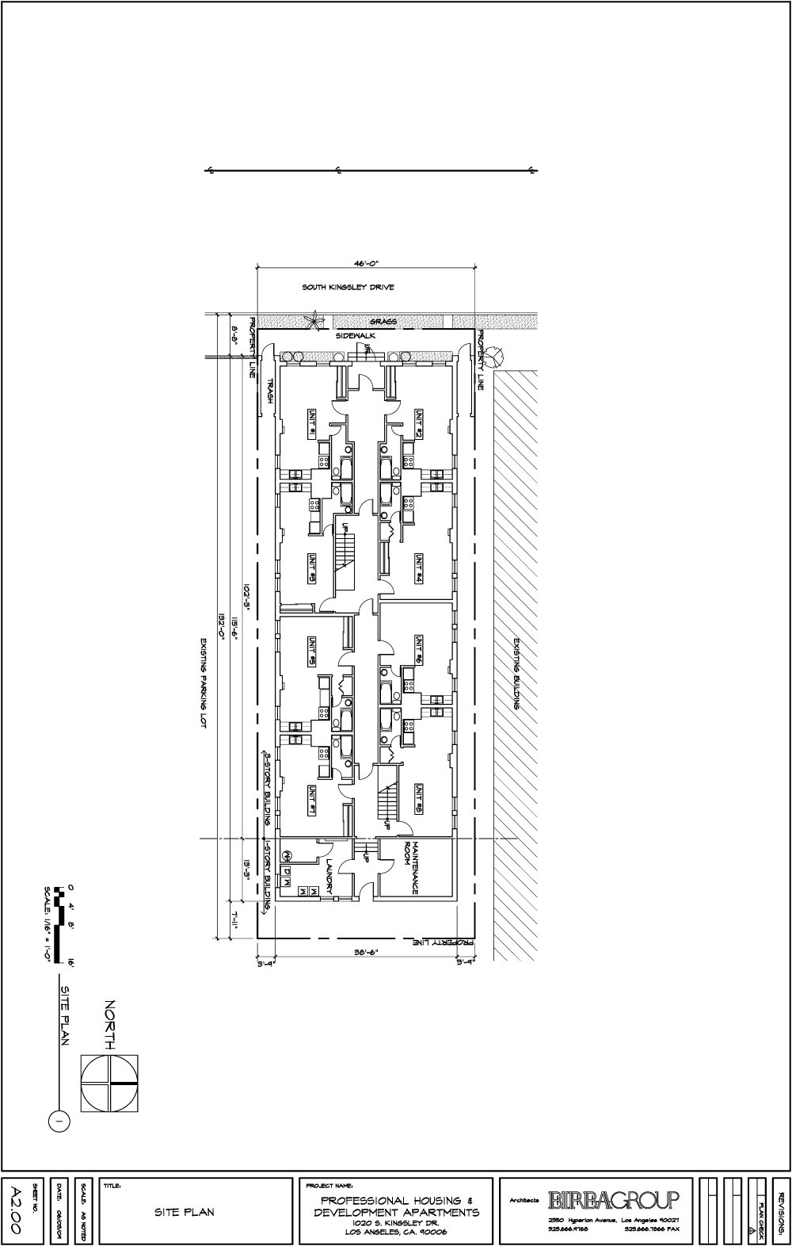

9.1.1. 1020 S Kingsley Dr
SECOND FLOOR
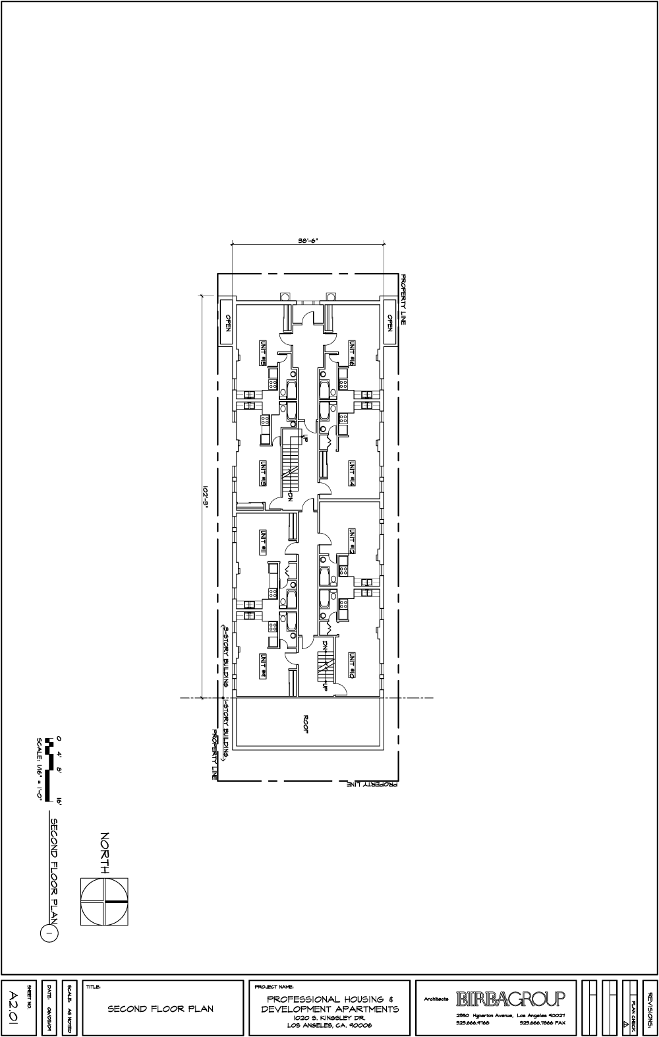

9.1.3 1020 S Kingsley Dr
THIRD FLOOR
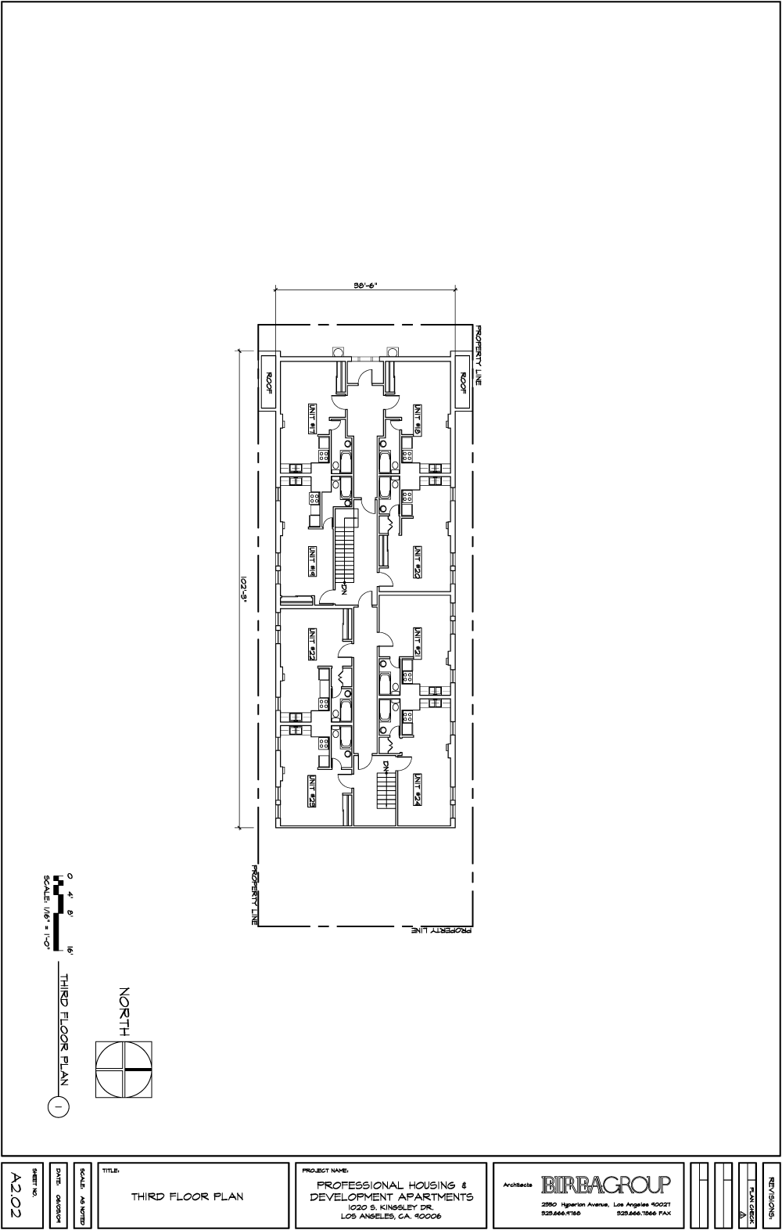

9.1.4 1400 S. Kenmore Ave
FIRST FLOOR
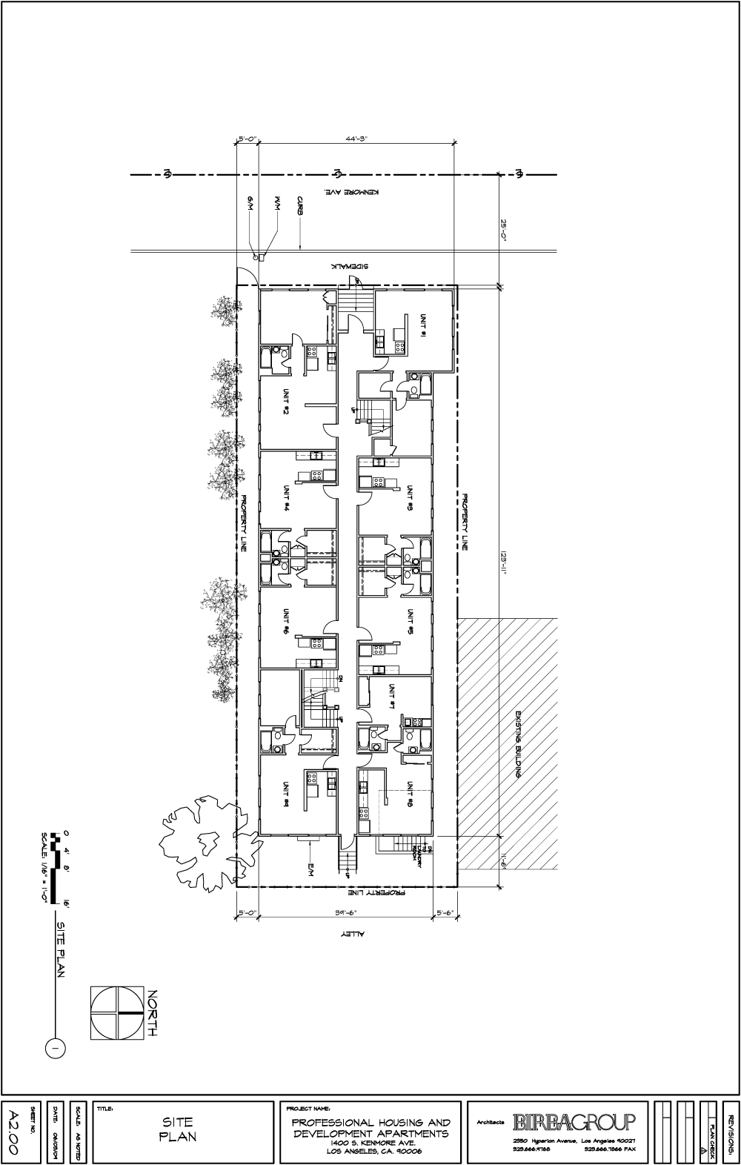

9.1.5 1400 S. Kenmore Ave
SECOND FLOOR
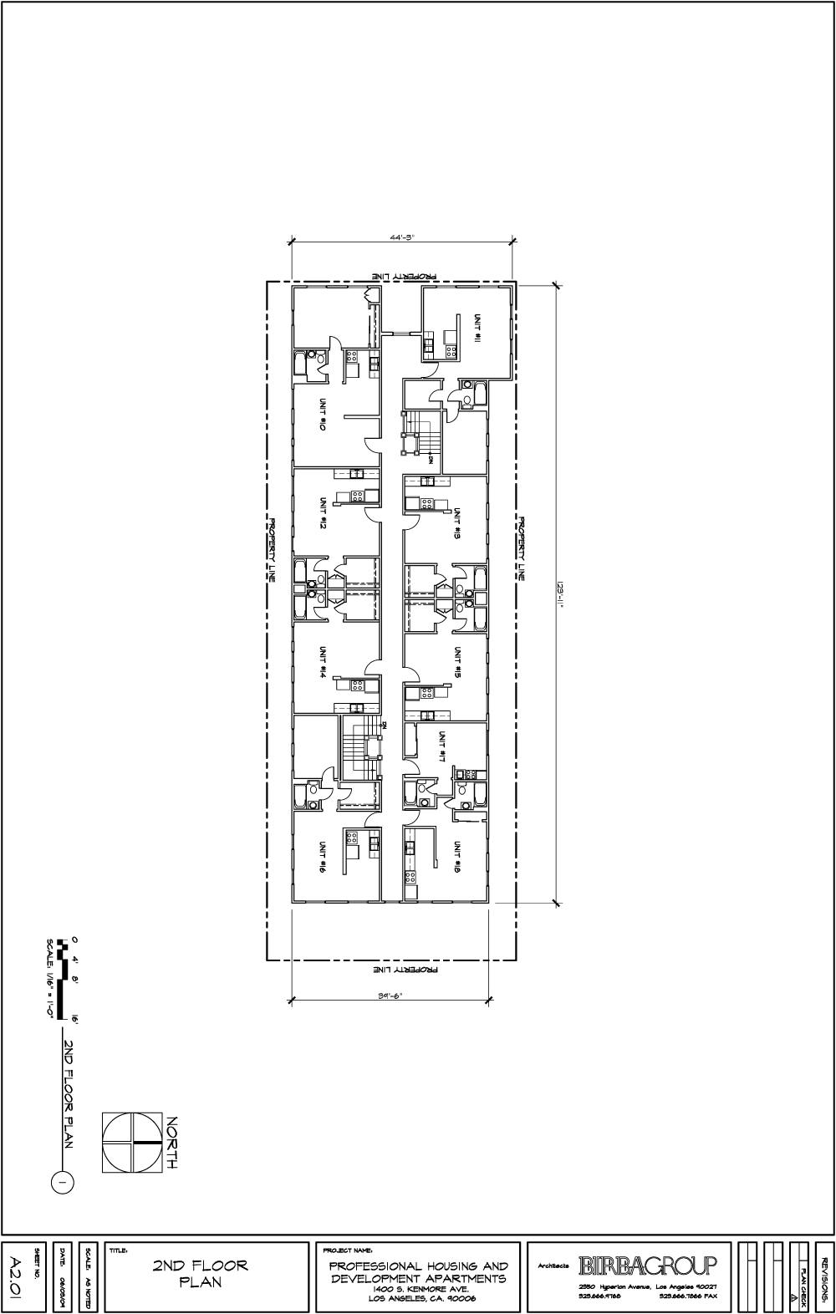

9.1.6 1401 S. Arlington Ave
FIRST FLOOR
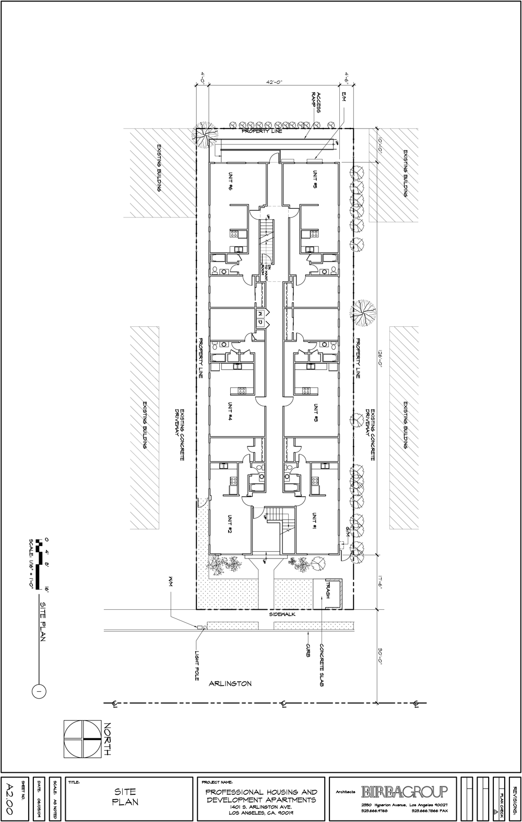

9.1.7 1401 S. Arlington Ave
SECOND FLOOR
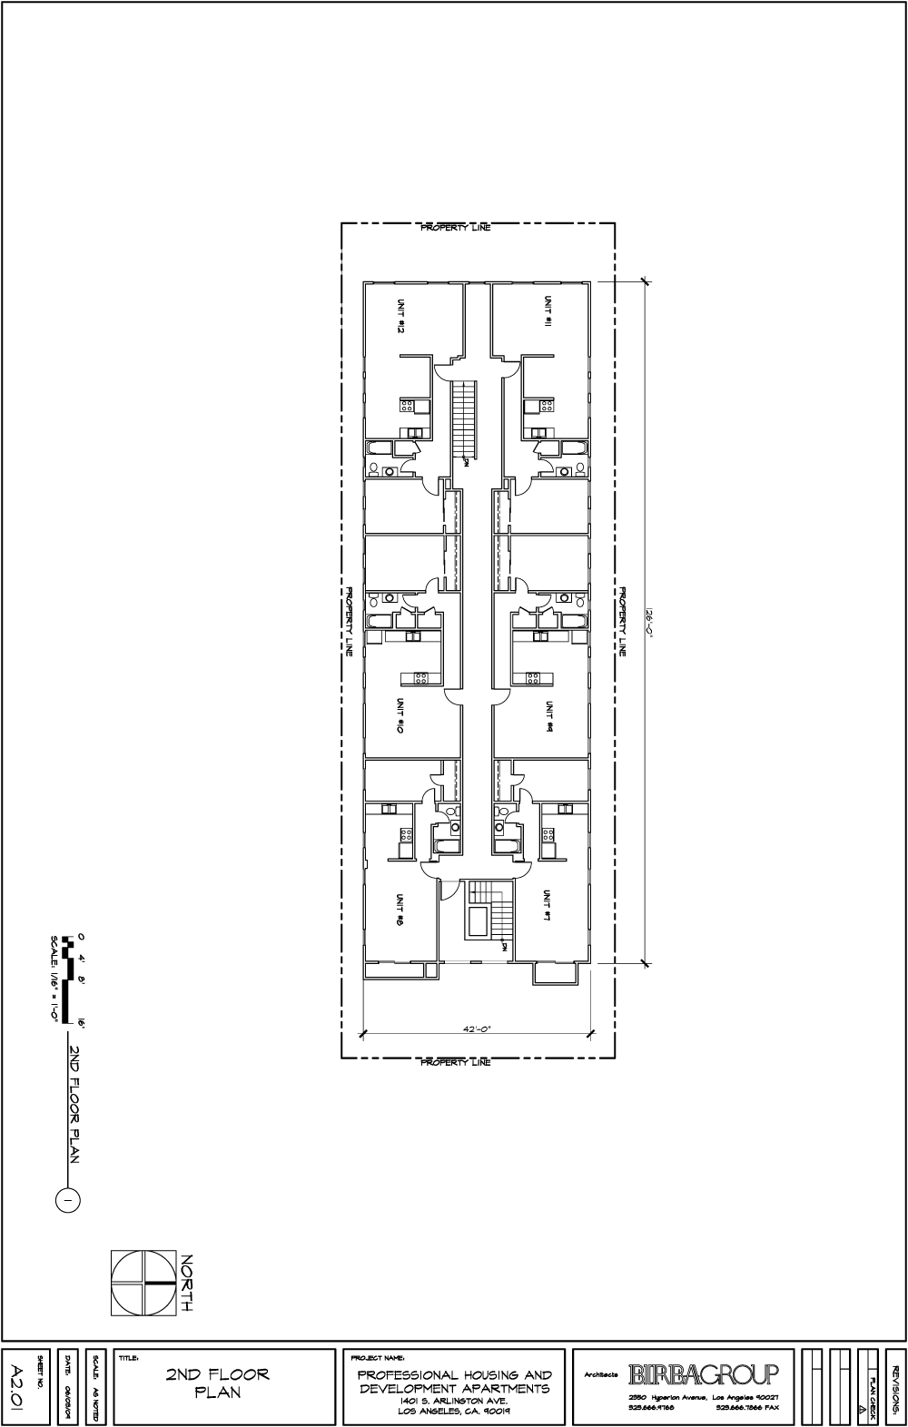

9.1.8 1745 W. 20th St, Los Angeles
FIRST FLOOR
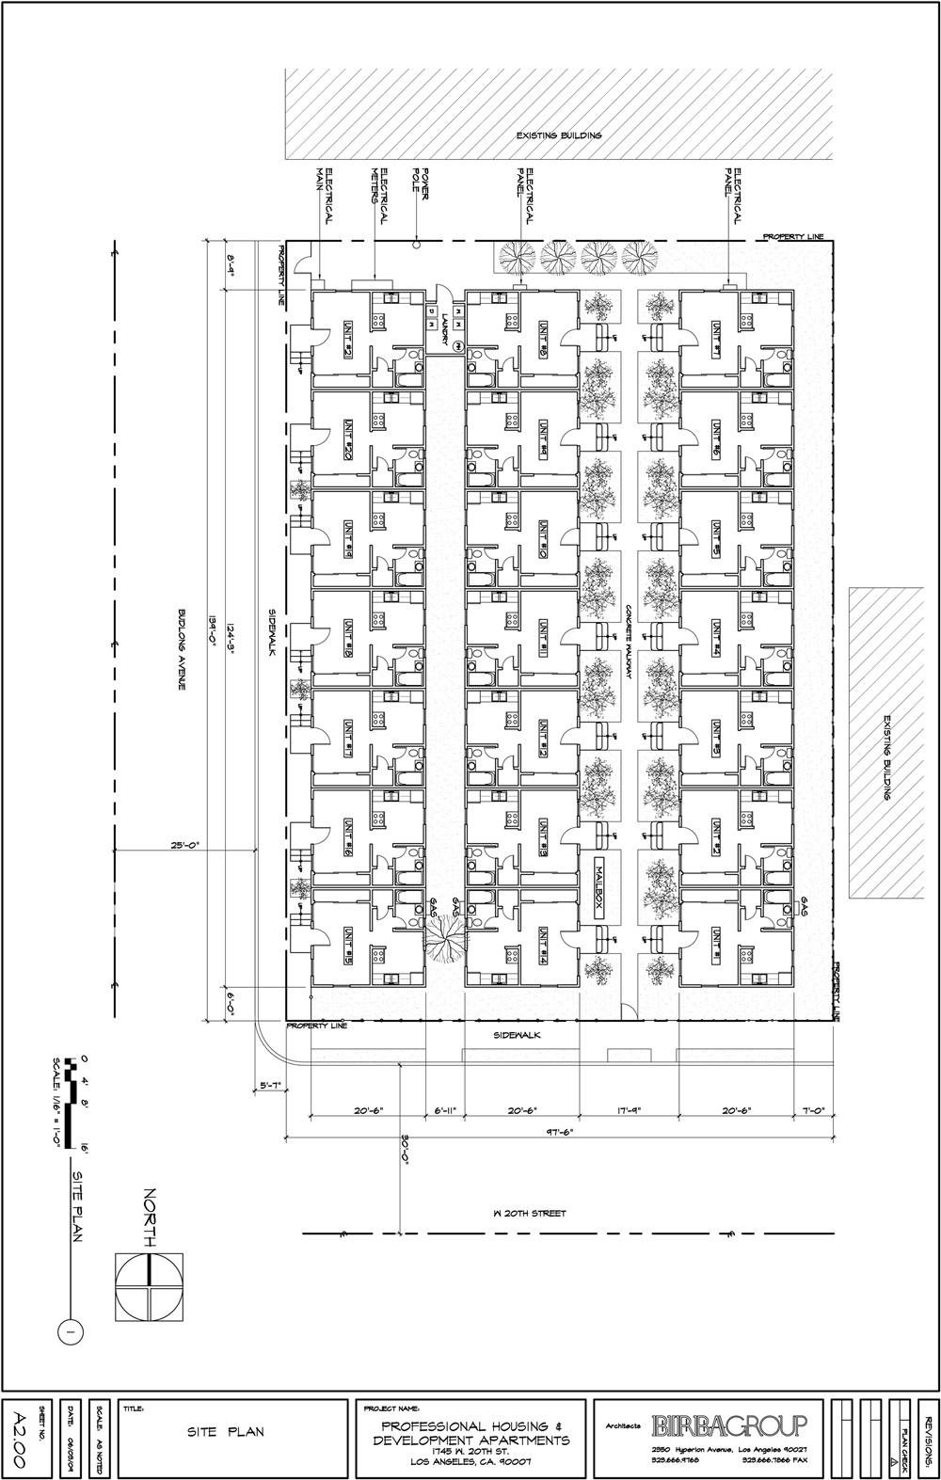

9.1.9 1810 S. Magnolia Ave
BASEMENT
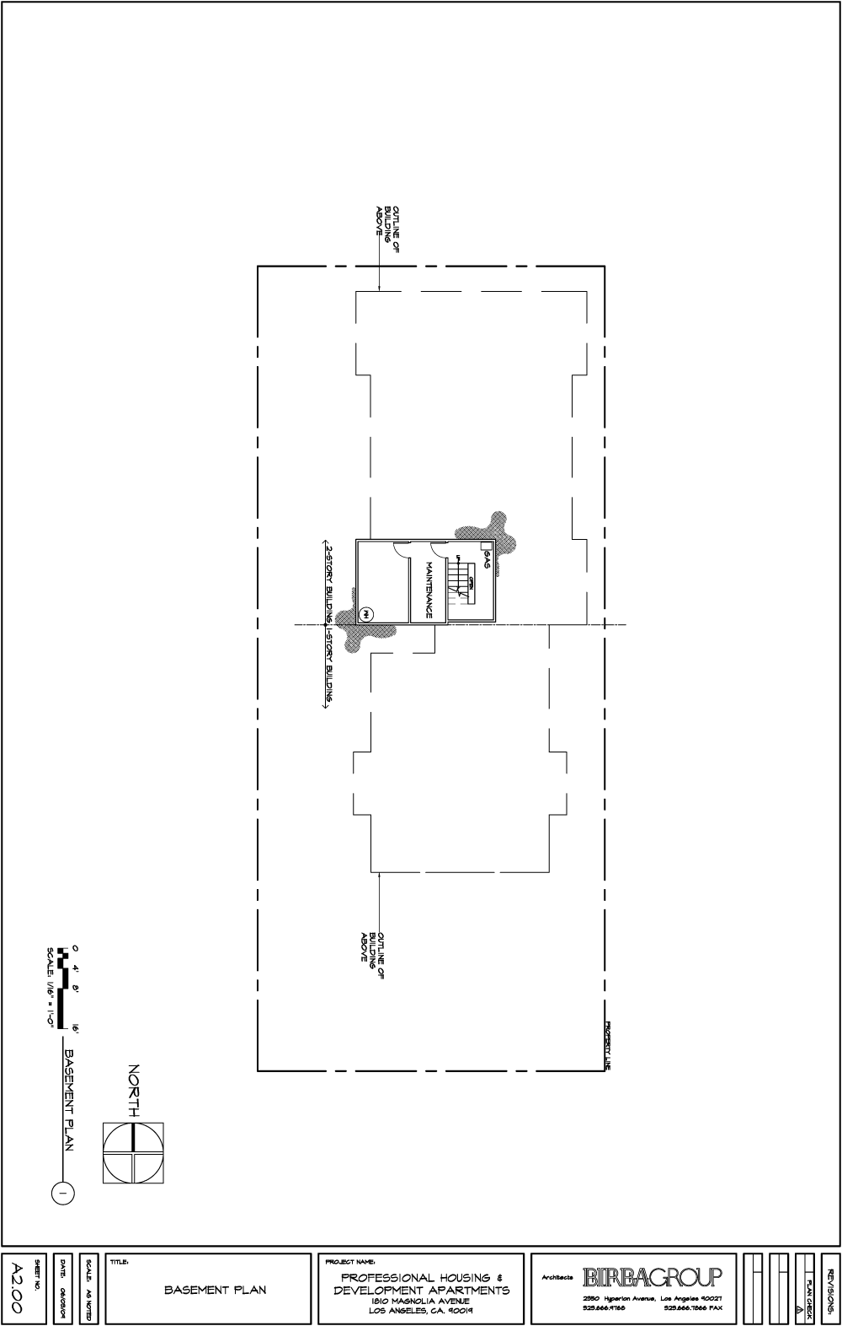

9.1.10 1810 S. Magnolia Ave
FIRST FLOOR
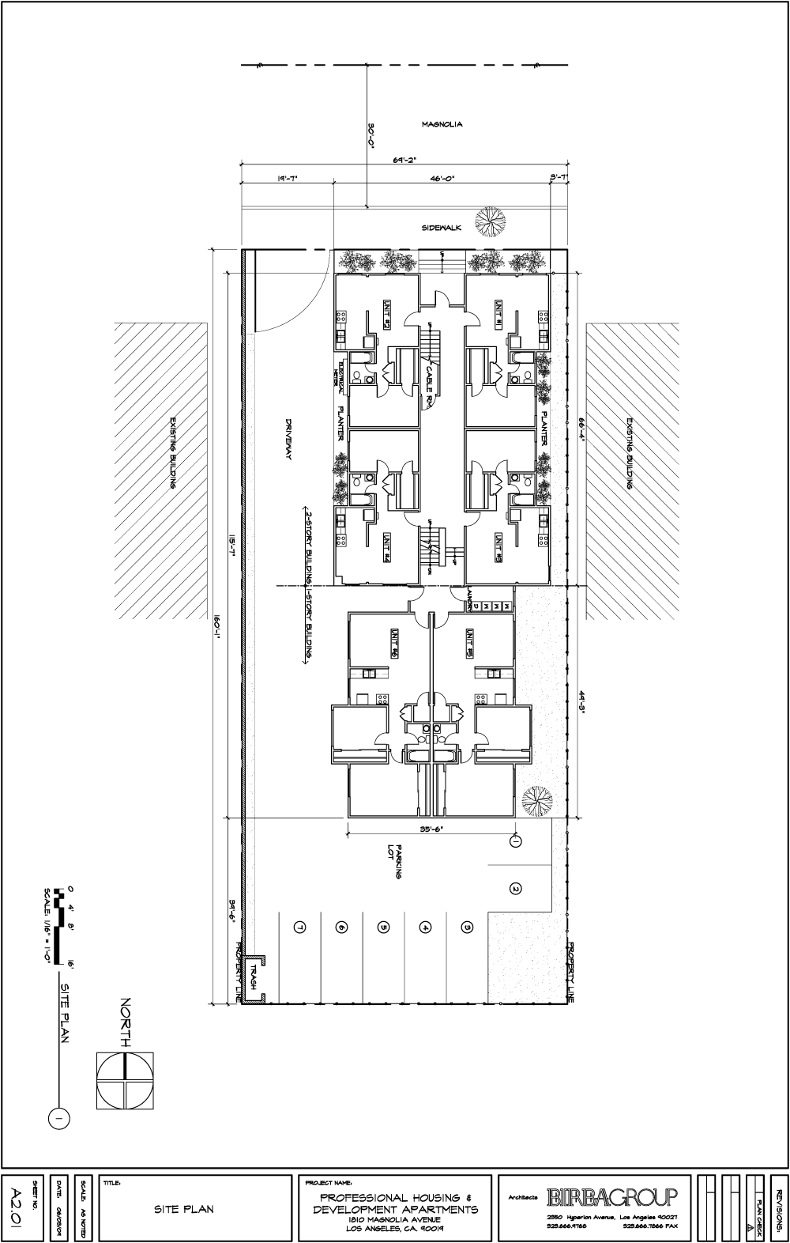

9.1.11 1810 S. Magnolia Ave
SECOND FLOOR
