Volunteer Management Handbook

Volunteer Management
- Promotion
- Recruitment
- Interview Process
- Orientation
- Management
- Retention

LRC & Timeline Breakdown
- Volunteer Management Structure
- Monthly Breakdown
- Semester Breakdown
- June Breakdown

Forms & Assessments
- Volunteer Application Form
- HOME, Inc. Code of Conduct
- Volunteer Activity Assessment Form (VAAF)

Volunteer Management on the HOME, Inc. Website
- Volunteer Management Handbook Online
- Linear Responsibility Layouts Online
- Volunteer/Organizational Contact Database
- Online Assessments

Volunteer Management

- Promotion
  - Promotional materials for volunteer recruitment are to be always on hand and constantly updated to fit the scope and need for volunteer skills and labor.
  - A marketing kit must be kept current. This kit includes but is not limited to past volunteer tasks/roles, past volunteer experiences, HOME, Inc. informational brochures, HOME, Inc. project reports, promotional DVD of most up-to-date student work, etc.
  - The HOME, Inc. Brochure must be update at least once a year to include the most relevant, up-to-date information on opportunities, programs and initiatives offered through HOME, Inc.
  - Single sheet flyers must be generated and updated throughout the year. Flyers are critical to on-campus and local community center postings and recruitment campaigns.
  - A ready-made selection of project descriptions/volunteer must be updated consistently. These ‘blurbs’ function within community service newsletters, general interest emails to volunteer service centers and for promotional flyers and posters.
  - A Volunteer Fair kit needs to be maintained for use in various annual college/university volunteer fairs. Included in this are numerous marketing kits, flyers/posters, tablecloth, fold out display and HOME, Inc. banner.
  - Contact must be established and maintained between HOME, Inc. and College/University departments offering relevant internships. These contacts must be reaffirmed and updated during the year. Because of HOME, Inc.’s reliance on volunteer labor, interns are essential.
  - Contact must be established and maintained between HOME, Inc. and College/University Service Learning centers and departments. Service Learning is a part-class/part-field opportunity for students to apply their course work to real world situations. Because of HOME, Inc.’s reliance on volunteer labor, Service Learning students are essential.
  - Contact must be established and maintained between HOME, Inc. and College/University Community Service/Volunteer Service Centers. Service centers are the hub of college volunteerism and must be constantly in contact and made aware of HOME, Inc. and HOME, Inc. related programs, projects and initiatives. Because of HOME, Inc.’s reliance on volunteer labor, communication with College Service Centers is essential.

- Recruitment
  - Volunteers will be proactively recruited on a rolling basis by HOME, Inc. staff Volunteer Coordinator as well as major recruitment campaigns at the beginning of each semester.
  - Volunteers must meet key criteria including computer literacy, media production and/or teen leadership/mentoring to aid programming.
  - Relationships with local college/university volunteer service centers need to be developed and maintained. These centers typically will recruit for the organization so long as HOME, Inc. and our programs are known to them.
  - Posting weekly/monthly advertisements/announcements in college and community service newsletters is an essential part to reaching volunteers on an individual basis.
  - Posting on internet based networking sites must be made monthly. Past examples of successful posting includes Craigslist.com and Volunteermatch.com. The ready-made ‘Blurbs’ (section 1.5) can be simply copied and pasted into online submission forms.
  - Community organizations such as the YMCA, Boys and Girls Club and other community centers should be in contact and posters announcing volunteer opportunities posted on community bulletin boards at these facilities.’
  - HOME, Inc.’s volunteer section of its website must be maintained and updated regularly. A volunteer application form will be offered through the site and must also be updated as necessary.
  - Service-Learning opportunities are to be developed with local colleges/universities. Service-Learning combines classroom learning with real-world volunteer experiential learning. Typically these opportunities must be coordinated 2 months prior to the start of the next semester (ex. if the semester begins in January, S.L. must be set-up with colleges before November).
  - A large scale flyer posting campaign must be executed across College/University campuses at the beginning of each semester in order to both directly recruit and also spread the name/image of HOME, Inc.3.2
  - A minimum of 2 volunteers per site is necessary so recruitment is a year round, consistent activity.

- Interview process
  - All volunteers will be interviewed prior to working within the schools or with HOME, Inc offices to determine suitability to programs and interests.
  - The Volunteer Manager will process and evaluate all incoming volunteer applications and queries to determine the suitability of each volunteer at various sites.
  - During the interview process, expectations of the individual volunteer will be determined by working 1-on-1 with all potential volunteers to ensure service with HOME, Inc. is consistent with personal and professional development of volunteers/interns
  - Whenever possible the staff person who will most closely work with the volunteer/intern will be present during the interview.
  - Scheduling and availability of workdays, dates and hours will also be determined during the interview process.
  - All volunteers working in Boston Public Schools will need to submit to a CORI check to ensure the safety of the school environment.

- Orientation
  - All volunteers will receive an orientation to HOME, Inc. prior to service that accurately portrays the aims and goals of the organization, the specific program/project which they are involved and also a detailed orientation to the role under which they will perform.
  - On-site training will be provided to develop necessary skills utilized immediately during their volunteer service. Examples of which could be teaching unfamiliar software or how to use a piece of hardware.
  - Staff will be responsible for on-site volunteer training at each lab they are stationed. Current experienced volunteers can also help to perform on-site training. Training is to be given throughout the year as needed/requested.
  - Each Volunteer will receive a detailed job description laying out exactly what they will be involved in/responsible for and a timeframe under which to accomplish their activities.

- Management
  - Volunteers will consider the Volunteer Coordinator as their supervisor during their service. Executive director and VISTA’s do not qualify as supervisors.
  - The Volunteer Coordinator will check-in with volunteers every two weeks to ensure that both previously defined personal expectations and also the expectations of HOME, Inc. are being met. Checking-in involves direct communication such as phone-calls and site visits.
  - All volunteers will be forwarded, copied and given all emails, letters, communications and initiatives that are pertinent to their role.
  - Volunteers will be included in any decision making process that may affect their role and service.
  - Evaluation will occur ever 3 months as a means to chart volunteer growth, give feedback on performance, seek out program/organizational suggestions and to continue individual interest in the volunteer.
  - Volunteers will be primarily assessed by the Project Manager, with aid of the on-site staff, to ensure expectations and performance standards are being met.
  - HOME, Inc. reserves the right to dismiss any volunteer. These reasons include but are not limited to: absenteeism, alcohol/drug abuse affecting performance, misconduct, theft, failure to uphold HOME, Inc. policies and procedures.
  - Volunteers will be reimbursed for most reasonable expenses incurred while in service such as transportation, program food purchases, necessary equipment purchases, etc.
  - A minimum of 2 volunteers must be maintained for each site throughout the year.
  - The volunteer database section of the HOME, Inc. website must be constantly updated to include up-to-date information on all current and past volunteers. This back-end component must also centralize all contacts for College/University Community/Volunteer Service Centers, Internship contacts, Service-Learning contacts, Community Center information, etc.
  - At the end of each month Lab Coordinators must report back to the Volunteer Coordinator on the quantity and quality of volunteer aid at each site. This report is formalized in the Volunteer Activity Assessment Form (VAA Form).
  - VAA Forms must be assessed by the volunteer coordinator also at the end of each month in order to gauge if HOME, Inc. CMLP’s are receiving enough high quality volunteer service.
  - The Volunteer Manager’s assessment must be shared with the Executive Director so that appropriate changes or alterations can be made to optimize HOME, Inc.’s volunteer program.

- Retention
  - Relationship development is key to the successful retention of HOME, Inc. volunteers. Both formal and informal relationships between the volunteers and the organization must be maintained to ensure a happy and productive returning volunteer base.
  - Volunteers will be recognized for their efforts throughout the year directly through potential events/lunches, and indirectly through consistent consultation on program development and valuing their views and experiences.
  - Every effort should be made to establish career opportunities and pathways for volunteers and interns who seek to become professionals in media or education.
  - Exit interviews should be conducted whenever a volunteer leaves HOME, Inc. to fully evaluate the individual experience of the volunteer and also their role within the organization.

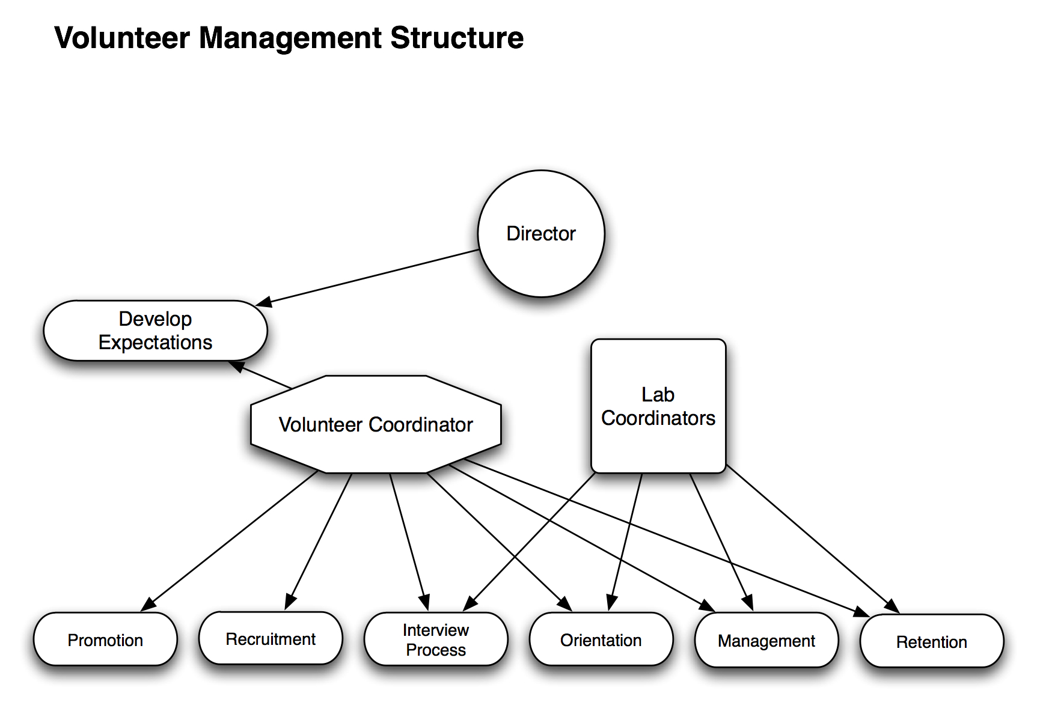

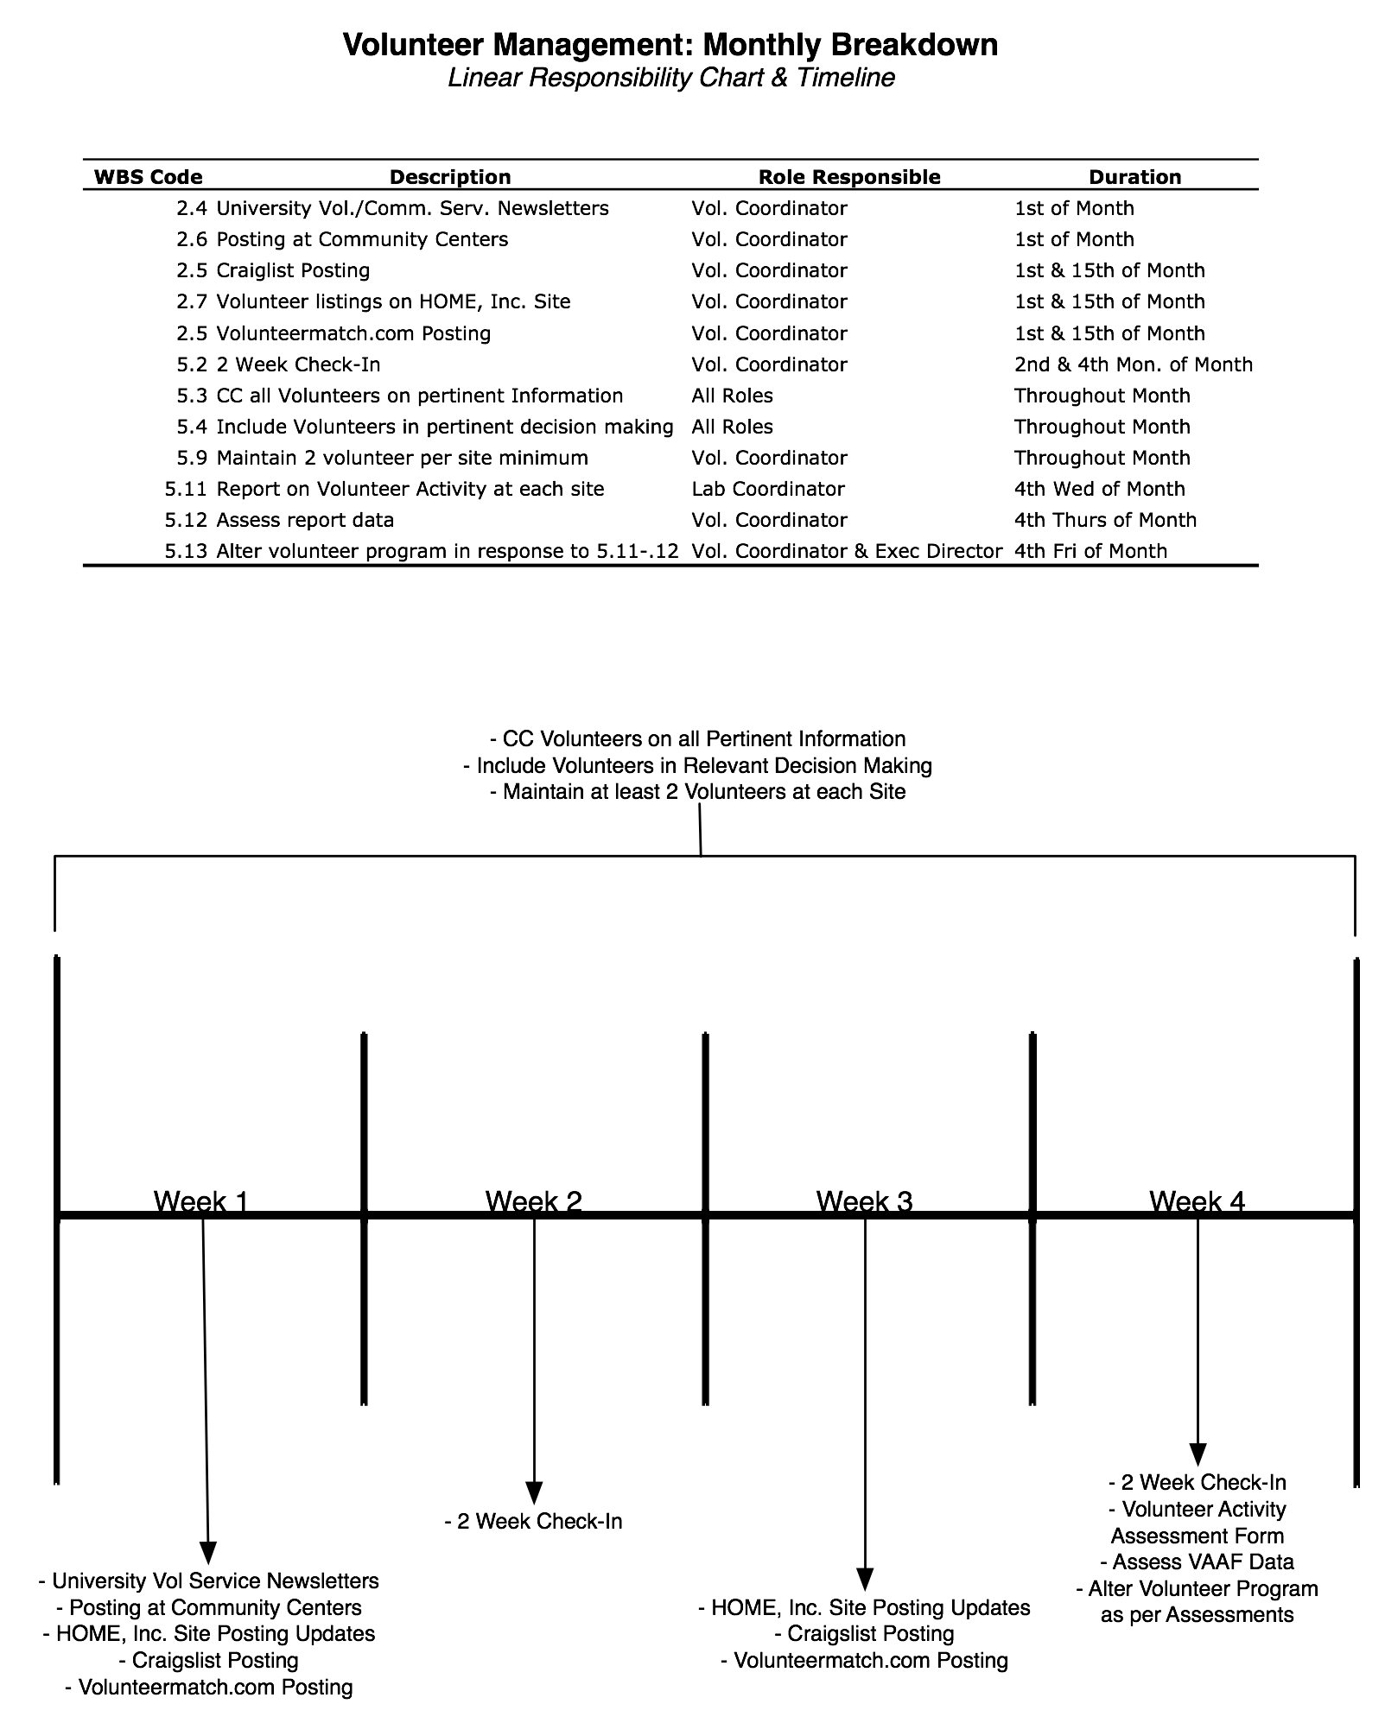

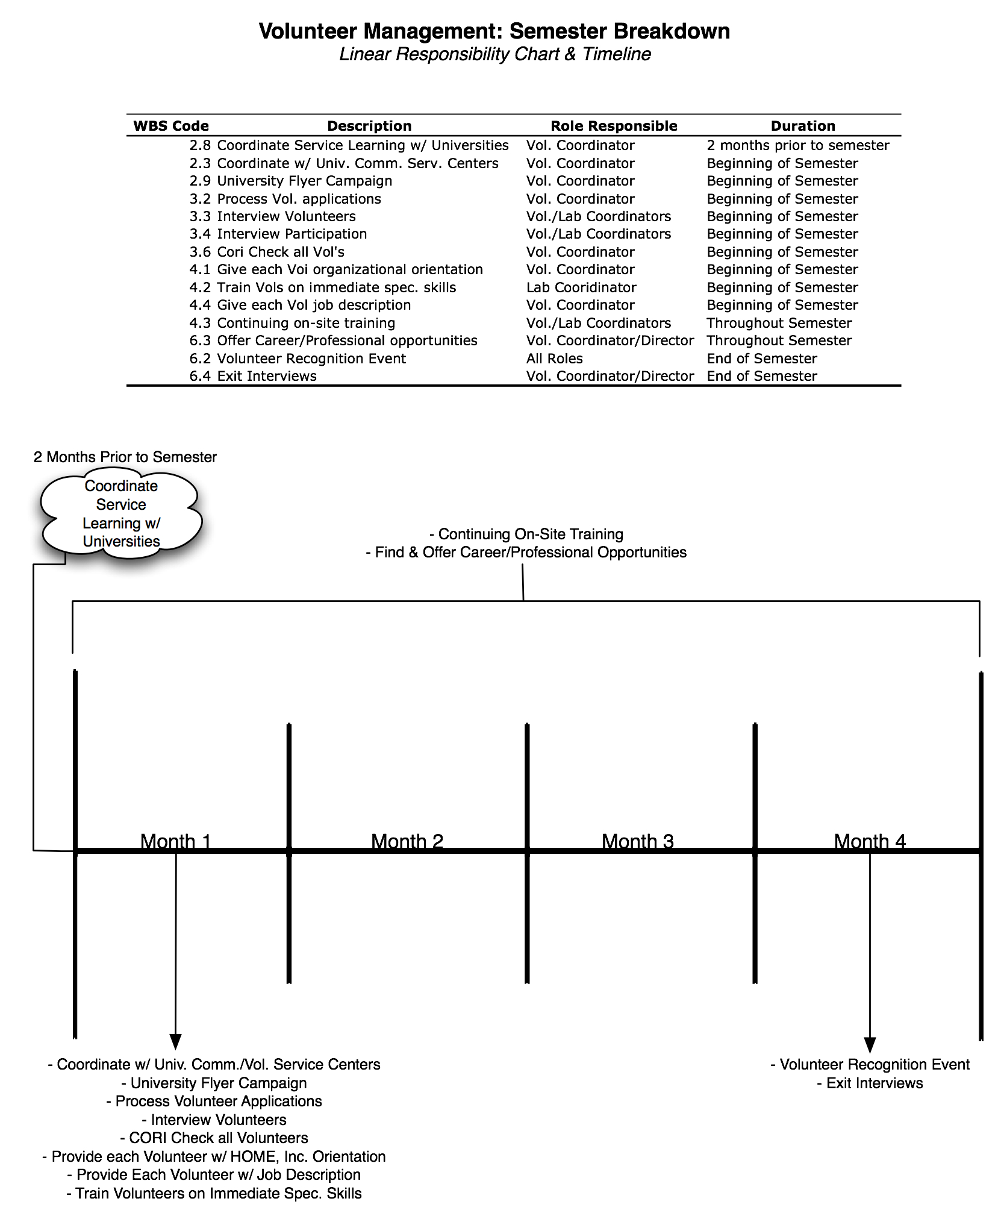

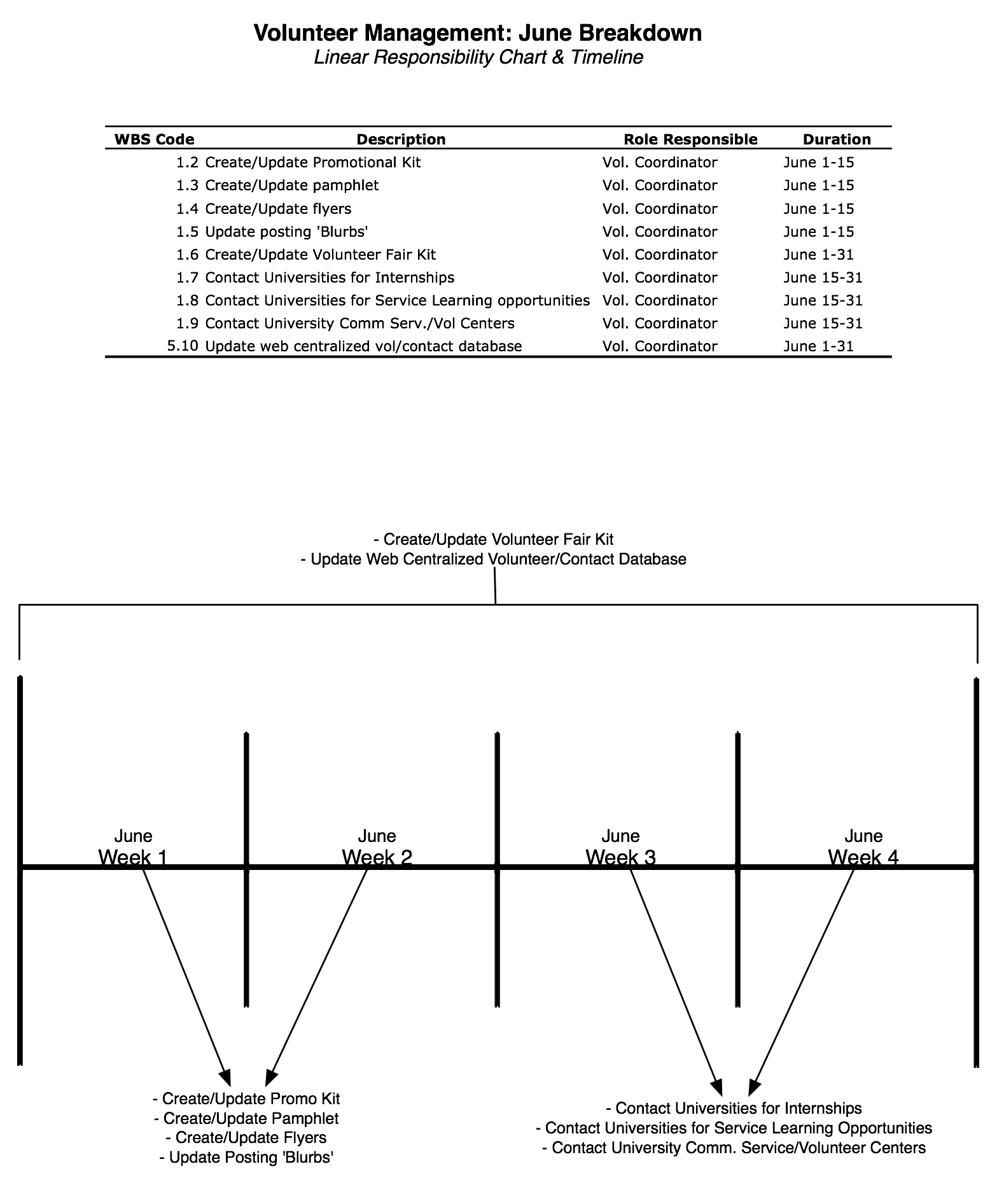

HOME, Inc. Volunteer Application Form

Name: (last) __________________ (first) ___________________________

Address: _______________________________________________________

_______________________________________________________________

Phone: __________________ Email: _______________________

Please list any experience in teaching, media production or working with youth:
_______________________________________________________________
_______________________________________________________________

When are you usually available?

Monday
Tuesday
Wednesday
Thursday
Friday

Have you ever been convicted of a felony?
_______No
_______Yes

If yes, explain: _____________________________________________________________________________________________________________________________________________________________________________________________

Knowledge: (check all that apply).
- PhotoShop
- Final Cut Pro
- Flash
- Web Design
- Animation
- Graphic Design
Other
____________________________

I understand that misrepresenting my background on this application is grounds for dismissal.
__________________________ _______________________ ______________
Print Name Signature Date

Home Inc. Code of Conduct:

• Volunteers have a special place in schools and assist in many ways. This may include interaction with individuals and small groups of students in a range of different activities.

• To assist schools in providing a safe environment and a positive educational climate, volunteers are asked to comply with the Code of Conduct for Volunteers. This code of conduct has been formulated to clarify the type of conduct that is expected of volunteers when participating in programs and activities in schools.

• Observe similar standards of behavior and ethical conduct to that required of staff. For example you are expected to act within the law, be honest and fair, respect other people (including students), and work to the best standard of your ability.

• Appreciate that students have rights and aspirations. Treat students with dignity and respect.

• Observe confidentiality in respect of all information gained through your participation as a volunteer. All information held by schools should be handled with care. Some information is especially sensitive. Sensitive and/or personal information requires additional caution in the way it is treated. For example, volunteers should not discuss nor disclose personal information about students, staff or students’ parents/careers to others.

• Accept and follow directions from the principal/supervisor/teacher and seek guidance through clarification where you may be uncertain of tasks or requirements. You may need to familiarize yourself with the department’s policies and guidelines on particular issues.

• Observe safe work practices which avoid unnecessary risks, apply reasonable instructions given by supervisors and report to the supervising staff and school administration any hazard or hazardous practice in the workplace.

• You are prohibited from making any statement that would discriminate students or from taking action that is intended to influence others towards one religious or political party.

• Report any problems as they arise to your supervisor including incidents, injury
or property damage.

Home Inc. will not disclose your information without your consent. Information includes, name, address, phone number and other contacts.

I certify that I have read and understood the Code of Conduct of Home Inc. and agree to comply with it.

_______________________ ______________
Signature Date

Volunteer Confidentiality Statement:
As a volunteer of Home Inc. I understand that I may be working with students and any information about those students will remain within the boundaries of my service with Home Inc.

_______________________ ______________
Signature Date

Volunteer Activity Assessment Form (VAAF)

Site Name:

Lab Coordinator:

Current Volunteers Names:

Current number of Days/Hours of Volunteer labor on site:

Are there currently enough volunteers on site?

Is volunteer availability currently enough/too little/too much?

Are there any skills/training current volunteers request or you feel they need (software, hardware, etc.)?

Do you feel volunteers are working productively on site (too much work, too little, not enough resources, etc.)?

Do you feel volunteers are getting enough support from HOME, Inc./the Volunteer Coordinator?

Other comments, questions or suggestions?

