Reno Apartments Wireless Mesh Deployment

Residents in Reno Apartments have expressed interest in obtaining internet access. One way to address the lack of internet access at Reno Apartments at a low cost is to install a wireless mesh network. This network would provide a secure signal that would cover the entire building and allow all residents equal access to the internet.

Wireless Mesh

Mesh networks are a good way to provide inexpensive wireless signal to a large area. To set up broadband internet access to Reno, we will need a mesh consisting of two Open Mesh Pro units per floor, one each end, for a total of 8 OM Pro units.

The wireless coverage on each floor will resemble this:
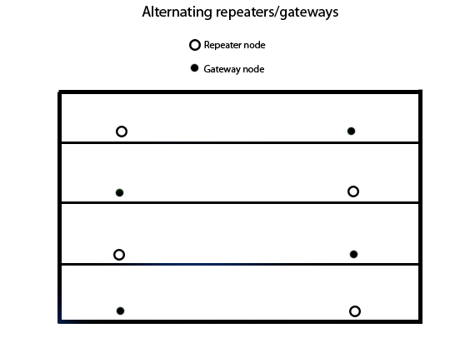
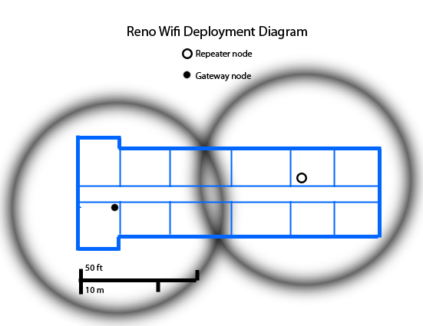

Each floor will have one OM Pro unit connected directly to the internet (a "Gateway" unit) that broadcasts the wifi signal. Each floor will also have one unit that shares this signal with the other side of the building (a "repeater" unit).

Broadband Over Powerlines (BPL)
By using BPL, we can share a single internet connection with the "Gateway" units on each floor and thus lower long-term maintenance costs. BPL requires special adapters that plug into electrical outlets.

Budget
$400 = 8 Open Mesh Professional units @ $50 each
$160 = 2 BPL kits @ ~$80 each (2 adapters per kit = 4 adapters total)
Total cost for equipment: $560

Ongoing Costs
A high speed cable internet connection (at least 6Mbps download speed) costs $40-80/mo.

Schedule
We anticipate deploying the network by November 20, 2009. A general tenant meeting would be held afterward to announce the network.

