Social Entrepreneurship
What is Social Entrepreneurship?
Social Entrepreneurship is when a social issue, problem, or inequity is recognized and a venture is developed to solve or alleviate. At the center of Social Entrepreneurship is the idea of the social value proposition, which is the bottom-line for social entrepreneurs. This is opposed to the financial or monetary bottom-line that is at the center of typical business entrepreneurship.

What does it take to be a Social Entrepreneur?
To be a Social Entrepreneur you have to have a massive quantity of skills to bring to bear on the unique challenges posed by working in the social sector. Luckily if you’ve been going through this book and actively participating in training sessions, you already have been exposed to most of the necessary skills and know-how to get started.

There are two key qualities that make up a successful social entrepreneur. The first is knowledge of their field/industry/sector. To start up a successful enterprise, the entrepreneur must have the experience and knowledge to understand exactly what’s needed to start and grow. This know-how includes knowledge of their customers/community, current key players, others doing the same work, supply sources, and what types of people/professionals to get on board.

Another key characteristic of a budding entrepreneur is to already be established, well known, and have a multitude of contacts within their field/industry/sector. Much more so than working in the private sector or for the government, the social sector forms many alliances and partnerships between organizations. Thus, there is a huge reliance upon networking, making connectedness a prerequisite. Also, having a strong reputation is immensely important.

Here are some of the distinct issues and challenges faced when acting as an entrepreneur within the social sector:

- Social need far exceeds resources no matter how much funding you receive (makes scaling very difficult)
- Pay and wages for employees is often “below-market” compared to other sectors
- Need to form alliances with other organizations and nonprofits to achieve social mission (as opposed to competitive private enterprise where alliances are rarely made)
- Fragmented funding streams (foundation grants, federal funding, private donors) make sustainable and consistent funding very hard to achieve
- Difficulty in determining and assessing social value bottom-line as opposed to a private/market monetary bottom-line
- Bad performance often goes unaddressed while high performance is rarely commended in the social sector

Examples of Social Entrepreneurship
Each organization where CTC VISTAs serve are Social Entrepreneurship ventures. They have seen a need or gap in their communities and created an organization that works to solve or alleviate it.

There is a large world-wide movement of non-governmental organizations (NGO’s) who are global social entrepreneurs, working to solve health, educational, economic, and other issues. The most lauded among these is Nobel Prize winner Muhammad Yunus who founded the Grameen Bank, which grants microloans (also known as microfinance or microcredit) to people with no collateral who need just a few dollars to buy supplies to begin new businesses or ventures in developing countries.

Defining Your Venture
It’s time to consider being a social entrepreneur when you’ve figured out a new approach to a social issue or when you’ve found an innovation to old methods of addressing a social issue. And it is definitely time to become one when you have the drive and passion to be the change agent who researches, implements, and spreads your enterprise.

After you’ve got the initiative to start your own social entrepreneurial project you’ll need to think, plan, and strategize thoroughly. One tried and true method to do so is to create Logic Models.

Logic Models
One great way to begin understanding all the in’s and out’s of starting up and achieving your social mission is to form a “Logic Model”. Logic Models allow for better understanding your social entrepreneurship project/program by conceiving from “inputs” all the way through to “impacts”. These models also help you to look critically at any assumptions you might be making before starting.

Logic Models progress in a causal chain: Inputs (staffing, resources, money, etc.) lead to Activities (community organizing, running programs, building online communities, etc.) lead to Outputs (projects completed, completed hours of programming, services delivered, etc.) lead to Outcomes (knowledge and skills learned, attitudes changed, practices changed, etc.) lead to Impacts (system level changes, changes in the broader community, organizational changes, policy changes, etc.).

Here is a Logic Model template chart that should make the chain clear:

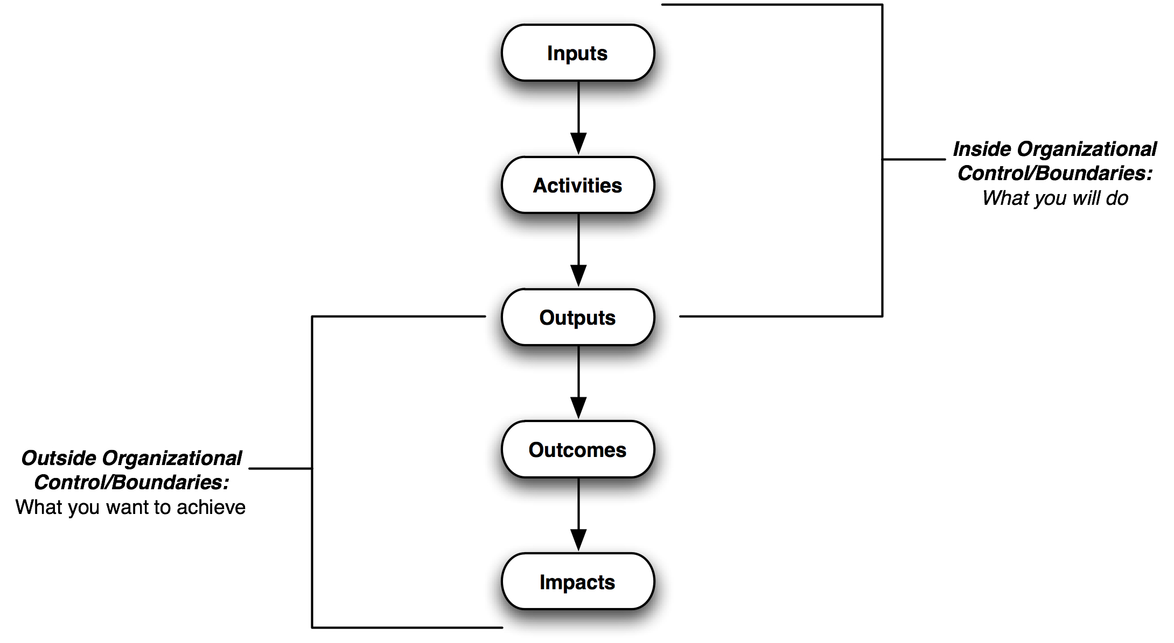

The further you get away from Inputs towards Impacts the ability to control and manage at an organizational level decreases at each stage. Additionally, the time it takes for effects to occur increases the further away from ‘Inputs’ you get, i.e. it takes longer to go from Outcomes to Impacts than it does from Inputs to Activities.

Evaluation also becomes more difficult the closer you get towards Impacts, i.e. measuring Outcomes and Impacts is much more complex and difficult than being able to measure your organizational Inputs and Activities.

What should be lined up to start?
For a full-blow organization starting up, be it nonprofit or for-profit, there are several key components to flesh out so you can establish the vision, scope, growth, sustainability, and future of your organization. This is otherwise known as your Business Plan.

By documenting these components you will be able to get potential Board members, funders, and supporters on-board and on the same page very quickly. If you’ve completed a Logic Model, then most of this process should be filling in the details.

Here is a list of some of those pieces:

- Vision/Mission Statements
- Staff/Founder Bios (who is your team doing the work?)
- Market/Competitive Analysis (who is doing similar work in the same field?)
- Financial Projections
- Funding Plan
- Product, Service, or Programming Descriptions
- Marketing Plan
- Strategic Plan

Fiscal Sponsorship
If you find yourself unready to commit to starting a private company or a nonprofit for your social entrepreneurship undertaking, consider using already established nonprofit organizations that would be willing to work with you on establishing and funding your idea.

Fiscal sponsorship has many benefits such as testing out whether or not your idea is viable in a real-world scenario, being able to apply immediately for foundational or government funding under your sponsors nonprofit name and reputation, seeing what it would realistically take to operationalize your idea, and also giving you the time to properly set-up your organization while still getting “the work” done and, hopefully, getting paid.

The benefit to organizations that act as fiscal sponsors includes being able to add supplementary or complimentary programming to their activities, grow alliances within the sector (if you establish a new nonprofit), receive portions of grants received, and create relationships with new funders or strengthen relationships with existing ones.

As a VISTA, you should be continually establishing contacts and strengthening the relationship with your host organization throughout your year. Always keep in mind that if you have an idea or an initiative you want to try to test out and get funded, then you may want to approach your host organization or other nonprofit contacts you have to see if any would want to be fiscal sponsors. However if you do find a fiscal sponsor, make sure the agreement between you both is clear, documented, and legal.
Logistics of Starting Up a Nonprofit
As mentioned in the Nonprofit 101: Structure section of this book, starting up a nonprofit is a multistep process that takes a great deal of time. However, thousands of nonprofits start up each year, so it can’t be that hard! (Note: as with everything else in this book, none of this should be construed as legal advise)

Leverage Those Contacts!
Before you being your foray into legal documentation and filings, make sure you find and have a lawyer to contact, if necessary, throughout the process. You should also look into getting an accountant or someone who knows how to set up simple bookkeeping. Around the time of finding a lawyer and an accountant, open up a bank account for your organization with a bank that handles small NPO’s.

At this point you should also begin recruiting potential Board members. Having a Board in place is a prerequisite for filing to become a nonprofit so it’s better to start sooner than later after you’ve begun filing out all the forms. Use as any contacts as you have from your VISTA service year as well as any previous or outside contacts to recruit and select Board membership from.

Legal Documents and Filings (nobody enjoys this)
Hopefully by this point you will have completed a Logic Model so you can better understand exactly what it is your seeking to do from start to finish (inputs to impacts). With a fleshed out idea in hand, start to think of a name for your NPO. The name should reflect your mission or vision or activities.

With your name selected, check with for your state’s regulations on reserving a corporation name. Often these are found in the State Secretary’s website usually in the Corporations Division. It is a short form that costs around $30 to file (depending on your state).

Next on the list it to establish your Bylaws, which is going to be an exhaustive process that will take many hours. You must research samples, templates, and any other resources you can find to ensure your Bylaws are accurate and will pass state and IRS inspection as a nonprofit. There is no specific form to fill out for these, but there are preferred formats to use. Again, research and find samples. Bylaws typically have no filing fee as they are sometimes attached to the Articles of Incorporation and to the IRS Form 1023.

Another form to be obtained at the state level is your Articles of Incorporation form (again likely found on the State Secretary’s website). This is a lengthier form that requires you to state explicitly your purpose, activities, that you’re seeking nonprofit status, and who your initial staff/Board members are. Filing your Articles of Organization costs several hundred dollars (typically $200-$300 depending on your state).

After you’re officially recognized as a corporation in your state, you need to get an Employer Identification Number (EIN) from the federal government. This is another fairly easy process to complete as the IRS has enabled it to be submitted online. You must have an EIN to apply for 501(c)(3) public charity status from the IRS since it will act as your tax ID.

Next is The Big One, the IRS Form 1023. This is by far the most complicated, confusing, frustrating, and time-consuming form you will have to file in this process. This form enables your nonprofit to receive official 501(c)(3) status. Once filed, it takes between 2-6 months for IRS to grant you 501(c)(3) status. This process can become drawn out if your Form 1023 is not thorough or clear enough for the IRS.

While you can fill the Form 1023 out yourself, it is not recommended. When you get to this form, it’s a good time to contact the lawyer you’ve hopefully already secured. Most lawyers will have Form 1023 templates all setup and ready to fit to your specifications so it is a simple (but expensive) way to fill it out. If you decide to fill it out without a lawyer, consult as many books and how-to’s as possible. See Further Resources below for more resources on this.

The cost of filing the Form 1023 is high at $750 if your organization will exceed $10,000 in gross income annually over four year. If your organization will make less than $10,000 annually, then the cost of filing is $300.

Altogether, the cost of starting up a 501(c)(3) nonprofit generally ranges from $1000-$2000 (depending on state filing costs and whether you seek legal council during the process).

You’re not through with the Government yet
After you incorporate your organization and receive your 501(c)(3) public charity status from the IRS, there are several reports and forms you must fill out every year in order to maintain your nonprofit status.

One form is the IRS Form 990, which must be filled out each year to document financial information to make sure nonprofit public charity status is not being abused. Also, your organization will likely have to file an annual report with your state that details Board Membership and any organizational changes. There may be fees to submit required annual reports.

Parting Words
It is the sincere hope of those of us at CTC VISTA Project HQ that your VISTA year will go a long way to instilling the entrepreneurial spirit in you. It is also hoped that this book and your training sessions will give you the knowledge, tools, and understanding to be a successful social entrepreneur in the future.

Further Resources
Mancuso, Anthony. How To Form a Nonprofit Corporation. Nolo, 2007.

Wei-Skillern, Jane, Austin, James E., Leonard, Herman, and Stevenson, Howard. Entrepreneurship in the Social Sector. California: Sage Publications, 2007.

W.K. Kellogg Foundation Logic Model Development Guide. 2004. (www.wkkf.org/Pubs/Tools/Evaluation/Pub3669.pdf)

IRS Information and Forms related to Nonprofits (http://www.irs.gov/charities/)

Logic Model for Social Entrepreneurship
Map out your venture idea in the logic model below, defining the aspects of each stage.

