How do you search for a job after Americorps?

Knowing Where You Want To Go
Here’s the unfortunate thing about Americorps, it’s not a career path. It’s a one year commitment that you can re-up for a few years, but that’s about it. So planning your path is extremely important throughout your VISTA year.

In the very rare case that you know exactly what career path you want to go down, your service year should be full with ample opportunities to go to conferences and make contacts with people and organizations doing the work you want to do.

For The Rest of Us Without a Defined Career Path
A lot of VISTAs have only a general idea of where they want to go beyond Americorps; so don’t feel anxious or guilty about not being 100% sure!

There are many books and resources that give highly detailed ways of figuring out your dream career, and we encourage you to seek those out if necessary (see Further Resources at the end for some). However, here’s some quick and dirty ways to get at what you want to get in to:

- List all the skills you are good at and enjoy using the most (event planning, public speaking, writing code, etc.)
- List all fields of knowledge that interest you the most (nonprofit management, public policy, digital media, etc.)
- Ask everyone you know who you think might be relevant what they would define the job as. You’ll hopefully get a few people saying “Oh, that sounds like [insert dream job name you didn’t know of]”.
- Seek out and talk to people who are in those jobs now. Ask them how they got there and for any advice they might have for you.
- Research and find those organizations that are doing that work

Contacts: The Best Way to Land a Job

Tip
For those searching for the next step, one good way to go about your year is to get engaged in as many networks, conferences, and functions as possible. The VAST majority of jobs in any sector are gained through personal or professional contacts. The broader the net you cast out, the more contacts you’ll have. It’s pretty simple. Remember CONTACTS! CONTACTS! CONTACTS!

Many VISTAs have found jobs after Americorps with their organizations, other organizations they’ve worked with, or through other Americorps contacts. Think about it this way, it’s easier for an executive director to hire someone they know or someone recommended by a person they know and trust rather than going through an exhausting hiring process. It saves the E.D. a lot of work since they or someone they trust already approves.

Using Your Federal Noncompetitive Eligibility Status
After completing your full year of VISTA service, the government grants you “Noncompetitive Eligibility Status”. What this means is that you can apply for any federal job that you meet minimum qualifications for and get to forgo the formalities of the competitive process. Hiring government agents do have the choice, however, to decide whether or not to use the status.

Go to http://www.usajobs.gov to search jobs and find agencies that will favor “Noncompetitive Eligibility Status” or just to see what kind of jobs the government offers. Typically you’ll have this status for only 12 months after your service ends.

Build Your Work Portfolio From Day One

Tip
Following the old adage “show, don’t tell”, you should, from your first day on, be documenting the work that you do so you can demonstrate to potential employers how effective you really are. Documented work can be strategic plans, program outlines, curricula, media produced, code developed, projects managed, grants submitted, etc… You know you are a good worker. Make sure you have the evidence to back it up!

Your Host Organization Should Be Supportive
Your organization and supervisor should be mindful throughout the year, but especially during the last few months of your service, that they need to support you as you transition and find your way to the next step. This means being flexible with hours when if you’re studying for an entrance test (GRE, GMAT, etc.), visiting potential schools for next year, job searching, or going out to interview.

Your organization should be committed to and support your professional development. If there is a course that is related to your work you want to take or a book you need to get then you should free to ask your organization to support your endeavor financially of possible.

Framing Your Work with CTC VISTA

The Three Sectors
The U.S. economy is divided into three separate sectors, private, public, and nonprofit. The private sector includes all for-profit companies from General Electric to the pizza place on the corner. The public sector is anything related to federal, state, or local government (Americorps falls into this sector). Lastly, the nonprofit, or third sector, is comprised of organizations founded to be in the public interest (all of the organizations CTC VISTAs serve at are nonprofits). It is important to note that while you have been working in the nonprofit sector, you have been paid and supported through the public sector.

Communicating Your CTC VISTA Work

Tip
VISTAs work both for Americorps (public sector) and for their host organizations (nonprofit sector), so what’s the best way to explain this to potential employers? The best answer is: include it all! State that you were an “Americorps VISTA with the CTC VISTA Project working with [insert name of your host organization].” You should also add that you “worked with a national network of technology related nonprofits and VISTAs through Americorps.” Trust us, all of that is very impressive.

The Resume

Your resume is one part of the job hunting process, not the entire thing
Warning
Resumes usually serve the purpose of being able to cull large numbers of applicants down to a manageable few who then get interviews. It’s easy to fall into the trap of thinking your resume is the be-all, end-all of getting a job (online resume posting is very seductive yet highly ineffective), but it is really just a way to land an interview.

Your resume acts as a lengthier business card (no 3 page resumes!). You want to leave employers wanting to know more about you. Hence, you will hopefully get an invitation to an interview where you can explain and expand further on your skills, interests, aspirations, and experience on your resume.

Know Your Skills
Coming out of your VISTA year, you will have TONS of skills and know-how. While it’s daunting to have to narrow down your skills to a resume-safe 3 or 4, it’s not actually that difficult.

Think of one big project or workplan goal you worked on during the year. Now, break that down to its constituent objectives and actionable steps (see the Project Management section for more detail). Each actionable step requires some skill that you had to employ. And each objective is made up of many steps so completing any objective takes a cluster of skills. This balloons on up to goals, which require many objectives, so completing a goal means you have amassed a number of skills.

Tip

But which skills do you put down on your resume? The answer is the ones you enjoy most, are the most effective at, and are the most complex. By most complex we mean the skills highest up on the goal/objective/actionable step hierarchy. Think of it this way, if you put a high-end skill such as “program management” down, it also implies a whole host of other skills like “planning classes, recruiting members, evaluating effectiveness, etc.” so you don’t have to explicitly state these.

Writing your resume
There are literally hundreds of resume writing resources available and you can spend days researching them all, but here is a quick CTC VISTA recipe for a resume:

- Define what job title you are looking for (i.e. consultant, administrator, programmer, volunteer coordinator, etc.) and research what skills, experience, and knowledge are needed to get that title.
- Make a list of 3-4 of your strongest skills and/or knowledge that make you a solid candidate for that job title.
- Write down successful instances where you’ve used those skills or knowledge in your past work.
- Attach “action words” to each accomplishment that communicates results
- List all previous work experience. Make sure you have no work gaps or can explain gaps (you can use volunteer work to explain gaps).
- List all previous education or training you’ve had including college/university work, seminars, certifications, etc.
- List all community service experience you’ve had. REMEMBER VISTA is not community service. It is work experience. Use it that way!

Tip
Choosing the proper format is also important. Most job types and titles have specific and commonly used formats (i.e. secondary education, social work, computer science). It is highly recommended to scour the internet looking for resume examples for the job type you are looking for.

The Interview

What to Expect (Generally) During the Interview
Employers will ask a lot of questions to poke and prod and figure out if you’re the person for the job. However, most interview questions boil down to these basic points of interest so make sure you can answer these in a variety of ways:

- Why are you drawn to their organization?
- How can you help their organization?
- Who are you (your past, present, and future)?
- What sets you apart from others applying for the position?

In turn, you should ask the following from employers if they do not touch upon it:

- What exactly is the job (activities, responsibilities, etc.)?
- What kind of skills is the organization looking for?
- What is the general culture of the organization/what is it like to work there?

Asking these questions not only allows you to get the information you need but also demonstrates to the interviewer that you’re attentive to the organization’s needs.

Tip
Just as important as enjoying the work you’ll be doing is the environment in which you’ll do it. During the interview, be sure to ask yourself: Would I get along with the people who work there? And is this the kind of organizational culture I can thrive in? Keep in mind you’re interviewing them too.

Telling a Good Story
During your interview you will probably be asked to “talk about a time you had to manage a project, reach a deadline, work with difficult people, etc…” This is interviewer code for “tell me a story.” So, before you even walk into the interview think hard about a good cross section of “times you had to [insert situation here]” and prepare little stories for each one. Here’s one easy way to format your narratives:

1. Start with what you wanted to do, your goal.
2. Say what the challenges and hurdles you faced were
3. Give step-by-step detail of what you did to reach that goal
4. Describe what happened/outcomes
5. Describe how you were able to measure or quantify those outcomes
Emphasize your transferable skills (as you defined earlier) as much as possible in the narrative. Remember, employers typically ask about your past in order to determine your value to their organization in the future.

Here are some other general interview tips:

- Listen as much as you talk.
- Use your VISTA work to demonstrate your commitment and drive (i.e. the sacrifice of living at poverty level for you personal values/beliefs).
- Do not bad-mouth your VISTA host organization or complain about your supervisor. Be creative and say there were 'differences' but you worked amicably towards your goals as a VISTA (see Conflict Course Navigation).
- Bring documentation of your work. If you have DVDs, manuals, research, websites, reports, marketing materials, etc.
- Do not make the focus of your interview your resume. That was the entry point for getting the interview.
- Answer questions between half-a-minute and two minutes.

Further Resources:
Bolles, Richard Nelson. What Color is Your Parachute? California: Ten Speed Press, 2008.
Job Star (www.jobstar.org)
Corporation for National and Community Service - Resource Center (http://nationalserviceresources.org/node/17068)

Finding Your Transferable Skills
Since listing each and every skill, big or small, is impossible on a resume or in an interview, you will want to put down only the most complex skills. That is skills that encompass the most sub-skills and abilities. These are typically known as transferable skills since they can be transferred to any job or sector.

For example you might have written code, collaborated with other programmers, and set timetables for a project, but you wouldn’t have space to write all that so you lump it all under the transferable skill of Project Management. Complete the charts below to narrow down some of your transferable skills:

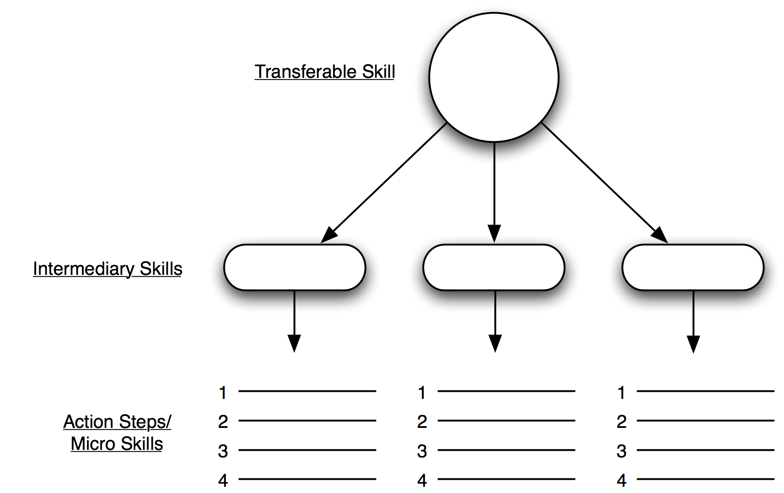

At The Interview: Telling the Story
In any interview, you will inevitably be asked to tell the interviewer of “a time when you had to deal with a conflict, managed volunteers, oversaw a project, etc…” It’s best if you already have a few of these mini-narratives already planned out prior to the interview so you will be able to prove how capable, smart, and organized you are. Use the template below to plot out one of those short narratives.

What is the project, program, event, instance, etc., that you are describing?

What was the mission or goal of that undertaking?

What were the challenges you faced?

Describe how you achieved your goal or mission step-by-step:

Described what happened/the outcomes:

Describe how you were able to measure and evaluate those outcomes:

