Project Management
So you've just received your workplan with all your projects, programs, and goals listed out for you in more-or-less detail. You're walking into the office and getting ready to tackle that first big project... but how do you do that? Where do you start? How will you know what to do and when and by who?!? It's time to Project Manage!

What is Project Management?
Project Management is the discipline of planning, organizing, and managing resources to bring about the successful completion of specific project goals and objectives. There is an entire professional field dedicated to this discipline.

Why Project Manage?
You will have to balance resources, people, deadlines, budgets, and outcomes for each of your workplan goals. Without methods and systems for handling the many aspects of getting the job done, you will in all likelihood be unsuccessful. See the Lifeline of Your Project below for a start to finish look on getting your project done:

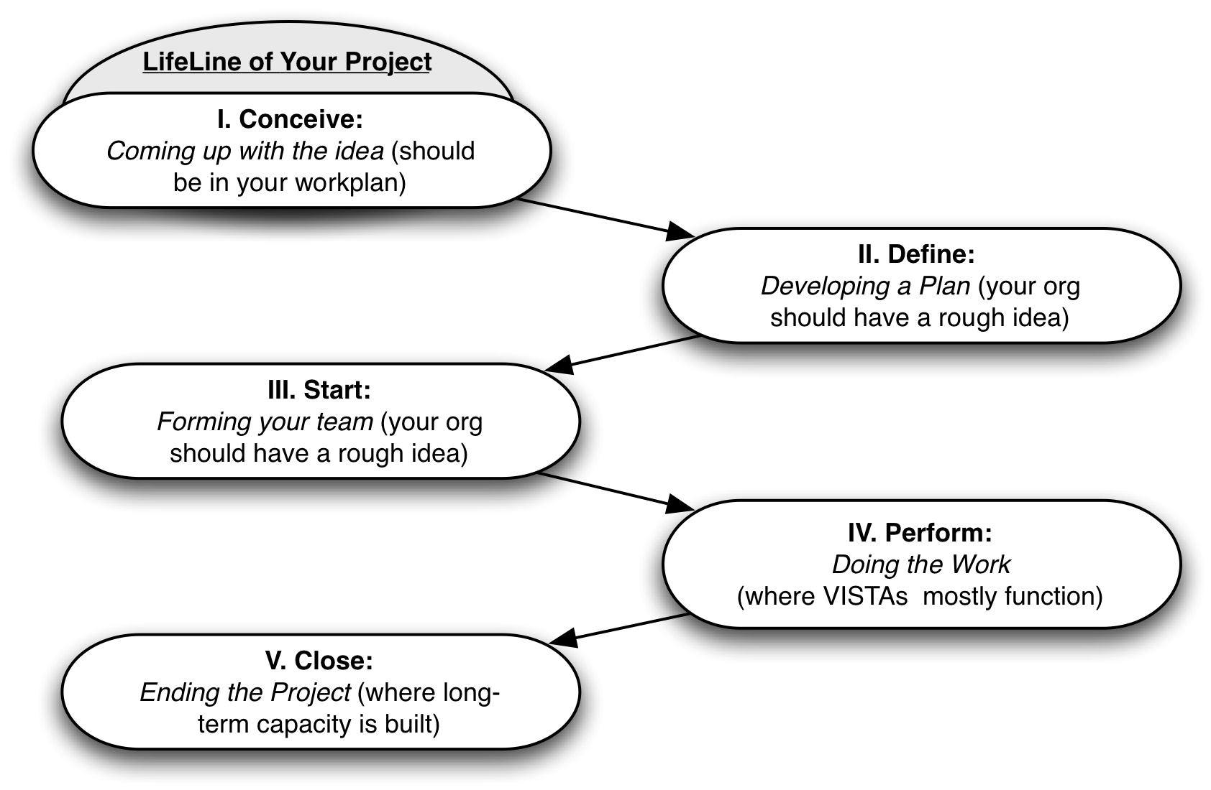

Typical Problems in your Project’s Lifeline
Warning

- Skipping directly from "Conceive" to "Perform"
- Not defining the people needed
- Not revisiting the conceive and define phase even if your org has already  done this (you may have useful input!)
- Not tackling the close phase

I. Conceive
Your organization should have already laid out the general idea of what you are doing in your workplan. However, you should ALWAYS go back and check with your supervisor to make sure the idea has not changed or evolved from your stated goals.

Tip
When going over your organization's workplan goals ask yourself whether these goals are SMART (Specific, Measurable, Aggressive, Realistic, and Time-sensitive). By keeping SMART goals, your project will be clearly defined with measurable indicators that will be challenging & achievable within a reasonable time frame.

Some questions to ask yourself before you start:

- Do you want to be everyone's friend or do you want to get the job done?
- Do you like to work by yourself or with others? hint: capacity building  necessitates working with others
- Are you comfortable dealing with people at every level of your organization?

II. Define
While your organization may have a rough idea of what needs to be done (a supervisor may point you in a few different directions to get started), but before you go any further, document exactly WHAT you will be doing.
To Do

One of the ways to document the WHAT of your project is to create a Work Breakdown Structure (WBS).

One easy recipe for figuring out exactly what work needs to be done and added to the WBS is to list every major task or task category then determine every sub-step or action under each. Go through your entire project until literally everything needed from start to finish is broken down by major task and sub-task or action.

Indented-Outline and Organizational Chart are two useful and standard ways of formatting your WBS (shown below).

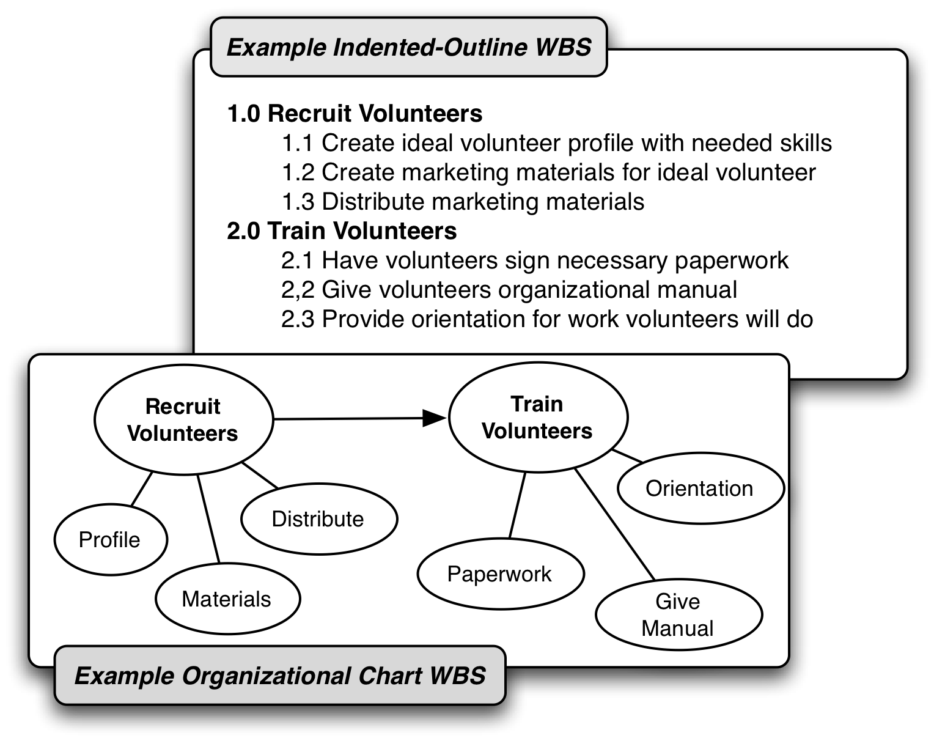

III. Start (People Power)
Figuring out who needs to be involved in your project and getting them on-board is one of your most critical jobs.

Start by figuring out a few key roles for your project
1. Project Champion(s): typically an executive director or the person who came up with your workplan ideas, possibly board members or your supervisor. Champions will advocate for what you are doing in administrative meetings and communications.
2. Project Driver(s): almost always your supervisor or the person you directly report to. They tell you what you should be doing.
3. Project Supporters: those good folks who'll be doing the grunt work that you'll help coordinate.

Once you've figured out who has what role, you can begin breaking down their responsibilities. Luckily you've already drawn up a WBS so you can start dividing tasks by person, role, and responsibility with a Linear Responsibility Chart (LRC) shown below.
To Do

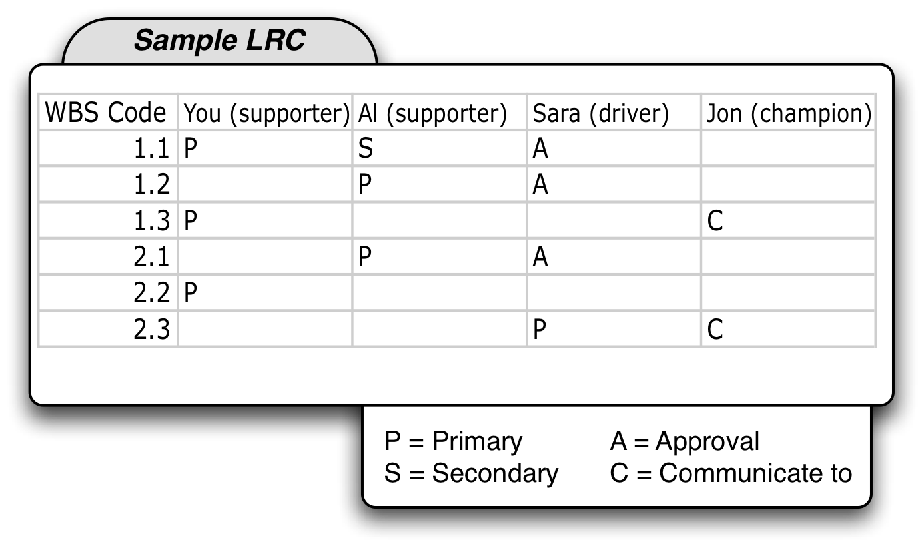

Tip
Be sure to include all external stakeholders your planning. These stakeholders could be the local community, grant/foundation funders, and outside collaborators/partners.

IV. Perform
To Do
This is the point of your project where all your previous preparation comes together. To keep track of progress, it is recommended to use a Gantt chart, which adds time management into the mix. Simply list out the activities listed in your WBS, add a time interval at bottom, and then just plan out how long each activity ought to take.
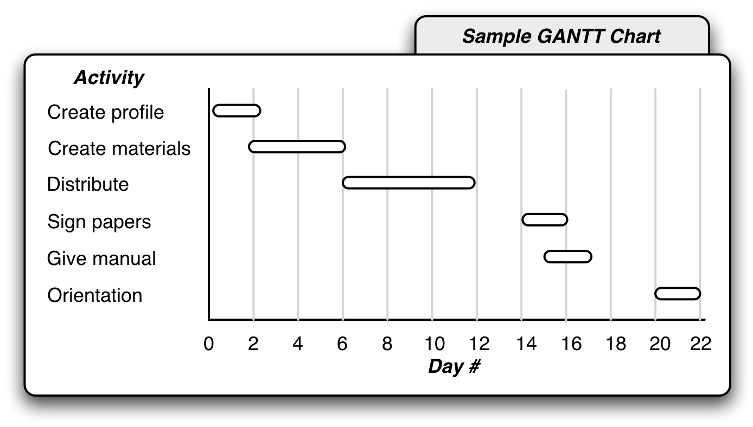

Leadership vs. Management

Tip
Leadership and management are not the same discipline. As project manager you will have to find a balance between both throughout the life of your project. Key differences are shown below.

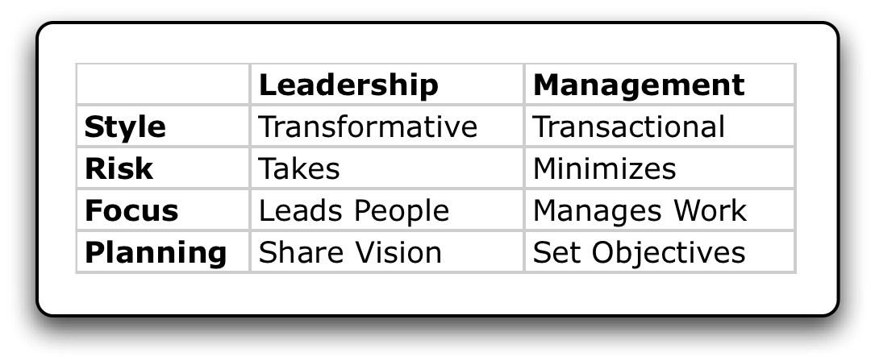

Getting your project back on track
So, it's day 14 of your project. You haven't gotten past your day 4 work and now it's your job to figure out why. Here are some tips to get you project back on track:

- Figure out what changes are necessary by looking back at each step of the WBS, LRC and Gantt
- Reconvene with Project Champion(s) and Driver(s) and explain where to change
- Get Project supporters (co-workers) updated
- Update WBS, LRC and Gantt as necessary (use different colors for revisions, but keep original documents)
- Send any new or changed information out to relevant external stakeholders

Watching out for Scope Creep
Scope Creep occurs when a project moves and changes size or direction without any formal recognition by anyone involved. Example: your supervisor just got back from a conference about web 2.0 and now wants to have "Second Life presence" for your volunteer recruitment project, but says it to you in conversation. You realize this will take away valuable time and resources to your already focused project, not to mention the new idea is very hazy.
Warning

How do you mitigate scope creep?

- Make sure everything is well documented so you can reference easily why an addition or change to the project is not a good idea
- Keep open communication throughout the duration of the project, especially with project champions and drivers (both in Formal meetings/progress reports and informally in conversations and emails)
- Most importantly, be honest

V. Close
For VISTAs, ending a project is just as important as, if not more than, starting and executing it, because this is where you really determine and set your project’s long-term capacity building.

If you have been documenting your work so far in terms of what work was done (Work Breakdown Structure), who did what (Linear Responsibility Chart), and in what timeframe (Gantt Chart), then most of the "closing" work is already done. Since your organization only has you for a year, any successful project you've completed will want to be repeated and with you gone your documentation will be all they have to reference.

Post-Project Evaluation
To Do
Evaluations are key to ensuring your project will have a positive and sustained impact at your organization. The evaluation should be somewhat formal or at least something
that can be printed, filed, and electronically referenced. Some key things to try and deliver in the evaluation include:

- Tips and best practices to include in future projects
- The best way to go about implementing those practices
- What should be avoided on future projects
- How to avoid those unwanted practices

Get the Word Out

Tip
With your project successfully completed, email everyone involved and let them know about its success and how they helped. Be sure to let others at your organization know as well as any external stakeholders such as funders, the local community, and especially CTC VISTA Project HQ!

Further Resources
Project Management: A Systems Approach to Planning, Scheduling, and Controlling. Harold, Ph.D. Kerzner. Wiley Publishing, Inc.
Project Management For Dummies. Portney, Stanley. Wiley Publishing, Inc.
Free Management Library/Management Help (http://www.managementhelp.org/plan_dec/project/project.htm)
Projects @ Work (http://www.projectsatwork.com/)
Project Management Institute (www.pmi.org)

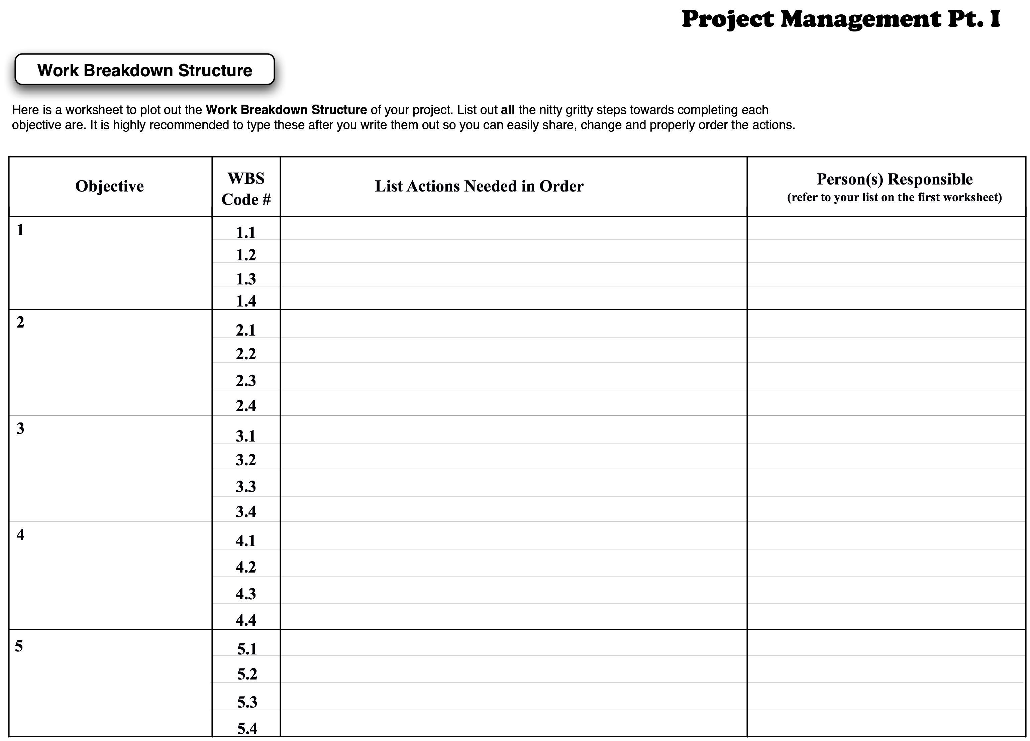
Project Management

Linear Responsibility Chart (LRC)
For each person related to your project, write down their name and their role (Supporter, Driver, Champion). Reference the WBS Code # from your Work Breakdown Structure (WBS) sheet for each action step. In the empty boxes place a P for “Primarily Responsible”, S for “Secondarily Responsibly”, A for “Needs to Approve”, and C for “Communicate to”.

WBS Code # | Name:  Role: | Name:  Role: | Name:  Role: | Name:  Role: | Name:  Role:
1.1
1.2
1.3
1.4
2.1
2.2
2.3
2.4

Gantt Chart
Again, referencing your WBS Code # from your Work Breakdown Structure sheet for each action, plot out how long each action is anticipated to take. Draw a line for each action from what day or week it will start to its end.

Wk 1 | Wk 2 | Wk 3 | Wk 4 | Wk 5 | Wk 6 | Wk 7 | Wk 8 | Wk 9 | Wk 10 | Wk 11
WBS
Code #

1.1
1.2
1.3
1.4
2.1
2.2
2.3
2.4

