Strategic Planning
At some point during your VISTA year you may asked to take part in or prepare a section for your organization’s strategic planning. You may even be asked to coordinate it as past VISTAs have been. Or your organization may not even have a plan past the next 3 months. This section is an introduction to the concepts and methods of Strategic Planning you may have to use during your service year.

What is Strategic Planning?
Strategic planning is typically a 1-3 year forecast of what the organization will look like and how it will “get there”. In the case of nonprofits, especially over the last several years, strategic planning has become key to being more "competitive" within the social service sector as funding is dries up for an ever increasing population of nonprofit organizations.

When is the right time to plan?

- There are no major professional or personal conflicts between executives or board members
- The executive director and/or board president are committed to planning
- There are enough resources and time to devote to the process
- There are no major decisions or organizational chaos in the next several months that could undermine the process (i.e. leadership changes)
- Your organization has been operating to several years
- Your organization is committed top-down to implementing any and all strategies developed

Where to Plan
Strategic planning can occur over the course of an organizational retreat where board members, directors, and staff come together for a day or weekend to plan out their future. These retreats usually happen off-site at hotels, restaurants, etc. and are reasonably well catered (or should be!). However, the plan needs to be revisited, revised, and evaluated throughout the year on a regular basis.
Start BIG go small
The strategic planning process typically starts from the big picture (Vision/Mission) and drills down to the most practical action steps (Objectives) needed to fulfill the plan. Each stage in the process determines the shape and detail of the next stage (shown below):

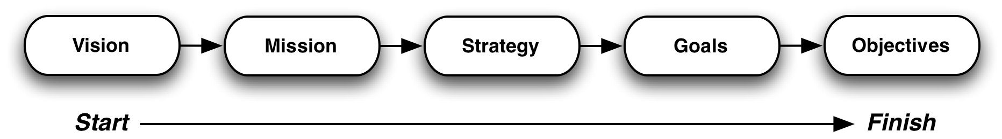

The strategic planning process is framed by three key questions:

- Where have you been? (What do we do/have we done?)
- Where do you want to go? (What will we do/want to do?)
- How do you get there? (How will we accomplish that?)

Where have you been?
To know where you want to go you first have to know where you’ve been as an organization. To start, evaluate performance in the last year. Look at both successes and failures and try to understand why in each specific goal your organization did or did not succeed.

Tip
If work is not well documented, you can create surveys for staff and/or the community you serve to better understand your organization’s achievements or lack-there-of. Bad news usually never flows up, so your executive staff may not even be aware of certain problems. Anonymous surveys may get at some of these unsaid issues.

Looking back is also a good opportunity to revisit your organization’s mission statement. Good questions to ask when refocusing your mission statement include:

- What is the purpose of the nonprofit (this is usually the Vision statement)?
- What actions are the nonprofit going to take to achieve this vision?
- Who is going to benefit from these actions?

Where do you want to go?
Now that you now where you’ve been, it’s time to look at where your organization wants to go. Before you jump right into defining goals, you first should define all the factors that go into the future success or failure of your organization. The SWOT (strengths, weaknesses, opportunities, and threats) Analysis does this very well. By breaking down both internal and external factors that influence your organization’s growth. Here is an example that could fit any nonprofit:
To Do

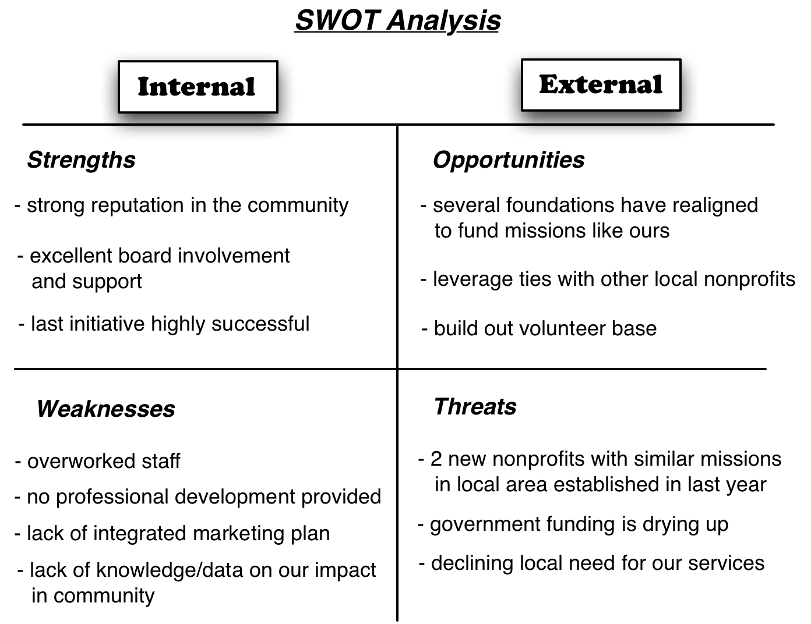

Another great framework to explore the external influences on your organization is the PEST (Political, Economic, Social, and Technological) Analysis. Sometimes added to this are also legal, education, and even environmental influences. Keeping all these external factors in mind is especially critical to nonprofits that work in and impact nearly all these external variables.

Tip

How will you get there?
To Do
So you know where your strengths, weaknesses, opportunities, and threats lie, but now what? It’s time to make your SWOT analysis actionable by putting them in a new chart that pits your strengths to your threats, your weaknesses with to opportunities, etc. (shown below).

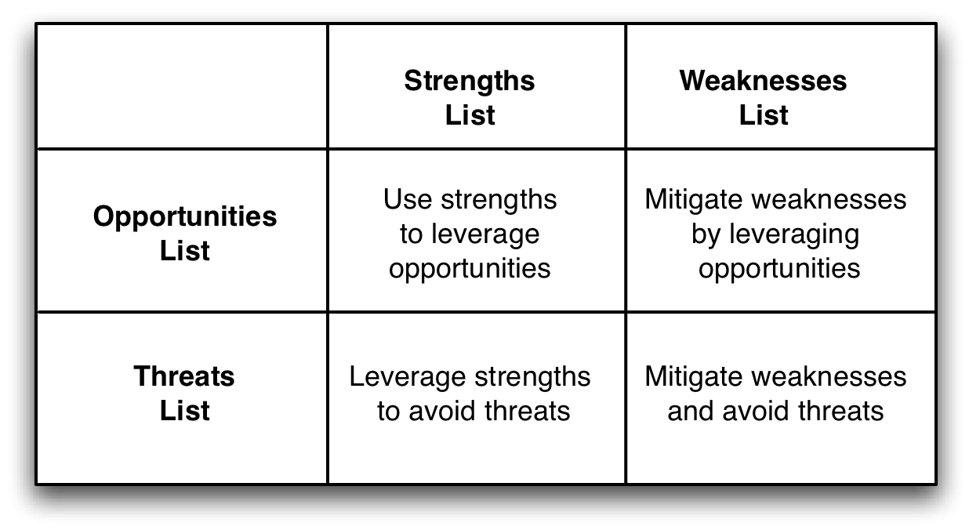
Here are some ways of how this might work using the previous SWOT example. Note that each idea that comes out of this analysis can be categorized as a “Goal”:

- By pairing up with other local nonprofits (Opportunity) you can collaborate on projects which will decrease the workload on your staff (Weakness)
- Since your last initiative was successful (Strength), you can market this to foundations that now could potentially fund you (Opportunity) while also using your strong board (Strength) to make contacts within those foundations

The Final Product
With goals developed from looking at your SWOT and from staff/director/board/community input, you can now begin the process of further breaking down the plan from organizational goals to specific objectives and next actions. Without objectives and next steps, your strategic plan will be highly ineffective towards reaching goals.

Tip
The easiest way to lay out objectives in detail is to give each one to the person whose role it is to complete it and have them generate all the next actions. At this point in your strategic planning process, you begin to find overlap with project management, as each objective becomes more-or-less a separate project (see the Project Management section for more details).

A finalized strategic plan includes, but is not limited to, the following:

- Vision & Mission Statements
- Long-term Strategies
- Targeted Client/Community Profiles (not discussed in this session)
- Stakeholder Analysis (not discussed in this session)
- SWOT Analysis
- Strategic Objectives for Goals
- Next Actions and Steps for Each Objective
- Financial Projections (VISTAs almost never engage with these)

Last Minute Tips
Warning
Here are some common problems people run into during planning or implementing a strategic plan:

- No plan for implementation
- No point person to continually evaluate plan’s implementation
- No one communicates or disseminates the plan to the entire organization
- Getting stuck in the day-to-day and losing sight of long-term goals
- The plan is never integrated or looked at as part of the day-to-day
- Strategic planning and evaluation occurs once every year or two
- No one is accountable for their own objectives or next actions

Further Resources
Strategic Planning for Nonprofit Organizations. Allison, Michael. Wiley Publishing, Inc. 2003.
Strategic Planning for Dummies. Olsen, Erica. Wiley Publishing, Inc.
Alliance For Nonprofit Management (http://www.allianceonline.org/FAQ/strategic_planning)
Free Management Library/Management Help (http://www.managementhelp.org/plan_dec/str_plan/str_plan.htm)

