Network Maintenance Volunteer Training Curriculum Syllabus

Introduction

About the Handbook
This handbook is a short course on maintaining and repairing the free wireless internet networks at properties managed by Little Tokyo Service Center. The course relies mostly upon wiki materials and hands on exercises. The wiki is available at wiki.ltsc.org.

About the Training
This curriculum is designed for a small class setting (1-5 students). Each "module" should be 2-3 hours of instruction time including mini-lectures, discussions, and hands-on activities. Plenty of extra time should be allotted for questions and impromptu discussions. Ideally, classes should be grouped by building, or at least by similar network setup.

Module 1: Introduction to Wireless Networks
Important Links
- Networking Basics
http://wiki.ltsc.org/index.php/Networking_Basics

Introduction to LTSC Wireless

Your responsibilities as a Network Volunteer will include registering users for the wireless internet, monitoring the networks for problems or outages, and fixing network problems in a timely manner. You will also be responsible for involving LTSC in the case that a problem is outside what you have been trained to do. In return, you'll learn a lot about networking, have a say in certain network decisions, be helping you and your neighbors get the best possible service we can provide, and a small stipend.

The Internet at Your Building

Please see attached for your building-specific network equipment list.

How to Connect to the Internet at Your Building

Connecting to a Network

From: http://wiki.ltsc.org/index.php/Networking_Basics#Connecting_to_Wireless_Internet

Since this manual deals primarily with the maintenance of wireless networks and wireless internet, let's briefly go over the steps of connecting to a wireless network:
- Connect your USB wireless adapter or wireless network card to your computer. Instructions should come from the manufacturer, usually in the product manual.
- Install the drivers for the card/adapter. Drivers are the software programs that make a piece of hardware work for your computer. Usually, your adapter comes with a CD that will guide you through installing the drivers, but other times you might have to download the drivers from the manufacturer's website.
- In Windows, go to the lower right hand corner and find the Wireless Network Connection icon. Double click it.
- A new window will pop up. This is the Wireless Network Connections window. Your wireless card or adapter searches for all the networks in the area that are broadcasting.
Here, it sees the LTSC_Wireless, Little Tokyo Unplugged, and yoon networks. Click on the network to which you want to connect, then click the Connect button.
- If the network is uses WEP or WPA key, you will be prompted to enter it now. We'll go over WEP and WPA keys and wireless security later.
Wireless Password prompt window
- The wireless router will start talking with your machine:
- In a few seconds, your computer should be connected to the wireless network you selected. If this wireless network provides an internet connection, you will now be able to use the internet:

Logging into CoovaOM

Currently, all of the LTSC Wireless networks use a free system called CoovaOM to manage the users of the wireless network.

To use a wireless network at LTSC, you must be registered. You can get a registration form from your resident manager. You must create a user name and password that you will use to log in to the internet.
To log in, open a web browser (such as Firefox, Internet Explorer, Safari). When you open the browser and try to use the internet, you will see this page:
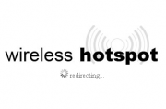
You will then automatically be taken to the login page. If you get stuck on this "wifi hotspot" page, it is possible that you do not have enough signal or that your browser needs to be updated. Internet Explorer 6 will not work with the wifi, you will need to get a free upgrade to Internet Explorer 8, Firefox, or another free web browser. LTSC has copies of these free browsers.
Once you are taken to the login page, you will see an announcement from LTSC and two links: Begin Browsing and User Login.
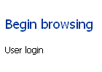
Click User Login.
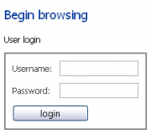
A form will pop up. Enter the user name and password that you registered with LTSC. Then, click the login button.
If your login is correct, you will automatically be taken to the next page:
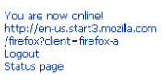
You are now online! Once you've logged in, you can use the internet as normal. Enjoy!

Networking Basics

What is Hardware? What is Software?
To do anything with a computer, you need to make sure you have the proper hardware. Hardware is the physical pieces of a computer: its hard drive, CD drive, the processor, etc. Software are the programs that run on the computer. Examples of software are word processing programs, computer games, and web browsers.

Network Hardware
To connect to the internet, many computers have a device called an Ethernet card. This network card has a plug where you can connect an Ethernet cable, or CAT-5 cable. An Ethernet Card has a place for you to plug in a cable, which will allow you to connect to the network and to the internet.
An Ethernet Card. Also known as a PCI Adapter or Ethernet PCI Card.

An Ethernet or Cat-5 cable.
The ethernet cable plugs into a router. This router in turn plugs into an outlet in the wall—either a phone line for DSL, or a cable plug for cable internet.
A router.
A router is a machine that helps sort and forward information to and from the internet before it goes to your computer.
A wireless router.
Some routers also have an antenna that sends a radio signal. These routers are called wireless routers. You can use the signal from a wireless router to connect to the internet
Your computer needs special devices to hear the signals sent from the wireless router. These devices are called wireless cards or wireless adapters.
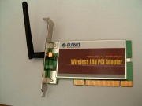
A wireless card or wireless PCI card.
To wirelessly connect to the internet, you must have wireless network card. These are similar to regular network cards, except that they usually have an antenna, which helps the card pick up the signal from the wireless router.
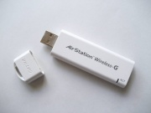
A USB Wireless Adapter.
Another way to connect to the internet via a wireless signal is to use a USB wireless adapter. These adapters work the same way as a wireless network card, they are just smaller and plug into a computer's USB port (this is the same place you would connect a USB flash drive). USB wireless adapters are small, so they are good for using with laptops; however, most laptops already have wireless network cards built in.

Connecting to Wireless Internet
Since this manual deals primarily with the maintenance of wireless networks and wireless internet, let's briefly go over the steps of connecting to a wireless network:
- Connect your USB wireless adapter or wireless network card to your computer. Instructions should come from the manufacturer, usually in the product manual.
- Install the drivers for the card/adapter. Drivers are the software programs that make a piece of hardware work for your computer. Usually, your adapter comes with a CD that will guide you through installing the drivers, but other times you might have to download the drivers from the manufacturer's website.
- In Windows, go to the lower right hand corner and find the Wireless Network Connection icon. Double click it.
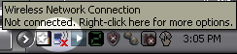
Wireless Network Connections icon.
- A new window will pop up. This is the Wireless Network Connections window. Your wireless card or adapter searches for all the networks in the area that are broadcasting.
Here, it sees the LTSC_Wireless, Little Tokyo Unplugged, and yoon networks. Click on the network to which you want to connect, then click the Connect button.
- If the network is uses WEP or WPA key, you will be prompted to enter it now. We'll go over WEP and WPA keys and wireless security later.
- The wireless router will start talking with your machine:
- In a few seconds, your computer should be connected to the wireless network you selected. If this wireless network provides an internet connection, you will now be able to use the internet:

What is a network? What is the internet?
You are volunteering to help provide tech support and expertise to the LTSC wireless networks. But what is a network? What does a network have to do with wireless internet?
A network is a group of machines that can talk with each other and share information.
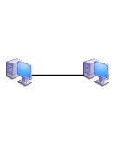
A simple network.

Networks can be as simple as two home computers sharing a printer at home.
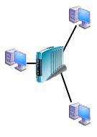
A more complex network.
Networks can also be huge and complex—such as computers networked in an office space.
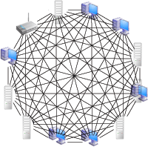
The internet is also a network. It is a huge global network made of computers all over the world. All of these machines are able to share information with each other. Many wireless networks also provide wireless access to the internet.
The internet, like a complex web of connection between machines

Servers and Clients
Say you want to go to LTSC's website, [1]. When you connect to the internet and go to a website, the page that you see is actually information that is being sent to your computer from another computer called a server. The server is essentially a computer where all the information that makes up a website is stored. Your computer's web browser (ie Firefox or Safari) is called the “client.”
Your web browser and the server computer are forming a relationship, kind of like the relationship between a waiter and a customer at a restaurant. That is why your computer is called a client, and the machine where the website data is located is called the server. The client (your web browser) orders an item (the web page). The server (where the web page is stored) then gives the item to the client.

Internet Protocol
For your computer to be able to order a web page from the server, all of these machines must use the same “language,” or protocol. This language is called the Internet Protocol or IP.
Every machine that connects to the internet has an IP Address. Your router gives you this IP Address when you connect to the network. The IP Address is similar to a telephone number. It gives your computer and every other machine on the internet a location. This is useful because it lets your machine and the server recognize each other and exchange information.
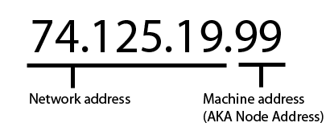
An IP Address.

Every IP address is a set of four numbers separated by decimals.
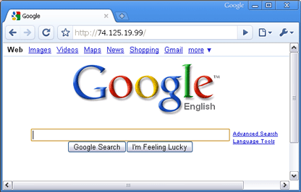
If you want to view a website, you type in the IP Address of the server machine. For instance, one of the Google server's IP Addresses is 74.125.19.99. If you type this IP Address into the address bar of a web browser, you will be able to visit the Google homepage.

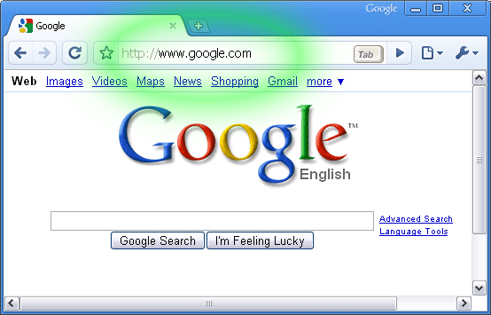
It is kind of like dialing a phone number; the server picks up the phone on the other end and starts sending you the website information. However, IP Addresses are difficult to remember. To access a website, you usually type in a Uniform Resource Locator or URL. These look like this:
Using a URL to visit Google

URLs work the same way as IP Addresses; they are a way to dial up and talk with the server machine. When you enter a URL into the address bar, they are interpreted as an IP Address. That is why you can type in an address, such as www.google.com instead of 74.125.19.99. What is important to take away from this is that IP Addresses can be used to talk with other machines.
IP does have limitations. For example, there are a limited number of IP Addresses available, just like there are a limited number of telephone numbers to go around. How can anyone keep track of which machine is which? And, more importantly, how will we be able to keep track of the different machines on our networks?

MAC Addresses
On a network, machines also have another address, called a Media Access Control Address or MAC Address. A MAC Address is the unique address of your Ethernet card/Wireless card.
We compared an IP Address with a phone number. A family can share a single house phone, so that if you called that phone number, you couldn't be sure which family member was going to pick up. IP Addresses are similar. If you connect to the internet using a wireless network, you could be given the IP Address 198.1.1.1, but that IP Address could be given to someone after you leave the wireless network. IP Addresses can and do change. MAC Addresses stay the same.

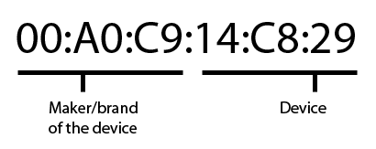
A MAC Address identifies the hardware itself: the physical computer's wireless card, the network router, etc. The first half of the MAC Address identifies who made the device. For example, you can tell that a machine with an address beginning with 0012CF is made by the Accton company. You can look up the different brands and their MAC Addresses here, for free: [2]
The last half of the MAC Address doesn't have a special meaning; it is just unique for each device so we can tell them apart. For instance, one Accton device might have the MAC Address 00:12:CF:83:72:10, another might have the address 00:12:CF:89:8F:EB
For example:
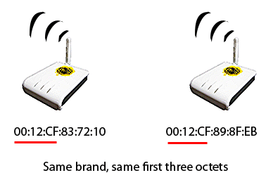
If two devices are the same brand, the first half of their MAC Address will be the same. The last half is the ID of the device.
The first part of the address is the same for both (00:12:CF) tells us the maker is Accton. The last half of each address (83:72:10 and 89:8F:EB) is like the "name" of the device.
The MAC Address is useful for taking care of networks because if something goes wrong, you can tell exactly which machine is having a problem.

A Web of Machines
When you go to a web site, you usually aren't just talking directly with the server computer. The internet is a hierarchy of many different machines. If you want to view a web page, that web page must travel through these many machines from the server to you.
Basic internet hierarchy: your computer, to your router, to your ISP, to the internet.
Your computer connects to the internet via a modem or router. Depending on the network, this router is indirectly connected through wireless, DSL, or fiber optic cable of your Internet Service Provider or ISP. The ISP connects to a web of high speed cable that forms the internet backbone. The internet backbone goes all over the world and allows any computer that connects to the internet to have access to websites anywhere else in the world.

Wireless Connections
Connecting to a wireless router or "acess point" is just like connecting directly to a router with an Ethernet cable. The only difference is that you connect using radio signals instead of plugging a cable from your computer directly into the router.
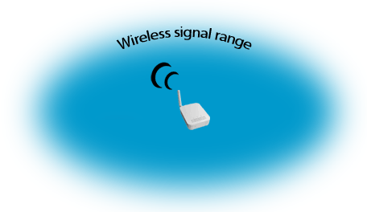
A wireless router produces a radio signal.
To connect to a wireless access point, your computer has to be within range. Just like how a radio broadcast only goes so far, a wireless router can only broadcast a signal in a certain distance.
If your computer is within range of the wireless signal, you can connect to the internet.

This distance depends on a lot of factors: the size of the access point's antenna, the power of the antenna, other access points that might be broadcasting nearby, to name a few.
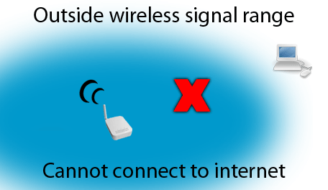
If you go outside the range of the access point, your wireless adapter will lose the signal.
If your computer is outside of the wireless signal range, you cannot connect to the internet.

If you don't have a signal, you won't have any way to connect to the router. Without a way to connect to the router, there is no way to connect to the internet.

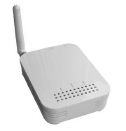
Wireless Mesh
An Open Mesh router or "access point"

There are a lot of different types of wireless networks. One problem in making a wireless network: how to provide coverage to a wide area. High powered routers with wide signals can be expensive.
A low-cost way to cover a big area in wireless signal is to just have a few routers connected to the internet and then use small, inexpensive devices called repeaters.
Say you have a wireless router/access point that is connected via an Ethernet cable to the internet. This router is called the "gateway node." A repeater node takes the signal from the gateway router, but then it re-broadcasts or “repeats” that signal.
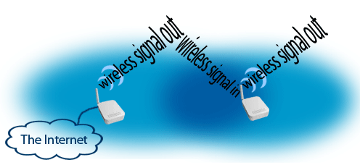
How wireless repeaters work:
- A wireless router is connected to the internet. This is the gateway node.
- The gateway broadcasts a wireless internet signal.
- A nearby repeater node picks up the signal.
- The repeater node re-broadcasts the wireless internet signal. This creates a “cloud” of signal over an area. We call this area a wireless mesh. The signal overlaps, kind of like a mesh or cloth, that can cover a large area with wireless signal.
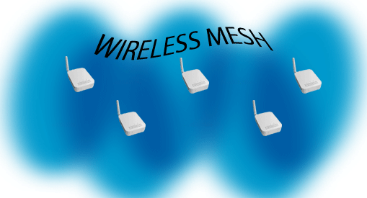
Overlapping signals provide wireless internet signal to a wide area.

If you or any other machine are within range of this mesh, you will be able to connect to the wireless internet—even if you are very far away from the signal of the router.
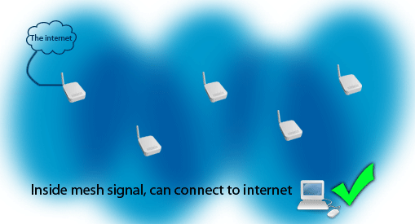
If you are within the mesh signal, you can connect to the internet.

Of course, if your computer is not within range of the mesh signal, you will not be able to connect to the network or to the internet.
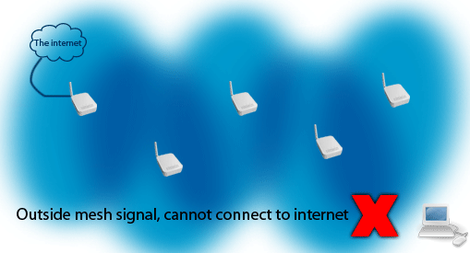
If you are outside of the mesh signal, you won't be able to connect to the internet.

Another useful thing about wireless mesh is that you can move around within the mesh and still stay connected to the network.
If you move out of range of the signal from one repeater, the next nearest repeater will automatically provide you the signal you need. You won't lose a connection even though you're technically getting signal from a different machine (from a different repeater node).

Signal Strength and Connection Speed
When you try to connect your computer to a wireless network, you will usually see a window like this, where you can choose a network:
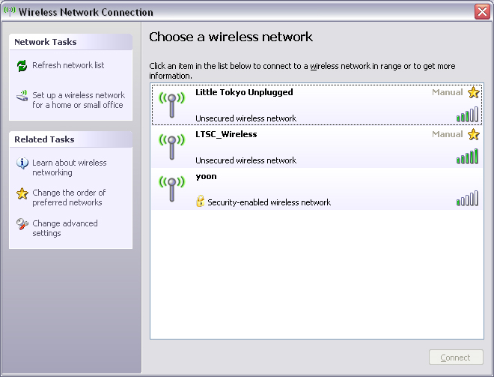

In this example, there are a few different networks broadcasting. However, not every network has the same signal strength. You want a strong signal, because signal strength limits the speed of your wireless internet connection. As we discussed earlier, going outside of the mesh signal will mean that you cannot connect to the internet. However, being on the edges of the signal area will slow down your internet or even prevent you from connecting.
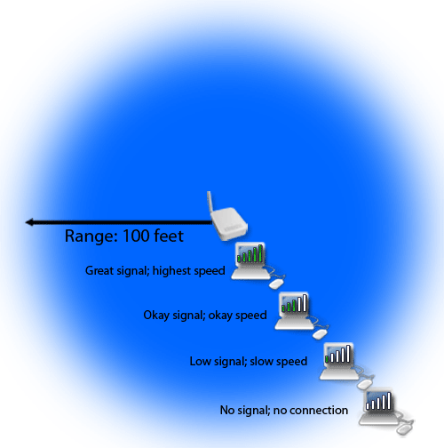
The further you are from a wireless access point, the weaker the signal and the slower your internet connection.
Signal strength is usually displayed in “bars.” One bar means that the signal strength is very low, but four or five bars means that the signal is very strong.
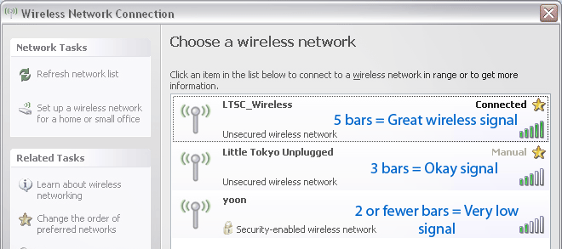
Signal strength is often displayed as "bars." The more bars, the stronger the signal.

Internet connection speed is different from signal strength. Internet connection speed is usually measured in megabits per second or Mbps.
What is a bit? What is a megabit? A byte? Information stored on computers is measured in bits and bytes (megabytes, kilobytes, etc). There are 8 bits in a byte. To give you some perspective, an image like this:
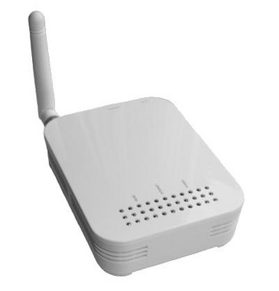
Is about 10,240 bytes, or 81,920 bits.
For instance, an internet connection might be 1Mbps download speed (1 megabit = 1 million bits). This means that you could download about 1 million bits of information per second. If your connection speed is 1Mbps, you could download several of the above pictures in one second.
Again, signal strength is different from internet connection speed. You can have five bars of signal strength but still have a slow wireless internet connection. Wireless internet speed is also limited by the speed provided by the router.
If your original internet connection is 6Mbps at the wireless router, this is the maximum speed you will be able to have anywhere on your network. This speed will just decrease the further your computer is from the router.
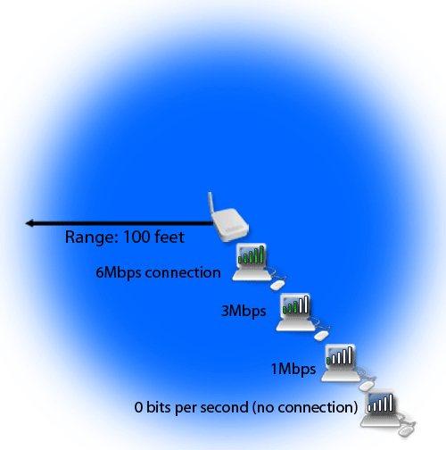
As the wireless signal strength decreases, internet connection speed usually decreases too.
Now that you know the basics of signal strength and internet speed, let's go over another part of how wireless networks work: channels.

Repeater Nodes Working Together on Channels
Wireless internet also works because of channels. When you try to connect to the wireless network, sometimes there are many different networks being broadcast.
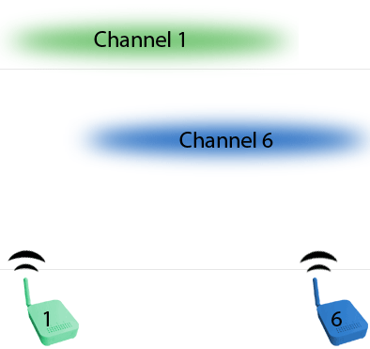
Mulitple wireless networks in range.

In the United States, wireless networks are allowed to broadcast on eleven different channels. The router and all of the repeater nodes on a network must be set to broadcast their signal on the same channel in order for the mesh to work.
Repeater nodes set to different channels cannot communicate with each other to form the mesh.
For example, if a repeater node broadcasts on channel 6, it will also only be looking for broadcasts from other nodes on channel 6. Therefore, if a different node is broadcasting on channel 11, the nodes won't be able to talk with each other.
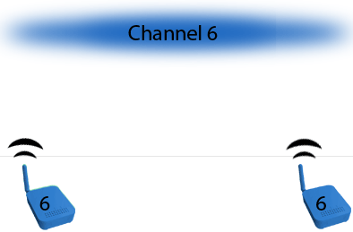
Nodes set to the same channel can talk with each other and share the internet signal.
We want the nodes to form a strong, continuous wireless signal over the entire area, so we set every node and router on the network to broadcast on the same channel.

Wireless Security
Even though wireless internet is often a convenient and cost-effective alternative to wired networks, there are some security concerns. There are several types of wireless security measures, and some of these measures are used on LTSC networks.
There are a few main types of wireless network protection you will see:

Captive Portal Authentication
The system that LTSC currently uses, captive portals are a way to manage network use. When a user connects to the network and tries to browse the web, a login page requests a user name and password. This method is useful because it is generally compatible with a multitude of computers and web browsers (there are exceptions), whereas WEP/WPA is sometimes not compatible.
We use CoovaOM to manage our captive portal, and this system lets us give unique user names and passwords to individual residents. This way, we're able to keep track of how many people are using the network and provide better statistics for grants, configure the network to better support our users, and hopefully be more accountable to our residents.

WEP Encryption
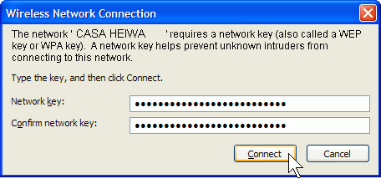
Connecting to a network with a WEP key.

Some networks use WEP or “Wireless Equivalent Privacy” encryption. This is an older way to protect networks. It isn't the most secure protection against network intruders and “hackers.” To log on to a network that is protected by WEP encryption, you will usually be asked to enter a password or “WEP key” that is 26 letters and numbers long.
Example WEP key: 3E1ABCAE59D1EF8FAF35D16AF5
Currently, none of our networks use WEP encryption.

WPA
Another type of protection is a WPA-PSK or “Wi-fi Protected Access with Pre Shared Key.” Networks with WPA are more secure than WEP. The key is usually given to users in the form of a password. The password could be 8 to 63 characters long. You enter this key the same way you would enter a WEP key (your computer will prompt you to type it in).

Open Networks
Open networks (no password required). To connect to these networks, you only need to be within range of their wireless signal. Anyone can connect to these networks, but that doesn't mean that they are unsafe. When doing business or banking online, you should only be using companies that encrypt (protect) your data. You should also only do business with websites that you trust with your information. You can usually tell that your data is protected because a little picture of a lock will appear in your browser, usually at the bottom of the window.
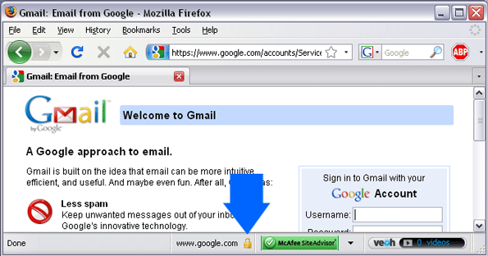
This lock icon means that this website uses encryption.

Wireless Security Tips
Always connect to a wireless network that you trust. Only do online business/banking on legitimate websites that are secure. Only share your network's WEP or WPA key with people you trust.

Building Tour and Intro to Maintaining the Wifi
At this point, we'll go on a brief tour of your building and the location of its wireless equipment. We'll also go over one of the most common solutions to a network outage.

How to Cycle the Power on a Node
- Locate the node. If you need help finding the node, consult the Dashboard for a detailed list of locations: Open Mesh Dashboard
- If you need help getting access to the node, contact the building manager.
- Check the power light, WLAN light, and Internet light. If the power light is on, proceed.
- Unplug the power from the back of the node. If the node is powered with a Power over Ethernet cable, unplug this cable.
- Wait 60 seconds.
- Plug the power back in.
- Wait for the power light, WLAN light, and Internet light to come on.
- Wait five minutes before checking on the node status on the Wiki or the Dashboard. Check to see if the node is up.

Module 2: Monitoring the Network
Important Links
- Using the Wiki to Monitor Networks http://wiki.ltsc.org/index.php/Using_the_LTSC_Wireless_Wiki#Using_the_LTSC_Wireless_Wiki_to_Monitor_Networks
- Using the Dashboard to Monitor Networks http://wiki.ltsc.org/index.php/Using_the_Dashboard

What is the Dashboard?
The Open-Mesh Dashboard is a website that lets you see what is happening in any LTSC network. Open-Mesh is one of the companies that sells wireless mesh nodes, and they provide this Dashboard website as a free service. The Dashboard shows all sorts of useful information: how many people are using the network, which nodes are working, and more.
Let's take a tour of the Dashboard.

Going to the Dashboard
To view the Dashboard, you must be connected to the internet.
To go to the Dashboard start page, open a web browser, type this address into the address bar, then press enter: http://www.open-mesh.com/dashboard.php
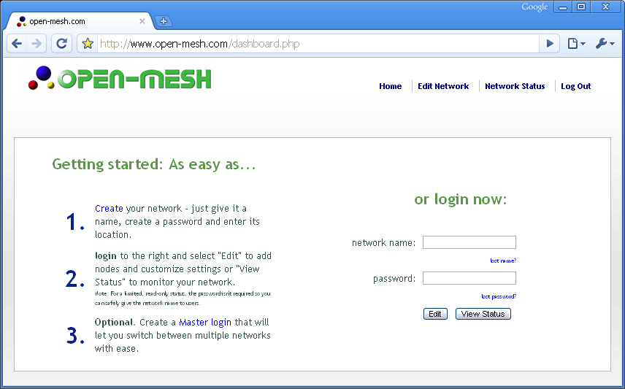
The Dashboard.
This is the start page of the Dashboard. From here, you can view any of the LTSC wireless mesh networks.

Selecting a Network to View
On the Dashboard start page, there is a section marked “login now.”
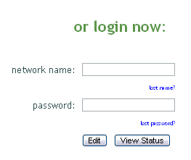

This is where you select a network to view.
There is a text box for network name, and a text box for a password. To view a network's status, all you need to know is the network name.
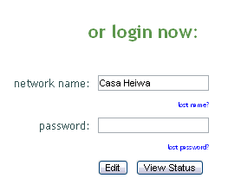
Enter the name of a network, for example, “Casa Heiwa,” in the network name text box:
Example: Selecting the Casa Heiwa network.
The name is not case-sensitive, which means that it doesn't matter if you type it “CASA HEIWA” or “casa heiwa,” as long as it is spelled correctly.
You can find a list of LTSC Network names and the locations those networks serve by clicking here: Network Names

After typing in the network name, click the View Status button:
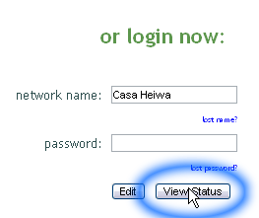
Click the View Status button to confirm your network selection.
After clicking the View Status button, the Network Status page will load:
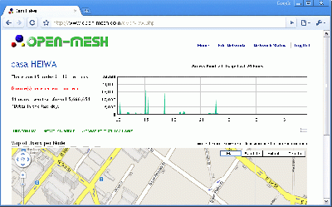

Network Status Page
On the Network Status page, there is a lot of information about the current status of the network. While you are logged in to the network, you can return to this page at any time by clicking the “Network Status” link at the top of the page:
Let's go over the different sections of the Network Status Page.
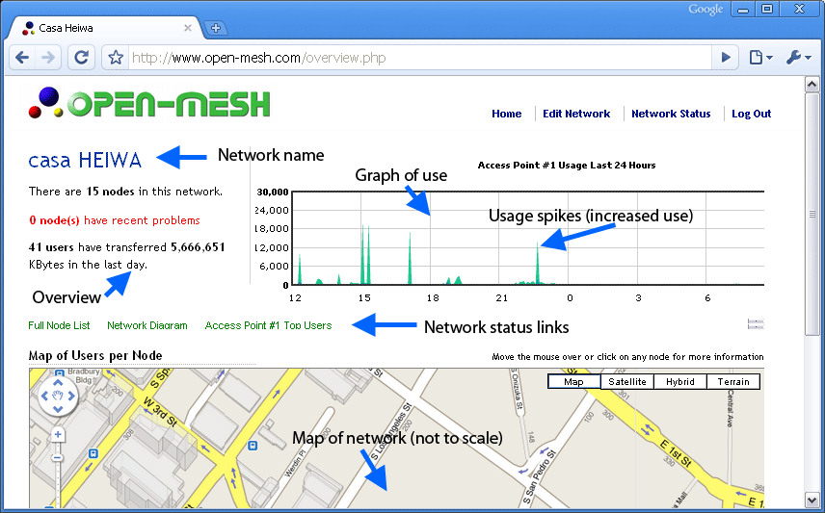
Near the top of the page is the name of the network. In this example, the name of the network is Casa Heiwa.
Directly beneath this is an overview of the network status. It lists how many nodes are in the network, how many nodes have recently had problems, and how many people have been on the network in the last day.
Right of the overview is a graph of the usage. This graph shows internet use, also known as “traffic,” over the past day. Spikes in the graph show times when there has been a lot of internet usage.
Below the network overview and graph are three links: Full Node List, Network Diagram, and Access Point #1 Top Users. We'll go over these one by one, but first look below the links to see the Map of Users per Node.
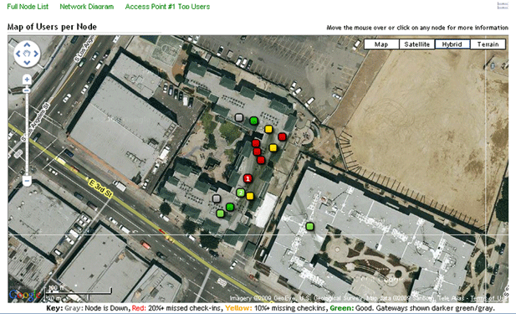
You will see a street map with several little squares. This map shows the approximate location of all of the nodes on the network. Each of the squares represents a node. The nodes might be different colors. What do the different colors mean?
If you scroll to the bottom of the web page, below the map is a Key.
The key tells you what the different colors mean. Each color corresponds with different node status.
Gray: node is down, not working, not talking with the other nodes
Red: node has missed 20% of its checkins. This means that over the last 24 hours, the node has only been talking with the other nodes for 20% of the time. There are a lot of reasons for this, and we will go over the reasons and how to fix them.
Yellow: node has missed 10% of its checkins over the last 24 hours.
Green: node is up and working.
A node with a number inside: The number is how many people that are connected to the node right now (how many people are using the node to use the internet). Now, let's go back to the links above the network map. Click on Full Node List.

Full Node List
When you click on the Full Node List in the Dashboard, it lists all of the nodes that make up the network.
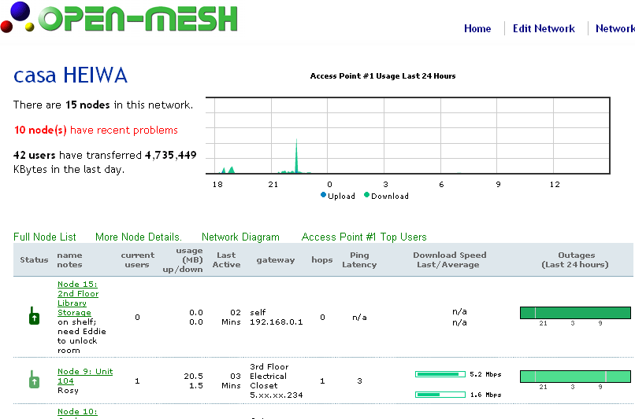
Each node has its own row. Here is the information that you will see for each node:

Status
Whether the node is working or not working, color-coded. If the arrow is pointing up, the node is “up” and working. If the arrow is pointing down, the node is not working. In this example, the node is "up."

Name and Notes
The name of the node and notes. The name and notes usually tell you where the node is located (for example, “4th floor” is the name of a node in Casa Heiwa).

Current Users
The number of people who are connecting to the internet via the node. Useage (MB) Up/Down. Information is measured in units called megabytes. Here, Dashboard tells you exactly how much data has been downloaded from the internet.

Last Active
This column shows how much time it has been since the network has been able to talk with the node. Ideally, the node should never take more than 5 minutes to check in with the network.
If it has been a while since the node has checked in, a Late! Message will be displayed:
If days have passed since the node has checked in, a Down! Message will display:

Gateway
This column lists where the node is connecting to. This could be to a router, or to another node. Gateway nodes are nodes that are connected to the internet via an Ethernet cable.

Hops
This column lists how many nodes it takes to form a pathway back to the router and to the internet. This number should not be more than three. A node that is many hops away from the router will be much slower than a node that is only one hop away from the router.

Ping Latency
You probably won't have to worry about this statistic. It tells you how long it takes to get a response back from the node if you try to talk with it. The lower the number, the faster the node is to reply.

Download Speed Last/Average.
This column shows how fast in Megabits per second (Mbps) the internet is at the node, both currently and on average. The higher the number, the faster the internet is for anyone connecting to the internet via that node.

Outages (Last 24 Hours)
Lastly, this graph shows a history of the node over the last 24 hours. An outage is just another way to say the node is “down” or not working right. Green sections mean that the node has been connected, and gray sections show when the node has been “down” or not working. <image annotated of green versus gray>
This information is useful, but as a network volunteer, you may need more information, such as the MAC address of the node. If you need this information, there is a way to get it.
From the Full Node List, you can now click on the More Node Details link, which is right above the node list.

More Node Details
The More Node Details link expands the node list so you can see the IP Address and MAC Address of each node. Other than that, the list is mostly the same, and the IP and MAC Address is probably the only information you will need from the More Node Details list.
You will notice that the IP and MAC Addresses are not complete. They have x's that partially block out some of the address. The Dashboard automatically does this so that the network will be safe and secure. You will still be able to use the partial IP and MAC address to identify nodes. These addresses match the IP and MAC Addresses that can be found on each node sticker.
To go back to the Full Node List, just click on the Full Node List link or the Fewer Node Details link.

Network Diagram
Another Dashboard tool is the Network Diagram. You can see the Network Diagram by clicking on the Network Diagram link.
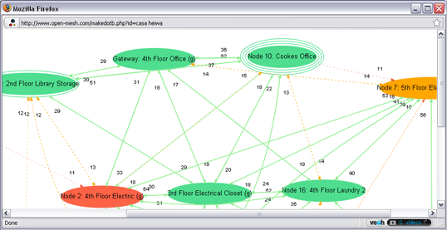

The Network Diagram.
You probably won't need to use the Network Diagram. It is a way to see the relationships between the nodes on the network. Each node is an oval, and the lines drawn between the ovals show that the nodes can connect with each other.
Again, you probably won't have to look at the Network Diagram, but you can find out more about the Network Diagram here: Open Mesh Website: Using the Dashboard

Access Point #1 Top Users
Lastly, let's go over the Access Point #1 Top Users section of the Dashboard. If you click on the Access Point #1 Top Users link, a window will open that shows the network overview, the use graph, and a list:
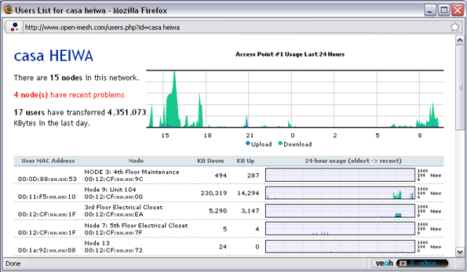
Top Users list.
This list shows all of the machines that have connected to the network in the past 24 hours. It gives the machine's MAC Address, which node they were connecting to, and how much they downloaded and uploaded to the internet. It also shows a graph of when the machine was using the internet.
This list includes all machines that connect to the network; laptops, desktop computers, portable gaming devices, even phones that use the internet. All of these machines have unique MAC Addresses.
Why would you need to use this list? Sometimes, the network has problems because of usage. One machine might be using more than its share of the internet and making it slow for everyone. Too many people might be connected to a particular node. So, this list is useful for solving those sorts of problems.

Logging Out
If you want to look at a different network or if you are leaving the computer, you will need to log out. For the security of the network, always exit or “log out” of the Dashboard when you leave a public or shared computer.
In the top right corner of the Dashboard, there is a link that reads: “Log Out.” When you are done using the Dashboard, always click the Log Out link.
Click the "Log Out" link to log out of the current network.
Clicking the Log Out link will take you to the Dashboard start page. From here, you can enter a Network Name and look at a different network, or you can close the browser.

Module 3: User Management on CoovaOM

In this section, we'll go over how to add residents to the wireless networks.

Important Links
- Logging into a CoovaOM Network http://wiki.ltsc.org/index.php?title=Logging_into_a_Wifi_Network_with_CoovaOM
- CoovaOM Network Admin Guide http://wiki.ltsc.org/index.php/CoovaOM_Network_Admin_Guide

Usage Statistics and User Management with CoovaOM

To keep track of how many users we have on a network, how much bandwidth they are consuming, and to prevent non-residents from taking bandwidth, we use a system called CoovaOM. Short for "Coova Open Mesh," this system is completely web-based, meaning you can use any web browser from any location to access it. Knowing how to use CoovaOM will allow you to give new residents access to the internet.

Logging into CoovaOM

To log into CoovaOM, first log into the Open Mesh Dashboard (covered in Module 2). Logging into the Open Mesh Dashboard automatically logs you into CoovaOM. Under the Edit Network section, click the SSID1 tab:
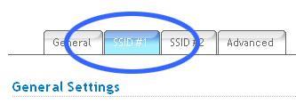
This tab controls the residential network. Scroll to the bottom of the page and click the Configure Coova button:
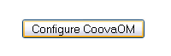

You will be taken to the CoovaOM management page. From here, we can add or delete users, monitor how many users are on the network, and more.
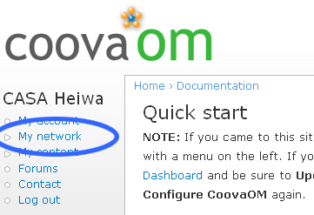

How to Add a New User

Log in to CoovaOM. Click "My Network" to begin:

Click the New User button:
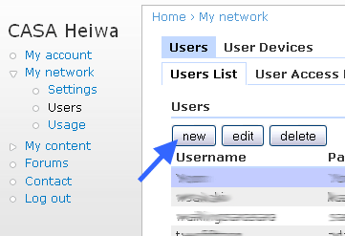
Next, fill out the New User Form. The user name and password can contain letters and/or numbers. Enter their e-mail address and/or phone number and their apartment number. Lastly, select the Residential Free Policy for their access policy (this policy gives them unlimited network usage):
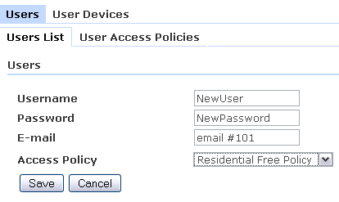
Click the Save button, and the new user will be added to the network. The resident will be able to use their login information in about five minutes.
You can use this same form and process to edit or delete a user.

