Reno Apartments Wireless Mesh Deployment

Goals
- To provide wireless internet services to the building, decent coverage to all floors and all sections of the building.
- To ensure the security of these networks and the network devices of which they are comprised.

Approach

The Building
- The building is about 110-120 feet long and 50 feet across (40 feet across the main part of the building, 50 for the front two rooms. There are four floors and 48 units.
- Building is divided by doors into sections: The first two larger rooms near the front, a cluster of six central apartments, then a cluster of four apartments. A hallway runs down the center of the building.
- Each apartment has its own breaker, but there are public wall outlets in the central hallway.

Gateways
- One main gateway/high speed internet connection on first floor (Bo's office)
- At least one other gateway on each floor. These gateways could be additional DSL connections, or they could be routers connected to BPL (broadband over powerline) adapters.
- The gateways (other than the first floor office gateway) should be central if possible. There are a few options, including placing the central gateway nodes with residents, or placing them in the central hallway and then securing them with a sprinkler box/something similar.
  - Gateway nodes that are easier to access without bugging the residents will be easier to maintain, but at the risk of vandalism/theft.

Repeaters
- The recommended number of nodes is one per 4-6 apartment units. A repeater's range is about 50-150 feet, so we could possibly get away with only deploying two nodes per floor and still achieve adequate coverage. So, the total number of nodes needed, including gateway nodes, would be at least 8 but likely no more than 12.

Security
- Locked plastic sprinkler/wiring boxes for nodes in hallway/public spaces.
- WEP Encryption and/or MAC Address filtering.

Maintenance
- The more nodes that are in public places, the easier it will be for one or two people to take care of them all.
- Hold trainings for anyone who hosts a node in their apartment and for wireless volunteers.

Equipment Cost Estimates
- Mesh nodes
  - $1200 = 8 @ $150 each Meraki Indoor OR
  - $240 = 8 @ $30 each Open Mesh low cost OR
  - $400 = 8 @ $50 each Open Mesh professional
- Lockable sprinkler boxes or wiring enclosures
  - $280 = 8 @ ~ $35 each Sprinkler boxes OR
  - $120 = 8 @ ~$15 each wiring enclosures
  - $??? Other options http://www.hometech.com/hts/products/wiring/enclosures/weatherproof/index.html
- Broadband over Powerline adapters
  - $260 = 2 kits @ ~$120 each (2 adapters per kit = 4 adapters total)
Total cost for equipment: $620-$1740

Other Costs and Considerations
- DSL connection(s)
- Will BPL work in this building? Will it work in tandem with gateways being hosted by tenants?
- Is it fair to put a gateway in a resident's apartment when it consumes quite a bit of electricity?

Placement Plan

First Floor
Main gateway + BPL in Bo's office. Repeater in the 4-unit cluster hallway or in unit.
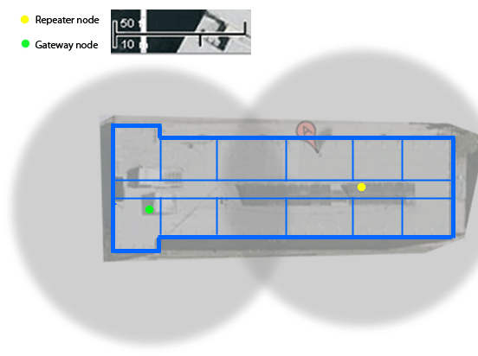
Second Floor
BPL gateway to 4-unit cluster hallway or a unit, + repeater in west hallway.
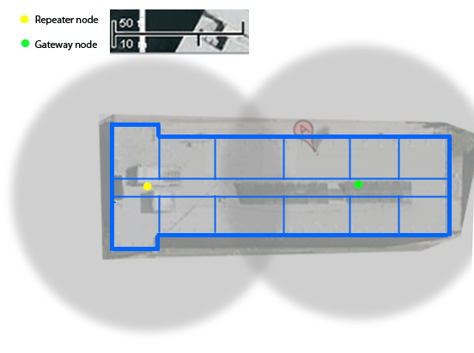
Third Floor
BPL gateway west side of building, repeater on east side.
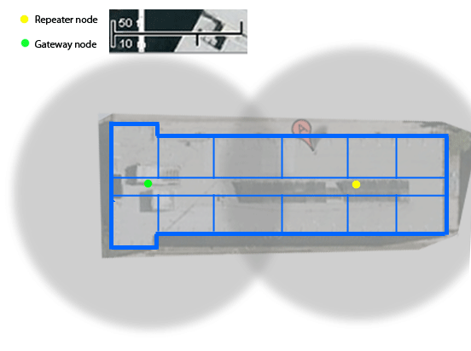

Fourth Floor
BPL gateway east side, repeater node west side.
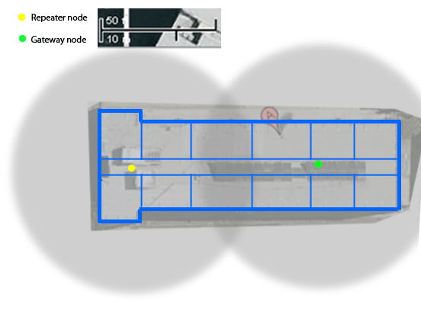
Side View
Stagger gateways and repeaters for equal coverage on east and west side of building.
