*BUILDING COMMUNITY THROUGH TECHNOLOGY*

**Winter**

11

STOP MOTION ANIMATION WORKSHOP

08

**Fall**

DISKovery Center ⬩ 353 E. 1st Street ⬩ Los Angeles, CA 90012

213.621.4158

www.diskovery.org

**STOP MOTION ANIMATION WORKSHOP**

January - February 2011

**ABOUT THIS COURSE**

This classoffers an overview of the fundamental concepts of stop motion animation, including timing, storyboarding, and animation effects.

Students will learn what equipment, such as software and cameras, is necessary and how to use it properly to animate stationary objects. Students will build an understanding of filmmaking using animation and apply these concepts to discuss and analyze animations, including their own.

This course is designed for those with little to no experience with animation or filmmaking.

[Add legalese] This curriculum is solely the property of the DISKovery Center, a program of the Little Tokyo Service Center. No portion of this document shall be copied, used or reproduced in part or in full without prior consent of the Little Tokyo Service Center. For questions concerning use of this material please call 213.621.4158.

**TABLE OF CONTENTS**

1. **What is an Animation? . . . . . . . . . . . . . . . . . . . . . . . . . . . . . . . . . . . . . . 4**
2. **Cameraless Animation . . . . . . . . . . . . . . . . . . . . . . . . . . . . . . . . . . . . . . .6**
3. **Setting Up. . . . . . . . . . . . . . . . . . . . . . . . . . . . . . . . . . . . . . . . . . . . . . . . . 7**
4. **Paper Cutout Animation . . . . . . . . . . . . . . . . . . . . . . . . . . . . . . . . . . . . . 9**
5. **Tips and Tricks. . . . . . . . . . . . . . . . . . . . . . . . . . . . . . . . . . . . . . . . . . . . . 11**
6. **Other Types of Animation. . . . . . . . . . . . . . . . . . . . . . . . . . . . . . . . . . . .13**
7. **Screening List. . . . . . . . . . . . . . . . . . . . . . . . . . . . . . . . . . . . . . . . . . . . . .14**

# WHAT IS ANIMATION?

Animation is the rapid display of a sequence of images in order to create the illusion of movement.

# WHAT IS STOP MOTION ANIMATION?

Stop motion is an animation technique used to make a physically manipulated object appear to move on its own. The object is moved in small increments and photographed one frame per increment, creating an illusion of movement when the images are played as a continuous sequence.

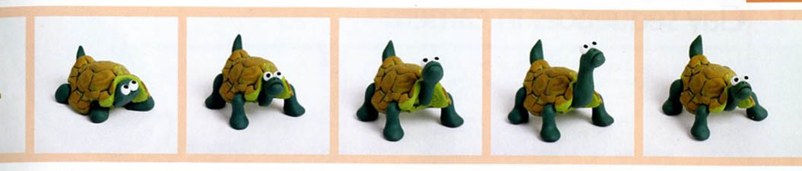

# TERMS TO KNOW:

**Persistence of vision:**

When an image is flashed before our eyes, our brain holds it for a short time. If a second image follows close behind the first, our brain blends the two images. By flashing enough images in quick succession, the brain perceives the image stream as motion.

**Frame rate:**

The number of frames per second at which a film is viewed.

**Shooting in 2s:**

A commonly used animation process whereby every frame of animation is recorded twice, cutting down on shooting time. You shoot in twos by taking two shots, or frames every time you move or modify the object.

**Shooting a hold:**

Often used at the start and end of a simple sequence, shooting a hold involves recording a number of frames without moving or modifying the subject. This allows the viewer a few seconds to take in the subject before the animation begins. It can also be used in the middle of a sequence to help pace action.

**This is a frame.**

**Why is frame rate important?**

The amount of frames per second used in an animation dictates how fluid the motion will be.

Most feature films are shot or transferred to 35mm film and are screened at a rate of 24 frames per second. That means that in order to have a 1 second long animation at this rate, you will need to take 24 pictures. However, if you are willing to lose a small amount of fluidity, you can lower your frame rate to 12 or 15 frames per second.

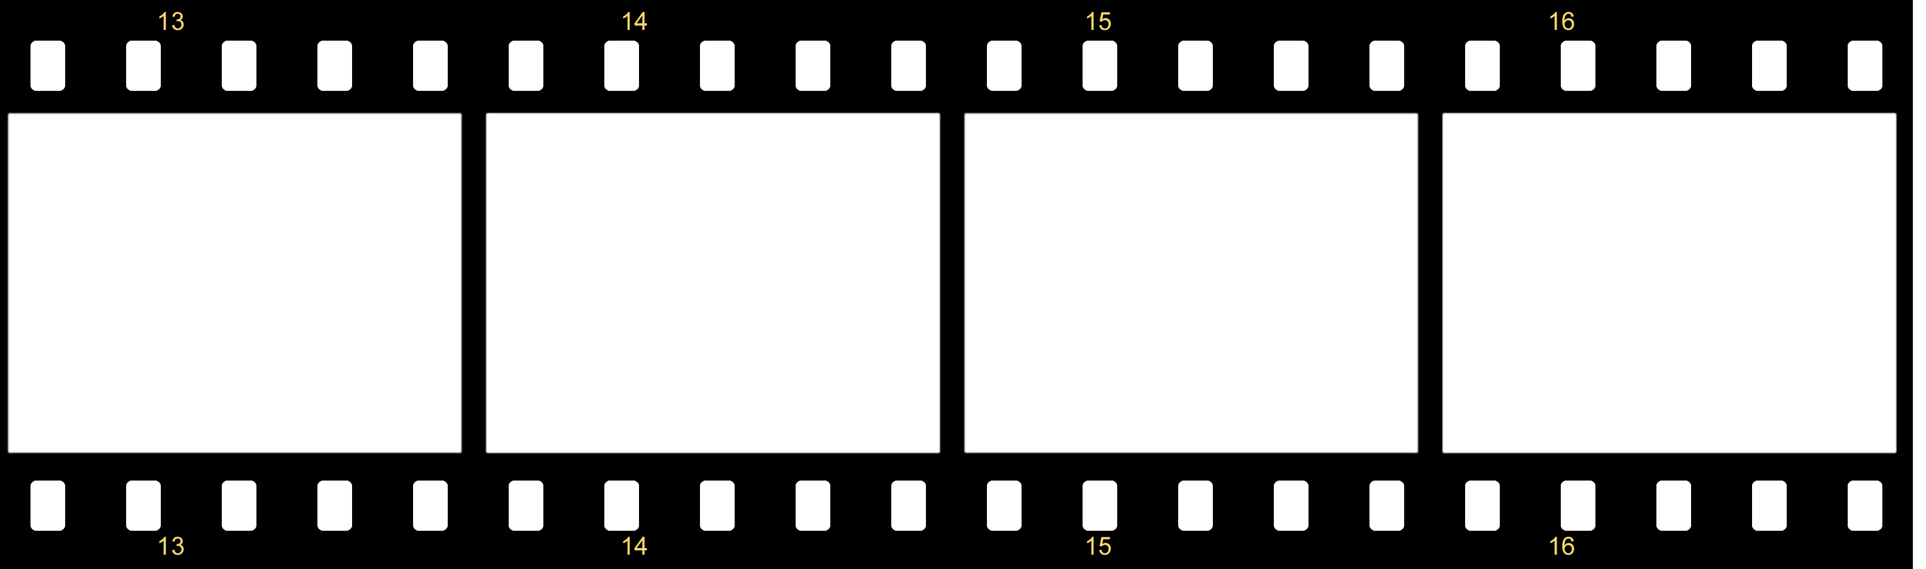

24 FRAMES PER SECOND

**TERMS TO KNOW FOR CAMERALESS ANIMATION EXERCISE:**

**16mm film:**

An economical gauge of film used for motion pictures and non-theatrical filmmaking. 16mm refers to its width.

**Leader:**

A film leader is a length of film attached to the head or tail of a film to assist in threading a projector or telecine. Leader can also be used for camera-less animation. Clear leader can be drawn, painted, etc and black leader can be scratched frame by frame to produce an animated sequence.

**Splicer:**

A splicer allows you to join two individual pieces of film to create one longer piece.

**Splicing Tape:**

Tape with perforated edges that align with the edges of the leader.

**Projector:**

A projector is an optical device for projecting a beam of light. You must thread your 16mm film through a 16mm projector in order to screen your animation.

**Cameraless Animation**

Cameraless animation, also referred to as direct animation, is an animation technique where footage is produced by creating, or drawing, images directly onto film stock. In this course, we will be drawing on 16mm clear leader and/or scratching on 16mm black leader.

**DIRECTIONS:**

1. Keep the sprocket holes on the left. Write HEAD and your name on the first frames, otherwise your words might be backwards or your images upside-down.
2. You can use the guide at right as a template to find the frame lines. Note the two margins on each side. A projector will not project the area reserved for a soundtrack (even on clear film without a soundtrack).
3. The projector will project your film at **24 frames per second.** Make some special markings so that later you will remember and see what one frame will look like and what 24 together look like.
4. Have fun! Don’t worry about any one frame, the projector moves very quickly.
5. **Watch out!** Anything that peels off, flakes off or rubs off after it dries may wreck the projector! Whatever material is applied to the film must be flexible and light must be able to pass through it.

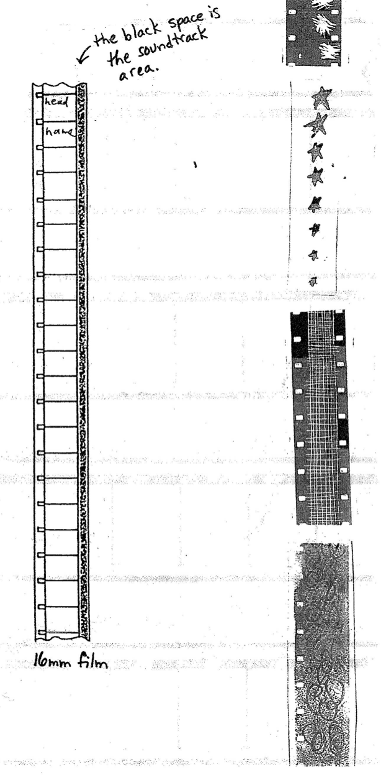

**What did you learn?**

After the cameraless animation exercise, you should now understand the basics of animation. You understand that the standard exposure rate is **24 frames per second**, although you can adjust the rate depending on what medium you are working with. You also understand that **frame rate** determines how fluid and ‘life-like’ your animation appears, and that animation is about **patience** and working in **increments.**

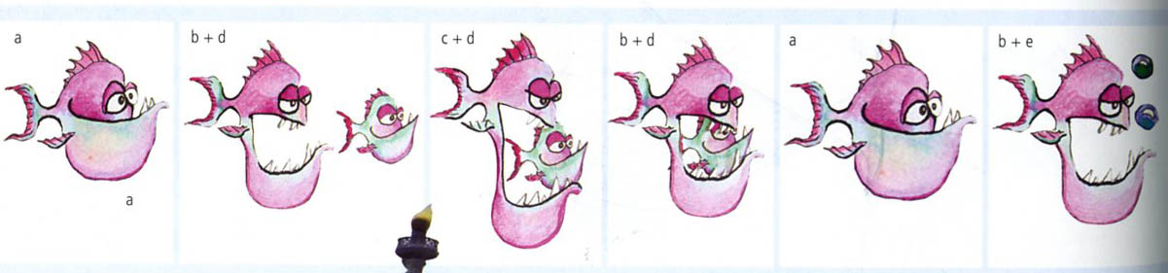

**Ready to animate?**

Cameraless animation is a good technique that helps us learn the basics of animation. Now, we can begin to explore stop motion.

## What equipment do you need?

You need the following list of equipment:

* A **computer** with an **animation program**. For this class, we will be using **FrameThief** 2.1, a program that you can download online.
* A **camera** – any kind of Mini-DV camera
* A **tripod** to hold your camera steady and in place.
* A **capture station** – a professional copystand is preferable, however, something as simple as a desk or table will work.
* Appropriate **lighting** – although you can use whatever lighting is available to you, it is best to have lights that our focused on your animated object.
* **Objects** to animate! You can use a variety of objects, such as toys, kitchen utensils, basically anything that can be moved. You can also make characters out of paper or clay.

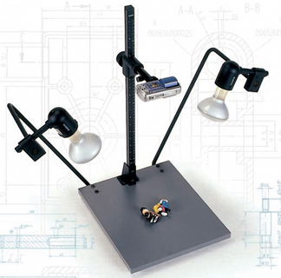

## Setting Up an Animation Station

The object to the left is a professional copystand. It has a mount at the top to hold your camera steady above your animation workstation. The mount can move up and down the pole so that you can get closer or farther away from your object. The two adjustable lights are key to keeping your station and animation well lit.

Although a professional copystand is ideal, it is also very expensive. There are other methods of creating an animation station that work as well.

The image below shows what kind of set up works for our purposes.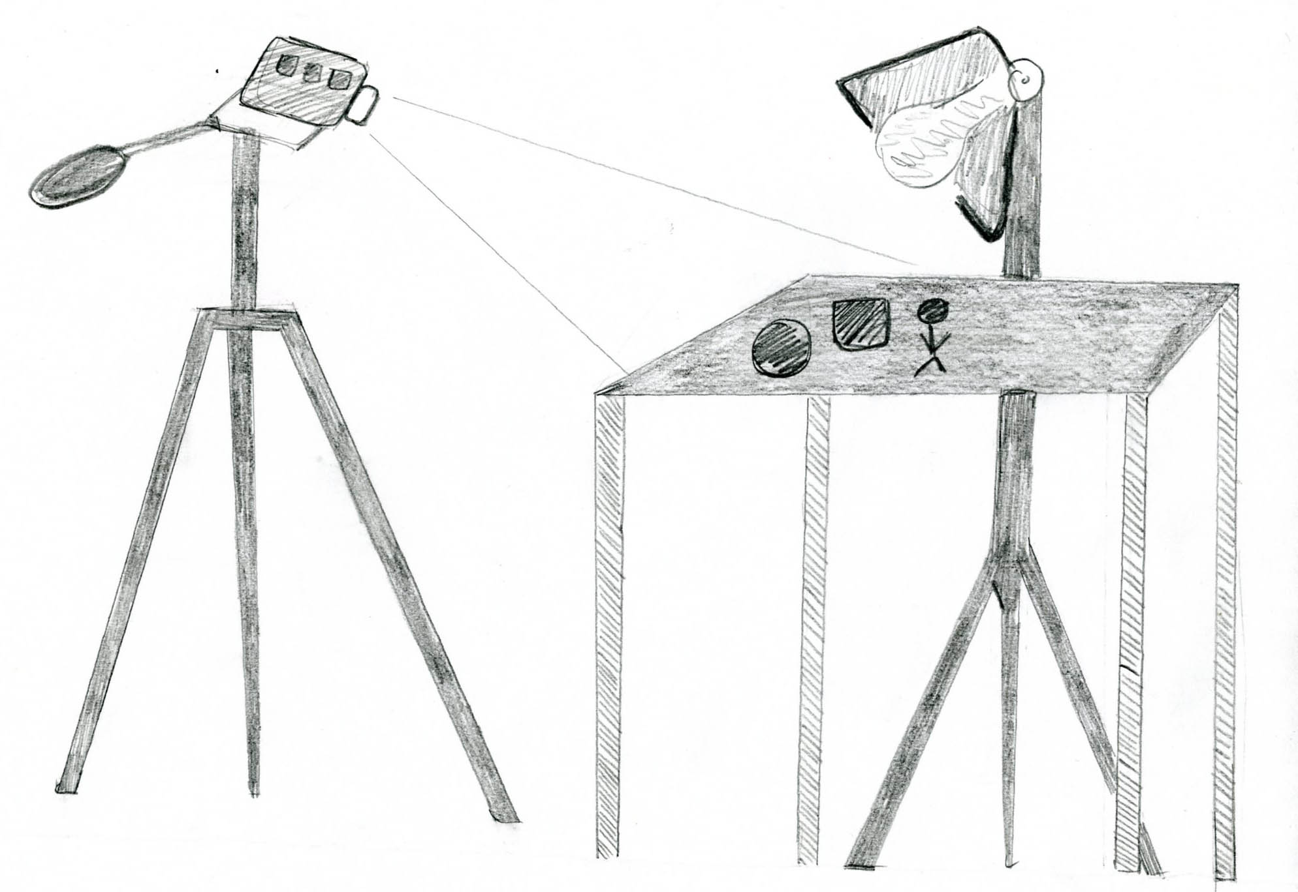



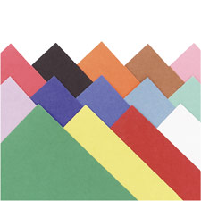

**Cutout Animation**

Cutout animation is a technique for producing animations using flat characters, props and backgrounds cut from materials such as paper, card, stiff fabric, or even photographs. The world’s earliest known animated feature films were cut out animations (made in Argentina by Quirino Cristiani). The first episodes of *South Park* used paper cutout animation.

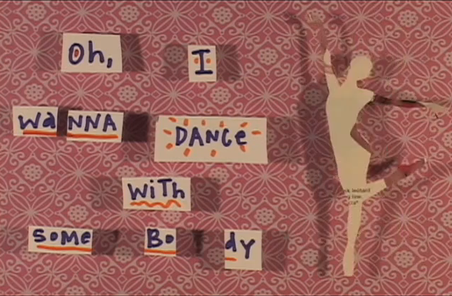

**Preparation**

You can use a variety of materials for your cutout animation. You can build characters and scenery from scratch, using your own drawings or colored paper, you can cut out images from a magazine, and/or you can take pictures from your computer and print them out. Don’t be afraid to combine all of these materials to give your animation a collage look. Below is a still from Chicago-based artist Jodie Mack’s *Karaoke Video* (2009).

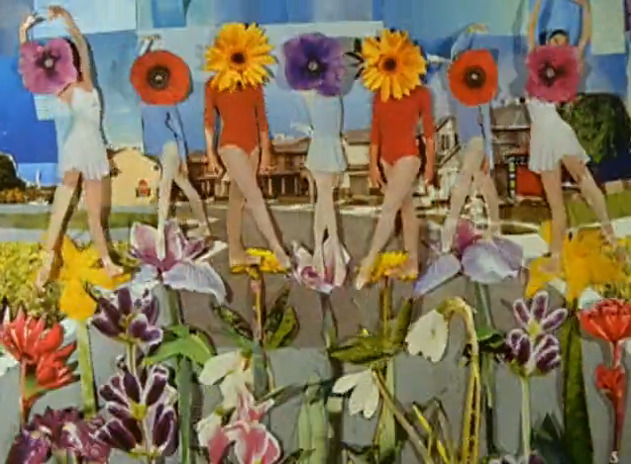

**Preparation**

On the left is a still image from Jodie Mack’s *Yard Work is Hard Work* (2008). As you can see, paper cutout animation allows you to use real images to create surreal environments. The word animate means “to give life to; enliven.” Do not be afraid to try new things; be imaginative and give life to objects that otherwise would be inanimate.

**Using any paper materials you find, create characters and an environment for your character to live in (i.e. a background and some moveable objects, such as cars, flowers, etc.). See the attached handout on how to make a paper puppet.**

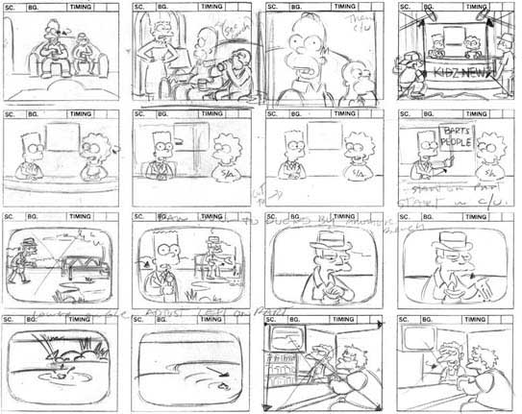

**Pre-Production**

Once you have prepared your backgrounds, puppets, and other cutout objects, you are almost ready to begin animating. If you are trying to tell a story through your animation, then you will have to do some prep work to organize how you are going to tell the story. A **storyboard** is a series of rough illustrations or images depicting scenes, copy and shots proposed for a film, commercial, animation, etc. To the right is an example storyboard from the animated television series, *The Simpsons*.

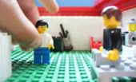

**Animate!**

Once you have set up your animation station, backgrounds, and characters, you are finally ready to begin animating!

**TIPS AND TRICKS**

1. Tape the background to the table so that it does not move during your shoot.
2. It is best to take 1 image per movement, however, you can also take 2 images per movement and it will still look pretty smooth. Remember that the amount of images you take per movement will determine how smooth or ‘life-like’ your animation is and also how quickly your character moves. More frames per movement will look slower than less frames per movement.
3. If you want there to be a pause in your animation – for example, if you want to show the title of your animation for several seconds – take A LOT of frames. If your animation is running at 24 frames per second, then you will need 72 frames to pause for 3 seconds.
4. Be patient! Moving your characters in small increments will look best! Notice how small the movements are in the picture on the left.
5. Careful not to bump the camera or your animation will jerk suddenly!
6. Be conscious of your lighting and make sure it does not move or alter during your shoot.
7. Always try to shoot a scene in one session! It’s hard to recreate the exact scene again (lighting, camera placement, etc.).

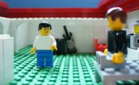

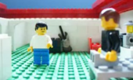

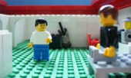

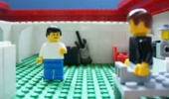

**MORE TIPS AND TRICKS**

1. Size: What do you do if you want to make an object grow smaller or larger? For example, let’s say that you want to make a heart grow from small to big. You simply cut out 10-15 hearts, each one a little bigger than the last. Then you take 1-2 frames of the first heart, then replace it with a slightly larger heart and take 1-2 frames, and continue until you have used up all of your hearts. Play back your animation and you should see it grow!
2. Shape: Using the same technique as above, you can alter the shape of an image until it becomes something else. You simply replace each shape with a slightly altered version every 1-2 frames.
3. Add/Subtract: Draw or erase part of an image in each frame to create the effect of something being drawn or erased by an invisible hand.
4. If you create a character with a mouth, you can have it chomp down on something and make it disappear. See the image on page 7 to see how it’s done!
5. If you made a puppet with moveable limbs and you want to make it walk naturally, you can use the walk cycle below as a starting point for creating that movement.

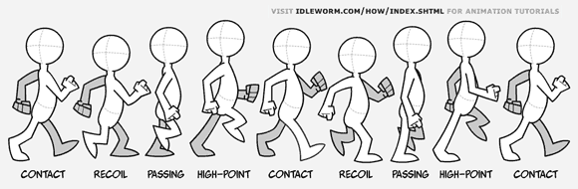

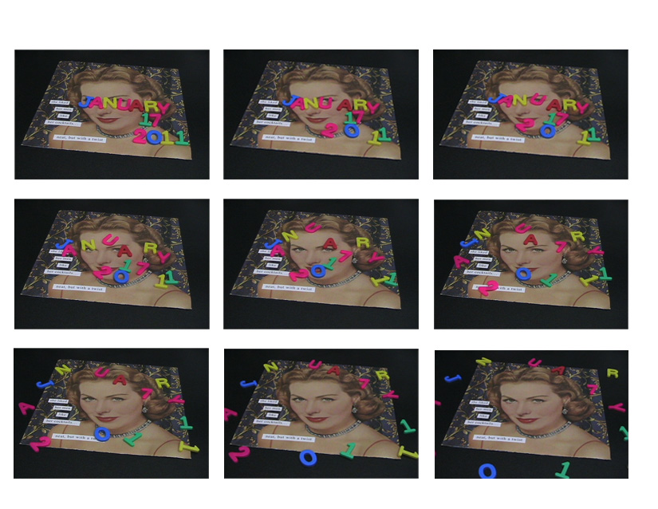

**Using other objects in your animation**

We started out using paper and magazines because it is simple, inexpensive and easy. However, if you have the resources, feel free to add different kinds of objects to your animation. Popular items are Legos, toy figurines, letter magnets, or really anything that is small enough to fit on your animation station.

**Learn More**

There is plenty more to learn about stop motion animation. This class is meant to give you an introduction to the core concepts. However, if you wish to learn more or are interested in a particular type of stop motion, for example claymation, I encourage you to do some research online or at your local library. There are hundreds of books, websites, and videos dedicated to the art of stop motion. Your stop motion journey has only just begun! On the following page is a list of online videos selected to teach and inspire you – enjoy!

**Screening List**

1. **Films**
   1. *The Fantastic Mr. Fox*
   2. *Robot Chicken*
   3. *The Nightmare Before Christmas*
2. **Commericals**
   1. Sony Bunny Commercial - <http://www.youtube.com/watch?v=QdDUlptT_60>
   2. XBOX animation - <http://www.youtube.com/watch?v=YNudcX_uUwM>
3. **Cameraless Animation**
   1. <http://www.youtube.com/watch?v=r9wpMoh5r58>
   2. <http://vimeo.com/4447025>
   3. A Joy – Jodie Mack (2005) <http://vimeo.com/8375376>
   4. All Stars – Jodie Mack (2006) <http://vimeo.com/8408671>
4. **Early Animations**
   1. El Hotel Electrico – directed by Segundo de Chomon (Spanish) One of the earliest uses of stop motion animation in history; an early use of pixilation. -http://www.youtube.com/watch?v=aZFdaqQky2o
   2. Edward Muybridge - <http://www.youtube.com/watch?v=UrRUDS1xbNs&feature=related>
5. **Object Animation**
   1. Scrabble Letters Music Video - <http://www.youtube.com/watch?v=Gpknd104ATE&feature=related>
   2. PES: Using objects for special effects –http://www.youtube.com/watch?v=7bmpFCwZbwM
   3. Deadline- http://www.youtube.com/watch?v=BpWM0FNPZSs
   4. Lego - <http://www.youtube.com/watch?v=ijpH6an-JIQ>
6. **Paper Cutout Animation**
   1. Reel Grrls - <http://wimeo.com/13524351>
   2. Shiver - <http://www.youtube.com/watch?v=QX82ggGCF7c>
   3. I wanna dance with somebody – Jodie Mack - <http://vimeo.com/8629772>
   4. Palentine #2 – Jodie Mack (2010) - <http://vimeo.com/9193319>
7. **Using Photographs of People**
   1. Taller Than Trees – Joseph Mann, Glasgow School of Art – <http://vimeo.com/1840168>
   2. Skateboard Animation - <http://www.youtube.com/watch?v=c4uiRfxnAPU>
8. **Personal Story**
   1. Getting To Know Me and My Toes – Joseph Mann, Glasgow School of Art – <http://vimeo.com/5665664>
   2. Shark Bite Luv Fog – Alex Mitchell (2009) - <http://www.youtube.com/watch?v=vc_lnnnekwk&feature=fvsr>
9. **Drawing (Direct Manipulation Animation)**
   1. Whiteboard Animation - <http://www.youtube.com/watch?v=3GPg8djk5nY&feature=related>
10. **Claymation**
    1. *Wallace & Gromit*
    2. *Gumby*
    3. <http://www.youtube.com/watch?v=45j6jFr3_pw&NR=1>
11. **Animation People (Pixilation)**
    1. Human Skateboard – PES - <http://www.youtube.com/watch?v=_5IqwECL6bo>
    2. Best Fwends by Libby Bass - <http://www.youtube.com/watch?v=NdDjl1khbP4>
    3. European Students - <http://www.youtube.com/watch?v=QZ5aZ8LiWFs&feature=related>
    4. OK GO music video - <http://www.youtube.com/watch?v=V2fpgpanZAw&feature=fvw>
    5. The White Stripes, “Hardest Button to Button” - <http://www.youtube.com/watch?v=gLESpHrtvxs>
12. **Simple, but amazing.**
    1. <http://www.youtube.com/watch?v=mOWzcHD-V5o&feature=related>
    2. <http://www.youtube.com/watch?v=6gi-8zVp2EE&feature=related>
    3. <http://www.youtube.com/watch?v=zqb7PeY7I2M&feature=related>
13. **Time Lapse**
    1. Flower Growing - <http://www.youtube.com/watch?v=46McQiTLZvU&feature=related>