*BUILDING COMMUNITY THROUGH TECHNOLOGY*

**Fall**

10

08

**Fall**

DISKovery Center ⬩ 353 E. 1st Street ⬩ Los Angeles, CA 90012

213.621.4158

www.diskovery.org

DIY Radio: Podcast This!

**DIY Radio: Podcast This!**

Fall 2010

**ABOUT THIS COURSE**

Adults used to control the media, but not anymore. Youth with stories to tell can become journalists and radio hosts by creating "podcasts" or internet radio shows. In this after school course, students will learn how to record, edit, and publish your own podcasts.

Students will learn how to use a free audio recording and editing program called Audacity. They will also learn storytelling and interviewing techniques.

This course is intended for students who already know the basics of using a computer and navigating the internet.

This curriculum is solely the property of the DISKovery Center, a program of the Little Tokyo Service Center. No portion of this document shall be copied, used or reproduced in part or in full without prior consent of the Little Tokyo Service Center. For questions concerning use of this material please call 213.621.4158.

Contents

Syllabus 4

What is a podcast? 6

Podcast Vocabulary 8

Interviewing 10

Interviewing Exercise 12

How to Record in Audacity 13

Editing in Audacity 15

Writing a Treatment 17

Writing a Radio Script 18

SAMPLE PODCAST SCRIPT 19

How to Publish Your Podcast 20

Publicizing Your Podcast 26

# Syllabus

FALL 2010

Instructor: Melissa Niiya

mniiya@ltsc.org / 213-473-1642

Thursdays 330-530pm

**About the Class**

Adults used to control the media, but not anymore. Youth with stories to tell can become journalists and radio hosts by creating "podcasts" or internet radio shows. In this after school course, you will learn how to record, edit, and publish your own podcasts.

**What will I learn?**

We will go over how to use a free audio program called Audacity, how to craft stories for radio, and how to make your voice heard by sharing your podcast online.

**What will classes be like?**

Each two hour class will consist of a discussion portion and a lab portion. In the discussion part, we'll share our work and go over strategies for making good podcasts. In the lab part, we'll go over equipment and software and then have open lab time.

**Equipment**

Students will not be required to have their own equipment. We will provide microphones for use in the lab. Microphones will be available for checkout for use at home. Students who want to work on their projects at home must bring in their own flash drive / hard drive.

**Attendance**

Please be to class on time. If you know you will be late or absent, please try to let the instructor know ahead of time.

**Class Schedule**

Thursday, October 7

**Day 1: Introduction to Podcasts**

What is a podcast? What is Audacity and how do I use it?

Lab: using Audacity, search for cool podcasts

**Homework**: podcast show and tell – bring podcasts / radio you enjoy. Bring in 5 ideas for podcast topics

Thursday, October 14

**Day 2: Treatments and Editing**

What makes a good podcast? How do I interview? How do I record an interview? How do I make a plan for my podcast? How do I edit in Audacity? In lab exercise: practice interview.

Thursday, October 21

**Day 3: Scripts and Editing**

Share show treatments/plans. We talk about how to give (and how to take) honest critique. How to edit and add effects in Audacity. We go over how to write a radio script.

**In-class activity:** write a treatment for your podcast.

Thursday, October 28

**Day 4: Recording Your Own Podcast**

Write your episode script and then and record and edit it.

**In-class activity:** record your first episode

Thursday, November 4

**Day 5: Getting Subscribers**

Class wrap up. Now that you've started a podcast, what can you do next? Resources for podcasting. We go over how to publish and publicize your podcast. Final lab to finish your projects. Continue recording and editing.

**Note**: If you need extra time in lab to work on your project, please e-mail/call me so we can arrange a time!

# What is a podcast?

A **podcast** is a type of internet radio. Instead of being streamed live like regular broadcast radio, podcasts are published as media files (like mp3s) and released in episodes.

Podcasts are usually distributed via **web syndication** (online podcast delivery service or "feed" that automatically lets you download the latest podcasts to your computer, phone, or other media player).

One of the best things about podcasts is that they are almost always FREE! Most people post podcasts because they are passionate about a subject, not because they are trying to make money. Some podcasts do have product placements or commercials, and some podcasts are not free. But most podcasts feature 100% free content for you to enjoy and share.

***Who makes podcasts?***

Anyone can make a podcast. Most podcasters want to say something about a topic that means a lot to them. Some podcasts are all about promoting products or businesses.

***Are there different types of podcasts?***

There are podcasts about many different subjects, from news and politics to art and cooking. Some podcasts are humorous, some are serious, some are inflammatory. Some podcasts are like typical radio: a host takes calls and plays music. Other podcasts are in atypical formats – sometimes, a host will just read a story or host a poetry jam. Sometimes, the host is more like a reporter and will interview subjects.

***Where can I find podcasts?***

There are many ways to find podcasts. Here are a few ways to get you started:

**Google**

http://www.google.com

Many music artists, authors, tv shows, video game companies, sports broadcasters, and magazines have their own podcasts. For example, you can search for "The Daily Show podcast" to find Jon Stewart's podcast.

**iTunes**

http://www.apple.com/itunes/podcasts/

iTunes is a free program that allows you to purchase and download music and videos. In the iTunes marketplace, you can search for podcasts and download them to your computer or iPod.

**Podcast Alley**

http://www.podcastalley.com/

Podcast Alley is a search engine for podcasts. You can search by subject.

**Podcaster App / Google Listen**

http://www.nextdayoff.com/

http://listen.googlelabs.com/index.html

You can use applications on your phone to download and listen to podcasts, too. Examples of apps include Podcaster and Google Listen.

**Radio Shows**

Many broadcast radio shows now also publish podcasts (either recorded versions of their radio shows or other content). Some radio shows make you pay for this content.

# Podcast Vocabulary

**Microphone** - a device that converts sound into an electric signal.

**Dynamic Microphone** - generally less expensive and more rugged than condenser microphones. Often used in live performances and do not require phantom power.

**Condenser Microphone** - commonly referred to as studio mics, these microphones require an external source of power known as phantom power and are much more sensitive than dynamic mics.

**USB Microphone** - unlike conventional microphones that require separate audio interfaces to connect to a computer, these microphones connect via USB and have built-in digital audio conversion.

**Cardoid** - also known as “unidirectional,” these microphones pick up sound from the front and block sound from all other directions.

**Omnidirectional** - these microphones pick up sound from all directions equally.

**Monitoring** - the process of listening to a recording as it takes place in order to make sure all of the levels are correct and there is no clipping or feedback.

**Input Level** - the volume at which the microphone is picking up sound.

**Output Level** - the volume at which the monitors are playing the sound back.

**Clipping** - the term for when the input level is too high and breaches a threshold where sound will not be recorded.

**Feedback** - a high pitch squeak that is created when the microphone picks up and amplifies the sound from the monitors.

**Latency** - the amount of time it takes an audio signal to travel through a system.

**Sound** - mechanical vibrations transmitted through a medium as waves known as longitudinal or compression waves

**Frequency** - the measurement of the number of times a repeated event occurs per unit of time. Measured in Hertz (Hz), human beings can only hear frequencies between 12 Hz to 20,000 Hz.

**dB** (decibel) - the measure of the ratio between two quantities. In audio, dB is used to measure sound levels relative to 0 dB.

**Analog Audio Recording -** the method of storing audio signals as a continual wave in or on the media. The wave might be stored as a physical texture on a phonograph record, or a fluctuation in the field strength of a magnetic recording.

**Digital Audio Recording -** the process of converting analog audio signals into a stream of discrete numbers.

**Codec** - short for “compressor-decompressor,” a codec is a program that encodes or decodes, as in encoding an MP3 file from a WAV file.

**Bit Rate** - The number of bits that are processed per unit of time. The more bits stored per second, the better the audio fidelity and the larger the resulting file.

**Waveform Audio File Format** (.wav) - developed by Microsoft and IBM in 1991, compatible with both Mac and Windows, typically an uncompressed high quality audio file format.

**Audio Interchange File Format** (.aiff) - co-developed by Apple in 1988, another uncompressed high quality audio file format that is compatible with both Mac and Windows.

**MPEG-1 or MPEG-2 Audio Layer III** (.mp3) - a compression technique used to create small audio files that contain nearly faithful reproductions of the original music file. The most common format for music on the Internet and the default format for podcasts.

**Advanced Audio Coding** (AAC) - the audio file format chosen by Apple for use in its iTunes service and iPod devices.

**Podcatcher** - programs used to subscribe to and download podcasts.

**RSS** (Really Simple Syndication) - the most popular news feed syndication format. RSS 2.0 is the default feed format for podcasting.

# Interviewing

First, some basics. The person you interview is the **subject**. You are the **interviewer**.

Interviewing can be as scary as hell, but remember that the person you are interviewing is probably twice as nervous as you. After all, they are worried about sounding dumb on your podcast. And they might be right to be worried – most people don't naturally know how to tell a story for the radio. But that's okay! As an interviewer, it is your job to get the subject to tell a good story – and even your most nervous subject can tell a good story. Here are some tips for getting a good interview.

**Before the Interview**

Know what you want. Ideally, you should go into the interview with a plan. Not a strict step-by-step plan. Know what you want your subject to say.

That's crazy, right? You can't control what your subject says. But if you know that you want your brother to talk about soccer, specifically the moment that he scored the tie-breaking goal, then your plan should be to ask him about that. It's simple, but having a plan will help you keep on topic – and that will help your subject stay on topic too.

Calm down. If you're calm, your subject will be calm.

**Preparing Your Subject**

Fair warning. You shouldn't tell your subject exactly what you want them to talk about, and they definitely should not be reading from cards. But it's only fair to warn them at the beginning of the interview that you want to talk about the time their cat Fluffy died in a skiing accident. That gives them a moment to collect their thoughts and be emotionally prepared for the interview.

Interrupting. Make sure your subject knows that they can and should interrupt you. If they have something great to say, you don't want them waiting for you to finish asking your question. In the meantime, they may forget what they were going to say!

**During the Interview**

Keep your plan in mind. Don't forget that you have a few things that you really want your subject to talk about. Write down a list if you have to.

Ask open-ended questions. Asking "yes" or "no" questions will only get you "yes" or "no" answers.

Show, don't tell. This is a phrase that gets kicked around every storytelling medium, but it is so important for radio. If the subject (and you) are not describing the scene, then the audience will not be able to create a mental image of what is going on in the story. Ask your subject to describe where they were, what they saw, what did it feel like?

Don't be afraid to ask tough questions. Sometimes, it's awkward to ask questions. It might be a touchy subject, or it might come off as being critical. But you can get great responses by asking these questions. Say you're talking to someone who got in an accident. Did they really think it was a good idea to get in the car with a drunk driver? Don't they feel some responsibility? Maybe they'll get mad, but that's okay. Listening to people defend themselves is interesting.

However, don't go overboard. There's a difference between asking critical questions and just criticizing the person for who they are. It isn't about judging them. It is about getting them to think (and speak) about their decisions.

**After the Interview**

Thank them for their time.

Make sure you know their contact information so you can give them a copy of your podcast. It is good manners to give copies of your work to all the people who helped you make it!

# Interviewing Exercise

In pairs, take turns being the interviewer and the subject. Record the subject's interview using Audacity.

Pick one of the following topics (or come up with your own) and try to get your subject to tell an interesting story. How old were they? Where were they? Describe what lead up to that moment. What happened? How did they feel about it afterward?

Talk about a time when you were really embarrassed.

When was the last time you were really angry at a family member?

Describe a time when you helped someone.

Talk about someone who is no longer your friend. Why aren't you friends anymore? What happened?

Talk about a moment when you felt proud. What had you done?

When was the first time you fell in love?

# How to Record in Audacity

1.) Plug the microphone and headphone into the computer.

2.) Open Audacity.

3.) The first thing you have to do is check your recording level. To see what your recording level is, you have to put the record meter into monitoring mode. Click the arrow next to the small microphone icon, and select Monitor Input, as shown.

*If you’re still not seeing any level, you may need to check your Audacity Preferences to make sure Audacity is configured to use your preferred audio device.

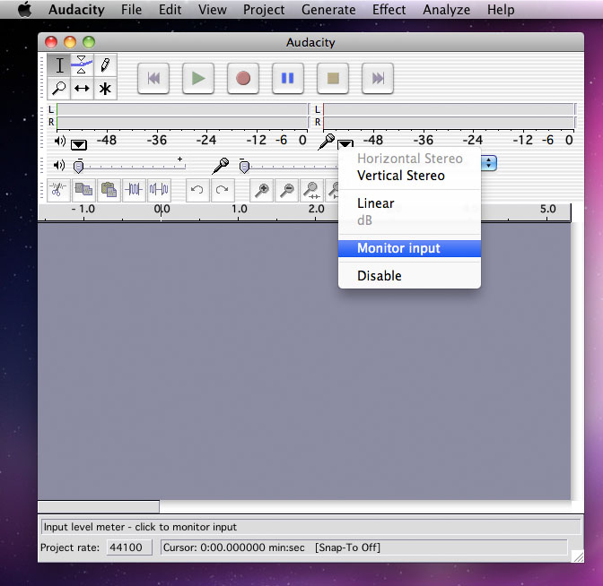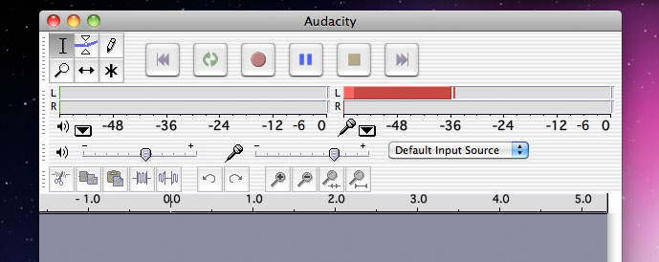

4.) Adjust the level of your microphone by sliding the microphone mixer control until your input level is peaking in the -12 to -6dB range.

5.) When you’re ready to begin, click the red record button on the Control toolbar. It usually takes Audacity a moment to start recording, so wait until you see an audio track appear and a cursor moving across the screen. It’s a good idea to begin each recording with a countdown, something as simple as “3...2...1...” will do just fine.

6.) If you make a mistake, don’t worry. You can edit it out later. The thing to remember is to pause before you start talking again, so you have a good pla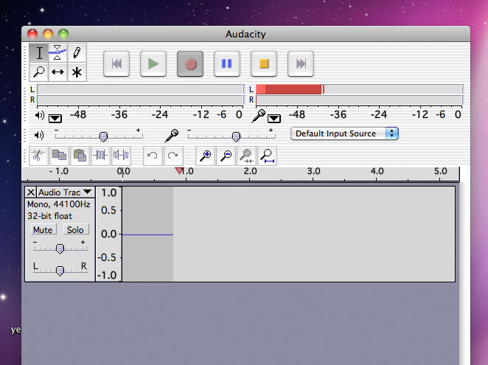ce to edit.

7.) When you’ve had your say, stop the recording by clicking the yellow stop button. Save your project by selecting Save Project from the File menu.

# Editing in Audacity

There are many professionally produced podcasts out there, but what makes podcasting great is that anyone can start their own podcast without the need for expensive professional recording equipment. However, that is not to say that the audience will enjoy hearing unintended background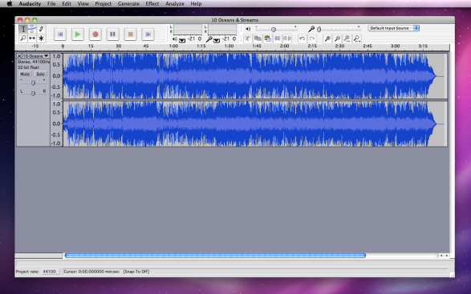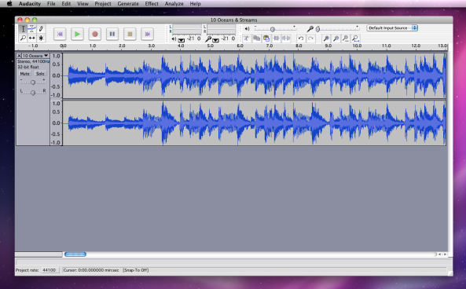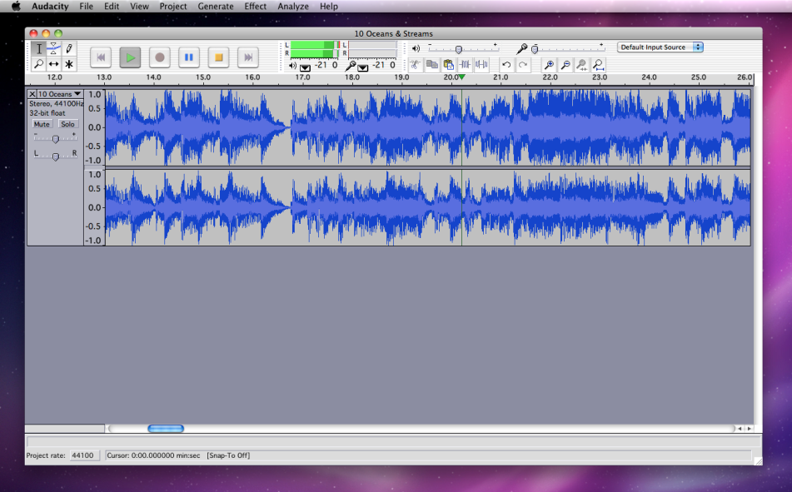 noise or the phrase, “umm...so...uh...” over and over. The following is a quick guide to editing out unwanted sounds.

1.) First click the Zoom In button to get a better view of the waveform.

2.) Next, listen and find the portion of the waveform where the unwanted sound occurs.

3.) Select the portion of the waveform that you would like to remove by clicking and dragging with the Selection Tool. The highlighted region can be finely adjust on both sides. Once you have highlighted a region, pressing the Play button will allow you to listen to only the highlighted region.

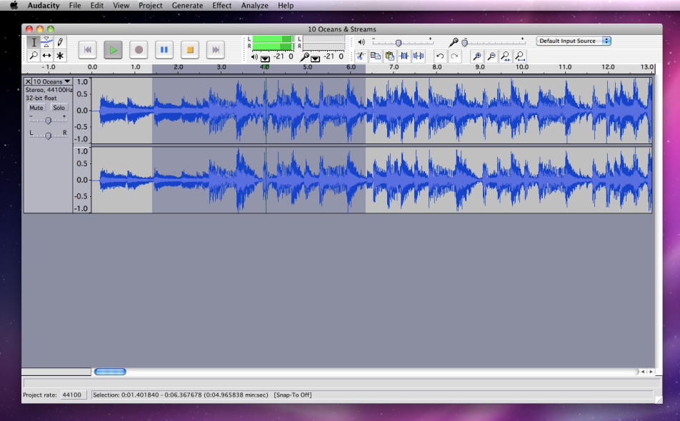5.) Now that you have listened and decided on the portion of the waveform you would like to remove, use the Edit pull-down menu and select Delete, or you could just press the Delete Key.

6.) Go back a few seconds before the deletion and press Play to make sure your edit sounds good. If it doesn’t, you can always Undo what you’ve done and try again until you get it just right.

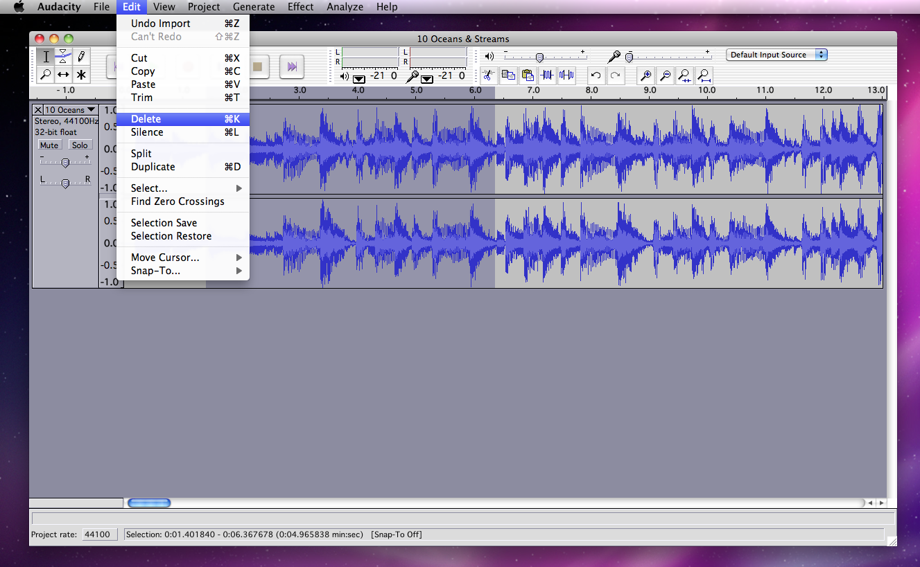

# Writing a Treatment

A treatment is the overall plan for your podcast. Even though every episode will be different, your episodes will probably follow a similar format (and if not, you should include that in your treatment). Treatments don't follow a strict format, but here is a template to get you started.

**Podcast Title**

Catchy blurb or short description of what your podcast is about. If someone was looking for podcasts, you would want this description to grab their attention. You also want to give it the flavor of what your podcast is like. If your podcast is funny, then you can write it in a funny way. This can be short. 2-3 sentences.

**Format**

The next section should include an outline of how a show would go. This is kind of like a timeline, a path for your show to follow. Include the length of the podcast in minutes. You might want to have different segments in your podcast depending on your topic. Name those here, too.

Example:

**PidgeonPod**

Flock to this podcast where we interview key pidgeons for updates on the best roosting spots, the hottest bird baths, and the ideal places to dive bomb unsuspecting pedestrians.

**Format**

Running Time: 10 minutes

* Intro theme song
* In a Wingbeat: Latest pidgeon news
* Flying Foodie: Which outdoor culinary events will be the most delicious to flock around this week?
* Around the Flock: Interview with pidgeon community member – discussing the politics of pooing on everything from monuments to street signs to peoples' heads
* From the Coop: e-mail/snail mail questions from the audience
* Good-bye / outro theme song

In-Class Assignment:

Write a first draft of a treatment for your podcast.

# Writing a Radio Script

Not all podcasts or radio shows are scripted, but many are. Sometimes, scripts are written after you have recorded interviews, discussions, etc. In a script, you can plan where to add sound effects, organize the sound bytes you have, or decide ahead of time what you want to say when you record.

Also keep in mind that 1 page = 1 minute. If you have 10 pages of script, your podcast will run about 10 minutes.

See the next page for an example radio script.

**In-class Activity**

If your podcast is scripted, then write out a script for your first episode. If your podcast is not scripted, then write a treatment for the episode, using your overall treatment as a guide.

SAMPLE PODCAST SCRIPT

MUSIC: INTRO MUSIC. DESCRIPTION OF INTRO MUSIC.

1. Host: This is what a radio script looks like, sort of.

2. Interviewee: It varies a lot. But generally, whoever is talking has their name like so. Mine says “Interviewee.” Yours says host. Each line of speech is numbered, but that’s not that important.

3. Host: And the dialogue goes in a column over on this side.

4. Interviewee: Yes. It’s easier to read that way.

5. MUSIC: OBNOXIOUS POP SONG PLAYS.

6. Host: What was that?

7. Interviewee: That was music. When you play music or sound effects or anything other than talking, you put it in all capital letters. Instead of writing the dialogue, you write a description of the music or sound effect.

8. SOUND EFFECT: A SOUND EFFECT IS LIKE THIS. SOMETIMES YOU WILL SEE SOUND EFFECTS OR MUSIC UNDERLINED TOO. IT GRABS YOUR ATTENTION.

9. Host: Are there any other formatting issues you’d like the audience to know?

10. Interviewee: Don’t forget to put the title and page number at the top of each page of script. Scripts all look the same without them, and you could get pages mixed up.

# How to Publish Your Podcast

There are several steps to publishing a podcast for free:

* Create an Archive.org / Our Media account
* Upload your podcasts to Our Media
* Create a Blogger account for your podcast
* Post on your blog
* Log in to Feedburner
* Create a "Feed" for your podcast using Feedburner

**1. Create an Archive.org / Our Media account**

Storing your podcasts on the internet usually costs money, but Archive.org will provide anyone with free space for their media (music, movies, images, and of course podcasts).

Go to this web address: <http://www.archive.org/account/login.createaccount.php>

Fill out the form. Note: you will need a valid e-mail address to register.

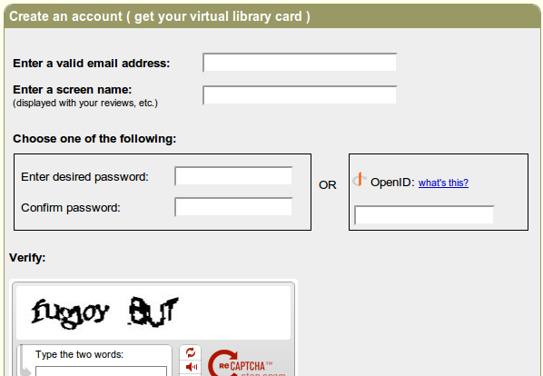

**2. Upload your podcasts to Our Media**

Next, go to Our Media. <http://www.ourmedia.org/upload>

Our Media and Archive.org are partners that work together to provide free space for people to upload and access media for free.

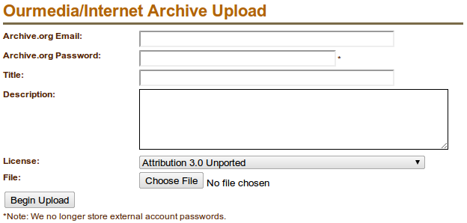

Complete the upload form.

***Archive.org Email:*** this is the e-mail you used to register at Archive.org

***Archive.org Password:*** this is the password you created at Archive.org

***Title:*** give your podcast a title, probably the name of your show plus the episode title or date

***Description:*** A short description of your podcast and episode.

***License:*** You have a few options.

*Public domain* means anyone can distribute, use, or remix your podcast for free.

*Attribution 3.0* – anyone can distribute or remix your stuff, but they have to "attribute" it to you, they have to give you credit

*Attribution Noncommercial 3.0* – anyone can distribute or remix your stuff as long as they give you credit, but no one can use your work to make money

*Attribution Noncommercial No Derivative Works* – anyone can distribute your work, but they can't use it to make other works and they can't make money by distributing your work (they can't sell your podcast0

*Attribution Noncommercial Share Alike* – anyone can distribute or remix your work, but if they remix it, they can only distribute it under a similar license and can't make money from it

*Attribution No Derivative Works* – anyone can distribute your work or even make money off of it, but no one can remix it and they must give you credit

*Attribution Share Alike* – anyone can distribute or remix your work if they give you credit, but it has to be distributed under the "Attribution Share Alike" license

**File:** select your mp3/ogg file on your computer

**Upload:** click the button to upload!

Our Media will send you an e-mail containing the link to your uploaded file. Keep these e-mails in a safe place, as you will need them later.

**3. Create a Blogger Account**

Blogger is a free "blog" or online journal service. We can also use it to publish a list of our podcasts.

Go to: [https://www.blogger.com](https://www.blogger.com/)

Click on the "Create Blog" button.

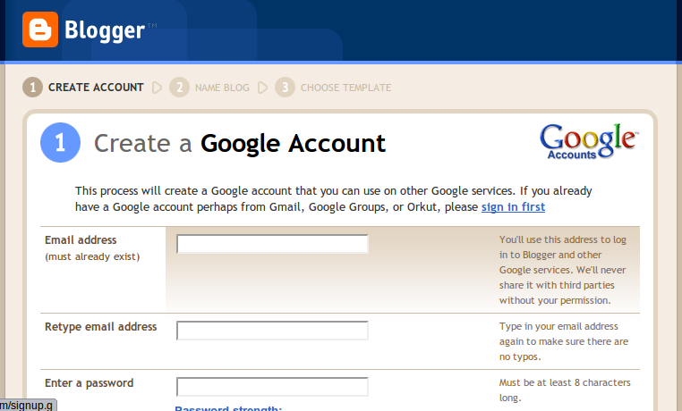

Complete the form.

Use the same e-mail that you used to sign up for Archive.org. Name your blog, choose your template (you can always change the template later), and then go to the **Settings** tab and then click the **Formatting** link:

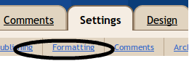

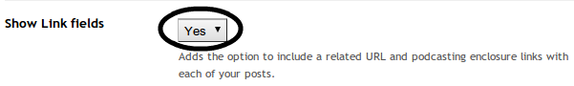Scroll down and make sure the "Show Link" setting is set to "Yes." Then scroll down and click "Save Settings."

**4. Post on your blog**

Now, go to the Posting tab and click New Post. Every time you want to publish a podcast, you will create a new post. Give the post the same title as the podcast episode, then write a description of your episode in the body of the blog post.

Click the blue Link button to add a link to your podcast.

This link should be to the same link that Our Media e-mailed you – the one that points to your uploaded podcast file.

Then, publish your post. Your post will now appear on your blog. You could give people the link to your blog, but the standard format for subscribing to podcasts is called RSS feeds or "Really Simple Syndication." We need to make an RSS feed for your blog.

**5. Log in to Feedburner**

Some people make their RSS feeds by hand – but that can be a pain. We will use Feedburner to create our RSS feeds.

Go to: [www.feedburner.com](http://www.feedburner.com/)

Since Feedburner and Blogger are both owned by Google, you can use the same e-mail address and password to log in to Blogger and Feedburner.

6. Create a "Feed" for your podcast using Feedburner

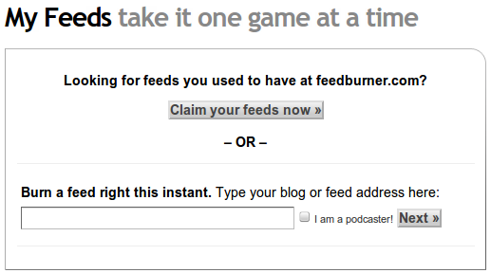This is the main Feedburner account page:

Enter the URL of your blog (for example, myblogname.blogspot.com). This is the same address that you tell people when they want to visit your blog.

Check the "I am a podcaster!" box, then click Next.

If, prompted, select the "Atom" feed and click Next.

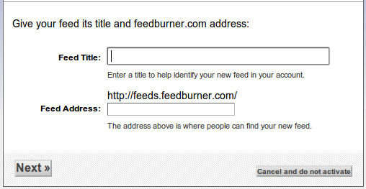

Now type in the title for your feed (the name of your podcast). Then, type in an address for your feed. For example, if your podcast was called "My Great Podcast," then you would type mygreatpodcast into the feed address box. People will use your**feed address** to subscribe to your podcast using their iPod or computer.

Once you complete this process, feedburner will create your RSS feed. You can now share this feed with friends and family – and you can use this RSS feed to promote your podcast on the web, at the iTunes store, and more.

# Publicizing Your Podcast

Here are a few ways to reach more listeners:

**Submit Your Podcast Feed to the iTunes Store**

* Download and install iTunes (it's free).
* Open iTunes.
* On the left, click iTunes Store and then Podcasts.
* In the left column of the Podcasts page, in the Learn More box at the bottom, click on the Submit a Podcast link.
* Follow the instructions on the [Submit a Podcast](https://phobos.apple.com/WebObjects/MZFinance.woa/wa/publishPodcast) page.
* Note that you will need a valid iTunes account, and you will need to be logged into iTunes. If you are not logged in, iTunes will prompt you to do so before accepting your submission. By requiring you to log in, iTunes increases the likelihood of valid contact information for each submission. Your credit card will not be charged for submission of a podcast.

For more information, go to the iTunes page on how to submit your podcast:

<http://www.apple.com/itunes/podcasts/specs.html>

**Make a Descriptive RSS Feed**

When you create a feed for your podcast, it should contain keywords and a good description. You want to inform and intrigue potential listeners so that they hit the subscribe button! Also, include a link to your podcast in the description so that they can download an episode without subscribing – lots of listeners want to try before they subscribe.

**Submit Your Podcast to a List**

There are many websites that maintain lists of podcasts. Most of them will not charge you to submit your podcast. You can find podcast lists here:

<http://www.podcasting-tools.com/submit-podcasts.htm>