*BUILDING COMMUNITY THROUGH TECHNOLOGY*

**Fall**

10

08

**Fall**

# Editing in Audacity

There are many professionally produced podcasts out there, but what makes podcasting great is that anyone can start their own podcast without the need for expensive professional recording equipment. However, that is not to say that the audience will enjoy hearing unintended background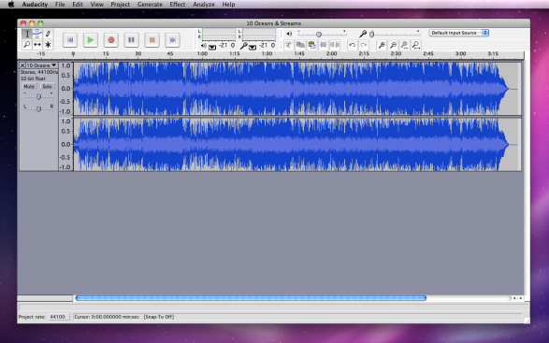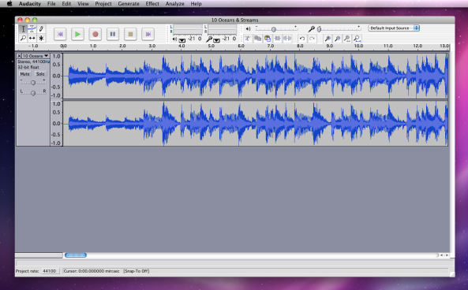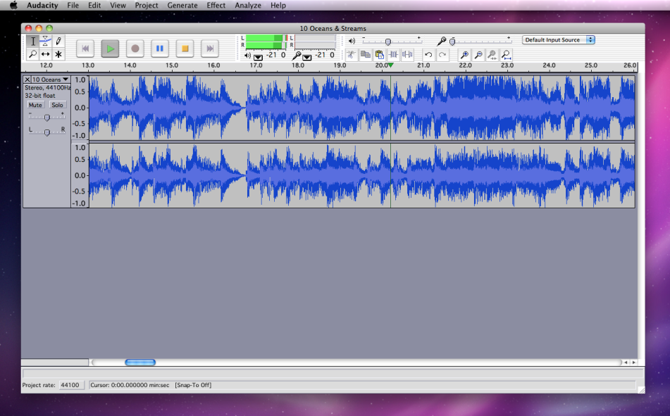 noise or the phrase, “umm...so...uh...” over and over. The following is a quick guide to editing out unwanted sounds.

1.) First click the Zoom In button to get a better view of the waveform.

2.) Next, listen and find the portion of the waveform where the unwanted sound occurs.

3.) Select the portion of the waveform that you would like to remove by clicking and dragging with the Selection Tool. The highlighted region can be finely adjust on both sides. Once you have highlighted a region, pressing the Play button will allow you to listen to only the highlighted region.

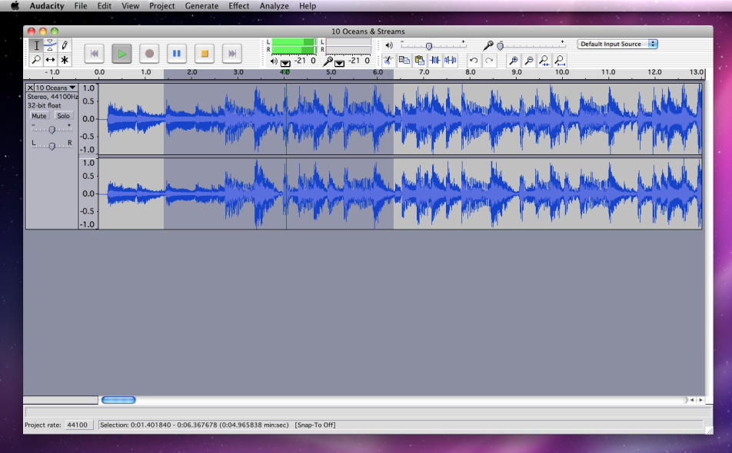5.) Now that you have listened and decided on the portion of the waveform you would like to remove, use the Edit pull-down menu and select Delete, or you could just press the Delete Key.

6.) Go back a few seconds before the deletion and press Play to make sure your edit sounds good. If it doesn’t, you can always Undo what you’ve done and try again until you get it just right.

