Deb Sen
Benjamin Shih
David Wasser
Jamaal Royal

Period 2 Block A

6/5/06

Melting the Ice
Problem Statement
This project will consider several deicers and determine their maximum capacity and why some are more effective than others. A selection of water soluble substances will be selected. These substances will be evaluated quantitatively for lowering the freezing point of water.

Pictures
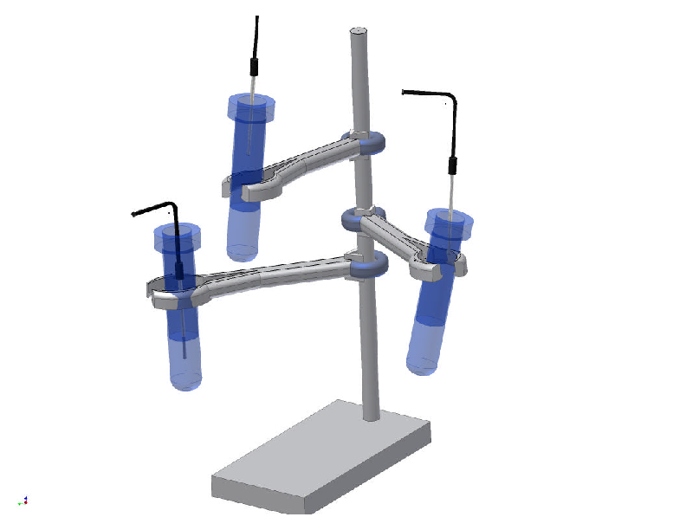
Engineering Description
In order to measure the temperature of each solution we clamped each test tube of frozen solution in a ring clamp and used a hole made by a nail to insert a temperature probe in the tube during the freezing period in the freezer. We measured six solutions at a time using two CBLs and six temperature probes on a single ring stand. With this design we could put up many ( but chose six) ring clamps to hold the frozen solutions, and measure the temperature of them all in one trail. With the help of a ring stand and six ring clamps we were able to do a trail for our experiment by only putting a temperature probe in each solution and waiting ten minutes for the temperature to be measured every fifteen seconds. This device was easy to use and needed minimal effort. The problem with this device was that the probe would often touch the sides of the tube causing the temperature of the tube to be measured. This served as one of our major errors for our experiment because we only wanted the temperature of the solution to be measured. Another problem was what happened when the temperature probe was not inserted deep into the frozen solution. When this happened there would be too much of the probe sticking out of the test tube and in the air. When this happened the temperature of the air was measured as well as the solution. Other than how the temperature probe was inserted into solution there were no other weaknesses in our device.

Scientific Conclusions
We hypothesized that CaCl₂ will be the best deicer, followed by NaCl, KCl, then C₆H₁₂O₆. Our data did not support our hypothesis; we found that the order of deicer effectiveness was CaCl_{2,} KCl, NaCl, and lastly, C₆H₁₂O_{6.}

