Research and Experimentation
Problem 2


Jamaal Royal
Debattama Sen
Benjamin Shih
David Wasser

Due: May 26, 2006
Block A

THE PROBLEM

Introduction
Deicers are an important part of life in places experiencing cold weather conditions. They prevent road and airplane accidents, and insure unrestricted mobility even in very cold weather. There are many different types of deicers but most are based on the same underlying principles.
Freezing point is a colligative property, meaning it differs from those of the pure solvent by amounts which are directly proportional to the molal concentration of the solute. Solutes lower the freezing point of the solvent in which they are dissolved. This phenomenon is called freezing point depression. Molecules in ice have lower energy than they do in liquid water, because they are more strongly attracted to their neighbors, but they also have lower entropy because they cannot move about. Entropy is more important at high temperatures, so fluids form at high temperatures and solids at low. Solutes scarcely dissolve in ice, so the entropy of ice is unaffected by their presence. However, dissolved solutes in water increase the entropy of the water molecules, and so the compromise between lowering energy and maximizing entropy occurs at a lower temperature.

Sodium chloride is one of the most common deicers. It has a eutectic temperature of about -21° C. Eutectic temperature is the lowest possible temperature that can be reached by freezing-point depression. Calcium chloride is another common deicer. The eutectic temperature of calcium chloride is -51° C. Sometimes potassium chloride is also used to lower the freezing point of water. Its eutectic temperature is -11° C. All the compounds mentioned above are ionic compounds. However C₆H₁₂O_{6,} or sugar is not an ionic compound. Ionic compounds have a higher freezing-point depression effect than non-ionic compounds. Ions interact strongly with each other, so they move about in solution less freely than uncharged molecules do. This means it takes more energy to freeze or melt a solution of ionic compound than that with a non-ionic compound. This can be seen in the results of a table derived from prior experiments.

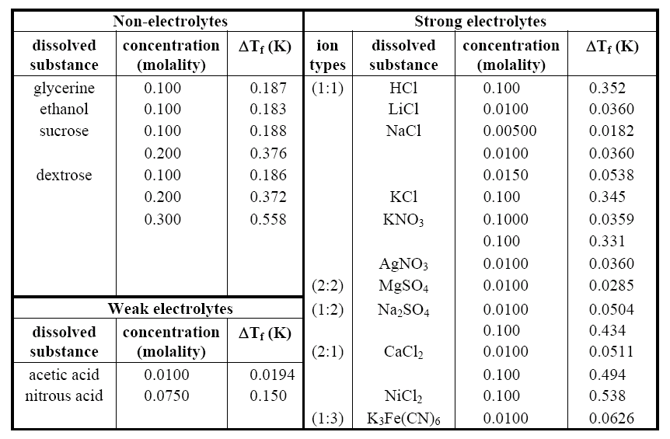
Problem
The purpose of this experiment is to compare the effectiveness of four different compounds as deicers. We will be using the compounds: NaCl, KCl, C₆H₁₂O_{6,} CaCl₂ and pure H₂O as the control. This table shows that calcium chloride is the best deicer, followed by NaCl, KCl and finally, sugar. This can also be concluded because of their respective eutectic temperatures: calcium chloride has a much lower one compared to the others.
Variables
The independent variables are the solutions of the 5 different compounds. The units of measurement are molarity in moles per liter and volume in mL. The dependent variable is temperature. The unit of temperature is °C.

MATERIAL AND METHODS

Materials

- 1 M CaCl₂ (10 mL)
- 1 M NaCl (10 mL)
- 1 M KCl (10 mL)
- 1 M C₆H₁₂O₆ (10 mL)
- Distilled water (10 mL)
- Freezer
- 2 CBLs
- 6 temperature probes
- 6 test-tube clamps
- Ring-stand
- 6 Big nails
- 14 mL Polypropylene Round-Bottom Tubes
- Small cooler

Procedures
Experimental Set-up
- Place 10 mL of each solution in a tube.
- Poke a hole through the lid and push nail through.
- Place each of the tubes in a freezer to ensure the solutions are properly frozen.
- Remove 6 tubes from the freezer and carry them to the R&E lab in a cooler.
- Place the tubes into test-tube holder attached to a ring-stand. Remove nail.
Data Collection
- Record the temperature of each of the frozen solutions every 15 seconds using the CBL temperature probes.
- Continue for 10 minutes.
- Repeat steps 5-6 until all the cups have melted. This completes one trial.
- Graph the data into a line graph showing the time versus temperature. Analyze the data to find the melting/freezing point.
- Repeat experiment until a reasonable number of trials have been completed.

ANALYSIS OF DATA AND CONCLUSIONS

Data

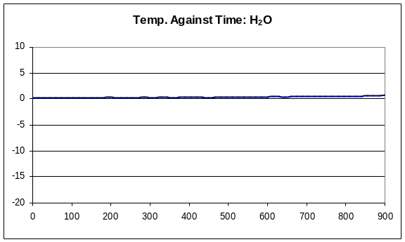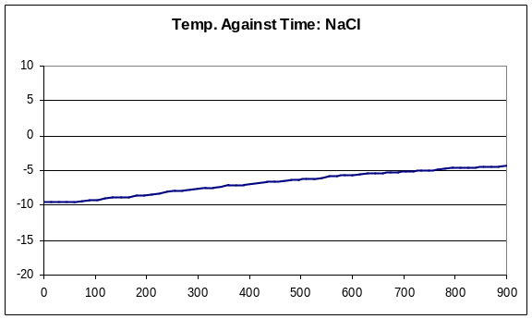
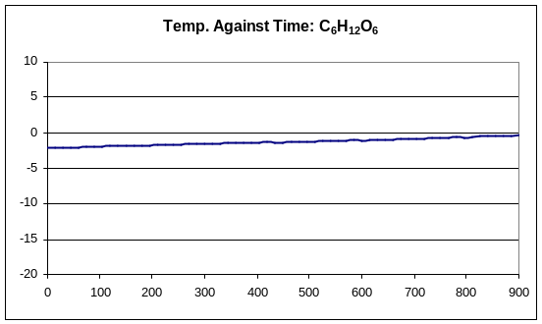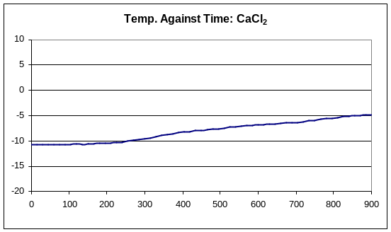
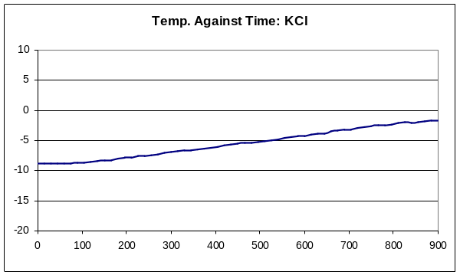

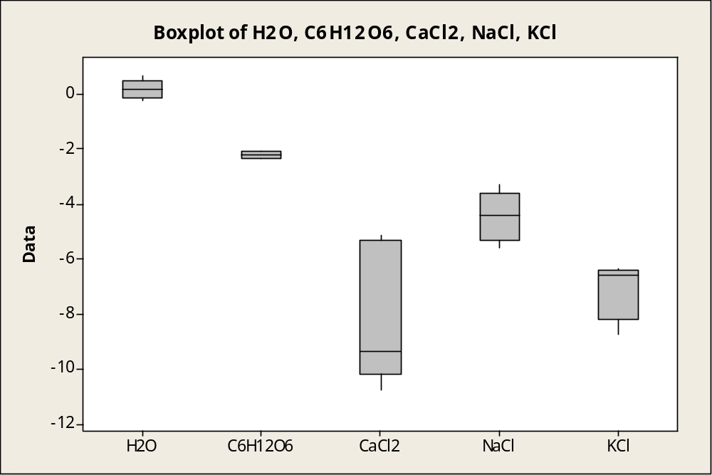

Variable | Minimum | Q1 | Median | Q3 | Maximum | IQR
H2O | -0.226 | -0.129 | 0.156 | 0.469 | 0.656 | 0.598
C6H12O6 | -2.345 |  | -2.207 |  | -2.069
CaCl2 | -10.74 | -10.14 | -9.38 | -5.29 | -5.15 | 4.85
NaCl | -5.593 | -5.302 | -4.429 | -3.59 | -3.31 | 1.712
KCl | -8.72 | -8.204 | -6.577 | -6.388 | -6.35 | 1.816

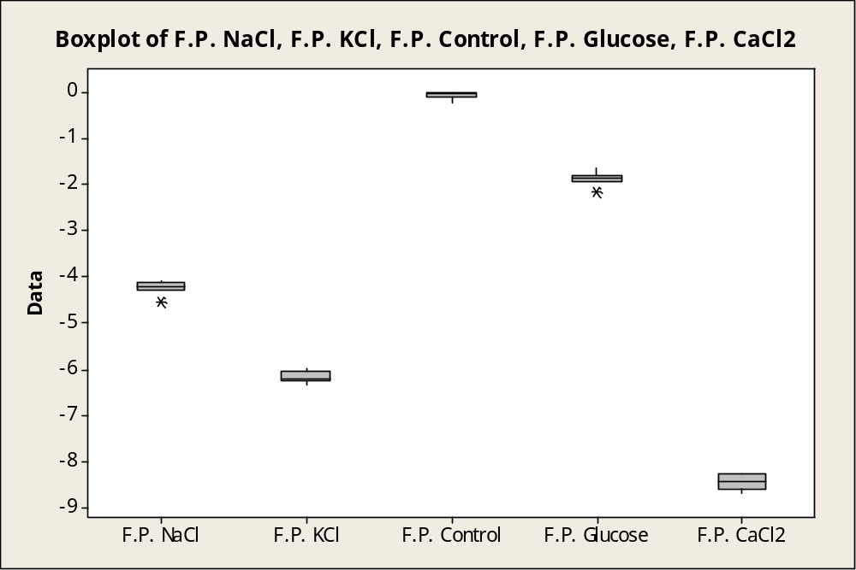

Variable Mean Minimum Q1 Median Q3 Maximum IQR
F.P. KCl -6.1573 -6.3415 -6.2235 -6.1931 -6.0380 -5.9648 0.1854
F.P. NaCl -4.2347 -4.5326 -4.2860 -4.2153 -4.1253 -4.0840 0.1607
F.P. Control -0.0802 -0.2258 -0.1248 -0.0355 -0.0222 -0.0219 0.1027
F.P. Glucose -1.8684 -2.1483 -1.9250 -1.8650 -1.8000 -1.6450 0.1250
F.P. CaCl2 -8.4291 -8.6648 -8.5600 -8.4000 -8.2460 -8.2400 0.3140

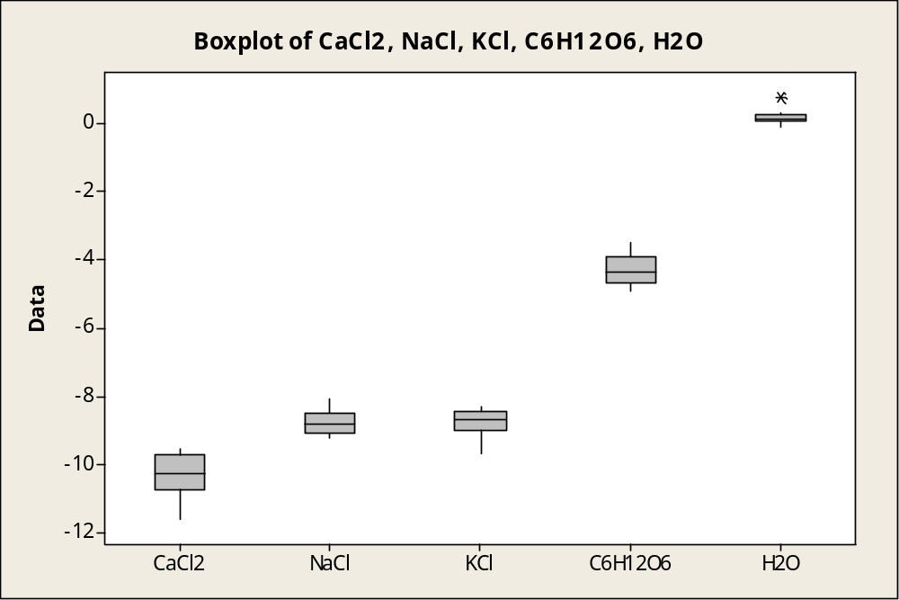
Variable Minimum Q1 Median Q3 Maximum IQR
CaCl2 -11.570 -10.730 -10.260 -9.723 -9.540 1.007
NaCl -9.210 -9.043 -8.805 -8.465 -8.060 0.578
KCl -9.670 -8.973 -8.665 -8.408 -8.280 0.565
C6H12O6 -4.890 -4.663 -4.375 -3.883 -3.500 0.780
H2O -0.1000 0.0750 0.1000 0.2625 0.7500 0.1875

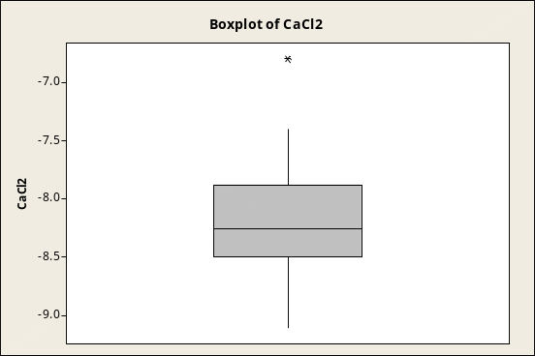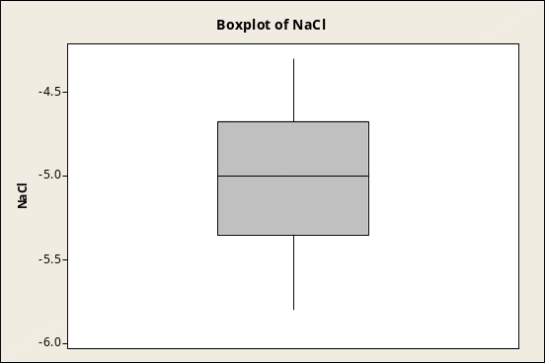

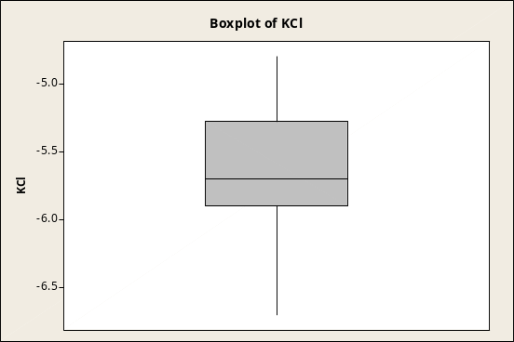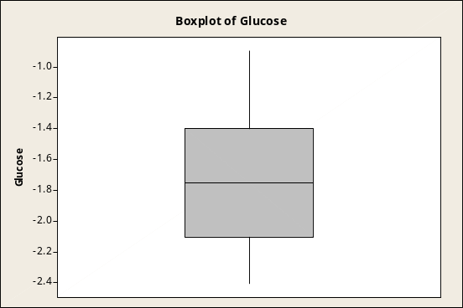

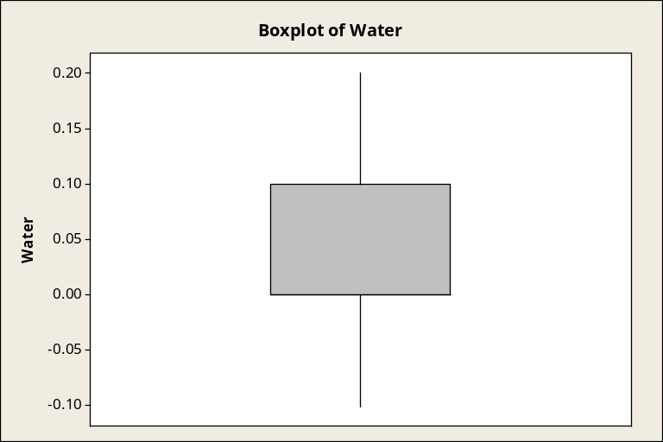

Variable Minimum Q1 Median Q3 Maximum IQR
CaCl2 -9.1000 -8.5000 -8.2500 -7.8750 -6.8000 0.6250
NaCl -5.8000 -5.3500 -5.0000 -4.6750 -4.3000 0.6750
KCl -6.7000 -5.9000 -5.7000 -5.2750 -4.8000 0.6250
Glucose -2.4000 -2.1000 -1.7500 -1.4000 -0.9000 0.7000
Water -0.1000 0.000000000 0.000000000 0.1000 0.2000 0.1000

Data Analysis

The experimental data shows that CaCl2 creates the greatest freezing-point depression, reducing the freezing point to -10.74 at the lowest. The median freezing temperature for CaCl2 is -9.38, which is significantly lower than the medians of the other chemicals. From this data, it can be said that CaCl2 would be the most effective deicer. However, the box plot for CaCl2 has the highest IQR. This is explained by the speed at which CaCl2 melts, making it difficult to get the accurate freezing point. KCl has a median freezing point of -6.577, the second highest. This makes it the second best deicer, followed by NaCl which has a median freezing point of -4.429. Glucose creates the smallest freezing point depression, lowering the freezing point by only 2.363 °C. The data collected is very consistent since the highest IQR was 4.85. All the other IQRs are less than 2.
Comparing our data with the data from other blocks, the conclusions that can be drawn are almost the same. In the data of block C, CaCl2 has a median freezing point of -10.26. It also has an IQR of 1.007, the largest of all the chemicals. However, NaCl and KCl have freezing points of -8.805 and -8.665 respectively. These points are close to each other, but the data is different because according to their data, KCl is a worse deicer than NaCl. Glucose is still the worst with a median freezing point of -4.375. Compared to block D, our data agrees on the order of best deicers. CaCl2 has a freezing point of -8.25, KCl has a freezing point of -5.7, NaCl has a freezing point of -5, and glucose has a freezing point of -1.75. The data from block B also agrees with the order of best deicers. Their median freezing point of CaCl2 is -8.4, KCl is -6.1931, NaCl is -4.2153, and glucose is -1.865. In conclusion, the data from the other groups shows that our data is consistent, and they also agree that the order of best deicers is CaCl2, KCl, NaCl, and lastly, C6H12O6.
Problems Encountered
Several difficulties were encountered while running the experiment. One major issue was finding the right amount of liquid to freeze and the right container for effective use. Initially, 50 mL of solution was frozen in paper cups with Styrofoam lids and wooden pegs were left in the ice to leave a hole for the thermometer. The wood absorbed some of the solution and froze with the ice, making it difficult to remove. After trying out other possibilities, finally it was decided that 10 mL of solution would be frozen in small plastic test tubes, also giving the maximum surface area between the temperature probe and the ice. Problems also occurred with chemical contamination. Mold grew in two solutions of chemicals while they were freezing.

In the future one way to improve the experiment would be to have a sterile freezing environment. To increase the consistency of the experiment is the same batch of chemicals should be used throughout the entire experiment, because the molar concentration will be slightly different in each batch made. Since the temperature probe measures temperature from the complete probe and not just the bottom, any part exposed to the air might skew the data. In addition, the block of ice inside the tube forced the probe to the sides of the tube because the tube was too small. The probe doesn’t measure the ice completely because it was exposed to the room temperature through the thin tube wall. To solve this problem, the temperature probe should be completely covered with ice to assure that the only the temperature of the ice is being measured.

Conclusion
The data generated supports the first part of the hypothesis. Calcium chloride lowered the freezing point of water the most, making it the most effective deicer. It was also predicted that NaCl would work better than KCl. This was proven wrong by the experimental data. KCl had a greater effect on the freezing point than NaCl. Glucose, which is non-ionic was the least effective. Therefore, the four deicers in order of effectiveness are CaCl2, KCl, NaCl and C6H12O6 and our hypothesis was partly confirmed. Future research may be conducted on other factors affecting the freezing point depression by changing the molarity of the solutions, or trying out different combinations of deicers.

