Nail-It

By
Christopher Hsing
Benjamin Shih
Louis Teng
Nick Vujcic

Submitted on 10/27/07 to Dr. Witte

Abstract
A compact assistant device in hammering small, finishing nails; it possesses functionalities for striking, clamping, sliding. A V shaped clamp in the base of the device is held together by springs, where it holds the nail at ninety degrees. An arm, headed by a steel weight, is positioned through use of plastic rails, sealed on by metal dowels running through the base. The rails and dowels restrict movement in three dimensions, instead allowing the parts to move 6 inches in one dimension to help optimize striking angle. A taut spring running over the arm allows the user to pull back the arm and strike the nail without additional force.
Introduction
The purpose of the Nail-It is to simplify the hammering process of small finishing nails. The device is important because many people have problems with these nails. Patents that existed before our project include: slits in a piece of foam to hold nails, a device that guides nails, and various other devices. All of them share an identical goal – simplifying the daunting task of striking a nail initially and keeping the nail straight. Data collected through testing Nail-It shows that it fulfills these objectives as well. However, while those devices are not concerned with finger safety during initial strikes, where accidents occur most frequently, Nail-It removes the risk by using a built in arm. After starting the nail, the user can easily use a hammer to complete the process without risking his fingers.
Nail-It will revolutionize the amateur hammering world as it is known. By eliminating potential injury during initial strikes, more people will be drawn to recreational building. The device will form a communal market with nail, hammer, and wood markets because of the number of people tempted by safer hammering.

Construction
The prototype was constructed over a period of three weeks – approximately twenty total hours were spent on building and testing. Fifteen hours were spent in the R&E room, constructing our device from raw materials. The device was constructed using the blueprints we created and the following materials:
Item | Approximate | Quantity/Dimensions
Spring | $0.15 | 3
Aluminum Dowel | $0.20 | 1
Plastic Wheels | $0.02 | 4
Steel Dowel | $0.25 | 1
Plastic | $1.00 | 7.825x.75x.125, 2.25x1x.125, .125x1.75x1.75
Copper Dowel | $0.25 | 1
Wood | $5.00 | 10x.5x2.5, 10x3x1
Nail/Screw/Washers | $0.15
Hot Glue | Negligible
Prototype Cost | $7.38
Actual Cost | $9.38

First, we cut out the rectangular pieces of wood for the base, arm, and sides of the arm. After drilling holes in the pieces, we put in dowels and the steel head. One of the problems we had with the steel head was cutting a small piece off the long steel dowel. Because steel is such a tough material, we had to use a titanium blade to cut it. In addition, the dowel kept falling out, so we sealed the sides with glue. The spring for pulling back on the arm was also screwed in. At the same time, the V shaped base was being constructed. A V shape was cut into one of the rectangular pieces of wood, and the tip of the V sanded a little to help hold the nail straight when the two pieces are held together. We encountered a difficulty at this point in time because we originally intended to make a lock for clamping the pieces together. However, we were not sure how to do so. After experimenting with a screw and nut clamp, we decided to try springs. After constructing two test “spring clamps”, Nick and Chris created the final base. Two pieces of plastic were added on the bottom to prevent the two pieces of the base from bending over due to spring tension. Next, we used a circular saw to drill slits in the arm sides, where the railing would go. Using a drill, we began to drill a slit in a piece of plastic for the railing. Realizing the inefficiency of this method, we switched to the scroll saw to drill the second railing in much less time. Filling the slits from the circular saw with glue, we stuck the railing in. The last step was to drill holes through the base, and feed dowels through the base and the railing to create the prototype.
In order to test the device, we went to Nick’s house. He provided us with a piece of wood and nails ranging from 2D to 8D in increments of two. Each member of the group performed a trial, taking turns hammering with the Nail-It and with a normal hammer as control. The striking was collected on a yes or no basis – the hammer or Nail-It either hit the nail or it didn’t. The angle was measured after five strikes with either device using a protractor. After the testing for each nail size was completed, we calculated the average percent of strikes connected and the average angle the nail entered the board. The data is as seen in the appendix.
If we had purchased the materials for the device from a vendor, such as Home Depot, the estimated price of the device would have been $7.38. However, all the materials could be found in the R&E room. The actual device would be constructed out of metal instead of wood, and thus is estimated to be $9.38. We plan to sell it for $12.00, for a sizable $2.62 profit. This price is cost effective and marketable because it is a cheap device that greatly assists novice users in a fairly common task. In addition, of approximately 120 students and parents surveyed in our market research report, 47.7% would pay $1-15 and 34.9% would pay $16-30, while only 13.6% were not interested at all.
A few changes were made to the original design. We originally planned to have multiples holes to hold multiple nail sizes. However, we removed this design because a large range of nail sizes would require an even larger hammerhead. Because we did not want to deal with cutting a metal stronger than steel, and because we also decided to focus on smaller, finishing nails, we restricted our device to smaller nails. In addition, we originally planned to use rubber bands to launch the arm. However, we had no effective way to attach the rubber bands, so we switched to putting a spring over the arm near the axel to achieve the same effect. The last change we made was changing our lock into a tension-based spring clamp. The lock was originally made out of screws and nuts and attached to the outside of the device, in the way of the rails. No screws were long enough in proportion to the size of the accompanying nut because our base is only half an inch. The lock could only be employed when the screw was too short to reach the nut; essentially, a lock could not be made this way. We decided to switch to springs burrowed into the base because this way they would attain the clamping effect desired, as well as move out of the way of the rails.
Advertisement
In order to convince consumers that our product, the Nail-It, is marketable, worth their money, and better for their own safety, our team created an advertisement. We took into consideration how much the advertisement would cost, and we decided to make an ad that would require the least materials. The entire process totaled to about five hours, consisting of script writing (½ hr), rehearsal (½ hr), and filming (2 hrs). The ad parodied a Mac VS PC advertisement. The final forty-five second ad consists of only two actors, a newspaper, and dialogue. In order to make the ad interesting, the dialogue needed to be clear, but funny; and numerous camera shots from different angles were used to capture the intended humor and expressions. Editing took roughly an hour and a half in Windows Movie Maker. With the numerous camera angles and lack of high-tech editing software, making transitions flawless was difficult. The same music from the original Mac VS PC advertisement was also used in our ad. Additionally, in parallel to the Mac VS PC end to the ad with their Mac Computer photo, we used a Nail-It photo, which was taken with a camera from Benjamin Shih, and then edited for a grey and white gradient background.
We made several changes in the original ad in order to make the filming possible. While the original ad had an entirely white background (floor, walls, ceiling), we could not find such an environment, so we went used a manila wall. The Mac VS PC ad also referenced a review in the Wall Street Journal, and in order to make the ad more relating to our audience (which consisted mostly of Blair students), we changed the newspaper to Silver Chips. A copy of Silver Chips was used as a prop.
The advertisement, although targeted to Blair students, was meant for everyone, and since audio levels were not great, white subtitles were added. However, our ad would appeal more to those who are in tune with computers, specifically Macs. Despite this, the ad is easy to understand, even without knowledge of computers, and has information about the device that would encourage viewers to buy the product such as, "…lowest price on the market."

Discussion

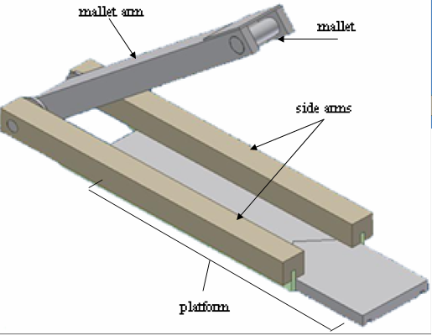

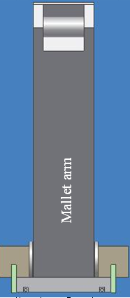
The Nail-It consists of three main components: the swinging arm with the mallet, the platform acting as a nail holder, and the sliding mechanism of the two side arms. The mallet is able to swing up and down because of the copper dowel that goes through the pivoting end of the arm and the two supporting sides.

The hammering aspect of the device is performed by pulling back the mallet arm and allowing the large spring (not pictured) near the pivot to snap the arm back down upon the nail. The mallet swings easily and smoothly because washers are placed on the sides of the arm, causing less friction than would occur if the wooden arm was rubbing against the two wooden sides. A small steel cylinder acts as the mallet, glued through the sides of the arm itself, and a metal piece is glued above the mallet to strengthen and protect the wood around the mallet from breaking.

The platform has a V-shaped cross section which is used to secure a nail at the vertex of the V. The platform locks the nail in place because two springs embedded on the sides of the V keep the platform intact so that the nail cannot freely move at all. Three yellow pieces of Plexiglas (not pictured) are attached to the bottom of the platform so that the two parts of the platform cannot be bended perpendicular to each other, but instead remain parallel so the user can easily lock the nail in place without worrying about the angles of the two parts of the platform.

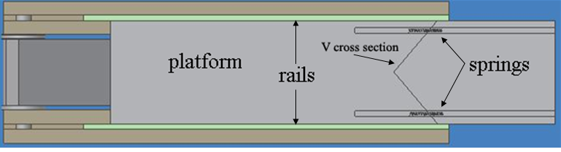

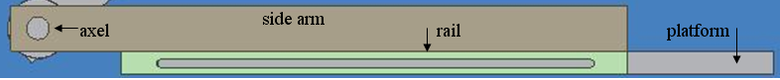
The two non-swinging side arms have a plastic rail inserted into each of them and is secured to the platform via two metal dowels which penetrate through the rails and the platform, secured by four plastic/rubber wheels (not pictured), one on each side of each rod.

The purpose of our device is to minimize the number of injuries caused by amateur use of hammers, act as a lightweight and portable alternative to the hammer, and make the initial striking of small finishing nails easy and safe. Currently, our prototype effectively reduces the amount of injuries while striking a nail if used properly, because the user no longer has to hold the nail in place with his/her fingers. However, even though our device does appear to be more lightweight and portable than a heavy, clunky hammer, a hammer is still needed to finish inserting a nail through a surface because our device only allows the nail head to reach the level of the platform. This could reduce the marketability of our device as buyers contemplating the Nail-It would realize a hammer is still required and deem the invention obsolete and useless, especially for professionals. Another problem is the durability of the prototype, because our springs wear out and get stretched after finishing only a few nails, and because the exposed, unpolished wood can become damaged after a while.
Our device is a long way from becoming a product that could be patented. First of all, the device would have to be designed to have a more practical use. For example, the device might be useful for striking nails in small areas where there is not enough room to swing a regular size hammer. Ideally, it would be best for the device to be able to generate the same force striking nails into a wall from the side as striking nails into horizontal surfaces. This was not possible using our prototype design, so changes would have to be made such that the device could perform equally as well at any angle. Another thing is that although our device is supposed to “replace the conventional hammer”, the device can only drive nails up to the platform, which means that a hammer would still be necessary to finish driving in nails. Before getting the device patented, this flaw would have to be addressed. Probably the simplest method in fixing this problem would be to have the platform, which is only used in the initial holding of the nail, be detachable, so that the hammer part with the spring could still be used to drive in the nails with a considerable force.
Another aspect of the device that would have to be changed in order to get the device patented would be to change the main spring design. Currently, the spring is screwed into the arms, which make the device useful only for a limited amount of time – until the spring wears out. In the patent design, it would be more efficient if hooks attached the spring to the arms so that the spring could easily be changed without much trouble. If all of the issues mentioned above were to be tackled, then the Nail-It could be patented.
The advertisement promoting the Nail-It was based off of a previous Mac vs. PC commercial, which compared the convenience of the Mac computer versus the PC. We believed that this was applicable in comparing the Nail-It and the hammer in terms of safety. However, because the advertisement was very convoluted, most people had trouble connecting it to the Mac commercials. Therefore, the advertisement was not as affective in the presentation as we would have hoped it would be. In the future, it would probably be best to re-film the ad with a more explanation so that it would have more of an impact to all audiences. Also, no where in the ad was there a mention of what the Nail-It actually does, nor a demonstration of how it works, which would be completely useless to anyone who had never heard of the device before. It would have had much more effect if there were actually some sort of demonstration in the commercial to show how the Nail-It improves the safety using nails.

The prototype of the Nail-It was standard size and for the most part will be the same size for mass construction. However, we can design a different model that would be a bit larger, which could be used for larger sized nails, or we can design a smaller model for much smaller nails and even brads that would not work in the current size. We would not need to do anything major for mass construction because the entire device consists of rectangular prisms with holes. This would not pose any issues during construction. Also, all of the parts are very simple and can just be constructed from common parts – there is no need to customize any of the components. The device therefore would be very easy to build.
To make our device more marketable, we must attract not only amateurs who don’t own hammers, but also professionals who are less likely to injure themselves and who do own hammers. As of now, amateurs would probably find our device to difficult to operate, and obsolete because a hammer is still needed. To solve this problem, our mallet must be made detachable so that nails can be inserted all the way into a surface solely using the Nail-It. This way, the Nail-It would be able to replace a traditional hammer, and thus compete with one. For professionals seeking a powerful, sleek, durable, and most importantly, useful design, the Nail-It would have to be upgraded. Such modifications would include: metal instead of wood for the main parts; a tighter, more durable spring to allow more force to hit the nails, remain as strong as the first use, and let the mallet reach the nail even if the device is working against gravity; and a locking mechanism for the platform to allow an accurate hit every time. After these modifications, the Nail-It would be able to compete against the hammer for any type of buyer.
Appendices
Changes Suggested by Mr. Kaluta and Templin
  - Minimize the range of nail sizes because people are more likely to need assistance when hammering in small nails.
  - Shrink the overall design because people have more trouble hammering small nails. The device will also be more portable.

Bibliography
"Number of nonfatal occupational injuries and illnesses involving days away from
work(1) by source of injury or illness and selected parts of body affected
by injury or illness, 2005." Bureau of Labor Statistics. 7 Nov. 2006. 22
Sept. 2007 <http://stats.bls.gov/iif/oshwc/osh/case/ostb1682.txt>.

“Manually operable device for driving nails.” Hall Jr., Thomas. 29 Nov. 2005. 22
Sept. 2007 U.S. Patent No. 6968989. Washington, DC: U.S. Patent and Trademark Office. <http://patft.uspto.gov/netacgi/nph-Parser?Sect1=PTO2&Sect2=HITOFF&u=%2Fnetahtml%2FPTO%2Fsearch-adv.htm&r=2&f=G&l=50&d=PTXT&p=1&p=1&S1=%22nail+guard%22&OS=%22nail+guard%22&RS=%22nail+guard%22>

“Devices and methods for guiding nails.” Stephenson Jr., Roger. 30 Sept. 1997. 22
Sept. 2007 U.S. Patent No. 5671641. Washington, DC: U.S. Patent and Trademark Office. http://patft.uspto.gov/netacgi/nph-Parser?Sect1=PTO2&Sect2=HITOFF&u=%2Fnetahtml%2FPTO%2Fsearch-adv.htm&r=2&f=G&l=50&d=PTXT&p=1&p=1&S1=(hammer+AND+%22finger+guard%22)&OS=hammer+And+%22finger+guard%22&RS=(hammer+AND+%22finger+guard%22)
90%
4.5
Average
80%
4
8D
80%
4
6D
100%
5
4D
100%
5
2D
Percentage
Number of Accurate Strikes (out of 5)
Nail Size
Accuracy of Driving in Finishing Nails with the Nail-It
88.5°
Average
86°
8D
89°
6D
89°
4D
90°
2D
Angle After 5 Strikes
Nail Size
Angle of Finishing Nails Parallel to Direction of Strikes Using Nail-It
93.75%
5
5
3.75
5
Average
100%
5
5
5
5
8D
90%
5
5
3
5
6D
95%
5
5
4
5
4D
90%
5
5
3
5
2D
Percentage
Number of Accurate Strikes (out of 5)
Nail Size
Accuracy of Driving in Finishing Nails with a Hammer
86.50°
87.25°
82.75°
87.75°
Average
84°
87°
85°
88°
8D
89°
86°
83°
87°
6D
86°
88°
83°
89°
4D
87°
88°
80°
87°
2D
Angle After 5 Strikes
Nail Size
Angle of Finishing Nails Parallel to Direction of Strikes Using Hammer

