Radial Angular Measures
- Have your partner hold the instrument for you while you look through the straws. The point where both straws meet should be facing you, and the instrument should be parallel to the ground.
- Make sure both levels are level.
- Align the first object with the stationary straw (the left straw).
- Align the second object with the straw attached to the string (the right straw).
- Check the number of degrees between the two straws

Inclination Measures
- Make sure that you are standing up straight (If you are not, it may change the angle measure).
- Look through the straw to the tip of whatever it is you’re trying to measure
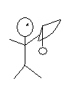
- Let the string attached to the washer hang perpendicular to the ground.
- Check the number of degrees between the two straws.
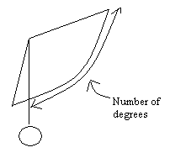
- Subtract 90 from the number of degrees.
