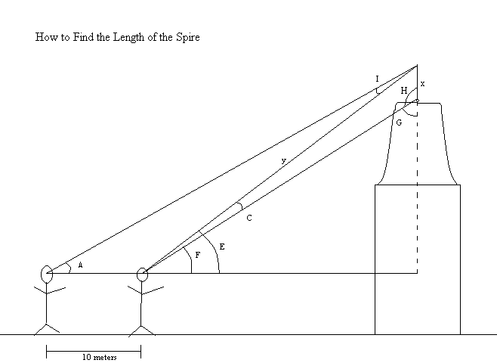
1. Measure angles A, E, F
2. 180 - A = B
3. E - F = C
4. 90 – F = G
5. 180 - G = H
6. 180 - (A + B) = I
7. 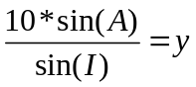
8. 