Benjamin Shih

Variable | Mean | Minimum | Q1 | Median | Q3 | Maximum | Range | IQR
Our Instrument | 10.700 | 7.000 | 8.500 | 12.000 | 12.250 | 13.000 | 6.000 | 3.750
Class IQRS | 21.00 | 3.75 | 10.38 | 12.25 | 39.50 | 43.25 | 39.50 | 29.13
Class Medians | 35.00 | 11.00 | 12.50 | 23.50 | 67.50 | 70.00 | 59.00 | 55.00

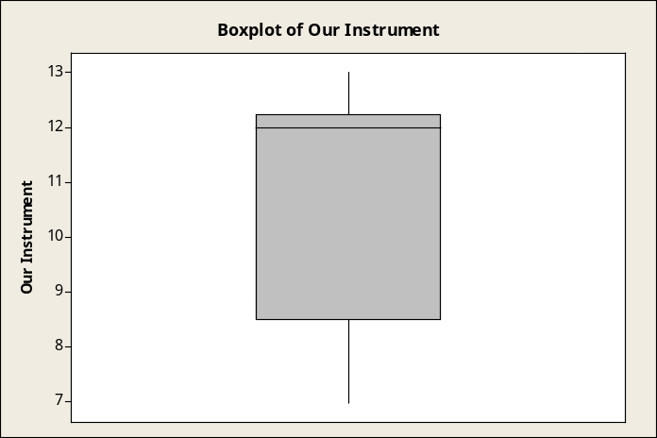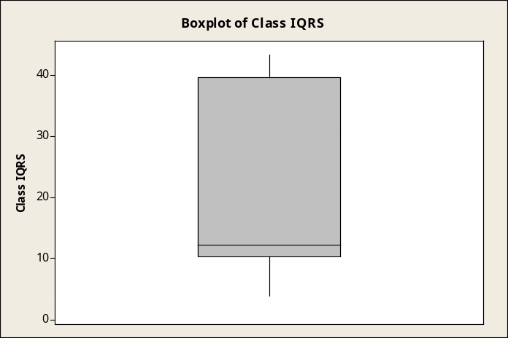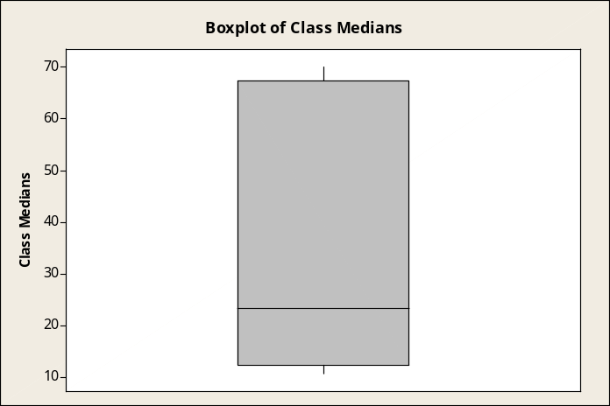
By comparing our box plots to the box plots of the class IQRs and class medians, I have found that our data is more consistent and accurate than the class data. Our median is 12, while the median of the class medians is 23.5 and the median of the class IQRs is 12.25. The Q1 of our trebuchet is 8.5 while the Q1 of the class medians and class IQRs are 12.5 and 10.38. Our Q3 is 12.25 while the Q3 of the class medians and class IQRs are 67.5 and 39.5. The range of our instrument is 6, while the range of the class median and class IQRs are 59 and 39.5.
With a range of 6 and an IQR of 3.75, our data is more consistent than the class data. With a maximum of 13 and median of 12, our data is also quite accurate. With this data, I have come to the conclusion that our instrument is more consistent and accurate than the class’ medians and IQRs.

Variable | Mean | Minimum | Q1 | Median | Q3 | Maximum | IQR
A | 58.10 | 27.00 | 33.00 | 70.00 | 70.00 | 70.00 | 37.00
B | 20.10 | 0.00 | 9.25 | 17.50 | 21.50 | 70.00 | 12.25
C | 54.50 | 18.00 | 28.00 | 70.00 | 70.00 | 70.00 | 42.00
D | 12.10 | 0.00 | 5.25 | 11.00 | 16.00 | 35.00 | 10.75
E | 32.10 | 14.00 | 17.50 | 33.00 | 36.25 | 70.00 | 18.75
F | 12.50 | 4.00 | 4.75 | 13.00 | 16.00 | 34.00 | 11.25
G | 10.70 | 7.00 | 8.50 | 12.00 | 12.25 | 13.000 | 3.750
H | 23.30 | 9.00 | 19.25 | 23.50 | 29.25 | 34.00 | 10.00
I | 50.40 | 14.00 | 26.75 | 65.00 | 70.00 | 70.00 | 43.25

