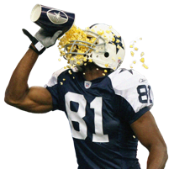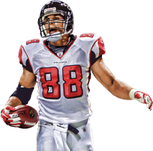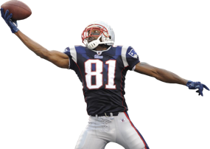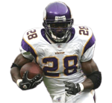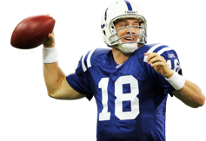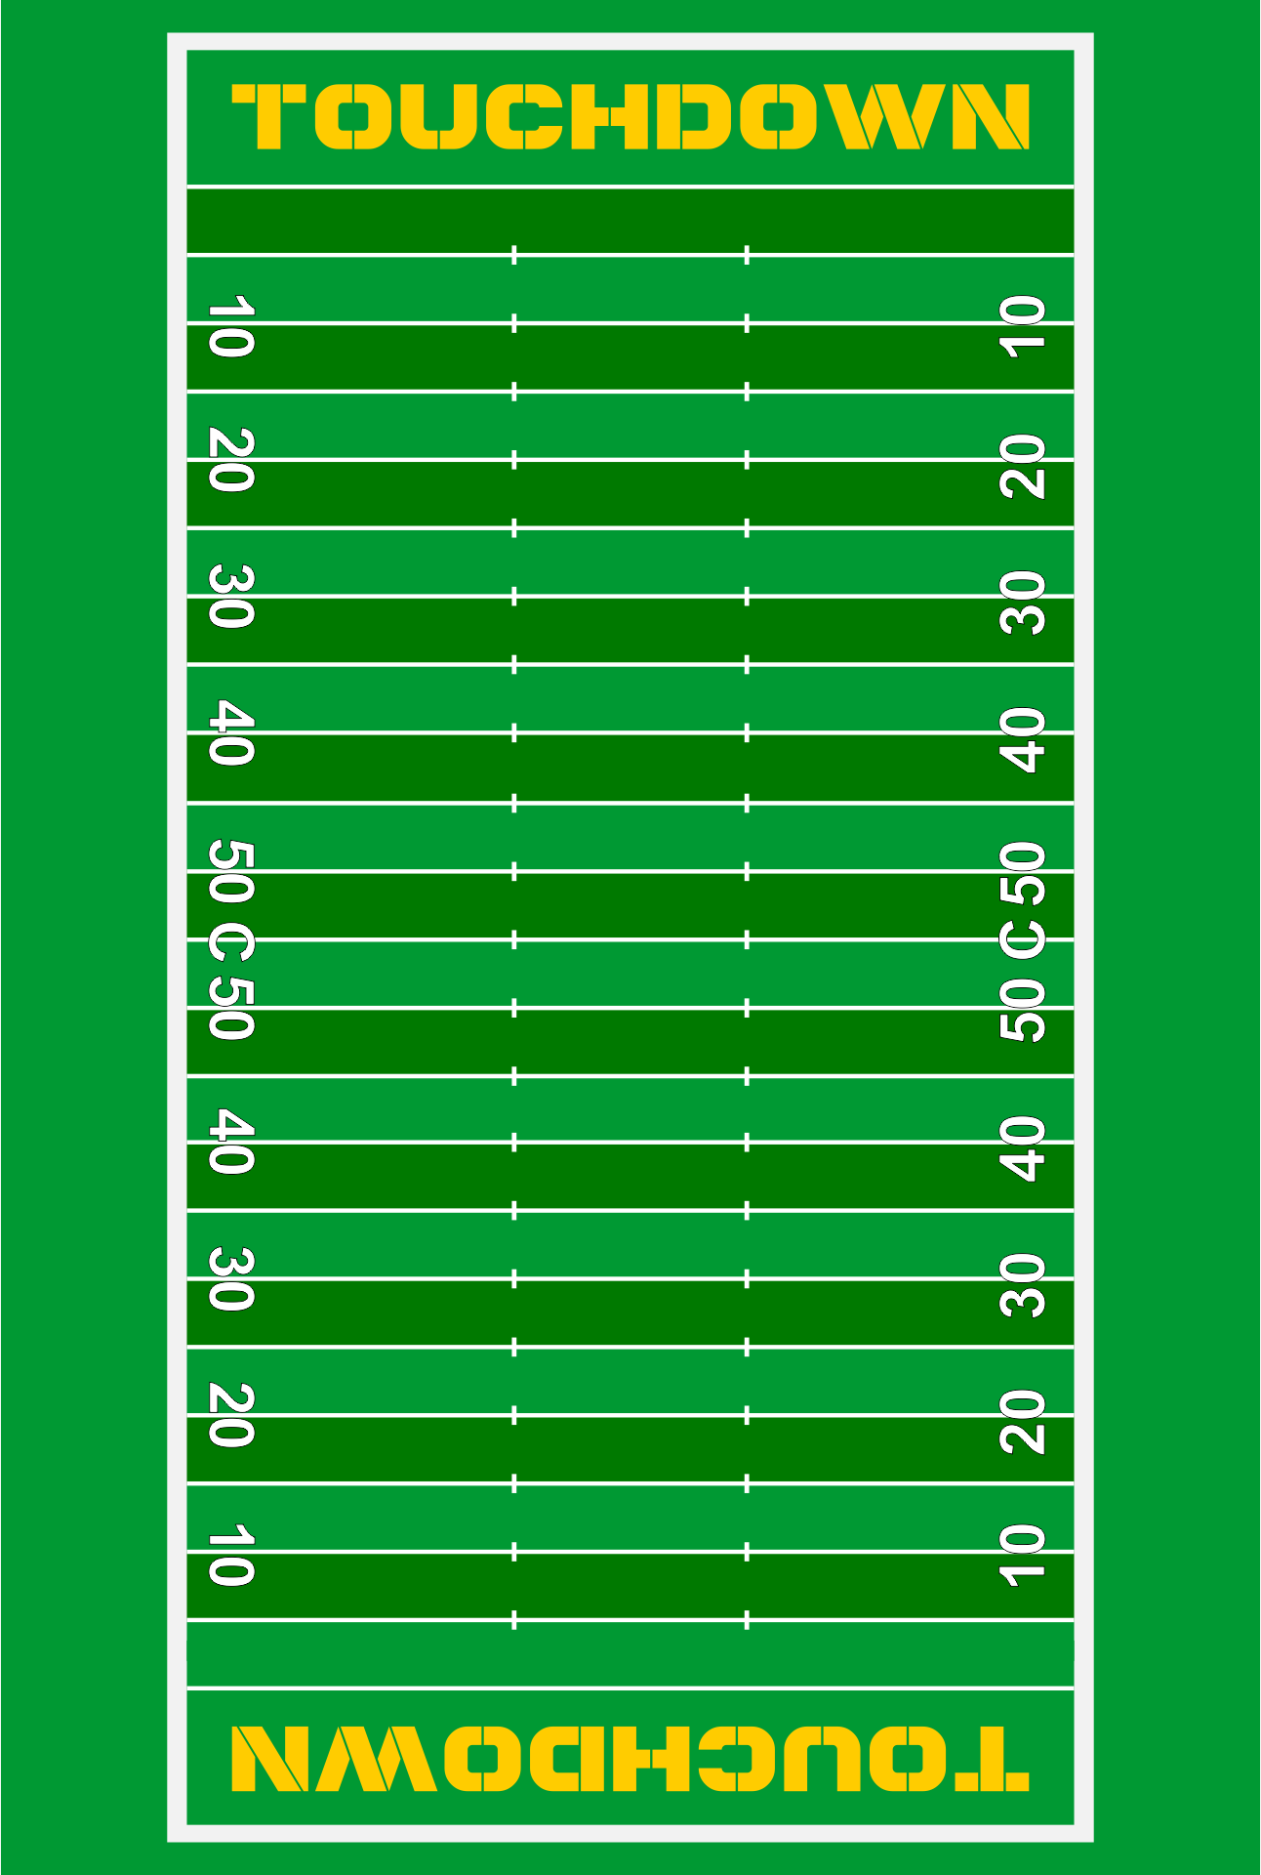

Note: Data only runs until 2015, leaving certain aspects outdated. Nonetheless, analysis for this time period still holds value. Stats listed at top of infographic are in comparison to other players drafted between 1995 and 2015.

The Ravens, Colts, 49ers, and Seahawks drafted most high-end talent. How have they done it? Click the next tab for further draft analysis.

**Of this group, only Terrell Owens was drafted outside the 1st round.**

**Superstars of this Era:**

**3.97%** of players drafted have been selected to an All-Pro 1st Team

Stars are found throughout the draft. Who has been best at finding elite talent?

Peyton Manning: QB Leader in Career Passing TDS, Yards, and 1st Team Selections

Tony Gonzales: TE Leader in Career Receiving TDS, Yards, and 1st Team Selections

Adrian Peterson: RB Leader in All-Pro 1st Team Selections

Terrell Owens: WR Leader in All-Pro 1st Team Selections and Career Receiving Yards

Randy Moss: WR Leader in Career Receiving TDS

**X**

**X X**

**X X X X X X**



**NFL Draft History from 1995 - 2015**