PENETRATION TESTING REPORT
FOOTPRINTING, RECONNAISSANCE & NETWORK SCANNING PHASES
W2-PM-FINAL | CYBERSECURITY & ETHICAL HACKING | NETWORKWALKS

Pentester Name (Cybersecurity Professional) | Emeka Nnorom
Program / Batch | B084A - Networkwalks
Date | 10 November 2026
Modules Completed | W2-PM1 (Multiple Kali Tools)  W2-PM4 (Footprinting & Reconnaissance with theHarvester)  W2-PM5 (Network Scanning with Zenmap)
Client / Target | 1. Networkwalks (networkwalks.com — written permission secured)  2. Microsoft (microsoft.com — passive OSINT/public sources only)  3. Local Lab LAN Network (10.0.0.0/24 — owned virtual environment)
Permission Secured from Client? | Yes (Written authorization for active domain recon & owned lab network)
Phases Covered | Phase 1: Footprinting & Reconnaissance Attacks with Multiple Kali Tools  Phase 2: Footprinting & Reconnaissance with theHarvester  Phase 3: Network Scanning with Zenmap  Phases 4–5: In Progress
1. Liability Disclaimer
I have performed these activities strictly on systems and devices where I had secured explicit written permission or within virtual lab networks that I own and control. All materials, commands, and outputs documented in this report are for authorized educational and cybersecurity research purposes only. Unauthorized reconnaissance, scanning, or access against external infrastructure without documented consent is illegal and carries severe legal penalties. Every action taken is the sole responsibility of the practitioner.
2. Introduction
This report documents the Week 2 practical deliverables of my Cybersecurity & Ethical Hacking internship program at Networkwalks. It covers three core reconnaissance and discovery modules: Footprinting & Reconnaissance Attacks with Multiple Kali Tools (W2-PM1), Passive OSINT Footprinting with theHarvester (W2-PM4), and Local Network Scanning with Zenmap (W2-PM5).
Together, these exercises demonstrate the structured progression of an attacker or penetration tester—moving from passive open-source intelligence (OSINT) and active domain enumeration to mapping live hosts, MAC addresses, and network topologies inside a local subnet. All activities were executed using Kali Linux and a Windows 10 virtual machine in Oracle VirtualBox, with command outputs and screenshots captured as verifiable evidence.
3. Tools Used
The table below summarizes the operating environments and reconnaissance utilities utilized across all three phases:
Tool / Environment | Purpose & Role in Assessment
Kali Linux & Windows 10 VM | VirtualBox host and guest operating systems used for CLI reconnaissance and GUI scanning.
WHOIS | Query domain registration records, registrar details, creation/expiry dates, and authoritative name servers.
WhatWeb | Fingerprint web technologies, CMS versions, plugins, server software, and HTTP headers.
nslookup | Query DNS servers to resolve domain names to their corresponding IPv4/IPv6 addresses.
curl -I | Inspect raw HTTP response headers, server banners, cookies, and exposed API endpoints.
Wafw00f | Identify and fingerprint Web Application Firewalls (WAF) protecting the target web application.
DNSRecon | Enumerate DNS infrastructure records including NS, MX, TXT/SPF, SRV, and zone configurations.
theHarvester | Gather emails, subdomains, hosts, and employee data passively from public OSINT sources and search engines.
Zenmap (Nmap GUI) | Perform host discovery (ping sweep) across the local subnet, extract MAC vendors, and visualize network topology.
Windows CMD (ipconfig) | Identify local host IPv4 configuration, subnet mask, and default gateway prior to scanning.
4. Activities Performed
4.1 Footprinting & Reconnaissance Attacks with Multiple Kali Tools (W2-PM1)
In this phase, targeted reconnaissance was conducted against the authorized domain networkwalks.com using six command-line utilities in Kali Linux to build a technical profile of the target's external footprint:
• WHOIS Enumeration: Executed 'whois networkwalks.com' to retrieve public registration metadata. The output confirmed registration via GoDaddy.com, LLC, domain status locks (clientDeleteProhibited, clientTransferProhibited), unsigned DNSSEC status, and authoritative name servers NS6135.HOSTGATOR.COM and NS6136.HOSTGATOR.COM.
• Web Technology Fingerprinting (WhatWeb): Executed 'whatweb networkwalks.com' to fingerprint the web stack. The scan identified an Apache web server running WordPress 7.1.4 alongside WordPress Download Manager 3.3.76, jQuery 3.7.1, Bootstrap 7.1.4, and exposed contact email info@networkwalks.com.
• DNS Resolution (nslookup): Executed 'nslookup networkwalks.com' to verify DNS resolution via local resolver 192.168.100.1, resolving the domain to its public IPv4 hosting address 192.232.216.135.
• HTTP Header Inspection (curl): Executed 'curl -I https://networkwalks.com' to analyze raw HTTP/2 response headers. The headers confirmed the Apache server banner, cache directives (x-nginx-cache: WordPress), session cookie flags (__wpdm_client; secure; HttpOnly), and exposed WordPress REST API endpoints (/wp-json/).
• WAF Detection (Wafw00f): Executed 'wafw00f networkwalks.com' to probe for active perimeter defenses. The tool confirmed that the web application is protected behind a ModSecurity (SpiderLabs) Web Application Firewall.
• DNS Record Enumeration (DNSRecon): Executed 'dnsrecon -d networkwalks.com' to perform general DNS enumeration, confirming the A record resolution (192.232.216.135) and checking DNSSEC, SOA, and SRV records.
4.2 Footprinting & Reconnaissance with theHarvester (W2-PM4)
In this phase, passive open-source intelligence gathering was performed in Kali Linux using theHarvester v4.10.1 against microsoft.com without sending direct packets to the target infrastructure:
• Tool Initialization & Help Verification: Executed 'theHarvester -h' to review supported OSINT data sources, flags (-d, -l, -b), and proxy/API configuration options.
• Task 1 — Targeted Baidu Search: Executed 'theHarvester -d microsoft.com -l 1000 -b baidu' to query Baidu search indexes with a 1,000-result ceiling. Because Baidu enforces strict automated query filtering and primarily indexes regional domains, the query completed cleanly with zero hosts, IPs, or email addresses returned—illustrating why pentesters must test multiple intelligence sources.
• Task 2 — Multi-Source Passive Enumeration: Executed 'theHarvester -d microsoft.com -l 50 -b all' to aggregate results across all integrated OSINT modules (including certificate transparency logs, DNS databases, and search engines). Modules requiring commercial API keys (such as BeVigil, Bitbucket, BufferOverrun, and BuiltWith) were automatically bypassed while public modules extracted subdomains and host records.
4.3 Network Scanning with Zenmap (W2-PM5)
For the final activity, I used Zenmap to perform host discovery on my own local network from a Windows 10 VM running inside Oracle VirtualBox. Prior to launching Zenmap, I ran 'ipconfig' in Windows Command Prompt, which identified my local IPv4 address as 10.0.0.10 on subnet mask 255.255.255.0 with default gateway 10.0.0.1.
I then entered the target subnet '10.0.0.10/24' into Zenmap and selected the 'Ping scan' profile (executing 'nmap -sn 10.0.0.10/24'). The scan scanned all 256 IP addresses in 0.50 seconds and discovered four live hosts:
• 10.0.0.1: MAC 52:55:0A:00:00:01 (vendor unknown) — Default gateway
• 10.0.0.2: MAC 08:00:27:8A:35:D2 (Oracle VirtualBox virtual NIC) — Virtualization host/DHCP interface
• 10.0.0.3: MAC 52:55:0A:00:00:03 (vendor unknown) — Active local network node
• 10.0.0.10: The scanning host itself (Windows 10 VM; no MAC reported for local loopback/interface)
After completing the scan, I opened the Topology tab in Zenmap, enabled the Topology Legend to confirm marker meanings (green circle = host with fewer than 3 open ports; dashed lines = no traceroute information available), and reviewed the resulting star topology showing all discovered hosts connecting through localhost.
5. Risk Analysis & Security Impact
Based on the intelligence gathered across all three modules, the following informational observations and potential security exposures were identified:
# | Risk / Observation | Evidence Collected | Potential Impact | Risk Level
1 | CMS & Plugin Version Disclosure | WhatWeb revealed WordPress 7.1.4 and WordPress Download Manager 3.3.76 on networkwalks.com. | Attackers can cross-reference exact software versions against public CVE databases for known exploits. | ● Medium
2 | Public Email & API Endpoint Exposure | WhatWeb exposed info@networkwalks.com; curl -I exposed /wp-json/ REST API headers. | Facilitates targeted spear-phishing campaigns and automated user/API enumeration. | ● Low
3 | Hosting IP & DNS Infrastructure Mapping | nslookup & DNSRecon resolved 192.232.216.135; WHOIS mapped HostGator NS records. | Enables attackers to map hosting providers, mail routing, and potential origin server targets. | ● Low
4 | WAF Architecture Identification | Wafw00f identified ModSecurity (SpiderLabs) protecting the web application. | Reveals defensive filtering technology, allowing attackers to tailor evasion payloads. | ● Low
5 | Passive Subdomain & OSINT Leakage | theHarvester demonstrated automated extraction of subdomains and host records from public sources. | Forgotten or unmonitored subdomains expand the external attack surface without alerting defenders. | ● Medium
6 | Internal LAN Host Visibility | Zenmap ping sweep mapped 4 live hosts and MAC addresses on 10.0.0.0/24 in 0.50 seconds. | If an attacker gains internal foothold, rapid ARP/ICMP discovery exposes pivot targets and rogue devices. | ● Medium
Note: These findings represent reconnaissance observations rather than confirmed exploitable vulnerabilities. Active exploitation was strictly out of scope for Week 2.
6. Security Recommendations
• Minimize Version & Banner Disclosure: Configure Apache and WordPress security settings to suppress version numbers in meta generator tags and HTTP headers.
• Maintain Timely Patch Management: Keep WordPress core, themes, and plugins (such as WordPress Download Manager) updated against the latest security advisories.
• Harden HTTP Response Headers & REST API: Restrict unauthenticated access to sensitive /wp-json/ endpoints and audit exposed response headers.
• Audit Public OSINT & DNS Footprint: Periodically run tools like theHarvester and DNSRecon against organizational domains to identify and decommission stale subdomains or leaked email addresses.
• Maintain & Tune WAF Rules: Keep ModSecurity active with updated OWASP Core Rule Set (CRS) signatures to block automated scanning and injection attempts.
• Enforce Network Segmentation & NAC: Monitor internal subnets for unauthorized MAC addresses, enforce port security/802.1X, and maintain accurate network topology documentation.
7. Conclusion
During Week 2 of my Cybersecurity & Ethical Hacking internship at Networkwalks, I successfully executed passive footprinting, active domain enumeration, and local network host discovery across three practical modules. Using Kali Linux utilities (WHOIS, WhatWeb, nslookup, curl, Wafw00f, DNSRecon, and theHarvester), I demonstrated how public metadata and server responses reveal critical infrastructure details without intrusive exploitation. Using Windows CMD and Zenmap, I mapped active devices on my local 10.0.0.0/24 lab network and generated a visual star topology. These exercises reinforced the importance of thorough technical documentation, defensive hardening against information leakage, and strict adherence to authorized testing boundaries.
8. Evidences Collected
The following 11 screenshots document the execution and outputs of all assigned practical tasks across Modules W2-PM1, W2-PM4, and W2-PM5:
Figure 1: WHOIS Domain Enumeration — whois networkwalks.com (W2-PM1)
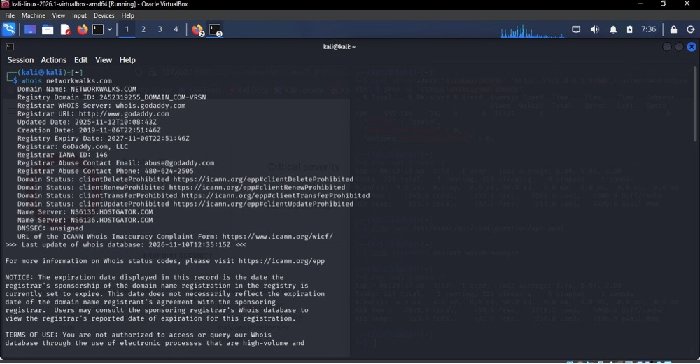
Figure 2: Web Technology Fingerprinting — whatweb networkwalks.com (W2-PM1)
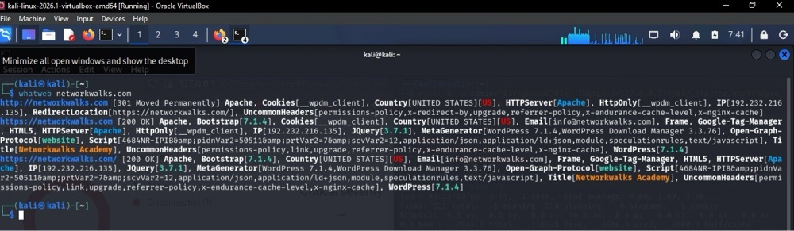
Figure 3: DNS Resolution Check — nslookup networkwalks.com (W2-PM1)
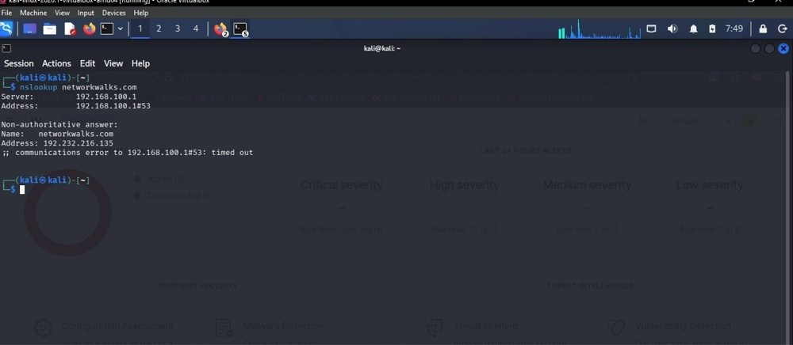
Figure 4: HTTP Response Header Inspection — curl -I https://networkwalks.com (W2-PM1)
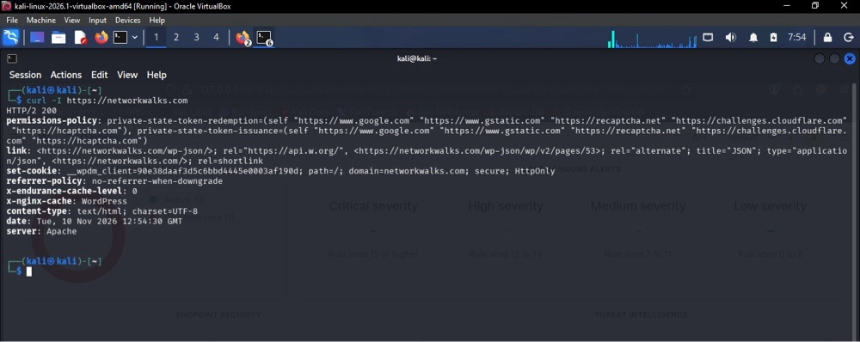
Figure 5: WAF Fingerprinting — wafw00f networkwalks.com (W2-PM1)
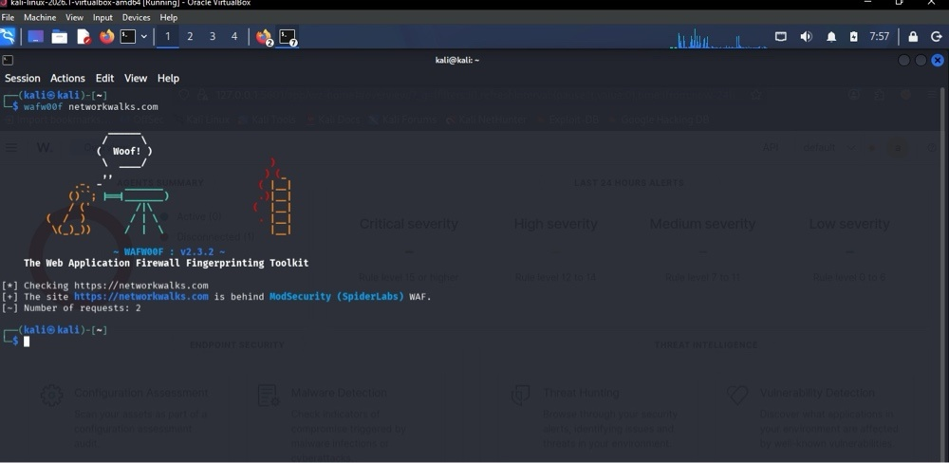
Figure 6: DNS Zone Enumeration — dnsrecon -d networkwalks.com (W2-PM1)
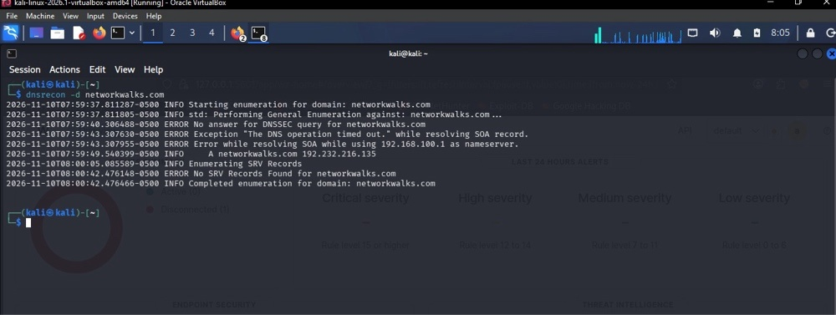
Figure 7: theHarvester Initialization & Usage Guidelines — theHarvester -h (W2-PM4)
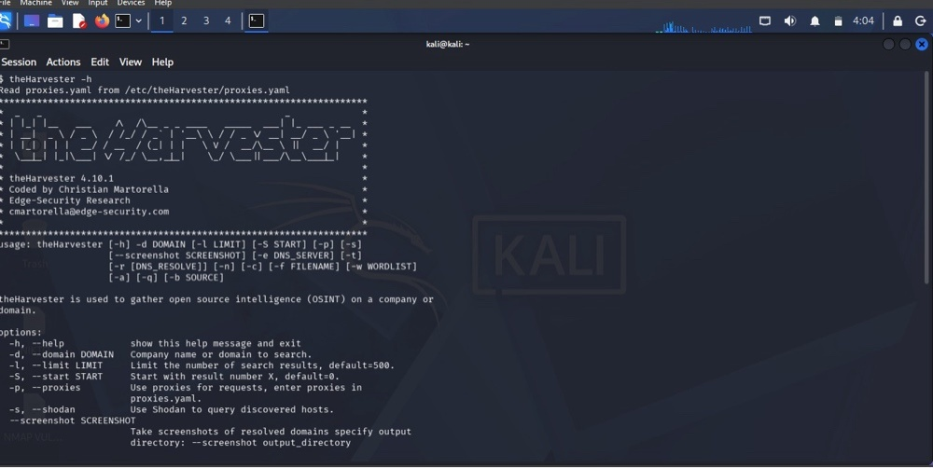
Figure 8: theHarvester Task 1 — Baidu Source Query (microsoft.com, Limit 1000) (W2-PM4)
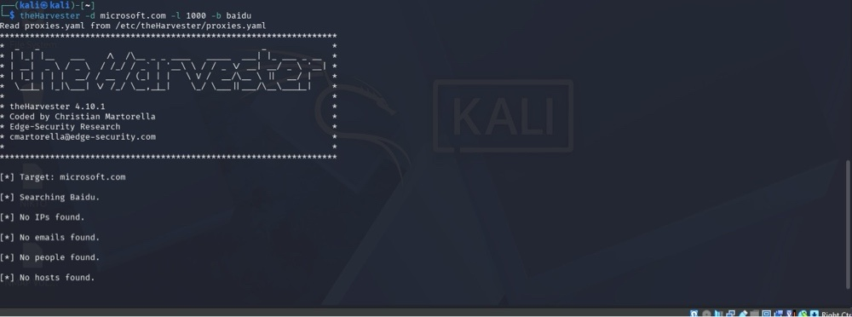
Figure 9: theHarvester Task 2 — All Sources Query Execution (microsoft.com, Limit 50) (W2-PM4)
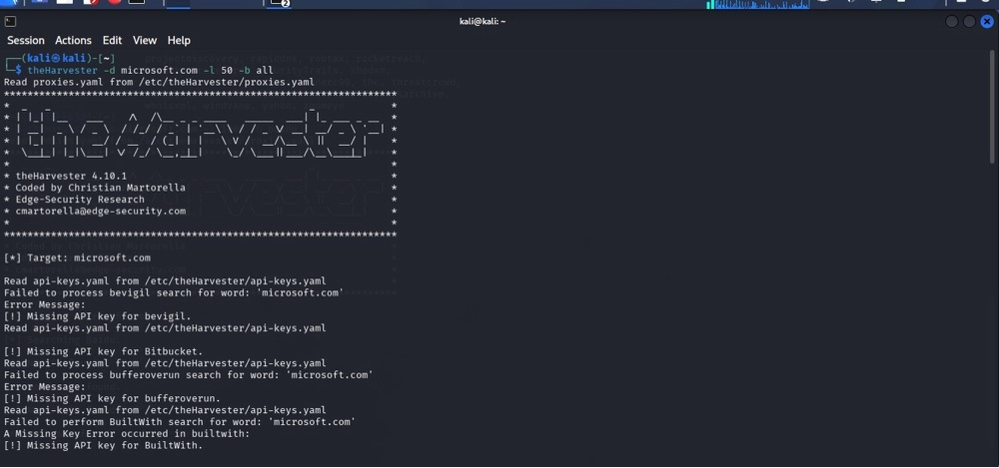
Figure 10: Zenmap Host Discovery Ping Scan — nmap -sn 10.0.0.10/24 (4 Hosts Up) (W2-PM5)
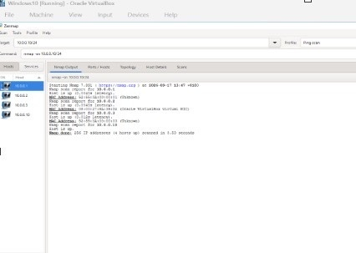
Figure 11: Zenmap Star Network Topology & Legend Verification (W2-PM5)
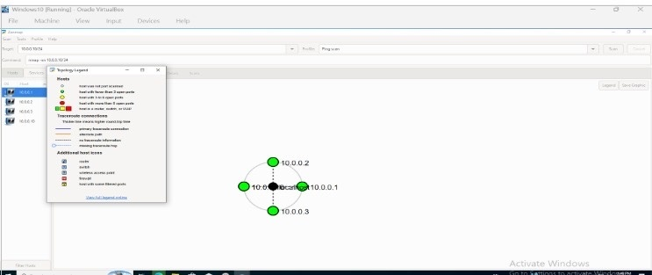

Author: Emeka Nnorom | Cybersecurity Professional | Batch B084A
Program: Cybersecurity & Ethical Hacking Internship at Networkwalks | Week 02 Final Deliverable

